SUPPLEMENTARY MATERIAL
Supplementary Methods
Protein extraction and western blot
Total proteins were extracted from bEND3 cell lysates using PhoSTOP (Merck, #4906845001) and cOmplete Mini (Merck, #11836153001) diluted in RIPA buffer (Merk, #R0278). Whole cell lysates were quantified using BCA Protein assay (Thermo Fisher, #23227). 30 µg of total proteins were separated using 4-12% Bis-Tris Mini Protein Gels (Invitrogen, #NP032BOX). Samples were diluted (v/v) in LDS sample buffer (Invitrogen, #NP0007) and DTT (Invitrogen, #NP0009) as reducing agent and denatured at 95°C 10 minutes before loading. Proteins were transferred onto a nitrocellulose membrane at 400 mA for 1 hour. Non-specific binding sites were blocked with a buffer containing 5% fat‐free milk in phosphate‐/Tris‐buffered saline (TBST, 100 mmol/L Tris HCl, 1.5 mol/L NaCl, 0.5% Tween‐20, pH 7.6 all purchased from Merck KGaA) and membranes were incubated overnight at 4°C with primary antibodies. Membranes were washed three times in TBST and incubated with anti‐mouse HRP-conjugated secondary antibody (Sigma) 2 hours at room temperature. Immunoreactive bands were visualized by ECL Western Blotting Substrate (Thermo Fisher, #32106) on C-DiGit Blot Scanner (LI-COR). The chemiluminescent signal was then densitometrically quantified using ImageJ, following the software guidelines. The following antibodies were used: anti-mouse TP (#CQA2296, Cohesion biosciences) diluted 1:1000, anti-mouse GAPDH (#G9545, Merk) diluted 1:500.

RNA extraction, reverse transcription, and quantitative PCR
RNeasy Mini Kit (#74104, Qiagen) was used to extract total RNA from bEND3 cells. Nanodrop spectrophotometer was used to quantify extracted RNA. Using the First-Strand cDNA Synthesis – SuperScript II kit (Invitrogen, #18064014), 500 ng of total RNA was reverse transcribed into cDNA following the manufacturer’s protocol. Real-time PCR was performed on 10 ng of cDNA per reaction, with TOptical Gradient PCR Thermal Cycler (Biometra) using ABsolute Blue SYBR Green Master Mix (Thermo Fisher, #AB4162B) and SYBR Green probes. GAPDH was used as housekeeping gene. Data are presented as fold changes relative to the expression levels of control samples in accordance with the 2^{−ΔΔCt} formula. The following gene probes were used: mouse TYMP and mouse GAPDH (Merck, both custom designed).
The oligonucleotide sequence (5’-3’) used for TYMP was:
Forward primer TGGAGGTGGAAGAAGCGTTGCT
Reverse primer CCGCTAATCCAAAGAATGGCGC
The oligonucleotide sequence (5’-3’) used for GAPDH was:
Forward primer ACAACTTTGGCATTGTGGAA
Reverse primer GATGCAGGGATGATGTTCTG

Supplementary Results
Evaluation of 50% TP silencing
Transfection of bEND3 cells with 25nM TP siRNA for 48h resulted in a significant reduction of TP mRNA expression compared to scramble-transfected cells, with a mean reduction of 34% at the mRNA level as assessed by real-time PCR (scramble: 1.00±0.00, normalized reference; TP siRNA: 0.66±0.12; t(4) = 4.857, p = 0.008; Supplementary Figure 1A). This was corroborated at the protein level by western blot analysis, which showed a mean reduction of 48% in TP protein expression (scramble: 1.00±0.00, normalized reference; TP siRNA: 0.52±0.07; t(4) = 11.880, p < 0.001; Supplementary Figure 1B).
Supplementary Figures
Supplementary Figure 1. Evaluation of TP silencing in bEND3 cells. Transfection with 25nM TP siRNA for 48h induced a significant reduction in TP expression at the mRNA level assessed by real-time PCR (A; 34% reduction; ** p = 0.008) and at the protein level assessed by western blot (B; 48% reduction, *** p < 0.001). Values are expressed relative to scramble-transfected control cells (normalized reference = 1.00). N = 3 independent biological replicates are shown in the graph. Each biological replicate represents the average of two technical replicates. Data are presented as mean (box height) ± SD (error bars).

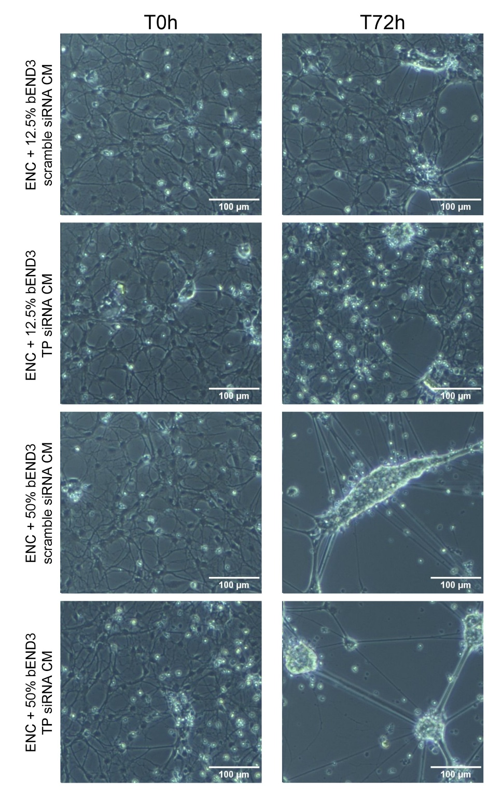
Supplementary Figure 2. Phase-contrast morphologic evaluation of enteric nervous system-derived cells exposed to bEND3 conditioned medium at concentrations excluded from the main experimental protocol. Representative phase-contrast images of ENCs treated with 12.5% or 50% CM from scramble siRNA- or TP siRNA-transfected bEND3 cells, acquired at T0h and T72h. ENC = enteric nervous system-derived cells, CM = conditioned medium. Scale bar: 100 μm.
Supplementary Figure 3. Representative live-cell imaging of enteric nervous system-derived cells exposed to scramble-transduced and TP-silenced endothelial cells conditioned medium. Images were captured at different time points to monitor the evolution of the same field over time: T0 (immediately after exposure), T24h, T48h, and T72h. ENC = enteric nervous system-derived cells, CM = conditioned medium. Scale bar: 400 μm.
Supplementary Figure 4. Neuronal network evaluation in enteric nervous system-derived cells after scramble-transduced and TP-silenced endothelial cells conditioned medium exposure. Representative fields of TUJ1 (green) IF staining for 24h and 48h time points. ENC = enteric nervous system-derived cells, CM = conditioned medium. Scale bar: 50 μm.

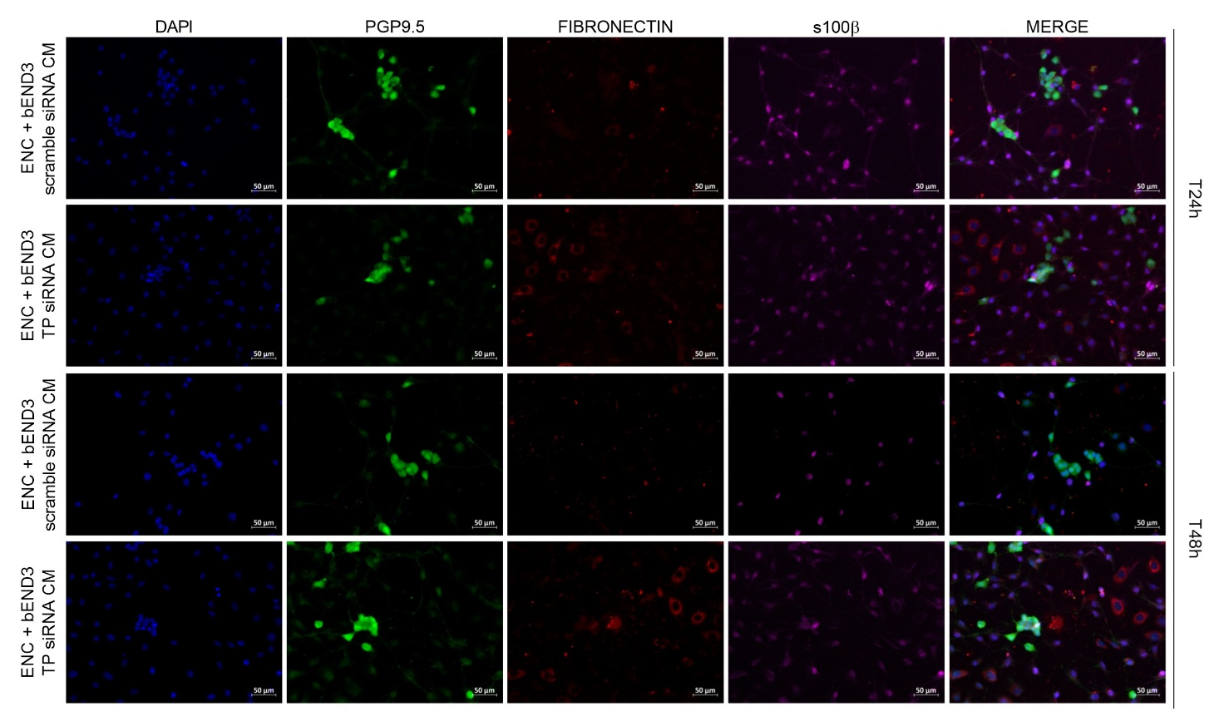
Supplementary Figure 5. Cellular subtypes evaluation in enteric nervous system-derived cells after scramble-transduced and TP-silenced endothelial cells conditioned medium exposure. Representative fields of PGP9.5 (green), fibronectin (red) and s100β (purple) IF staining for 24h and 48h time points. ENC = enteric nervous system-derived cells, CM = conditioned medium. Scale bar: 50 μm.

Supplementary Figure 6. Analysis of stress markers in enteric nervous system-derived cells after scramble-transduced and TP-silenced endothelial cells conditioned medium exposure. Representative fields of PGP9.5 (green), nNOS (red) and GFAP (purple) IF staining for 24h and 48h time points. ENC = nervous system-derived cells, CM = conditioned medium. Scale bar: 50 μm.

Supplementary Table 1. Relative signal intensities from the cytokine array screening. Values represent semi-quantitative signal intensities normalized to the membrane-specific internal reference value, set to 100. Only targets showing a detectable signal in at least one experimental condition are reported. A value of 0.00 indicates that no discernible signal was detected in that specific condition. ENC = enteric nervous system-derived cells; CM = conditioned medium.
Target | bEND3 scramble siRNA CM | bEND3 TP siRNA CM | ENC + bEND3 scramble siRNA CM | ENC + bEND3 TP siRNA CM
IFNγ | 13.39 | 10.49 | 1.76 | 18.11
IL-6 | 0.00 | 0.00 | 0.00 | 7.06
IL-7 | 0.00 | 0.00 | 0.00 | 6.93
IL-17 | 0.00 | 0.83 | 0.00 | 4.98
IL-27 | 0.00 | 0.00 | 0.90 | 0.00
CXCL10 | 4.79 | 14.81 | 23.67 | 90.29
CXCL1 | 41.19 | 32.04 | 55.41 | 58.10
M-CSF | 0.00 | 0.00 | 0.00 | 4.06
CCL2 | 90.10 | 102.59 | 97.21 | 119.12
CXCL2 | 0.00 | 0.00 | 0.96 | 1.84
CCL5 | 0.68 | 17.11 | 0.00 | 81.49
CXCL12 | 2.30 | 0.00 | 1.41 | 5.24
TIMP-1 | 91.40 | 95.77 | 121.97 | 103.20

