SUPPLEMENTARY MATERIAL
β-Hydroxybutyrate maintains energetically demanding neural functions during exogenous glucose deprivation
Rachel L. Ricks¹, Dallin S. Nevers², Tyler Poulos^{1,2}, T. Luke Shafer², Clayton Dunford¹, Jason M. Hansen¹, Paul R. Reynolds¹, Benjamin T. Bikman¹, R. Ryley Parrish^{1,2*}
¹ Brigham Young University, Department of Cell Biology and Physiology, Provo, Utah, USA
² Brigham Young University, Neuroscience Center, Provo, Utah, USA
* Corresponding author: R. Ryley Parrish, ryley_parrish@byu.edu

Running title: β-Hydroxybutyrate supports neural function without exogenous glucose
Keywords: energetics, spreading depolarization, spreading depression, brain metabolism, ketones

Number of Supplemental Pages: 8
Number of Supplemental Figures: 3
Number of Supplemental Tables: 0
Number of Supplemental Multimedia: 0

Supplementary Notes
ª In response to reviewer comments, additional high-resolution respirometry experiments were performed during manuscript revision in brain slices incubated without exogenous fuel substrates to complement the glucose and BHB datasets presented in Fig. 1. Neocortical slices were maintained in 10 mM sucrose aCSF for 4 hours and subsequently processed and analyzed using the same tissue preparation, MiR05 respiration medium, O2k SUIT protocol, quality-control procedures, and data analysis described for the glucose and BHB groups in the High-Resolution Respirometry Methods. These additional data are presented in Fig. S1.
^{b} In response to reviewer comments, additional spreading depolarization experiments were performed during manuscript revision using aCSF containing 2 mM BHB with 8 mM sucrose for osmotic balance to complement the original 10 mM glucose, 10 mM BHB, and 10 mM sucrose datasets presented in Fig. 2. Aside from the modified substrate condition, slice incubation, sequential 26 mM high-K⁺ SD induction, IOS acquisition and analysis, and statistical procedures were identical to those described for the original experimental groups in the Intrinsic Optical Signal Recording and Analysis Methods. A concentration of 2 mM BHB was selected to approximate circulating concentrations commonly observed during nutritional ketosis. Circulating substrate concentrations, however, cannot be directly equated with concentrations in the bathing medium of ex vivo brain slices. In vivo, substrates are continuously delivered throughout brain tissue by the vasculature, whereas substrate delivery within 400-µm brain slices depends largely on diffusion from the surrounding aCSF. Consequently, bath concentrations approximating those in circulation may provide lower substrate availability within deeper regions of the slice and should not be interpreted as reproducing in vivo cerebral BHB availability. The resulting data are presented in Fig. S2.
^{c} In response to reviewer comments, data assessing the glutathione redox potential in brain slices following 3-hour incubation in aCSF containing 10 mM glucose or 10 mM BHB were added to the Supplementary Material during manuscript revision. Following incubation, brain slices were collected in 5% perchloric acid and boric acid (0.2 M) containing γ-glutamylglutamate (10 μM, Sigma-Aldrich) as an internal standard. Intracellular concentrations of glutathione (GSH) and its oxidized form, glutathione disulfide (GSSG), were measured by reverse-phase high-performance liquid chromatography as S-carboxymethyl, N-dansyl derivatives using γ-glutamylglutamate for normalization, as described previously (Jones et al. 1998). Proteins were acid precipitated, and the samples were centrifuged at 16,000 × g for 5 min, after which the soluble fractions were derivatized. Samples were analyzed using an e2695 Separations Module (Waters) fitted with a Supelcosil LC-NH2 5 μm column (Sigma-Aldrich), and peaks were detected using a 2474 FLR Detector (Waters) with excitation at 335 nm and emission at 518 nm. The GSSG/GSH redox potential (Eh) was calculated from GSH and GSSG concentrations using the Nernst equation (Harris and Hansen 2012). No statistically detectable difference in E_{h}(GSSG/GSH) was observed between glucose- and BHB-incubated tissue under the conditions tested (Fig. S3). This finding does not establish equivalent redox homeostasis between conditions or exclude oxidative stress through other mechanisms.

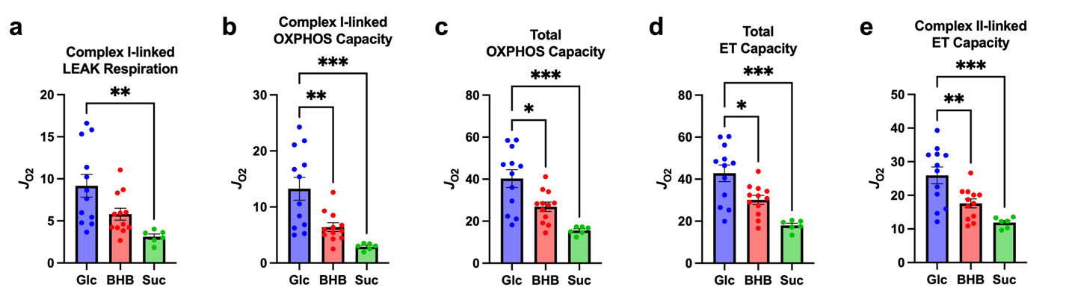
Fig. S1 Mitochondrial oxygen flux (J_{O2}; pmol·s⁻¹·mg⁻¹) in mouse neocortex following 4-hour incubation with 10 mM glucose (Glc), 10 mM β-hydroxybutyrate (BHB), or 10 mM sucrose (Suc; no-exogenous-fuel condition). (a) Complex I-linked LEAK respiration, representing non-phosphorylating J_{O2} associated with proton leak, proton slip, cation cycling, and electron leak at high chemiosmotic potential following addition of glutamate and malate. (b) Complex I-linked oxidative phosphorylation (OXPHOS) capacity, representing maximal J_{O2} supported by electron entry through complex I coupled to ATP production following addition of ADP. (c) Total OXPHOS capacity, representing maximal J_{O2} from the combined contributions of complex I- and complex II-linked electron supply pathways converging at the Q-junction coupled to ATP production following addition of succinate. (d) Total electron transfer (ET) capacity, representing maximal uncoupled mitochondrial respiration following stepwise addition of the uncoupler carbonyl cyanide m-chlorophenylhydrazone (CCCP). (e) Complex II-linked ET capacity, representing maximal J_{O2} supported by electron entry through complex II in the uncoupled state following inhibition of complex I with rotenone. Residual oxygen consumption (ROX), determined by antimycin A addition at the end of the substrate-uncoupler-inhibitor titration (SUIT) protocol, was subtracted from J_{O2} values to isolate mitochondrial respiration. Data are presented as mean ± SEM (one-way ANOVA with Tukey’s multiple-comparisons test; n = 12 for Glc and BHB, n = 6 for Suc). *p < 0.05, **p < 0.01, ***p < 0.001.

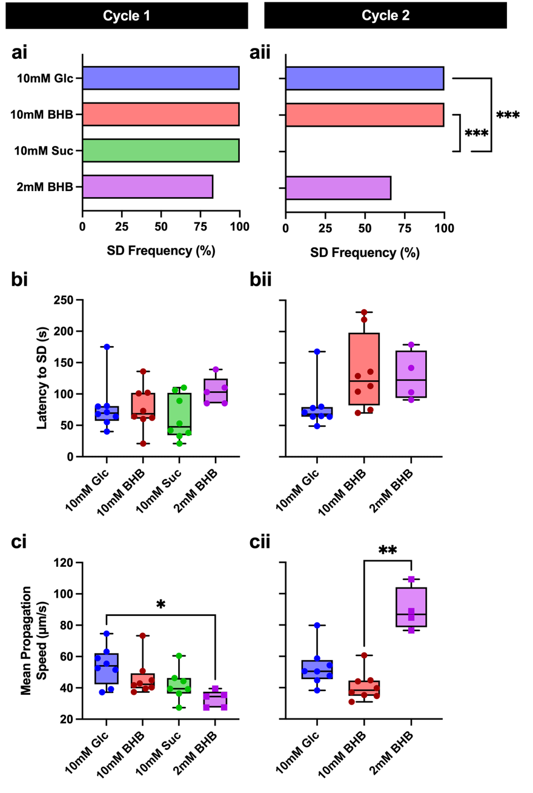
Fig. S2 Spreading depolarization (SD) occurrence, latency, and propagation speed in mouse neocortical brain slices incubated with 10 mM glucose (Glc), 10 mM β-hydroxybutyrate (BHB), 10 mM sucrose (Suc; no-exogenous-fuel condition), or 2 mM BHB with 8 mM sucrose. SDs were induced by high-K⁺ (26 mM) aCSF during two sequential induction cycles. (a) SD occurrence following high-K⁺ stimulation during (ai) cycle 1 (overall two-tailed Fisher’s exact test, p = 1.000; n = 8 for Glc, 10 mM BHB, and Suc; n = 6 for 2 mM BHB) and (aii) cycle 2 (overall two-tailed Fisher’s exact test, p < 0.0001; pairwise Fisher’s exact tests with Bonferroni correction; n = 8 for Glc, 10 mM BHB, and Suc; n = 6 for 2 mM BHB; Glc vs Suc, p = 0.0006; 10 mM BHB vs Suc, p = 0.0006). (b) Latency from high-K⁺ exposure to SD onset during (bi) cycle 1 (Kruskal–Wallis test, p = 0.1309; n = 8 for Glc, 10 mM BHB, and Suc; n = 5 for 2 mM BHB) and (bii) cycle 2 (Kruskal–Wallis test, p = 0.0239, with Dunn’s multiple comparisons test; n = 8 for Glc and 10 mM BHB, n = 4 for 2 mM BHB; n.s.). (c) Mean SD propagation speed during (ci) cycle 1 (Kruskal–Wallis test, p = 0.0155, with Dunn’s multiple comparisons test; n = 8 for Glc and 10 mM BHB, n = 7 for Suc, n = 5 for 2 mM BHB; Glc vs 2 mM BHB, p = 0.0111) and (cii) cycle 2 (Kruskal–Wallis test, p = 0.0004, with Dunn’s multiple comparisons test; n = 8 for Glc and 10 mM BHB, n = 4 for 2 mM BHB; 10 mM BHB vs 2 mM BHB, p = 0.0019). Boxplots display the median and interquartile range, with whiskers extending to the minimum and maximum values. *p < 0.05, **p < 0.01, ***p < 0.001.

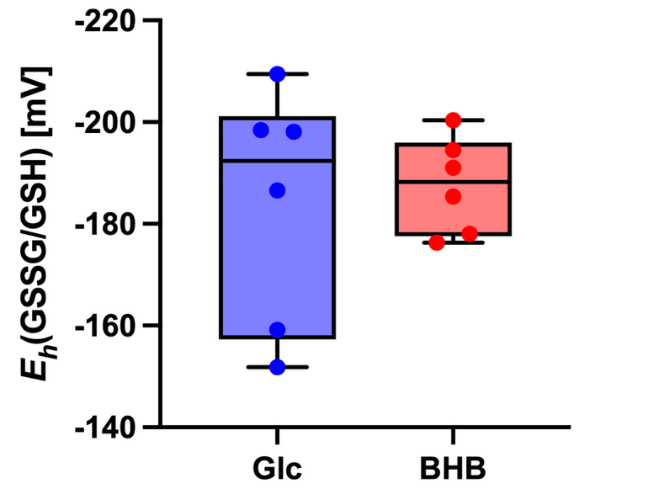
Fig. S3 Glutathione redox potential in mouse brain slices following incubation with glucose or β-hydroxybutyrate (BHB). Acute mouse brain slices were incubated for 3 hours in aCSF containing 10 mM glucose or 10 mM BHB. Reduced glutathione (GSH) and glutathione disulfide (GSSG) were quantified by HPLC and used to calculate the GSSG/GSH redox potential [E_{h}(GSSG/GSH)], with more positive values indicating a more oxidized redox state. Samples were analyzed in technical duplicate, with duplicate measurements averaged to yield one value per biological sample. E_{h}(GSSG/GSH) did not significantly differ between glucose- and BHB-incubated tissue (two-tailed unpaired Welch’s t test, p = 0.7314; n = 6 per group). Box plots show the median and interquartile range, with whiskers extending to the minimum and maximum values.

Supplementary References
Harris C, Hansen JM (2012) Oxidative Stress, Thiols, and Redox Profiles. In: Harris C, Hansen JM (eds) Developmental Toxicology: Methods and Protocols. Humana Press, Totowa, NJ, pp 325–346. doi:10.1007/978-1-61779-867-2_21
Jones DP, Carlson JL, Samiec PS, Sternberg P, Mody VC, Reed RL, Brown LAS (1998) Glutathione measurement in human plasma: Evaluation of sample collection, storage and derivatization conditions for analysis of dansyl derivatives by HPLC. Clinica Chimica Acta 275 (2):175–184. doi:https://doi.org/10.1016/S0009-8981(98)00089-8

