Figure S1

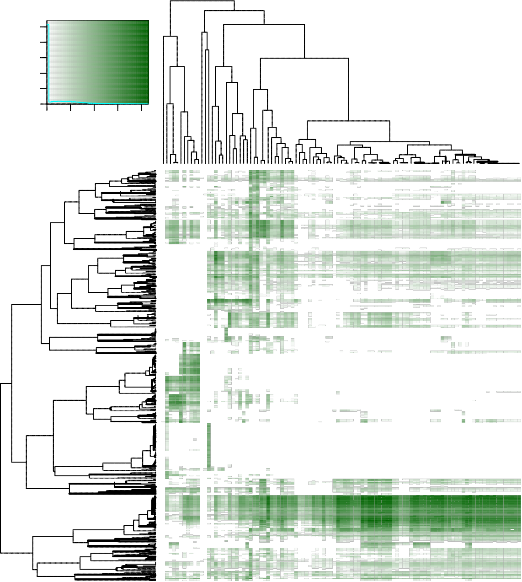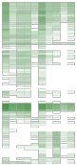Color Key and Histogram
25000

2 2.5 3 3.5 4
Count
10000
0
Value

USF2_1.motif_USF2
TFEC_1.motif_TFEC ENO1_1.motif_ENO1
ATF6_1.motif_CREBZF ATF6_1.motif_ATF6
ARNTL_1.motif_ARNTL HES1_1.motif_HES6
HES1_1.motif_HES1
HES4_1.motif_HES4
ARNT_2.motif_ARNT ZBTB14_1.motif_ZBTB14
HEYL_1.motif_HEYL IRF6_1.Infer.motif_IRF6
HES7_1.motif_HES7
ZBTB7A_2.motif_ZBTB7A NFKB1_1.motif_NFKB1
NFKB2_1.motif_NFKB2
TCF3_1.motif_TCF3
ZFY_1.motif_ZFY ZFX_1.motif_ZFX TFAP2A_1.motif_TFAP2A ZFAT_2.motif_ZFAT ZNF441_1.motif_ZNF441
ZNF597_2.motif_ZNF597
TFAP2D_1.motif_TFAP2D ZIC4_1.motif_ZIC4
ZIC5_3.motif_ZIC5
PLAGL1_1.motif_PLAGL1
RELA_1.motif_RELA NFKB1_2.motif_NFKB1
ZBTB33_1.motif_ZBTB33
RELB_1.motif_RELB EBF1_1.motif_EBF2
EBF1_1.motif_EBF1
EBF1_1.motif_EBF4
ZNF329_1.motif_ZNF329
KLF12_1.motif_KLF12
ZNF606_1.motif_ZNF606
ZNF445_3.motif_ZNF445
ZFP64_1.motif_ZFP64
ZNF768_1.motif_ZNF768
ZNF550_1.motif_ZNF550
ZNF781_1.motif_ZNF781
ZNF343_1.motif_ZNF343
ZNF777_2.motif_ZNF777
ZNF142_3.motif_ZNF142
TFAP2A_2.motif_TFAP2A TFAP2E_1.motif_TFAP2E TFAP2A_3.motif_TFAP2A ZNF594_4.motif_ZNF594
MAFG_1.motif_MAFG MAFF_2.motif_MAFF MXI1_1.motif_MXD3
MXI1_1.motif_MXD1
MXI1_1.motif_MXD4
MXI1_1.motif_MXI1
MAX_2.motif_MAX MYCN_1.motif_MYCL NPAS2_1.motif_NPAS2
CREB3L3_1.motif_CREB3L3
CREB3L2_1.motif_CREB3L2
CLOCK_1.motif_SOHLH1
CLOCK_1.motif_CLOCK ARNT_1.motif_ARNT USF1_1.motif_USF1
TFEB_1.motif_TFEB TFE3_1.motif_TFE3
ATF3_1.motif_ATF3
BHLHE40_1.motif_BHLHE40
MLXIPL_1.motif_MLXIPL ZNF433_2.motif_ZNF433
MTF1_1.motif_MTF1
NR1H4_1.motif_NR1H4
RARA_1.motif_RARA NR2F1_2.motif_NR2F1
RXRA_4.motif_RXRA NR2C1_1.motif_NR2C1
RHOXF1_1.motif_RHOXF2B RHOXF1_1.motif_RHOXF1
RHOXF1_1.motif_RHOXF2
ZNF827_1.motif_ZNF827
ZNF292_1.motif_ZNF292
ZNF579_1.motif_ZNF579
ZNF100_1.motif_ZNF100
MYF6_1.motif_MYF6
MYF6_1.motif_ASCL3
MSC_1.motif_MSC TCF21_1.motif_TCF21
ASCL2_1.motif_ASCL2
MYOG_1.motif_MYOG ATOH1_1.motif_ATOH1
MYF5_1.motif_ASCL5
MYF5_1.motif_ASCL1
MYOD1_1.motif_MYOD1
TCF12_1.motif_TCF12
FERD3L_1.motif_FERD3L ATOH7_1.motif_ATOH7
NEUROD1_1.motif_NEUROD1
MAFB_1.motif_MAFB ZNF516_2.motif_ZNF516
NRL_1.motif_NRL MAF_1.motif_MAF RFX1_1.motif_RFX1
ZNF732_1.motif_ZNF732
ZFP57_1.motif_ZFP57
PTF1A_1.motif_PTF1A ZNF208_2.motif_ZNF208
ZNF208_1.motif_ZNF208
ZNF594_2.motif_ZNF594
ZNF2_1.motif_ZNF2
TFAP4_2.motif_TFAP4
LYL1_1.Infer.motif_LYL1
SMAD3_2.motif_SMAD7
SMAD3_2.motif_SMAD3
SMAD4_1.motif_SMAD6
ZNF763_2.motif_ZNF763
SMAD2_2.motif_SMAD2
RFX5_1.motif_RFX5
ZNF536_2.motif_ZNF536
ZNF547_1.motif_ZNF547
ZNF699_1.motif_ZNF699
ZNF716_1.motif_ZNF716
SMAD1_1.motif_SMAD9
MAFA_1.motif_MAFA ZNF836_2.motif_ZNF836
HIC1_1.motif_HIC1
RFX1_2.motif_RFX1
ZNF594_3.motif_ZNF594
MEIS2_1.motif_MEIS2
TGIF2LX_1.motif_TGIF2LX TAL1_1.motif_TAL1
ZBTB18_2.motif_ZBTB18
ZBTB42_1.motif_ZBTB42
NEUROD4_1.motif_NEUROD4
NFIX_1.motif_NFIX NFIB_1.motif_NFIB NFIA_1.motif_NFIA NFIX_2.motif_NFIX NFIC_1.motif_NFIC HAND1_1.motif_HAND1
TLX1_2.motif_TLX1
RFX4_2.motif_RFX4
RFX3_1.motif_RFX3
RFX2_3.motif_RFX2
RFX5_2.motif_RFX5
TEAD1_1.motif_TEAD2
TEAD3_2.motif_TEAD3
SIX1_1.motif_SIX1
JUNB_1.motif_JUNB FOS_1.motif_FOS FOSB_1.motif_FOSB JDP2_1.motif_JDP2
NFE2_2.motif_NFE2
JUN_1.motif_JUN FOSL1_1.motif_FOSL1
BACH2_1.motif_BACH2
BACH1_1.motif_BACH1
SMARCC1_1.motif_TADA2A SMARCC1_1.motif_SMARCC1
FOSL2_1.motif_FOSL2
JUND_1.motif_JUND NFE2L2_1.motif_NFE2L2
NFE2_1.motif_NFE2
PAX2_3.motif_PAX2
NKX2_8_1.motif_NKX2−8
NKX3_1_2.motif_NKX3−1
NKX2_4_2.motif_NKX2−4
NKX2_5_1.motif_NKX2−5
NKX2_2_1.motif_NKX2−2
NKX2_1_1.motif_NKX2−1
NKX2_3_1.motif_NKX2−3
NKX2_6_1.motif_NKX2−6
NKX2_5_3.motif_NKX2−5
PAX5_2.motif_PAX5
PAX1_1.motif_PAX1
PAX2_1.motif_PAX2
PAX6_1.motif_PAX6
PAX8_1.motif_PAX8
PAX8_2.motif_PAX8
KLF4_1.motif_KLF2
KLF4_1.motif_KLF17
KLF4_1.motif_KLF4
KLF1_1.motif_KLF1
KLF7_1.motif_KLF7
KLF14_1.motif_KLF14
KLF13_1.motif_KLF13
KLF13_1.motif_KLF11
KLF12_2.motif_KLF12
KLF5_1.motif_KLF5
KLF16_1.motif_KLF16
SP3_1.motif_SP3
HOXD13_1.motif_HOXD13
HOXA13_1.motif_HOXA13
HOXB13_2.motif_HOXB13
HOXC13_2.motif_HOXC13
HOXB13_1.motif_HOXB13
HOXD13_2.motif_HOXD13
HOXA11_1.motif_HOXA11
HOXD11_1.motif_HOXD11
CDX1_1.motif_CDX1
HOXC11_2.motif_HOXC11
HOXA10_1.motif_HOXA10
CDX2_1.motif_CDX2
HOXD12_1.motif_HOXD12
HOXA6_4.motif_HOXA6
ZNF560_3.motif_ZNF560
HOXD9_2.motif_HOXD9
HOXC12_2.motif_HOXC12
HOXA9_1.motif_HOXA9
HOXC10_1.motif_HOXC10
HOXD12_2.motif_HOXD12
HOXC11_1.motif_HOXC11
FOXQ1_1.motif_FOXQ1
HOXA13_2.motif_HOXA13
FOXD2_2.motif_FOXD2
FOXG1_1.motif_FOXG1
FOXD4_1.motif_FOXD4
FOXP3_1.motif_FOXP3
FOXA1_1.motif_FOXA1
FOXA2_1.motif_FOXA2
FOXC1_1.motif_FOXC1
FOXP1_1.motif_FOXP1
FOXF1_1.motif_FOXN1
FOXF1_1.motif_FOXF1
FOXF1_1.motif_FOXN4
FOXF2_1.motif_FOXF2
FOXD1_1.motif_FOXD1
FOXO3_1.motif_FOXO3
FOXK1_1.motif_FOXK1
FOXP2_1.motif_FOXP2
HOXC9_1.motif_HOXC9
HOXA6_10.motif_HOXA6
HOXA9_2.motif_HOXA9
PPARG_1.motif_PPARG RXRA_3.motif_RXRA NR2F1_1.motif_NR2F1
NR2F6_3.motif_NR2F6
NR2C2_1.motif_NR2C2
NR2F2_2.motif_NR2F2
PPARD_1.motif_PPARD HNF4G_1.motif_HNF4G HNF4A_1.motif_HNF4A HNF4A_2.motif_HNF4A RXRG_1.motif_RXRG RXRB_1.motif_RXRB NR4A2_3.motif_NR4A2
NR4A1_1.motif_NR4A1
NR4A3_1.motif_NR4A3
NR1H2_1.motif_NR1H2
LEF1_1.motif_LEF1
TCF7_1.motif_TCF7
GATA6_1.motif_MTA2
GATA6_1.motif_GATA6
GATA6_1.motif_RERE GATA5_1.motif_GATA5
GATA2_1.motif_ZGLP1
GATA2_1.motif_GATA2
HNF1B_1.motif_HNF1B HNF1A_1.motif_HNF1A GATA1_1.motif_GATAD2B GATA1_1.motif_GATA1
GATA4_1.motif_GATA4
GATA3_2.motif_GATA3
HOXA2_1.motif_HOXA2
BSX_1.motif_BSX LHX2_1.motif_LHX2
VAX1_1.motif_VAX1
NOBOX_1.motif_NOBOX HOXD3_1.motif_HOXD3
MNX1_1.motif_MNX1
NKX6_2_1.motif_NKX6−2
HOXB5_1.motif_HOXB5
BARX1_2.motif_BARX1
VAX2_1.motif_VAX2
EVX2_1.motif_EVX2
MEOX2_1.motif_MEOX2
NKX6_3_1.motif_NKX6−3
HOXA1_1.motif_HOXA1
HOXA6_7.motif_HOXA6
EN1_2.motif_EN1
ESX1_1.motif_ESX1
HOXB3_1.motif_HOXB3
HOXB2_1.motif_HOXB2
HOXD1_1.motif_HOXD1
GSX1_1.motif_GSX1
GSX2_1.motif_GSX2
LBX1_1.motif_LBX1
LMX1A_1.motif_LMX1A DLX6_1.motif_DLX6
GBX2_1.motif_GBX2
MSX1_1.motif_NKX1−2
MSX1_1.motif_MSX1
DLX2_1.motif_DLX2
DLX1_1.motif_DLX1
ALX3_1.motif_ALX3
PAX4_5.motif_PAX4
VSX1_1.motif_VSX1
OTP_1.motif_OTP PDX1_2.motif_PDX1
GBX1_1.motif_GBX1
ZFHX2_1.motif_ZFHX2
LMX1B_1.motif_LMX1B HOXA6_8.motif_HOXA6
LHX6_1.motif_LHX6
HOXA6_1.motif_HOXA6
HOXA5_2.motif_HOXA5
HOXC5_1.motif_HOXC5
HOXA6_9.motif_HOXA6
MEOX1_1.motif_MEOX1
RFX6_4.motif_RFX6
SOX6_1.motif_SOX6
SOX10_5.motif_SOX10
SOX3_1.motif_SOX3
ONECUT1_1.motif_SATB1
ONECUT1_1.motif_ONECUT1
ONECUT1_1.motif_SATB2
NR5A1_1.motif_NR5A1
ESRRG_3.motif_ESRRG HOXB7_1.motif_HOXB7
HOXB8_1.motif_HOXB8
HOXB4_1.motif_HOXB4
STAT2_1.motif_STAT2
IRF3_1.motif_IRF3
ZNF80_2.motif_ZNF80
IRF8_1.motif_IRF8
IRF4_2.motif_IRF4
IRF5_1.motif_IRF5
IRF7_1.motif_IRF7
IRF1_1.motif_IRF1
IRF9_1.motif_IRF9
MYBL1_1.motif_MYBL1
MYBL1_1.motif_DNAJC2
MYBL1_2.motif_MYBL1
MYBL1_2.motif_DNAJC2
IKZF5_1.motif_IKZF5
BARHL2_1.motif_BARHL2
BATF_1.motif_BATF BATF_1.motif_BATF2
FLI1_1.motif_FLI1
ETV4_1.motif_ETV4
ETS1_1.motif_ETS1
ERG_3.motif_ERG FEV_1.motif_FEV ETV2_1.motif_ETV2
ETV1_1.motif_ETV1
ERF_1.motif_ERF ERG_1.motif_ERG ELK4_1.motif_ELK4
ELK3_1.motif_ELK3
GABPA_1.motif_GABPA ELF2_1.motif_ELF2
ETV3_1.motif_ETV3L ETV3_1.motif_ETV3
ELK1_1.motif_ELK1
SPDEF_1.motif_SPDEF ETS2_1.motif_ETS2
EHF_1.motif_EHF ETV7_1.motif_ETV7
ETV5_1.motif_ETV5
ELF5_1.motif_ELF5
EHF_2.motif_EHF ELF3_1.motif_ELF3
ELF1_1.motif_ELF1
ELF4_1.motif_ELF4
SPIB_2.motif_SPIB SPIC_1.motif_SPIC SPI1_1.motif_SPI1
SPIB_1.motif_SPIB BCL11A_1.motif_BCL11A ETV6_1.motif_ETV6
SPI1_2.motif_SPI1
IKZF3_1.motif_IKZF3
RUNX2_1.motif_RUNX2
RUNX1_1.motif_RUNX1
CBFB_1.motif_CBFB RUNX3_1.motif_RUNX3
FLI1_2.motif_FLI1
ERG_2.motif_ERG ETS1_2.motif_ETS1
NR2C2_2.motif_NR2C2
ZNF296_2.motif_ZNF296
ZNF296_1.motif_ZNF296
ZNF721_2.motif_ZNF721
ZNF770_2.motif_ZNF770
ZNF705D_1.motif_ZNF705D
NKX3_2_1.motif_NKX3−2
ZNF681_1.motif_ZNF681
CEBPD_1.motif_CEBPD CEBPB_1.motif_CEBPB CEBPE_1.motif_CEBPE HLF_1.motif_HLF CEBPA_1.motif_CEBPA DBP_1.motif_DBP NR0B1_1.motif_NR0B2
NR0B1_1.motif_NR0B1
ZSCAN25_1.motif_ZSCAN25
ZIC5_1.motif_ZIC5
ZNF746_1.motif_ZNF746
ZNF19_1.motif_ZNF19
ZNF676_1.motif_ZNF676
ZNF579_3.motif_ZNF579
EGR2_1.motif_EGR2
EGR4_1.motif_EGR4
KLF6_1.motif_KLF6
ZIC5_2.motif_ZIC5
PLAGL2_2.motif_PLAGL2
E2F1_1.motif_E2F1
MYB_1.motif_RCOR2
MYB_1.motif_MYB MYB_1.motif_RCOR3
MYB_1.motif_SNAPC4
HIVEP2_1.motif_HIVEP2
ZNF350_1.motif_ZNF350
AHR_1.motif_AHR ZNF566_1.motif_ZNF566
ZNF91_3.motif_ZNF91
ZNF548_1.motif_ZNF548
MECP2_1.motif_MECP2
MBD2_1.motif_MBD2
ZNF335_1.motif_ZNF335
ZBTB1_1.Infer.motif_ZBTB1
PRDM15_4.motif_PRDM15
STAT3_1.motif_STAT3
STAT1_1.motif_STAT1
ZNF445_2.motif_ZNF445
CREB5_1.motif_CREB5
ATF7_1.motif_ATF7
hesc_derived_cd184positive_endoderm_cultured_cells..nih_roadmap
islet_cell..knih
hepatocyte..deep hapatocyte..crest
liver..crest fetal_intestine..nih_roadmap normal_human_colon_absorptive_epithelial_cells..crest sigmoid_colon..nih_roadmap large_intestine_colon_ascending_.right...ceehrc
large_intestine_colon..ceehrc large_intestine_colon_rectosigmoid..ceehrc
ips..knih hesc_derived_cd56positive_ectoderm_cultured_cells..nih_roadmap neurosphere_cultured_cells_cortex_derived..nih_roadmap neurosphere_cultured_cells_ganglionic_eminence_derived..nih_roadmap muscle..ceehrc
brain..ceehrc
brain_hippocampus_middle..nih_roadmap thyroid..ceehrc podocyte..knih mesangial..knih preadipocyte..knih kidney..ceehrc heart..nih_roadmap
adipocyte..knih
mesenchymal_stem_cell_of_the_bone_marrow..blueprint class_switched_memory_b_cell..blueprint plasma_cell..blueprint
b_cell..ceehrc
cd19positive_cells..ceehrc
adult_endothelial_progenitor_cell..blueprint
cd4_positive_alpha_beta_memory_t_cell..deep memory_b_cell..blueprint germinal_center_b_cell..blueprint venous_blood..blueprint
effector_memory_cd4_positive__alpha_beta_t_cell..blueprint
effector_memory_cd8_positive__alpha_beta_t_cell..blueprint
effector_memory_cd8_positive__alpha_beta_t_cell__terminally_differentiated..blueprint
endothelial_cell_of_umbilical_vein_.proliferating...blueprint endothelial_cell_of_umbilical_vein_.resting...blueprint erythroblast..blueprint cd8_positive__alpha_beta_t_cell..blueprint central_memory_cd8_positive__alpha_beta_t_cell..blueprint
cytotoxic_cd56_dim_natural_killer_cell..blueprint
naive_cd4_positive_t_cell..deep
cd34_negative__cd41_positive__cd42_positive_megakaryocyte_cell..blueprint hematopoietic_multipotent_progenitor_cell..blueprint cd38_negative_naive_b_cell..blueprint precursor_lymphocyte_of_b_lineage..blueprint cd4_positive__alpha_beta_t_cell..blueprint hematopoietic_stem_cell..ceehrc
cd4_naive..ceehrc cd4_positive_helper_t_cell..ceehrc
t_cell..ceehrc
central_memory_cd4_positive__alpha_beta_t_cell..deep central_memory_cd4_positive__alpha_beta_t_cell..blueprint regulatory_t_cell..blueprint
eosinophil..ceehrc mature_eosinophil..blueprint macrophage..deep monocyte..deep monocyte..ceehrc monocyte..blueprint
osteoclast..blueprint immature_conventional_dendritic_cell..blueprint
mature_conventional_dendritic_cell..blueprint cd14_positive__cd16_negative_classical_monocyte..blueprint conventional_dendritic_cell..blueprint
macrophage..blueprint
alternatively_activated_macrophage..blueprint inflammatory_macrophage..blueprint myeloid_cell..blueprint neutrophilic_metamyelocyte..blueprint neutrophilic_myelocyte..blueprint
mature_neutrophil..blueprint
segmented_neutrophil_of_bone_marrow..blueprint
band_form_neutrophil..blueprint cd3_negative__cd4_positive__cd8_positive__double_positive_thymocyte..blueprint cd8_positive__alpha_beta_thymocyte..blueprint cd4_positive__alpha_beta_thymocyte..blueprint
precursor_b_cell..blueprint
naive_b_cell..blueprint
b_cell_from_peripheral_blood..blueprint
natural_killer_cell_from_peripheral_blood..blueprint
cd4positive_t_cell_from_peripheral_blood..blueprint
cd8positive_t_cell_from_peripheral_blood..blueprint
megakaryocyte_from_bone_marrow..blueprint
monocyte_from_peripheral_blood..blueprint
neutrophil_from_peripheral_blood..blueprint
hematopoietic_stem_cell_from_peripheral_blood..blueprint
hematopoietic_stem_cell_from_fetal_liver..blueprint
hematopoietic_stem_cell_from_cord_blood..blueprint
multipotent_progenitor_from_cord_blood..blueprint
megakaryocyte_erythrocyte_progenitor_from_peripheral_blood..blueprint
granulocyte_macrophage_progenitor_from_peripheral_blood..blueprint
common_myeloid_progenitor_from_peripheral_blood..blueprint
hematopoietic_stem_cell_from_bone_marrow..blueprint
multipotent_progenitor_from_peripheral_blood..blueprint
immature_lymphoid_progenitor_0_from_peripheral_blood..blueprint
immature_lymphoid_progenitor_1_from_peripheral_blood..blueprint
common_lymphoid_progenitor_from_peripheral_blood..blueprint
immature_lymphoid_progenitor_2_from_peripheral_blood..blueprint
immature_lymphoid_progenitor_3_from_peripheral_blood..blueprint

