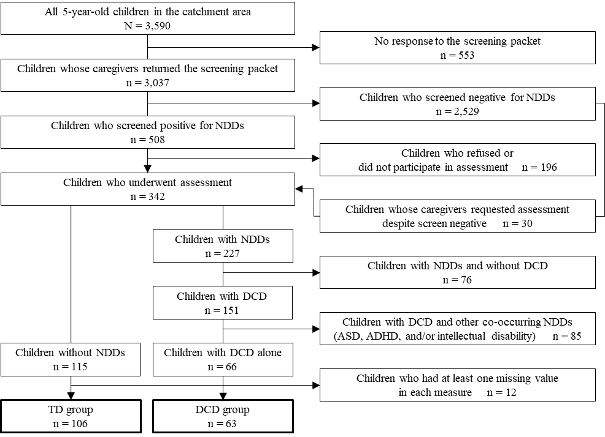
Supplemental figure. Flow chart of the Hirosaki Five-year-old Developmental Checkup and Assessment. NDDs = neurodevelopmental disorders; ASD = autism spectrum disorder; DCD = developmental coordination disorder; ADHD = attention deficit hyperactivity disorder; TD = typically developing.

