Figure S1 Flow chart of participants

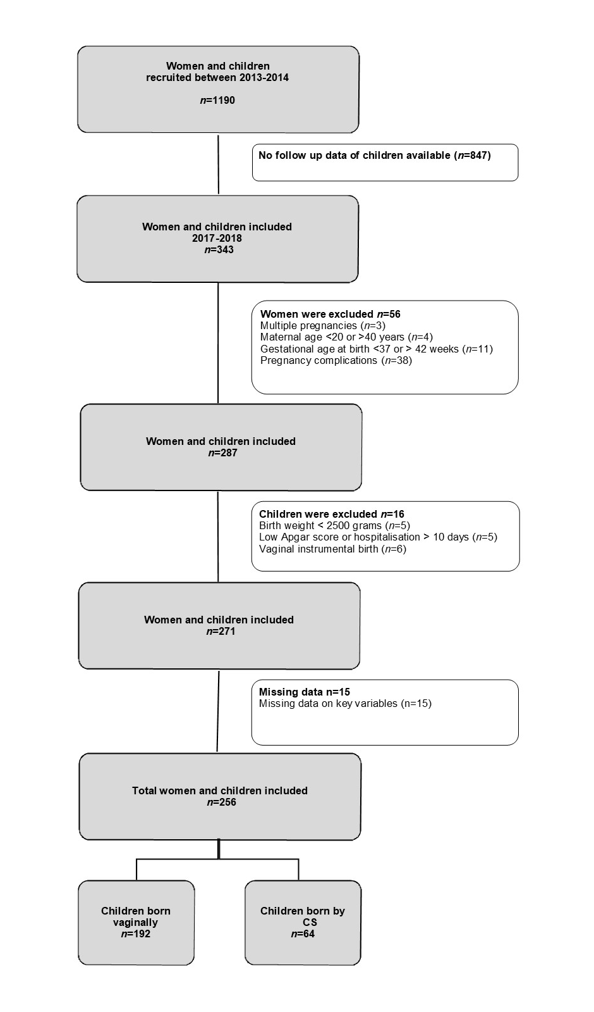

Table S1 Comparison of women who were included in the final sample and who dropped-out of the study or were excluded based on exclusion criteria; data derived from five maternity wards of non-academic hospitals located in the Vysočina Region, Czech Republic, between 2013 and 2014

 |  | TOTAL INCLUDED POPULATION  N (%) | TOTAL EXCLUDED POPULATION  N (%) | Statistical differences between included vs. excluded  p-value
 |  | N=256 | N=934
MATERNAL CHARACTERISTICS
Age |  |  |  | ≤0.001
 | 20-24 years | 12 (4.7) | 84 (9.0)
 | 25-29 years | 79 (30.9) | 337 (36.1)
 | 30-34 years | 119 (46.5) | 309 (33.1)
 | 35-40 years | 46 (18) | 152 (16.3)
 | Missing |  | 52 (5.6)
Educational level |  |  |  | ≤0.001
 | Vocational | 20 (7.8) | 103 (11.0)
 | Secondary | 122 (47.7) | 484 (51.8)
 | University | 111 (43.4) | 268 (28.7)
 | Missing | 3 (1.2) | 79 (8.5)
Marital status at baseline |  |  |  | ≤0.001
 | Married | 194 (75.8) | 575 (61.6)
 | Single/divorced | 61 (23.8) | 315 (33.7)
 | Missing | 1 (0.4) | 44 (4.7)
Parity |  |  |  | 0.82
 | Nulliparous | 121 (47.3) | 434 (46.5)
 | Multiparous | 135 (52.7) | 500 (53.5)

Table S2 Mean scores on the measures of developmental (Ages and Stages Questionnaire) and behavioral (Children’s Behavior Questionnaire and Strength and Difficulties Questionnaire) outcomes stratified by the type of CS
 |  | Score  CESAREAN SECTION | Score  ELECTIVE CS  n=28 | Score  EMERGENCY CS  n=36 | Statistical differences among groups differentiated by type of CS
Developmental outcomes |  | Mean (SD) ª | Mean (SD) ª | Mean (SD) ª | P-value
 | ASQ Communication | 55.2 (6.9) | 54.0 (7.9) | 56.3 (5.8) | 0.23
 | ASQ Fine motor | 47.1 (12.4) | 44.6 (13.5) | 49.4 (11.0) | 0.17
 | ASQ Gross motor | 51.7 (9.5) | 51.3 (10.8) | 52.0 (8.3) | 0.81
 | ASQ Problem solving | 55.4 (6.2) | 56.3 (4.3) | 54.6 (7.4) | 0.35
 | ASQ Personal-Social | 52.4 (7.7) | 54.1 (6.7) | 51.1 (8.3) | 0.17
Behavioral outcomes
 | CBQ Effortful control | 5.5 (0.9) | 5.4 (1.0) | 5.6 (0.8) | 0.44
 | CBQ Negative affectivity | 3.9 (0.9) | 3.7 (1.0) | 4.2 (0.9) | 0.04
 | CBQ Surgency | 4.3 (0.9) | 4.5 (0.9) | 4.2 0.8) | 0.09
 | SDQ Externalizing problems | 10.0 (3.4) | 10.1 (3.7) | 9.9 (3.1) | 0.79
 | SDQ Internalizing problems | 6.5 (2.5) | 6.2 (1.9) | 6.7 (2.8) | 0.44

ª Standard deviation

