Supplementary materials for Zhao& Gibson Peer Play
Contents
Supplementary tables 2
Table S1 2
Descriptive statistics of demographic factors for selected sample and full population at wave 1 2
Table S2 3
Exploratory factor analysis results for all children in the sample 3
Table S3 4
Correlations between key measures for full population 4
Table S4 5
Correlations between key measures for low-persistence and high-reactivity groups 5
Table S5 7
Mediational analyses on sibling play/family play/peer relationships difficulties, peer play abilities and internalising/externalising problems 7
Supplementary figures 8

Supplementary tables

Table S1

Descriptive statistics of demographic factors for selected sample and full population at wave 1
 | Retained sample between wave 1 to 4 |  | Selected sample |  | Wave 1 full population
Variables | N | Mean (SD)/ prevalence (%) | N | Mean (SD)/ prevalence (%) | N | Mean (SD)/ prevalence (%)
Gender (male: female)
Male | 2187 | 51.6%: | 868 | 51.8%: | 2608 | 51.1%
Female | 2055 | 48.4% | 808 | 48.2% | 2499 | 48.9%
Exposure to languages not English at home
Other languages | 399 | 9.4% | 125 | 7.5% | 552 | 10.8%
English Only | 3843 | 90.6% | 1551 | 92.5% | 4555 | 89.2%
Indigenous status
Indigenous status | 145 | 3.4% | 54 | 3.2% | 230 | 4.5%
Not indigenous status | 4097 | 96.6% | 1622 | 96.8% | 4877 | 95.5%
Socioeconomics index at birth | 1675 | 0.09 (0.98) | 1675 | 0.23 (0.98)*** | 4088 | 0.00 (1) ***
Total number of observations | 4242 |  | 1676 |  | 5107
Note. *** p < 0.001 for Wilcoxon rank sum tests between retained sample (wave1 to 4) and selected sample; between retained sample (wave1 to 4) and wave 1 full population

Table S2

Exploratory factor analysis results for all children in the sample
 | Factor loadings | Commonalities
Simple peer play | 0.76 | 0.58
Pretend peer play | 0.72 | 0.52
Goal-directed peer play | 0.79 | 0.63
Game with rules peer play | 0.65 | 0.42
Note. SS loading was 2.14; proportion of variance explained was 54%; root mean square of the residuals was 0.03.

Table S3

Correlations between key measures for full population
 | 1 | 2 | 3 | 4 | 5 | 6 | 7 | 8 | 9 | 10 | 11 | 12 | 13 | 14 | 15 | 16
- SES at birth | 1
- Simple peer play | .03 | 1
- Peer pretend play | .04 | .5*** | 1
- Goal-directed peer play | .06* | .61*** | .56*** | 1
- Rule-governed peer play | .01 | .41*** | .5*** | .46*** | 1
- Persistence | .03 | .1*** | .05 | .11*** | .11*** | 1
- Reactivity | -.1*** | -.09** | -.13*** | -.13*** | -.1*** | -.1*** | 1
- Number of siblings | -.02 | -.02 | .03 | <.001 | -.01 | -.04 | <.001 | 1
- Family play experiences | .1*** | <.001 | -.05 | .03 | -.01 | .15*** | -.04 | -.16*** | 1
- Peer relationships difficulties | .04 | -.07* | -.1*** | -.06 | -.1** | -.18*** | .21*** | .06* | .02 | 1
- Maternal distress | -.11*** | -.04 | -.05* | -.07** | -.07** | -.14*** | .22*** | .03 | -.04 | .2*** | 1
- Language abilities | .11*** | .11 | .11*** | .13*** | .16*** | .2*** | -.13*** | -.04 | .15*** | -.1*** | -.05 | 1
- Hyperactivity | -.18*** | -.1*** | -.12*** | -.17*** | -.08** | -.24*** | .23*** | -.07** | -.03 | .1*** | .13*** | -.14*** | 1
- Conduct problems | -.18*** | -.11*** | -.1*** | -.14*** | -.09*** | -.23*** | .31*** | <.001 | -.11*** | .13*** | .16*** | -.09** | .5*** | 1
- Emotional problems | -.08** | -.09*** | -.11*** | -.1*** | -.07* | -.07* | .19*** | -.06* | -.03 | .19*** | .21*** | -.05 | .19*** | .27*** | 1
- Peer problems | -.12*** | -.12*** | -.16*** | -.14*** | -.12*** | -.11*** | .12*** | -.05 | -.06* | .18*** | .19*** | -.09** | .28*** | .33*** | .41*** | 1
Note. * p < 0.05, ** p < 0.01, *** p < 0.001

Table S4

Correlations between key measures for low-persistence and high-reactivity groups
 | 1 | 2 | 3 | 4 | 5 | 6 | 7 | 8 | 9 | 10 | 11 | 12 | 13 | 14 | 15 | 16
- SES at birth | 1 | .14* | .1 | .04 | 04 | -.03 | -.06 | .09 | .02 | .01 | -.13 | .01 | -.17* | -.14* | -.17* | -.18**
- Simple peer play | .12 | 1 | .55*** | .7*** | .61*** | .26*** | -.04 | -.02 | -.06 | -.11 | -.08 | .1 | -.19** | -.13 | -.06 | -.07
- Peer pretend play | .07 | .63*** | 1 | .63*** | .6*** | .09 | -.08 | .07 | -.1 | -.08 | -.02 | .08 | -.18* | -.02 | -.06 | -.05
- Goal-directed peer play | .07 | .75*** | .7*** | 1 | .56*** | .22*** | .01 | .03 | -.11 | -.06 | -.06 | .14* | -.21** | -.14* | -.08 | -.09
- Rule-governed peer play | .02 | .51*** | .5*** | .53*** | 1 | .29*** | -.12 | <.001 | -.06 | -.12 | -.06 | .1 | -.18* | -.11 | -.07 | -.11
- Persistence | .11 | .15* | .12 | .2** | .14* | 1 | .04 | -.17** | .03 | -.19** | -.23 | .11 | -.26*** | -.3*** | .01 | -.15*
- Reactivity | -.07 | -.22*** | -.2** | -.24*** | -.22** | -.13* | 1 | -.09 | .03 | -.01 | .16* | -.14* | .11 | .16* | .12 | .09
- Number of siblings | -.01 | -.04 | .02 | -.01 | -.02 | -.15* | .06 | 1 | -.03 | .1 | .1 | .01 | -.02 | .12 | -.12 | .01
- Family play experiences | .11 | .04 | -.06 | <.001 | -.12 | <.001 | .04 | -.2*** | 1 | .12 | .08 | .11 | .03 | -.05 | .04 | -.05
- Peer relationships difficulties | -.01 | -.12 | -.14* | -.14* | -.2** | -.17** | .17* | .12 | .11 | 1 | .22*** | -.16* | .08 | .07 | .23*** | .28***
- Maternal distress | -.18** | -.16* | -.16* | -.15* | -.12 | -.13* | .28*** | .04 | .07 | .22*** | 1 | -.15* | .19** | .23*** | .18** | .16*
- Language abilities | .13* | .15* | .13* | .14* | .23*** | .14* | -.11 | -.13* | .15* | -.07 | -.03 | 1 | -.08 | -.09 | <.001 | -.11
- Hyperactivity | -.17** | -.21*** | -.19*** | -.29*** | -.07 | -.13* | .25*** | -.07 | -.05 | .18** | .19** | -.07 | 1 | .45*** | .16* | .25***
- Conduct problems | -.23*** | -.21*** | -.1 | -.25*** | -.14* | .21*** | .35*** | .04 | -.1 | .13* | .24*** | .02 | .51*** | 1 | .12 | .23***
- Emotional problems | -.05 | -.29*** | -.22*** | -.28*** | -.11 | -.1 | .18** | -.02 | -.01 | .18** | .31*** | -.06 | .28*** | .29*** | 1 | .51***
- Peer problems | -.14* | -.21** | -.15* | -.27*** | -.07 | -.09 | .13* | .06 | <.001 | .23*** | .32*** | -.08 | .25*** | .34*** | .45*** | 1

Note. * p < 0.05, ** p < 0.01, *** p < 0.001. Low-persistence group correlations are below the diagonal and in grey shade. High-reactivity group correlations are above the diagonal and without shade.

Table S5

Mediational analyses on sibling play/family play/peer relationships difficulties, peer play abilities and internalising/externalising problems
 | Hyperactivity | Conduct problems | Emotional problems | Peer problems
All children in the group N=1,676
Number of siblings to peer play ability to outcome | 0 [-0.004, 0.005] | 0 [-0.004, 0.005] | 0 [-0.005, 0.005] | 0 [-0.007, 0.008]
Family play experiences to peer play ability to outcome | 0.003 [-0.002, 0.007] | 0.002 [-0.002, 0.007] | 0.003 [-0.002, 0.008] | 0.004 [-0.003, 0.012]
Peer relationships difficulties to peer play ability to outcome | 0.012 [0, 0.024] | 0.01 [0, 0.02] | 0.007 [-0.001, 0.015] | 0.007 [-0.001, 0.015]
Low-persistence group N=270
Number of siblings to peer play ability to outcome | -0.001 [-0.023, 0.02] | -0.001 [-0.016, 0.015] | -0.002 [-0.034, 0.03] | -0.001 [-0.024, 0.022]
Family play experiences to peer play ability to outcome | -0.001 [-0.022, 0.021] | 0 [-0.016, 0.015] | -0.001 [-0.032, 0.031] | -0.001 [-0.023, 0.022]
Peer relationships difficulties to peer play ability to outcome | 0.031 [-0.002, 0.064] | 0.023 [-0.007, 0.052] | 0.041 [0, 0.082] | 0.033 [-0.001, 0.068]
High-reactivity group N=243
Number of siblings to peer play ability to outcome | -0.004 [-0.025, 0.017] | -0.001 [-0.008, 0.006] | -0.001 [-0.008, 0.006] | 0 [-0.005, 0.004]
Family play experiences to peer play ability to outcome | 0.014 [-0.011, 0.039] | 0.004 [-0.011, 0.019] | 0.004 [-0.011, 0.019] | 0.001 [-0.012, 0.014]
Peer relationships difficulties to peer play ability to outcome | 0.02 [-0.009, 0.049] | 0.006 [-0.014, 0.025] | 0.006 [-0.014, 0.025] | 0.002 [-0.016, 0.02]
Note. Standardised coefficients were reported. Other coefficients were reported in Table 2-4. * p < 0.05, ** p < 0.01, *** p < 0.001.

Supplementary figures
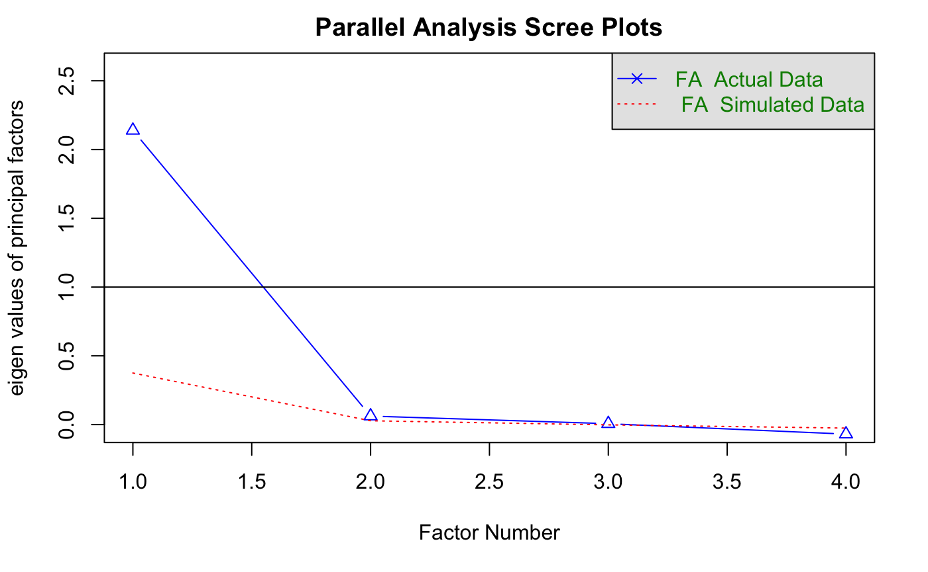
FigureS1. Parallel analysis scree plots for factor analysis for all children in the sample

