Appendix A
Parent Interview Guide
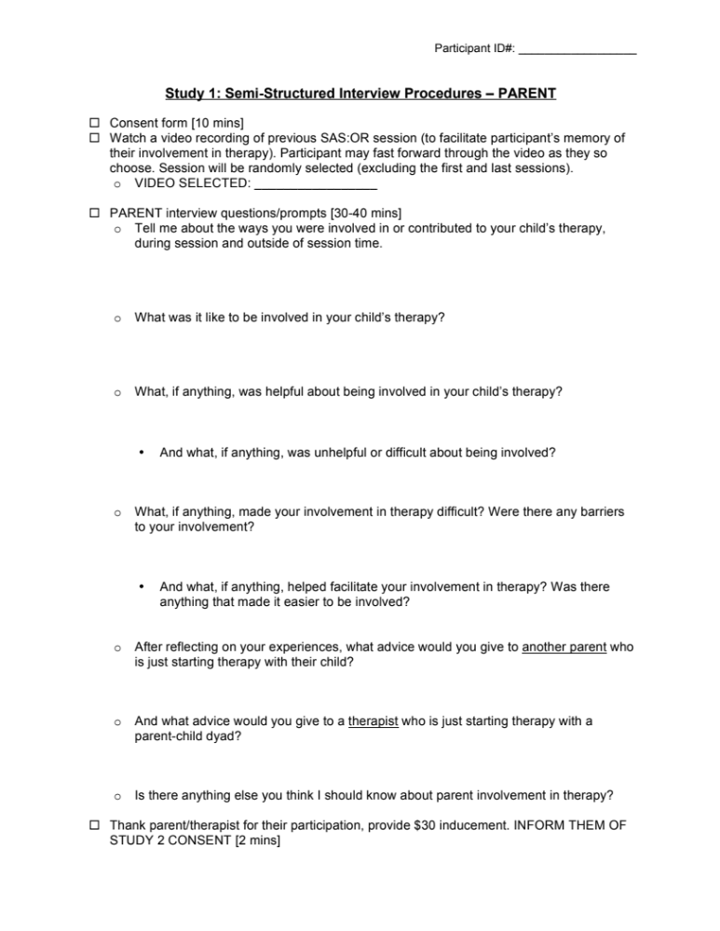

Appendix B
Therapist Interview Guide
