Supplementary Information

Article Title:
Daily Parental Responses to Disruptive Child Behavior: A Multilevel Latent Profile Analysis
Journal Name:
Child Psychiatry & Human Development
Author Names:
Merlin Nieterau¹, G. J. Melendez-Torres², Geertjan Overbeek¹, Daniel S. Shaw³, and Patty Leijten¹
Affiliations:
¹ University of Amsterdam, Research Institute of Child Development and Education, Amsterdam, The Netherlands
² Faculty of Health and Life Sciences, University of Exeter, Exeter, United Kingdom
³ University of Pittsburgh, Department of Psychology, Pittsburgh, PA, United States
Corresponding Author:
Merlin Nieterau
Research Institute of Child Development and Education, University of Amsterdam
Nieuwe Achtergracht 127, 1018 WS Amsterdam, The Netherlands,
E-mail: h.j.m.nieterau@uva.nl
ORCID ID: 0000-0003-4815-5629
Figure S1
Minimum and Maximum Levels of Daily Disruptive Child Behavior
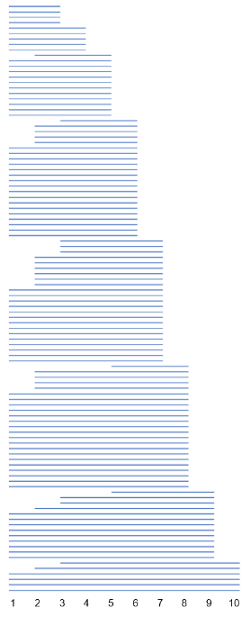
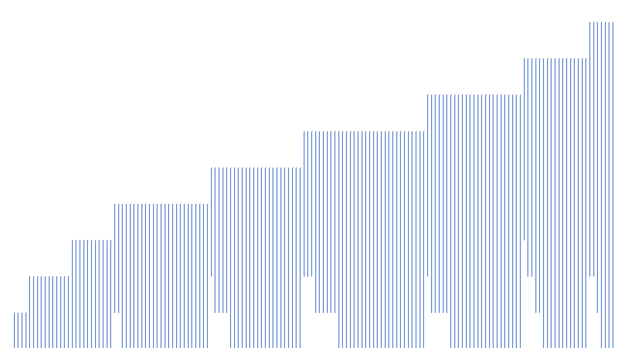
Note. Each line represents minimum and maximum levels of disruptive child behavior of one family (scale 1−10 scale).

Table S1
Information Criteria Latent Profile Analysis
N profiles | Log-likelihood | N parameters | BIC | Entropy | LRT p
1 | -5565.78 | 4 | 11162.09 | . | .
2 | -5339.78 | 8 | 10740.63 | 0.79 | < .001
3 | -5279.23 | 12 | 10650.06 | 0.76 | < .001
4 | -5223.94 | 16 | 10570.02 | 0.80 | < .001
5 | -5175.57 | 20 | 10503.82 | 0.84 | < .001
6 | -5166.41 | 24 | 10516.04 | 0.81 | .999
Note. The chosen model is shown in bold. BIC = Bayesian Information Criterion; LRT = Vuong-Lo-Mendell-Rubin likelihood ratio test.

Table S2
Information Criteria Multilevel Latent Class Analysis
N classes | Log-likelihood | N parameters | BIC | Entropy
1 | -5223.94 | 16 | 10570.02 | 0.80
2 | -5072.48 | 20 | 10297.64 | 0.88
3 | -5031.20 | 24 | 10245.62 | 0.83
4 | -5018.36 | 28 | 10250.47 | 0.82
Note. The chosen model is shown in bold. BIC = Bayesian Information Criterion.

Table S3
Characteristics of the Three Classes at the Family-level
 | Class 1 | Class 2 | Class 3
 | n_{families} = 28; 18% | n_{families} = 92; 59% | n_{families} = 36; 23%
 | n_{day} = 362; 18% | n_{day} = 1221; 60% | n_{day} = 483; 23%
Profile 1 | n_{day} = 326; 90% | n_{day} = 588; 48% | n_{day} =66; 14%
Profile 2 | n_{day} = 31; 9% | n_{day} = 474; 39% | n_{day} = 150; 31%
Profile 3 | n_{day} = 5; 1% | n_{day} = 122; 10% | n_{day} = 198; 41%
Profile 4 | n_{day} = 0; 0% | n_{day} = 37; 3% | n_{day} = 69; 14%
Note. Profile 1 = Low Levels of Disruptive Behavior, Harsh Responses, and Giving in. Profile 2 = Elevated Disruptive Behavior and Harsh Responses. Profile 3 = Higher Levels of Disruptive Behavior, Harsh Responses, and Giving in. Profile 4 = High Levels of Disruptive Behavior and Harsh Responses but Less Giving in.

Table S4
Explorations of Associations of Family Characteristics with the Family-level Classes
 | Class 3 versus Class 1ª |  |  |  |  |  |  | Class 3 versus Class 2ª |  |  |  |  |  |  | Class 1 versus Class 2ª
Covariates | β | SE | p | OR | LL | UL |  | β | SE | p | OR | LL | UL |  | β | SE | p | OR | LL | UL
Income | −0.22 | 0.34 | .521 | 0.80 | 0.41 | 1.56 |  | −0.21 | 0.20 | .298 | 0.81 | 0.55 | 1.20 |  | 0.02 | 0.29 | .954 | 1.02 | 0.58 | 1.79
Education | 0.23 | 0.44 | .595 | 1.26 | 0.54 | 2.97 |  | 0.61 | 0.30 | .041 | 1.84 | 1.02 | 3.29 |  | 0.38 | 0.32 | .248 | 1.45 | 0.77 | 2.75
Depression | 0.19 | 0.27 | .472 | 1.21 | 0.72 | 2.03 |  | 0.16 | 0.12 | .160 | 1.17 | 0.94 | 1.47 |  | −0.03 | 0.26 | .920 | 0.97 | 0.59 | 1.62
Self-efficacy | −0.15 | 0.15 | .294 | 0.86 | 0.64 | 1.14 |  | −0.28 | 0.11 | .014 | 0.76 | 0.61 | 0.95 |  | −0.13 | 0.11 | .231 | 0.88 | 0.71 | 1.09
Conduct problems | 1.55 | 0.37 | .000 | 4.69 | 2.26 | 9.74 |  | 0.40 | 0.16 | .012 | 1.49 | 1.09 | 2.05 |  | −1.15 | 0.34 | .001 | 0.32 | 0.16 | 0.61
Age | −0.04 | 0.02 | .103 | 0.96 | 0.92 | 1.01 |  | −0.03 | 0.02 | .088 | 0.97 | 0.94 | 1.00 |  | 0.01 | 0.02 | .595 | 1.01 | 0.98 | 1.05
Gender | −0.71 | 0.78 | .362 | 0.49 | 0.11 | 2.25 |  | 0.27 | 0.54 | .617 | 1.31 | 0.45 | 3.80 |  | 0.96 | 0.67 | .156 | 2.60 | 0.69 | 9.76
Note. OR = odds ratio; LL = lower limit 95% confidence interval for the odds ratio; UL = upper limit 95% confidence interval for the odds ratio.
ª Reference class

