Supplementary Table 2
Summary of suggestions by participants and changes implemented
Suggestions |  |  | Changes Implemented
Post-session Feedback | Post-intervention Interview
A downloadable goal tracker for parents to track their progress in implementing sleep hygiene |  |  | A sleep hygiene tracker was created and added to the Session 1 resources. | 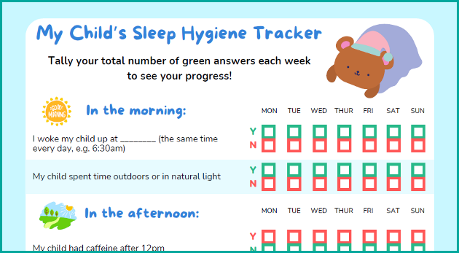
Tips on how to implement change in sleep hygiene |  |  | In addition to the sleep hygiene tracker, tips on how to implement change into your household has been incorporated into Session 1. | 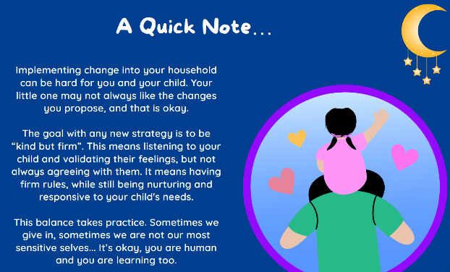
How to manage more than one child at the same time. |  |  | Bedtime routine charts and reward jars are emphasized to be used for all children in the household. | 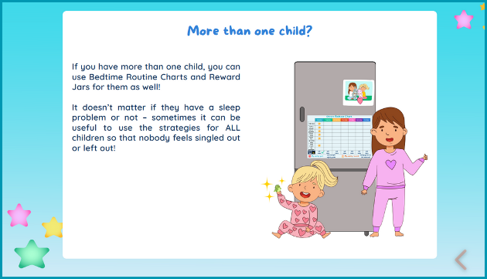
To be able to copy/paste the pictures provided into their charts |  |  | A tip about how to copy and paste the images into the charts has been inserted into the images document. | 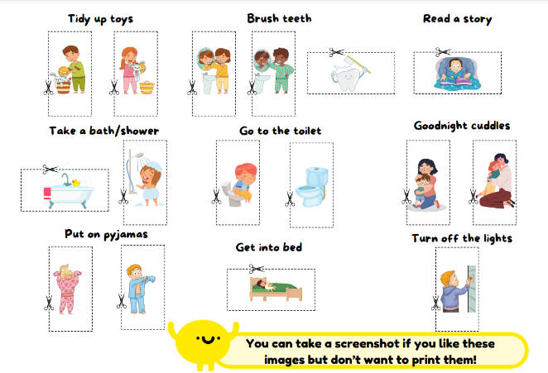
Familiar and repetitive content in sessions 1 and 2 | Theme 1: The cascade of positive changes following completion of the program > Sub-theme: Rethinking established processes |  | The sessions 1 and 2 have been kept as the foundational sessions in the program by creating introductory videos at the beginning of these sessions emphasizing the importance of spotting behaviours in what you are already doing and/or environmental factors that contribute to sleep problems.
The Lights out ladder examples for different problems (e.g., dark fear). |  |  | The Lights Out Ladder examples for separation anxiety and fear of dark have been added the resources pack. | 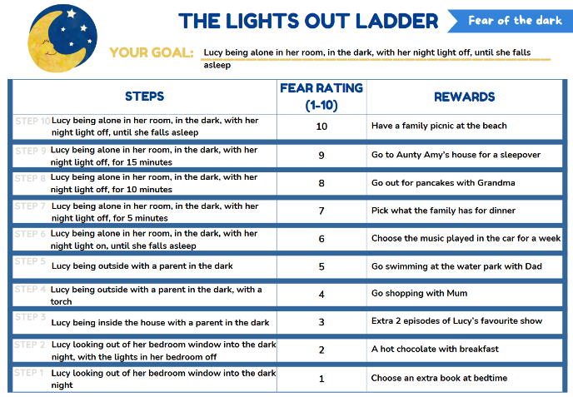
Balanced content and separate strategies to help child fall asleep and fall back to sleep |  |  | All the strategies introduced in session 3 have been flagged indicating when to be used (i.e., before sleep, during sleep). | 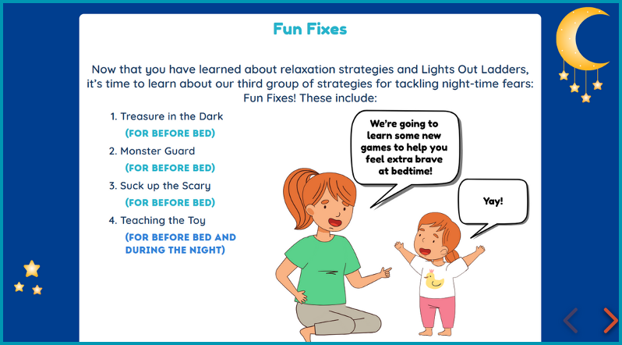
Time Out is not perceived as a responsive or supportive parenting strategy. |  |  | The Lights Out Online Team has carefully revised the presentation of the time out strategy considering the things the parents like in the program by adding an introductory video explaining the time out strategy. The video highlights 3 main points:  1) When to use time out: The potential situations to use time out have been described clearly, such as when the child is being non-compliant at bedtime, engages in a behaviour that is unacceptable (e.g., breaking house rules, being violent, throwing, or yelling), and the other strategies were implemented but did not work;  2) Evidence base: Evidence showing the effectiveness of time out when used correctly;  3) No pressure: As noted earlier parts of the program, the parents are reminded that they do not have to use all the strategies; it is up to them to pick the strategies that will fit their parenting style and work for them.  After the video, implementation of time out is explained step by step with a realistic example through visual tools, which has been reported to be highly positive by the participants.
What to do when the strategies did not work | Theme 1: The cascade of positive changes following completion of the program > Sub-theme: Improving clarity  Theme 2: The gradual process required for implementation and change |  | The revisions included key wording changes with a more compassionate acknowledgment that the strategies can be difficult to implement, and demonstrations of the ways they could be used in a ‘firm but kind’ manner.
To bulk download the resources at the end of the session. |  |  | An option to download session all session resources as a booklet at the end of the session. | 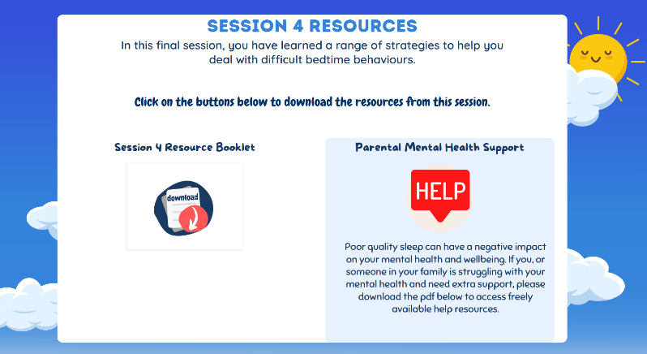
Some participants wanted a mobile phone friendly version of the program. | Theme 4: The need for  flexibility in delivery |  | Future mobile friendly versions

