Electronic Supplementary Material
Gas production is a specialized topic that is unfamiliar to most people, including most scientists. Best practice descriptions cover many aspects of gas drilling and hydrofracturing (e.g., API HF1, 2009), but we have found very few descriptions of well completion and flowback procedures (e.g., Lavelle, 2010), and these are quite general. We therefore describe below what we have discerned from conversations with those experienced with drilling and completion that makes it seem unlikely that fugitive methane emissions are occurring at anything like the rates Howarth et al. suggest.

Completing and Bringing a Well Into Production
Consider what happens in completing a well and bringing it into production: The well is drilled, logged, and then hydrofractured. When the hydrofracturing is finished, the wellbore and producing formations are full of water. Drilling out the plugs which divide the well into hydrofracture intervals occurs at this stage. Because the well is filled with water, only water is typically produced from the well during this process, and only gas dissolved in this water is brought to the surface, at least initially. Generally this condition persists during the full drill out period, but sometimes gas enters the well during drill out and must be dealt with at this stage. When the drill out is under water-filled-wellbore conditions, the gas leakage rate is comparatively small because, compared to a freely venting gas well, very little gas can be brought to the surface dissolved in water since gas solubility in water is low. The water produced at this stage is usually (and could always be) put into a capped tank where the gas exsolves from the water and is flared or captured. When the drill out occurs with substantial gas in the wellbore, more and perhaps very much more gas can be produced, but for safety and economic reasons (see below) it is not vented, but captured and either flared of diverted to sales through a pipeline. After drill out is completed, the operator begins to flow water from the well and the flowback stage begins. Normally no gas (or very minimal dissolved gas) is produced initially, but after a period ranging from hours to multiple days, the well starts to produce slugs of gas, and shortly thereafter enough gas that the well effluent can be diverted to a separator. The gas flow from the separator is generally either flared or put into a pipeline for sale. The first well on a pad may be flared (the methane is not released), but after this the gas is generally diverted to a pipeline and delivered to sales once enough gas pressure is obtained (or a skid-mounted compressor is utilized).
Figure S1 shows gas well production curves for the Haynesville Shale that include the pre-IP production (that portion of a well’s production that took place before the flowback was completed and the production peaked). It shows clearly that production rates during the pre-IP production period are much lower than the monthly maximum production rates of the wells (which are themselves less than their reported IP rates). Production of gas is essentially non-existent in the early flow-back period (when only frac water is being produced). Significant gas flow starts only when enough frac water has been removed to let the gas begin to flow. The duration of the flowback period is poorly defined and there is no firm correlation between how a well will perform and the volume of gas that is produced during the flowback period. Gas production rates peak days to months later when frac water has been recovered from every producing frac stage and the well is operating optimally. From this maximum the production steadily declines. Most published production curves shown for unconventional gas production do not include the initial start up of gas production but begin when the well is considered to be done flowing back and in regular production and declining from its peak production.

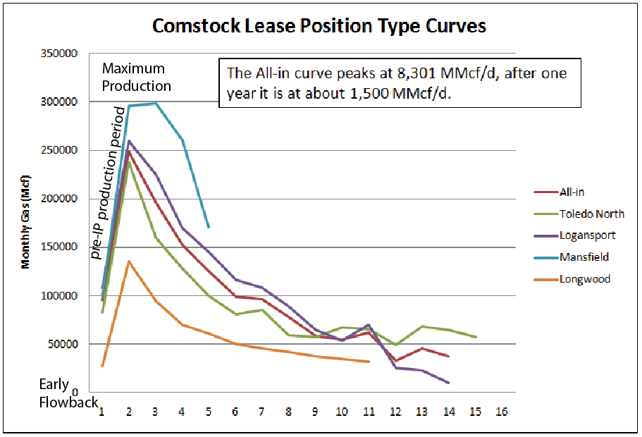
Figure S1. Production curves for Haynesville shale gas production. Figure is modified from DI ESP (2010) by the addition of text. The horizontal axis is time in months.

Scout Reports
A scout report, such as the one cited by Howarth et al. for their initial Haynesville leakage and production numbers, rarely indicates what the operator actually does with their gas during the initial testing of a well. Initial production figures therefore generally can’t be used to estimate methane emissions because these reports are intended to convey how the well produces at its peak, not what the operator does with the production. The only entry in the source document Howarth et al. reference that gives any information related to emissions (Eckhardt et al., 2009) suggests that the gas flow noted was captured: “The 1 Moseley was reported producing to sales at the daily rate of 14 million cu ft of gas equivalent through perforations at 12,800-15,260 ft while the operator was still cleaning up frac load.” In other words, at the time the gas flow rate was measured, the flowback was still ongoing and gas was producing to sales. This is the exact opposite of the venting of the gas to the atmosphere that Howarth et al. suggest.
One of the authors of this scout report (Philip H. Stark) recently published a statement regarding the use of their data by Howarth et al. (Appendix 1 in Barcella et al., 2011). His conclusion matched the one we made independently here - that their (eg., Stark and others) report did not contain “any evidence of such methane emissions”.

Economic and Safety Considerations
The large values for methane lost during completion that Howarth et al. suggest is routine industry practice is incompatible with elementary safety and economic considerations. Consider again the Haynesville Shale case. Howarth et al. indicate that 6.8 million cubic meters of Haynesville natural gas (3.2% of a typical well’s lifetime production) is released during an assumed flowback period of 10 days. Releasing 6.8 million cubic meters of gas into the atmosphere is equivalent to venting roughly $1,000,000 worth of natural gas (wholesale) from a single well. This leakage rate is equal to the consumption rate of 100,000 households, a city the size of Buffalo, NY (assuming 2.6 people per household) (EIA 2010). It’s also a volume of potentially explosive gas so large that no driller (let alone their employees, contractors and regulators) would willfully release it. The volume of this gas can be appreciated from the fact that it could cover a square mile of land to a height of 176 feet with a combustible 5% mix of methane. It is equivalent to the gas transmission in a small gas pipeline (e.g., Smith, 2010). Of course, during venting much of this methane would be injected at pressure and at some height above the platform, and pure methane would buoyantly rise from the well. However, methane that is mixed with 95% air is still explosive and its distribution would be governed by air currents (convection) as well as buoyancy. Any spark could trigger an explosion that would be followed by a controlled burn (similar to flaring). Think how a homeowner worries what a very small emission from a gas stove might do to their house if not properly turned off before they leave for the theatre. The concern is not the small burning flame, but the explosion that could result from accumulated methane if the burner were blown out. The idea that methane is released in a routine fashion at the rates and volumes suggested by Howarth et al. is simply not credible on safety considerations alone.
If an operator could find a way to safely vent such a high volume of shale gas, and preferred to do that over flaring or selling the gas, they could theoretically do so. It's illegal on this scale in most states (see 25 PA Code Sec. 78.74, for instance), and would clearly violate the terms of their liability insurance, but it could physically happen during initial production testing. As a practical matter, however, we have seen no evidence that it happens on any such scale except in very rare circumstances, such as a well blow-out, and it cannot happen during the periods when there is still substantial frac water in the well (generally the case during the drill out and early flow back periods) which is the period when Howarth et al. suggest the methane is released.

EPA’s Venting Analysis
Howarth et al. support their very high leakage estimate in general terms by citing the EPA’s (2010) conclusion that large quantities of methane accompany the flow back of water and are vented in the first few days or weeks after hydrofracture injection. The basis for the EPA’s (2010, p. 84 ff) conclusion is their observation that 51% of the U.S. unconventional production (coal bed methane and shale gas only - no tight sands gas data was available) in 2007 was in Wyoming (of which none was from shale), where flaring is required by law, and 49% was in Texas, Oklahoma, and Louisiana, where it is not required, but isn‘t banned either. The EPA then assumed that where regulations did not require the methane to be flared, it was all released directly into the atmosphere (not flared or sold), and they generalized this to be universally true. The EPA thus concludes that 4.6 million cubic feet of methane (50% of the typical 9.2 million cubic feet that they estimate is produced from an unconventional gas well during flowback) is released into the atmosphere. For all the reasons discussed above, we believe that this is a highly questionable assumption, and certainly one that is clearly stated by the EPA to be speculative. They did not document the venting, and are very clear that their basis is the assumption that when not required by law to flare or sell gas, unconventional wells are vented (into the atmosphere) during initial production. At least the EPA acknowledges that a significant portion of the methane emissions may be flared, rather than vented, in contrast to Howarth et al, who appear to assume 100% venting, the least likely scenario for real world operations.

References Cited
API HF1 (2009) Hydraulic fracturing operations-well construction and integrity guidelines, http://www.api.org/policy/exploration/hydraulicfracturing/.
Barcella, ML, Gross S, and Rajan S (2011) Mismeasuring Methane: estimating greenhouse gas emissions from upstream natural gas development, iHS Cerra Report, http://www.ihs.com/info/en/a/mis-measuring-methane-report.aspx.
DI ESP (2010) Haynesville Shale News and Analysis from DI Energy Strategy Partners, http://info.drillinginfo.com/urb/haynesville/operators/2010/05/comstock-lease-positions-and-quarterly-earnings-call/
EIA (2010) Trends in U.S. Residential Natural Gas Consumption, Office of Oil and Gas, June, 12p. http://www.eia.doe.gov/pub/oil_gas/natural_gas/feature_articles/2010/ngtrendsresidcon/ngtrendsresidcon.pdf
Eckhardt M, Knowles B, Maker E, Stork P (2009) IHS U.S. Industry Highlights. (IHS) Houston, TX, Feb–Mar 2009. http://www.gecionline.com/2009-prt-7-final-reviews
EPA (2010) Greenhouse gas emissions reporting from the petroleum and natural gas industry. Background Technical Support Document. http://www.epa.gov/climatechange/emissions/downloads10/Subpart-W_TSD.pdf
Lavelle M (2010) Special Report: The Great Shale Gas Rush, National Geographic News, http://news.nationalgeographic.com/news/2010/10/101022-energy-marcellus-shale-gas-science-technology-water/ .
Smith CE (2010) Natural gas pipelines continue growth despite lower earnings, oil profits grow, Oil and Gas Journal, Nov 1, 102-122.

