Supplementary Material for Climatic Change

Impacts of 21st century climate change on global air pollution-related premature mortality
Yuanyuan Fang^{1,2}, Denise L. Mauzerall^{1, 3,}, Junfeng Liu⁴, Arlene M. Fiore⁵ and Larry W. Horowitz⁶
¹Woodrow Wilson School of Public and International Affairs, Princeton University, Princeton, NJ, 08544
²Now at Department of Global Ecology, Carnegie Institution for Science, Stanford, CA, 94305
³Civil and Environmental Engineering Department, Princeton University, Princeton, NJ, 08544
⁴College of Urban and Environmental Sciences, Peking University, Beijing, China, 100871
⁵Department of Earth and Environmental Sciences, Columbia University and Lamont Doherty Earth Observatory, Palisades, NY, USA
⁶Geophysical Fluid Dynamics Laboratory, National Oceanic and Atmospheric Administration, Princeton, NJ, 08540

Address correspondence to Denise L. Mauzerall, Princeton University, Princeton, NJ, 08544, USA. E-mail: mauzeral@princeton.edu

Tables

Table S1. Model simulation configurations. Both “Present” and “Future” simulations are run for 21 years with the first year used for spin-up.

Simulations | Sea surface temperature (SST) and sea ice (SIC) boundary conditions | Long-lived GHGs (CO₂, N₂O, CFCs) | CH4 in global radiation and tropospheric chemistry calculations | Short-lived species emissions
“Present” | Observed 1981-2000 monthly varying climatological mean from the Hadley Center for Climate Prediction and Research | 1990 | 1990 level in both | 1990
“Future” (A1B)ª | Observed 1981-2000 monthly varying climatological mean from the Hadley center + 19 model monthly-varying ensemble mean changes from 1981-2000 to 2081-2100 of the IPCC AR4 A1B scenario results | 2090A1B^{b} | 1990 level in tropospheric chemistry calculation,  2090 level in radiation calculation according to A1B scenario^{c} | 1990
ª Except lightning NO_{x} source, which is determined by simulated meteorology.
^{b} The IPCC A1B scenario describes a rapidly growing while still balanced world which assumes similar improvement rates apply to all energy supply and end use technologies; its global CO₂ equivalent concentration and corresponding temperature response fall in the middle of the range of scenarios in the IPCC Special Report on Emissions Scenarios (SRES) (Nakicenovic et al. 2000) and appears to be below current concentration trajectories.
^{c} In this way, we avoid the impact of projected CH₄ increase on global background O₃ and thus ensure any change in surface O₃ is driven by climate change only.

Table S2. Population age 30 and over, and their corresponding mortality rate from all-cause and respiratory disease. Population aged 30 and older (unit: million, CIESIN 2005; WHO 2003), all-cause and respiratory mortality rate (unit: % per year, WHO 2003) for regions used in this study.

 | POP (≥30) | All-cause mortality rate | Respiratory mortality rate
North America | 218 | 1.28 | 0.09
South America | 135 | 1.20 | 0.08
Europe | 359 | 1.73 | 0.08
Africa | 238 | 2.08 | 0.11
South Asia | 469 | 1.59 | 0.13
Southeast Asia | 163 | 1.29 | 0.14
East Asia | 711 | 1.15 | 0.18
Middle East | 97 | 1.39 | 0.07
Rest of Asia | 65 | 2.02 | 0.09
Australia | 11 | 1.05 | 0.06

Table S3. Regional changes in annual premature mortality. Change in annual premature mortality associated with 21st century climate change induced changes in PM_{2.5} and O₃ exposures over continental regions given constant population. Values are thousands of deaths, and corresponding percentage change, (shown in parentheses) and its 95% CI (see methods).

Change in Premature mortalities (1000s deaths) | PM_{2.5} mortality  (Chronic, all-cause) |  | O₃ mortality  (Chronic, respiratory)
Change in Premature mortalities (1000s deaths) | Mean | CI | Mean | CI
World | 98.6 (4%) | (66.4, 130.0) | 6.3 (0.9%) | (1.6, 10.4)
North America | 11.8 (8%) | (8.0, 15.6) | 1.0 (2.2%) | (0.2, 1.7)
South America | 2.4 (5%) | (1.6, 3.1) | ~ 0 (0%) | (0, 0)
Europe | 3.3 (1%) | (2.2, 4.4) | 0.3 (0.6%) | (0.1, 0.5)
Africa | 13.4 (4%) | (9.0, 17.7) | -0.8 (-1.5%) | (-0.2, -1.3)
South Asia | 19.8 (4%) | (13.3, 26.1) | 1.4 (1.0%) | (0.4, 2.3)
Southeast Asia | 3.9 (3%) | (2.6, 5.1) | 0.2 (0.5%) | (0.05, 0.3)
East Asia | 42.6 (5%) | (28.7, 56.2) | 4.3 (1.5%) | (1.1, 7.2)
Middle East | -0.8(-1%) | (-0.5, -1.1) | -0.2 (-1.3%) | (-0.05, -0.3)
Rest of Asia | 1.2 (2%) | (0.8, 1.6) | 0.07 (0.6%) | (0.02, 1.1)
Australia | 0.1(5%) | (0.1, 0.1) | ~0 (-0%) | (0, 0)

Table S4. Regional changes in years of life lost (YLL) associated with climate-induced changes in PM_{2.5} and O₃ concentrations.

Region | YLL due to change in PM_{2.5} exposure (thousand years, %) |  | YLL due to change in O₃ exposure (thousand years, %)
Region | Mean | 95% CI Range | Mean | 95% CI Range
World | 855 (4%) | (576, 1128) | 38 (0.5%) | (19.5, 55.5)
North America | 72 (8%) | (48, 95) | 9.3 (1.9%) | (4.8, 13.7)
South America | 20 (5%) | (13, 26) | 0.6 (0.3%) | (0.2, 0.5)
Europe | 17 (1%) | (11, 22) | 5.8 (0.5%) | (3.0, 8.6)
Africa | 187 (4 %) | (126, 247) | -17.4 (1.2%) | (-9.0, -25.7)
South Asia | 198 (4%) | (133, 261) | 19.4 (0.9%) | (10.0, 28.7)
Southeast Asia | 35 (3.5%) | (239, 469) | 2.7 (0.8%) | (1.4, 4.0)
East Asia | 320 (5.4%) | (215, 422) | 20.1 (1.4%) | (10.4, 29.7)
Middle East | -7 (-0.9%) | (-4.4, -8.7) | -4.4 (1.1%) | (-2.3, -6.4)
Rest of Asia | 10 (2.4%) | (7.0, 13.8) | 2.0 (0.7%) | (1.0, 3.0)
Australia | 0.6 (5.2%) | (0.4, 0.8) | ~ 0 | (0, 0)

Table S5. Modeling studies of the effect of climate change on PM or aerosols.
References | Model | Scenario | Time horizon | Metric reported | PM/aerosol change
Liao et al. (2006); Racherla and Adams (2006) | Global  GCM-CTM | A2 | 2100 vs. 2000 | Annual mean | Central Europe: +1 μg/m³ (sulfate); +0.5-1 (carbonaceous)
Unger et al. (2006) | Global GCM-CTM | B1 and A1B | 2050 vs. 2000 | Annual mean | Southern Europe: +0.1-1 μg/m³ (sulfate)
Heald et al. (2008) | Global GCM-CTM | A1B | 2100 vs. 2000 | Annual mean | Eastern U.S.: +0.5 μg/m³ (secondary organic aerosols)
Jacobson et al. (2008) | Global and urban |  | Present vs. preindustrial CO₂ | July-Nov mean | U.S.: +0.5 μg/m³ (carbonaceous)
Kloster et al. (2010) | Global CCM | B2 | 2000 vs. 2030 | Annual mean | Global: + 2-7% (global burden of aerosols)
Rae et al. (2007) | Global CCM | A2 | 1990s to 2090s | Annual mean | Global: 9% increase (global burden of sulfate aerosols)

Figures
Evaluation of AM3 “present” simulation
In order to detect climate change signals rather than inter-annual or internal model variability, our AM3 “present” simulation is driven with a monthly 20-year mean (1981-2000) annually invariant climatology of observed sea surface temperature and sea ice from the Hadley Center. Emissions of short-lived air pollutants (including aerosols and O₃ precursors) in both simulations are kept at 1990 levels. The simulation is run for 21 years with the first year used for spin-up and discarded. The model simulated surface O₃ and PM_{2.5} thus represent average conditions between 1981-2000, and model evaluation requires comparison of results with multi-year mean observations. Several U.S. networks have long-term records of surface PM_{2.5} and O₃, including the U.S. Air Quality System (USAQS) for PM_{2.5} and the U.S Clean Air Status and Trends Network (CASTNET) for O₃. Over Europe, the European Monitoring and Evaluation Programme (EMEP) also provides long-term observations of O₃ and aerosols. EMEP observations for PM_{2.5} are rare and therefore, instead of evaluating PM_{2.5}, we evaluate sulfate (a major component of PM_{2.5}). Over Asia, we collect O₃ and SO₄ observations from various published papers (see figure captions) and data report from Acid Deposition Monitoring Network in East Asia (EANET, http://www.eanet.cc/product/index.html). In this evaluation, we focus on evaluating annual mean concentrations of PM_{2.5}, O₃ and sulfate. Figures S1, S2 and S3 show the evaluation of annual PM_{2.5}, O₃ and SO₄ over the United States, Europe and Asia. In general, the model captures the spatial distribution of these air pollutants (R = 0.5-0.8). Pollutant concentrations are also well simulated with a mean bias within ±30%.

Figure S1. Scatter plot (left panel) and the relative difference (i.e., (model-obs)/obs, right panel) between the “present” simulated (AM3, 1981-2000) and observed annual mean concentrations of O₃ (top panel) and PM_{2.5} (bottom panel) concentrations over the United States. O₃ observations are from the U.S. Clean Air Status and Trends Network (CASTNET, 1997-2008 averages, http://java.epa.gov/castnet/); PM_{2.5} observations are from the U.S. Air Quality System (AQS) Database (1988-2009 average, http://www.epa.gov/ttn/airs/airsaqs/). 1:1 line is shown in red.

Figure S2. Scatter plot (left panel) and the relative difference (i.e., (model-obs)/obs, right panel) between the “present” simulated (AM3, 1981-2000) and observed annual mean concentrations of O₃ (top panel) and SO₄ (bottom panel) over Europe. Observations are obtained from the European Monitoring and Evaluation Programme (EMEP, http://www.emep.int/). The O₃ and SO₄ observations are from 1990-2006 and 1977-2004 respectively. 1:1 line is shown in red.

Figure S3. Scatter plot (left panel) and the relative difference (i.e., (model-obs)/obs, right panel) between the “present” simulated (AM3, 1981-2000) and observed annual mean concentrations of O₃ (top panel) and SO₄ (bottom panel) over east Asia. O3 observations are obtained from Li et al. (2007), Carmichael et al. (2003) and the EANET 2000-2001 data reports. SO₄ observations are from Liu et al. (2009) and Zhang et al. (2011). 1:1 line is shown in red.

Ten world regions chosen in this study
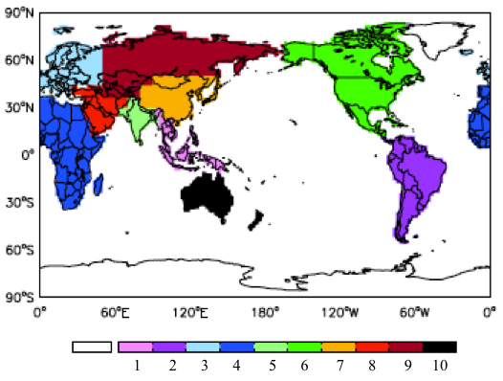
Figure. S4 The 10 continental regions used to calculate changes in regional premature mortality. (1: Southeast Asia; 2: South America; 3: Europe; 4: Africa; 5:South Asia; 6: North America; 7: East Asia; 8: Middle East; 9: Rest of Asia; 10: Australia)

21st century climate change induced changes in the concentrations of major PM_{2.5} components, as simulated by AM3
a
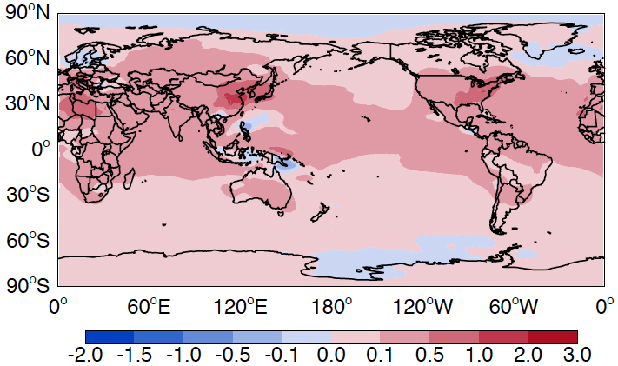
b
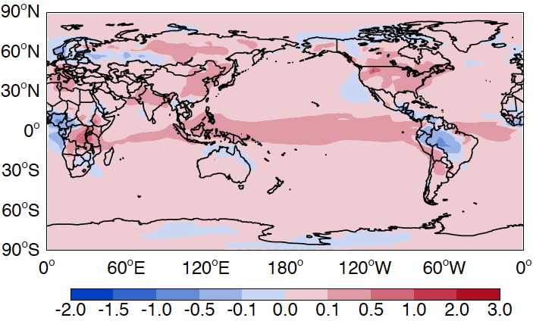
c
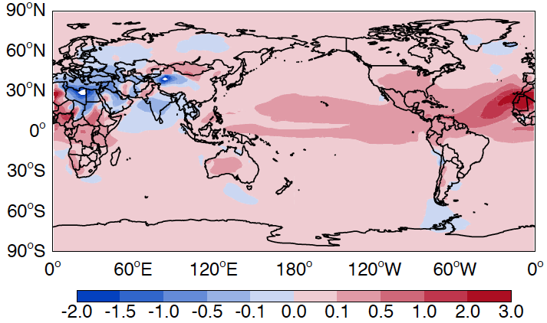
Figure S5. Late 20th century (“present”) to late 21st century (“future”) climate change induced changes in annual mean surface (a) sulfate aerosol; (b) organic matter; (c) fine dust (dust with a dry radius less than 0.1 µg) concentration (unit: µg/m³)

The effect of population growth increases the effect of climate change induced changes in PM_{2.5} on premature mortality
To isolate the effect of climate change induced changes in air quality on health, we keep population unchanged at approximately 6 billion in our paper. However, population is expected to increase over the 21st century and the SRES A1B and A2 scenarios project 7 and 8 billion persons, respectively, in 2100, passing through higher populations mid-century. Our results are influenced by the size of the exposed population. Using the population projection from the A1B scenario, we find that global premature mortality associated with climate change induced changes in PM_{2.5} exposure increases by 110,000 deaths (4.4%) over the 21st century (about 10% higher than the estimate due to climate change alone). The largest mortality increase is in India and Africa due to their rapid population growth and substantially larger population in A1B 2100 than 2000. In China, the estimated mortality change including both climate change and population growth is lower than with climate change alone, reflecting the A1B projected decrease in 2100 Chinese population. Using projected 2100 population in the A2 scenario, premature mortality attributed to PM_{2.5} increases by over 230,000 deaths, 11% higher than the all-cause mortality due to climate change induced changes in PM_{2.5} exposure alone.

