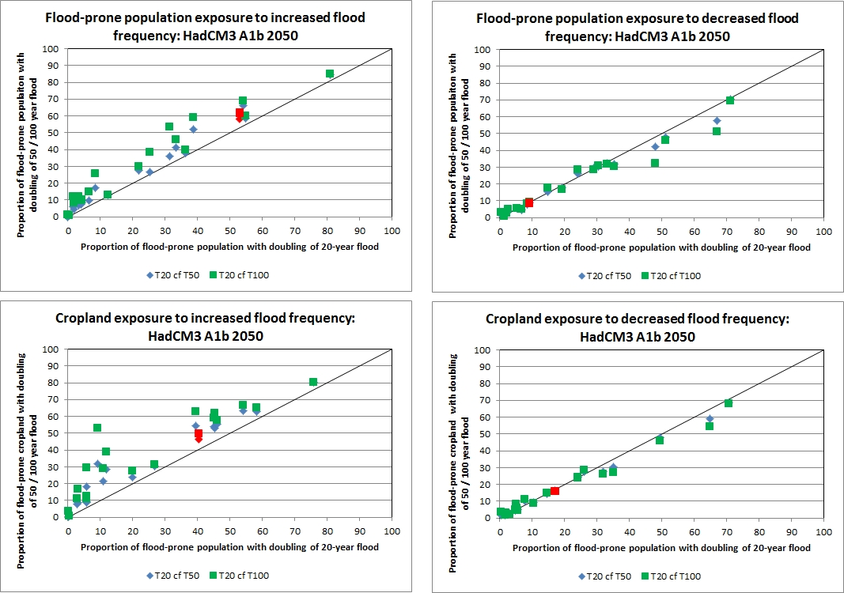

Figure S3: Sensitivity of the proportion of regional flood-prone population and cropland exposed to a doubling or halving of flood frequency to indicator return period (A1b emissions, 2050, HadCM3 pattern). The red symbols denote the global aggregate value

