Online Resource 6. Monetizing Changes in Acreage Burned by Wildfires and Terrestrial Ecosystem Carbon Storage
Climatic Change Article: Quantifying and Monetizing Potential Climate Change Policy Impacts on Terrestrial Ecosystem Carbon Storage and Wildfires in the United States
Authors: David Mills, Russell Jones, Karen Carney, Alexis St. Juliana, Richard Ready, Allison Crimmins, Jeremy Martinich, Kate Shouse, Benjamin DeAngelo, and Erwan Monier
Corresponding author: David Mills, Stratus Consulting Inc., DMills@stratusconsulting.com
This analysis used data from the National Wildfire Coordinating Group (NWCG) to monetize the anticipated changes in acreage burned by wildfires. Specifically, the analysis developed regional wildfire response costs from NWCG data on the size (i.e., acres burned), origin, and total response costs for distinct wildfires in the contiguous United States (U.S.) from 2002 to 2010 (NWCG 2011).
Figure 6.1 provides the Geographic Area Coordination Center (GACC) boundaries used by the NWCG to coordinate wildfire responses and to collect and report wildfire-related data (GACC 2011).
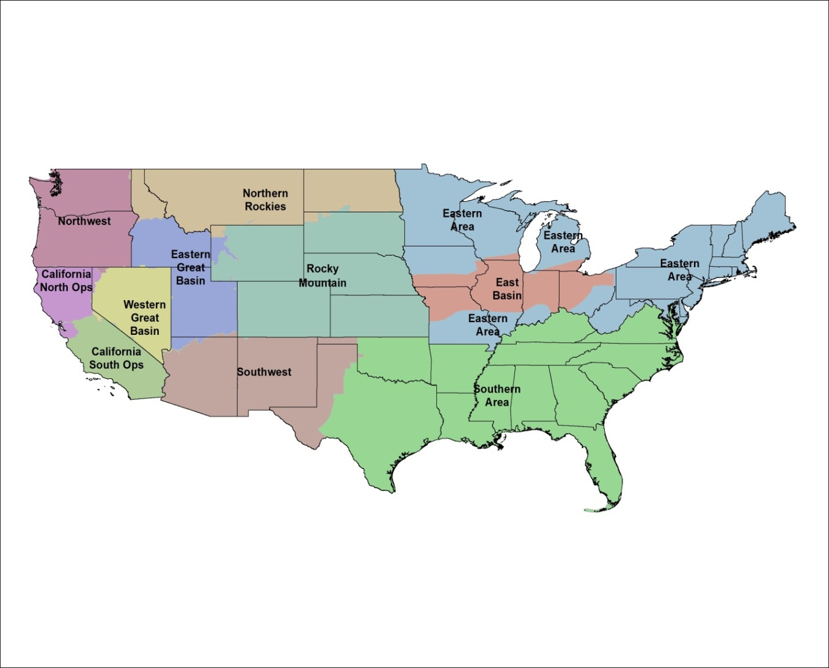
Fig. 6.1 GACC fire region boundaries
Using the available information, we calculated the following response cost measures for each GACC region after first adjusting to their year 2005 equivalent values using the Consumer Price Index for All Urban Consumers (U.S. DOL 2011):
Average response cost per acre for all wildfires: calculated by dividing the total response cost by the total acres burned for all reported wildfires
Average response cost per acre for all wildfires with incurred response expenditures: calculated by dividing the total response cost by the total acres burned for wildfires where response cost expenditures were incurred (i.e., response cost > $0)
Maximum observed response cost per acre: identified by sorting the response costs per acre burned by region and selecting the maximum value.
Table 6.1 presents the information used to calculate these values and the results by GACC.
Table 6.1 Summary of regional wildfire response costs and acres burned (2002–2010)
GACC region | Number of wildfires | Acres  burned | Sum of response costs  (2005$) | Average response cost per acre burned (2005$) | Maximum response cost per acre burned (2005$)
All wildfires
California North Ops | 445 | 1,648,624 | $1,114,310,697 | $676
California South Ops | 978 | 3,548,842 | $1,347,330,837 | $380
East Basin | 70 | 12,145 | $47,896 | $4
Eastern Area | 1,067 | 596,149 | $22,289,100 | $37
Eastern Great Basin | 1,298 | 6,125,473 | $402,367,135 | $66
Northern Rockies | 781 | 3,197,797 | $672,858,664 | $210
Northwest | 546 | 2,862,643 | $939,971,815 | $328
Rocky Mountain | 639 | 1,703,763 | $304,699,432 | $179
Southern Area | 6,445 | 5,310,903 | $170,563,509 | $32
Southwest | 1,383 | 5,617,454 | $476,861,077 | $85
Western Great Basin | 460 | 2,984,566 | $95,012,721 | $32
Total | 14,112 | 33,608,359 | $5,546,312,882 | $165
Only wildfires with incurred response costs
California North Ops | 316 | 1,310,935 | $1,114,310,697 | $850 | $16,940
California South Ops | 514 | 2,985,101 | $1,347,330,837 | $451 | $17,803
East Basin | 9 | 2,220 | $47,896 | $22 | $49
Eastern Area | 460 | 285,859 | $22,289,100 | $78 | $2,401
Eastern Great Basin | 545 | 3,622,204 | $402,367,135 | $111 | $23,755
Northern Rockies | 579 | 2,688,733 | $672,858,664 | $250 | $16,343
Northwest | 330 | 2,150,098 | $939,971,815 | $437 | $33,949
Rocky Mountain | 343 | 1,166,140 | $304,699,432 | $261 | $30,947
Southern Area | 1,603 | 1,904,392 | $170,563,509 | $90 | $6,011
Southwest | 831 | 3,397,534 | $476,861,077 | $140 | $16,328
Western Great Basin | 140 | 954,319 | $95,012,721 | $100 | $9,198
Total | 5,670 | 20,467,535 | $5,546,312,882 | $271
Totals may not sum due to rounding.

Table 6.1 shows a total of about 34 million acres being burned by wildfires from 2002 to 2010, or roughly 3.7 million acres each year with average annual response costs of roughly $616 million (2005$). Table 6.1 also highlights that a significant portion of the reported acreage burned by wildfires, roughly 40% or 13.1 million acres over the period, did not incur any response costs. These results also highlight the regional variation in wildfire response expenditures. For example, while wildfires in the Southern Area, Southwest Area, and Eastern Great Basin combined account for about half of the fires and acreage burned in the 2002−2010 data, the combined total response costs from these areas are less than those of the California North Ops region. For our monetized analyses, we rely on the regional average response costs per acre burned developed from evaluating all wildfires, including those with no reported response costs. We believe that this is a more appropriate measure reflecting both a general shift in wildfire management practices and the expectation that, consistent with current experience, not all future wildfires will receive active response activity.
Wildfire response costs in a year and region are calculated for projections of acres burned by multiplying the acres burned in a GACC region by the appropriate regional cost measure. These annual values were then discounted back to the assumed policy year (2015) using a 3.0% annual discount rate.
Monetizing Changes in Terrestrial Ecosystem Carbon Storage
Changes in terrestrial ecosystem carbon storage are monetized using the U.S. government’s social cost of carbon (SCC) estimates (U.S. Interagency Working Group on Social Cost of Carbon 2013). These SCC estimates were generated using three different integrated assessment models that translate changes in climate into changes in economic impacts. The SCC values represent the discounted stream of monetized damages associated with a unit change in carbon dioxide (CO₂) emissions, typically one metric ton, in a given year. The estimates are meant to provide a comprehensive estimate of the monetized value of damages, including changes in net agricultural productivity, human health, and the value of ecosystem services, associated with a small increase in carbon emissions. In practice, however, the estimates are not comprehensive because current models do not yet capture all of the important physical, ecological, and economic impacts associated with CO₂ emissions.
The U.S. Interagency Working Group on Social Cost of Carbon (2013) provides four different SCC estimates on an annual basis from 2010 to 2050. The SCC estimates represent the present value of all future impacts from a marginal change in CO₂ emissions, discounted back to the date of emission, but denominated in constant 2007 dollars. Three of the SCC estimates represent the model average at discount rates of 2.5%, 3.0%, and 5.0%. The fourth SCC value is the 95th percentile of the model estimates at a 3.0% discount rate. The interagency group included the 95th percentile estimate to account for the risk that climate change damages may be much higher than the damages associated with the model average SCC estimates (U.S. Interagency Working Group on Social Cost of Carbon 2010).
The SCC is most often used to estimate the benefits associated with reductions in CO₂ emissions, but analysts have begun to explore applications to value changes in biological CO₂ storage (Marshall 2009). Biological CO₂ storage is similar to CO₂ reductions to the extent that they both represent avoided emissions and, therefore, avoided CO₂ damages. One potential difference, however, relates to the permanence of biological CO₂ storage − a reduction in CO₂ emissions is assumed to be permanent whereas biological CO₂ storage may not be. The MC1 analysis allows for the examination of biological carbon storage through the year 2100, but does not project levels of storage after 2100. This is potentially important because the U.S. government SCC estimates represent the net present value of a stream of avoided damages from each analysis year through 2300. Application of these SCC estimates effectively assumes that any change in biological carbon storage attributed to greenhouse gas (GHG) policies during the 2010−2100 period is maintained through the year 2300; this approach would therefore overestimate the value of carbon storage to the extent that any CO₂ is released between the years 2100 and 2300. The effect of discounting so far into the future, however, would likely diminish this issue. That is, the change in the estimate of the marginal benefit resulting from the release of a metric ton of CO₂ between 2100 and 2300 would be small because of the effect of discounting to present-day values. Furthermore, the net effect is vague because the SCC estimates do not currently capture all the impacts associated with climate change.
Another key consideration for this application is whether the change in biological carbon storage qualifies as marginal. The SCC estimates the damages associated with small CO₂ changes relative to a projected emission pathway and, therefore, does not accurately represent the value of changes that would significantly alter the emissions trajectory. Although there is no quantitative definition regarding what constitutes a marginal change for the purposes of SCC, the annual changes in carbon storage in U.S. terrestrial vegetation and soils are small relative to the net total increase in atmospheric GHG stocks. Specifically, the annual changes in carbon storage in U.S. terrestrial vegetation and soils will be small relative to the net total increase in atmospheric GHG stocks. For example, Bachelet et al. (2003) found changes in total carbon storage (soil plus vegetation) in the conterminous U.S. of 13 to 17 Pg by the end of the century (using Canadian and Hadley climate projections, respectively), which translates to an average change in carbon storage of 0.16 to 0.19 Pg per year, respectively. The current total worldwide carbon emissions − about 8 Pg per year − clearly dwarfs the annual average change in total carbon storage.
Finally, the Interagency Working Group developed SCC estimates only to the year 2050. Our carbon storage model projects out to the year 2100. We extrapolated the SCC values by estimating a linear regression for each SCC estimate, based on the available SCC estimates for 2010−2050. All SCC estimates were discounted back to the policy year (2015) using the same discount rates as those used in the SCC analysis (i.e., 2.5%, 3%, or 5%). Also, we adjusted the federal government’s SCC values from the reported dollar year 2007 to their 2005 equivalent values using the Consumer Price Index for All Urban Consumers (U.S. DOL 2011). Table 6.2 presents the SCC values used in this analysis, rounded to the nearest dollar.
Table 6.2 SCC values used to estimate carbon storage impacts (dollars per metric ton, discounted to year 2015 and expressed in US$ 2005)
Year | 3% discount rate (average value) | 3% discount rate  (95th percentile value) | 2.5% discount rate (average value) | 5.0% discount rate (average value)
2010 | $35 | $98 | $55 | $13
2011 | $35 | $99 | $55 | $13
2012 | $35 | $100 | $55 | $12
2013 | $35 | $101 | $55 | $12
2014 | $35 | $102 | $55 | $11
2015 | $35 | $102 | $55 | $11
2016 | $35 | $103 | $54 | $10
2017 | $35 | $103 | $54 | $10
2018 | $35 | $103 | $54 | $10
2019 | $35 | $104 | $54 | $9
2020 | $35 | $104 | $53 | $9
2021 | $34 | $103 | $53 | $9
2022 | $34 | $102 | $53 | $9
2023 | $34 | $102 | $52 | $8
2024 | $33 | $101 | $52 | $8
2025 | $33 | $100 | $51 | $8
2026 | $33 | $99 | $51 | $8
2027 | $32 | $98 | $50 | $8
2028 | $32 | $98 | $50 | $8
2029 | $32 | $97 | $49 | $7
2030 | $31 | $96 | $49 | $7
2031 | $31 | $95 | $48 | $7
2032 | $31 | $94 | $48 | $7
2033 | $30 | $93 | $47 | $7
2034 | $30 | $92 | $47 | $7
2035 | $29 | $91 | $46 | $7
2036 | $29 | $90 | $46 | $6
2037 | $29 | $89 | $45 | $6
2038 | $28 | $88 | $45 | $6
2039 | $28 | $87 | $44 | $6
2040 | $28 | $86 | $44 | $6
2041 | $27 | $84 | $43 | $6
2042 | $27 | $83 | $43 | $6
2043 | $26 | $82 | $42 | $5
2044 | $26 | $81 | $42 | $5
2045 | $26 | $79 | $41 | $5
2046 | $25 | $78 | $41 | $5
2047 | $25 | $77 | $40 | $5
2048 | $24 | $76 | $40 | $5
2049 | $24 | $75 | $39 | $5
2050 | $24 | $73 | $39 | $5
2051 | $23 | $73 | $38 | $4
2052 | $23 | $72 | $38 | $4
2053 | $23 | $71 | $37 | $4
2054 | $22 | $70 | $37 | $4
2055 | $22 | $69 | $36 | $4
2056 | $21 | $67 | $36 | $4
2057 | $21 | $66 | $35 | $3
2058 | $21 | $65 | $35 | $3
2059 | $20 | $64 | $34 | $3
2060 | $20 | $63 | $34 | $3
2061 | $20 | $62 | $33 | $3
2062 | $19 | $61 | $33 | $3
2063 | $19 | $60 | $32 | $3
2064 | $19 | $59 | $32 | $3
2065 | $18 | $58 | $31 | $3
2066 | $18 | $57 | $31 | $2
2067 | $18 | $56 | $30 | $2
2068 | $17 | $55 | $30 | $2
2069 | $17 | $54 | $29 | $2
2070 | $17 | $53 | $29 | $2
2071 | $16 | $52 | $29 | $2
2072 | $16 | $51 | $28 | $2
2073 | $16 | $50 | $28 | $2
2074 | $15 | $49 | $27 | $2
2075 | $15 | $48 | $27 | $2
2076 | $15 | $47 | $26 | $2
2077 | $14 | $46 | $26 | $2
2078 | $14 | $46 | $26 | $2
2079 | $14 | $45 | $25 | $2
2080 | $14 | $44 | $25 | $1
2081 | $13 | $43 | $24 | $1
2082 | $13 | $42 | $24 | $1
2083 | $13 | $41 | $24 | $1
2084 | $13 | $40 | $23 | $1
2085 | $12 | $40 | $23 | $1
2086 | $12 | $39 | $22 | $1
2087 | $12 | $38 | $22 | $1
2088 | $12 | $37 | $22 | $1
2089 | $11 | $37 | $21 | $1
2090 | $11 | $36 | $21 | $1
2091 | $11 | $35 | $21 | $1
2092 | $11 | $34 | $20 | $1
2093 | $10 | $34 | $20 | $1
2094 | $10 | $33 | $20 | $1
2095 | $10 | $32 | $19 | $1
2096 | $10 | $32 | $19 | $1
2097 | $10 | $31 | $19 | $1
2098 | $9 | $30 | $18 | $1
2099 | $9 | $30 | $18 | $1
2100 | $9 | $29 | $18 | $1

References
Bachelet D, Neilson RP, Hickler T, Drapek RJ, Lenihan JM, Sykes MT, Smith B, Sitch S, Thonicke D (2003) Simulating past and future dynamics of natural ecosystems in the United States. Glob Biogeochem Cycles 17(2):1045. doi:10.1029/2001GB001508
GACC (Geographic Area Coordination Centers) (2011) National GACC portal. http://gacc.nifc.gov/index.php. Accessed 2 March 2011
Marshall L (2009) Biofuels and the time value of carbon: Recommendations for GHG accounting protocols. WRI Working Paper. World Resources Institute, Washington, DC. http://www.wri.org/publications. Accessed 12 June 2012
NWCG (National Wildfire Coordinating Group) (2011) Historical incident ICS-209 reports. http://fam.nwcg.gov/fam-web/hist_209/report_list_209. Accessed 1 April 2011
U.S. DOL (U.S. Department of Labor) (2011) Consumer Price Index, All Urban Consumers (CPI-U) – U.S. City Average, All Items, 1982-84 = 100. ftp://ftp.bls.gov/pub/special.requests/cpi/cpiai.txt. Accessed 1 April 2011
U.S. Interagency Working Group on Social Cost of Carbon (2010) Technical support document: Social cost of carbon for regulatory impact analysis under Executive Order 12866http://www.whitehouse.gov/sites/default/files/omb/inforeg/for-agencies/Social-Cost-of-Carbon-for-RIA.pdf
U.S. Interagency Working Group on Social Cost of Carbon (2013) Technical support document: Technical update of the social cost of carbon for regulatory impact analysis under Executive Order 12866. http://www.whitehouse.gov/sites/default/files/omb/inforeg/social_cost_of_carbon_for_ria_2013_update.pdf. Accessed 5 August 2013

. The U.S. government has also used SCC to estimate damages, i.e., costs associated with marginal increases in CO₂ emissions.

