Online Resource 7. Historical Vegetation, Carbon, and Wildfire Dynamics
Climatic Change Article: Quantifying and Monetizing Potential Climate Change Policy Impacts on Terrestrial Ecosystem Carbon Storage and Wildfires in the United States
Authors: David Mills, Russell Jones, Karen Carney, Alexis St. Juliana, Richard Ready, Allison Crimmins, Jeremy Martinich, Kate Shouse, Benjamin DeAngelo, and Erwan Monier
Corresponding author: David Mills, Stratus Consulting Inc., DMills@stratusconsulting.com
Potential Natural Vegetation
To allow comparison to other studies, the vegetation types output by MC1 (a dynamic global vegetation model) in the historical period (i.e., prior to 2000) were first grouped into seven aggregate vegetation types as per a 1964 summary of United States (U.S.) vegetation (Kuchler 1964). The Kuchler map represents the best estimate of the potential vegetation of the U.S., absent the impact of human management and urbanization. Because MC1 does not address land use change and other impacts on vegetation, comparisons with satellite imagery or ground-truthed land use maps would not be appropriate (Bachelet et al. 2003). The simulated vegetation distribution produced by MC1 was generally accurate when compared to Kuchler (1964), however there were some exceptions (Figure 7.1). Coniferous forest cover is lower for MC1 in the Northwest, northern California, Rocky Mountains, and Great Lakes region than Kuchler, as is desert cover in the Southwest. In addition, areas in the Midwest portrayed as woodland/savannah in Kuchler are simulated as forest in MC1. MC1 also simulated grassland in Texas where Kuchler portrays woodland/savannah.
Carbon
We used MC1 to calculate the average annual total carbon (above- and below-ground carbon) over a 10-year period, centered on 1989 (average of 1985−1994). Our modeled result of 131.9 Pg of carbon for the contiguous U.S. was within 5% of approximately 135 and 138 Pg of carbon for Bachelet et al. (2001) and Bachelet et al. (2003), respectively.
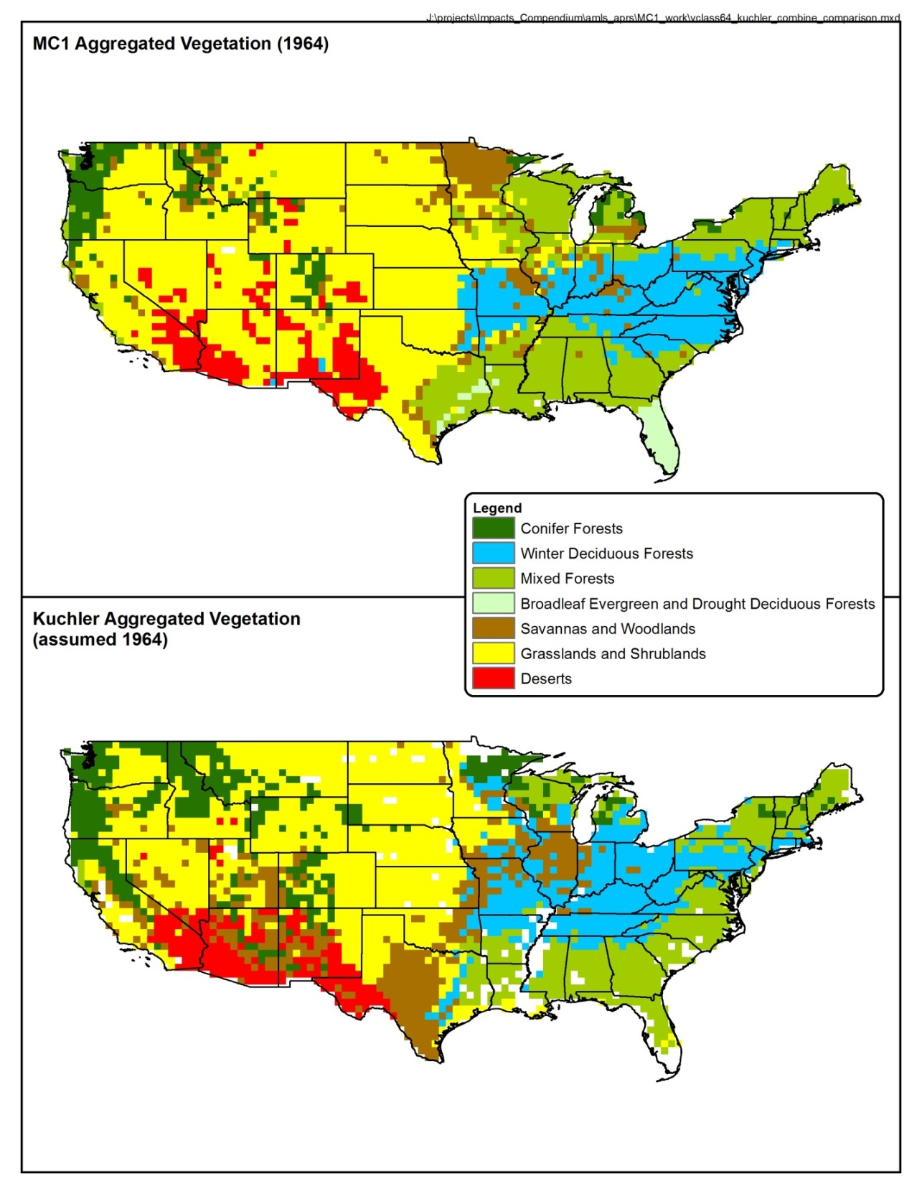
Fig. 7.1 Comparison of potential natural vegetation simulated by MC1 with that portrayed by Kuchler (1964)

Wildfire
While vegetation and carbon patterns were similar between ours and other studies, historical wildfire extent in our study tended to be a bit lower than other national studies. Leenhouts (1998) provided ranges for minimum and maximum area burned per year for contemporary and pre-industrial (~ 200–500 BP) time periods for different Kuchler physiognomic types. We compared our pre-fire suppression data with Leenhouts’ pre-industrial range, and our post-fire suppression data with Leenhouts’ contemporary range (Table 7.1). Our ranges matched those of Leenhouts well for winter deciduous forests and savannahs and woodlands. However, our ranges were low (while overlapping at times) for coniferous forests, mixed forests, grasslands and shrublands, and deserts. Similarly, prior to fire suppression initiation, MC1 produced an average historical burned area of approximately 13 × 10⁶ hectares per year as compared to 33 × 10⁶ in Bachelet et al. (2003). In California, our historical burned area range (0.2–5.5%) was again lower than Lenihan et al. (2003) (approximately 5–15%). In the Northwest fire region, our average of 0.643 was higher than that calculated by Rogers et al. (2011) for the Pacific Northwest (0.326). However, Rogers et al. (2011) excluded areas in eastern Washington and Oregon that are included in the Northwest fire region; these areas encapsulate grass- and shrublands that burn more frequently than the ecosystems farther to the west.
Table 7.1 Comparison of percent area burned across habitat types between this study and Leenhouts (1998, minimum-maximum)
Vegetation type | MC1 pre-fire suppression | Leenhouts  pre-industrial | MC1 post-fire suppression | Leenhouts contemporary
Coniferous forests | 0.01–1.21% | 2.98–7.64% | 0–2.92% | 2.58–6.69%
Winter deciduous forests | 0–2.44% | 0.88–1.47% | 0–0.25% | 0.41–0.71%
Mixed forests | 0–2.54% | 7.09–14.94% | 0–0.23% | 2.47–6.05%
Savannas and woodlands | 0.23–10.53% | 3.75–10.22% | 0.01–4.71% | 2.29–5.67%
Grasslands and shrublands | 0.94–8.95% | 8.22–17.58% | 0.09–2.19% | 3.37–6.10%
Deserts | 0.47–3.45% | 1.30–3.26% | 0.04–0.13% | 1.29–3.22%

References
Bachelet D, Lenihan JM, Daly C, Neilson RP, Ojima DS, Parton WJ (2001) MC1: A dynamic vegetation model for estimating the distribution of vegetation and associated ecosystem fluxes of carbon, nutrients, and water, technical documentation. Version 1.0. General Technical Report PNW-GTR-508. June
Bachelet D, Neilson RP, Hickler T, Drapek RJ, Lenihan JM, Sykes MT, Smith B, Sitch S, Thonicke K (2003) Simulating past and future dynamics of natural ecosystems in the United States. Glob Biogeochem Cycles 17(2):1045. doi:10.1029/2001GB001508
Kuchler AW (1964) Potential natural vegetation of the conterminous United States. American Geographical Society, Special Publication No. 36
Leenhouts B (1998) Assessment of biomass burning in the conterminous United States. Conservation Ecology (online) 2(1):1. http://www.consecol.org/vol2/iss1/art1/. Accessed 16 May 2012
Lenihan, JM, Drapek R, Bachelet D, Neilson RP (2003) Climate change effects on vegetation distribution, carbon and fire in California. Ecol Appl 13(6):1667–1681
Rogers B, Neilson R, Drapek R, Lenihan J, Wells J, Bachelet D, Law B (2011) Impacts of climate change on fire regimes and carbon stocks of the U.S. Pacific Northwest. J Geophys Res-Biogeo 116:G03037

. We modified the biogeography rules within the MC1 model to better classify the southeastern forests by adjusting the temperate-subtropical boundary. We changed the minimum monthly temperature value of the tropical zone temperature threshold from 7.75°C to 12.5°C.

