GCAM:
GCAM is a dynamic-recursive model combining representations of the global economy, the energy system, agriculture and land use, water, and climate (Edmonds and Reilly, 1985; Kim et al., 2006; Clarke et al., 2007). Exogenous inputs include (among other variables) present and future population, labor productivity, energy and agricultural technology characteristics, and resource availabilities. The model is calibrated to historical energy, agricultural, land, and climate data through the 2005 time period, and runs in five-year time steps to 2095, establishing market-clearing prices for all energy, agriculture, and land markets such that supplies and demands of all modeled markets are in equilibrium. In GCAM, the water system includes both supply and demand modules.

Water supply:
The global hydrologic module in GCAM is a gridded monthly water balance model with a resolution of 0.5x0.5 degrees. It requires gridded monthly precipitation, temperature, and maximum soil water storage capacity (a function of land cover), and computes the amounts of evapotranspiration to the atmosphere, runoff, and soil moisture in the soil column (Hejazi et al., 2013a,b). The model structure is consistent with existing global water balance models, and with the FAO’s model formulation for modeling water resources in Africa (FAO, 2001). GCAM tracks the fraction of rainfall that feeds into the soil column (green water) and runoff (blue water) at a monthly scale. The model accounts for the monthly green water storage and estimates the fraction of green and blue water that is evaporated back to the atmosphere through evapotranspiration from vegetation and cultivated lands and evaporation from bare soil or water bodies. The maximum soil moisture storage capacity (S_{m}) with a resolution of 0.5x0.5 degrees is obtained from the soil map of the world and soil properties (FAO, 1998, 2003). Information with regard to the "maximum soil moisture storage capacity" in mm/m is derived from the "Derived Soil Properties" of the "Digital Soil Map of the World" which contains raster information on soil moisture in different classes (FAO, 1998, 2003). Maximum available soil moisture is estimated from estimates of root depth, field capacity, and wilting point values (typically ranges between 15-350 mm/m). The root depth estimate is itself a function of land cover and water stress conditions. In this study, a static S_{m} map over time is assumed. Water routing capabilities and reservoir operation rules are not included. The water supply module is first evaluated against observational data and other models, and then simulated into the future to provide estimates of total water supply up to the end of the 21st century. Hejazi et al. (2013a,b) provide a detailed description of the hydrology module in GCAM.

Water demand:
Six water demand components, namely: agriculture (irrigation and livestock), primary and secondary energy production, manufacturing and mining, and the municipal sector are endogenously modeled in GCAM (Hejazi et al., 2014). Water demand in GCAM is represented as follows. First, base-year water use is assigned or calculated for the agricultural, industrial, and municipal sectors at the appropriate level of sectoral or technological specificity for GCAM. Agricultural water demand calculations are detailed, with derivations for twelve crop commodity classes at sub-regional scales (Chaturvedi et al., 2013). Industrial water demands are calculated for a wide range of technologies in GCAM’s energy production and transformation sectors (Davies et al., 2013; Kyle et al., 2013), with the remainder of industrial water use assigned to manufacturing, modeled as an aggregate value. Municipal estimates of water use are determined at a regional scale as a function of GDP per capita, water price, and a technological change parameter (Hejazi et al., 2013c). The energy, industrial, and municipal sectors are represented in fourteen geopolitical regions, with the agricultural sector further disaggregated into as many as eighteen agro-ecological zones (AEZs) within each region. Base-year water demands—both gross withdrawals and net consumptive use—are assigned to specific modeled activities in a way that maximizes consistency between bottom-up estimates of water demand intensities of specific technologies and practices, and top-down regional and sectoral estimates of water use. Note that the present study focuses only on freshwater abstraction; in-stream water demands for uses such as ecosystem services, navigation, and recreation are not addressed here, nor is the use of any saline water explicitly modeled. However, hydropower water use is included within the electrical sector in GCAM, as documented in Davies et al., 2013.

Spatial downscaling of IGSM-CAM:
In the present study, the Bias Correction and Spatial Disaggregation (BCSD) statistical downscaling method (Wood et al. 2002) is used. Original model output is in 2.5° x 2° degree resolution, and downscaling adds spatial details at 0.5° x 0.5° degree resolution comparable to available high-resolution observation datasets, which are obtained from CRU3.0 (Mitchell and Jones 2005). This statistical downscaling scheme is based on probability mapping; the probability distribution of climate model output is transformed to that of observation with high resolution and unbiased with equal quantile mapping. The spatial downscaling method is applied to generate higher resolution precipitation, surface air temperature, and diurnal temperature range (Figure S1). Details of the procedure can be found in Yoon et al. (2012a, b). The method is modified to ensure the amount of the downscaled precipitation is consistent in term of both interannual variability as well as long-term trend to the original modeled precipitation data from IGSM-CAM and the pattern-scaled simulations (Figure S2). Figure S2 shows that area-averaged precipitation over the globe and North America exhibit similar standard deviation and long-term trend in both original and downscaled pattern.

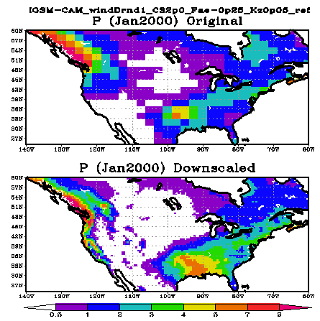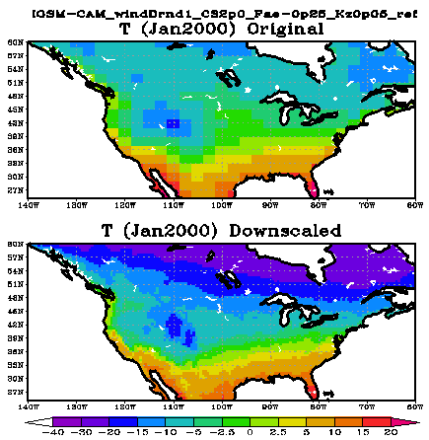
Figure S1: Examples of spatial downscaling using BCSD. Left (right) panels show precipitation (surface air temperature) of January 2000. Original model output from ‘IGSM-CAM RefCS2 Wnd1’ case are in top panels and downscaled patterns are in the bottom.
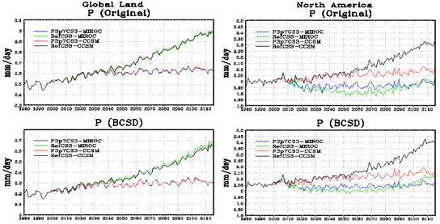
Figure S2: Evaluating the skill of BCSD in preserving interannual variability as well as long-term trend to the original modeled precipitation data from IGSM for the globe and North America.

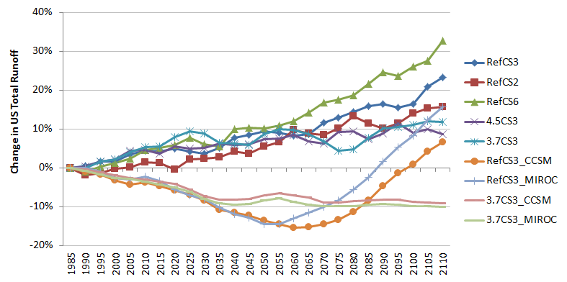
Figure S3: Percent change in total annual runoff in the U.S. as compared to the year of 1985 under each of the adopted scenarios.

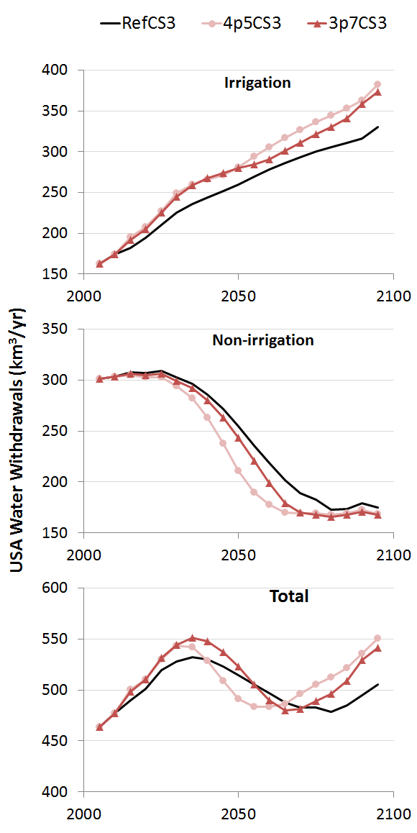
Figure S4: Total annual water demand estimates for the U.S. under the RefCS3, 4p5CS3, and 3p7CS3 scenarios;

Table S1: Total annual water runoff in the U.S. under each of the scenarios
 | RefCS3 | RefCS2 | RefCS6 | 4.5CS3 | 3.7CS3 | RefCS3  _CCSM | RefCS3  _MIROC | 3.7CS3  _CCSM | 3.7CS3  _MIROC
1,985 | 2,544 | 2,668 | 2,575 | 2,550 | 2,541 | 2,146 | 2,127 | 2,124 | 2,128
1,990 | 2,554 | 2,620 | 2,550 | 2,558 | 2,539 | 2,126 | 2,127 | 2,116 | 2,111
1,995 | 2,585 | 2,631 | 2,583 | 2,589 | 2,582 | 2,107 | 2,107 | 2,099 | 2,090
2,000 | 2,585 | 2,663 | 2,606 | 2,607 | 2,597 | 2,075 | 2,072 | 2,083 | 2,072
2,005 | 2,632 | 2,673 | 2,638 | 2,660 | 2,645 | 2,053 | 2,063 | 2,068 | 2,068
2,010 | 2,654 | 2,708 | 2,691 | 2,669 | 2,678 | 2,065 | 2,078 | 2,060 | 2,053
2,015 | 2,651 | 2,699 | 2,708 | 2,642 | 2,680 | 2,046 | 2,054 | 2,049 | 2,036
2,020 | 2,667 | 2,658 | 2,728 | 2,689 | 2,742 | 2,021 | 2,008 | 2,035 | 2,021
2,025 | 2,652 | 2,728 | 2,774 | 2,676 | 2,779 | 1,997 | 1,975 | 2,006 | 1,996
2,030 | 2,636 | 2,731 | 2,730 | 2,682 | 2,766 | 1,966 | 1,955 | 1,970 | 1,956
2,035 | 2,676 | 2,743 | 2,718 | 2,708 | 2,707 | 1,916 | 1,909 | 1,948 | 1,932
2,040 | 2,739 | 2,780 | 2,832 | 2,701 | 2,702 | 1,896 | 1,871 | 1,950 | 1,927
2,045 | 2,760 | 2,768 | 2,839 | 2,704 | 2,693 | 1,882 | 1,852 | 1,955 | 1,929
2,050 | 2,785 | 2,815 | 2,835 | 2,739 | 2,763 | 1,852 | 1,819 | 1,972 | 1,951
2,055 | 2,771 | 2,846 | 2,858 | 2,741 | 2,794 | 1,834 | 1,818 | 1,984 | 1,962
2,060 | 2,753 | 2,927 | 2,883 | 2,766 | 2,789 | 1,814 | 1,850 | 1,974 | 1,942
2,065 | 2,763 | 2,903 | 2,944 | 2,726 | 2,760 | 1,818 | 1,883 | 1,960 | 1,924
2,070 | 2,838 | 2,894 | 3,008 | 2,709 | 2,712 | 1,835 | 1,913 | 1,933 | 1,916
2,075 | 2,873 | 2,937 | 3,028 | 2,785 | 2,654 | 1,856 | 1,947 | 1,934 | 1,918
2,080 | 2,910 | 3,023 | 3,055 | 2,790 | 2,664 | 1,902 | 2,006 | 1,943 | 1,916
2,085 | 2,948 | 2,975 | 3,135 | 2,738 | 2,737 | 1,967 | 2,075 | 1,946 | 1,924
2,090 | 2,960 | 2,941 | 3,209 | 2,777 | 2,798 | 2,047 | 2,160 | 1,950 | 1,930
2,095 | 2,939 | 2,975 | 3,187 | 2,843 | 2,809 | 2,116 | 2,241 | 1,948 | 1,926
2,100 | 2,961 | 3,044 | 3,245 | 2,779 | 2,823 | 2,165 | 2,303 | 1,939 | 1,917
2,105 | 3,073 | 3,079 | 3,285 | 2,803 | 2,844 | 2,237 | 2,389 | 1,935 | 1,919
2,110 | 3,137 | 3,089 | 3,421 | 2,770 | 2,843 | 2,289 | 2,462 | 1,929 | 1,912

Table S2: Total annual water demand in the U.S. for each of the water demand sectors and under the reference scenario and the two climate mitigation policy scenarios
 |  | 1990 | 2005 | 2010 | 2015 | 2020 | 2025 | 2030 | 2035 | 2040 | 2045 | 2050 | 2055 | 2060 | 2065 | 2070 | 2075 | 2080 | 2085 | 2090 | 2095
Biomass | RefCS3 | 0 | 0 | 0 | 0 | 6 | 17 | 26 | 32 | 36 | 41 | 46 | 54 | 61 | 68 | 74 | 80 | 84 | 88 | 92 | 105
Biomass | 4p5CS3 | 0 | 0 | 0 | 0 | 4 | 16 | 33 | 36 | 36 | 37 | 44 | 56 | 69 | 81 | 91 | 100 | 108 | 116 | 126 | 148
Biomass | 3p7CS3 | 0 | 0 | 0 | 0 | 5 | 18 | 31 | 37 | 40 | 41 | 41 | 43 | 47 | 57 | 67 | 77 | 87 | 99 | 118 | 134
Crops | RefCS3 | 143 | 163 | 174 | 182 | 188 | 194 | 199 | 204 | 208 | 211 | 213 | 215 | 217 | 218 | 219 | 220 | 221 | 223 | 224 | 225
Crops | 4p5CS3 | 143 | 163 | 174 | 196 | 204 | 211 | 216 | 224 | 230 | 234 | 237 | 237 | 237 | 236 | 236 | 236 | 237 | 237 | 236 | 234
Crops | 3p7CS3 | 143 | 163 | 174 | 192 | 200 | 207 | 214 | 222 | 228 | 233 | 238 | 242 | 244 | 244 | 244 | 244 | 243 | 242 | 240 | 239
Livestock | RefCS3 | 1 | 1 | 1 | 1 | 1 | 1 | 1 | 1 | 2 | 2 | 2 | 2 | 2 | 2 | 2 | 2 | 2 | 2 | 2 | 2
Livestock | 4p5CS3 | 1 | 1 | 1 | 1 | 1 | 1 | 1 | 1 | 1 | 2 | 2 | 2 | 2 | 2 | 2 | 2 | 2 | 2 | 2 | 2
Livestock | 3p7CS3 | 1 | 1 | 1 | 1 | 1 | 1 | 1 | 1 | 1 | 2 | 2 | 2 | 2 | 2 | 2 | 2 | 2 | 2 | 2 | 2
Domestic | RefCS3 | 54 | 69 | 71 | 74 | 76 | 78 | 81 | 83 | 85 | 88 | 91 | 93 | 95 | 97 | 98 | 99 | 100 | 101 | 102 | 103
Domestic | 4p5CS3 | 54 | 69 | 71 | 74 | 76 | 78 | 81 | 83 | 85 | 88 | 91 | 93 | 95 | 97 | 98 | 99 | 100 | 101 | 102 | 103
Domestic | 3p7CS3 | 54 | 69 | 71 | 74 | 76 | 78 | 81 | 83 | 85 | 88 | 91 | 93 | 95 | 97 | 98 | 99 | 100 | 101 | 102 | 103
Primary Energy | RefCS3 | 3 | 2 | 3 | 4 | 6 | 7 | 4 | 4 | 4 | 3 | 3 | 3 | 3 | 3 | 3 | 3 | 3 | 3 | 8 | 3
Primary Energy | 4p5CS3 | 3 | 2 | 3 | 4 | 6 | 7 | 4 | 4 | 3 | 3 | 2 | 2 | 2 | 2 | 2 | 2 | 2 | 3 | 6 | 2
Primary Energy | 3p7CS3 | 3 | 2 | 3 | 4 | 6 | 7 | 4 | 4 | 3 | 3 | 3 | 3 | 2 | 2 | 2 | 2 | 2 | 3 | 5 | 2
Electricity | RefCS3 | 142 | 193 | 194 | 195 | 193 | 189 | 183 | 173 | 160 | 142 | 122 | 101 | 82 | 63 | 49 | 41 | 30 | 29 | 29 | 29
Electricity | 4p5CS3 | 142 | 193 | 194 | 193 | 190 | 185 | 176 | 162 | 141 | 113 | 84 | 61 | 48 | 39 | 37 | 36 | 33 | 33 | 33 | 33
Electricity | 3p7CS3 | 142 | 193 | 194 | 194 | 192 | 188 | 181 | 171 | 156 | 137 | 114 | 89 | 67 | 45 | 36 | 33 | 30 | 31 | 31 | 32
Manufacturing | RefCS3 | 56 | 37 | 35 | 34 | 31 | 33 | 34 | 34 | 35 | 36 | 37 | 37 | 37 | 37 | 38 | 38 | 38 | 38 | 38 | 38
Manufacturing | 4p5CS3 | 56 | 37 | 35 | 33 | 30 | 31 | 32 | 32 | 32 | 32 | 32 | 32 | 31 | 31 | 31 | 31 | 31 | 30 | 29 | 29
Manufacturing | 3p7CS3 | 56 | 37 | 35 | 33 | 31 | 32 | 32 | 33 | 34 | 34 | 34 | 34 | 33 | 33 | 32 | 32 | 31 | 31 | 30 | 30
TOTAL | RefCS3 | 399 | 464 | 477 | 490 | 501 | 519 | 528 | 532 | 530 | 523 | 515 | 505 | 497 | 487 | 483 | 483 | 479 | 485 | 495 | 505
TOTAL | 4p5CS3 | 399 | 464 | 477 | 500 | 510 | 530 | 543 | 542 | 529 | 509 | 492 | 484 | 483 | 486 | 496 | 506 | 512 | 522 | 535 | 550
TOTAL | 3p7CS3 | 399 | 464 | 477 | 498 | 510 | 532 | 544 | 551 | 548 | 537 | 523 | 505 | 490 | 480 | 481 | 489 | 496 | 509 | 529 | 541

References:
Chaturvedi, V., M.I. Hejazi, J. Edmonds, L. Clarke, P. Kyle, E. Davies, M. Wise, and K. Calvin. Impact of emission mitigation policies on long term global agricultural water demand, Pacific Northwest National Laboratory, Richland, Washington, 2013.
Clarke, L., Lurz, J., Wise, M., Edmonds, J., Kim, S., Pitcher, H., and Smith, S.: Model Documentation for the MiniCAM Climate Change Science Program Stabilization Scenarios, Pacific Northwest National Laboratory Richland, WA, USA, 2007.
Davies, Evan G. R., Page Kyle, and James A. Edmonds (2013). An integrated assessment of global and regional water demands for electricity generation to 2095. Advances in Water Resources, 52, 296-313.
Edmonds, J., and Reilly, J.: Global energy: Assessing the future, Oxford University Press, New York, 1985.
FAO: Digital soil map of the world and derived soil properties, [Version 3.5] ed., FAO, Rome, Italy :, 2003.
FAO: Digital soil of the world and derived soil properties, Rome, 1998.
FAO: Water Resources and Irrigation in Africa, Initially published in "Atlas of Water Resources and irrigation in Africa (CD-ROM)", FAO, Rome, 2001.
Hejazi, M.I., J. Edmonds, L. Clarke, P. Kyle, E. Davies, V. Chaturvedi, M. Wise, P. Patel, J. Eom, and K. Calvin (2013a). Integrated assessment of global water scarcity over the 21st century: Global water supply and demand under extreme radiative forcing, Hydrology and Earth System Sciences Discussion, 10, 3327–3381, doi:10.5194/hessd-10-3327-2013.
Hejazi, M.I., J. Edmonds, L. Clarke, P. Kyle, E. Davies, V. Chaturvedi, J. Eom, M. Wise, P. Patel, and K. Calvin (2013b). Integrated assessment of global water scarcity over the 21st century: Climate change mitigation policies, Hydrology and Earth System Sciences Discussion, 10, 3383–3425, doi:10.5194/hessd-10-3383-2013.
Hejazi, M.I., J. Edmonds, L. Clarke, P. Kyle, E. Davies, V. Chaturvedi, M. Wise, P. Patel, J. Eom, K. Calvin, R. Moss, and S. Kim (2014). Long-term global water use projections using six socioeconomic scenarios in an integrated assessment modeling framework, Technological Forecasting and Social Change, 81, 205–226, DOI: 10.1016/j.techfore.2013.05.006.
Hejazi, M.I., Jae Edmonds, and Vaibhav Chaturvedi, Evan Davies, and Jiyong Eom (2013c). Scenarios of Global Municipal Water Use Demand Projections over the 21st Century, Hydrological Sciences Journal, doi:10.1080/02626667.2013.772301
Kim, S., Edmonds, J., Lurz, J., Smith, S., and Wise, M.: The object-oriented energy climate technology systems (ObjECTS) framework and hybrid modeling of transportation in the MiniCAM Long-term, global integrated assessment model, The Energy Journal, 27, 63–92, //10.5547/ISSN0195-6574-EJ-VolSI2006-NoSI2-4, 2006.
Kyle, P., E. Davies, J. J Dooley, S. J Smith, L. Clarke, J. Edmonds, and M.I. Hejazi (2013). Influence of climate change mitigation technology on global demands of water for electricity generation. International Journal of Greenhouse Gas Control, 13:112–123. doi:10.1016/j.ijggc.2012.12.006
Mitchell and Jones, 2005: An improved method of constructing a database of monthly climate observations and associated high-resolution grids. Int. J. Climatology, 25, 693-712, Doi: 10.1002/joc.1181.
Raskin, P., P. Gleick, P. Kirshen, G. Pontius, and K. Strzepek (1997), Water Futures: Assessment of Long-range Patterns and ProspectsRep., Stockholm Environment Institute, Stockholm, Sweden.
Wada, Y., L. van Beek, D. Viviroli, H. Dürr, R. Weingartner, and M. Bierkens (2011), Global monthly water stress: 2. Water demand and severity of water stress, Water Resour. Res., 47(7), W07518.
Wood, A. W., E. P. Maurer, A. Kumar, and D. P. Lettenmaier (2002), Long-range experimental hydrologic forecasting for the eastern United States, J. Geophys. Res., 107(D20).
Yoon JH, K Mo, and E Wood. 2012a. "Dynamic-Model Based Seasonal Prediction of Meteorological Drought over the Contiguous United States." Journal of Hydrometeorology 13(2):463-482. doi:10.1175/JHM-D-11-038.
Yoon JH, LYR Leung, and J Correia Jr.. 2012. "Comparison of Dynamically and Statistically Downscaled Seasonal Climate Forecasts for the Cold Season over the United States." Journal of Geophysical Research. D. (Atmospheres) 117:D21109. doi:10.1029/2012JD017650

