Supplementary Information

Impacts Models

Impacts of climate change on water resources are characterised by the numbers of people living in water-stressed watersheds where average annual river runoff decreases (increased exposure to water resources stress) or increases (decreased exposure to stress) significantly (see Gosling & Arnell (2013) for more detailed results and a discussion on comparisons with other global studies). A water-stressed watershed has average annual runoff less than 1000 m³/capita/year (Arnell et al., 2011; Gosling & Arnell, 2013), and a ‘significant’ change in runoff is greater than the standard deviation of 30-year average annual runoff, which varies between 5 and 10%. River runoff at the 0.5x0.5º scale is simulated using the MacPDM.09 global hydrological model (Gosling & Arnell, 2011; Arnell & Gosling, 2013). Impacts of climate change on river flood risk are characterised by the numbers of people living in floodplains where the frequency of the current 20-year flood either doubles (increased exposure to flooding) or halves (reduced exposure to flooding). The flood frequency distribution in each 0.5x0.5º grid cell is estimated by fitting a GEV distribution to maximum flows from the MacPDM.09 simulations (see Arnell & Gosling, 2014 for more details on methodology and results). MacPDM.09 performs similarly to other global hydrological models, both in terms of its simulation of current hydrological behaviour (Haddeland et al., 2011) and its response to climate change (Hagemann et al., 2013).

Changes in coastal flood risk and coastal wetland extent are calculated using the DIVA model (Vafiedis et al., 2008; Hinkel & Klein, 2009; Brown et al., 2013), which combines changes in sea level with estimates of vertical land movement to determine local sea level rise. DIVA incorporates coastal protection (dike protection and nourishment), which is assumed in this analysis to increase as population and wealth increases in the flood-prone areas without taking sea level rise into account. Coastal flood risk is characterised by the average annual number of people flooded in coastal floods. Previous published applications of DIVA (e.g. Nicholls, 2004; Nicholls et al., 2011) have assumed either no increase in coastal protection standards or enhanced levels of protection which take into account not only socio-economic change but also sea level rise.

The impacts of climate change on agriculture are represented by changes in the suitability of cropland for cropping, and changes in the productivity of three major crop types. Effects on suitability are based on changes in Ramankutty et al.’s (2002) crop suitability index, which defines suitability based on soil properties, growing degree days and the availability of water to plants; it does not take into account the occurrence of extreme weather events such as prolonged periods of high temperatures. Changes in the productivity of three example crops - spring wheat, maize and soybean (all both irrigated and rain-fed) - are estimated using the GLAM global crop model (Challinor et al., 2004; Osborne et al., 2012), which includes changes in both climate and CO₂ concentration. Three varieties are simulated for each crop for each grid cell, and the variety with the highest yield selected; this can change with climate. Planting dates vary with climate, so the crop model therefore explicitly incorporates some autonomous adaptation. Regional average yield for each crop is estimated by weighting the GLAM simulations of yield with current cultivated rain-fed and irrigated areas (Portmann et al., 2010). Increases in crop yield due to technical and management improvements are not incorporated into GLAM; it is assumed that the percentage impacts of climate change on yield are independent of such improvements (implicitly assuming that the improvements do not improve resilience to climatic variability). A visual comparison of GLAM results with those from other models (Easterling et al., 2007) suggests that GLAM produces slightly more negative changes than most models, probably because of the more explicit incorporation of the adverse effects of high temperature extremes.

Impacts on terrestrial ecosystems are represented by the changes in the regional forested area, regional average Net Primary Productivity (NPP), and regional average soil organic carbon (SOC) content: soil organic carbon contributes to soil fertility and is a major carbon store. Changes in forest extent (forest plant functional types) and NPP due to changes in climate and CO₂ concentration are simulated using the dynamic global vegetation model JULES/IMOGEN (Huntingford et al., 2010), and regional values are calculated only across grid cells that have less than 500 km² of land classified as either cropland or pasture. There remains significant uncertainty in aspects of land surface modelling, and differences between alternative models can be large. Changes in SOC stocks in mineral soils are simulated (for seven climate model patterns) using RothC (Smith et al., 2005; Gottschalk et al., 2012) at a spatial resolution of 0.5x0.5º. Changes in SOC are a balance between changes in soil respiration (decomposition) which is a function of temperature and precipitation, and inputs from vegetation (characterised by NPP). The simulations here estimated changes in NPP for each climate model by rescaling the IMAGE 2.4 A1b pattern of change in NPP to the changes in temperature and precipitation as simulated by that climate model (see Gottschalk et al., 2012 for more detailed description and results, and a discussion of comparisons with results from other global SOC models). The IMAGE 2.4 projected changes in NPP are based on assumptions about change in the extent of agricultural land, and specifically the conversion of forest to arable land.

Regional domestic heating and cooling energy requirements (which currently consume a third of end-use energy) are estimated using a model based on Isaac & van Vuuren’s (2009) residential energy demand model. The model projects energy requirements from heating and cooling degree days, together with population, household size and assumptions about heating and cooling technologies and efficiencies. The model does not incorporate adaptation to climate change in terms of either preferences or technologies. Changes in residential domestic heating energy requirements are directly proportional to changes in regional population-weighted heating degree days, but changes in cooling energy requirements increase more rapidly than regional population-weighted heating degree days because air-conditioning penetration is assumed to be related to temperature. The model as applied here differs from Isaac & van Vuuren’s (2009) model in three ways. First, it makes global, rather than regionally-varying assumptions about changes in energy technologies and efficiencies. Second, the GDP data base used to estimate cooling appliance penetration and efficiency is based on market exchange rates (MEX) rather than purchasing power parity (PPP) as used in the derivation of the empirical relationships in the model; this would likely lead to lower estimates of cooling energy demand in low GDP regions. Third, and most importantly, the model is implemented here at the 0.5x0.5º resolution rather than the regional scale as in Isaac & van Vuuren (2009). Because of the non-linear relationships between income and cooling appliance penetration and efficiency, the model as implemented here therefore produces lower estimates of future cooling energy demand than in Isaac & van Vuuren (2009) and van Vuuren et al. (2011); the proportional changes in separate heating and cooling energy demands are similar, but changes in total demands are therefore different.

All but two of the impact indicators represent aggregations of impact across a region. The exceptions are regional crop productivity, which represents change in average regional yield, and change in regional NPP which represents change in the regional average NPP per unit area.

Supplementary References

Arnell NW, van Vuuren DP, Isaac M (2011) The implications of climate policy for the impacts of climate change on global water resources. Global Environmental Change 21:592-603.
Arnell NW & Gosling SN (2013) The impacts of climate change on river flow regimes at the global scale. Journal of Hydrology 486: 351-364. doi:10.1016/j.hydrol.2013.02.010
Arnell NW & Gosling SN (2014) The impacts of climate change on river flood risk at the global scale. Climatic Change doi: 10.1007/s10584-014-1084-5
Brown S, Nicholls RJ, Lowe J, Hinkel J (2013) Spatial variations of sea-level rise and impacts: An application of DIVA. Climatic Change doi:10.1007/s10584-013-0925-y
Gosling SN, Arnell NW (2011) Simulating current global river runoff with a global hydrological model: model revisions, validation, and sensitivity analysis. Hydrological Processes 25:1129-1145.
Gosling, SN. & Arnell, NW (2013) A global assessment of the impact of climate change on water scarcity. Climatic Change doi 10.1007/s10584-013-0853-x
Challinor AJ, Wheeler TR, Craufurd PQ, Slingo JM, Grimes DIF (2004) Design and optimisation of a large-area process-based model for annual crops. Agricultural and Forest Meteorology 124:99-120.
Easterling WE, Aggarwal PK, Batima P, et al. (2007) Food, fibre and forest products. in Parry ML, Canziani OF, Palutikof JP, Van der Linden P, Hanson CE (eds.) Climate Change 2007: Impacts, Adaptation and Vulnerability. Contribution of Working Group II to the Fourth Assessment Report of the Intergovernmental Panel on Climate Change. Cambridge University Press, Cambridge, pp. 273-313.
Gottschalk P, Smith JU, Wattenbach M, et al. (2012) How will organic carbon stocks in mineral soils evolve under future climate? Global projections using RothC for a range of climate change scenarios. Biogeosciences 9: 3151-3171.
Haddeland I, Clark DB, Franssen W et al., 2011. Multimodel Estimate of the Global Terrestrial Water Balance: Setup and First Results. Journal of Hydrometeorology, 12(5): 869-884.
Hagemann S., Chen C, Clark DB et al. (2013) Climate change impact on available water resources obtained using multiple global climate and hydrology models. Earth System Dynamics 4: 129-144.
Hinkel J, Klein RJT (2009) Integrating knowledge to assess coastal vulnerability to sea-level rise: The development of the DIVA tool. Global Environmental Change 19:384-395.
Huntingford C, Booth BBB, Sitch S, et al. (2010) IMOGEN: an intermediate complexity model to evaluate terrestrial impacts of a changing climate. Geoscientific Model Development 3:679-687.
Isaac M, van Vuuren DP (2009) Modeling global residential sector energy demand for heating and air conditioning in the context of climate change. Energy Policy 37:507-521.
Nicholls RJ (2004) Coastal flooding and wetland loss in the 21st century: changes under the SRES climate and socio-economic scenarios. Global Environmental Change 14:69-86.
Nicholls RJ, Marinova N, Lowe JA, et al. (2011) Sea-level rise and its possible impacts given a 'beyond 4 degrees C world' in the twenty-first century. Philosophical Transactions of the Royal Society a-Mathematical Physical and Engineering Sciences 369, 161-181.
Osborne, T., Rose, GA & Wheeler, TR (2012) Variation in the global-scale impacts of climate change on crop productivity due to climate model uncertainty and adaptation. Agricultural and Forest Meteorology 170: 183-194.
Portmann FT, Siebert S & Doll P (2010) MIRCA2000 – Global monthly irrigated and rainfed crop areas around the year 2000: a new high resolution data set for agricultural and hydrological modelling. Global Biogeochemical Cycles 24: Gb1011 10.1029/2008gb003435
Ramankutty N, Foley JA, Norman J, McSweeney K (2002) The global distribution of cultivable lands: current patterns and sensitivity to possible climate change. Global Ecology and Biogeography 11:377-392.
Smith J, Smith P, Wattenbach M, et al. (2005) Projected changes in mineral soil carbon of European croplands and grasslands, 1990-2080. Global Change Biology 11:2141-2152.
Vafeidis AT, Nicholls RJ, McFadden L, et al. (2008) A new global coastal database for impact and vulnerability analysis to sea-level rise. Journal of Coastal Research, 24,(4), 917-924. doi:10.2112/06-0725.1.
Van Vuuren DP, Isaac M, Kundzewicz Z, et al. (2011) The use of scenarios as the basis for combined assessment of climate change mitigation and adaptation. Global Environmental Change 21: 575-591.

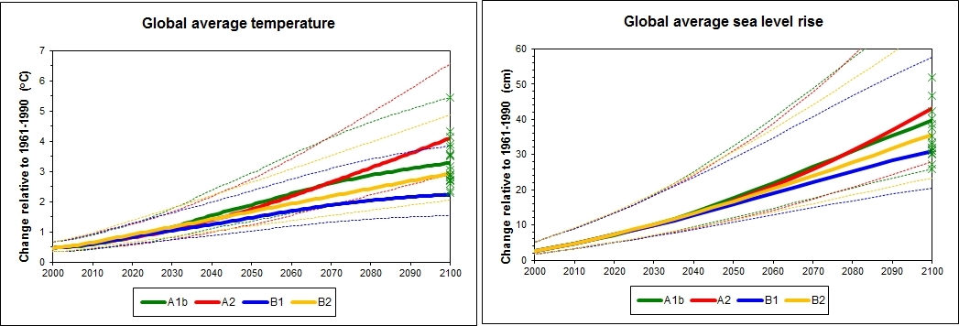

Supplementary Figure 1

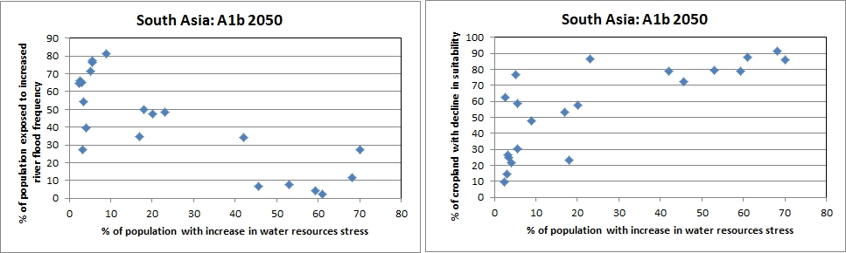

Supplementary Figure 8

Table S1: Regional classification
West Africa | Benin, Burkina Faso, Gambia, Ghana, Guinea, Guinea-Bissau, Ivory Coast, Liberia, Mali, Mauritania, Niger, Nigeria, Senegal, Sierra Leone, Togo
Central Africa | Cameroon, Cape Verde, Central African Republic, Chad, Congo, DR Congo, Equatorial Guinea, Gabon, Sao Tome and Principe,
East Africa | Burundi, Djibouti, Ethiopia, Eritrea, Kenya, Rwanda, Somalia
Southern Africa | Angola, Botswana, Lesotho, Madagascar, Malawi, Mauritius, Mozambique, Namibia, Seychelles, South Africa, Swaziland, Tanzania, Zambia, Zimbabwe, plus western Indian Ocean islands
South Asia | Afghanistan, Bangladesh, Bhutan, India, Iran, Maldives, Nepal, Pakistan, Sri Lanka
South East Asia | Brunei, Cambodia, East Timor, Indonesia, Laos, Malaysia, Myanmar, Philippines, Singapore, Thailand, Vietnam
East Asia | China, Japan, Rep. of Korea, Dem. Rep. of Korea, Mongolia, Taiwan
Central Asia | Kazakhstan, Kyrgyz Rep., Tajikistan, Turkmenistan, Uzbekistan
Australasia | Australia, New Zealand, Papua New Guinea, Pacific Ocean islands
Western Europe | Andorra, Austria, Belgium, Denmark, Finland, France, Germany, Greece, Iceland, Ireland, Italy, Liechtenstein, Luxembourg, Malta, Netherlands, Norway, Portugal, Spain, Sweden, Switzerland, UK
Central Europe | Albania, Bosnia-Herzegovina, Bulgaria, Croatia, Cyprus, Czech Rep., Estonia, Hungary, Latvia, Lithuania, Poland, Romania, Slovakia, Slovenia, Macedonia, Montenegro, Serbia
Eastern Europe | Azerbaijan, Armenia, Belarus, Georgia, Moldova, Russia, Ukraine
North Africa | Algeria, Libya, Morocco, Western Sahara, Sudan, Tunisia, Egypt
West Asia | Bahrain, Oman, Saudi Arabia, Qatar, United Arab Emirates, Yemen, Iraq, Israel, Jordan, Kuwait, Lebanon, Occupied Palestinian Terr., Syria, Turkey
Canada | Canada
USA | USA
Central America | Belize, Costa Rica, Cuba, El Salvador, Guatemala, Honduras, Nicaragua, Mexico, Panama, and the Caribbean Islands
Brazil | Brazil
South America | Argentina, Bolivia, Chile, Colombia, Ecuador, French Guiana, Guyana, Paraguay, Peru, Suriname, Uruguay, Venezuela

Table S2: Climate models used in the assessment
IPCC I.D. | Centre and location
UKMO-HadCM3 | Hadley Centre for Climate Prediction and Research (UK)
UKMO-HadGEM1 | Hadley Centre for Climate Prediction and Research (UK)
ECHAM5/MPI-OM | Max Planck Institute for Meteorology (Germany)
CSIRO-Mk3.0 | CSIRO Atmospheric Research (Australia)
CSIRO-Mk3.5 | CSIRO Atmospheric Research (Australia)
CGCM3.1 (T47) | Canadian Centre for Climate Modelling and Analysis (Canada)
CGCM3.1 (T63) | Canadian Centre for Climate Modelling and Analysis (Canada)
IPSL-CM4 | Institut Pierre Simon Laplace (France)
CCSM3 | National Center for Atmospheric Research (USA)
PCM | National Center for Atmospheric Research (USA)
BCCR-BCM2.0 | Bjerknes Centre for Climate Research (Norway)
CNRM-CM3 | Météo-France, Centre National de Recherches Météorologiques (France)
GFDL-CM2.0 | Geophysical Fluid Dynamics Laboratory (USA)
GFDL-CM2.1 | Geophysical Fluid Dynamics Laboratory (USA)
GISS-AOM | NASA/Goddard Institute for Space Studies (USA)
GISS-EH | NASA/Goddard Institute for Space Studies (USA)
GISS-ER | NASA/Goddard Institute for Space Studies (USA)
INM-CM3.0 | Institute for Numerical Mathematics (Russia)
MIROC3.2 (medres) | Centre for Climate System Research, National Institute for Environmental Studies, Frontier Research Center for Global Change (Japan)
MIROC3.2 (hires) | Centre for Climate System Research, National Institute for Environmental Studies, Frontier Research Center for Global Change (Japan)
MRI-CGCM2.3.2 | Meteorological Research Institute (Japan)

