Supplementary Material

Methods
Table S1 - Distribution of presence locations (1) from projects, (2) survey data (IBGE 2012), and (3) Google earth; shares of global production (USDA 2012). The sampling bias for the biased background method is calculated by dividing the share of presence points in a country by the share of global production. Using this approach the geographic bias in presence locations is cancelled out by a similar bias in the random background noise samples (Dudík et al. 2005). Thus, pixel cells in countries that are overrepresented in the presence location database are more likely to be picked as a background cell. This is meant to avoid the biased fitting of the models to conditions of the overrepresented regions.
Country | Arabica locations | Arabica production share '98-'02 | Robusta locations | Robusta production share '98-'02
Benin | 0 | 0% | 5³ | 0%
Brazil | 1042² | 36% | 164² | 16%
Burundi | 8³ | 1% | 0 | 0%
Cameroon | 0 | 0% | 22³ | 2%
China | 5³ | 0% | 0 | 0%
Colombia | 169¹ | 16% | 0 | 0%
Congo (Democratic Republic) | 1³ | 0% | 0 | 0%
Costa Rica | 124¹ | 4% | 0 | 0%
Côte d'Ivoire | 0 | 0% | 20³ | 10%
Ecuador | 43¹ | 1% | 17¹ | 1%
El Salvador | 55¹ | 3% | 0 | 0%
Ethiopia | 9³ | 5% | 0 | 0%
Guatemala | 230¹ | 6% | 0 | 0%
Honduras | 158¹ | 4% | 0 | 0%
India | 2³ | 3% | 21³ | 7%
Indonesia | 184¹ | 1% | 22³ | 16%
Kenya | 111¹ | 2% | 0 | 0%
Mexico | 407¹ | 7% | 0 | 0%
Mozambique | 14¹ | 0% | 0 | 0%
Nicaragua | 170¹ | 2% | 0 | 0%
Panama | 4³ | 0% | 0 | 0%
Philippines | 0 | 0% | 20³ | 2%
Rwanda | 18¹ | 0% | 0 | 0%
Tanzania | 9³ | 1% | 0 | 1%
Thailand | 0 | 0% | 15³ | 3%
Uganda | 24¹ | 1% | 17¹ | 7%
United States | 2³ | 0% | 0 | 0%
Venezuela | 3³ | 2% | 0 | 0%
Vietnam | 19¹ | 0% | 41¹ | 27%
Yemen | 4³ | 0% | 0 | 0%
Zimbabwe | 46¹ | 0% | 0 | 0%

Results

Variable contribution
Table S2 - Variable contribution across all models
Bioclimatic variable |  | Unit | Average Variable Weight in % |  | Median Rank of Variable
 |  |  | Arabica | Robusta | Arabica | Robusta
BIO 1 | Annual Mean Temperature | °C | 10 | 5 | 4 | 12
BIO 2 | Mean Diurnal Range (Mean of monthly (max temp - min temp)) | °C | 4 | 12 | 12 | 1
BIO 3 | Isothermality (BIO2/BIO7) (* 100) | - | 4 | 2 | 9 | 15
BIO 4 | Temperature Seasonality (standard deviation *100) | °C | 4 | 6 | 11 | 7
BIO 5 | Max Temperature of Warmest Month | °C | 13 | 9 | 2 | 3
BIO 6 | Min Temperature of Coldest Month | °C | 5 | 4 | 8 | 11
BIO 7 | Temperature Annual Range (BIO5-BIO6) | °C | 2 | 11 | 16 | 2
BIO 8 | Mean Temperature of Wettest Quarter | °C | 13 | 6 | 3 | 8
BIO 9 | Mean Temperature of Driest Quarter | °C | 6 | 3 | 6 | 16
BIO 10 | Mean Temperature of Warmest Quarter | °C | 15 | 7 | 1 | 7
BIO 11 | Mean Temperature of Coldest Quarter | °C | 6 | 2 | 6 | 17
BIO 12 | Annual Precipitation | mm | 2 | 5 | 15 | 8
BIO 13 | Precipitation of Wettest Month | mm | 4 | 4 | 11 | 11
BIO 14 | Precipitation of Driest Month | mm | 1 | 3 | 18 | 13
BIO 15 | Precipitation Seasonality (Coefficient of Variation) | - | 1 | 7 | 16 | 6
BIO 16 | Precipitation of Wettest Quarter | mm | 3 | 4 | 13 | 12
BIO 17 | Precipitation of Driest Quarter | mm | 1 | 4 | 18 | 10
BIO 18 | Precipitation of Warmest Quarter | mm | 5 | 4 | 9 | 11
BIO 19 | Precipitation of Coldest Quarter | mm | 2 | 2 | 17 | 15

Future coffee suitability
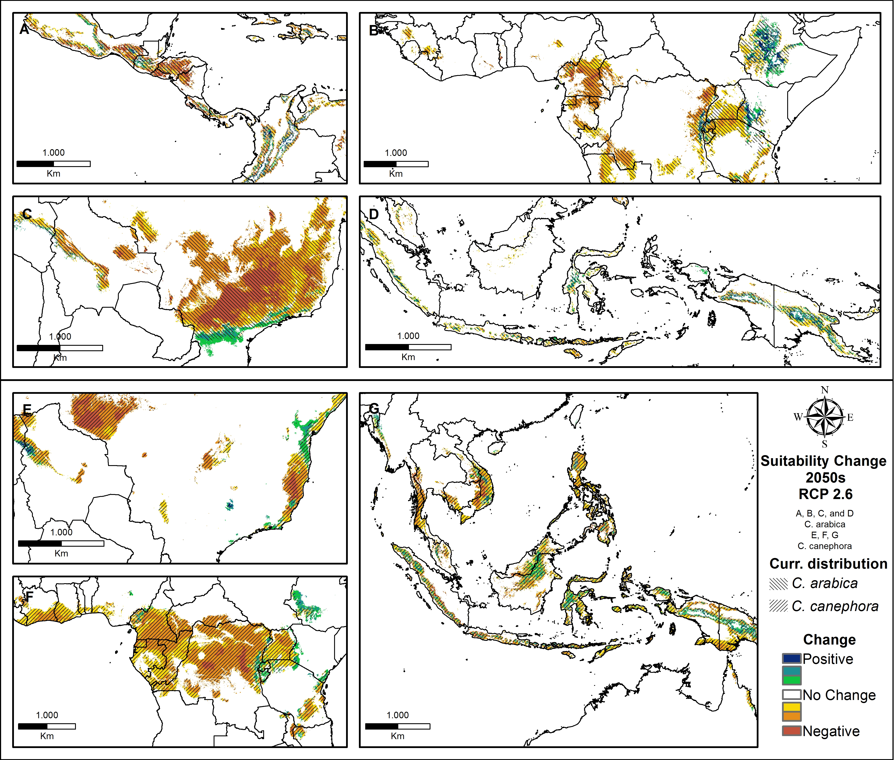
Fig. S1 Suitability changes by the 2050s in the RCP 2.6 scenario; A-D: Arabica, E-G: Robusta. Hatching indicates the current suitability distribution; Warm colors represent areas with negative climate change impacts and cold colors positive changes
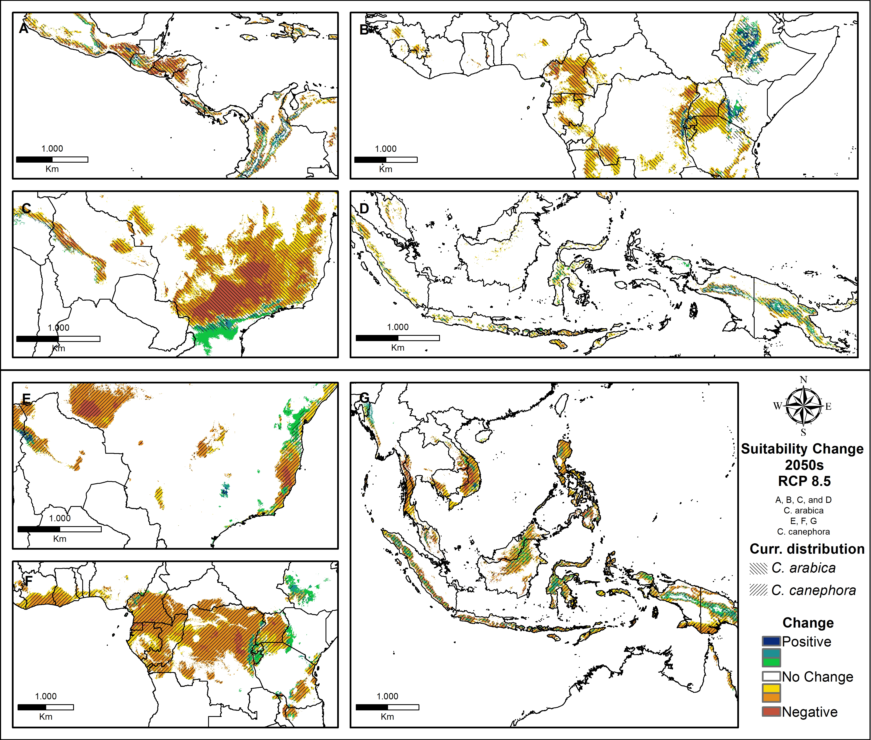
Fig. S2 Suitability changes by the 2050s in the RCP 8.5 scenario; A-D: Arabica, E-G: Robusta. Hatching indicates the current suitability distribution; Warm colors represent areas with negative climate change impacts and cold colors positive changes
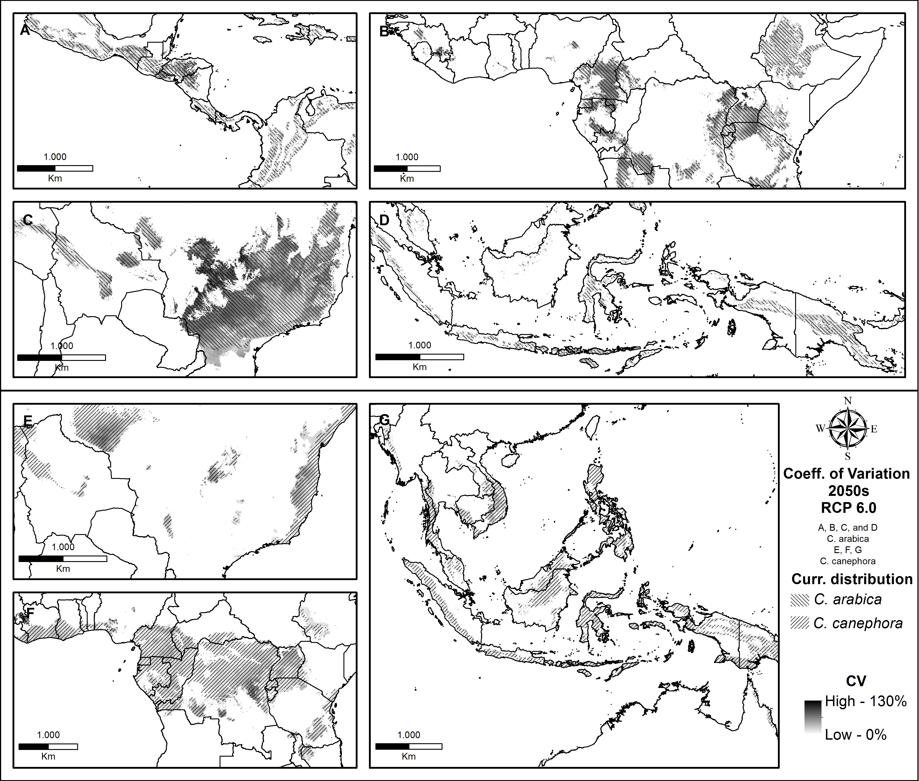
Fig. S3 Coefficient of variation for 5 GCM outputs by the 2050s in the RCP 6.0 scenario; A-D: Arabica, E-G: Robusta. Hatching indicates the current suitability distribution;

Suitability change by region
Table S3 shows the relative suitability by 2050 for coffee regions across scenarios. Min and Max are derived considering the lowest and highest suitability scores found in the 5 GCMs. The mean is derived from the mean values of a pixel cells for the 5 GCMs.
Table S3 Suitability by region in percent of current suitability
 |  |  | C. arabica
 |  |  |  | RCP 2.6 |  |  |  |  |  | RCP 6.0 |  |  |  |  |  | RCP 8.5
 |  |  |  | Min |  | Mean |  | Max |  | Min |  | Mean |  | Max |  | Min |  | Mean |  | Max
Africa |  | Congo Basin |  | 17% |  | 24% |  | 40% |  | 13% |  | 20% |  | 37% |  | 10% |  | 15% |  | 22%
 |  | East Africa |  | 58% |  | 87% |  | 124% |  | 54% |  | 82% |  | 121% |  | 42% |  | 70% |  | 105%
 |  | South Africa |  | 36% |  | 49% |  | 70% |  | 27% |  | 43% |  | 75% |  | 21% |  | 34% |  | 55%
 |  | West Africa |  | 15% |  | 28% |  | 45% |  | 9% |  | 19% |  | 54% |  | 5% |  | 10% |  | 23%
America |  | Brazil |  | 24% |  | 45% |  | 71% |  | 16% |  | 38% |  | 64% |  | 11% |  | 29% |  | 48%
 |  | Central America |  | 44% |  | 59% |  | 76% |  | 39% |  | 52% |  | 69% |  | 29% |  | 42% |  | 59%
 |  | North America |  | 40% |  | 57% |  | 78% |  | 35% |  | 52% |  | 74% |  | 28% |  | 43% |  | 64%
 |  | South America |  | 52% |  | 71% |  | 92% |  | 47% |  | 66% |  | 90% |  | 37% |  | 58% |  | 83%
Asia |  | Asian Islands |  | 55% |  | 75% |  | 98% |  | 50% |  | 68% |  | 88% |  | 38% |  | 58% |  | 78%
 |  | Pacific Islands |  | 70% |  | 91% |  | 119% |  | 65% |  | 86% |  | 115% |  | 56% |  | 79% |  | 107%
 |  | South Asia |  | 23% |  | 40% |  | 62% |  | 19% |  | 33% |  | 52% |  | 14% |  | 27% |  | 49%
 |  | South East Asia |  | 24% |  | 40% |  | 63% |  | 18% |  | 28% |  | 46% |  | 12% |  | 24% |  | 49%
Global |  |  |  | 0.38 |  | 0.57 |  | 0.81 |  | 0.32 |  | 0.51 |  | 0.77 |  | 0.24 |  | 0.42 |  | 0.63
 |  |  | C. canephora
 |  |  |  |  | RCP 2.6 |  |  |  |  |  | RCP 6.0 |  |  |  |  |  | RCP 8.5
 |  |  | Min |  | Mean |  | Max |  | Min |  | Mean |  | Max |  | Min |  | Mean |  | Max
Africa | Congo Basin |  | 11% |  | 23% |  | 43% |  | 11% |  | 22% |  | 52% |  | 5% |  | 11% |  | 24%
Africa | East Africa |  | 43% |  | 84% |  | 145% |  | 44% |  | 87% |  | 145% |  | 24% |  | 70% |  | 140%
Africa | South Africa |  | 34% |  | 63% |  | 106% |  | 28% |  | 64% |  | 143% |  | 15% |  | 53% |  | 108%
Africa | West Africa |  | 23% |  | 52% |  | 89% |  | 10% |  | 42% |  | 121% |  | 5% |  | 27% |  | 57%
America | Brazil |  | 26% |  | 40% |  | 82% |  | 23% |  | 41% |  | 75% |  | 19% |  | 37% |  | 75%
America | Central America |  | 34% |  | 60% |  | 80% |  | 32% |  | 54% |  | 77% |  | 25% |  | 40% |  | 59%
America | North America |  | 23% |  | 41% |  | 70% |  | 18% |  | 33% |  | 64% |  | 14% |  | 28% |  | 54%
America | South America |  | 40% |  | 58% |  | 84% |  | 36% |  | 55% |  | 76% |  | 28% |  | 45% |  | 65%
Asia | Asian Islands |  | 50% |  | 66% |  | 88% |  | 46% |  | 61% |  | 78% |  | 35% |  | 49% |  | 67%
Asia | Pacific Islands |  | 52% |  | 74% |  | 102% |  | 47% |  | 66% |  | 90% |  | 43% |  | 60% |  | 83%
Asia | South Asia |  | 43% |  | 61% |  | 89% |  | 40% |  | 56% |  | 79% |  | 31% |  | 43% |  | 69%
Asia | South East Asia |  | 31% |  | 48% |  | 72% |  | 24% |  | 40% |  | 65% |  | 17% |  | 31% |  | 60%
Global |  |  | 0.31 |  | 0.49 |  | 0.78 |  | 0.28 |  | 0.46 |  | 0.78 |  | 0.20 |  | 0.36 |  | 0.61

References

IBGE (2012) Sistema IBGE de Recuperação Automática - SIDRA. In: IBGE. http://sidra.ibge.gov.br/. Accessed 28 Mar 2013

Dudík M, Phillips SJ, Schapire RE (2005) Correcting sample selection bias in maximum entropy density estimation. Advances in neural information processing systems. pp 323–330

USDA (2012) PSD Online - Home. In: Production, Supply and Distribution Online. http://www.fas.usda.gov/psdonline/. Accessed 21 Dec 2012

