Online resource 6: MCA dimension projection plot

Covering the head against the sun (V1) | Taking showers or baths (V2)
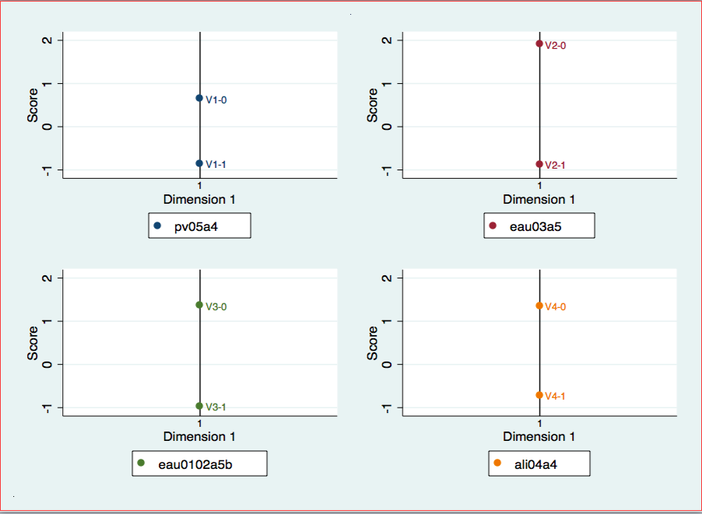
Sponging/spraying/face/neck (V3) | Eating iced foods (V4)
Switching off the computer when not in use (V5) | Reducing use of dryer (V6)
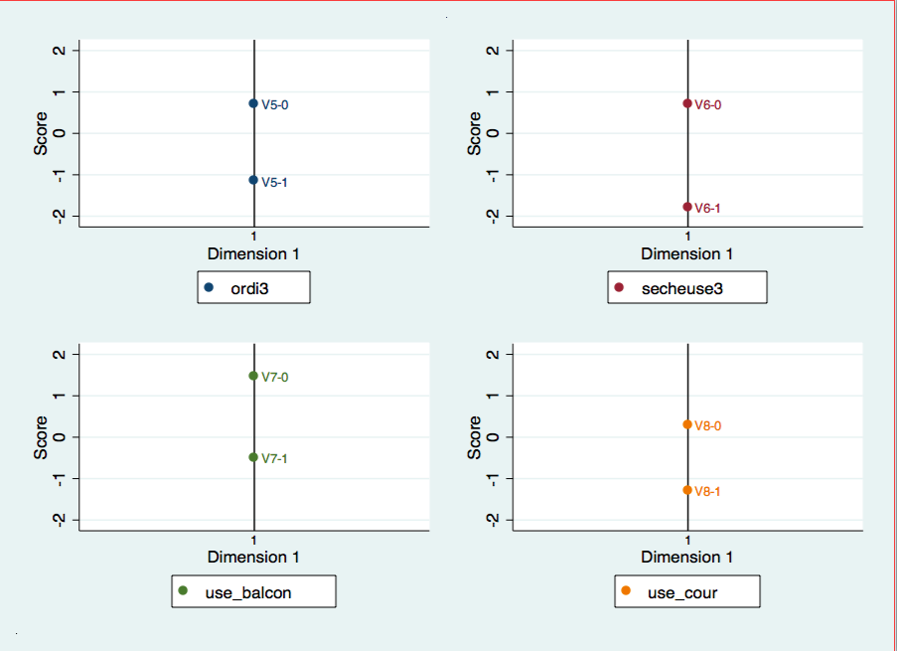
Using balcony in the evening (V7) | Using back yard in the evening (V8)
Supplementary figure 1: MCA dimension projection plot (continued)

Swimming (V9) | Frequenting air-conditioning places (V10)
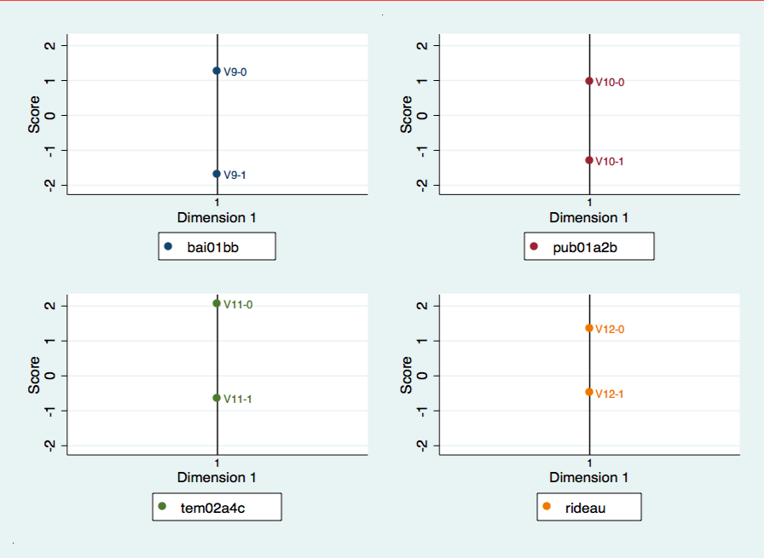
Adopting preventive behavior according to  weather report (V11) | Closing the curtains or blinds  against the sun (V12)
Decreasing oven use (V13) | Drinking tap water as main beverage (V14)
