Drought Tolerant maize for farmer adaptation to drought in sub-Saharan Africa: Determinants of adoption in East and Southern Africa: Fisher et al.
Supplemental Resource 1

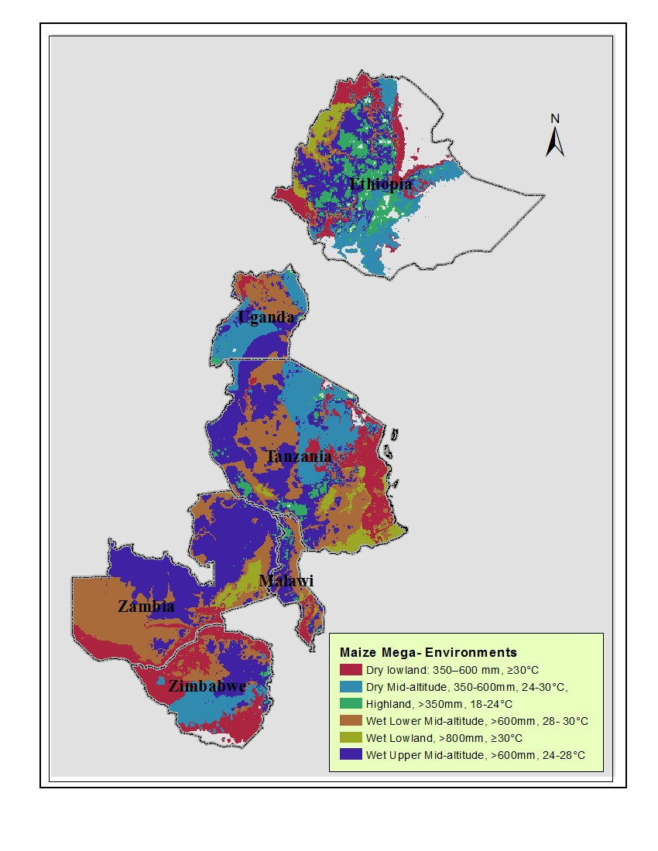Figure S1. Maize Mega-Environments for Ethiopia, Tanzania, Uganda, Malawi, Zambia, and Zimbabwe. A maize mega environment (MME) is an area growing > 1 Mha of maize having relatively minor interactions of environment with variety (i.e., similar variety performance across the MME) (Hartkamp et al. 2000). MMEs are stratified by altitude, day length, mean temperature, and seasonal rainfall over the maize growing season, defined as the five consecutive months with greatest ratio of precipitation to potential evapotranspiration. The legend indicates values for rainfall during the growing season and average daily maximum temperature for the middle 70% of the maize growing season.

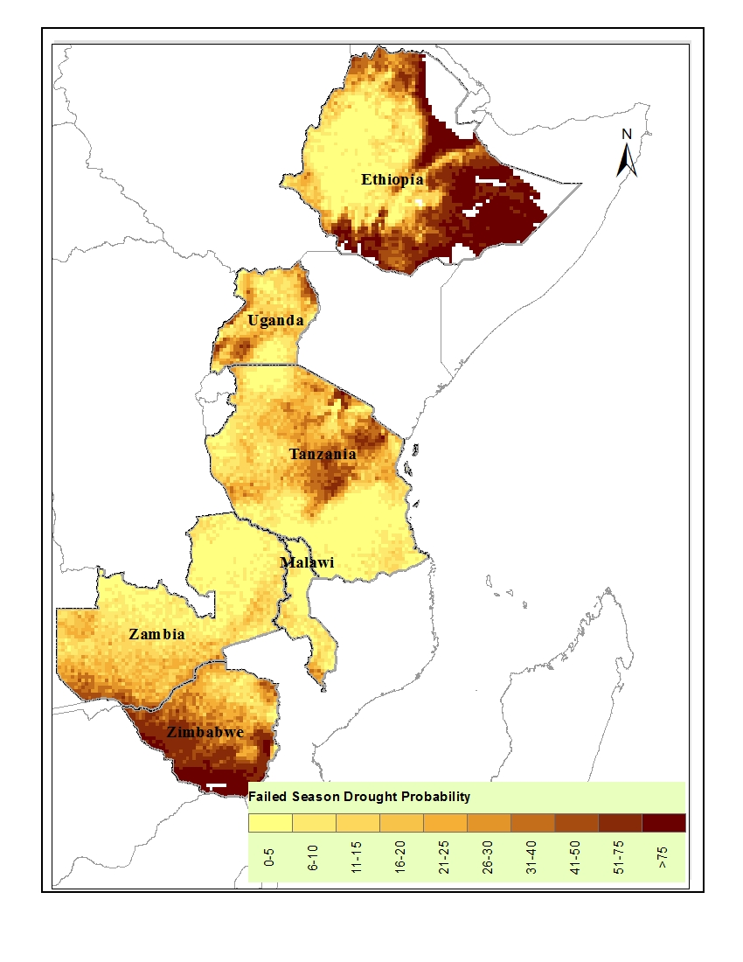
Figure S2. Failed season drought probability is an indicator for frequency of insufficient availability of water (Jones and Thornton 2014). The water shortage can arise from a very short growing season or a very severe level of water stress within the growing period. Water availability depends on rainfall, water holding capacity of the soil profile, and how much water is taken up by the crop during its growing period. To generate the data for the figure, 100 years of simulated rainfall, evapotranspiration, and soil profile data were used (La Rovere et al. 2010).

References

Hartkamp AD, White JW, Rodriguez Aguilar A., Banziger M, Srinivasan G, Granados G, Crossa J (2000) Maize production environments revisited: A GIS-based Approach. CIMMYT, Mexico, D.F. http://repository.cimmyt.org/xmlui/bitstream/handle/10883/1004/70209.pdf
Jones PG, Thornton PK (2014) Failed season drought probability. International Center for Tropical Agriculutre, Dataverse, V2 http://dx.doi.org/10.7910/DVN/27504
La Rovere R, Kostandini G, Abdoulaye T, Dixon J, Mwangi W, Guo Z, Bänziger M (2010) Potential impact of investments in drought tolerant maize in Africa. CIMMYT, Addis Ababa, Ethiopia.

