Supplementary Material

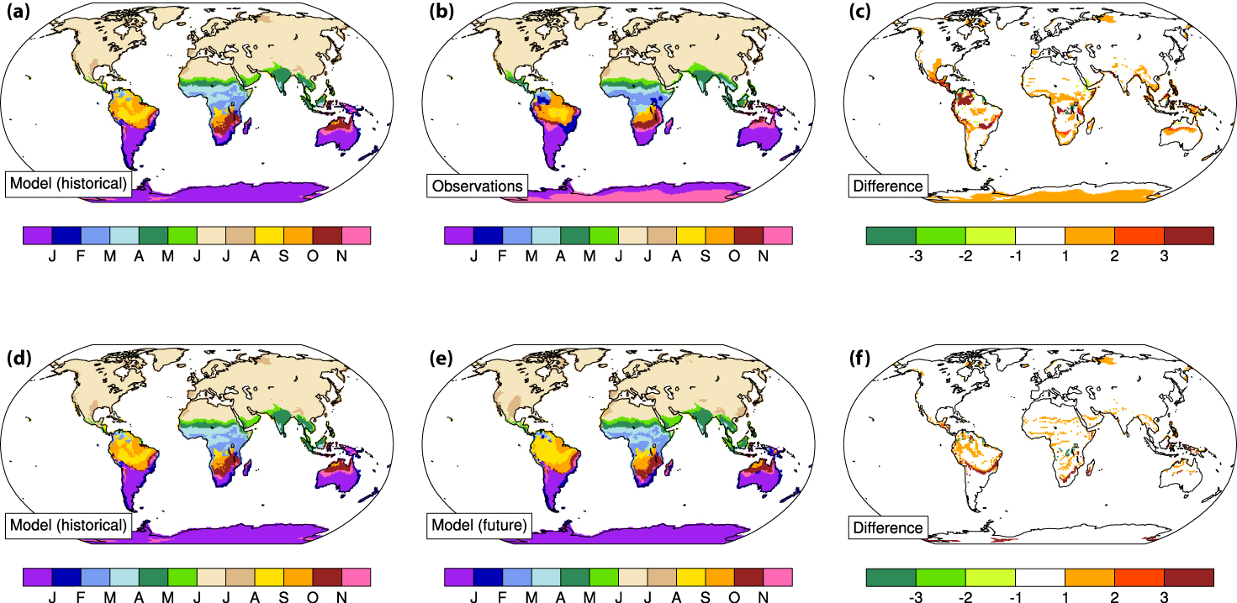

Fig. S1 Central month of climatologically warmest 3-month period during 1920-2014 at a given location in (a) CESM LE and (b) observations. (c) The difference between (a) and (b) can be interpreted as model bias in units of months. (d) Same as (a). (e) as in (a) but for 2061-2080. (f) The difference between (d) and (e) indicates a change in seasonality with global warming. The reference period for the climatology is the quadratically detrended 3-month running mean time series from 1920 to 2014. Observations are Berkeley Earth Surface Temperature data set (BEST; Rohde et al. (2013)). For the model, the reference period has been extracted from all ensemble members of the CESM LE, quadratically detrended, and then concatenated before calculating the climatology. The procedure for the future climatology is analogous, but uses the time period 2061-2080

