Landslides and synoptic weather trends in the European Alps
Wood, J.L.¹, Harrison, S. ¹, Turkington, T.A.R.², Reinhardt, L. ¹
¹ College of Life and Environmental Sciences, University of Exeter, UK.
² Faculty of Geo-Information Science and Earth Observation, University of Twente, Netherlands.
Corresponding author: J.L.Wood@Exeter.ac.uk

Supplementary material
This document contains a number of figures and tables to support the main paper.

Text S1: Earthquakes
Given the incidence of seismic activity in the Alps, it is important to distinguish landslides which are potentially triggered by earthquakes. The USGS Earthquakes Hazard Programme catalogue was downloaded for the period 1969 to 2002, for an area covering 38°N to 53°N and 1°E to 21°E. Earthquakes ≥M4 are capable of triggering landslides (Malamud et al. 2004; Sidle and Ochiai 2006) within a finite area (as defined by Keefer 2002):
$\log_{10}A^{'}=M-3.46\left(±0.47\right)$ (Eq. S1)
where A’ is the potential area affected and M is earthquake magnitude ≥M4. Landslide locations from the inventory were analysed with the USGS catalogue to highlight any landslides triggered on the same day, and in the week, month or year following an earthquake. We found that no landslides intersected the areas defined by Equation S1 within these time-frames, and so all landslides were included in the analyses.

Text S2: 1957 to 2002
The COST733 database is available for the period September 1957 to August 2002. The earliest recorded landslide in the inventory is 1248, although the majority of the inventory remains incomplete prior to the 1970's. The Monte Carlo Permutation test was carried out on the dataset for the full time period (1957-2002) to see if this had an effect on the results. The results showed that only two weather types - a blocking pattern with an anticyclone over the British Isles, and a central European anticyclone connected with Azores high - were affected by the longer time-period used. The results still showed these to be associated with low landslide numbers, but the location of these in the table just switched over (Table S1); both also feature low precipitation anomalies across the extent of the region covered by the landslide inventory. As the difference in using all data available compared with the post-1970 data is negligible, using the full extent of the available inventory and COST733 catalogue had little effect on the outcome of the MCP tests.

Text S3: Winter precipitation winter event (February 1990)
The winter of 1990 accounts for ~25% of all landslides recorded during the winter months. Further analysis shows that ~90% of these occurred on the 13th (type #06), 14th and 15th (both type #05) February, 1990. This anomalously high rainfall event has also been documented in a paper by Isotta et al. (2014, Figure S4). The high-resolution grid dataset from pan-Alpine rain-gauge data used in the study, exhibits a consistency with the high rainfall anomaly of synoptic weather types #06 (Figure S2) and #05 (Figure 2).

Text S4: COST733 weather types through time (1957-2002)
In line with Text S2, linear regression was used to detect changes through time in the frequency of the 28 weather types from the top ranking classification (Table 1). Only four weather types had either a significant decrease or increase in frequency between 1957-2002 (Table 3). During summer, the number of days associated with an Azores anticyclone (type #16; Figure S2; associated with higher numbers of observed landslides) significantly increased in frequency over the duration of the COST733 catalogue, whilst the Meridional pattern, with an Azores anticyclone and central Europe low weather (type #21; Figure 2; LsD) decreased over time, although not significantly (Table 3, Figure 4a). The summer the anticyclone over central Europe (type #18, associated with low landslide numbers; LLsD) increased in frequency; although not significantly (p=0.168). This increase (type #16) and decrease (type #21) in weather types associated with LsD, is reflected in recorded landslide numbers, which have not changed over time (Figure 5).

Figure S1. COST733 types discussed in the main paper. (top) Mean sea level pressure (MSLP; with red indicating high pressure and blue, low), (middle) precipitation anomaly (blue areas indicate a positive anomaly whilst red, negative), (bottom) temperature anomaly (with red areas indicative of a positive temperature anomaly and blue a negative anomaly). Weather types in which the number of recorded landslides exceeded that which would reasonably be expected based on the MCP tests for summer (type #16), autumn (type #26) and winter (#type 06). These typically feature high precipitation anomalies over the European Alps with the exception of the summer weather type (#16) which features high mean sea level pressure over the Alps, combined with higher temperatures, and low pressure systems over the Mediterranean which are associated with convective storms and heavy downpours in the region.
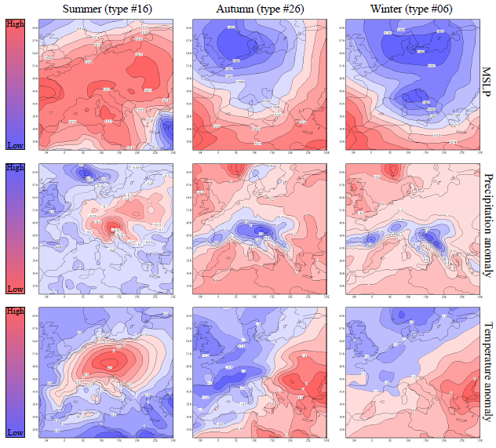

Figure S2. COST733 types discussed in the main paper. (top) Mean sea level pressure (MSLP; with red indicating high pressure and blue, low), (middle) precipitation anomaly (blue areas indicate a positive anomaly whilst red, negative), (bottom) temperature anomaly (with red areas indicative of a positive temperature anomaly and blue a negative anomaly). For summer (type #15) and winter (types #03 and #01) there were a number of weather types in which the number of landslides recorded fell within the range that would reasonably be expected based on the MCP tests.
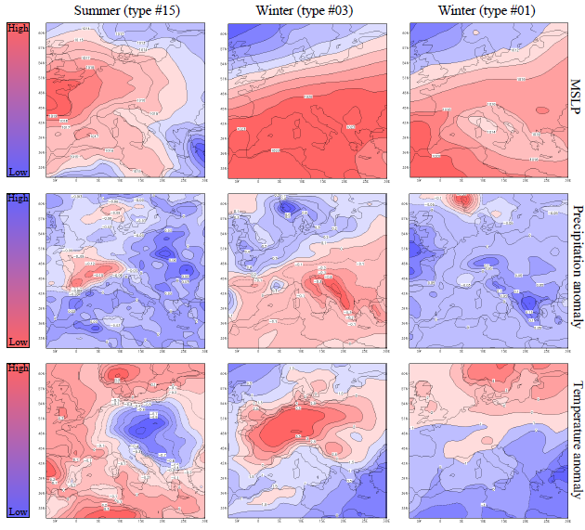

Figure S3. COST733 types discussed in the main paper. (top) Mean sea level pressure (MSLP; with red indicating high pressure and blue, low), (middle) precipitation anomaly (blue areas indicate a positive anomaly whilst red, negative), (bottom) temperature anomaly (with red areas indicative of a positive temperature anomaly and blue a negative anomaly). For the spring (type #12) and winter (type #04), significantly lower recorded landslide numbers than the MCP tests predicted were recorded under weather types which feature low precipitation anomalies over the European Alps.
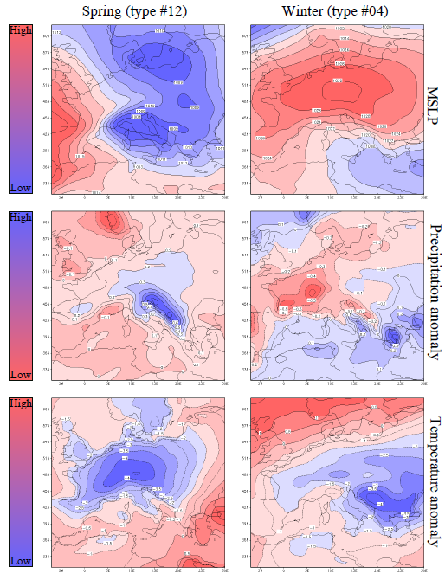

Figure S4 (personal communication, F. Isotta). An anomalously high precipitation event of the 13th and 14th February, 1990 was captured in an analysis by Isotta et al. (2014). Precipitation data (taken from Isotta et al., 2014) is summed over the two days and displayed as total precipitation (mm).
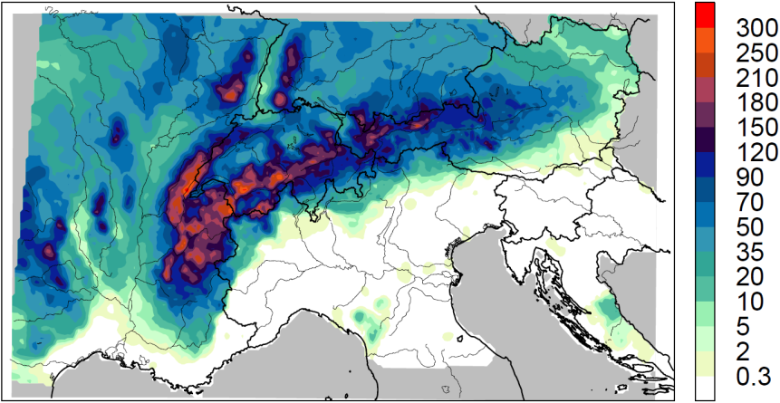
Figure S5. Annual landslide frequency for spring (green), autumn (brown) and winter (blue) with regression lines fitted to indicate the overall trend of the landslide inventory (1970-2002).
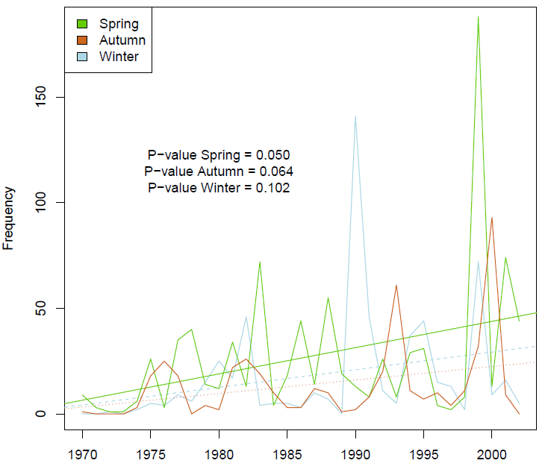

Table S1. The change between the 1970-2002 and the 1957-2002 analysis was negligible, with a difference in weather types only occurring during the spring. This difference is highlighted in grey whereby weather types 13 and 14 have switched places in the results; both are still associated with anomalously low landslide numbers (see also Text S2).
 | Spring (1970-2002) |  |  |  |  |  |  | Spring (1957-2002)
 | LsD |  |  | LLsD | LLsD | LLsD | LLsD | LsD |  |  | LLsD | LLsD | LLsD | LLsD
COST type | 10 | 11 | 9 | 12 | 14 | 13 | 8 | 10 | 11 | 9 | 12 | 13 | 14 | 8
Observed landslides (n) | 373 | 126 | 132 | 57 | 29 | 41 | 113 | 375 | 126 | 137 | 57 | 43 | 29 | 116
Observed LsD (n) | 101 | 55 | 69 | 39 | 25 | 31 | 83 | 103 | 55 | 73 | 39 | 33 | 25 | 86
Total n days for weather type | 549 | 369 | 547 | 358 | 272 | 322 | 619 | 740 | 506 | 759 | 472 | 432 | 366 | 865
Expected number of landslides (mean, MCP) | 157 | 106 | 156.7 | 102.9 | 77.8 | 92.81 | 177.8 | 157.8 | 108.3 | 161.7 | 100.8 | 92.3 | 78.03 | 184.1
Expected lower limit (0.5% confidence, MCP) | 129 | 83 | 128 | 80 | 58 | 70 | 150 | 129 | 81 | 130 | 78 | 70 | 58 | 155
Expected higher limit (0.5% confidence, MCP) | 184 | 128 | 187 | 128 | 101 | 119 | 207 | 192 | 136 | 191 | 125 | 114 | 101 | 214
Observed LsD (%) | 18.40 | 14.91 | 12.61 | 10.89 | 9.19 | 9.63 | 13.41 | 13.92 | 10.87 | 9.62 | 8.26 | 7.64 | 6.83 | 9.94

Table S2. Changes in the frequency of weather types over the duration of the COST733 catalogue (1957-2002). The slope of the regression line is indicative of observed trend. Significant changes (p<0.05) are highlighted by the grey shading.
 |  | 1957-2002
 | COST733 weather type (#) | Slope | p-value | LsD/LLsD
Winter | 1 | -0.114 | 0.099
Winter | 2 | 0.191 | 0.08 | LLsD
Winter | 3 | 0.177 | 0.003
Winter | 4 | 0.141 | 0.026 | LLsD
Winter | 5 | -0.128 | 0.025 | LsD
Winter | 6 | -0.111 | 0.053 | LsD
Winter | 7 | -0.078 | 0.224 | LLsD
Spring | 8 | -0.053 | 0.469 | LLsD
Spring | 9 | 0.106 | 0.139
Spring | 10 | 0.119 | 0.105 | LsD
Spring | 11 | -0.006 | 0.916
Spring | 12 | -0.036 | 0.566 | LLsD
Spring | 13 | 0.115 | 0.087 | LLsD
Spring | 14 | 0.01 | 0.843 | LLsD
Summer | 15 | 0.029 | 0.627
Summer | 16 | 0.162 | 0.026 | LsD
Summer | 17 | 0.057 | 0.381
Summer | 18 | 0.095 | 0.168 | LLsD
Summer | 19 | -0.039 | 0.490 | LLsD
Summer | 20 | -0.003 | 0.956 | LLsD
Summer | 21 | -0.052 | 0.203 | LsD
Autumn | 22 | -0.156 | 0.069 | LLsD
Autumn | 23 | -0.013 | 0.854 | LLsD
Autumn | 24 | -0.069 | 0.391 | LLsD
Autumn | 25 | 0.003 | 0.969 | LsD
Autumn | 26 | -0.037 | 0.454 | LsD
Autumn | 27 | 0.054 | 0.296 | LLsD
Autumn | 28 | -0.035 | 0.506 | LLsD

References
- Isotta FA, Frei C, Weilguni V et al. (2014) The climate of daily precipitation in the Alps: development and analysis of a high-resolution grid dataset from pan-Alpine rain-gauge data. International Journal of Climatology 34, 1657-1675.
- Keefer DK (2002) Investigating landslides caused by earthquakes - a historical review. Surveys in Geophysics 23, 473-510.
- Malamud BD, Turcotte DL, Guzzetti F, Reichenbach P (2004) Landslides, earthquakes, and erosion. Earth and Planetary Science Letters 229, 45-59.
- Sidle RC, Ochiai H (2006) Landslides: processes, prediction, and land use. Vol. 18, American Geophysical Union.

