Online Supplementary Information 1. Survey procedure and sample characteristics of the survey

A single survey provided all data collected for our analysis. Two focus groups were held in 2012 with NYC officials involved in flood risk management to get feedback on the sample selection and design of the survey. Another focus group with NYC residents tested understanding of the survey questions. The survey was implemented over the phone by Kerr and Downs Research. The phone survey was first office-tested among 40 people, and then pre-tested among 35 NYC residents. Thirty-five professional and trained interviewers conducted the phone interviews between March and April 2013 using computer assisted telephone interviewing (CATI).

Only individuals who owned a house with a ground floor in areas that are prone to flooding were contacted to participate in the survey. The sample was designed as follows: First, a selection was made of census blocks in NYC which fall inside the FEMA 1/100 or 1/500 flood zones and are flooded at least once during the 549 storm simulations of the flood risk model developed by Aerts et al. (2014) and described in Online Supplementary Information 4. The reason for excluding areas which are located in the FEMA flood zones but are not flooded in the flood risk model is that the FEMA maps in 2012 were outdated, and were being revised by FEMA at that time. By using both the FEMA maps and the flood risk model for the selection of flood-prone areas we can be more confident that the respondents are from areas that can actually be flooded. On the basis of this geographical selection, telephone records were selected to be randomly called by the professional survey company. A first set of questions checked whether the respondent meets the sample criteria. In particular, the location of the home was checked to confirm it is located within the identified flood-prone areas, and respondents were asked whether they own their house and whether it has a ground flood. Only respondents who met these criteria were asked to participate in the remainder of the survey.

Of the qualified respondents, 73% completed the survey which resulted in 1,035 observations. The high response rate indicates that many floodplain inhabitants were willing to participate in the survey on this theme after NYC experienced flooding from Hurricane Sandy. The demographic variables used for the regression analyses are gender, education level and income. 43% of the total sample is male. The age range in the total sample is 18-87 years; M=53.82, SD=13.89. Percentage shares in the sample per category of total household income before taxes are 2% for <$15,000, 4% for $15,000-$24,999, 8% for $25,000-$39,999, 24% for $40,000-$79,999, 23% for $80,000-$124,999, 16% for >125,000 and 23% refused to answer. Highest educational attainment is some high school for 3%, high school for 23%, some college for 20%, college graduate for 31%, and postgraduate for 21%, and 2% refused to answer. “Don’t know” and “not sure” responses to questions are coded as missing observations for the dependent and explanatory variables in our analysis.

Online Supplementary Information 2: Survey questions for individual perceptions of flood risk and expectations of post-disaster federal assistance

Several questions were included in the survey to elicit indicators of flood risk perceptions, as shown below, which were part of the larger survey. Important quantitative dimensions of risk are its likelihood of occurrence and financial consequences that were elicited by asking respondents about flood probability p and anticipated damage L should her/his residence be flooded. The perceived flood probability was asked by: “Experts have estimated that a flood in Special Flood Hazard Areas in New York occurs on average once in 100 years. Do you think that a flood at your home will occur as often as once in 100 years, or more often or less often?” A follow-up question determined a range of the expected flood probability. This range was then given to the respondent by the interviewer in a question that asked to provide a best-guess estimate. Next, a question asked whether the following applied to the respondent “Some people think that the flood probability is too low to be concerned about. These people find that the flood probability is below their threshold level of concern.” The threshold variable is relevant since it has been shown that individuals may ignore risks whose subjective odds are perceived to be below their threshold level of concern (Slovic et al. 1978; Slovic 1987; McClelland et al. 1993). The question “What would it cost to repair the damage to your home and its contents if your home did flood” asked for anticipated flood damage. An indicator of perception of future flood risk was obtained by asking whether the respondent expects climate change to increase the risk of flooding. In addition, behavioural indicators of individual feelings toward risk are generally thought to have a large influence on individual decision-making (see, Finucane et al. 2000; Loewenstein et al. 2001). We elicited such indicators by asking each respondent whether they worry about flooding in the future and have trust in the local government’s ability to properly manage flood risk. Worry was measured by asking how far the respondent agrees with the statement “I am worried about the danger of a flood at my current residence.” Trust was elicited in relation to “the ability of NYC officials to help you and other residents prepare their houses to withstand a flood,” which is consistent with current flood risk management policies in NYC. Trust in government risk management and worry is commonly seen as important indicators of risk perceptions that influence individual decision making (Kellens et al. 2013; McClelland et al. 1993; Baron et al. 2000). Expectations of receiving federal disaster relief were measured using a question as to whether or not respondents expect to receive any financial assistance from the federal government after a flood. Respondents who expect government relief were then asked what percentage of the damage that their residence would suffer from a future flood they anticipated being compensated by the federal government.

Climate change awareness

Will climate change increase or decrease the risk of your home flooding or will it have no impact?
❑ Increase
❑ No impact
❑ Decrease
❑ Not sure
❑ Don't believe in climate change

Worry about flooding

Please tell me if you strongly agree, agree, neither agree nor disagree, disagree or strongly disagree with the following: I am worried about the danger of a flood at my current residence.
❑ Strongly agree
❑ Agree
❑ Neither agree nor disagree
❑ Disagree
❑ Strongly disagree
❑ Not sure

Perceived flood probability

Experts have estimated that a flood in Special Flood Hazard Areas in New York occurs on average once in 100 years.
Do you think that a flood at your home will occur as often as once in 100 years, or more often or less often?
❑ As often as 1 in 100 years
❑ More often
❑ Less often
❑ Not sure

If the respondent has answered “more often than 100 years” then the following question is posed:

Do you think that a flood at your home will occur on average more often than once in 10 years?
❑ Yes, more often than 1 in 10 years
❑ No, not more often than 1 in 10 years
❑ Not sure

If the respondent has answered “less often than 100 years” then the following question is posed:

Do you think that a flood at your home will occur on average more often than once in 1,000 years?
❑ Yes, more often than 1 in 1,000 years
❑ No, not more often than 1 in 1,000 years
Not sure

So you expect that a flood occurs on average [depending on previous answers]: more than 1 in 10 years [or] between 1 in 10 years and 1 in 100 years [or] between 1 in 100 years and 1 in 1000 years [or] less often than 1 in 1000 years.

What is your best estimate of how often a flood would occur at your home? Once every ....years?

Threshold level of concern

Some people think that the flood probability is too low to be concerned about it. These people find that the flood probability is below their threshold level of concern. Does this apply to you?

❑ Yes
❑ No
❑ Don't know

Anticipated flood damage

What would it cost to repair the damage to your home and its contents if your home did flood?

If necessary, ask “Would it cost more or less than $25,000?” increase/decrease by $5,000 until the respondents gives the answer. The midpoint of the ranges offered to the respondent is recorded.
$

Trust

How much do you trust the ability of NYC officials to help you and other residents prepare their houses to withstand a flood. Do you: trust them completely, trust them somewhat, not trust them very much, not trust them at all.

Expected federal relief

Do you think the federal government will provide you with relief money to pay part of your flood damage if your home flooded in the future?

❑ Yes
❑ No
❑ Don't know

What percentage of the total damage would you expect to get back from the federal government?

Online Supplementary Information 3: Additional survey questions for the analysis of demand for investing in individual flood damage reduction measures

Demand for flood-proofing was elicited using the questions below. We considered a measure that entails retrofitting a house in such a way that water is prevented from entering the building for floods up to 3 feet. It reflects a typical flood risk adaptation investment with high upfront costs ($9,000) (Aerts et al. 2013). The reduction in average annual flood damage is about $500 per year and was derived from the probabilistic flood damage assessment developed for NYC (Aerts et al. 2014). This investment is thus cost neutral after 18 years. The question on the likelihood of investing in the flood-proofing measure in the yearly time frame (n=446) resulted in M=48.5 and SD=42.34 and for the 30-year frame (n=463) M=49.44 and SD=41.37. Of the respondents in the yearly frame 39% voted Democrat, 27% Republican and 5% Independent which is 42%, 25% and 7%, respectively, in the 30-year frame. A question asked how often the respondent’s current household was previously affected by floods caused by natural disasters which was used for creating the variable flood experience (M=0.74, SD=0.44). The question “Please tell me, how effective you think the following actions are in protecting your home and its contents against flooding?” in relation to flood-proofing provided the scale for the variable perceived effectiveness 1= not at all effective, 2= somewhat effective 3=effective, 4=very effective (M=2.18, SD=1.10). The time preference question “When it comes to financial decisions, how would you assess your willingness to give up something today in order to benefit from that in the future?” was measured on a scale from 1= you are “completely unwilling to give up something today” to 10 = “very willing to give up something today” (M=6.14, SD=2.94).

Willingness to invest in dry-flood proofing: Annual frame

The current likelihood that your home will be flooded next year is about 1 in 100. Suppose that for a onetime cost of $9,000 your house can be retrofitted in order to prevent flood water from entering your house. This will save you on average $500 in flood damage every year based on a 1 in 100 chance that your home will be flooded.

How likely are you to buy this flood-proofing measure? Please use a scale from 0% to 100%, where 0% means you “are definitely not willing” and 100% means you are “definitely willing."

Willingness to invest in dry-flood proofing: 30-year frame

The current chance that your home can be flooded at least once during the next 30 years is about 1 in 4. Suppose that for a onetime cost of $9,000 your house can be retrofitted to prevent flood water from entering your house. On average this measure will save you on average $15,000 over this 30-year period.

How likely are you to buy this flood-proofing measure? Please use a scale from 0% to 100%, where 0% means you “are definitely not willing” and 100% means you “are definitely willing.”

Perceived effectiveness of dry-flood-proofing

Please tell me, how effective you think the following actions are in protecting your home and its contents against flooding? Just tell me if each action is Very effective, Effective, Somewhat effective or Not At All effective.

Prevent flood waters from entering your home by using metal or wood water shields or sand bags, or installing a sump pump or drainage system?

❑ Very effective
❑ Effective
❑ Somewhat effective
❑ Not At All effective

Time preference

When it comes to financial decisions, how would you assess your willingness to give up something today in order to benefit from that in the future?

Please use a scale from 1 to 10, where 1 means you are “completely unwilling to give up something today” and a 10 means you are “very willing to give up something today.” You can also use the values in-between to indicate where you fall on the scale.

Discount rate

Would you prefer $700 in 5 years or $1,000 in 6 years?

❑ $700 in 5 years
❑ $1,000 in 6 years
❑ Not sure

Online Supplementary Information 4. Flood damage model for New York City

A detailed description of the probabilistic flood damage model we created for New York City (NYC) is provided in Aerts et al. (2014) and supplementary material of that study. Here, an overview of the main model components is given. As is common in catastrophe modelling (Grossi and Kunreuther 2005), our model for NYC calculates flood damage on the basis of hazard, exposure and vulnerability modules which will be described below. These calculations are done for many possible storms and on a very detailed spatial level, proving a unique database of objective flood damage information.
The hazard module uses a large set of 549 synthetic hurricanes with probabilities between 1/10 and 1/15,000 and surge heights which have been simulated by Lin et al. (2012) using a coupled hurricane (Emanuel 2006) and hydrodynamic model. For the latter the Advanced Circulation Model ADCIRC is used (Luettich et al. 1992). This surge information is input for the creation of inundation maps that show what areas of NYC are inundated for storms with a specific return period as well as the water level at these locations. Potential water depths are estimated with nearest neighbor interpolation of surge water levels at the coast and subtracting land elevation obtained from a high-resolution elevation model. The elevation data is based on LiDAR data that was provided to us by NYC. From the inundation maps the probability of experiencing inundation at the census block level where a respondent is located has been estimated. Linking this variable with the latitude and longitude coordinates of each respondent provides an indicator of the objective flood probability faced by our respondent. Moreover, the median inundation level per census block is derived which in combination with exposure and vulnerability is input for the flood damage estimation.
Exposure in the general flood damage model used by Aerts et al. (2014) is based on GIS information on the number and types of buildings and their values in NYC census blocks. Here we use respondent specific information on building type and value which were elicited using the survey in order to more accurately link a respondent to potential flood damage. The vulnerability module is based on HAZUS stage damage curves for specific building types (US Federal Emergency Management Agency (FEMA) 2009) which calculate potential flood damage on the basis of the median water level and exposed value. The result is an indicator of objective flood damage per respondent.
The general flood damage model (Aerts et al. 2014) can be used to calculate the reduction in expected annual average flood risk that can be obtained by installing various flood-proofing measures, including dry-flood proofing homes. Using this model, we estimated the average benefit per house of dry-flood-proofing a building in the 1-in-100 year floodplain which equaled approximately $500 per year. This is the damage savings mentioned in the survey question that elicited the willingness to invest in this flood-proofing measure.
Moreover, the flood damage model was used to guide the selection of sample areas for the survey. We only contacted individuals for participation in the survey who can be flooded according to both our flood damage model and the FEMA flood zone maps. This sample strategy aims to ensure that only people who actually face a flood hazard are included in our sample. Supplementary Figure 1 shows the location of our survey respondents in relation to the annual average flood risk per NYC census block.
We consider the perceived flood probability or perceived damage (PR) to being classified as a correct perception of the objective measurement of this variable (OR) if: OR×(1-EM) ≤ PR≤ OR×(1+EM) where the error margin (EM) represents uncertainty in measurement of risk (Botzen et al. 2015). Note that PR is an underestimation if PR<OR×(1-EM) and an overestimation if PR>OR×(1+EM). We set EM=0.5 which is approximately the 95% confidence interval of the flood risk estimates (Aerts et al. 2014).
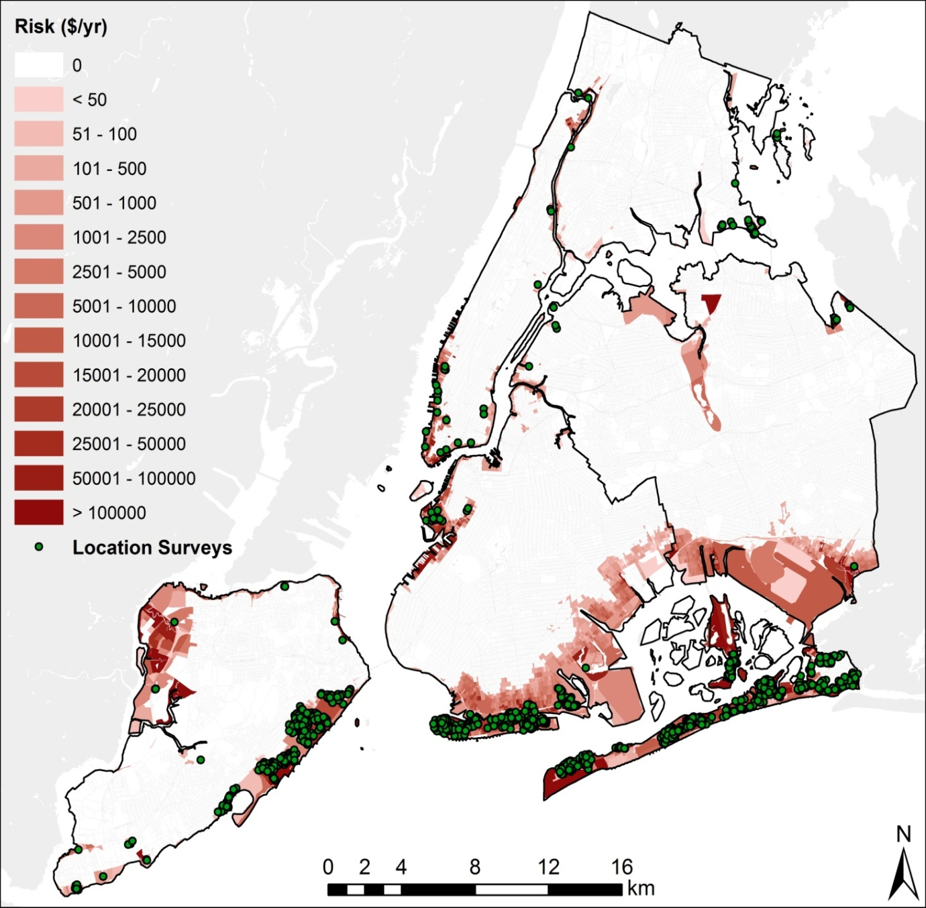Supplementary Figure 1. Location of our survey respondents (dots) overlaid with annual average flood risk (in US$ per year) per census block in NYC

Online Supplementary Information 5. Statistical methods
Statistical significance of differences in proportions of answer categories are tested using z-tests. An independent sample non-parametric test is used to examine the statistical significance of differences in the medians of anticipated flood damage as a percentage of property value between voting classes. A post-hoc ANOVA test that allows for observed differences in variances is used to test how the expected federal relief differs between voting classes. Ordinary Least Squares regressions were used for the regression analyses. The Hayes (2013) PROCESS macro is used for the moderated mediation models.
A listwise deletion method is used to handle missing observations of explanatory variables in the regression analysis, which is a common way of dealing with missing data. As a result, the observed drop in number of observations in regressions is due to missing observations of explanatory variables. We prefer this method over imputation methods, because the drop of observations due to deletion does not cause problems with statistical power in our study that uses a large sample size. Moreover, there are no a priori reasons to suspect why the occurrence of missing data is not due to a random process, which would justify the applied deletion method. An alternative imputation method to deal with missing observation is not feasible in our case due to a lack of a reliable basis for imputing missing values, which means that imputation is likely to add biases to our results, which is why it is not done here.

Online Supplementary Information 6. Regression models of demand for flood preparedness with additional explanatory variables

We examine whether effects of political affiliation on flood preparedness are robust when including other variables that are likely to influence demand for flood risk adaptation, as shown in the regression results in Table 6.1. These variables are motivated by behavioural economic theories which postulate that intuitive decision processes guide decision making with respect to low-probability disaster risk, like availability, threshold models of choice, and myopia which is related to discounting. Due to the availability bias (Tversky and Kahneman 1974), recent flood experience is often found to positively influence demand for flood protection. Emotional attitudes toward risk such as worry, trust and concern may also have a positive impact on the demand for protection as examined in Table 6.2. We find that a variable representing respondents who think that the flood probability is below their threshold level of concern negatively influences the likelihood of investing in flood proofing (Table 6.1). We find that rating the effectiveness (1=not at all effective, to 4=very effective) that respondents deem flood-proofing in protecting their home against future flood damage has a positive significant influence on their likelihood of investing in the measure, as expected on the basis of applications of Protection Motivation Theory to flood-preparedness (Grothmann and Reusswig 2006; Bubeck et al. 2013; Poussin et al. 2014). In addition, having a flood insurance policy lowers the demand for flood-proofing. Insurance and protection are substitutes according to standard expected utility theory (Ehrlich and Becker 1972).
Moreover, the flood-proofing investment with a relatively long payback period is influenced by individual time preferences using an attitudinal scale (1=unwilling to give up money now to gain from it in the future, to 10=very willing to do so). Individuals who are more willing to give up money in the future are also more likely to invest in loss reduction measures (Table 6.1). Alternative specifications of measurements of time preferences result in similar findings (Table 6.3). Of the demographic control variables, only age is significant in this model and is thus included in Table 6.1. Even after incorporating all these variables in the regression. Democrats have a significant higher likelihood of investing in flood proofing than Republicans (11.45 percentage points in the annual frame and up to 22.24 in the 30-year frame.

Table 6.1. Results of a regression model of the likelihood of investing in flood-proofing with political affiliation and framing and other significant explanatory variables
 | Coefficient | Standard error
Democrat (Democrat =1; Republican or Independent=0) | 11.45** | (4.94)
Frame (30-year period=1; yearly=0) | -8.43* | (4.75)
Frame × Democrat | 10.79* | (6.46)
Flood experience (flooded=1; not flooded=0) | 12.79*** | (3.61)
Flood probability below threshold level of concern (below=1; above=0) | -10.10*** | (3.72)
Perceived effectiveness of dry-proofing | 5.22*** | (1.48)
Flood insurance (covered=1; not covered=0) | -6.22*** | (2.07)
Time preference | 1.24** | (0.56)
Age | -0.43*** | (0.12)
Constant | 54.93*** | (10.13)
Adjusted R² | 0.14
Observations | 584
Notes: Unstandardized regression coefficients are reported and their standard errors are shown in parentheses.
*, **, *** stands for significance at the 10%, 5%, and 1% level, respectively.

Table 6.2. Results of a regression model of the likelihood of investing in flood-proofing with political affiliation and framing as well as other significant explanatory variables including worry about flooding and trust in government flood risk management
 | Coefficient | Standard error
Democrat (1=voted Democrat; 0=voted Independent) | 10.54** | (4.61)
Frame (30-year period=1; yearly=0) | -9.15* | (4.99)
Frame × Democrat | 11.53* | (6.56)
Flood experience (flooded=1; not flooded=0) | 12.50*** | (3.68)
Flood probability below threshold level of concern (below=1; above=0) | -10.10*** | (3.89)
Trust (1=agrees or completely agrees with the statement "…"; otherwise=0) | 0.79 | (3.43)
Worry (1=agrees of completely agrees with the statement "…"; otherwise=0) | 1.48 | (3.94)
Perceived effectiveness of dry-proofing | 5.03*** | (1.51)
Flood insurance (covered=1; not covered=0) | -6.27*** | (2.10)
Time preference | 1.18** | (0.57)
Age | -0.42*** | (0.12)
Constant | 55.21*** | (11.31)
Adjusted R² | 0.13
Observations | 571
Notes: Unstandardized regression coefficients are reported and their standard errors in parentheses. *, **, and *** stands for significance at the 10%, 5%, and 1% level respectively.

In Table 6.3 the variable time preference in the regression reported in Table 6.1 is replaced with a variable represent individuals with a high long term discount rate. Overall results remain similar, but this variable has a slightly lower significance level with a p-value of 0.055 and slightly worse model fit.

Table 6.3. Results of a regression model of the likelihood of investing in flood-proofing with political affiliation and framing as well as other significant explanatory variables including a high discount rate
 | Coefficient | Standard error
Democrat (1=voted Democrat; 0 voted Independent) | 9.27** | (4.71)
Frame (30 year period=1; yearly=0) | -10.31** | (5.06)
Frame * Democrat | 12.51* | (6.68)
Flood experience (flooded=1; not flooded=0) | 10.65*** | (3.72)
Flood probability below threshold level of concern (below=1; above=0) | -9.04** | (1.54)
Perceived effectiveness of dry-proofing | 6.11*** | (1.54)
Flood insurance (covered=1; not covered=0) | -6.86*** | (2.11)
High long term discount rate | -6.35* | (3.31)
Age | -0.38*** | (0.12)
Constant | 65.71*** | (9.60)
Adjusted R² | 0.12
Observations | 563

Online Supplementary Information 7: Moderated mediation model results
A moderated mediation analysis is used to further examine the mechanisms behind the regression results in Table 1 showing that Democrats have a higher demand for investments in flood-proofing and that the effect of the 30-year frame differs between Democrats and non-Democrats. In particular, we examine whether the effect of Democrats on demand for flood-proofing is mediated by risk perception and the influence of the 30- year frame as a variable that acts as a moderator. This is analysed using two models that are visualized in Supplementary Figure 2.
Model 1 examines how the effect of the Democrat variable (X) influences the dependent variable of demand for flood-proofing (Y) through the risk perception mediator variable (M). Moreover, the model estimates how the influence of Democrat on Y is moderated by the 30-year variable (W). C are covariates that directly influence Y and are the same as the demographic control variables used for the regression in Table 1 for the purpose of comparability. Model 2 is a different variant of which the difference with model 1 is the moderation effect. While model 1 examines whether the 30-year frame influences the relation between Democrat and Y, model 2 examines whether the 30-year frame influences the relation between the risk perception mediator variable (which is influenced by Democrat) and Y. The comparison of results between models 1 and 2 aims at obtaining insights into the mechanism behind the 30-year frame effects on Y observed in Table 1. The risk perception indicator used as mediator is a variable of perceptions of the influence of climate change on flood risk (1=decreases flood risk, 2=no impact, 3=increases flood risk). Figure 1 showed that pronounced differences exist in these perceptions between Democrats and non-Democrats which makes this variable a suitable candidate for the analyses here.

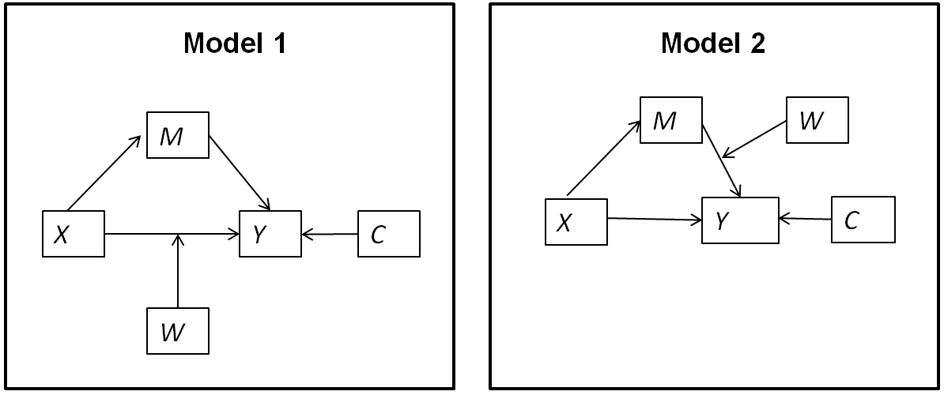
Supplementary Figure 2. Visualization of the two moderated mediation models

Table 7.1 present the results of model 1. The sub-model of climate risk perceptions confirms the significant positive relation with Democrat. Moreover, the coefficient of the mediation variable of climate risk perception is positive and significant in the main model of flood-proofing demand. These findings imply that the effect of Democrat is to indirectly increase flood-proofing demand through the climate risk perception variable. 95% confidence intervals of this indirect effect are obtained using the bootstrapping procedure explained in Hayes (2013). This results in a lower bound of 0.9 and a higher bound of 3.54, which is significant. Moreover, like in the regression analysis in Table 1 we find a significant positive effect of Democrat with the 30-year frame.
The results of model 2 are shown in Table 7.2. In model 2 we find a similar mediation effect of Democrat increasing flood-proofing demand through climate risk perception. The confidence interval is significant in the annual frame with a lower bound of 0.65 and a higher bound of 5.35, but not significant in the 30-year frame where the lower bound is -1.61 and the higher bound is 3.17. The latter finding is due to the insignificant coefficient of the interaction with the 30-year frame and climate risk perception. This implies that we do not observe that the effect of higher demand for flood-proofing in the 30-year frame among Democrats versus non-Democrats is related with higher climate risk perceptions. Model 1 showed that the effect of the 30-year frame is related with the Democrat variable itself.

Table 7.1. Results of moderated mediation model 1
Sub-model of climate risk perception | Coefficient | Standard error
Democrat | 0.19*** | (0.05)
Constant | 2.63*** | (0.04)
R² | 0.04
F-statistic | 16.70***
Main model of flood-proofing demand | Coefficient | Standard error
Climate risk perception | 9.14** | (4.16)
Democrat | 8.28 | (5.65)
Frame | -11,87* | (6.24)
Frame × Democrat | 17.10** | (7.98)
Sex | -0.60 | (3.81)
Education | -7.02 | (5.01)
Age | -0.52*** | (0.15)
Low income | -2.44 | (5.82)
Constant | 57.70*** | (13.93)
R² | 0.09
F-statistic | 5.57***
Observations | 444

Table 7.2. Results of moderated mediation model 2
Sub-model of climate risk perception | Coefficient | Standard error
Democrat | 0.19*** | (0.05)
Constant | 2.63*** | (0.04)
R² | 0.04
F-statistic | 16.70***
Main model of flood-proofing demand | Coefficient | Standard error
Climate risk perception | 14.83*** | (5.57)
Democrat | 17.28*** | (4.06)
Frame | 28.66 | (22.61)
Frame × Climate risk perception | -10.90 | (8.11)
Sex | -0.82 | (3.83)
Education | -8.56* | (5.01)
Age | -0.51*** | (0.15)
Low income | -4.98 | (5.76)
Constant | 37.82** | (16.85)
R² | 0.09
F-statistic | 5.20***
Observations | 444

Online Supplementary Tables
Online Supplementary Table 1. Flood risk perceptions and expectations of disaster relief of independents

Flood probability exceeds 1/100 | % of Independents
Climate change will increase flood risk | 47%
Worry about flooding | 77%
Trust in government flood risk management | 39%
Expects federal disaster relief | 37%
Expected relief as % of damage | 19%

Online Supplementary Table 2. Perceptions of climate change impacts on flood risk. Percentage shares of Democrats and Republicans per category.
 | Democrats | Republicans
Climate change will increase flood risk | 71%** | 47%**
Climate change will have no impact on flood risk | 12%** | 21%**
Does not believe in climate change | 0.5%** | 4%**
Climate change will decrease flood risk | 1% | 2%
Unsure about effects of climate change on flood risk | 16%** | 26%**
Notes: ** stands for a significant difference at the 5% significance level.

Online Supplementary Table 3. Accuracy of individual expectations of flood probability and damage (+/- 50% of the true value as computed by probabilistic flood risk model developed for NYC). Percentage shares of correct expectations or over- / under-estimations for the complete sample and Democrat or Republican voters
 | Complete  sample | Democrats | Republicans | Significant difference  (p-value<0.05) Democrat and Republican
Correct expectations flood probability | 23% | 24% | 22% | No
Overestimation flood probability | 51% | 53% | 46% | No
Underestimation flood probability | 27% | 23% | 32% | Yes
Correct expectations flood damage | 34% | 31% | 40% | Yes
Overestimation flood damage | 18% | 19% | 15% | No
Underestimation flood damage | 48% | 50% | 45% | No

Online Supplementary Table 4. Results of a regression model of the likelihood of investing in flood-proofing with political affiliation (Democrat, Republican versus Independent) and framing as explanatory variables

 | Coefficient | Standard error
Democrat (1=voted Democrat; 0=voted Independent) | 14.43** | (6.63)
Republican (1=voted Republican; 0=voted Independent) | 3.12 | (5.99)
Frame (30 year period=1; yearly=0; non-Democrats) | -7.80 | (4.75)
Frame × Democrat | 13.15** | (6.28)
Constant | 40.84*** | (5.96)
Adjusted R² | 0.05
Observations | 682
Notes: Unstandardized regression coefficients are reported and their standard errors in parentheses. *, **, and *** stands for significance at the 10%, 5%, and 1% level respectively.

References supplementary material

Aerts, J.C.J.H., Botzen, W.J.W., de Moel, H., Bowman, M. (2013). Cost estimates for flood resilience and protection strategies in New York City. Annals of the New York Academy of Sciences, 1294: 1-104.

Aerts, J.C.J.H., Botzen, W.J.W., Emanuel, K., Lin, N., De Moel, H., Michel-Kerjan, E. (2014). Evaluating flood resilience strategies for coastal mega-cities. Science, 344: 473-475.

Baron, J., Hershey, J.C., Kunreuther, H. (2000). Determinants of priority for risk reduction: the role of worry. Risk Analysis, 20, 413-428.

Botzen, W.J.W., Kunreuther, H. and Michel-Kerjan, E. (2015). Divergence between individual perceptions and objective indicators of tail risks: Evidence from floodplain residents in New York City. Judgment and Decision Making, 10(4): 365-85.

Bubeck, P., Botzen, W.J.W., Kreibich, H., Aerts, J.C.J.H. (2013). Detailed insights into the influence of flood-coping appraisals on mitigation behaviour. Global Environmental Change, 23(5): 1327-1338.

Ehrlich, I., Becker, G.S. (1972) Market insurance, self-insurance, and self-protection. The Journal of Political Economy, 80: 623-648.

Emanuel, K. (2006). Climate and tropical cyclone activity: A new model downscaling approach. J. Climate, 19, 4797-4802.

FEMA (2009). Hazus MH MR4 Technical manual. Federal Emergency Management Agency, Washington DC. Available at online at: http://www.fema.gov/plan/prevent/hazus/hz_manuals.shtm
Finucane, M. L., Alhakami, A., Slovic, P. & Johnson, S. M. (2000). The affect heuristic in judgments of risks and benefits. Journal of Behavioral Decision Making, 13(1), 1-17.

Grossi, P., Kunreuther, H.C. (2005). Catastrophe Modeling: A New Approach of Managing Risk. Springer, New York.

Grothmann, T., Reusswig, F. (2006). People at risk of flooding: Why some residents take precautionary action while others do not. Natural Hazards, 38(1-2): 101-120.

Hayes, A.F. (2013). Introduction to Mediation, Moderation, and Conditional Process Analysis. Guilford Press.

Kellens, W., Terpstra, T., De Maeyer, P. (2013). Perception and communication of flood risks: A systematic review of empirical research. Risk Analysis, 33(1): 24-49.

Loewenstein, G.F., Hsee, C.K., Weber, E.U., Welch, N. (2001). Risk as feelings. Psychological Bulletin, 127(2), 267-286.

Lin, N., Emanuel, K., Oppenheimer, M., Vanmarcke, E. (2012). Physically based assessment of hurricane surge threat under climate change. Nature Climate Change, 1389, 462-467. Doi:10.1038/nclimate1389.

Luettich, R.A., Westerink, J.J., Scheffner, N.W. (1992). ADCIRC: An Advanced Three-Dimensional Circulation Model for Shelves, Coasts, and Estuaries. Coastal Eng. Res. Cent. Vicksburg, Report 1: Theory and methodology of ADCIRC-2DDI and ADCIRC-3DL, Dredging Research Program Tech. Rep. DRP-92-6.

McClelland, G., Schulze, W., Coursey, D. (1993). Insurance for Low-Probability Hazards: A Bimodal Response to Unlikely Events. Journal of Risk and Uncertainty, 7: 95–116.

Poussin, J., Botzen, W.J.W., Aerts, J.C.J.H. (2014). Factors of influence on flood damage mitigation behaviour by households - Literature review and results from a French survey. Environmental Science and Policy, 40: 69-77.

Slovic, P. (1987). Perception of risk. Science, 236(4799): 280-285.

Slovic, P., Fischhoff, B. and Lichtenstein, S. (1978). Accident probabilities and seat belt usage: A psychological perspective. Accident Analysis and Prevention 10, 281–285.

Tversky, A., Kahneman, D. (1974). Judgment under uncertainty: Heuristics and biases. Science, 185(4157): 1124-1131.

For simplicity, we do not discount the benefits over time nor reduce the flood insurance premium to reflect the reduction in claims from having a flood proofing measure in place.
Other risk perception indicators that may influence general flood-proofing demand, like the perceived flood probability, perceived flood damage, and perceived federal disaster compensation, are less relevant for our analysis here. The reason is that these variables are direct indicators of the perceived benefits of flood-proofing, while the objective benefits were already explicitly stated to respondents for the particular flood-proofing measure for which their investment demand was elicited (Online Supplementary Information 3).

