Electronic Supplementary Materials for “A comparison of changes in river runoff from multiple global and catchment-scale hydrological models under global warming scenarios of 1°C, 2°C and 3°C.”

Climatic Change

Simon N. Gosling^{1*}, Jamal Zaherpour¹, Nick Mount¹, Fred F. Hattermann², Rutger Dankers³, Berit Arheimer⁴, Lutz Breuer^{5,6}, Jie Ding^{7,8}, Ingjerd Haddeland⁹, Rohini Kumar¹⁰, Dipangkar Kundu¹¹, Junguo Liu^{7,12}, Ann van Griensven^{13,14}, Ted I.E. Veldkamp¹⁵, Tobias Vetter², Xiaoyan Wang¹⁶, Xinxin Zhang¹²

¹ School of Geography, University of Nottingham, Nottingham NG7 2RD, United Kingdom.
² Potsdam Institute for Climate Impact Research, Telegrafenberg A62, D-14473 Potsdam, Germany.
³ Met Office, Exeter, United Kingdom.
⁴ Swedish Meteorological and Hydrological Institute (SMHI), 60176 Norrköping, Sweden.
⁵ Institute for Landscape Ecology and Resources Management (ILR), Research Centre for BioSystems, Land Use and Nutrition (IFZ), Justus Liebig University Giessen, Germany
⁶ Centre for International Development and Environmental Research, Justus Liebig University, Germany.
⁷ School of Environmental Science and Engineering, South University of Science and Technology of China, Shenzhen, 518055, China.
⁸ Institute of Water Resources Management, Hydrology and Agricultural Hydraulic Engineering, Leibniz Hannover University, Hannover 30167, Germany.
⁹ Norwegian Water Resources and Energy Directorate, Oslo, Norway.
¹⁰ UFZ-Helmholtz Centre for Environmental Research, Leipzig, Germany.
¹¹ Department of Environmental Sciences, Faculty of Agriculture and Environment, The University of Sydney.
¹² School of Nature Conservation, Beijing Forestry University, Beijing, 10083, China.
¹³ Department of Hydrology and Hydraulic Engineering, Vrije Universiteit Brussel, Belgium.
¹⁴ UNESCO-IHE Institute for Water Education, the Netherlands.
¹⁵ Vrije Universiteit, Institute for Environmental Studies (IVM), Amsterdam, the Netherlands.
¹⁶ State Key Laboratory of Hydrology-Water Resources and Hydraulic Engineering, Center for Global Change and Water Cycle, Hohai University, Nanjing 210098, China.
* All correspondence to:
Email: simon.gosling@nottingham.ac.uk
Telephone: +44(0)115 951 5437
Fax: +44 (0)115 951 5249

Online Resource 1: The eight study catchments (shaded) and their gauges (red filled circles).
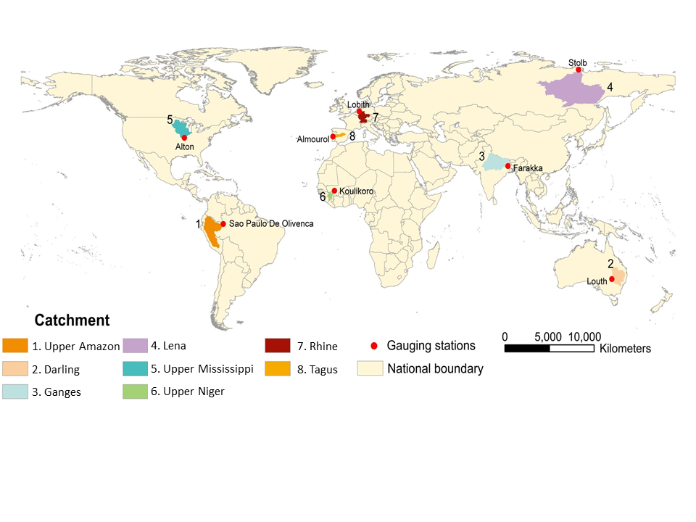

Online Resource 2: Key model characteristics of the Glob-HMs and Cat-HMs employed in this study. Tmin = minimum temperature, Tmax = maximum temperature, P = precipitation, AH= air humidity, RAD = solar radiation, WS = wind speed, LAI = leaf area index, LW = longwave radiation, PET = potential evapotranspiration, SP = surface pressure.
Model | Spatial disaggregation | Representation of soils | Representation of vegetation | Input climate parameters | Method: potential evapotranspiration | Method: snow melt | Method: runoff routing
VIC-Cat-HM  (Cat-HM) | Grid cells with sub-grid heterogeneity accounting method | Three soil layers,  19 parameters | Fixed monthly plant characteristics | Tmin, Tmax, P, AH, WS | Penman-Monteith | Two-layer energy  Balance at the  snow surface | Linearized St. Venant’s  equations
SWIM  (Cat-HM) | Subbasins and hydrotopes | Up to 10 soil layers, 11 soil parameters | A simplified EPIC approach | Tmin,  Tmean, Tmax, P, AH, RAD | Priestley-Taylor or  Turc-Ivanov | An extended degree-day method | Muskingum method + reservoirs and irrigation
WaterGAP3  (Cat-HM) | Grid cells (5 arc min.) with elevation subgrid (1 arc min.) | One soil layer, 2 soil parameters | Temperature- dependent LAI, fixed rooting depth | Tmean, P, RAD, LW | Priestley-Taylor | Degree-day method | Linear reservoir, flow velocity based on Manning-Strickler
mHM  (Cat-HM) | Grid cells with sub-grid heterogeneity accounting method | N soil layers (here two soil layers were used) | Fixed monthly plant characteristics | Tmax, Tmin, Tmean and P | Hargreaves and Samani method + aspect correction | Enhanced Degree-day method | Muskingum method
HBV  (Cat-HM) | Subbasins, 10 elevation zones & land use classes | One soil layers, 2 soil  parameters | Fixed monthly plant  characteristics | Tmean and P | Blaney–Criddle | Degree-day method | A simple time lag method
HYMOD  (Cat-HM) | Lumped model, a single basin structure | One soil layer, 7 soil parameters | NA | P, Tmean and PET | Hargreaves and Samani method | Degree-day method | Quick and slow flows tanks and linear reservoirs
SWAT  (Cat-HM) | Subbasins and hydrologic response units (HRU) | Up to 10 soil layers, 11 soil parameters | A simplified EPIC approach | Tmin, Tmax, P, AH, RAD, WS | Penman-Monteith, Hargreaves, Priestely-Talyor | Degree-day method | Muskingum, Variable Storage + Reservoirs, ponds and wetlands method
HYPE  (Cat-HM) | Subbasins and hydrological response units (HRU) | Three soil layers and up to 10 soil types with individual parameters | Fixed plant  characteristics | Mandatory: Tmean & P, optional: Tmin, Tmax, AH, RAD | Priestley-Taylor, modified Hargreaves-Semani and other | Degree-day method or simplified energy approaches | Reservoir cascade from ground and surface discharge
DBH  (Glob-HM) | Grid cells with sub-grid heterogeneity accounting method | Three soil layers and one underlying groundwater layer at the bottom | Prescribed spatial distribution of natural vegetation and agricultural land cover | P, Tmean, WS,AH,  LW, RAD, SP | Energy balance | Energy balance | Kinematics wave method to compute flow routing in a river network
H08  (Glob-HM) | Globally covered 0.5x0.5 degree resolution | 1-layer leaky bucket soil. Its runoff properties vary with climate zones. | Natural use: Globally uniform. No-specific land type is assigned, as known as Manabe's bucket. | Tmean, Rainfall, Snowfall, WS, AH, RAD, LW, surface pressure | Bulk formula | Energy balance | Saturation-excess, with a non-linear function of soil moisture.
LPJmL  (Glob-HM) | Grid cells (30 arc min resolution) with land cover and land use classes | Five hydrologically active soil layers, coupled to carbon and thermal balance | Dynamic simulation of growth and productivity (with prescribed spatial distribution of crops and pasture); daily | P, Tmean, RAD | Priestley-Taylor (modified for transpiration) | Degree-day method with precipitation factor | Continuity equation derived from linear reservoir model
Mac-PDM.09  (Glob-HM) | 0.5x0.5 degree grid across the land-surface of the globe | One soil layer, 7 soil texture types | Fixed plant charactertistcs, 13 types of natural land-cover | P, Tmean, WS, AH, LW, RAD | Penman-Monteith | Degree-day method | Two linear reservoirs for direct runoff
MATSIRO  (Glob-HM) | Grid cells (0.5x0.5 degree) | 19 layers with dynamical ground water schime. 13 soil type with 7 parameters. | Monthly LAI, and fixed vegetation characteristics for 12 types of natural land cover | Tmean, Rainfall, Snowfall, AH, LW, RAD, WS, SP | Penman-Monteith | Energy balance | Linear reservoir, ﬁxed flow velocity at 0.5 m/s globally
MPI-HM  (Glob-HM) | Grid cells (0.5 deg) | 1 soil layer (bucket scheme), 6 parameters | Fixed climatology of vegetation fraction | Tmean, P, PET | Penman-Monteith | Degree-day method | Linear reservoir
PCR-GLOBWB  (Glob-HM) | Grid cells (30 arc min.) with elevation subgrid (30 arc sec.) | Two soil layers and one underlying groundwater layer at the bottom | Prescribed vegetation, agriculture, and land use cover | Tmean, P, PET | Hamon | Degree-day method | Characteristic distance approach based on channel  Characteristics.
VIC-Glob-HM  (Glob-HM) | Grid cells with sub-grid heterogeneity accounting method | Three soil layers,  19 parameters | Fixed monthly plant  characteristics | Tmin, Tmax, P, AH, WS, SP, RAD, LW | Penman-Monteith | Two-layer energy  Balance at the  snow surface | Linearized St. Venant’s  equations
WBM (Glob-HM) | Grid cell, resolution flexible | 1 soil layer, bucket model, one parameter | Fixed vegetation, constant over time | P, Tmean | Hamon | Empirical  Tmean and  P based  formula | Muskingum method

Online Resource 3: Central years of 31-year periods corresponding to the different levels of global-mean warming (compared to pre-industrial) in the individual GCMs under RCP8.5. Other RCPs are available (van Vuuren et al., 2011) but we used RCP8.5 in line with previous work (Schewe et al., 2014) because it enable investigation of global-mean warming levels up to 3°C for all five GCMs, whereas not all other RCPs reach this level of warming.
Warming level | HadGEM2-ES | IPSL-CM5A-LR | MIROC-ESM-CHEM | GFDL-ESM2M | NorESM1-M
1°C | 2006 | 2008 | 2008 | 2015 | 2013
2°C | 2031 | 2035 | 2032 | 2053 | 2047
3°C | 2051 | 2055 | 2051 | 2082 | 2072

Online Resource 4: Further details on the calculation of the magnitude of annual maximum daily runoff and annual minimum 7-day runoff associated with the 2, 5, 10, 20, 25, and 50-year return periods.

Maximum and minimum daily runoff values corresponding to different occurrence intervals (2, 5, 10, 20, 25, and 50 year return periods) were estimated in this study using extreme value analysis techniques.
To cover maximum runoff values, a Gumbel distribution (Gumbel, 1941) was fit through the 31-year long time series of annual maximum daily runoff, for each GCM-Glob-HM/Cat-HM combination, for each climate change scenario, and for each catchment. Subsequently, we applied the estimated Gumbel parameters to calculate the maximum daily runoff values for return periods varying from 2 up to 50 years. We thereby accounted continuously for the probability of zero runoff (Stedinger et al., 1993). To ensure that the runoff time-series were statistically independent, a pre-requisite for such an extreme value analysis (Katz et al., 2002; Leadbetter et al., 1983), we used hydrological years rather than calendar years to find the maximum daily runoff values per year (Dettinger and Diaz, 2000; Ward et al., 2010). For each catchment and GCM-Glob-HM/Cat-HM combination, we assessed for the historical time-period the timing of long-term mean maximum daily runoff values. If this maximum daily long-term mean runoff value of a GCM-Glob-HM/Cat-HM combination in a specific catchment, fell in the months September, October, or November, we used the period July-June to characterise the hydrological year. In all other cases we used the standard hydrological year convention for peak flows that runs from October-September (Ward et al., 2014).
We covered extreme minimum runoff with the use of annual minimum 7-day flows (WMO, 2009), using a moving average of 7-days runoff. Subsequently, we fitted a Weibull distribution (Weibull, 1951) – often used in low flow studies due to its lower bound and flexibility – through each of the 31-year long time-series of annual minimum 7-day flow. We used the estimated Weibull parameters to return minimum 7-day runoff values for the different return periods. In doing so, we accounted for the occurrence of zero flows by the use of a conditional probability model (Stedinger et al., 1993). The use of calendar years might not be always the proper choice to select the annual minimum 7-day flows for input of the extreme value analysis (Katz et al., 2002; Leadbetter et al., 1983; WMO, 2009). We therefore assessed for each GCM-Glob-HM/Cat-HM combination and for each catchment whether the use of calendar years would possibly split the long-term mean low-flow season in the historical time-period (WMO, 2009). If the timing of the long-term mean low flow period fell in the months December, January, or February, we applied a hydrological year that runs from August-July (WMO, 2009). In all other cases, we used the standard hydrological year distinction for low flows, which runs from January-December (WMO, 2009).

Online Resource 5: The magnitude of maximum daily runoff (“High”) and minimum 7-day moving average of runoff (“Low”) associated with 2, 5, 10, 20, 25, and 50-year return periods for the Glob-HM ensemble and Cat-HM ensemble. The lines show the median for each ensemble and the box-whiskers show the 10th, 25th, 50th, 75th and 90th percentiles of the distribution of changes for the 50-year return period only.
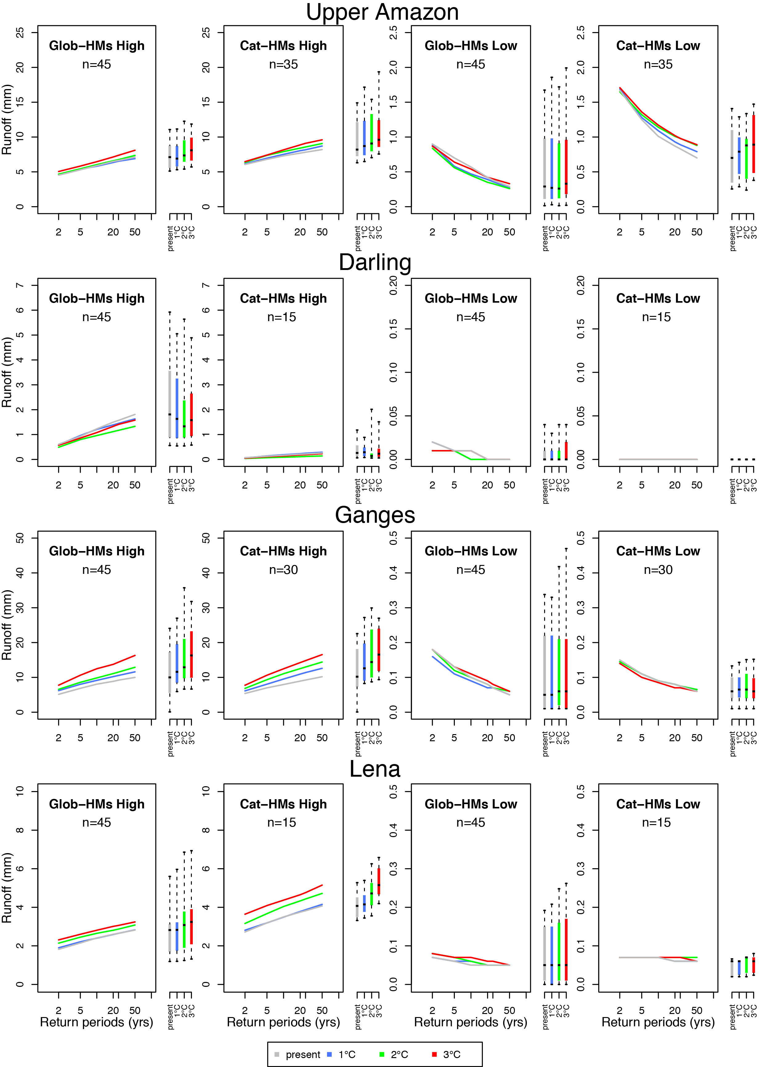
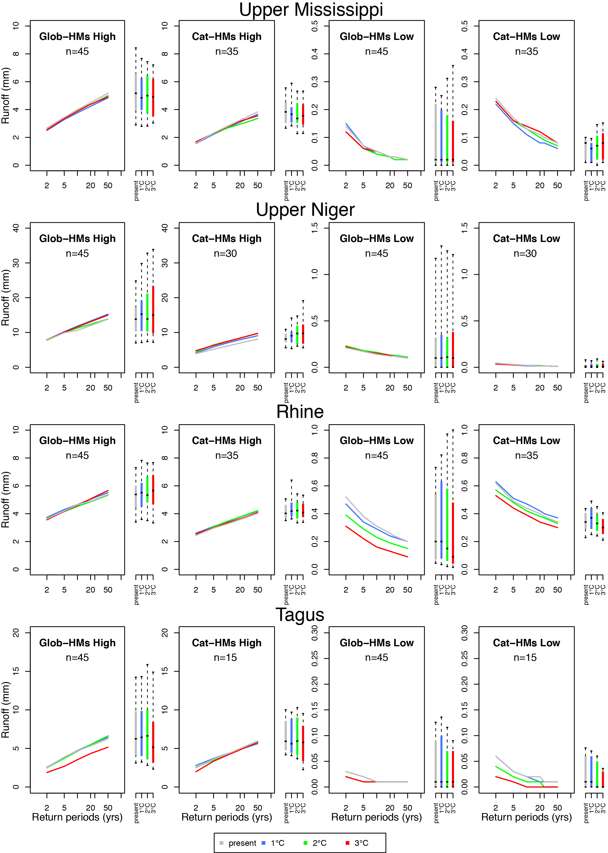

References
Dettinger MD, Diaz HF (2000) Global Characteristics of Stream Flow Seasonality and Variability. Journal of Hydrometeorology 1:289-310.
Gumbel EJ (1941) The Return Period of Flood Flows. 12:163-190.
Katz RW, Parlange MB, Naveau P (2002) Statistics of extremes in hydrology. Advances in Water Resources 25:1287-1304.
Leadbetter MR, Lindren G, Rootzen H (1983) Extremes and related properties of random sequences and processes. Springer-Verlag, New York, USA.
Schewe J, Heinke J, Gerten D, Haddeland I, Arnell NW, Clark DB, Dankers R, Eisner S, Fekete BM, Colón-González FJ, Gosling SN, Kim H, Liu X, Masaki Y, Portmann FT, Satoh Y, Stacke T, Tang Q, Wada Y, Wisser D, Albrecht T, Frieler K, Piontek F, Warszawski L, Kabat P (2014) Multimodel assessment of water scarcity under climate change. Proceedings of the National Academy of Sciences 111:3245-3250.
Stedinger JR, Vogel RM, Foufoula-Georgiou E (1993) Frequency analysis of extreme events. in Maidment DR (ed.) Handbook of Hydrology. McGraw-Hill, New York, pp. 18.11- 18.66.
van Vuuren D, Edmonds J, Kainuma M, Riahi K, Thomson A, Hibbard K, Hurtt G, Kram T, Krey V, Lamarque J-F, Masui T, Meinshausen M, Nakicenovic N, Smith S, Rose S (2011) The representative concentration pathways: an overview. Climatic Change 109:5-31.
Ward PJ, Beets W, Bouwer LM, Aerts JCJH, Renssen H (2010) Sensitivity of river discharge to ENSO. Geophysical Research Letters 37:L12402.
Ward PJ, Eisner S, Flörke M, Dettinger MD, Kummu M (2014) Annual flood sensitivities to El Niño–Southern Oscillation at the global scale. Hydrol. Earth Syst. Sci. 18:47-66.
Weibull W (1951) Wide applicability. Journal of Applied Mechanics 13:293-297.
WMO (2009) Manual on low-flow estimation and prediction (http://www.wmo.int/pages/prog/hwrp/publications/low-flow_estimation_prediction/WMO%201029%20en.pdf).

