Online Resource 1. Detailed description of forest types.

This study was motivated by a need for a vulnerability assessment of southwestern forests. The results are intended to help inform the USDA Climate Hub for the Southwestern US in developing strategic planning and program objectives. One part of the assessment is a description of the 10 forest types assessed. These appear below, and are composed of the definition of which Landfire vegetation types were included, general forest description, and a brief description of the climate exposure and possible threats. Nomenclature follows the USDA plants database (plants.usda.gov).

Pinyon and juniper woodland
Landfire Vegetation Types Used: Colorado Plateau Pinyon-Juniper Woodland; Great Basin Pinyon-Juniper Woodland; Madrean Pinyon-Juniper Woodland; Southern Rocky Mountain Pinyon-Juniper Woodland.

Forest type characterization
Pinyon and juniper woodlands are the most widespread forest type in the Southwest region and are valued for livestock grazing, firewood, polewood, and biofuels, and for biological diversity (Vankat, 2013). This woodland association occurs in California along the Sierras and across much of Nevada, Utah, Arizona and western New Mexico. Elevations normally range from 1370-2438 m (4500-8000 feet) depending on latitude. Stands occur on flat to relatively steep sloping sites and on all aspects. The soils are variable, but old growth woodlands typically occur on shallow and lithic sites. Litter from trees may cover about half the ground surface in fully stocked stands. Cover of rock, pavement or bare ground may also be significant depending on the site.

The dominant tree species and associated understory species change across this broad region. Western juniper (Juniperus occidentalis) occurs along the Sierras in the west, Utah juniper (J. osteosperma ) is found across the Great Basin and Colorado Plateau, Rocky Mountain juniper (J. scopulorum ) occurs at higher elevations across the Colorado Plateau and Arizona/New Mexico Mountains, and one-seeded juniper (J. monosperma) is found largely on the Arizona/New Mexico Plateau. Single-leaf pinyon (Pinus monophylla) comingles with Utah juniper in the Great Basin, while two-needle pinyon (P. edulis) occurs with the Rocky Mountain juniper (J. scopulorm) and one-seeded juniper (J. monsperma) on the Colorado Plateau and Arizona/New Mexico Plateau and Mountains.

The vegetation is characterized by an open to moderately dense tree canopy (10-40% cover) depending on environmental conditions and time since the last fire. Pinyon – juniper woodlands in the Great Basin and Colorado Plateau are typically associated with sagebrush (Artemisia spp.) shrublands but transition into grassland associations in the Arizona/New Mexico Plateau. However, they comingle with numerous different vegetation associations across the region.

Climate exposure and possible threats
Climate change is already having adverse effects on these woodlands, and these effects are predicted to increase in coming decades (Rehfeldt et al. 2012). In model projections for the four climate scenarios (MG RCP4.5, MG RCP8.5, MI RCP4.5, MI RCP8.5), the percentages of the woodlands that are climatically exposed range from 4.4% to 51.9% by 2060 and from 3.5% to 72.2% by 2080, respectively (Online Resource 5; Table 1). Areas that appear most exposed to the impacts of climate change are typically along the southern and western edges of the forest distributions; areas that appear most resilient are in the northern and eastern populations, following temperature and precipitation gradients.

Several interacting factors will determine the rate and magnitude of change, and these factors will likely differ across this large region. In much of the region, the woodlands expanded during the 20th century as a result of inappropriate livestock grazing, periods of favorable tree establishment, increasing levels of CO₂ favoring woody species, and fire suppression beginning in the 1930s. In the initial stages of expansion, fire return intervals typically decrease as understory species (fine fuels) are reduced due to competition from the trees (Miller et al. 2013). However, as stand infilling progresses, crown fuels, fire severity and, in some cases, fire extent increase. Longer wildfire seasons and more extreme fire weather due to a warming climate will place these stands at increased risk of large and severe wildfires (Westerling et al. 2006). In areas that are climatically suitable for invasive annual grasses, conversion to annual grass dominance could result in an annual grass/fire cycle and significantly higher fire frequency (Littell et al. 2009; Miller et al. 2013).

Drought coupled with bark beetle infestations may result in regional-scale die-off of pinyon and/or juniper species. In one stand as much as 90% of the dominant overstory tree species, two-needle pinyon, died in 2002-2003 in response to drought and associated bark beetle infestations (Breshears et al. 2005). Regionally, Pinus edulis suffered mortality rates of 1-2% per year across its entire range during and after the early 2000s drought (Anderegg et al. 2015). In Nevada, recent droughts have resulted in die-off of single-leaf pinyon in warmer and drier portions of the woodlands (Greenwood and Weisberg, 2008).

Mid-montane mixed-conifer forest
Landfire Vegetation Types Used: White fir (Abies concolor) Forest Alliance; Southern Rocky Mountain Mesic Montane Mixed Conifer Forest and Woodland; Sierran Intermontane Desert Western White Pine-White Fir Woodland; Mediterranean California Mixed Oak Woodland; Mediterranean California Mesic Mixed Conifer Forest and Woodland; Mediterranean California Lower Montane Black Oak-Conifer Forest and Woodland; Mediterranean California Dry-Mesic Mixed Conifer Forest and Woodland.

Forest type characterization
Mixed conifer forest is an assemblage of conifer and hardwood species that forms a multi-layered forest. This type is particularly abundant in the Sierras of California. Historically, burning and logging have caused wide variability in stand structure, resulting in both even-aged and uneven-aged stands. When openings occur, shrubs are common in the understory. Closed canopy stand distribution is both extensive and patchy depending on scale, site, slope, soils, microclimate, and history.

Five conifers and one hardwood typify the mixed conifer forest in California: white fir (Abies concolor), Douglas-fir (Pseudotsuga menziesii), ponderosa pine (Pinus ponderosa), sugar pine (Pinus lambertiana), incense-cedar (Calocedrus decurrens), and California black oak (Quercus kelloggii). White fir tends to be the most ubiquitous species (though most often a minor overstory component) because it tolerates shade and has the ability to survive long periods of suppression in early seral brush fields. Douglas-fir dominates the species mix in the north, but is absent south of the Merced River. Ponderosa pine dominates at lower elevations and on south slopes. Jeffrey pine (Pinus jeffreyi) commonly replaces ponderosa pine at high elevations, on cold sites, or on ultramafic soils. Sugar pine is found throughout the mixed conifer type. Black oak is a minor, but widespread component in mixed conifer stands. In the central and particularly southern Sierra Nevada, giant sequoia is a striking associate of the mixed conifer type. Deerbrush (Ceanothus integerrimus), manzanita (Arctostaphylos spp.), chinquapin (Castanea spp.), tanoak (Notholithocarpus densiflorus), bitter cherry (Prunus emarginata), gooseberry (Ribes spp.), rose (Rosa spp.), and mountain misery (Chamaebatia spp.) are common shrub species in the mixed conifer understory.

We include a number of common, coexisting forest types within this heading of mid-montane mixed-conifer. This includes what is often referred to as Sierran mixed-conifer, white fir, Jeffrey pine, and California black oak. In much of the range of this composite of forest types, covering over 50,000 km², the representative species of all types can be found co-occurring in the same landscape. These forest types are known from the Sierra Nevada range but also from the southern Cascades, Klamath, and Trinity mountains. Mid-montane mixed-conifer forests are valued for timber production, biological diversity, recreation, and as watersheds for the large majority of California’s urban and agricultural needs.

Climate exposure and possible threats
Climate change is already having notable effects on these forests, particularly in combination with the effects of prior land management practices such as fire exclusion and selective logging. Warming climates, contracted precipitation seasons, and reduced snow accumulation have resulted in extending the fire season by 30-45 days. In model projections for the four climate scenarios (MG RCP4.5, MG RCP8.5, MI RCP4.5, MI RCP8.5), the percentages of the woodlands that are climatically exposed range from 8.7% to 45.0% by 2060 and from 11.5% to 70.5% by 2080, respectively (Online Resource 5, Table 1). The most exposed examples of mixed conifer forest appear in the northern Sierra Nevada, while the most resilient appear in the Shasta – Trinity region of northern California (Online Resource 5). Given the broad nature of this classification, which contains many different species, much of the change in this forest type may be in composition.

The key ecosystem driver in these forest types has been and will likely continue to be fire. In most of these forests, fire historically occurred somewhere between every eight to 25 years. Due to forest management practices of the last 100 years, in particular fire exclusion and logging, forests of today tend to be more homogeneous stands (i.e., single age cohorts with similar structure across the forest). This creates an elevated level of risk for large, high severity fire (Miller and Safford 2012). With longer fire seasons and increasing levels of fuels, combined with more sources of ignition (i.e. more wildland urban interface), fire risk will only increase. Management options involve strategic thinning of small to medium sized trees, use of prescribed and wildland use fire, and communication and outreach with larger urban communities which will experience the effects of fire, such as smoke and loss of ecosystem services.

Douglas-fir forests

Landfire Vegetation Types Used: Mediterranean California Mesic Mixed Conifer Forest and Woodland; Mediterranean California Mixed Evergreen Forest; Southern Rocky Mountain Dry-Mesic Montane Mixed Conifer Forest and Woodland; Northern Rocky Mountain Dry-Mesic Montane Mixed Conifer Forest; North Pacific Maritime Mesic-Wet Douglas-fir-Western Hemlock Forest; North Pacific Maritime Dry-Mesic Douglas-fir-Western Hemlock Forest; Pseudotsuga menziesii-Quercus garryana Woodland Alliance.

Forest type characterization
The Douglas-fir forest type described here is that where Douglas-fir (Pseudotsuga menziesii) is a dominant species mixed with other co-dominants. This species is widely spread throughout western North America, growing under a wide variety of climatic conditions. Within the Southwest Climate Hub region, it is mapped across 11,653 km². It is a dominant species in much of northwest California, along the north coast and within the Siskiyou, Cascades, and northern Sierra Nevada mountains. It is also found as a dominant or co-dominant species in forests within Utah and a co-dominant in Colorado, Arizona, and New Mexico.

The Douglas-fir forest type in this region includes several forest types where the species is typically the dominant tree including Interior Douglas-fir, Douglas-Fir – Western Hemlock, Pacific Douglas-fir, and Douglas-fir – tanoak – Pacific madrone. The Douglas-fir – western hemlock type is more common in the Pacific Northwest, but it also occurs in northern California. This type does well under mild, humid climates. Pacific Douglas-fir is the well-known dominant forest type found from British Columbia to central California. In this type, Douglas-fir is the dominant species but many other species are co-dominants depending on where within the range it is found. The Douglas-fir-tanoak-Pacific madrone is confined to the coastal regions of California and is interspersed within the larger extent of other forms of Douglas-fir forest.

Douglas-fir is a high value species for timber production, more so in the Pacific Northwest than within the Southwest Region. Many portions of the range include high-valued areas of biological diversity, and the forests typically have fairly high levels of precipitation, primarily as rain.

Climate exposure and possible threats
Climate change represents a risk to these forests. In model projections for the four climate scenarios (MG RCP4.5, MG RCP8.5, MI RCP4.5, MI RCP8.5), the percentages of these forests that are climatically exposed range from 10.0% to 54.8% by 2060 and from 12.9% to 80.9% by 2080, respectively (Online Resource 5, Table 1). This type occurs largely in California, with the most resilient types being found in the Shasta-Trinity-Siskiyou region of northwestern California, and with some of the least exposed stands being found in the same location. The considerable species range of Douglas-fir outside our study area, and its topographic variability of these forests in our study area may confound ability to accurately predict future conditions. Most of the range of Douglas-fir is north of our study area, so climate impacts we estimated may be lower than what will occur because the tree actually generally occupies cooler and moister conditions.

Ponderosa and Jeffrey pine forests

Landfire Vegetation Types Used: Southern Rocky Mountain Ponderosa Pine Woodland; California Montane Jeffrey Pine (-Ponderosa Pine) Woodland; Northern Rocky Mountain Ponderosa Pine Woodland and Savanna; Southern Rocky Mountain Ponderosa Pine Savanna; East Cascades Oak-Ponderosa Pine Forest and Woodland.

Forest type characterization
Ponderosa and Jeffrey Pine forests are a major source of timber, but they are also important for wildlife habitat, recreational use, and aesthetic values. In the Southwest, Jeffrey pine forests occur largely in the Sierra Nevada and northern California, while ponderosa pine forests occur in the Sierra Nevada, northern California, and on the Mogollon Rim and Plateau in Arizona and New Mexico and are characterized by distinct subspecies (Jenkinson 1990; Oliver and Ryker, 1990). Typical sites are relatively warm (mesic) and relatively dry (xeric), and soils are generally well-drained and coarse-textured. Because these species are cold hardy, drought tolerant, and adapted to short growing seasons, they compete well with other conifers and typically dominate on cold, xeric, and infertile sites. Ponderosa pine (Pinus ponderosa) and Jeffrey pine (Pinus jefferyi) often co-occur with other pines (Pinus spp.), oaks (Quercus spp.), junipers (Juniperus spp.), fir (Abies spp.), Douglas-fir (Pseudotsuga menziesii), aspen (Populus tremuloides), and spruce (Picea spp.). Shrubs can include species of manzanita (Arctostaphylos spp.), sagebrush (Artemisia spp.), mountain mahogany (Cercocarpus spp.), ceanothus (Ceanothus spp.), snowberry (Symphoricarpos spp.), ninebark (Physocarpus spp.), rose (Rosa spp.), bitterbrush and cliffrose (Purshia spp.), and others. The understory ranges from dense shrub or graminoid layers to barren rock. The associated plant species vary with changes in geography and environmental conditions.

Climate exposure and possible threats
Climate change may have significant effects on these forests. In model projections for the four climate scenarios (MG RCP4.5, MG RCP8.5, MI RCP4.5, MI RCP8.5), the percentages of these forests that will be climatically exposed range are from 11.2% to 71.0% by 2060 and from 7.5% to 88.3% by 2080, respectively (Online Resource 5, Table 1). The most exposed locations appear scattered in the intermountain west and northeastern California, while the most resilient locations appear in southwestern Colorado, and perhaps some locations in the central or (higher) southern Sierra Nevada Mountains (Online Resource 5).

In general, Jeffrey and ponderosa pine trees respond positively to winter-spring precipitation and negatively to spring-summer temperature (Brown and Wu 2005). Recruitment is associated with moist and fire-free periods, while die-off is related to droughts lasting more than ten years. Since European settlement in the middle to late 1800s, historic livestock grazing and fire suppression have resulted in unnaturally dense stands of trees and increased understory fuels in many Jeffery and ponderosa pine forests (Allen et al. 2002). This change in stand structure, coupled with increases in the length of the fire season and more extreme fire weather due to a warming climate, places these stands at increased risk of large and severe wildfires (Westerling et al. 2006).

The likelihood of pine bark beetle outbreaks is increased by higher temperatures and forest homogeneity, and trees are most susceptible to beetles when drought stressed or after fire (Raffa et al. 2008). Increases in temperature and aridity coupled with greater stand density will likely cause reduced tree growth and greater tree stress (Williams et al. 2010). Thus, as the climate warms, increases in pine bark beetle outbreaks and die-offs are may occur more frequently in trees growing in homogenous stands and at the margin of their ecological tolerances.

Oak woodlands

Landfire Vegetation Types Used: California Lower Montane Blue Oak-Foothill Pine Woodland and Savanna; Pinus sabiniana Woodland Alliance; California Central Valley Mixed Oak Savanna.

Forest type characterization
Oak woodlands are an especially iconic vegetation type, with many different species dominating specific oak woodland types that are distributed throughout much of California. Our characterization of oak woodlands includes Central Valley mixed oak woodlands, California central valley mixed oak savanna, California lower montane blue oak – foothill pine woodland, and foothill pine woodland alliance. This type is restricted entirely to California and is comprised of nine different species of oaks (Pavlik et al. 1991). These woodlands are primarily used for grazing lands and open space protection, and they are valued for a variety of plants and animals that they support (Tyler et al. 2006). A principle threat to the oak woodlands of California is a failure to recruit (Tyler et al. 2006). Ranchers have varied in their treatment of oaks within woodland grazing areas from perceiving them as nuisance to be eradicated to valued species that increase grassland productivity and provide shade for animals.

Oak woodland stands are generally associated with a precipitation regime that is strongly Mediterranean, with most precipitation falling as rain between November and April. Summers are quite warm and dry. Winters are cool, but frosts are rare. Oak woodlands are characterized by the presence of several oak species, none of which achieve dominance. Characteristic oaks include California black oak (Quercus kelloggii), blue oak (Quercus douglasii), live oak (Quercus agrifolia), and valley oak (Quercus lobata). Other trees in the canopy or subcanopy may include California laurel (Umbellularia californica), California buckeye (Aesculus californica), Douglas-fir (Pseudotsuga menziesii), California foothill pine (Pinus sabiniana), ponderosa pine (Pinus ponderosa), Pacific madrone (Arbutus menziesii), and toyon (Heteromeles arbutifolia).

Climate exposure and possible threats
This type is among the four most climatically exposed forest types in out model projections under the four climate scenarios (MG RCP4.5, MG RCP8.5, MI RCP4.5, MI RCP8.5). The percentages of the woodlands that are climatically exposed range from 28.0% to 76.6% by 2060 and from 33.0% to 96.6% by 2080, respectively (Online Resource 5, Table 1). Regions that appear most at risk are along the Sierra Nevada foothills, the coast range just north of the San Francisco Bay area, and the southern coast range near Santa Barbara (Online Resource 5). The most resilient regions appear to be in the far northern and southern portion of the hills bordering the Central Valley.

Oak woodlands currently appear to have lower recruitment rates than needed for stand replacement. Recruitment patterns across the state do not conform to any predictions of climatic vulnerability or sensitivity (Zavaleta et al. 2007). Hypotheses for low recruitment rates include increased water stress from facultative-sprouting and earlier-growing non-native grasses; shading from non-native grasslands on seedlings; and shifts in the abundance of animal communities leading to greater acorn predation and parasitism rates (Callaway 1992; Gordon and Rice 1993; Gordon et al. 1989; Tyler et al. 2006). Overlain on the threat of low oak seedling recruitment is the recent spread of sudden oak death (Phytophthora ramorum) in oaks of the northern California coastal counties from Monterey northward (Rizzo et al. 2005). Inland spread of sudden oak death may be limited by climatic conditions, and so it has minimal overlap with the oak woodland types at present, although mixed conifer-hardwood stands may be at risk. Adult oak trees appear very resilient to climatic stress, and barring management action to remove oaks, they have the capacity to persist for long periods under adverse climatic conditions, although the recent hot drought may have caused more than background mortality among blue oak stands. Also, the extremely low rates of recruitment observed over most portions of the range are likely to worsen with increased moisture stress from climate change and losses of adult oaks resulting in slowly declining abundance except in the most resilient microclimates (e.g., riparian zones).

Aspen forests

Landfire Vegetation Types Used: Rocky Mountain Aspen Forest and Woodland; Inter-Mountain Basins Aspen-Mixed Conifer Forest and Woodland.

Forest type characterization
Aspen forests support a diversity of ecosystem services, including watershed protection, livestock grazing, habitat for a broad array of wildlife species, recreational use, and aesthetics (Shepperd et al. 2006). Aspen (Populus tremuloides) stands are typically composed of clones representing one or more genetic lines. They vary from a few stems on less than 1 ha (2.5 acres) to thousands of stems on 20 ha (50 acres) or more. Associated subdominant tree species may include willows (Salix spp.), alders (Alnus spp.), black cottonwood (Populus balsamifera L. ssp. trichocarpa), lodgepole pine (Pinus contorta), Jeffrey pine (Pinus jeffreyi), ponderosa pine (Pinus ponderosa), red fir (Abies magnifica), white fir (Abies concolor), Douglas-fir (Pseudotsuga menziesii), and Engelmann spruce (Picea engelmannii). In communities near climax, however, quaking aspen is conspicuously the dominant species in the canopy.

Mature stands of quaking aspen usually have relatively open canopies, often shared with other deciduous trees and a few conifer species, typically pines. Average canopy closures of stands in eastern California range from 60 to 100 percent in young and intermediate-aged stands and from 25 to 60 percent in mature stands. The open nature of the stands results in substantial light penetration to the ground. Stands thus tend to have an herbaceous understory with about half maintaining a tall shrub layer.

Climate exposure and possible threats
These forests are already seeing declines, and ongoing climate change may increase the rate and magnitude of change. In model projections for the four climate scenarios (MG RCP4.5, MG RCP8.5, MI RCP4.5, MI RCP8.5), the percentages of these forests that are climatically exposed range from 7.9% to 39.0% by 2060 and from 9.5% to 63.1% by 2080, respectively (Online Resource 5, Table 1). These models indicate that the most exposed populations are found in the southern end of the range in Arizona, while the least climatically exposed populations are found in eastern Utah (Online Resource 5).

Research indicates that drought results in accumulated hydraulic damage in aspen that can increase mortality over a period of years and result in greater vulnerability to subsequent droughts (Anderegg et al. 2013). Recent drought has caused sudden aspen decline (SAD) in which rapid, widespread branch dieback and mortality occurs. SAD is correlated with increases in several species of pathogens and insects, including Cytospora canker, bronze poplar borer, and aspen bark beetles (Marchetti et al. 2011). The most extensive SAD is in the hottest and driest areas—low-lying, south-facing slopes. The pattern suggests that the region's extreme drought and high temperatures have weakened the trees, allowing more disease and insect attacks (Worrall et al. 2010). Furthermore, these patterns are consistent with climate change predictions.

Both wild and domestic browsers at high density, or in lower numbers for extended periods, can also disrupt aspen ecosystems and may exacerbate the effects of climate change. Finally, fire suppression and progressive expansion of conifers into aspen stands may be increasing the rate of decline. In addition to reducing or eliminating aspen recruitment, there are cascading effects on species that depend on aspen habitat such as goshawks and various species of woodpeckers.

Riparian Woodlands

Landfire Vegetation Types Used: North American Warm Desert Riparian Systems; California Montane Riparian Systems; Inter-Mountain Basins Montane Riparian Systems; Rocky Mountain Montane Riparian Systems; California Central Valley Riparian Woodland and Shrubland; Western Great Plains Floodplain Systems.

Forest type characterization
Riparian woodlands are vital to the human communities and natural ecosystems in the Southwest. They increase stream/river geomorphic stability, retain floodwaters and increase groundwater retention, serve as buffers from upland sources of nutrients, pollutants and sediments, provide shade, temperature regulation, and organic inputs for aquatic organisms, and support recreational activities for humans (National Research Council 2002).

Riparian woodlands occur primarily along permanent streams and rivers, where the water table remains elevated during most or all of the year (National Research Council 2002). The species of trees that occur in these woodlands differ from those in surrounding uplands because they are less dependent on seasonal water availability. These woodlands occur across the entire Southwest, but they reach their greatest extents along streams and rivers with fairly broad floodplains. Species associations differ across the Southwest region. They also differ locally along climate (elevation) gradients, and are highly dependent on stream and river geomorphic characteristics such as slope and substrate type and hydrological characteristics such as flow regime.

The dominant tree species are typically deciduous. The most widespread riparian trees are several species of cottonwoods (Populus spp.), alders (Alnus spp.), birch (Betula spp.), and maple (Acer spp.). Species such as aspen (Populus tremuloides) often occur along higher elevation streams in more moderate climates, while species such as sycamore (Platanas spp.) can occur along desert streams. Associated shrubs almost always include one or more species of willow (Salix spp.) and often include rose (Rosa spp.). Invasive species are common in these highly productive environments, especially at low to mid-elevations. Among the most widespread and deleterious of these are several species of salt cedar (Tamarix spp.) and Russian olive (Elaeagnus angustifolia spp.).

Climate exposure and possible threats
Climate change will likely alter stream/river flow amounts and seasonal distributions, flood regimes, and sediment inputs and thus will affect the composition and structure of riparian forests. In model projections for the four climate scenarios (MG RCP4.5, MG RCP8.5, MI RCP4.5, MI RCP8.5), the percentages of these forests that are climatically exposed range from 4.5% to 68.4% by 2060 and from 5.5% to 79.6% by 2080, respectively (Online Resource 5, Table 1). Riparian types are scattered in their distribution throughout the region, with a high concentration in Southeastern California. Among all of the types discussed in this assessment, riparian forests may have the most uncertainty associated with their exposure assessment. This is because this vegetation responds strongly to the water table and hydro period, which are attributes not captured in the model output. Rerunning our exposure analyses using a hydroclimatic model such as the Basin Characterization Model (Flint et al. 2013) could perhaps improve predictions for this type.

For areas of the Southwest that experience an increase in temperature and a decrease in precipitation, it is likely that both recharge and base flows will decrease, resulting in significant decreases in the extent of riparian areas and of riparian forests (Serrat-Capdevila et al. 2007). To meet increasing human demands for water, it is likely that water-development activities in the form of canal and reservoir construction will accelerate while salinity increases and other water quality measures decrease (Poff et al. 2002). Consequently, invasive forest species that are tolerant of saline conditions and decreased soil water availability such as salt cedar and Russian olive are likely to increase (Kerns et al. 2009). The increase in aridity and change in species composition may result in an increase in fire frequency in these forests (Dwire and Kauffman 2003).

Red fir forests
Landfire vegetation types used: Mediterranean California Red Fir Forest.

Forest type characterization
Red fir (Abies magnifica) is limited to the higher elevations of the Sierra Nevada, and the Cascade and Siskiyou Mountains of California and portions of southern Oregon (North et al. 2012). It covers approximately 11,165 km² in these mountain ranges. It is the dominant species in this relatively cool and moist high-elevation forest. Commonly associated with red fir is lodgepole pine (Pinus contorta), which occupies the wetter sites within red fir forests. In the drier portions of the southern Sierra, sugar pine (Pinus lambertiana) and western white pine (Pinus monticola) are also found within red fir stands (North et al. 2012).

Red fir is not especially valued for timber production. Many portions of the range include highly valued recreational areas and areas of biological diversity. Also, these forests store considerable amounts of snowpack and thus are important for releasing water over the spring and summer for California’s urban and agricultural water needs.

Climate exposure and possible threats
Climate change is already having notable effects on these forests, particularly as a result of declining levels of snowpack. This type is among the four most climatically exposed forest types in out model projections under the four climate scenarios (MG RCP4.5, MG RCP8.5, MI RCP4.5, MI RCP8.5). The percentages of these forests that are climatically exposed range from 15.0% to 75.8% by 2060 and from 15.7% to 96.1% by 2080, respectively (Fig. S9, Table S9). Our expectation is that as climate warms, red fir forest may experience higher mortality rates, and may be invaded by species from lower montane regions.

Coastal redwood forests
Landfire vegetation types used: California Coastal Redwood Forest.

Forest type characterization
Coastal redwood forests have been a rich source of highly valued timber products and contain considerable biological diversity. These giant mixed-conifer forests are restricted to the coastal fog belt in northern California and the extreme southwestern part of Oregon, with scattered sites further south. Elevations are below 500 m in Oregon and 900 m in California. Stands can occupy steep slopes and ridges of coastal mountains on any aspect. In southwestern Oregon, they also occur on moist toe slopes and valleys. The mixed stands generally occur in the upper part of the coastal fog belt, inland of the very wet coastal stands of nearly pure redwood (Sequoia sempervirens). Soils are shallow and well-drained.
The canopy of these forests is dominated by Douglas-fir (Pseudotsuga menziesii) and redwood trees that often exceed 60 m in height. There is almost always a subcanopy of tanoak (Notholithocarpus densiflorus), usually between 10-30 m tall, that is occasionally co-dominant with California laurel (Umbellularia californica). Tanoak also occurs in the subcanopy with both Pacific rhododendron (Rhododendron macrophyllum) and California huckleberry (Vaccinium ovatum). Salal (Gaultheria shallon) and Cascade barberry (Mahonia nervosa) are common, and in moist pockets swordfern (Polystichum munitum) and redwood-sorrel (Oxalis oregana) can be found. In wetter northern stands, swordfern (Polystichum munitum), redwood-sorrel (Oxalis oregana), and Andrew's clintonia (Clintonia andrewsiana) dominate the herbaceous layer.

Climate exposure and possible threats
The future of the people and wildlife that depend on coastal redwoods may be risk as a consequence of climate change. Species level projections based on a variety of climate models predict that redwood distribution could shift northwards. This type is among the four most climatically exposed forest types in out model projections under the four climate scenarios (MG RCP4.5, MG RCP8.5, MI RCP4.5, MI RCP8.5). The percentages of these forests that are climatically exposed ranges from 35.2% to 61.3% by 2060 and from 59.4% to 99.4% by 2080, respectively (Online Resource 5, Table 1). Redwoods, however are long-lived trees. We did not find publications documenting drought mortality in redwoods, suggesting that transition from redwood forest to other forest types might, lacking disturbance, take centuries. However, fire could result in much more rapid change, and the interaction of fire-disturbed stands in which Sudden Oak Death syndrome has increased the fuel loads has been shown in increase redwood mortality risk fourfold (Metz et al. 2013) . For commercial timber producers, deciding when, where, and why to replant redwoods after timber harvest will likely become an important strategic choice.

A key uncertainty in these model predictions is the presence of coastal fog. Redwoods are highly dependent on fog-driven moisture during the summer months (Dawson 1998). Climate models do not yet do an adequate job of predicting change in coastal open temperatures, coastal upwelling or onshore flow of marine air. Despite recent warming, trends in coastal upwelling suggest uncertainty about the future of the coastal fog zone. Fully understanding the future of California coastal redwood depends strongly on how changing climate will affect summer fog.

Subalpine conifer forests
Landfire Vegetation Types Used: Rocky Mountain Subalpine Dry-Mesic Spruce-Fir Forest and Woodland; Rocky Mountain Lodgepole Pine Forest; Mediterranean California Subalpine Woodland; Sierra Nevada Subalpine Lodgepole Pine Forest and Woodland; Inter-Mountain Basins Subalpine Limber-Bristlecone Pine Woodland; Juniperus occidentalis Woodland Alliance; Northern California Mesic Subalpine Woodland; Rocky Mountain Subalpine-Montane Limber-Bristlecone Pine Woodland; Rocky Mountain Foothill Limber Pine-Juniper Woodland; Northern Rocky Mountain Subalpine Woodland and Parkland; Pinus albicaulis Woodland Alliance; Rocky Mountain Subalpine Mesic-Wet Spruce-Fir Forest and Woodland; North Pacific Mountain Hemlock Forest.

Forest type characterization
These upper montane or subalpine conifer forests are found in many of the mountainous areas of the western U.S. within cool and relatively dry climate regimes. Stands may also occur at montane elevations where cold-air drainage modifies the environment. These forests are typically found where marginal growing conditions such as low precipitation, or droughty sites or substrates produce an open tree canopy (Fites-Kauffman et al. 2007). Parent materials and soils are variable across the distribution of this vegetation classification type.

The subalpine forests of the Southwest are a mixed suite of coniferous forests that often occur in single species dominated stands. In the Southwest, subalpine forests are represented by 13 different LANDFIRE vegetation types and include 10 species, most of which are characterized by highly disjunct populations distributed across subalpine zones of the Southwest and western US. These species may have had highly mixed populations during colder glacial periods, and they now exhibit highly isolated populations distributed across the region (Billings and Mooney 1968). The ten most common subalpine conifer species in the Southwestern U.S. are as follows:

- Limber pine | Pinus flexilis
- Bristlecone pine | Pinus longaeva
- Mountain hemlock | Tsuga mertensiana
- Western juniper | Juniperus occidentalis
- Foxtail pine | Pinus balfouriana
- Lodgepole pine | Pinus contorta
- Western white pine | Pinus monticola
- Whitebark pine | Pinus albicaulis
- Engelman spruce | Picea engelmannii
- Alpine fir | Abies lasiocarpa
In mature stands in the eastern portion of the region, the association is characterized by subalpine fir (Abies lasiocarpa) as the dominant tree species, often with Engelmann spruce (Picea engelmannii). In seral stands, other conifers can be important or even dominant, but subalpine fir is always present in the regeneration layer. Toward the western edge of our region, species composition is more mixed, and subalpine fir and Engelmann spruce are absent. These mixed tree associates include a suite of subalpine pines (whitebark pine, limber pine, foxtail pine, Great Basin bristlecone pine, and western white pine; P. albicaulis, P. flexilis, P. balfouriana, P. longaeva, and P. monticola, respectively). Where soils are adequate, most associations have well-developed shrub layers.

Climate exposure and possible threats
This forest type is among the four most exposed in our model projections under the four climate scenarios (MG RCP4.5, MG RCP8.5, MI RCP4.5, MI RCP8.5). The percent of area that is climatically exposed in these forests ranges from 14.6% to 75.9% by 2060 and from 18.9% to 93.4% by 2080 (Online Resource 5, Table 1). Other studies that have focused on the changing distributions of major vegetation types suggest that the subalpine zone will experience great loss in area (Lenihan et al. 2008; Rehfeldt et al. 2012). The most exposed subalpine communities are on the lowest elevation mountains, and least exposed on the highest (e.g., southern Sierra Nevada). A concern with changing climates is that these species will experience population losses and that as warming progresses their habitats could be invaded by less cold-tolerant species. Subalpine conifers may have the ability to colonize newly suitable areas relatively quickly as work by Millar et al. (2015) found that limber pine and bristlecone pine showed a pulse of recruitment above forest borders between 1955 and 2000, although they found no evidence of change before or after this period. Most studies of high elevation species suggest that climatic refugia will likely occur in pockets of cooler areas and result in the persistence of some populations even if these are reduced in abundance (Theurillat and Guisan 2001); but Millar et al (2012) found recent increased mortality for whitebark pine on low north facing slopes (which might be considered refugia under topographic modeling), where changes in climatic water deficit were proportionally greater than in areas that already were drier, and that these areas had extensive bark beetle outbreaks. Further, diseases of five-needled pines are increasing (Raffa et al. 2008), and increasing stand density creates more continuous fuels. At present, the frequent lightning strikes at high elevations typically lead to highly localized fires. If trees become stressed from disease, and fuels become more continuous (next paragraph), there could be increased mortality through disease and fire that speeds transition, although for whitebark pine current levels of white pine blister rust in the Tahoe basin affect fecundity but not survival (Maloney et al. 2012). The high climatic exposure we project could represent significant losses in biological diversity, as there are a suite of animals that live in close association with subalpine conifers (e.g., Clark’s Nutcracker) (Barringer et al. 2012; Lanner and Vanderwall 1980).

Recent observations suggest that there may be considerable uncertainty regarding the future of subalpine forests. First, some observations of ecological change in subalpine forests found increasing growth rates and increasing recruitment in stands (Dolanc et al. 2014; Dolanc et al. 2013a; Dolanc et al. 2013b). Warming temperatures have resulted in increased demographic performance of some species (Bunn et al. 2005; Millar et al. 2004). Thus, warming may not result in the failure of most tree species, although if warming increases climatic water deficit, trees may be at higher risk. Second, the predicted upslope shift in trees from lower elevations is slow to non-existent. Predictions of subalpine forest loss from global dynamic vegetation models (Lenihan et al 2008) are principally through displacement. Red fir and other species may move upslope and displace subalpine species, however, this has not been recorded where studies have looked for it (Dolanc et al. 2014; Dolanc et al. 2013a; Dolanc et al. 2013b). Further, where alpine displacement of plant species is being observed – for example, herbaceous species in the French Alps (Theurillat and Guisan 2001) – there are no records of extirpations. Montane microclimatic variation appears to result in a significant number of cool micro-habitats for persistence of more cold tolerant species (Varner and Dearing 2014). It may be that such microclimates could be essential to the persistence in tree species that have some of the longest life spans of known organisms.

Online Resource 2. The nineteen bioclimatic variables used to model distribution of forest types (from Hijmans et al., 2005).

BIO1 = Annual Mean Temperature
BIO2 = Mean Diurnal Range (Mean of monthly (max temp - min temp))
BIO3 = Isothermality (BIO2/BIO7) (* 100)
BIO4 = Temperature Seasonality (standard deviation *100)
BIO5 = Max Temperature of Warmest Month
BIO6 = Min Temperature of Coldest Month
BIO7 = Temperature Annual Range (BIO5-BIO6)
BIO8 = Mean Temperature of Wettest Quarter
BIO9 = Mean Temperature of Driest Quarter
BIO10 = Mean Temperature of Warmest Quarter
BIO11 = Mean Temperature of Coldest Quarter
BIO12 = Annual Precipitation
BIO13 = Precipitation of Wettest Month
BIO14 = Precipitation of Driest Month
BIO15 = Precipitation Seasonality (Coefficient of Variation)
BIO16 = Precipitation of Wettest Quarter
BIO17 = Precipitation of Driest Quarter
BIO18 = Precipitation of Warmest Quarter
BIO19 = Precipitation of Coldest Quarter

Online Resource 3. The projected range of temperature and precipitation change for 17 global climate model projections of late 21st century (2061-2080) climate under the high greenhouse gas representative concentration pathway.

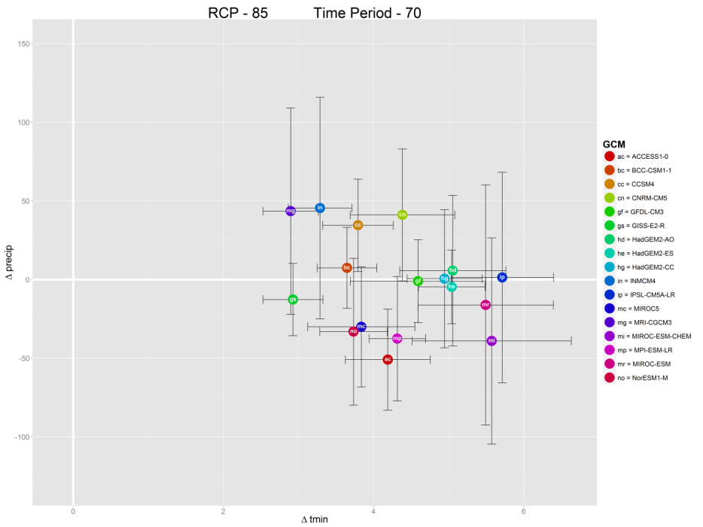

Figure 1. The projected change from current conditions (1950-2000) for temperature (minimum temperature of the warmest month, ºC) and precipitation (annual, mm) under 17 global climate model projections of late 21st century (2061-2080) climate using the high greenhouse gas representative concentration pathway (RCP8.5). We used this information to select climatic projections that represented the wetter (MRI-CGCM3) and the drier and hotter (MIROC-ESM-CHEM) available models.

Differences of annual minimum temperature and annual precipitation between current (1950-2000) and the 2061-2080 time period.
 | ac | bc | cc | cn | gf | gs | hd | he | hg | in | ip | mc | mg | mi | mp | mr | no
Δtmin | 4.19 | 3.65 | 3.79 | 4.39 | 4.59 | 2.93 | 5.06 | 5.04 | 4.95 | 3.29 | 5.72 | 3.84 | 2.90 | 5.57 | 4.32 | 5.49 | 3.73
Δprecip. | -50.92 | 7.44 | 34.50 | 41.10 | -1.04 | -12.71 | 5.65 | -4.67 | 0.52 | 45.44 | 1.34 | -30.02 | 43.53 | -39.05 | -37.55 | -16.18 | -33.12

Online Resource 4. Climate models and scenarios.
The global distribution of biome types can be described based on mean annual temperature and mean annual precipitation (Whittaker 1975). Since that time, the fundamental observation that forests are restricted to particular combinations of annual temperature and precipitation has been reaffirmed and refined using satellite imagery. We used this fundamental approach and downscaled it to the forest types of the Southwest using a bioclimatic envelope approach (Heikkinen et al. 2006) to examine exposure of forests to change. We projected Southwest forest types onto a multi-dimensional climate surface to categorize the climate conditions (or climate envelope) of each forest type by describing the frequency distribution of climates it occupies. We then applied two CMIP5 climate models and two emission scenarios (General Circulation Models; IPCC 2013) to project where and when different areas of lands occupied by each forest type are anticipated to have a future climate that currently that type occupies only 1% of the time, or that it does not currently occupy. This analysis is essentially a climate exposure method that leverages satellite mapping of vegetation and increasingly high-spatial resolution climate maps.

The details of our climate exposure modeling are as follows, and can also be examined in Thorne et al. (2016). LANDFIRE maps (Landscape Fire and Resource Management Planning Tools; www.landfire.gov; accessed August 2014) portray a variety of metrics for the United States, including land cover which is produced at 30 m resolution. We resampled this land cover to a spatial resolution of 300-meter pixels using majority rule in GIS. Each pixel in the landscape is described by a single dominant vegetation type and we constrained our analysis to 10 forest types derived from 53 forest and woodland categories in LANDFIRE (crosswalk by forest type in Online Resource 1).

WorldClim (Hijmans et al. 2005) provides mean base climate values for Tmin, Tmax, and Precipitation on a monthly and annual basis using a 30 arc second grid that is equivalent to a 1x1 km grid cell size. The base (current time) mean values for this study were 1950-2000. The accuracy of a gridded climate surface to actual temperature and precipitation values at any given point is relative to the density of weather stations that can be used to generate the surface, and a number of other factors including topographic complexity and wind. While the absolute accuracy is less certain, the intent of such climate surfaces is to be used for relative, or comparative, studies (Fick and Hijmans 2017). WorldClim climate grids from current time were also used by Hijmans et al. to statistically downscale and bias correct the future climate used in the study (http://www.worldclim.org/cmip5v1). The WorldClim data have been used in several thousand studies. We used the current and future projections to measure climatic change relative to the current conditions, and to obtain differences in conditions for the four future climate conditions used. We recommend that use of our results be made by comparing the relative magnitude of change among the four futures, relative to the current estimated climate conditions, and that users not expect the values at any given place to correspond to actual measured values, a limitation common to all climate conditions when they are projected through space and time.

WorldClim provides 19 derivative climatic variables that are calculated from the monthly mapped values of air temperature and precipitation and known collectively as the “BioClim” variables. These include variables such as mean annual temperature, mean temperature of driest quarter mean annual precipitation, precipitation seasonality, and mean temperature of the wettest quarter (Online Resource 2) on a gridded surface. Each forested cell was linked to its 19 BioClim attribute values for current climate, and to one of the four future climate scenarios (described below).

To select the future climate projections, we screened 17 GCMs and chose the two that projected outer-bound conditions of future modelled climate. The MRI-CGCM3 model was selected because it resulted in the least warm and wettest combined projected change by the end of the century under the highest greenhouse gas emission pathway (RCP8.5; IPCC 2013) and the MIROC-ESM-CHEM model because it resulted in the hottest and driest projections under RCP8.5 at the end of the century for the Southwestern U.S. Thus, these two models bracket from a low to a high highest potential for climate to act as a driver of vegetation change through temperature and precipitation shifts (Online Resource 3). For these two GCMs, we used two emission pathways (RCP4.5 and RCP8.5) separately.

We used principal components analysis to reduce the dimensionality of the Bioclim variables for the entire study area. We used the first two PCA axes from four analyses that each used the current and one of the projected future climate scenario data. These first two principle components explained a mean of 74% of the climatic variation in the data set across the models that we used. We described the climatic envelope of a forest type using a 99% frequency envelope for forested pixels using the current climate PCA values. This approach identifies the locations and climate conditions that occur only 1% of the time for the lands occupied by each forest type. We used the current climate frequency categories to identify the level of future climate exposure to find which pixels moved from a common (and therefore not climatically stressed under this approach) to an uncommon (climatically stressed) condition, represented by the climates that a type only occupies 1% of the time. This process also allowed us to use the future climate projection to forecast when and where the forested portion of the Southwest landscape no longer falls within the climate that describes the current distribution of that forest type.

To quantify exposure to change, we needed to describe the degree to which a particular location, in a particular time window, was marginal (i.e., external) to the current bioclimatic envelope. We used a two-dimensional density kernel estimator to draw the frequency contours around the current bioclimatic distribution of a forest type in our principle components climate space. We then plotted these same locations on this climate surface for two summarized future time periods: 2041-2060 and 2061-2080, which we refer to as mid- and late-century projections. We then classified each location in each future climate projection relative to the probability contour interval based on current distributions. Finally, we characterized fractions of forest types that are at risk of change by assessing what fraction of a particular type falls outside the 99th percentile of the climate space for current representatives of that type.

If a location is projected to be highly exposed by the end of the century, we mean that the climate of that location is projected to fall outside the climatic attributes that describe 99 percent of current locations for that forest type. By color-coding the degree of marginality with respect to current distributions, we can map climate change exposure and depict where on the landscape, for mid- and late-21st century, we expect forests to be secure and fall within the center of their climatic envelopes, and where they are exposed to change by falling outside their climatic envelopes.

This projection does not specifically predict the sensitivity of these forest types to drivers of forest cover change (e.g., stress-related mortality, fire, disease), nor does it specifically assess the adaptive capacity of forest types. Instead, we use life history attributes of constituent species for communities that we argue are linked with sensitivity and adaptive capacity of forest types. We do not predict particular outcomes for the constituent species within communities, nor do we predict what kinds of vegetation would replace the existing vegetation were a change in cover type to occur, although other studies predict movement of vegetation to higher latitudes and elevations (e.g. Lenihan et al. 2003; Rehfeldt et al. 2012). These projected changes in climate do not necessarily mean that current forests will disappear in locations anticipated to be outside the current climatic envelope. Forest trees are long-lived organisms, and changes in vegetation will be governed by a number of factors such as fire and drought in addition to climate. These projections merely describe when and where different forest types are predicted to be at increased climatic risk as a consequence of climate stressors. We acknowledge that feedbacks such as tree stress leading to broader beetle or pathogen outbreaks, or whether tree mortality may lead to greater fire risk (Hart et al. 2015; Linn et al 2013; Simard et al. 2011), are possibilities, but this paper does not attempt to integrate such interactions. In addition, this approach looks at the means of change, and does not address extreme events (e.g. Berg and Hall 2015), or how climate change may be affecting changes in disturbances such as the size, frequency or elevations of wildfire (Williams and Abatzoglu 2016; Schwartz et al. 2015; Williams et al. 2010) which might be the catalyst for type conversion. Rather, we focused on the base level of climatic stress anticipated for the forests types where they stand.

Online Resource 5. Climate exposure map for each forest type of the Southwestern U.S.
All forests combined, and then each of the 10 forests types analysed in this study is presented in a series of maps depicting the climate exposure relative to mean current conditions (1950-2000).

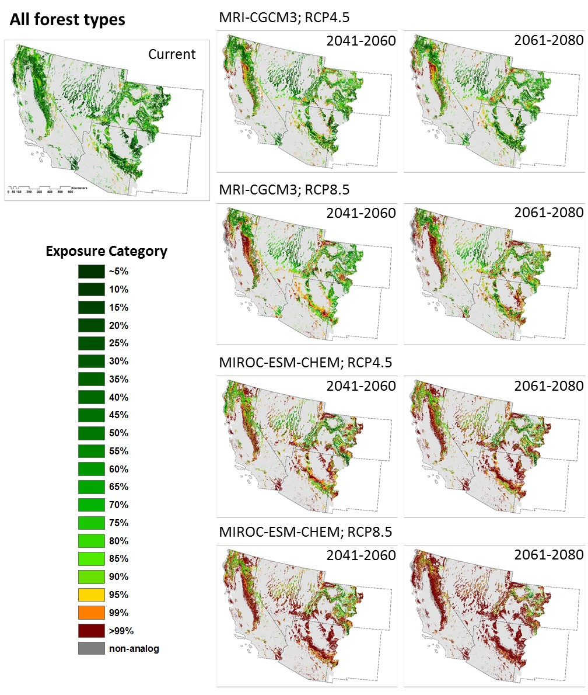
Figure 1. Exposure map for all 10 forest types.

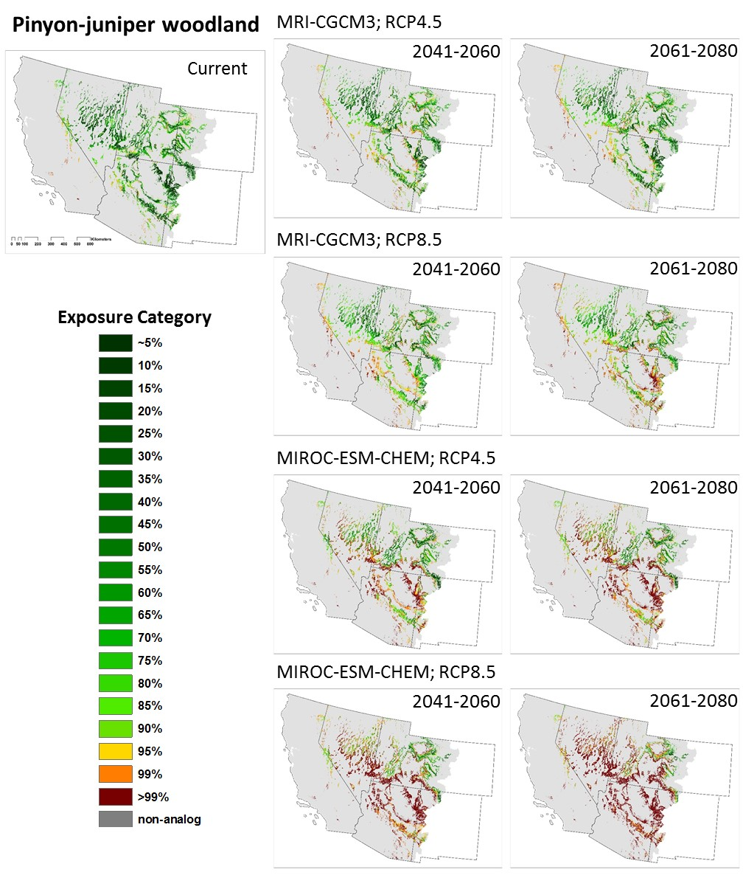
Figure 2. Exposure maps for pinyon-juniper woodlands.

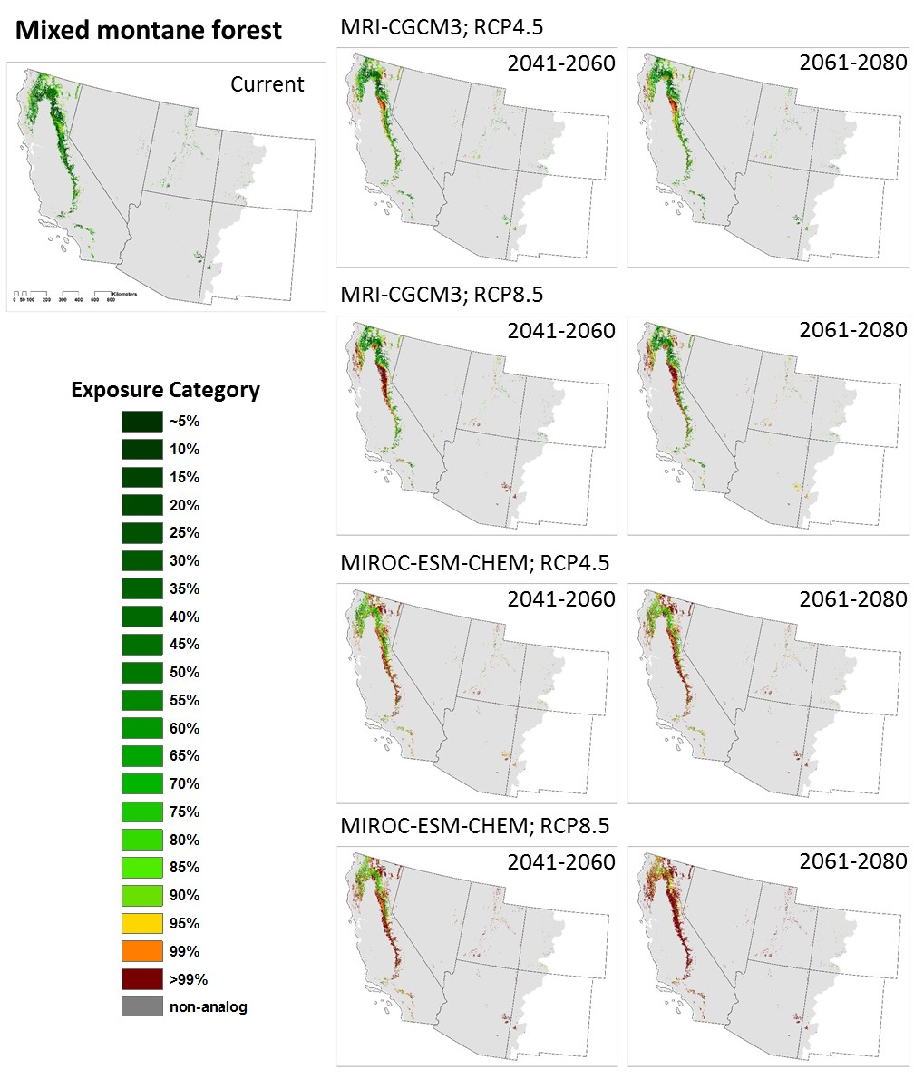
Figure 3. Exposure maps for mid-montane mixed conifer forests.

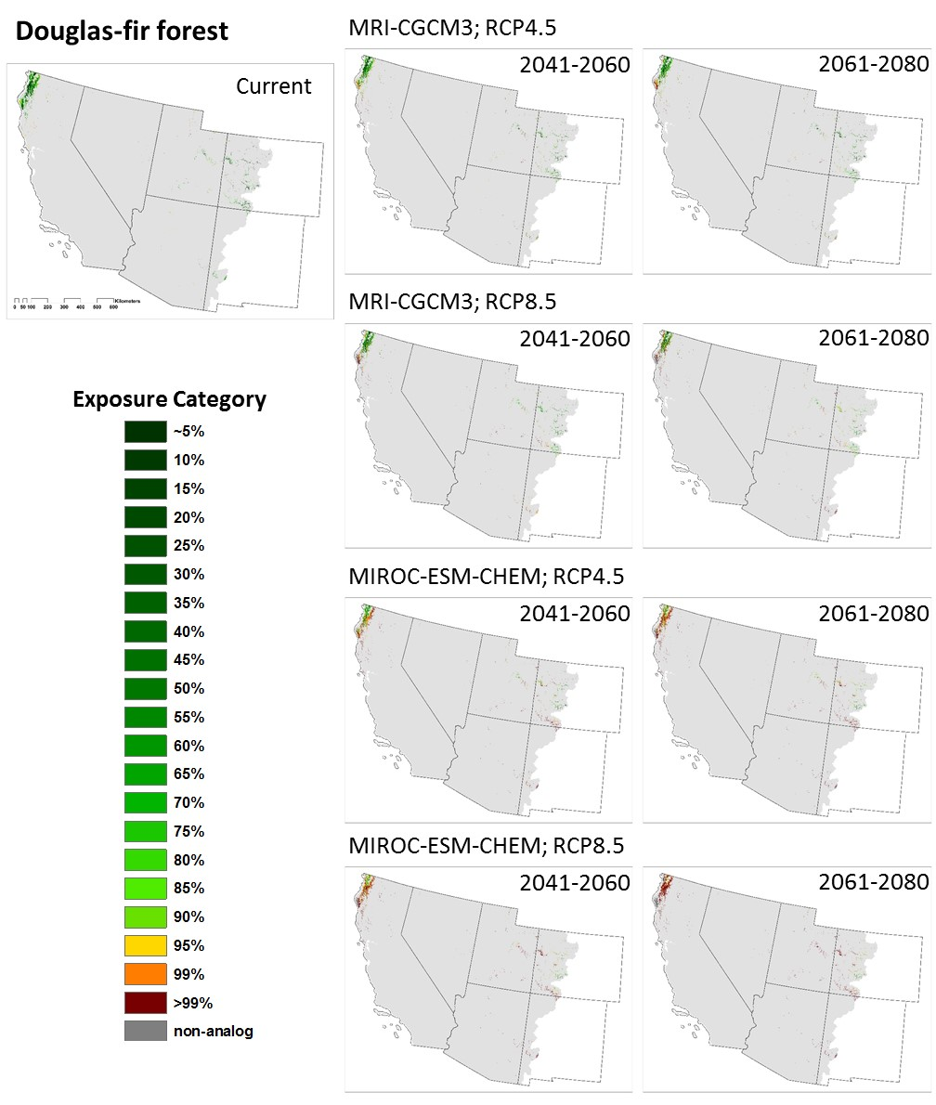
Figure 4. Exposure maps for Douglas-fir forests.

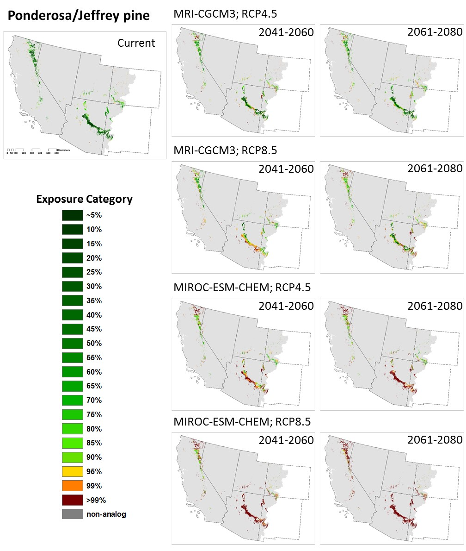
Figure 5. Exposure maps for Jeffrey and ponderosa pine forests.

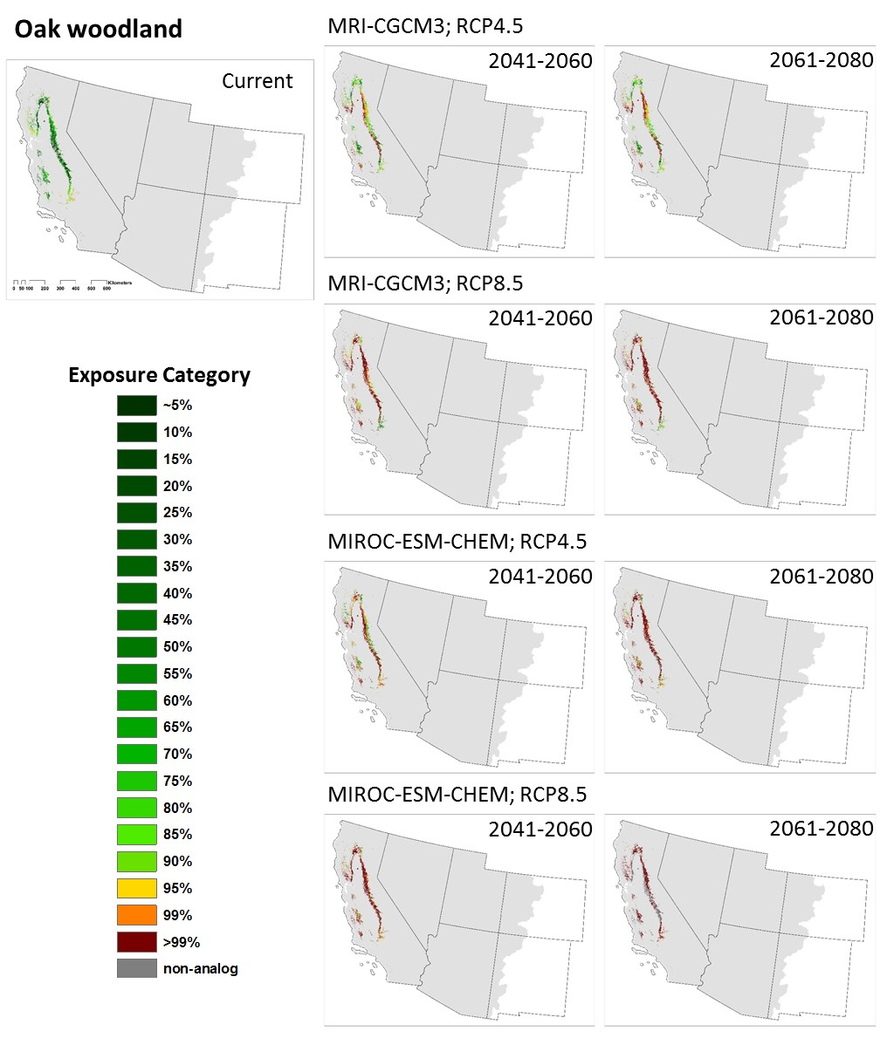
Figure 6. Exposure maps for oak woodlands.

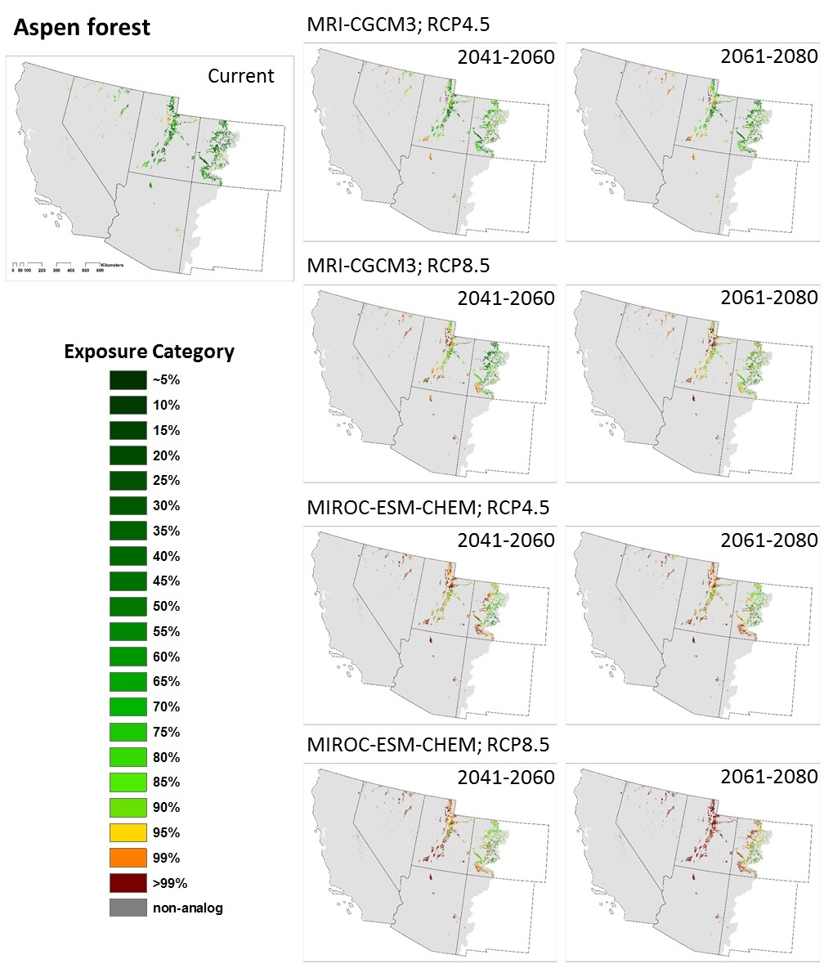
Figure 7. Exposure maps for aspen forests.
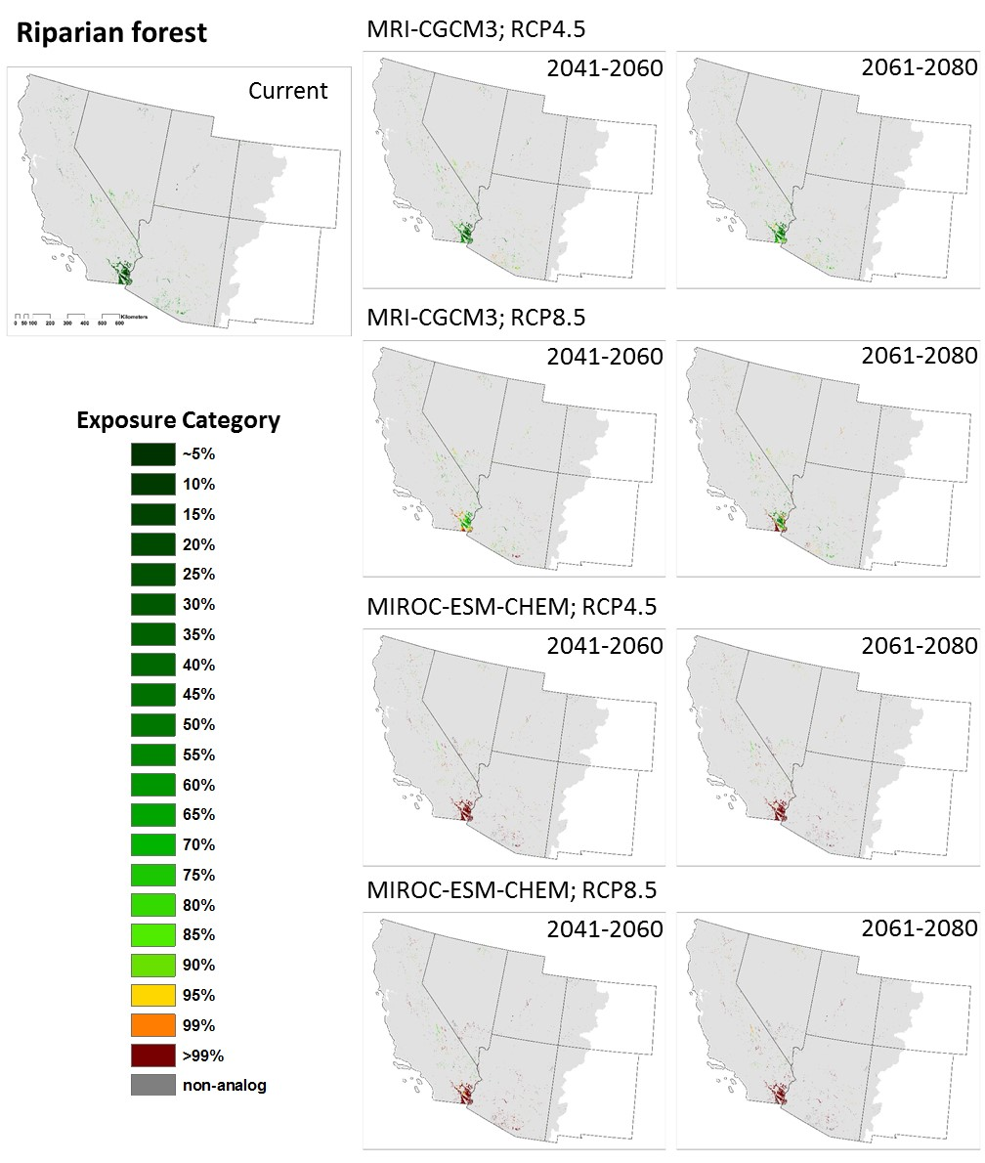
Figure 8. Exposure maps for riparian woodlands.

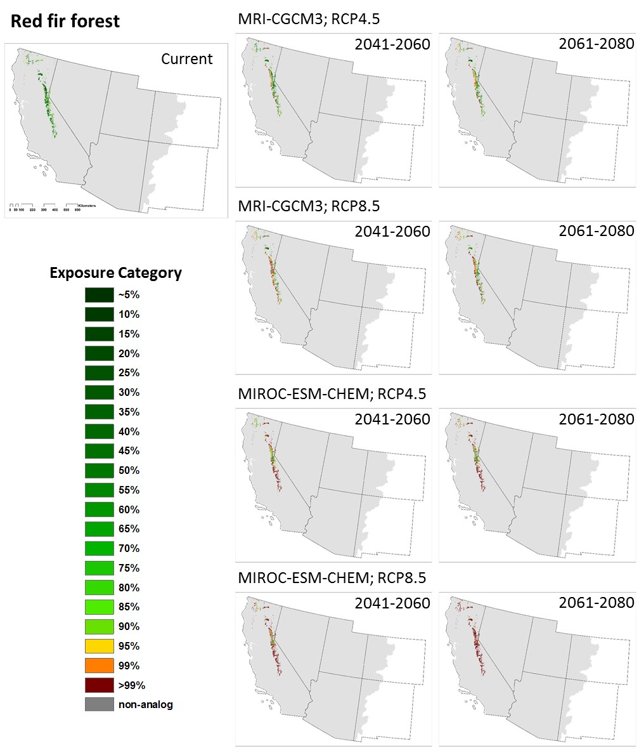
Figure 9. Exposure map for red fir forests.

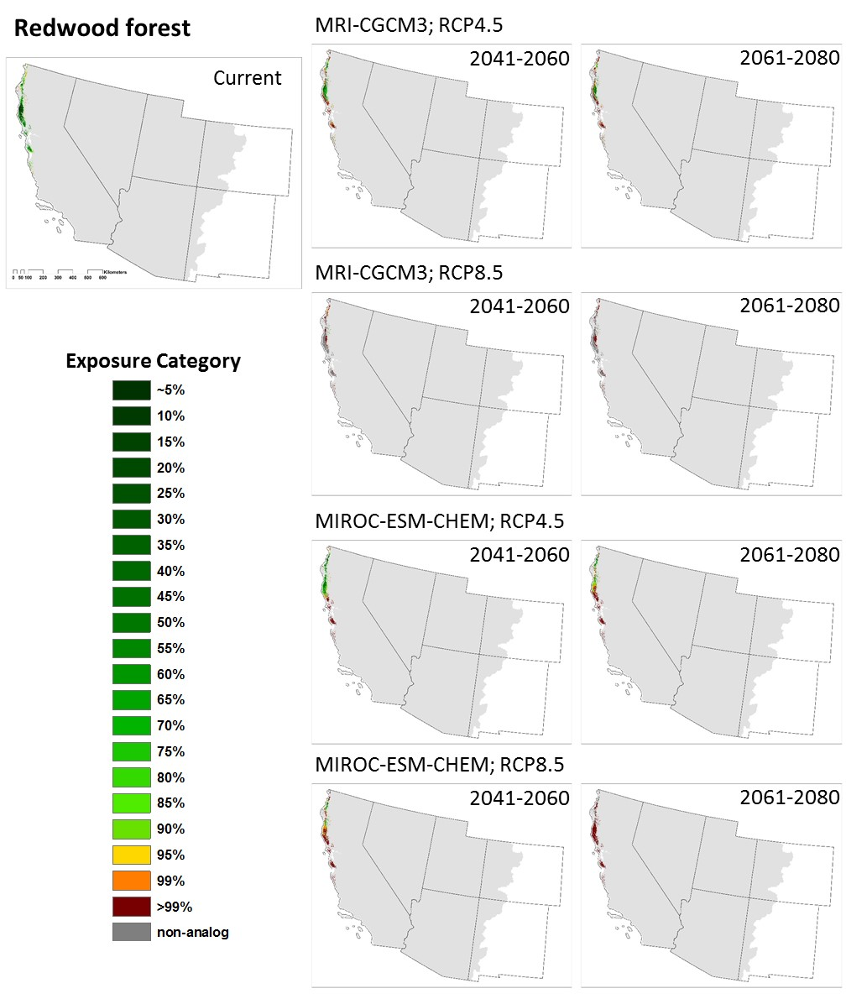
Figure 10. Exposure map for redwood forests.

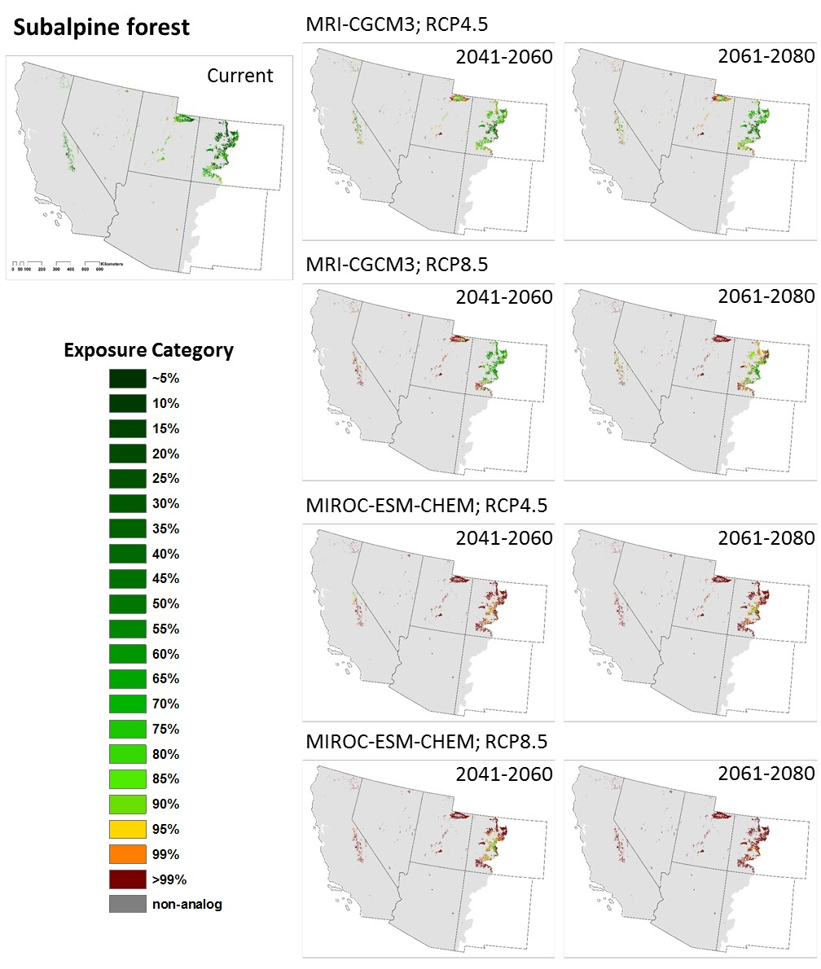
Figure 11. Exposure map for subalpine conifer forests.

Online Resource 6. Exposure analysis for each ecoregion type of the Southwestern U.S.
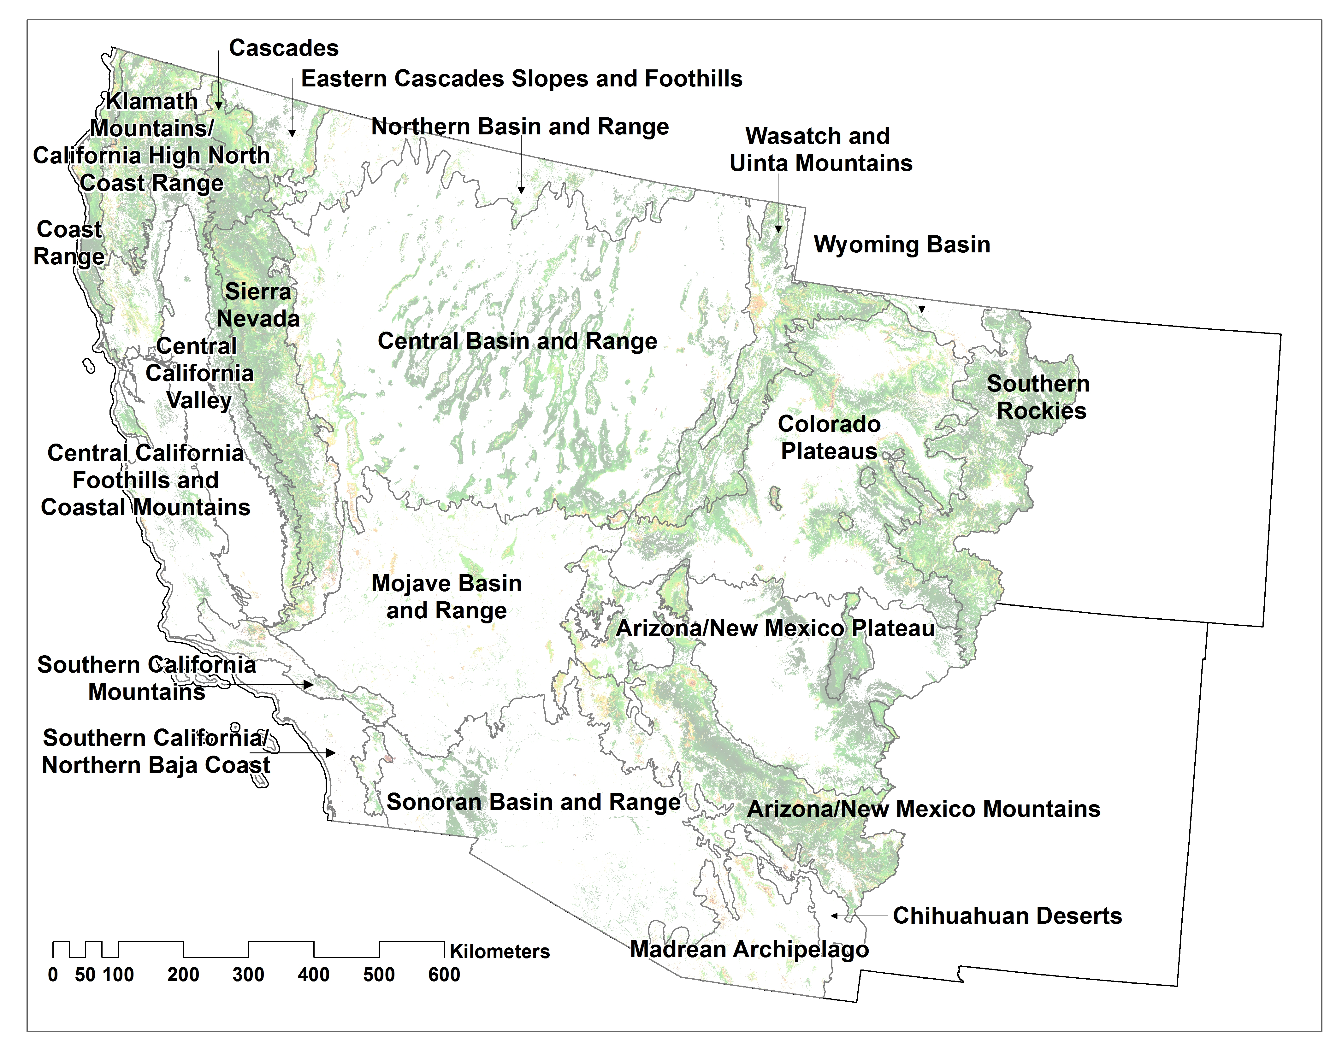
Figure 1. Ecoregions in the Southwestern U.S.

Table 1. Forest types, their area in the Coast Range, and their extent of exposure to climate change under different scenarios.
Forest type | Area (km²) | % of total  forest | MG45 | MG45 | MG85 | MG85 | MI45 | MI45 | MI85 | MI85
Forest type | Area (km²) | % of total  forest | 2060 | 2080 | 2060 | 2080 | 2060 | 2080 | 2060 | 2080
Pinyon-juniper woodland | 0 | 0.0 | 0.0 | 0.0 | 0.0 | 0.0 | 0.0 | 0.0 | 0.0 | 0.0
Mixed montane forest | 402 | 3.9 | 264.0 | 376.8 | 393.1 | 402.1 | 168.2 | 265.2 | 282.3 | 376.0
Ponderosa / Jeffrey pine forest | 2 | 0.0 | 2.0 | 2.0 | 2.0 | 2.0 | 2.0 | 2.0 | 2.0 | 2.0
Douglas-fir forest | 3,089 | 30.2 | 485.5 | 839.3 | 1,482.2 | 2,045.1 | 1,146.2 | 1,968.5 | 2,030.4 | 2,836.0
Oak woodland | 29 | 0.3 | 28.4 | 28.3 | 28.8 | 28.8 | 22.9 | 26.3 | 27.4 | 28.8
Aspen forest | 0 | 0.0 | 0.0 | 0.0 | 0.0 | 0.0 | 0.0 | 0.0 | 0.0 | 0.0
Riparian forest | 38 | 0.4 | 10.1 | 22.1 | 34.0 | 37.2 | 8.8 | 21.2 | 20.2 | 36.8
Red fir forest | 0 | 0.0 | 0.0 | 0.0 | 0.0 | 0.0 | 0.0 | 0.0 | 0.0 | 0.0
Subalpine forest | 0 | 0.0 | 0.0 | 0.0 | 0.0 | 0.0 | 0.0 | 0.0 | 0.0 | 0.0
Redwood forest | 6,681 | 65.2 | 2,386.2 | 4,155.2 | 6,280.3 | 6,609.0 | 1,569.4 | 3,099.1 | 3,820.3 | 6,647.0

Table 2. Forest types, their area in the Central Basin and Range, and their extent of exposure to climate change under different scenarios.
Forest type | Area (km²) | % of total  forest | MG45 | MG45 | MG85 | MG85 | MI45 | MI45 | MI85 | MI85
Forest type | Area (km²) | % of total  forest | 2060 | 2080 | 2060 | 2080 | 2060 | 2080 | 2060 | 2080
Pinyon-juniper woodland | 46,663 | 92.0 | 579.9 | 682.7 | 1,041.6 | 1,715.5 | 10,186.2 | 16,044.8 | 24,070.5 | 36,340.0
Mixed montane forest | 349 | 0.7 | 85.2 | 106.7 | 88.4 | 248.9 | 137.5 | 168.8 | 268.5 | 329.3
Ponderosa / Jeffrey pine forest | 712 | 1.4 | 81.5 | 51.1 | 57.1 | 187.6 | 349.4 | 411.8 | 454.0 | 630.5
Douglas-fir forest | 87 | 0.2 | 8.9 | 38.5 | 69.0 | 68.2 | 12.9 | 17.6 | 44.6 | 74.5
Oak woodland | 0 | 0.0 | 0.2 | 0.2 | 0.2 | 0.2 | 0.2 | 0.2 | 0.2 | 0.2
Aspen forest | 1,378 | 2.7 | 251.9 | 423.8 | 746.2 | 649.1 | 806.9 | 771.2 | 978.8 | 1,190.9
Riparian forest | 795 | 1.6 | 11.3 | 26.1 | 80.2 | 47.8 | 302.9 | 297.7 | 547.8 | 636.9
Red fir forest | 3 | 0.0 | 1.0 | 0.3 | 0.2 | 1.0 | 2.1 | 2.8 | 2.7 | 2.9
Subalpine forest | 745 | 1.5 | 243.1 | 366.1 | 450.1 | 537.2 | 463.1 | 575.3 | 675.7 | 733.4
Redwood forest | 0 | 0.0 | 0.0 | 0.0 | 0.0 | 0.0 | 0.0 | 0.0 | 0.0 | 0.0

Note: The fraction of the type exposed to change includes both cells that fall outside the 99% probability envelope and cells that fall outside the overall climatic envelope and are projected to be in non-analog climate space.

Table 3. Forest types, their area in the Mojave Basin and Range, and their extent of exposure to climate change under different scenarios.
Forest type | Area (km²) | % of total  forest | MG45 | MG45 | MG85 | MG85 | MI45 | MI45 | MI85 | MI85
Forest type | Area (km²) | % of total  forest | 2060 | 2080 | 2060 | 2080 | 2060 | 2080 | 2060 | 2080
Pinyon-juniper woodland | 2,080 | 45.3 | 208.7 | 263.6 | 835.6 | 445.5 | 835.7 | 944.1 | 1,238.0 | 1,681.1
Mixed montane forest | 77 | 1.7 | 29.6 | 30.0 | 27.8 | 45.2 | 57.4 | 64.7 | 67.1 | 76.1
Ponderosa / Jeffrey pine forest | 104 | 2.3 | 3.2 | 5.9 | 86.0 | 5.5 | 20.8 | 27.2 | 59.3 | 96.4
Douglas-fir forest | 0 | 0.0 | 0.0 | 0.0 | 0.0 | 0.0 | 0.0 | 0.0 | 0.0 | 0.0
Oak woodland | 1 | 0.0 | 0.1 | 0.1 | 0.0 | 0.1 | 0.1 | 0.1 | 0.1 | 0.1
Aspen forest | 1 | 0.0 | 0.9 | 1.4 | 0.2 | 1.2 | 1.4 | 1.4 | 1.4 | 1.4
Riparian forest | 2,264 | 49.3 | 126.8 | 133.0 | 159.8 | 258.0 | 816.8 | 798.2 | 966.1 | 1,383.1
Red fir forest | 0 | 0.0 | 0.0 | 0.0 | 0.0 | 0.0 | 0.0 | 0.0 | 0.0 | 0.0
Subalpine forest | 62 | 1.4 | 32.8 | 11.6 | 62.0 | 43.6 | 60.2 | 62.3 | 62.2 | 62.2
Redwood forest | 0 | 0.0 | 0.0 | 0.0 | 0.0 | 0.0 | 0.0 | 0.0 | 0.0 | 0.0

Table 4. Forest types, their area in the Wyoming Basin, and their extent of exposure to climate change under different scenarios.
Forest type | Area (km²) | % of total  forest | MG45 | MG45 | MG85 | MG85 | MI45 | MI45 | MI85 | MI85
Forest type | Area (km²) | % of total  forest | 2060 | 2080 | 2060 | 2080 | 2060 | 2080 | 2060 | 2080
Pinyon-juniper woodland | 492 | 70.1 | 15.3 | 0.3 | 0.5 | 4.1 | 0.1 | 0.0 | 0.1 | 44.5
Mixed montane forest | 0 | 0.0 | 0.0 | 0.0 | 0.0 | 0.0 | 0.0 | 0.1 | 0.1 | 0.3
Ponderosa / Jeffrey pine forest | 11 | 1.6 | 4.9 | 4.1 | 4.2 | 4.4 | 0.3 | 0.8 | 1.2 | 9.9
Douglas-fir forest | 4 | 0.6 | 0.0 | 0.0 | 0.0 | 0.3 | 0.9 | 1.2 | 3.3 | 4.0
Oak woodland | 0 | 0.0 | 0.0 | 0.0 | 0.0 | 0.0 | 0.0 | 0.0 | 0.0 | 0.0
Aspen forest | 56 | 7.9 | 4.1 | 3.2 | 3.0 | 9.0 | 4.4 | 8.9 | 22.6 | 53.2
Riparian forest | 80 | 11.4 | 9.9 | 8.3 | 5.0 | 59.0 | 60.9 | 60.9 | 60.5 | 62.6
Red fir forest | 0 | 0.0 | 0.0 | 0.0 | 0.0 | 0.0 | 0.0 | 0.0 | 0.0 | 0.0
Subalpine forest | 58 | 8.3 | 10.5 | 13.6 | 13.1 | 49.1 | 51.2 | 56.8 | 56.7 | 57.8
Redwood forest | 0 | 0.0 | 0.0 | 0.0 | 0.0 | 0.0 | 0.0 | 0.0 | 0.0 | 0.0

Note: The fraction of the type exposed to change includes both cells that fall outside the 99% probability envelope and cells that fall outside the overall climatic envelope and are projected to be in non-analog climate space.

Table 5. Forest types, their area in the Wasatch and Uinta Mountains, and their extent of exposure to climate change under different scenarios.
Forest type | Area (km²) | % of total  forest | MG45 | MG45 | MG85 | MG85 | MI45 | MI45 | MI85 | MI85
Forest type | Area (km²) | % of total  forest | 2060 | 2080 | 2060 | 2080 | 2060 | 2080 | 2060 | 2080
Pinyon-juniper woodland | 7,663 | 1092.6 | 160.7 | 613.8 | 939.8 | 201.2 | 225.5 | 258.1 | 735.1 | 2,777.5
Mixed montane forest | 1,971 | 281.0 | 187.8 | 244.5 | 385.7 | 408.2 | 803.5 | 1,099.0 | 1,542.1 | 1,939.1
Ponderosa / Jeffrey pine forest | 711 | 101.3 | 23.2 | 69.0 | 30.2 | 21.2 | 77.0 | 222.8 | 653.9 | 699.7
Douglas-fir forest | 331 | 47.2 | 61.6 | 75.2 | 156.6 | 124.9 | 136.4 | 184.2 | 220.4 | 279.1
Oak woodland | 0 | 0.0 | 0.0 | 0.0 | 0.0 | 0.0 | 0.0 | 0.0 | 0.0 | 0.0
Aspen forest | 10,919 | 1556.8 | 843.8 | 1,315.7 | 3,033.7 | 3,419.0 | 3,777.8 | 4,196.4 | 6,002.2 | 9,777.3
Riparian forest | 153 | 21.8 | 7.5 | 17.8 | 31.8 | 27.1 | 54.0 | 48.1 | 60.8 | 71.0
Red fir forest | 0 | 0.0 | 0.0 | 0.0 | 0.0 | 0.0 | 0.0 | 0.0 | 0.0 | 0.0
Subalpine forest | 5,480 | 781.4 | 1,808.2 | 2,428.9 | 4,355.1 | 5,404.8 | 5,378.9 | 5,313.7 | 5,328.9 | 5,474.5
Redwood forest | 0 | 0.0 | 0.0 | 0.0 | 0.0 | 0.0 | 0.0 | 0.0 | 0.0 | 0.0

Table 6. Forest types, their area in the Colorado Plateaus, and their extent of exposure to climate change under different scenarios.
Forest type | Area (km²) | % of total  forest | MG45 | MG45 | MG85 | MG85 | MI45 | MI45 | MI85 | MI85
Forest type | Area (km²) | % of total  forest | 2060 | 2080 | 2060 | 2080 | 2060 | 2080 | 2060 | 2080
Pinyon-juniper woodland | 39,620 | 5649.0 | 1,771.0 | 949.7 | 1,740.3 | 4,084.3 | 7,642.0 | 12,285.1 | 16,774.7 | 23,965.7
Mixed montane forest | 341 | 48.7 | 40.6 | 48.2 | 72.4 | 97.4 | 167.9 | 235.2 | 284.0 | 339.7
Ponderosa / Jeffrey pine forest | 1,317 | 187.8 | 263.3 | 219.9 | 140.8 | 283.1 | 479.6 | 755.3 | 1,031.0 | 1,212.6
Douglas-fir forest | 1,081 | 154.1 | 148.4 | 106.1 | 160.2 | 323.7 | 467.6 | 611.6 | 887.9 | 1,064.9
Oak woodland | 0 | 0.0 | 0.0 | 0.0 | 0.0 | 0.0 | 0.0 | 0.0 | 0.0 | 0.0
Aspen forest | 1,465 | 208.9 | 66.6 | 41.6 | 61.0 | 161.9 | 330.8 | 374.3 | 536.9 | 1,084.1
Riparian forest | 190 | 27.0 | 23.9 | 14.9 | 20.7 | 51.2 | 65.0 | 92.2 | 109.2 | 131.6
Red fir forest | 0 | 0.0 | 0.0 | 0.0 | 0.0 | 0.0 | 0.0 | 0.0 | 0.0 | 0.0
Subalpine forest | 150 | 21.4 | 39.6 | 41.1 | 43.4 | 142.6 | 142.0 | 146.3 | 147.4 | 149.6
Redwood forest | 0 | 0.0 | 0.0 | 0.0 | 0.0 | 0.0 | 0.0 | 0.0 | 0.0 | 0.0

Note: The fraction of the type exposed to change includes both cells that fall outside the 99% probability envelope and cells that fall outside the overall climatic envelope and are projected to be in non-analog climate space.
Table 7. Forest types, their area in the Southern Rockies, and their extent of exposure to climate change under different scenarios.
Forest type | Area (km²) | % of total  forest | MG45 | MG45 | MG85 | MG85 | MI45 | MI45 | MI85 | MI85
Forest type | Area (km²) | % of total  forest | 2060 | 2080 | 2060 | 2080 | 2060 | 2080 | 2060 | 2080
Pinyon-juniper woodland | 3,826 | 545.5 | 42.2 | 136.0 | 306.6 | 91.5 | 148.2 | 75.8 | 36.5 | 242.5
Mixed montane forest | 746 | 106.4 | 9.7 | 4.9 | 7.2 | 14.5 | 12.4 | 40.8 | 47.3 | 132.8
Ponderosa / Jeffrey pine forest | 3,474 | 495.3 | 298.6 | 266.6 | 500.0 | 266.2 | 121.1 | 289.0 | 945.6 | 1,881.9
Douglas-fir forest | 1,829 | 260.8 | 33.4 | 22.7 | 135.5 | 153.5 | 795.4 | 910.4 | 757.3 | 1,068.3
Oak woodland | 0 | 0.0 | 0.0 | 0.0 | 0.0 | 0.0 | 0.0 | 0.0 | 0.0 | 0.0
Aspen forest | 13,932 | 1986.4 | 193.3 | 156.1 | 629.4 | 913.3 | 2,936.8 | 2,531.6 | 1,721.6 | 4,388.8
Riparian forest | 105 | 14.9 | 0.4 | 0.4 | 7.6 | 1.4 | 6.4 | 1.6 | 1.6 | 3.2
Red fir forest | 0 | 0.0 | 0.0 | 0.0 | 0.0 | 0.0 | 0.0 | 0.0 | 0.0 | 0.0
Subalpine forest | 17,085 | 2436.0 | 721.4 | 869.8 | 2,646.6 | 4,407.3 | 13,204.4 | 12,918.1 | 11,100.2 | 15,408.4
Redwood forest | 0 | 0.0 | 0.0 | 0.0 | 0.0 | 0.0 | 0.0 | 0.0 | 0.0 | 0.0

Table 8. Forest types, their area in the Arizona/New Mexico Plateau, and their extent of exposure to climate change under different scenarios.
Forest type | Area (km²) | % of total  forest | MG45 | MG45 | MG85 | MG85 | MI45 | MI45 | MI85 | MI85
Forest type | Area (km²) | % of total  forest | 2060 | 2080 | 2060 | 2080 | 2060 | 2080 | 2060 | 2080
Pinyon-juniper woodland | 19,255 | 2745.3 | 1,465.0 | 662.6 | 1,033.9 | 7,646.5 | 12,569.0 | 17,360.3 | 18,522.2 | 19,122.3
Mixed montane forest | 0 | 0.0 | 0.0 | 0.0 | 0.0 | 0.0 | 0.0 | 0.0 | 0.0 | 0.0
Ponderosa / Jeffrey pine forest | 396 | 56.4 | 37.2 | 20.8 | 32.8 | 239.8 | 353.3 | 372.2 | 395.5 | 395.5
Douglas-fir forest | 1 | 0.2 | 1.1 | 1.0 | 1.0 | 1.1 | 1.2 | 1.2 | 1.1 | 1.2
Oak woodland | 0 | 0.0 | 0.0 | 0.0 | 0.0 | 0.0 | 0.0 | 0.0 | 0.0 | 0.0
Aspen forest | 0 | 0.0 | 0.0 | 0.0 | 0.0 | 0.0 | 0.0 | 0.0 | 0.0 | 0.0
Riparian forest | 75 | 10.7 | 15.6 | 7.5 | 13.7 | 45.6 | 43.6 | 65.9 | 49.0 | 47.6
Red fir forest | 0 | 0.0 | 0.0 | 0.0 | 0.0 | 0.0 | 0.0 | 0.0 | 0.0 | 0.0
Subalpine forest | 0 | 0.0 | 0.0 | 0.0 | 0.0 | 0.0 | 0.0 | 0.0 | 0.0 | 0.0
Redwood forest | 0 | 0.0 | 0.0 | 0.0 | 0.0 | 0.0 | 0.0 | 0.0 | 0.0 | 0.0

Note: The fraction of the type exposed to change includes both cells that fall outside the 99% probability envelope and cells that fall outside the overall climatic envelope and are projected to be in non-analog climate space.
Table 9. Forest types, their area in the Arizona/New Mexico Mountains, and their extent of exposure to climate change under different scenarios.
Forest type | Area (km²) | % of total  forest | MG45 | MG45 | MG85 | MG85 | MI45 | MI45 | MI85 | MI85
Forest type | Area (km²) | % of total  forest | 2060 | 2080 | 2060 | 2080 | 2060 | 2080 | 2060 | 2080
Pinyon-juniper woodland | 27,161 | 3872.6 | 953.8 | 880.0 | 2,339.7 | 4,638.5 | 6,824.4 | 11,221.6 | 15,600.1 | 22,539.0
Mixed montane forest | 1,197 | 170.7 | 57.3 | 85.5 | 896.7 | 240.3 | 521.2 | 1,129.5 | 1,192.2 | 1,194.7
Ponderosa / Jeffrey pine forest | 19,432 | 2770.6 | 1,678.3 | 790.7 | 2,678.3 | 5,304.9 | 10,182.8 | 15,359.3 | 17,524.9 | 19,297.3
Douglas-fir forest | 559 | 79.7 | 160.2 | 132.6 | 168.2 | 456.4 | 469.3 | 531.8 | 552.3 | 558.4
Oak woodland | 0 | 0.0 | 0.0 | 0.0 | 0.0 | 0.0 | 0.0 | 0.0 | 0.0 | 0.0
Aspen forest | 974 | 138.9 | 344.7 | 203.1 | 631.4 | 900.0 | 947.4 | 973.4 | 967.3 | 974.1
Riparian forest | 635 | 90.5 | 78.8 | 128.2 | 340.2 | 135.0 | 305.5 | 414.1 | 406.7 | 306.4
Red fir forest | 0 | 0.0 | 0.0 | 0.0 | 0.0 | 0.0 | 0.0 | 0.0 | 0.0 | 0.0
Subalpine forest | 178 | 25.3 | 147.3 | 92.7 | 176.9 | 177.3 | 177.7 | 177.7 | 177.7 | 177.7
Redwood forest | 0 | 0.0 | 0.0 | 0.0 | 0.0 | 0.0 | 0.0 | 0.0 | 0.0 | 0.0

Table 10. Forest types, their area in the Chihuahuan Deserts, and their extent of exposure to climate change under different scenarios.
Forest type | Area (km²) | % of total  forest | MG45 | MG45 | MG85 | MG85 | MI45 | MI45 | MI85 | MI85
Forest type | Area (km²) | % of total  forest | 2060 | 2080 | 2060 | 2080 | 2060 | 2080 | 2060 | 2080
Pinyon-juniper woodland | 12 | 1.6 | 6.8 | 7.4 | 7.6 | 11.2 | 11.6 | 11.6 | 11.0 | 11.5
Mixed montane forest | 0 | 0.0 | 0.0 | 0.0 | 0.0 | 0.0 | 0.0 | 0.0 | 0.0 | 0.0
Ponderosa / Jeffrey pine forest | 0 | 0.0 | 0.0 | 0.0 | 0.0 | 0.0 | 0.0 | 0.0 | 0.0 | 0.0
Douglas-fir forest | 0 | 0.0 | 0.0 | 0.0 | 0.0 | 0.0 | 0.0 | 0.0 | 0.0 | 0.0
Oak woodland | 0 | 0.0 | 0.0 | 0.0 | 0.0 | 0.0 | 0.0 | 0.0 | 0.0 | 0.0
Aspen forest | 0 | 0.0 | 0.0 | 0.0 | 0.0 | 0.0 | 0.0 | 0.0 | 0.0 | 0.0
Riparian forest | 35 | 5.0 | 0.0 | 0.0 | 0.1 | 0.1 | 0.0 | 0.0 | 0.1 | 0.1
Red fir forest | 0 | 0.0 | 0.0 | 0.0 | 0.0 | 0.0 | 0.0 | 0.0 | 0.0 | 0.0
Subalpine forest | 0 | 0.0 | 0.0 | 0.0 | 0.0 | 0.0 | 0.0 | 0.0 | 0.0 | 0.0
Redwood forest | 0 | 0.0 | 0.0 | 0.0 | 0.0 | 0.0 | 0.0 | 0.0 | 0.0 | 0.0

Note: The fraction of the type exposed to change includes both cells that fall outside the 99% probability envelope and cells that fall outside the overall climatic envelope and are projected to be in non-analog climate space.
Table 11. Forest types, their area in the Cascades, and their extent of exposure to climate change under different scenarios.
Forest type | Area (km²) | % of total  forest | MG45 | MG45 | MG85 | MG85 | MI45 | MI45 | MI85 | MI85
Forest type | Area (km²) | % of total  forest | 2060 | 2080 | 2060 | 2080 | 2060 | 2080 | 2060 | 2080
Pinyon-juniper woodland | 9 | 1.3 | 5.7 | 6.7 | 8.4 | 7.9 | 1.3 | 0.9 | 6.0 | 6.0
Mixed montane forest | 7,304 | 1041.4 | 538.4 | 422.8 | 568.2 | 1,093.6 | 2,441.8 | 2,902.8 | 2,884.0 | 4,649.7
Ponderosa / Jeffrey pine forest | 3,463 | 493.8 | 349.3 | 363.2 | 460.5 | 801.0 | 1,127.5 | 1,380.0 | 1,440.8 | 2,526.1
Douglas-fir forest | 16 | 2.2 | 6.7 | 9.2 | 9.5 | 10.7 | 9.1 | 10.3 | 10.7 | 14.6
Oak woodland | 99 | 14.1 | 1.0 | 22.2 | 36.5 | 40.8 | 16.2 | 31.7 | 32.5 | 74.5
Aspen forest | 3 | 0.4 | 3.0 | 3.0 | 3.0 | 3.0 | 3.0 | 3.0 | 3.0 | 3.0
Riparian forest | 315 | 44.9 | 1.7 | 3.2 | 10.7 | 10.1 | 57.6 | 82.4 | 97.1 | 142.6
Red fir forest | 1,362 | 194.2 | 230.0 | 122.3 | 175.0 | 475.7 | 925.7 | 1,043.7 | 1,143.3 | 1,296.5
Subalpine forest | 51 | 7.3 | 23.7 | 26.1 | 28.2 | 43.1 | 44.7 | 48.9 | 48.5 | 50.7
Redwood forest | 0 | 0.0 | 0.0 | 0.0 | 0.0 | 0.0 | 0.0 | 0.0 | 0.0 | 0.0

Table 12. Forest types, their area in the Sierra Nevada, and their extent of exposure to climate change under different scenarios.
Forest type | Area (km²) | % of total  forest | MG45 | MG45 | MG85 | MG85 | MI45 | MI45 | MI85 | MI85
Forest type | Area (km²) | % of total  forest | 2060 | 2080 | 2060 | 2080 | 2060 | 2080 | 2060 | 2080
Pinyon-juniper woodland | 527 | 75.1 | 369.3 | 402.8 | 468.3 | 418.5 | 184.9 | 305.6 | 274.4 | 295.8
Mixed montane forest | 19,882 | 2834.7 | 2,438.8 | 3,121.4 | 8,396.0 | 7,748.0 | 7,669.1 | 9,628.0 | 11,403.7 | 16,797.5
Ponderosa / Jeffrey pine forest | 5,748 | 819.6 | 494.4 | 499.3 | 792.9 | 759.5 | 1,131.7 | 1,547.4 | 2,099.7 | 4,251.2
Douglas-fir forest | 51 | 7.3 | 31.2 | 30.0 | 27.1 | 33.5 | 40.1 | 38.1 | 38.5 | 47.6
Oak woodland | 2,576 | 367.3 | 123.8 | 269.9 | 830.3 | 1,508.7 | 249.8 | 1,342.3 | 1,095.6 | 2,273.2
Aspen forest | 189 | 26.9 | 163.4 | 168.8 | 181.7 | 187.4 | 176.2 | 184.7 | 179.9 | 187.7
Riparian forest | 466 | 66.5 | 41.4 | 70.7 | 184.6 | 82.0 | 53.3 | 28.2 | 44.7 | 88.6
Red fir forest | 8,505 | 1212.6 | 1,314.3 | 1,395.0 | 3,134.8 | 2,994.1 | 5,061.3 | 5,415.7 | 6,609.7 | 8,215.0
Subalpine forest | 2,397 | 341.7 | 469.6 | 723.1 | 1,888.2 | 1,060.7 | 1,546.7 | 2,038.6 | 2,163.7 | 2,392.7
Redwood forest | 0 | 0.0 | 0.0 | 0.0 | 0.0 | 0.0 | 0.0 | 0.0 | 0.0 | 0.0

Note: The fraction of the type exposed to change includes both cells that fall outside the 99% probability envelope and cells that fall outside the overall climatic envelope and are projected to be in non-analog climate space.
Table 13. Forest types, their area in the Central California Foothills and Coastal Mountains, and their extent of exposure to climate change under different scenarios.
Forest type | Area (km²) | % of total  forest | MG45 | MG45 | MG85 | MG85 | MI45 | MI45 | MI85 | MI85
Forest type | Area (km²) | % of total  forest | 2060 | 2080 | 2060 | 2080 | 2060 | 2080 | 2060 | 2080
Pinyon-juniper woodland | 2 | 0.3 | 2.3 | 2.3 | 2.3 | 2.3 | 2.4 | 2.4 | 2.3 | 2.3
Mixed montane forest | 1,684 | 240.1 | 424.9 | 513.5 | 863.1 | 1,018.1 | 935.7 | 1,252.9 | 1,314.2 | 1,603.3
Ponderosa / Jeffrey pine forest | 35 | 5.0 | 31.8 | 32.0 | 34.5 | 34.7 | 34.7 | 34.7 | 34.6 | 34.6
Douglas-fir forest | 128 | 18.3 | 85.5 | 91.6 | 112.9 | 121.3 | 128.0 | 127.9 | 127.3 | 128.0
Oak woodland | 16,454 | 2346.0 | 5,134.1 | 5,896.4 | 11,320.8 | 13,330.1 | 8,718.0 | 14,123.0 | 13,775.8 | 16,244.1
Aspen forest | 0 | 0.0 | 0.0 | 0.0 | 0.0 | 0.0 | 0.0 | 0.0 | 0.0 | 0.0
Riparian forest | 340 | 48.4 | 82.7 | 90.5 | 194.2 | 194.1 | 144.6 | 196.5 | 203.6 | 275.0
Red fir forest | 0 | 0.0 | 0.0 | 0.0 | 0.0 | 0.0 | 0.0 | 0.0 | 0.0 | 0.0
Subalpine forest | 0 | 0.0 | 0.0 | 0.0 | 0.0 | 0.0 | 0.0 | 0.0 | 0.0 | 0.0
Redwood forest | 1,130 | 161.1 | 470.6 | 665.8 | 1,045.9 | 1,100.2 | 935.4 | 1,095.5 | 1,092.1 | 1,129.1

Table 14. Forest types, their area in the Central California Valley, and their extent of exposure to climate change under different scenarios.
Forest type | Area (km²) | % of total  forest | MG45 | MG45 | MG85 | MG85 | MI45 | MI45 | MI85 | MI85
Forest type | Area (km²) | % of total  forest | 2060 | 2080 | 2060 | 2080 | 2060 | 2080 | 2060 | 2080
Pinyon-juniper woodland | 0 | 0.0 | 0.0 | 0.0 | 0.0 | 0.0 | 0.0 | 0.0 | 0.0 | 0.0
Mixed montane forest | 0 | 0.0 | 0.1 | 0.1 | 0.1 | 0.1 | 0.1 | 0.1 | 0.1 | 0.1
Ponderosa / Jeffrey pine forest | 0 | 0.0 | 0.0 | 0.0 | 0.0 | 0.0 | 0.0 | 0.0 | 0.0 | 0.0
Douglas-fir forest | 0 | 0.0 | 0.0 | 0.0 | 0.0 | 0.0 | 0.0 | 0.0 | 0.0 | 0.0
Oak woodland | 208 | 29.6 | 181.4 | 189.5 | 198.9 | 203.7 | 207.2 | 208.0 | 207.8 | 207.8
Aspen forest | 0 | 0.0 | 0.0 | 0.0 | 0.0 | 0.0 | 0.0 | 0.0 | 0.0 | 0.0
Riparian forest | 119 | 17.0 | 52.1 | 52.1 | 79.3 | 97.6 | 103.6 | 108.9 | 108.5 | 119.1
Red fir forest | 0 | 0.0 | 0.0 | 0.0 | 0.0 | 0.0 | 0.0 | 0.0 | 0.0 | 0.0
Subalpine forest | 0 | 0.0 | 0.0 | 0.0 | 0.0 | 0.0 | 0.0 | 0.0 | 0.0 | 0.0
Redwood forest | 0 | 0.0 | 0.0 | 0.0 | 0.0 | 0.0 | 0.0 | 0.0 | 0.0 | 0.0

Note: The fraction of the type exposed to change includes both cells that fall outside the 99% probability envelope and cells that fall outside the overall climatic envelope and are projected to be in non-analog climate space.
Table 15. Forest types, their area in the Klamath Mountains/California High North Coast Range, and their extent of exposure to climate change under different scenarios.
Forest type | Area (km²) | % of total  forest | MG45 | MG45 | MG85 | MG85 | MI45 | MI45 | MI85 | MI85
Forest type | Area (km²) | % of total  forest | 2060 | 2080 | 2060 | 2080 | 2060 | 2080 | 2060 | 2080
Pinyon-juniper woodland | 0 | 0.0 | 0.0 | 0.0 | 0.0 | 0.0 | 0.0 | 0.0 | 0.0 | 0.0
Mixed montane forest | 17,054 | 2431.6 | 315.7 | 1,034.6 | 2,883.5 | 3,278.4 | 1,579.6 | 3,247.7 | 3,373.4 | 8,381.7
Ponderosa / Jeffrey pine forest | 191 | 27.2 | 129.4 | 157.6 | 171.9 | 183.1 | 106.9 | 115.7 | 130.7 | 182.1
Douglas-fir forest | 4,395 | 626.7 | 104.5 | 129.2 | 364.6 | 893.3 | 1,071.6 | 1,685.3 | 1,655.5 | 3,293.7
Oak woodland | 576 | 82.1 | 78.7 | 139.0 | 270.4 | 290.2 | 63.1 | 182.3 | 180.2 | 460.4
Aspen forest | 0 | 0.0 | 0.1 | 0.1 | 0.1 | 0.1 | 0.1 | 0.1 | 0.1 | 0.1
Riparian forest | 83 | 11.8 | 2.8 | 5.1 | 10.7 | 9.7 | 5.5 | 5.4 | 5.2 | 8.9
Red fir forest | 1,251 | 178.4 | 95.3 | 207.4 | 227.9 | 360.8 | 287.5 | 538.6 | 665.7 | 1,177.7
Subalpine forest | 55 | 7.9 | 24.3 | 32.0 | 35.9 | 42.3 | 44.2 | 52.3 | 52.3 | 50.0
Redwood forest | 309 | 44.1 | 4.4 | 6.6 | 143.2 | 198.1 | 15.4 | 54.5 | 71.0 | 302.3

Table 16. Forest types, their area in the Madrean Archipelago, and their extent of exposure to climate change under different scenarios.
Forest type | Area (km²) | % of total  forest | MG45 | MG45 | MG85 | MG85 | MI45 | MI45 | MI85 | MI85
Forest type | Area (km²) | % of total  forest | 2060 | 2080 | 2060 | 2080 | 2060 | 2080 | 2060 | 2080
Pinyon-juniper woodland | 2,913 | 415.4 | 711.3 | 385.1 | 880.8 | 1,257.9 | 1,528.6 | 1,775.3 | 2,024.2 | 2,556.7
Mixed montane forest | 59 | 8.4 | 43.7 | 11.1 | 58.7 | 53.8 | 58.7 | 58.7 | 58.7 | 58.7
Ponderosa / Jeffrey pine forest | 99 | 14.1 | 98.2 | 73.9 | 93.2 | 97.8 | 95.0 | 98.9 | 98.6 | 98.5
Douglas-fir forest | 39 | 5.6 | 32.3 | 18.3 | 38.3 | 38.5 | 36.5 | 39.2 | 39.1 | 39.1
Oak woodland | 0 | 0.0 | 0.0 | 0.0 | 0.0 | 0.0 | 0.0 | 0.0 | 0.0 | 0.0
Aspen forest | 16 | 2.2 | 13.3 | 14.8 | 15.6 | 14.4 | 15.6 | 15.6 | 15.6 | 15.6
Riparian forest | 400 | 57.0 | 31.1 | 24.5 | 235.4 | 49.9 | 269.9 | 296.4 | 276.6 | 303.9
Red fir forest | 0 | 0.0 | 0.0 | 0.0 | 0.0 | 0.0 | 0.0 | 0.0 | 0.0 | 0.0
Subalpine forest | 1 | 0.1 | 0.7 | 0.7 | 0.7 | 0.7 | 0.7 | 0.7 | 0.7 | 0.7
Redwood forest | 0 | 0.0 | 0.0 | 0.0 | 0.0 | 0.0 | 0.0 | 0.0 | 0.0 | 0.0

Note: The fraction of the type exposed to change includes both cells that fall outside the 99% probability envelope and cells that fall outside the overall climatic envelope and are projected to be in non-analog climate space.
Table 17. Forest types, their area in the Southern California Mountains, and their extent of exposure to climate change under different scenarios.
Forest type | Area (km²) | % of total  forest | MG45 | MG45 | MG85 | MG85 | MI45 | MI45 | MI85 | MI85
Forest type | Area (km²) | % of total  forest | 2060 | 2080 | 2060 | 2080 | 2060 | 2080 | 2060 | 2080
Pinyon-juniper woodland | 342 | 48.8 | 311.7 | 307.5 | 341.2 | 306.3 | 302.7 | 334.8 | 305.4 | 319.6
Mixed montane forest | 2,381 | 339.4 | 132.9 | 107.6 | 364.2 | 267.3 | 414.6 | 502.8 | 785.8 | 1,410.5
Ponderosa / Jeffrey pine forest | 201 | 28.7 | 12.3 | 19.7 | 103.6 | 52.1 | 10.9 | 10.7 | 42.0 | 90.5
Douglas-fir forest | 0 | 0.0 | 0.0 | 0.0 | 0.0 | 0.0 | 0.0 | 0.0 | 0.0 | 0.0
Oak woodland | 163 | 23.2 | 42.7 | 51.5 | 84.2 | 95.0 | 50.0 | 95.5 | 68.2 | 125.5
Aspen forest | 0 | 0.0 | 0.0 | 0.0 | 0.0 | 0.0 | 0.0 | 0.0 | 0.0 | 0.0
Riparian forest | 19 | 2.7 | 2.1 | 2.1 | 5.9 | 5.1 | 1.7 | 3.2 | 2.6 | 6.6
Red fir forest | 0 | 0.0 | 0.0 | 0.0 | 0.0 | 0.0 | 0.0 | 0.0 | 0.0 | 0.0
Subalpine forest | 22 | 3.1 | 21.9 | 21.9 | 22.0 | 22.0 | 21.9 | 21.3 | 21.5 | 21.9
Redwood forest | 0 | 0.0 | 0.0 | 0.0 | 0.0 | 0.0 | 0.0 | 0.0 | 0.0 | 0.0

Table 18. Forest types, their area in the Northern Basin and Range, and their extent of exposure to climate change under different scenarios.
Forest type | Area (km²) | % of total  forest | MG45 | MG45 | MG85 | MG85 | MI45 | MI45 | MI85 | MI85
Forest type | Area (km²) | % of total  forest | 2060 | 2080 | 2060 | 2080 | 2060 | 2080 | 2060 | 2080
Pinyon-juniper woodland | 2,180 | 310.8 | 2.1 | 3.4 | 7.7 | 17.2 | 38.4 | 207.2 | 140.6 | 1,015.9
Mixed montane forest | 49 | 7.0 | 1.2 | 0.8 | 1.0 | 6.5 | 5.5 | 7.4 | 11.1 | 47.0
Ponderosa / Jeffrey pine forest | 16 | 2.3 | 3.7 | 3.2 | 3.7 | 6.8 | 14.9 | 16.2 | 16.2 | 16.2
Douglas-fir forest | 6 | 0.9 | 1.1 | 1.4 | 1.7 | 3.2 | 5.9 | 6.0 | 4.6 | 6.3
Oak woodland | 0 | 0.0 | 0.0 | 0.0 | 0.0 | 0.0 | 0.0 | 0.0 | 0.0 | 0.0
Aspen forest | 1,557 | 222.1 | 435.8 | 477.8 | 521.2 | 831.9 | 1,297.1 | 1,284.9 | 1,396.0 | 1,531.4
Riparian forest | 181 | 25.8 | 0.7 | 1.1 | 2.7 | 12.1 | 2.5 | 14.7 | 16.6 | 52.4
Red fir forest | 0 | 0.0 | 0.0 | 0.0 | 0.0 | 0.0 | 0.0 | 0.0 | 0.0 | 0.0
Subalpine forest | 224 | 32.0 | 147.4 | 176.9 | 213.6 | 215.4 | 224.3 | 224.3 | 223.6 | 223.6
Redwood forest | 0 | 0.0 | 0.0 | 0.0 | 0.0 | 0.0 | 0.0 | 0.0 | 0.0 | 0.0

Note: The fraction of the type exposed to change includes both cells that fall outside the 99% probability envelope and cells that fall outside the overall climatic envelope and are projected to be in non-analog climate space.
Table 19. Forest types, their area in the Sonoran Basin and Range, and their extent of exposure to climate change under different scenarios.
Forest type | Area (km²) | % of total  forest | MG45 | MG45 | MG85 | MG85 | MI45 | MI45 | MI85 | MI85
Forest type | Area (km²) | % of total  forest | 2060 | 2080 | 2060 | 2080 | 2060 | 2080 | 2060 | 2080
Pinyon-juniper woodland | 123 | 17.5 | 116.9 | 105.8 | 120.2 | 121.2 | 122.2 | 123.1 | 122.5 | 122.6
Mixed montane forest | 0 | 0.0 | 0.1 | 0.1 | 0.1 | 0.1 | 0.3 | 0.3 | 0.3 | 0.3
Ponderosa / Jeffrey pine forest | 0 | 0.0 | 0.0 | 0.0 | 0.0 | 0.0 | 0.0 | 0.0 | 0.0 | 0.0
Douglas-fir forest | 0 | 0.0 | 0.0 | 0.0 | 0.0 | 0.0 | 0.0 | 0.0 | 0.0 | 0.0
Oak woodland | 0 | 0.0 | 0.0 | 0.0 | 0.0 | 0.0 | 0.0 | 0.0 | 0.0 | 0.0
Aspen forest | 0 | 0.0 | 0.0 | 0.0 | 0.0 | 0.0 | 0.0 | 0.0 | 0.0 | 0.0
Riparian forest | 7,210 | 1027.9 | 103.2 | 125.0 | 682.3 | 1,938.2 | 6,694.1 | 6,780.2 | 6,325.7 | 7,120.4
Red fir forest | 0 | 0.0 | 0.0 | 0.0 | 0.0 | 0.0 | 0.0 | 0.0 | 0.0 | 0.0
Subalpine forest | 0 | 0.0 | 0.0 | 0.0 | 0.0 | 0.0 | 0.0 | 0.0 | 0.0 | 0.0
Redwood forest | 0 | 0.0 | 0.0 | 0.0 | 0.0 | 0.0 | 0.0 | 0.0 | 0.0 | 0.0

Table 20. Forest types, their area in the Southern California/Northern Baja Coast, and their extent of exposure to climate change under different scenarios.
Forest type | Area (km²) | % of total  forest | MG45 | MG45 | MG85 | MG85 | MI45 | MI45 | MI85 | MI85
Forest type | Area (km²) | % of total  forest | 2060 | 2080 | 2060 | 2080 | 2060 | 2080 | 2060 | 2080
Pinyon-juniper woodland | 1 | 0.1 | 0.9 | 0.9 | 0.9 | 0.9 | 0.9 | 0.9 | 0.9 | 0.9
Mixed montane forest | 42 | 5.9 | 35.1 | 30.1 | 39.4 | 38.3 | 37.4 | 40.4 | 39.0 | 41.5
Ponderosa / Jeffrey pine forest | 0 | 0.0 | 0.0 | 0.0 | 0.0 | 0.0 | 0.0 | 0.0 | 0.0 | 0.0
Douglas-fir forest | 0 | 0.0 | 0.0 | 0.0 | 0.0 | 0.0 | 0.0 | 0.0 | 0.0 | 0.0
Oak woodland | 59 | 8.4 | 58.8 | 58.3 | 57.5 | 59.2 | 59.2 | 59.2 | 59.2 | 59.2
Aspen forest | 0 | 0.0 | 0.0 | 0.0 | 0.0 | 0.0 | 0.0 | 0.0 | 0.0 | 0.0
Riparian forest | 42 | 6.0 | 14.4 | 13.8 | 32.3 | 37.4 | 34.0 | 37.4 | 37.1 | 41.0
Red fir forest | 0 | 0.0 | 0.0 | 0.0 | 0.0 | 0.0 | 0.0 | 0.0 | 0.0 | 0.0
Subalpine forest | 0 | 0.0 | 0.0 | 0.0 | 0.0 | 0.0 | 0.0 | 0.0 | 0.0 | 0.0
Redwood forest | 0 | 0.0 | 0.0 | 0.0 | 0.0 | 0.0 | 0.0 | 0.0 | 0.0 | 0.0

Note: The fraction of the type exposed to change includes both cells that fall outside the 99% probability envelope and cells that fall outside the overall climatic envelope and are projected to be in non-analog climate space.
Table 21. Forest types, their area in the Eastern Cascades Slopes and Foothills, and their extent of exposure to climate change under different scenarios.
Forest type | Area (km²) | % of total  forest | MG45 | MG45 | MG85 | MG85 | MI45 | MI45 | MI85 | MI85
Forest type | Area (km²) | % of total  forest | 2060 | 2080 | 2060 | 2080 | 2060 | 2080 | 2060 | 2080
Pinyon-juniper woodland | 831 | 118.5 | 12.2 | 16.7 | 27.6 | 169.1 | 3.8 | 3.9 | 16.6 | 12.2
Mixed montane forest | 0 | 0.0 | 201.1 | 164.2 | 128.7 | 445.6 | 1,044.3 | 1,270.7 | 1,199.6 | 1,371.4
Ponderosa / Jeffrey pine forest | 2,882 | 410.9 | 847.9 | 326.1 | 379.6 | 1,718.3 | 2,434.5 | 2,609.8 | 2,638.5 | 2,873.3
Douglas-fir forest | 11 | 1.6 | 4.1 | 4.0 | 5.6 | 8.1 | 9.5 | 10.3 | 10.4 | 10.9
Oak woodland | 0 | 0.0 | 0.0 | 0.0 | 0.0 | 0.1 | 0.1 | 0.1 | 0.1 | 0.1
Aspen forest | 97 | 13.9 | 97.0 | 90.4 | 97.1 | 97.0 | 87.8 | 92.3 | 97.2 | 97.2
Riparian forest | 138 | 19.7 | 2.3 | 0.5 | 0.5 | 7.6 | 21.3 | 21.6 | 37.4 | 63.0
Red fir forest | 41 | 5.9 | 32.8 | 27.9 | 26.5 | 39.9 | 41.2 | 41.2 | 41.2 | 41.2
Subalpine forest | 526 | 74.9 | 260.3 | 306.6 | 450.4 | 518.7 | 517.1 | 522.8 | 522.5 | 523.9
Redwood forest | 0 | 0.0 | 0.0 | 0.0 | 0.0 | 0.0 | 0.0 | 0.0 | 0.0 | 0.0
Note: The fraction of the type exposed to change includes both cells that fall outside the 99% probability envelope and cells that fall outside the overall climatic envelope and are projected to be in non-analog climate space.

References
Allen CD, Savage M, Falk DA, Suckling KF, Swetnam TW, Schulke T, Stacey PB, Morgan P, Hoffman M, Klingel JT (2002) Ecological restoration of Southwestern ponderosa pine ecosystems: A broad perspective. Ecological Applications 12:1418-1433.
Anderegg WRL, Plavcova L, Anderegg LDL, Hacke UG, Berry JA, Field CB (2013) Drought's legacy: multiyear hydraulic deterioration underlies widespread aspen forest die-off and portends increased future risk. Global Change Biology 19:1188-1196.
Anderegg WRL, Hicke JA, Fisher RA, Allen CD, Aukema J, Bentz B, Hood S, Lichstein JW, Macalady AK, McDowell N (2015) Tree mortality from drought, insects, and their interactions in a changing climate. New Phytologist 208:674-683. doi:10.1111/nph.13477
Barringer LE, Tomback DF, Wunder MB, McKinney ST (2012) Whitebark Pine Stand Condition, Tree Abundance, and Cone Production as Predictors of Visitation by Clark's Nutcracker. Plos One 7.
Berg N, Hall A (2015) Increased Interannual Precipitation Extremes over California Under Climate Change. Journal of Climate 28:6324-6334. doi:10.1175/JCLI-D-14-00624.1
Billings WD, Mooney HA (1968) ECOLOGY OF ARCTIC AND ALPINE PLANTS. Biological Reviews of the Cambridge Philosophical Society 43:481-&.
Breshears DD, Cobb NS, Rich PM, Price KP, Allen CD, Balice RG, Romme WH, Kastens JH, Floyd ML, Belnap J, Anderson JJ, Myers OB, Meyer CW (2005) Regional vegetation die-off in response to global-change-type drought. Proceedings of the National Academy of Sciences of the United States of America 102:15144-15148.
Brown PM, Wu R (2005) Climate and disturbance forcing of episodic tree recruitment in a southwestern ponderosa pine landscape. Ecology 86:3030-3038.
Bunn AG, Graumlich LJ, Urban DL (2005) Trends in twentieth-century tree growth at high elevations in the Sierra Nevada and White Mountains, USA. Holocene 15:481-488.
Callaway RM (1992) EFFECT OF SHRUBS ON RECRUITMENT OF QUERCUS-DOUGLASII AND QUERCUS-LOBATA IN CALIFORNIA. Ecology 73:2118-2128.
Dawson TE (1998) Fog in the California redwood forest: ecosystem inputs and use by plants. Oecologia 117:476-485.
Dolanc CR, Safford HD, Dobrowski SZ, Thorne JH (2014) Twentieth century shifts in abundance and composition of vegetation types of the Sierra Nevada, CA, US. Applied Vegetation Science 17:442-455.
Dolanc CR, Thorne JH, Safford HD (2013a) Widespread shifts in the demographic structure of subalpine forests in the Sierra Nevada, California, 1934 to 2007. Global Ecology and Biogeography 22:264-276.
Dolanc CR, Westfall RD, Safford HD, Thorne JH, Schwartz MW (2013b) Growth-climate relationships for six subalpine tree species in a Mediterranean climate. Canadian Journal of Forest Research-Revue Canadienne De Recherche Forestiere 43:1114-1126.
Dwire KA, Kauffman JB (2003) Fire and riparian ecosystems in landscapes of the western USA. Forest Ecology and Management 178:61-74.
Fick SE, Hijmans RJ (2017) WorldClim 2: new 1-km spatial resolution climate surfaces for global land areas. International Journal of Climatology. PUblished online: DOI: 10.1002/joc.5086.
Flint, L.E., A.L. Flint, J.H. Thorne, R.M. Boynton. 2013. Fine-scale hydrological modeling for regional landscape applications: Model development and performance. Ecological Processes. 2:25. http://www.ecologicalprocesses.com/content/2/1/25
Fites-Kauffman J, Rundel PW, N. S, D. A. Weixelman DA (2007) Montane and subalpine vegetation of the Sierra Nevada and Cascade Ranges In . , USA: . in Barbour MG, Keeler-Wolf T, Schoenherr AA (eds.) Terrestrial Vegetation of California (3rd ed.). University of California Press, Berkeley, CA.
Gordon DR, Rice KJ (1993) COMPETITIVE EFFECTS OF GRASSLAND ANNUALS ON SOIL-WATER AND BLUE OAK (QUERCUS-DOUGLASII) SEEDLINGS. Ecology 74:68-82.
Gordon DR, Welker JM, Menke JW, Rice KJ (1989) COMPETITION FOR SOIL-WATER BETWEEN ANNUAL PLANTS AND BLUE OAK (QUERCUS-DOUGLASII) SEEDLINGS. Oecologia 79:533-541.
Greenwood DL, Weisberg PJ (2008) Density-dependent tree mortality in pinyon-juniper woodlands. Forest Ecology and Management 255:2129-2137.
Hart SJ, Schoennagel T, Veblen TT, Chapman TB (2015) Area burned in the western United States is unaffected by recent mountain pine beetle outbreaks. Proceedings of the National Academy of Sciences 112:4375-4380. doi:10.1073/pnas.1424037112
Heikkinen RK, Luoto M, Araujo MB, Virkkala R, Thuiller W, Sykes MT (2006) Methods and uncertainties in bioclimatic envelope modelling under climate change. Progress in Physical Geography 30:751-777.
Hijmans RJ, Cameron SE, Parra JL, Jones PG, Jarvis A (2005) Very high resolution interpolated climate surfaces for global land areas. International Journal of Climatology 25:1965-1978.
IPCC (ed.): (2013) Climate Change 2013: The Physical Science Basis. Contribution of Working Group I to the Fifth Assessment Report of the Intergovernmental Panel on Climate Change, Cambridge University Press, Cambridge, United Kingdom and New York, NY, USA, p. 1535.
Jenkinson JL (1990) Pinus jeffreyi Grev. & Balf. Jeffrey Pine. in Service UF (ed.) Silvics Manual. US Forest Service.
Kerns BK, Naylor BJ, Buonopane M, Parks CG, Rogers B (2009) Modeling Tamarisk (Tamarix spp.) Habitat and Climate Change Effects in the Northwestern United States. Invasive Plant Science and Management 2:200-215.
Lanner RM, Vanderwall SB (1980) DISPERSAL OF LIMBER PINE SEED BY CLARKS NUTCRACKER. Journal of Forestry 78:637-639.
Lenihan JM, Bachelet D, Neilson RP, Drapek R (2008) Response of vegetation distribution, ecosystem productivity, and fire to climate change scenarios for California. Climatic Change 87:S215-S230.
Lenihan JM, Drapek R, Bachelet D, Neilson RP (2003) Climate change effects on vegetation distribution, carbon, and fire in California. Ecological Applications 13:1667-1681.
Linn RR, Sieg CH, Hoffman CM, Winterkamp JL, McMillin JD (2013) Modeling wind fields and fire propagation following bark beetle outbreaks in spatially-heterogeneous pinyon-juniper woodland fuel complexes. Agricultural and Forest Meteorology 173:139-153. doi:10.1016/j.agrformet.2012.11.007
Littell JS, McKenzie D, Peterson DL, Westerling AL (2009) Climate and wildfire area burned in western U. S. ecoprovinces, 1916-2003. Ecological Applications 19:1003-1021.
Maloney PE, Vogler DR, Jensen CE, Mix AD (2012) Ecology of whitebark pine populations in relation to white pine blister rust infection in subalpine forests of the Lake Tahoe Basin, USA: Implications for restoration. Forest Ecology and Management 280:166-175.
Marchetti SB, Worrall JJ, Eager T (2011) Secondary insects and diseases contribute to sudden aspen decline in southwestern Colorado, USA. Canadian Journal of Forest Research-Revue Canadienne De Recherche Forestiere 41:2315-2325.
Metz, MR, Varner JM, Frangioso KM, Meentemeyer RK, Rizzo DM (2013) Unexpected redwood mortality from synergies between wildfire and an emerging infectious disease. Ecology 94:2152-2159.
Millar CI, Westfall RD, Delany DL, Flint AL, Flint LE (2015) Recruitment patterns and growth of high-elevation pines in response to climatic variability (1883-2013), in the western Great Basin, USA. Canadian Journal of Forest Research 45:1299-1312.
Millar CI, Westfall RD, Delany DL, Bokach MJ, Flint AL, Flint LE (2012) Forest mortality in high-elevation whitebark pine (Pinus albicaulis) forests of eastern California, USA; influence of environmental context, bark beetles, climatic water deficit, and warming. Canadian Journal of Forest Research 42:742-765.
Millar CI, Westfall RD, Delany DL, King JC, Graumlich LJ (2004) Response of subalpine conifers in the Sierra Nevada, California, USA, to 20th-century warming and decadal climate variability. Arctic Antarctic and Alpine Research 36:181-200.
Miller RF, Chambers JC, Pyke DA, Pierson FB, Williams CJ (2013) A review of fire effects on vegetation and soils in the Great Basin Region: response and ecological site characteristics. . in Department of Agriculture FS (ed.) General Technical Report, Fort Collins, CO, p. 136.
Miller J, Safford H (2012) Trends in Wildfire Severity: 1984 to 2010 in the Sierra Nevada, Modoc Plateau, and Southern Cascades, California, USA. The Journal of the Association for Fire Ecology 8:41-57.
National Research Council (2002) Riparian areas – Functions and strategies for management. National Academy Press Washington, D.C.
North M, Oakley B, Chen J, Erickson H, Gray A, Izzo A, Johnson D, Ma S, Marra J, Meyer M, Purcell K, Rambo T, Rizzo D, Roath B, Schowalter T (2012) Vegetation and Ecological Characteristics of Mixed-Conifer and Red Fir Forests at the Teakettle Experimental Forest. General Technical Report. Pacific Southwest Research Station, Forest Service, U.S. Department of Agriculture, Albany, CA, p. 52.
Oliver WW, Ryker RA (1990) Pinus ponderosa Dougl. ex Laws. Ponderosa pine. Silvics manual. US Forest Service.
Pavlik BM, Muick PC, Johnson SG, Popper M (1991) Oaks of California. Cachuma Press, Los Olivos, CA.
Poff NL, Brinson MM, Day JWJ (2002) Aquatic ecosystems and global climate change: potential impacts on inland freshwater and coastal wetland ecosystems in the United States. Pew Center on Global Climate Change, Arlington, Virginia.
Raffa KF, Aukema BH, Bentz BJ, Carroll AL, Hicke JA, Turner MG, Romme WH (2008) Cross-scale drivers of natural disturbances prone to anthropogenic amplification: The dynamics of bark beetle eruptions. Bioscience 58:501-517.
Rehfeldt GE, Crookston NL, Saenz-Romero C, Campbell EM (2012) North American vegetation model for land-use planning in a changing climate: a solution to large classification problems. Ecological Applications 22:119-141.
Rizzo DM, Garbelotto M, Hansen EM (2005) Phytophthora ramorum: Integrative Research and Management of an Emerging Pathogen in California and Oregon Forests. Annual Review of Phytopathology 43:309-335.
Serrat-Capdevila A, Valdes JB, Perez JG, Baird K, Mata LJ, Maddock T (2007) Modeling climate change impacts and uncertainty on the hydrology of a riparian system: The San Pedro Basin (Arizona/Sonora). Journal of Hydrology 347:48-66.
Schwartz MW, Butt N, Dolanc CR, Holguin AJ, Moritz MA, North MP, Safford H, Stephenson NL, Thorne JH, Mantgem P (2015) Increasing elevation of fire in the Sierra Nevada and implications forest change. Ecosphere 6(7):121. http://dx.doi.org/10.1890/ES15-00003.1
Shepperd WD, Rogers PC, Burton D, Bartos DL (2006) Ecology, biodiversity, management, and restoration of aspen in the Sierra Nevada. . Gen. Tech. Rep. U.S. Department of Agriculture, Forest Service, Rocky Mountain Research Station, Fort Collins, CO, p. 122.
Simard M, Romme WH, Griffin JM, Turner MG (2011) Do mountain pine beetle outbreaks change the probability of active crown fire in lodgepole pine forests? Ecological Monographs 81:3-24. doi:10.1890/10-1176.1
Theurillat JP, Guisan A (2001) Potential impact of climate change on vegetation in the European Alps: A review. Climatic Change 50:77-109.
Thorne JH, Boynton RM, Holguin AJ, Stewart JAE, Bjorkman J (2016) A climate change vulnerability assessment of California’s terrestrial vegetation. California Department of Fish and Wildlife, Sacramento, CA, 331 pp.
Tyler CM, Kuhn B, Davis FW (2006) Demography and recruitment limitations of three oak species in California. Quarterly Review of Biology 81:127-152.
Vankat JL (2013) Pinyon-Juniper Vegetation. in Vankat JL (ed.) Vegetation Dynamics on the Mountains and Plateaus of the American Southwest. Springer-Verlag, pp. 268-332.
Varner J, Dearing MD (2014) The Importance of Biologically Relevant Microclimates in Habitat Suitability Assessments. Plos One 9.
Westerling AL, Hidalgo HG, Cayan DR, Swetnam TW (2006) Warming and earlier spring increase western US forest wildfire activity. Science 313:940-943.
Whittaker RH (1975) Communities and Ecosystems. Second edition. MacMillan Publishing, New York.
Williams AP, Abatzoglou JT (2016) Recent advances and remaining uncertainties in resolving past and future climate effects on global fire activity. Current Climate Change Reports 2:1-14. doi:10.1007/s40641-016-0031-0
Williams AP, Allen CD, Millar CI, Swetnam TW, Michaelsen J, Still CJ, Leavitt SW (2010) Forest responses to increasing aridity and warmth in the southwestern United States. Proceedings of the National Academy of Sciences of the United States of America 107:21289-21294.
Worrall JJ, Marchetti SB, Egeland L, Mask RA, Eager T, Howell B (2010) Effects and etiology of sudden aspen decline in southwestern Colorado, USA. Forest Ecology and Management 260:638-648.
Zavaleta ES, Hulvey KB, Fulfrost B (2007) Regional patterns of recruitment success and failure in two endemic California oaks. Diversity and Distributions 13:735-745.

