Supplementary material for “Historic nitrogen deposition determines future climate change effects on nitrogen retention in temperate forests”
Dirnböck, T., Foldal, C., Djukic, I., Kobler, J., Haas, E., Kiese, R., Kitzler, B.

Supplement 1. Derivation of climate and N deposition scenarios
Observed climate data (20-27 years time series of measured precipitation, maximum temperature, minimum temperature, humidity, and solar radiation) was acquired from the closest meteorological station of ZAMG (Zentralanstalt für Meteorologie und Geodynamik) except for ZB00, where on-site measurements were used.
Daily N deposition for 1950-2100 was derived from retrospective modelling and considered three future scenarios: the current legislation (CLE) scenario with revised Gothenburg Protocol emissions and the technically maximum feasible emission reduction scenario (MFR). CLE and MFR scenarios assume no change in deposition after 2030. A baseline scenario was defined by the 2010 deposition values with no further reductions (B10) (Supplement 1 T1). First, we derived annual N deposition for each site from modelled coarse scale (50 km resolution) historic deposition from 1950 to 2000 (Schöpp et al. 2003) and data for 2005, 2010, 2020 and 2030, which was provided by the Coordination Centre of Effects (RIVM, NL) using the latest EMEP model version (Simpson et al. 2012). Second, we scaled these long-term but coarse scale trends to measured data (Dirnböck et al. 2016; Jandl et al. 2012b; Jost et al. 2011; Smidt and Obersteiner 2007). At all sites measured throughfall deposition was available for the last 15-20 years except for AK22, where data from 1998 to 2005 was used). We calculated annual total deposition of NO₃⁻ and NH₄⁺ for each site as the sum of measured throughfall and modelled canopy exchange (can be positive or negative). The method to derive canopy exchange was based on (Adriaenssens et al. 2013) with sodium as an inert tracer ion. Third, we calculated time series of daily N deposition rates from these annual values. Daily concentrations of NO₃⁻ and NH₄⁺ in rainfall were derived by first calculating the annual mean concentration (dividing annual values with annual precipitation) and then superimposing a seasonal concentration pattern, i.e. a sinus function with a amplitude of 1.5 mg.l-1 NO₃⁻ and 0.7 mg.l-1 NH₄⁺, which is typical for N deposition in Austrian forests (Smidt and Obersteiner 2007).
Supplement 1 T1. Differences in air temperature, precipitation and N deposition in climate and N deposition scenarios between 1990-2010 and 2080-2100. Positive values indicate increases, negative values indicate decreases. See Table 1 for the current magnitude of T, Precipitation, and N deposition.
Site | climate scenario | Δ Temp (°C) | Δ Precip (mm) | CLE Δ N deposition  (kg N ha⁻¹ y⁻¹) | MFR Δ N deposition  (kg N ha⁻¹ y⁻¹)
AK22 | A1B ECHAM5 | 3.1 | -95 | -5.3 | -7.5
AK22 | A1B HADCM3 | 3.7 | -71 | -0.5 | -4.3
AK22 | A2 ECHAM5 | 3.8 | -133 | -1.7 | -5.4
AK22 | B1 ECHAM5 | 1.9 | 8 | -2.5 | -5.9
JO17 | A1B ECHAM5 | 3.2 | -103 | -2.3 | -2.6
JO17 | A1B HADCM3 | 3.8 | -156 | -1.6 | -2.1
JO17 | A2 ECHAM5 | 3.9 | -152 | -2.5 | -2.8
JO17 | B1 ECHAM5 | 2 | -51 | -2.2 | -2.5
KL09 | A1B ECHAM5 | 2.7 | 54 | -3.7 | -5.5
KL09 | A1B HADCM3 | 3.5 | -31 | -0.5 | -3
KL09 | A2 ECHAM5 | 3.7 | -57 | -3.3 | -5.2
KL09 | B1 ECHAM5 | 1.8 | 56 | -4.6 | -6.2
MG15 | A1B ECHAM5 | 3.1 | -43 | -3.7 | -4.2
MG15 | A1B HADCM3 | 3.7 | -153 | -2.9 | -3.6
MG15 | A2 ECHAM5 | 3.9 | -192 | -3.9 | -4.5
MG15 | B1 ECHAM5 | 2 | -66 | -3.8 | -4.3
MO11 | A1B ECHAM5 | 3 | -31 | -4.2 | -6.4
MO11 | A1B HADCM3 | 3.8 | -64 | -0.5 | -3.8
MO11 | A2 ECHAM5 | 3.8 | -178 | -2.1 | -5.3
MO11 | B1 ECHAM5 | 1.9 | -65 | -3.5 | -6.3
MU16 | A1B ECHAM5 | 3.5 | -69 | -0.4 | -0.5
MU16 | A1B HADCM3 | 4 | -110 | 0.2 | -0.1
MU16 | A2 ECHAM5 | 4.3 | -160 | -1 | -1.2
MU16 | B1 ECHAM5 | 2.3 | 26 | -0.4 | -0.6
UP02 | A1B ECHAM5 | 2.8 | -17 | -9.9 | -11.6
UP02 | A1B HADCM3 | 3.5 | -94 | -6.1 | -8.7
UP02 | A2 ECHAM5 | 3.7 | -72 | -8.5 | -10.7
UP02 | B1 ECHAM5 | 1.7 | 29 | -7.9 | -10.2
ZB00 | A1B ECHAM5 | 2.8 | -3 | -7.1 | -12.4
ZB00 | A1B HADCM3 | 3.5 | -106 | 0.9 | -6.6
ZB00 | A2 ECHAM5 | 3.6 | -170 | 0.1 | -7.5
ZB00 | B1 ECHAM5 | 1.7 | -35 | -5.5 | -11.4

Supplement 2. N pools and flux graphs
Supplement 2 F1. N pools (kg N ha⁻¹) and fluxes (kg ha⁻¹ y⁻¹) in forest sites at current state (2000: mean (1990-2010)) and mean effects (mean (2080-2100)-2000) on these pools and fluxes in climate and N deposition scenarios. Effects in comparison with the climate baseline and the MFR deposition scenario were calculated. Arrow widths are proportional to the fluxes and fluxes effects. Bold letters and full arrows indicate significant differences from null (Wilcox Test p value < 0.05, n=12 and 8 for climate and N deposition effects, respectively).

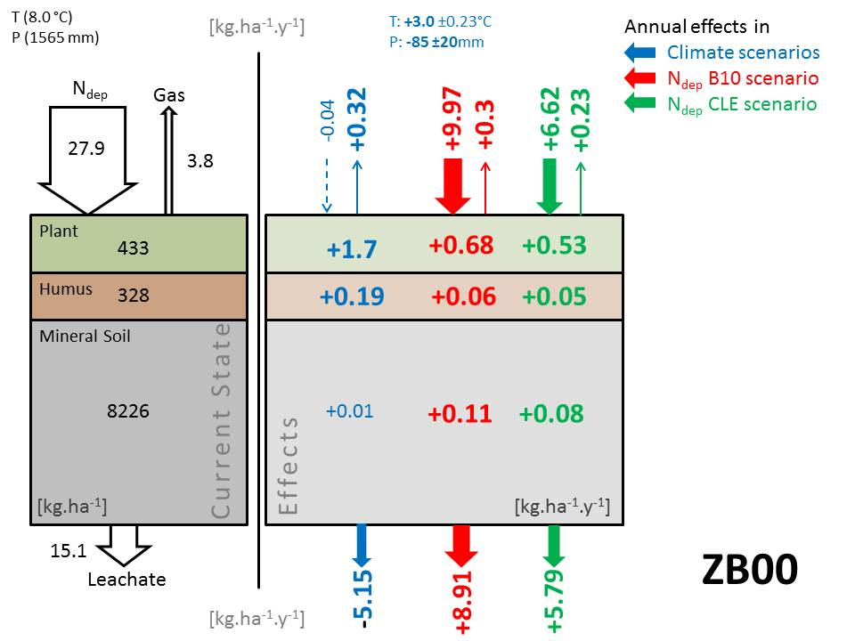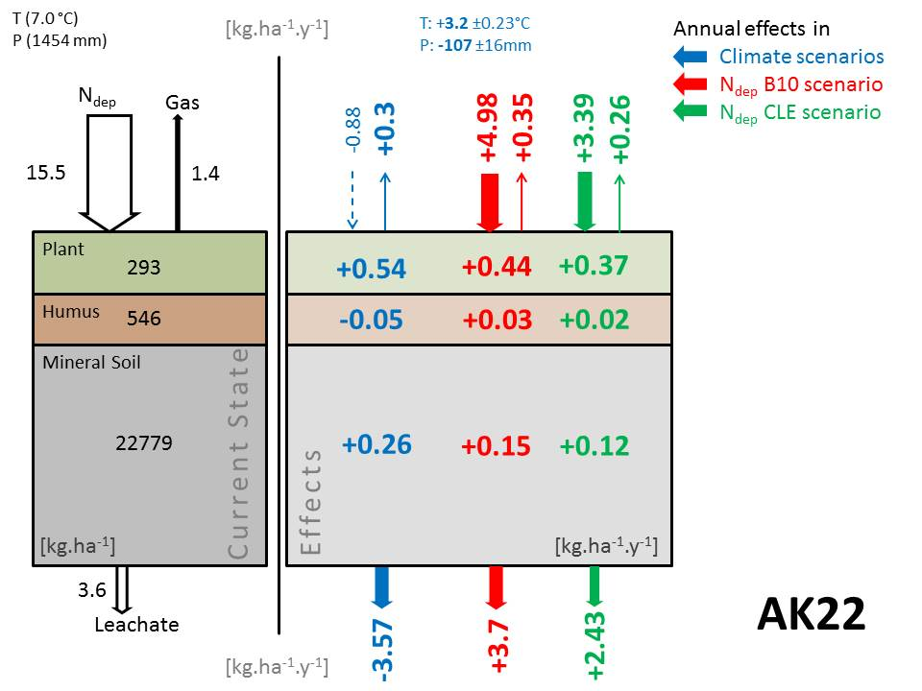
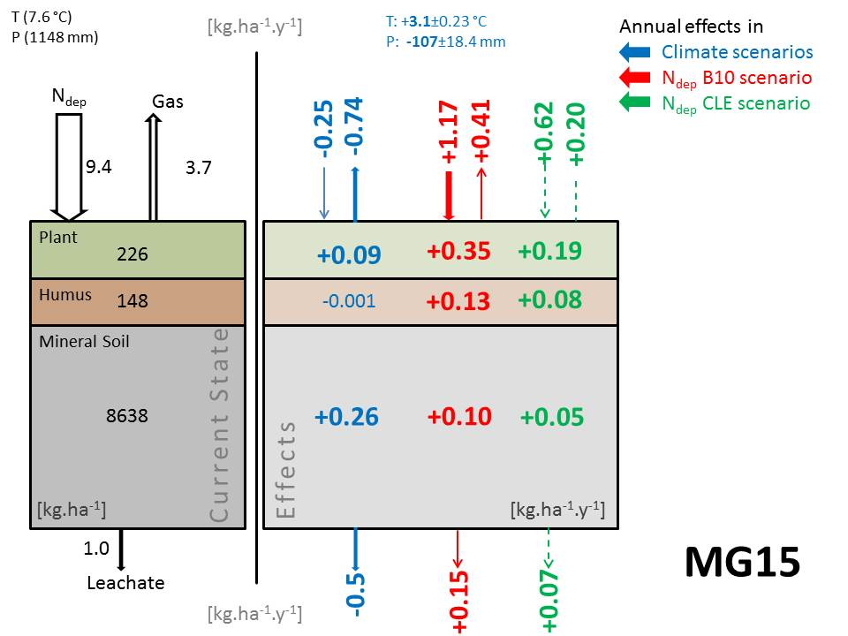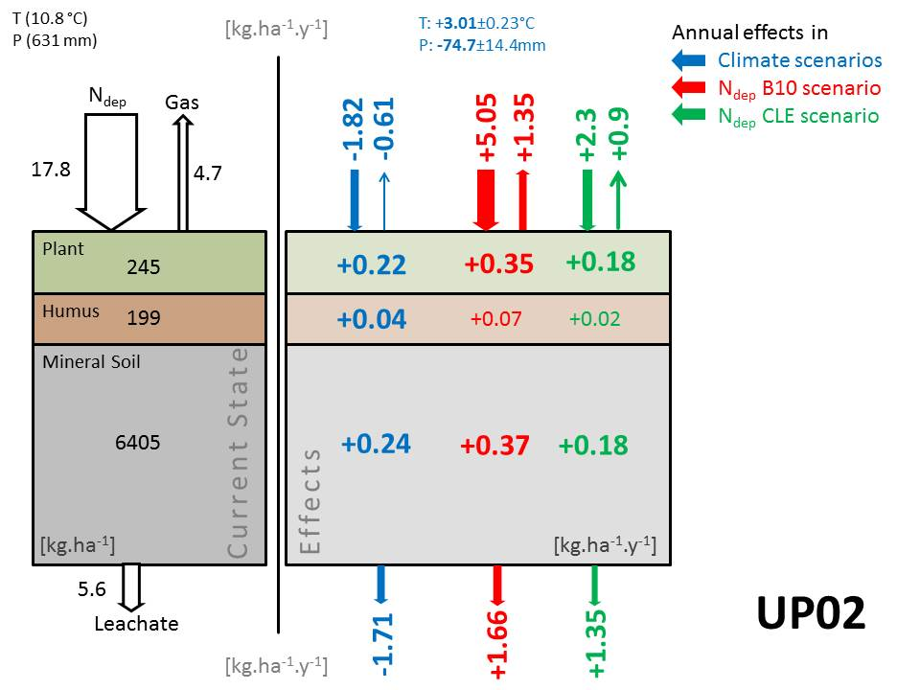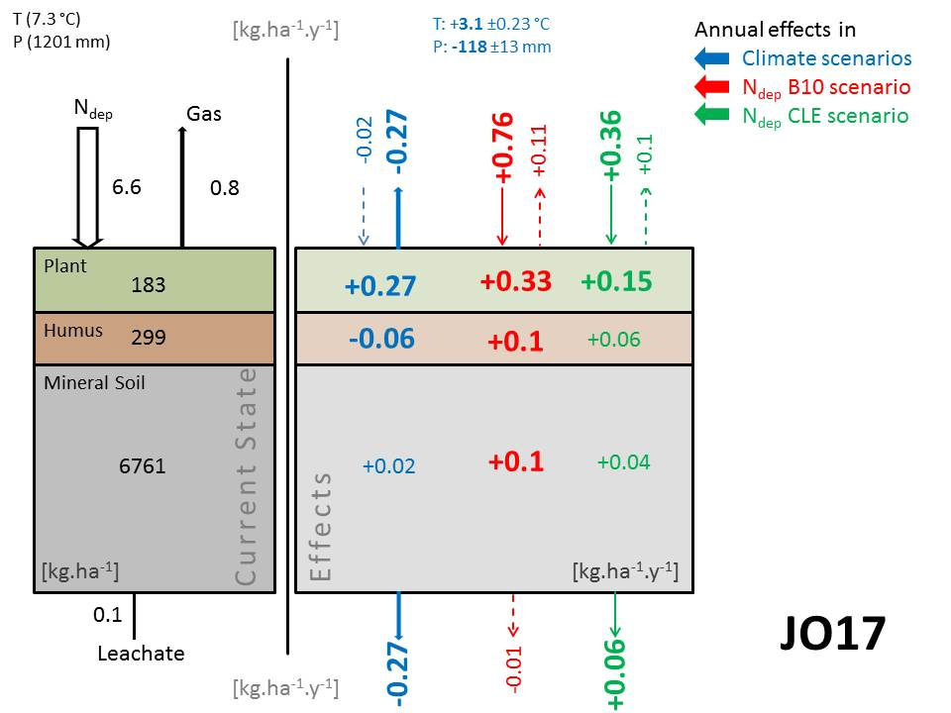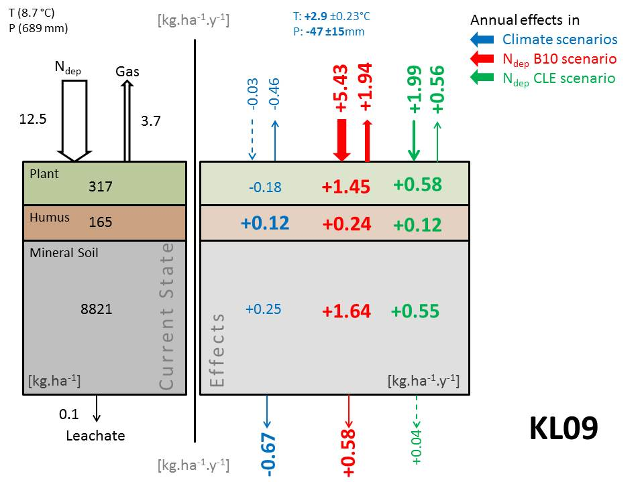
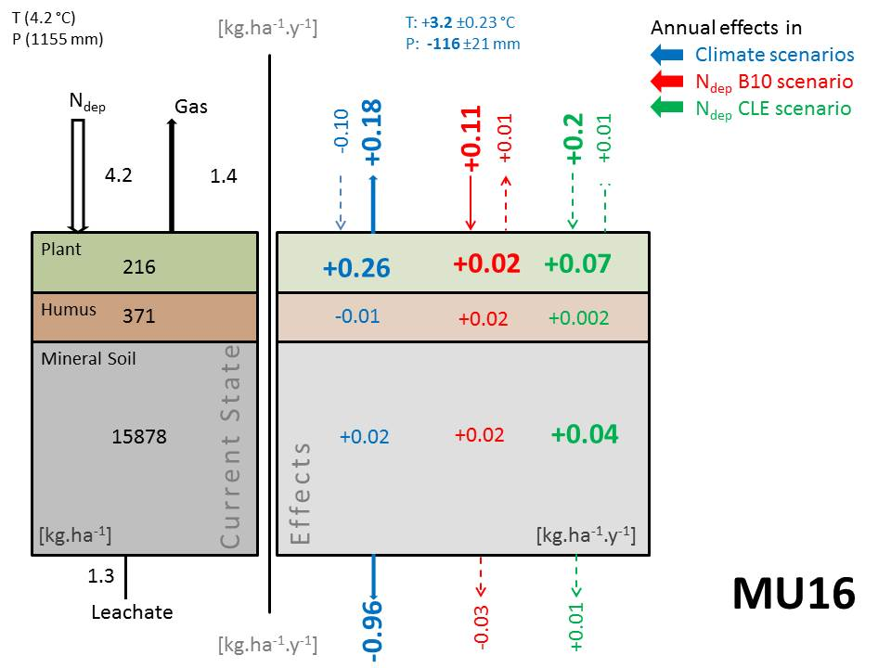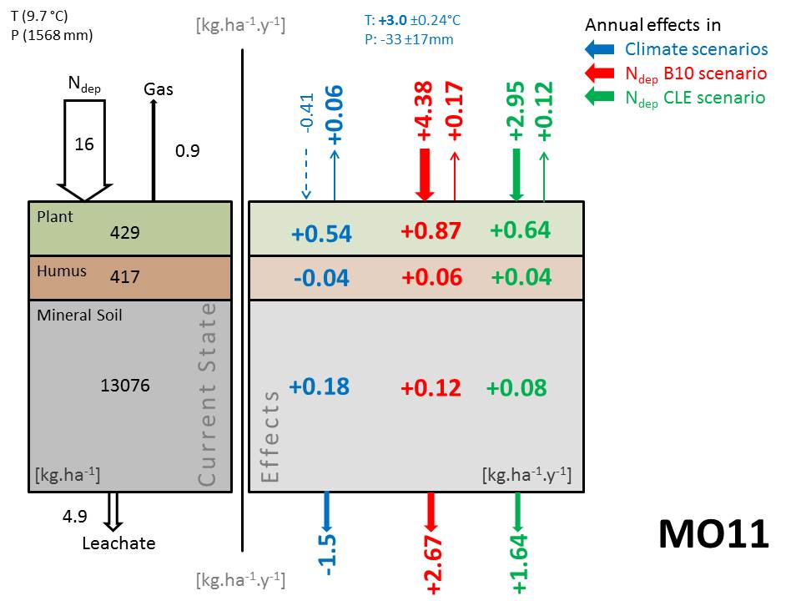

Supplement 3. SOM budgets
Supplement 3 F1. Mean and standard errors in annual total SOM N budgets between 2010 and 2100 in all climate scenarios (baseline, A1B, A2, B1) separated by N deposition scenarios. Δ SOM N values deviate from zero (Wilcox rank sum p<0.05, n=450) except for UP02 B10, KL09 CLE, and KL09 MFR scenarios.

Supplement 4. Model validation
Even though we used generated climate data rather than site measurements, mean annual (2009-2013) soil moisture at 15 and 30 cm soil depth, could be represented well at most sites. Mean annual deviation across all sites between measured and simulated values is less than 3% with a general trend of simulations overestimating measured values. Nevertheless, the model overestimates soil moisture in dryer and underestimates soil moisture in wetter conditions (Supplement 2 F1). Tree growth was calibrated for all sites for the dominant vegetation type (not addressing the understory development within the calibration) and hence had a very high agreement with the actual growth data (tree volume, height and diameter) at each site (Supplement 2 T1). While some sites like MO11 or ZB00 show a perfect agreement with the observation data for tree number, volume and diameter, other sites like AK22 or KL09 show a good overall agreement with small deviations either in tree volume or diameter.
Most of our investigated forest sites are characterized by degrading SOM N, only KL09 accumulated SOM N. However, with annual tree storage between 2.4 and 5.8 kg N ha⁻¹ y⁻¹ all forest ecosystems (60-150 years old) were either in steady state or a net sink for N. This result is in line with an Austrian-wide study summarizing long-term soil and nutrient monitoring data (Jandl et al. 2012a). It also corroborates site based studies at ZB00 and AK22 where N budgets have been derived from measurements and modelling. Jost et al. (2011) showed that soil N retention at ZB00 was in steady state but varied considerably between years (-20 to +20 kg N ha⁻¹ y⁻¹) and this variability was mostly driven by the hydrological control over nitrate leaching. N leaching, when excluding extreme dry years (e.g. drought year 2003) was between 17-31 kg N ha⁻¹ y⁻¹ which is in line with model simulations of this study, and an earlier study of Dirnböck et al. (2016). Similarly, for AK22 our model results show that SOM N is degrading with a rate of 2.5-2.7 kg N ha⁻¹ y⁻¹ after stand age of 40-60 years. Approx. 3 kg N ha⁻¹ y⁻¹ annually are stored in trees and the ecosystem accumulated N, though the magnitude is lower than the value of 5 kg N ha⁻¹ y⁻¹ presented by Jandl et al. (2012b). This might be explained by higher simulated N leaching rates (modelled: 5-15 kg N ha⁻¹ y⁻¹; measured 7 kg N ha⁻¹ y⁻¹) because modelled N gas losses of 1.5-2.5 kg N ha⁻¹ y⁻¹ are similar to those measured (Kitzler et al. 2006a). Gaseous N₂O measurements at KL09 resulted in 0.5-0.7 kg N₂O-N ha⁻¹ yr⁻¹ (Kitzler et al. 2006b). When adding an estimated N₂:N₂O ratio of 5-8 (Butterbach-Bahl et al. 2013) total N efflux is again very similar to our modelled amounts of 2.4-5.2 kg total N ha⁻¹ yr⁻¹ between 1990 and 2010. Together with former studies using the LandscapeDNDC for simulations of C (Grote et al. 2011; Molina-Herrera et al. 2015) and N (Díaz-Pinés et al. 2016; Dirnböck et al. 2016; Kesik et al. 2005; Kiese et al. 2011) in forest ecosystems we are convinced that LandscapeDNDC is suitable for evaluation of future trajectories of N fates at our study sites.
Supplement 4 F1. Comparison of measured and modelled annual mean soil moisture in 15 and 30 cm soil depth at the study sites.
Supplement 4 T1. Yield table and modelled forest growth of the dominant tree species for 5 study sites.

References
Adriaenssens S, Staelens J, Baeten L, Verstraeten A, Boeckx P, Samson R, Verheyen K (2013) Influence of canopy budget model approaches on atmospheric deposition estimates to forests. Biogeochemistry 116:215-229 doi:10.1007/s10533-013-9846-0
Butterbach-Bahl K, Baggs EM, Dannenmann M, Kiese R, Zechmeister-Boltenstern S (2013) Nitrous oxide emissions from soils: how well do we understand the processes and their controls? Philosophical Transactions of the Royal Society B: Biological Sciences 368 doi:10.1098/rstb.2013.0122
Díaz-Pinés E et al. (2016) Nitrate leaching and soil nitrous oxide emissions diminish with time in a hybrid poplar short-rotation coppice in southern Germany. GCB Bioenergy:n/a-n/a doi:10.1111/gcbb.12367
Dirnböck T, Kobler J, Kraus D, Grote R, Kiese R (2016) Impacts of management and climate change on nitrate leaching in a forested karst area. Journal of Environmental Management 165:243-252 doi:http://dx.doi.org/10.1016/j.jenvman.2015.09.039
Grote R, Kiese R, Grünwald T, Ourcival J-M, Granier A (2011) Modelling forest carbon balances considering tree mortality and removal. Agricultural and Forest Meteorology 151:179-190 doi:http://dx.doi.org/10.1016/j.agrformet.2010.10.002
Jandl R, Smidt S, Mutsch F, Fürst A, Zechmeister H, Bauer H, Dirnböck T (2012a) Acidification and Nitrogen eutrophication of Austrian forest soils. Applied and Environmental Soil Science 2012:9 doi:10.1155/2012/632602
Jandl R et al. (2012b) The carbon and nitrogen biogeochemistry of a montane Norway spruce (Picea abies (L.) Karst.) forest: a synthesis of long-term research. Plant Ecology & Diversity 5:105-114 doi:10.1080/17550874.2012.695813
Jost G, Dirnböck T, Grabner M-T, Mirtl M (2011) Nitrogen leaching of two forest ecosystems in a karst watershed Water Air Soil Pollut 218:633-649 doi:10.1007/s11270-010-0674-8
Kesik M et al. (2005) Inventories of N₂O and NO emissions from European forest soils. Biogeosciences 2:353-375 doi:10.5194/bg-2-353-2005
Kiese R, Heinzeller C, Werner C, Wochele S, Grote R, Butterbach-Bahl K (2011) Quantification of nitrate leaching from German forest ecosystems by use of a process oriented biogeochemical model. Environmental Pollution 159:3204-3214 doi:10.1016/j.envpol.2011.05.004
Kitzler B, Zechmeister-Boltenstern S, Holtermann C, Skiba U, Butterbach-Bahl K (2006a) Controls over N₂O, NO_{x} and CO₂ fluxes in a calcareous mountain forest soil. Biogeosciences 3:383–395
Kitzler B, Zechmeister-Boltenstern S, Holtermann C, Skiba U, Butterbach-Bahl K (2006b) Nitrogen oxides emission from two beech forests subjected to different nitrogen loads. Biogeosciences 3:293-310
Molina-Herrera S et al. (2015) Simulation of CO₂ fluxes in European forest ecosystems with the coupled soil-vegetation process model “LandscapeDNDC”. Forests 6:1779
Schöpp W, Posch M, Mylona S, Johansson M (2003) Long-term development of acid deposition (1880–2030) in sensitive freshwater regions in Europe. Hydrol Earth Syst Sci 7:436-446 doi:10.5194/hess-7-436-2003
Simpson D et al. (2012) The EMEP MSC-W chemical transport model and technical description. Atmos Chem Phys 12:7825-7865 doi:10.5194/acp-12-7825-2012
Smidt S, Obersteiner E (2007) 10 Jahre Depositionsmessung im Rahmen des europäischen Waldschadensmonitorings. Austrian Journal of Forest Science 124:83-104

