Assessing uncertainty of climate change impacts on long-term hydropower generation using the CMIP5 ensemble - The case of Ecuador
Supplementary Information
Pablo E. Carvajal^{1*}, Gabrial Anandarajah¹, Yacob Mulugetta², Olivier Dessens¹
¹UCL Energy Institute, University College London, Central House 14 Upper Woburn Place, London WC1H 0NN, UK
²Department of Science, Technology, Engineering and Public Policy, University College London, 36-37 Fitzroy Square, London W1T 6EY, UK
*Corresponding author: pablo.carvajal.14@ucl.ac.uk, +44 796 151 0256

Abstract
This document presents the Supplementary Information for the paper “Assessing uncertainty of climate change impacts on long-term hydropower generation using the CMIP5 ensemble - The case of Ecuador”, by Carvajal, Anandarajah and Mulugetta. The data and models used to quantify the impacts of climate change on Ecuador’s hydropower electricity generation are defined. Also provided is additional explanatory results for the mathematical formulation.

Data

Inflow data
Mean monthly flow from six gauging stations for a 30-year period (1971-2000) were provided by the Ecuadorian National Electricity Operator (CENACE) (see Table 1 and Fig. 1). However, to assure their validity, we compared these unregulated inflow values with quality-assured data from the Global Runoff Data Centre (GRDC) and corroborated that the values provided by CENACE were consistent with data that has passed quality control procedures and plausibility checks (GRDC 2016). Streamflow-gauging stations are considered to characterize the catchment basin, which is a necessary simplification due to the lack of historic datasets of inflow that cover larger areas of the catchment. Fig. 2 presents the obtained inflow 30-year time series for the six rivers that are assessed.

Climate change scenarios
Forty GCMs under the RCP4.5 scenario from the CMIP5 were used in this study and are presented in Table 2. It must be mentioned that, the framework presented here was also applied for the RCP2.6 and RCP8.5 scenarios, however differences among RCPs were found to be smaller compared to inter-GCM differences; inter-GCM uncertainty range was also found to have similar magnitude for all three concentration scenarios. Fig. 3 presents downloaded precipitation values for individual GCMs, the ensemble mean and the historic average. Our focus is to assess the discrepancy among individual GCMs and not among RCP scenarios. Assessing RCP2.6, RCP4.5 and RCP8.5 in Fig. 3, we observe that the range of disagreement among individual GCMs is similar in all three RCPs and performing the analysis for the three RCPs would be somehow redundant. We find in the literature that when the focus is on assessing inter-GCM uncertainty usually one RCP is considered, for example in the study of (Ho et al. 2015) and (Thompson et al. 2015) which assess GCM-related uncertainty and use only the RCP4.5, however when wanting to assess inter-scenario uncertainty and the extremes of RCPs, usually RCP2.6 and RCP8.5 are considered, for example in the studies of (Samaniego et al. 2016) and (van Vliet et al. 2016), however these leave out the large discrepancies among GCMs. Another reason is that the RCP4.5 is the scenario that bundles up more GCM models. RCP4.5 contains results from 41 GCMs compared to 26 GCMs for the RCP2.6, 17 GCMs for RCP6.0 and 30 GCMs for RCP8.5 (van Oldenborgh et al. 2013). Considering we want to assess the discrepancy of GCM models, we chose the GCM scenario that has the most modelling results. We also must mention that inter-GCM related uncertainty rather that inter-scenario uncertainty is mentioned in the literature as the main source of uncertainty for regional climate change scenarios (Escobar et al. 2011). A final reason to use the RCP4.5 is that it is considered like a ‘middle of the road’ pathway compared to the others (Thomson et al. 2011) and is the and also represents the 2°C by end of the 21st century central aim of the United Nations 2015 Paris Agreement.
Monthly precipitation and PET data for each GCM were obtained for two 30-year periods: baseline from 1971 to 2000, the same duration as the calibration period for the hydrological model, and future period (2071–2100) against which baseline period values were compared by simple scaling. This allows patterns of climate change to be expressed as the percentage change between the two time periods, also known as the delta factor approach (Fowler et al. 2007). The delta method’s limitations are related to the strong assumptions it makes about the nature of the changes, including a lack of change in the variability and spatial patters of climate, and that some extreme values are overlooked when working with averages (NORDEN 2010). The lack of meteorological data and high variability of the climate system in the Tropical Andes region complicate the use of more complex downscaling methods (Buytaert et al. 2010). GCM data were downloaded from the Royal Netherlands Meteorological Institute (KNMI) Climate Explorer database using a bilinear interpolation approach and averaging precipitation and PET gridded values for each of the six basins of the hydrological model (Trouet and Van Oldenborgh 2013). Data was bias-corrected using precipitation and PET values from the observed baseline period CRU datasets and using a multiplier on a monthly basis.

Climate-sensitive hydrologic-electricity model

Hydrological model
The hydrologic model consists of two steps similar to the methodology by De Lucena et al. (2009). First a statistical approach that combines 30 years of observed monthly time series of precipitation and inflow is used to assess the relationship between rainfall and inflow through a linear regression model (Jones et al. 2006) (see Eq.1).
$\ln\left(Q_{t}\right)=α+β_{1}\ln\left({Pr}_{t-m}\right)+β_{2}d_{2}\ln\left({Pr}_{t-m}\right)+ε$ (1)
where, $Q_{m}$ and ${Pr}_{t-m}$are the average observed monthly inflow and precipitation (1971-2000) for month t, ${α, β_{1}, β_{2} are the estimated regression coefficients, d}_{2}$ is a categorical variable , and $ε$ is the error term. The relevant regression coefficients are $β_{1}$ and${ β}_{2}$, which represent the sensitivity or ‘elasticity’ of average monthly inflow with respect to average precipitation (E_{Q-Pr}). When a month is in the d₂ period, the elasticity E_{Q-Pr} is equal to ($β_{1}$ +${ β}_{2}$), otherwise, it is equal to $β_{1}$.
In the first step the seasonal patterns are captured statistically but evapotranspiration and storage effects are omitted, so an additional step is included to correct for total annual discharge. The second step therefore includes the conceptual equation of the water balance: $WB=Pr-PET+∆S$, where WB is the water balance, Pr is precipitation, PET is potential evapotranspiration and $∆S$ is storage variation in soil and underground aquifers that throughout the seasonal cycle can be negligible since the dry period presents negative values and the wet period presents positive values of similar magnitude (Arnold et al. 1998). The water balance is applied therefore as a monthly correction factor to account other hydrological variables and future runoff is simulated with the following equation:
$Q_{t}^{future}=Q_{t}^{baseline}∙\left[1+E_{Q-Pr}∙\left(∆{Pr}_{t}^{future,baseline}-1\right)\right]∙ϕ_{WB,t}$ (2)

$ϕ_{WB}=\frac{{WB}_{a}^{GCM, future}}{Q_{a}^{GCM,future}}=\frac{\sum_{1}^{12}{({Pr}_{i,m}^{GCM, future}-{PET}_{i,m}^{GCM,future})}}{\sum_{1}^{12}{Q_{j,m}^{GCM, future}}}$ (Eq.3)

where, $ϕ_{WB}$ is the water balance correction factor defined by the ratio of the future annual water balance ${WB}_{a}^{GCM, future}$ and the projected annual inflow $Q_{a}^{GCM,future}$.
Fig. 4 shows observed and simulated mean monthly discharges into hydropower stations for the calibration period 1971-2000. Validation results for the hydrological model are presented in Table 3 and is classed between “excellent” (7 out of 18 performance statistics) and “very good” (6 out of 18 performance statistics). NSE for 5 gauging stations is classified as “excellent” or “very good”, meaning that the model represents variations in inflow well. Relatively high values of r are obtained for the Pacific watershed, which are above or close to 0.90, however lower r values are obtained for the Amazon watershed. Dv for all of the stations is mostly classified as “excellent” in both watersheds. The simulation of key hydrological indicators, such as river runoff driven by various climate projections from GCMs as input forcing data brings a number of uncertainties (Samaniego et al. 2016). With regards to the hydrological model, the greatest source of uncertainty comes from the data used for its development. This is, CRU data sets are only approximations based on the interpolation of data from disperse weather stations in the region, whose data may contain discontinuities or be poorly calibrated (Harris et al. 2014). Derived PET values computed by CRU using the Penman-Monteith approach also bring an additional uncertainty source; however, using a more advanced method would not have necessarily helped to reduce uncertainty since it would have depended on other variables provided the same CRU dataset. Observed inflow values provided by CENACE which were used to assess the performance of the hydrological model may be subject to human or instrumental error.

Hydropower model
To simulate the behaviour of the hydropower dam operators (Yi Ng et al. 2017), we model the available water that can be released for hydropower generation using reservoir specifications and according to the inflow time-series generated by the previous hydrological model. Releases are specified for each month of the year, as well as reservoir level and spillage. Storage dynamics are simulated using the laws of mass balance:
$S_{t}=S_{t-1}+Q_{t}+V_{t}^{*}-V_{t}$
$0≤S_{t}≤S_{usable}$ (3)
$V_{min}≤V_{t}≤V_{max}$
where $S_{t}$ in the reservoir storage in month $t$, $Q_{t}$ is the current period reservoir inflow, $V_{t}^{*}$ is the water release or spillage from an upstream hydropower dam (if any) and $V_{t}$ is the water release volume to the turbines. $S_{usable}$ is the maximum usable storage of the reservoir, $V_{max}$ is the maximum volume of water that can be released through the turbines for the hydropower station to work at maximum capacity in each period and $V_{min}$ is the minimum release that must satisfy turbine operation, downstream hydropower stations requirements and environmental flows.
Monthly hydropower production $E_{t}$ (MWh) and capacity factor CF is simulated as follows:
$E_{t}=η∙ρ∙g∙{H∙V}_{t}$ (4)
${CF}_{t}=E_{t}/(P∙T)$
where $η$ is plant efficiency, $ρ$ is the water density, $g$ is gravitational acceleration, $H$ is hydraulic head and $V_{t}$ is the inflow into the turbine. Efficiency $η$ accounts for turbine efficiency and friction losses, and is used as a calibration parameter. Hydraulic head considers penstock vertical head plus average dam height. In the capacity factor equation, $P$ is nominal capacity of the hydropower station and $T$ is number of hours in a month. We choose to assess the monthly capacity factor since hydro-climatic conditions are generally integrated into energy system models by exogenously defining the capacity factor of hydropower power generation technologies to characterise their availability according to inter-annual runoff seasonality (Gargiulo 2009; Kannan and Turton 2011; IFE 2013).
The model was run for all 10 hydropower stations, their technical detail depicted in Table 4. However, to calibrate and validate the model we compared modelled hydropower production for 4 hydropower stations (Mazar, Molino, Marcel Laniado and Agoyán) that represent different types of hydropower facilities i.e. single/cascading and run-of-river/dam. Fig. 5 compares modelled to observed monthly production. The close fit between modelled and observed hydropower production shows that our aggregated global results give a good indication of reality. Hydropower electricity model performance has been validated with similar to (Yi Ng et al. 2017) with two statistical measures i) Pearson’s correlation coefficient (r) and the (ii) standard error (e). Table 5 presents validation results and shows that Pearson’s correlation scores for observed versus simulated hydropower production demonstrate reasonable to strong performance for most hydropower stations in average a value of 0.9. Standard error is also low in average 1.2% of the value of total monthly generated electricity.

References
Arnold JG, Srinivasan R, Muttiah RS, Williams JR (1998) LARGE AREA HYDROLOGIC MODELING AND ASSESSMENT PART I: MODEL DEVELOPMENT. J Am Water Resour Assoc 34:73–89. doi: 10.1111/j.1752-1688.1998.tb05961.x
Bates B, Kundzewicz ZW, Wu S, Palutikof J (2008) Climate Change and Water. Technical Paper of the Intergovernmental Panel on Climate Change. Intergovernmental Panel on Climate Change (IPCC)
Buytaert W, Vuille M, Dewulf a., et al (2010) Uncertainties in climate change projections and regional downscaling in the tropical Andes: Implications for water resources management. Hydrol Earth Syst Sci 14:1247–1258. doi: 10.5194/hess-14-1247-2010
Célleri R (2007) Rainfall variability and rainfall-runoff dynamics in the Paute River Basin–Southern Ecuadorian Andes. Katholieke Universiteit Leuven
CONELEC (2012) Plan Maestro de Electrificacion 2013-2022. Quito - Ecuador
De Lucena AFP, Szklo AS, Schaeffer R, et al (2009) The vulnerability of renewable energy to climate change in Brazil. Energy Policy 37:879–889. doi: 10.1016/j.enpol.2008.10.029
Fowler HJ, Blenkinsop S, Tebaldi C (2007) Linking climate change modelling to impacts studies: recent advances in downscaling techniques for hydrological modelling. Int J Climatol 27:1547–1578. doi: 10.1002/joc.1556
GRDC (2016) The Global Runoff Data Centre. 56068 Koblenz, Germany
Harris I, Jones PD, Osborn TJ, Lister DH (2014) Updated high-resolution grids of monthly climatic observations - the CRU TS3.10 Dataset. Int J Climatol 34:623–642. doi: 10.1002/joc.3711
Henriksen HJ, Troldborg L, Højberg AL, Refsgaard JC (2008) Assessment of exploitable groundwater resources of Denmark by use of ensemble resource indicators and a numerical groundwater-surface water model. J Hydrol 348:224–240. doi: 10.1016/j.jhydrol.2007.09.056
Ho JT, Thompson JR, Brierley C (2015) Projections of hydrology in the Tocantins-Araguaia Basin, Brazil: uncertainty assessment using the CMIP5 ensemble. Hydrol Sci J 6667:150603015228007. doi: 10.1080/02626667.2015.1057513
Jones RN, Chiew FHS, Boughton WC, Zhang L (2006) Estimating the sensitivity of mean annual runoff to climate change using selected hydrological models. Adv Water Resour 29:1419–1429. doi: 10.1016/j.advwatres.2005.11.001
NORDEN (2010) Conference on Future Climate and Renewable Energy: Impacts, Risks and Adaptation. In: Conference on Future Climate and Renewable Energy: Impacts, Risks and Adaptation.
Samaniego L, Kumar R, Breuer L, et al (2016) Propagation of forcing and model uncertainties on to hydrological drought characteristics in a multi-model century-long experiment in large river basins. Clim Change. doi: 10.1007/s10584-016-1778-y
Trouet V, Van Oldenborgh GJ (2013) KNMI Climate Explorer: A Web-Based Research Tool for High-Resolution Paleoclimatology. Tree-Ring Res 69:3–13. doi: 10.3959/1536-1098-69.1.3
Yi Ng J, Turner S, Galelli S (2017) Influence of El Nino Southern Oscillation on global hydropower production.

Table 1 Gauging stations used in this study (refer to Fig. 1) (CONELEC 2012; GRDC 2016)
No. | River | Basin | Hydropower stations | Gauging stations
 |  |  |  | Name | Lat. (°) | Lon. (°)
Pacific watershed
1 | Toachi | Esmeraldas | Toachi*  Pilatón* | Toachi - A.J Pilatón | -0.31 | -78.95
2 | Daule | Guayas | Marcel Laniado | Marcel Laniado | -1.01 | -79.46
3 | Jubones | Jubones | Minas San Francisco* | Jubones - D.J. San Francisco | -3.30 | -79.50
Amazon watershed
4 | Paute | Santiago | Mazar  Molino  Sopladora** | Paute - D.J. Palmira | -2.57 | -78.57
5 | Pastaza | Pastaza | Agoyán  San Francisco | Pastaza - Baños | -1.38 | -78.42
6 | Coca | Napo | Coca Codo Sinclair** | Coca - San Rafael | -0.10 | -77.58
*Expected to enter operation in 2017
^{**Started operation in 2016}

Table 2 CMIP5 GCMs used in this study. Note that for the RCP4.5 emission scenario all 42 GCMs derive precipitation values, however only 40 GCMs derive PET. Therefore, we only use a maximum of 40GCMs (Trouet and Van Oldenborgh 2013)
No. | Model | Institution | RCP4.5
No. | Model | Institution | PR | PET
1 | ACCESS1-0 | Commonwealth Scientific and Industrial Research Organisation (CSIRO) and Bureau of Meteorology (BOM), Australia | ✓ | ✓
2 | ACCESS1-3 |  | ✓ | ✓
3 | BCC-CSM1.1 | Beijing Climate Centre, China Meteorological Administration | ✓ | ✓
4 | BCC-CSM1.1(m) | Beijing Climate Centre, China Meteorological Administration | ✓ | ✓
5 | BNU-ESM | College of Global Change and Earth System Science, Beijing Normal University | ✓ | ✓
6 | CanESM2 | Canadian Centre for Climate Modelling and Analysis | ✓ | ✓
7 | CCSM4 | National Centre for Atmospheric Research | ✓ | ✓
8 | CESM1-BGC | Community Earth System Model Contributors | ✓ | ✓
9 | CESM1-CAM5 | Community Earth System Model Contributors | ✓ | ✓
10 | CMCC-CM | Centro Euro-Mediterraneo per I Cambiamenti Climatici | ✓ | ✓
11 | CMCC-CMS | Centro Euro-Mediterraneo per I Cambiamenti Climatici | ✓ | -
12 | CNRM-CM5 | Centre National de Recherches Meteorologiques | ✓ | ✓
13 | CSIRO-Mk3-6-0 | Commonwealth Scientific and Industrial Research Organisation (CSIRO) | ✓ | ✓
14 | EC-EARTH | EC-Earth Consortium | ✓ | ✓
15 | FGOALS-g2 | LASG, Institute of Atmospheric Physics, Chinese Academy of Sciences | ✓ | ✓
16 | FIO-ESM | The First Institute of Oceanography, SOA, China | ✓ | ✓
17 | GFDL-CM3 | NASA Goddard Institute for Space Studies | ✓ | ✓
18 | GFDL-ESM2G | NASA Goddard Institute for Space Studies | ✓ | ✓
19 | GFDL-ESM2M | NASA Goddard Institute for Space Studies | ✓ | ✓
20 | GISS-E2-H p1 | NASA Goddard Institute for Space Studies | ✓ | ✓
21 | GISS-E2-H p2 | NASA Goddard Institute for Space Studies | ✓ | ✓
22 | GISS-E2-H p3 | NASA Goddard Institute for Space Studies | ✓ | ✓
23 | GISS-E2-H CC | NASA Goddard Institute for Space Studies | ✓ | ✓
24 | GISS-E2-R p1 | NASA Goddard Institute for Space Studies | ✓ | ✓
25 | GISS-E2-R p2 | NASA Goddard Institute for Space Studies | ✓ | ✓
26 | GISS-E2-R p3 | NASA Goddard Institute for Space Studies | ✓ | ✓
27 | GISS-E2-R CC | NASA Goddard Institute for Space Studies | ✓ | ✓
28 | HadGEM2-AO | Met Office Hadley Centre | ✓ | -
29 | HadGEM2-CC | Met Office Hadley Centre | ✓ | ✓
30 | HadGEM2-ES | Met Office Hadley Centre | ✓ | ✓
31 | INM-CM4 | Institute for Numerical Mathematics | ✓ | ✓
32 | IPSL-CM5A-LR | Institute Pierre-Simon Laplace | ✓ | ✓
33 | IPSL-CM5A-MR | Institute Pierre-Simon Laplace | ✓ | ✓
34 | IPSL-CM5B-LR | Institute Pierre-Simon Laplace | ✓ | ✓
35 | MIROC5 | Atmosphere and Ocean Research Institute (The University of Tokyo), National Institute of Environmental Studies, and Japan Agency for Marine-Earth Science and Technology | ✓ | ✓
36 | MIROC-ESM | Japan Agency for Marine-Earth Science and Technology | ✓ | ✓
37 | MIROC-ESM-CHEM | Ocean Research Institute and National Institute of Environmental Studies | ✓ | ✓
38 | MPI-ESM-LR | Max-Planck-Institute für Meteorologie | ✓ | ✓
39 | MPI-ESM-MR | Max-Planck-Institute für Meteorologie | ✓ | ✓
40 | MRI-CGCM3 | Meteorological Research Institute | ✓ | ✓
41 | NorESM1-M | Norwegian Climate Centre | ✓ | ✓
42 | NorESM1-ME | Norwegian Climate Centre | ✓ | ✓

Table 3 Range of model performance statistics based on mean monthly discharges for a lumped conceptual hydrological model for six inflow gauging stations at Ecuador’s largest hydropower stations for the calibration period (1971–2000). Model performance indicators are taken from (Henriksen et al. 2008)
No. | River | Gauging station |  |  | Dv (%) |  |  | NSE |  |  | r
Pacific watershed
1 | Toachi | Toachi - A.J Pilatón |  |  | -3.27 | ✩✩✩✩✩ |  | 0.79 | ✩✩✩✩ |  | 0.90 |  | ✩✩✩✩
2 | Daule | Marcel Laniado |  |  | -6.7 | ✩✩✩✩ |  | 0.87 | ✩✩✩✩✩ |  | 0.95 |  | ✩✩✩✩✩
3 | Jubones | Jubones - D.J. San Francisco |  |  | -1.99 | ✩✩✩✩✩ |  | 0.78 | ✩✩✩✩ |  | 0.89 |  | ✩✩✩
Amazon watershed
4 | Paute | Paute - D.J. Palmira |  |  | -1.95 | ✩✩✩✩✩ |  | 0.72 | ✩✩✩✩ |  | 0.85 |  | ✩✩✩
5 | Pastaza | Pastaza - Baños |  |  | -1.63 | ✩✩✩✩✩ |  | 0.58 | ✩✩✩ |  | 0.77 |  | ✩
6 | Coca | Coca - San Rafael |  |  | -1.48 | ✩✩✩✩✩ |  | 0.67 | ✩✩✩✩ |  | 0.82 |  | ✩✩
Performance indicator |  |  | Excellent | Very good |  |  | Fair |  |  | Poor |  | Very poor
 |  |  | ✩✩✩✩✩ | ✩✩✩✩ |  |  | ✩✩✩ |  |  | ✩✩ |  | ✩
Dv |  |  | <5% | 5 – 9 % |  |  | 10 – 14% |  |  | 15 – 19% |  | ≥20%
NSE |  |  | ≥0.85 | 0.65 – 0.84 |  |  | 0.50 – 0.64 |  |  | 0.20 – 0.49 |  | <0.20
r |  |  | ≥0.95 | 0.90 – 0.94 |  |  | 0.85 – 0.89 |  |  | 0.80 – 0.84 |  | <0.80

Table 4 Hydropower stations technical characteristics. Cascading systems are shown with arrows (refer to Fig.1) (CENACE 2015; MEER 2015; MICSE 2016)
N. | Hydropower station | River | Installed Capacity (MW) | Average generation (GWh/y) | Storage*** |  |  | Head (m) | Design flow (m3/s) | Location |  | Status
 |  |  |  |  | Min. (Hm³) |  | Max.  (Hm³) | Head (m) | Design flow (m3/s) | Lat.  (°) | Lon.  (°) | Status
Pacific watershed
1 | Pilatón* | Pilatón | 48.9 | 224 | - | - |  | 149 | 28.6 | -0.31 | -78.96 | Expected 2017 (completed 94% by Jan 2017)
2 | ↳Toachi* | Toachi+outflow Pilatón | 205.4 | 896 | 6.5 | 8.5 |  | 235 | 100 | -0.31 | -78.97 | Expected 2017 (completed 94% by Jan 2017)
3 | Marcel Laniado | Daule | 213 | 717 | 1733.6 | 5802.5 |  | 55 | 397.5 | -0.92 | -79.37 | In operation since 1987
4 | Minas S. Francisco* | Jubones | 275 | 1290 | 8.3 | 14.3 |  | 474 | 65 | -3.31 | -79.52 | Expected 2017 (completed 93% by Feb 2017)
Amazon watershed
5 | Mazar | Paute | 170 | 900 | 91.5 | 394.1 |  | 159 | 141.1 | -2.59 | -78.62 | In operation since 2010
6 | ↳Molino | Paute (outflow from Mazar) | 1100 | 4800 | 25.9 | 69.4 |  | 660 | 220.0 | -2.59 | -78.56 | In operation since 1983
7 | ↳Sopladora** | Paute (outflow from Molino) | 487 | 2800 | - | - |  | 363 | 150.0 | -2.57 | -78.47 | In operation since Aug 2016
8 | Agoyán | Pastaza | 156 | 1080 | 1.1 | 1.9 |  | 150 | 120.0 | -1.39 | -78.38 | In operation since 1987
9 | ↳San Francisco | Pastaza (outflow from Agoyán) | 230 | 1400 | - | - |  | 213 | 116.0 | -1.39 | .78.35 | In operation since Jun 2007
10 | Coca Codo Sinclair** | Coca | 1500 | 8734 | - | - |  | 620 | 287.0 | -0.12 | -77.44 | In operation since Oct 2016
Total system |  |  | 4368 | 22841
*Expected to enter operation in 2017
**Started operation in 2016
**Usable storage is equal to the difference between maximum and minimum storage

Table 5 Fit diagnostics for hydropower electricity output model
Hydropower station | Average generation  (GWh/y) | Type | Useful reservoir (Hm³) | R² | Std. error (GWh) | Calibration period
Mazar | 800 | Single/Dam | 302.6 | 0.88 | 10.1 | 2012-2015
Molino | 4900 | Cascading/RoR* | 43.5 | 0.89 | 58.2 | 2005-2015
Marcel Laniado | 717 | Single/Dam | 4069 | 0.87 | 13.9 | 2005-2015
Agoyán | 1080 | Single/RoR | 0.8 | 0.96 | 5.1 | 2005-2015
*ROR = Run of river

Fig. 1 Ecuador's six major river basins, hydropower stations and gauging stations used in this study
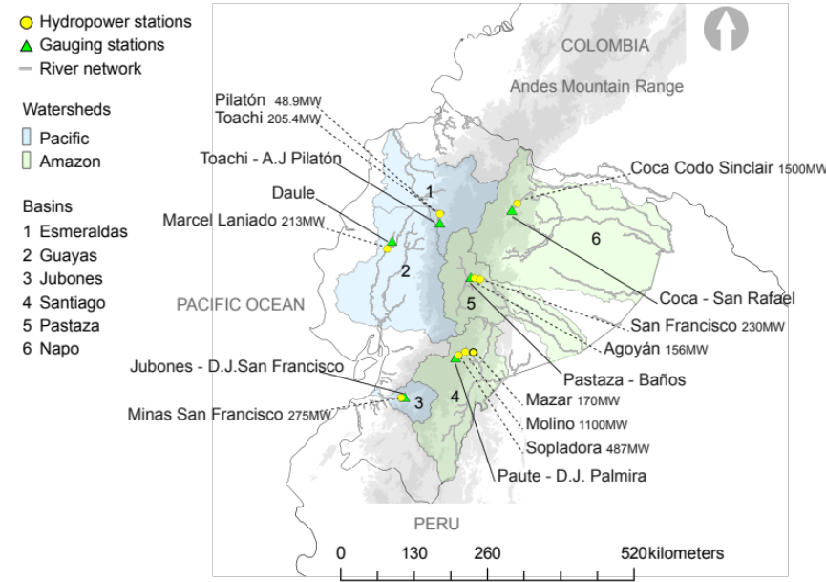

Fig. 2 Time series for assessed river basins in Ecuador (1971 – 2000)
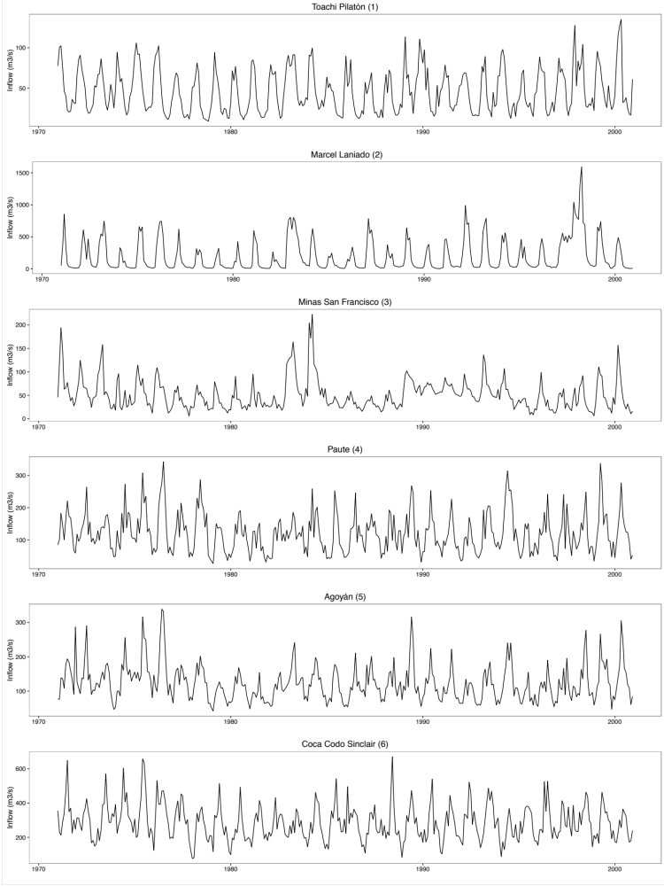

Fig. 3 Comparison of precipitation in the Paute River of Ecuador for individual GCM projections of the CMIP5 ensemble under three different RCPs and period 2017-2100.
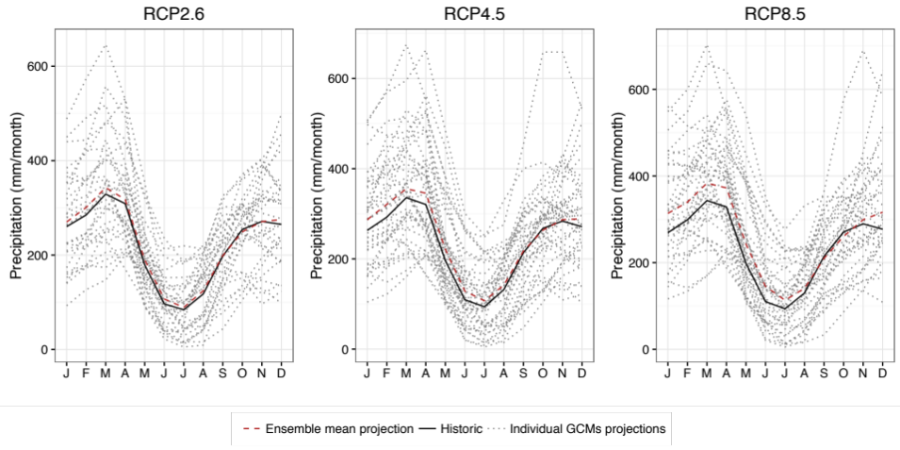

Fig. 4 Observed and simulated river regimes for inflow gauging stations in Ecuador’s major hydropower stations for the calibration period (1971–2000). Numbers in brackets refer to the gauging stations detailed in Table 2
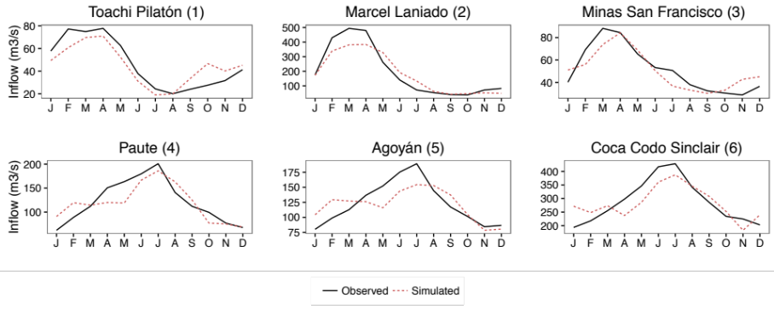
Fig. 5 Modelled (broken line) versus observed monthly hydropower production for four hydropower stations representing different types of hydropower stations detailed in Table 4 and different quality of fits detailed in Table 5 .
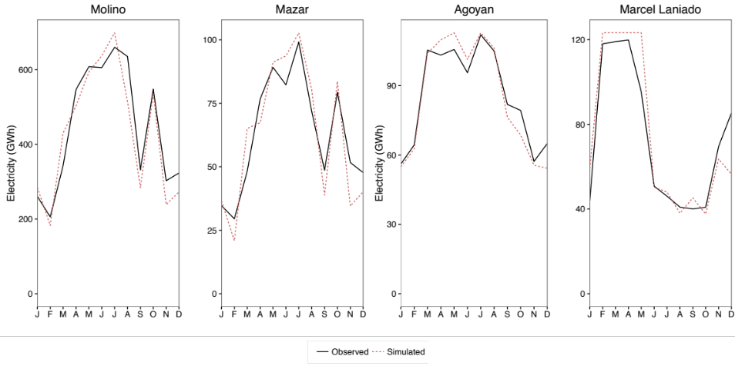

Precipitation has been identified as the leading driver for inflow in Ecuador (Célleri 2007). In regions with little or no snow, e.g. in the Amazon, changes in runoff are much more dependent on changes in rainfall than on changes in temperature (Bates et al. 2008).
Notice that there is a lag time m between precipitation and runoff, which has been adjusted to obtain the best model fit.
A categorical variable was inserted to improve regression fit and represent seasonal patterns, being d₂=0 for the dry season (from October to February) and d₂=1 for the wet season.

