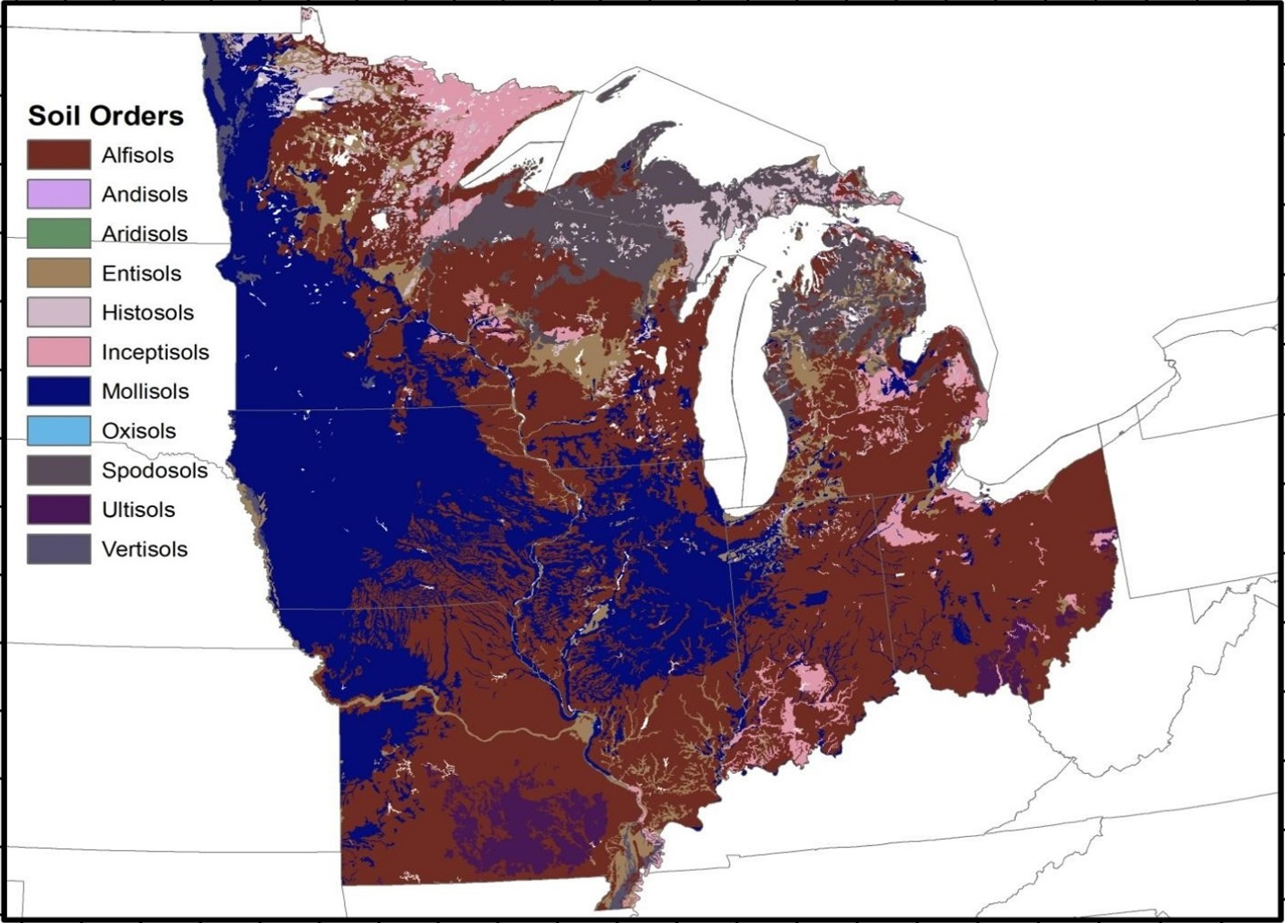
Supplemental Fig 1. Major soil orders across the Midwest region. Data taken from USDA NRCS Web Soil Survey 2016

