Online Resource 5. Projected midcentury (2040-2069) county level summer maximum temperatures.

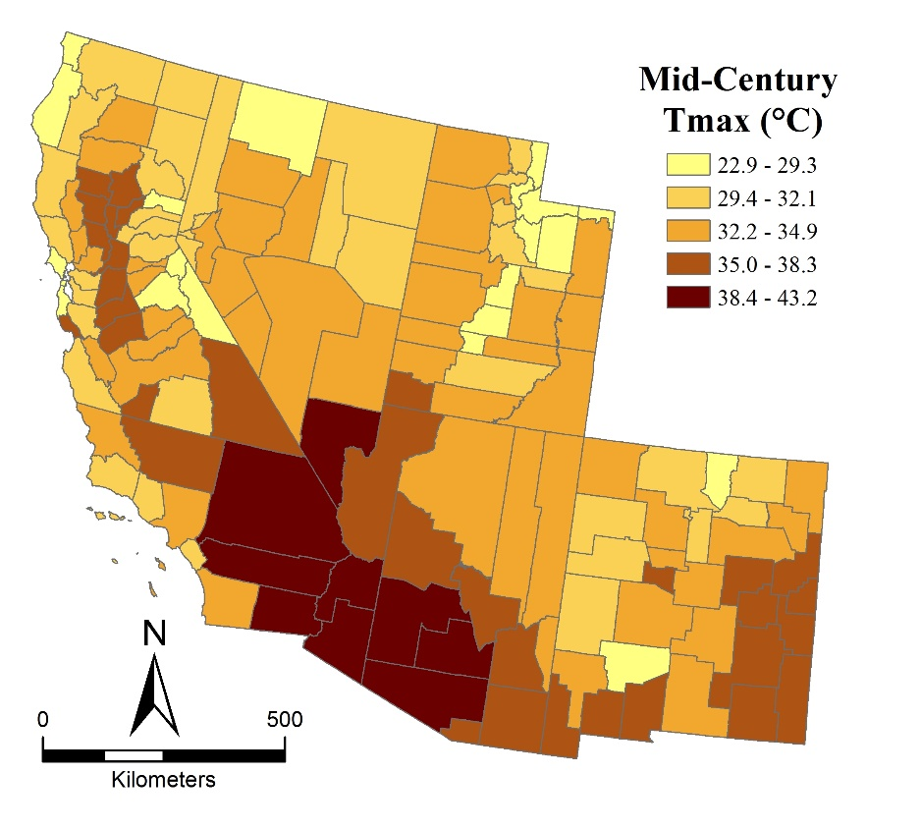
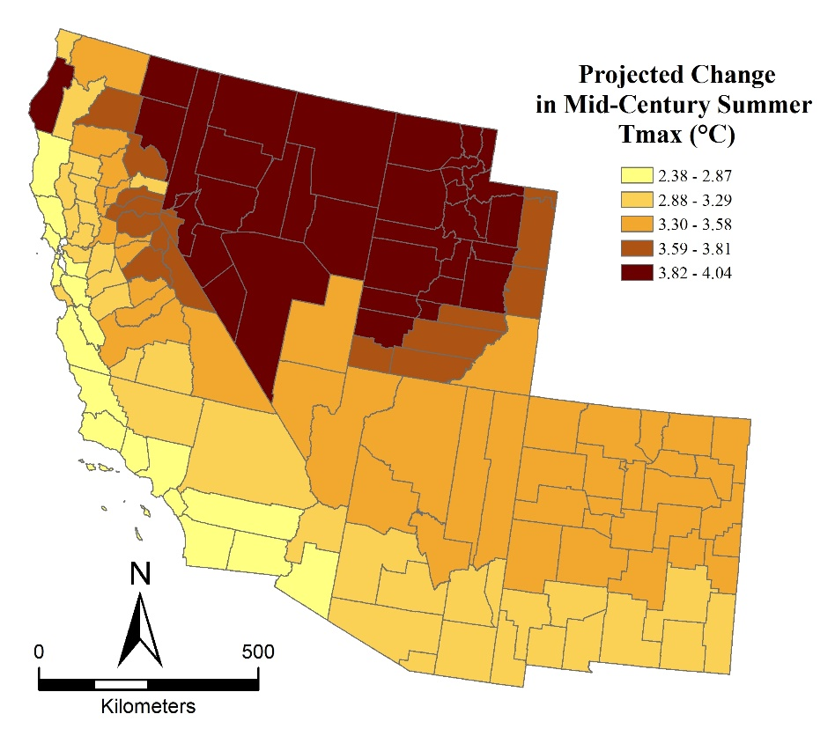
Projected midcentury (2040-2069) county level summer changes in maximum temperature.

