Electronic Supplementary Material—Hohmann et al. Paper “Alpine foreland running drier? Sensitivity of a drought vulnerable catchment to changes in climate, land use, and water management“

S1 Input Data
The input data for the WaSiM model setup as well as their sources are summarized in Table S1 and briefly described below.
The meteorological input for temperature and precipitation is based on daily station data. The data were received from the Austrian Hydrographic Service and the Austrian National Weather Service (ZAMG) in quality-controlled form and were visually quality controlled as a cross-check. In WaSiM the station data are internally interpolated to a target grid (1 km x 1 km in our study), for which different interpolation options are available. For the interpolation of temperature, we used the method of Inverse Distance Interpolation (IDW), weighted in with 75%, employed together with a combination of nearest neighbor selection and constant lapse rate (Thiessen laps rate), weighted in with 25%. For precipitation interpolation we used 100% IDW. Illustrative results showing climatologically averaged interpolated fields for the period 2003 to 2009 are depicted in the lower panels of Fig. S1, exhibiting the average of the annual mean temperatures (left) and the average of the annual precipitation amounts (right).
The runoff data are also available as daily data from gauging stations in the catchment and were received from the Austrian Hydrographic Service. We indirectly used them for the WaSiM modeling only, for comparison of simulated and observed runoff as part of model calibration and validation.
The digital elevation model (DEM), received from the state of Styria and state of Burgenland geographic information services as a 10 m/30 m DEM, was aggregated to the 1 km target grid.
The land use type dataset adopted is the CORINE data set from 2006, because this fits best for the calibration period (2003-2009). We cross-checked for temporal change but no drastic changes are found in the catchment of interest from inter-comparing the CORINE data sets for 1990, 2000, 2006, and 2012. As part of the modeling preparation, the land use data were as well resampled from the 100 m CORINE resolution to the 1 km target grid. The dataset is illustrated in the upper left panel of Fig. S1.
The soil texture data are based on the Agricultural Soil Map of Austria provided by the Austrian forest research center (BFW) as a free online dataset (https://geometadaten.lfrz.at Agricultural Soil Map of Austria). The soil information was only available for agricultural areas. We also aggregated the soil data to the 1 km target grid, with soil texture in the forest areas computed by stretching them in from the surrounding agricultural areas. The data are illustrated in the upper right panel of Fig. S1.
Because of a lack of detailed information about different soil layers, the same soil texture, combined with the hydraulic parameters, was assumed to be applicable for the total soil depth. For numerical reasons the model resolution of the soil layers, to solve the Richards equation, is separated into different soil layers: we divided the upper soil part with a thickness of 40 cm in 10 cm layers, the middle part of 60 cm in 15 cm layers, and the lower part with a thickness of 9 m in 0.3 m layers. In the unsaturated zone module in WaSiM the parameter with the Van Genuchten parametrization are based on literature (Carsel and Parrish 1988; Schulla 2015). These settings were found robust and adequate from extensive sensitivity tests on how various soil discretization setups influence the modeling performance.
Table S1 Raw data sets for the Raab catchment used as a model input to WaSiM (ZAMG … Austrian Meteorological Service; AHYD … Austrian Hydrographic Service; Land Stmk & Land Bgld … Government departments on water resources of the Austrian States of Styria and Burgenland)
Data type | No. stations/ Data set | Resolution | Source
Precipitation | 32 | daily (within 1982-2011) | ZAMG and AHYD
Temperature | 9 | daily (within 1982-2011) | ZAMG
Runoff | 9 | daily (within 1982-2011) | AHYD
Topography | Digital elevation model | 10 m 1 km grid | Land Stmk and Land Bgld
Land cover | CORINE (2006) data | 100 m 1 km grid | http://land.copernicus.eu/pan-european/corine-land-cover
Soil | Soil texture map | polygon agricultural areas 1 km grid | https://geometadaten.lfrz.at Agricultural Soil Map of Austria

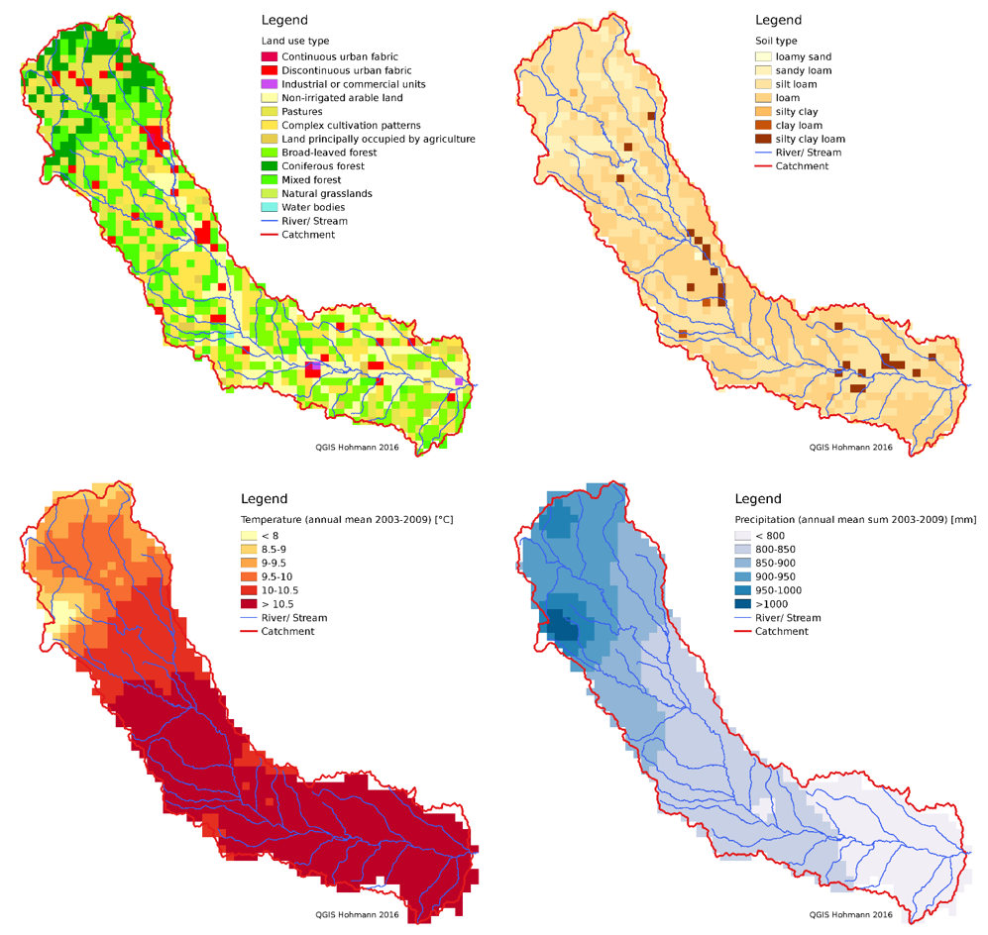
Fig. S1 Illustration of gridded input data to WaSiM. At the top the land use grid (left) and soil grid (right) are shown. The lower panels show the average annual-mean temperature (left) and the average annual precipitation a (right) over the calibration period from 2003 to 2009, calculated within WaSiM.

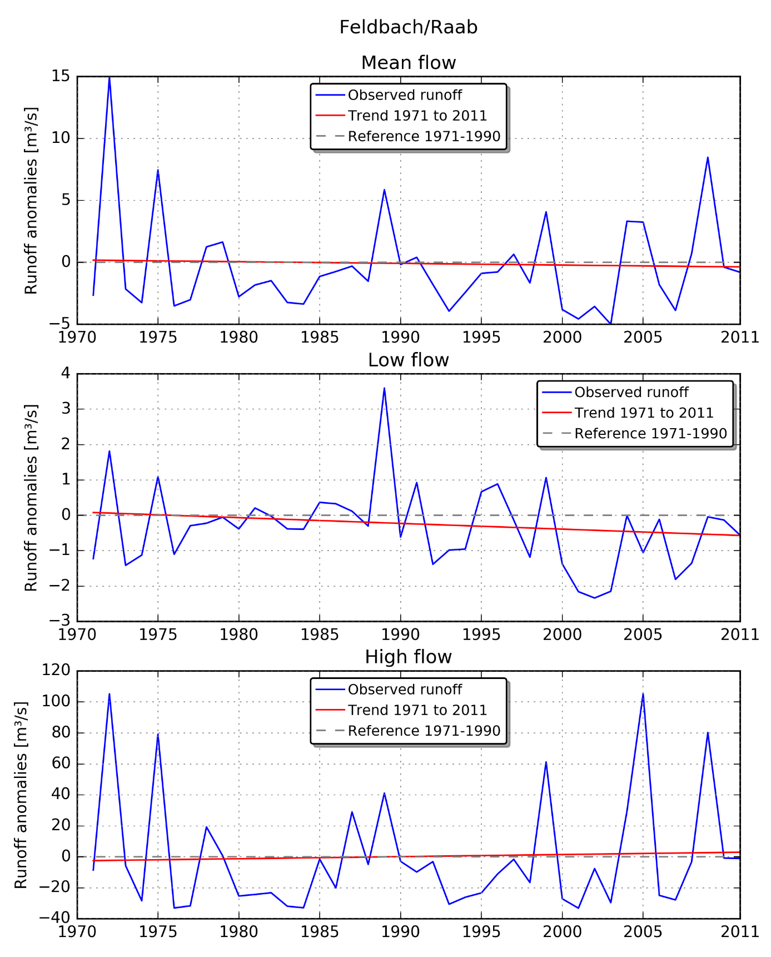
Fig. S2 Runoff anomalies at gauge station Feldbach/Raab from 1971 to 2011 to the reference period 1971 to 1990 for the extended summer month (Mai to September) with mean, low and high flows of each year.

S2 Model Calibration and Validation

S2.1 Calibration and Validation Setup
For the model calibration we used the runoff time series of three gauging stations, namely for the upper, middle and lower Styrian Raab catchment, and employed the shuffled complex evolution optimization algorithm developed at the University of Arizona (SCE-UA) (Duan et al. 1992; Duan et al. 1994) (as described in Sect. 2 of the main paper). The weighting of the three gauging station in the calibration process was set to 25% St. Ruprecht, 25% Takern II and 50% Neumarkt, respectively, because our focus region is the lower Raab valley between Takern II and Neumarkt.
We used the times series from 2003 to 2009 as a calibration period, complemented by an independent validation period from 1995 to 2001. Each of these periods was preceded by a five years warm up period for WaSiM. Both time periods include specific dry (2003/2001) and wet (2009/1996) years. The evaluation and classification related to dry and wet years was based on the Standardized Precipitation Evapotranspiration Index (SPEI) which we calculated with the R-package “SPEI” (Version 1.6, http://sac.csic.es/spei). We performed this SPEI evaluation to inform our choice of adequate calibration and validation periods.
We chose the set of calibration parameters and their range based on the WaSiM model description (Schulla 2015) and a literature review (e.g., Cullmann et al. 2006; Kunstmann and Stadler 2005). The chosen set of five parameters, together with their physical units and allowed ranges, is summarized in Table S2 (a sixth parameter ki is set to always adopt the value of kd).
Table S2 Set of calibration parameters used for the WaSiM calibration for the Styrian Raab catchment, given by parameter name (WaSiM acronym), description, unit, reference area, and value range allowed within the calibration algorithm’s optimization procedure.
Parameter | Description | Unit | Area | Permissible Range
krec | recession constant for sat. hydr. conductivity | 1 | total  catchment | 0.01-1.0
dr | drainage density for interflow | m⁻¹ | sub-basin | 1-30
kd | storage coefficient direct flow | h | sub-basin | 1-60
ki | storage coefficient interflow | h | sub-basin | ki = kd
Q0 | scaling factor for baseflow | mm h⁻¹ | sub-basin | 0.2-1.5 (St. Ruprecht)  0.1-1.0 (Takern II, Neumarkt)
kb | storage coefficient for baseflow | m | sub-basin | 0.2-1.5 (St. Ruprecht)  0.0001-1.0 (Takern II, Neumarkt)

To estimate the model performance in the calibration process we used the Nash-Sutcliffe Efficiency (NSE) (Nash and Sutcliffe 1970), which ranges from -∞ to 1. To emphasize more on the low flow, we also weighted in the logarithmic version of NSE, NSE_{log}. For the algorithm’s optimization runs, the model efficiency targeted by the maximization procedure was chosen as a weighted sum of 50% NSE and 50% NSE_{log}. These efficiency measures are defined as
$$NSE=1- \frac{\sum_{i=1}^{n}{{\left({obs}_{i}-{sim}_{i}\right)}^{2}}}{\sum_{i=1}^{n}{{\left({obs}_{i}-\overline{obs}\right)}^{2}}} ,$$

$${NSE}_{log}=1- \frac{\sum_{i=1}^{n}{{\left(\log\left({obs}_{i}\right)-\log\left({sim}_{i}\right)\right)}^{2}}}{\sum_{i=1}^{n}{{\left(\log\left({obs}_{i}\right)-\log\left(\overline{obs}\right)\right)}^{2}}} ,$$
where i is the index for individual days in the period, n the total number of days, and sim denotes the simulated runoff, obs the observed runoff, and $\overline{obs}$ the mean observed runoff averaged over the period.
Regarding the validation of the calibrated model, beside the validation being based on a different time period (1995-2001) the runoff components (direct flow, interflow, baseflow) where visually analyzed. Another important aspect with hydrological models is the water balance, which was validated by assessing in addition to NSE and NSE_{log} also the relative bias (in percent) of the model-simulated runoff against the observations, PBIAS (Moriasi et al. 2007),
$$PBIAS=100∙\frac{\sum_{i=1}^{n}{\left({sim}_{i}-{obs}_{i}\right)}}{\sum_{i=1}^{n}{\left({obs}_{i}\right)}} ,$$
where the meaning of the symbols is the same as in the equations above.

S2.2 Calibration and Validation Results
Fig. S3 shows the results over the calibration and validation period for the gauging station Neumarkt, as a representative example. The other calibration stations St. Ruprecht and Takern II exhibit similar results (thus not shown). As an overall indication of the performance, the NSE, NSE_{log}, and PBIAS values of the calibrated model at the three calibration stations are summarized in Table S3. The corresponding parameter values of the calibrated model are listed in Table S4.
The validation-period results are in general very similar and essentially as good as the calibration-period ones, except for the NSE values of the middle and lower Raab valley, reflected by the Takern II and Neumarkt results. This somewhat decreased NSE performance is probably caused by the simple model setup and non-modeled human influences like for example small hydro-power stations along the Raab. The NSE_{log} values still score at 0.7 or higher and the PBIAS stays within about 20%.
We also carried out careful visual analysis of time series of observed and simulated runoff, which is another important element of quality evaluation, and found reasonable and good overall agreement of the observed and simulated runoff curve characteristics. In addition, besides the total runoff as the formal calibration variable, the components of the runoff (cf. Fig. 2 in the main paper) were visually inspected as part of assessing the performance. The inspection showed that the runoff is dominated by interflow and the high runoff peaks are also fed by direct runoff. The base flow in the middle and lower Raab is quite small, but also shows a realistic behavior. Overall we found that a physically realistic distribution of the components base flow, interflow and direct runoff was simulated.
To conclude, the calibration and validation results show a sufficient model performance to use this model setup for the sensitivity analysis of the drought vulnerable Raab catchment.

Table S3 WaSiM runoff modeling performance measures Nash-Sutcliffe efficiency (NSE), logarithmic NSE (NSE_{log}), and relative simulation bias vs. observations (PBIAS, in percent), for the calibrated model. Results for both the calibration (2003-2009) and validation (1995-2001) period are listed, for the stations St. Ruprecht, Takern II, and Neumarkt.
Gauging Station | Calibration period |  |  | Validation period
Gauging Station | NSE | NSE_{log} | PBIAS | NSE | NSE_{log} | PBIAS
St. Ruprecht | 0.72 | 0.76 | 11.8 | 0.76 | 0.77 | 15.6
Takern II | 0.76 | 0.77 | 15.2 | 0.59 | 0.75 | 20.9
Neumarkt | 0.75 | 0.75 | 19.5 | 0.59 | 0.70 | 17.3

Table S4 Parameter values obtained for the calibrated model, which was then chosen as the basis for the sensitivity analysis. All values except the recession constant for saturated hydraulic conductivity (krec) depend on characteristics of the sub-basin (see Table S2), including the upper (St. Ruprecht), middle (Takern II), and lower (Neumarkt) Raab basins.
Parameter | St. Ruprecht | Takern II | Neumarkt
krec | 0.80 | 0.80 | 0.80
dr | 13.7 | 11.4 | 9.4
kd & ki | 19.9 | 19.0 | 50.4
Q0 | 0.88 | 0.63 | 0.17
kb | 1.34 | 0.21 | 0.94

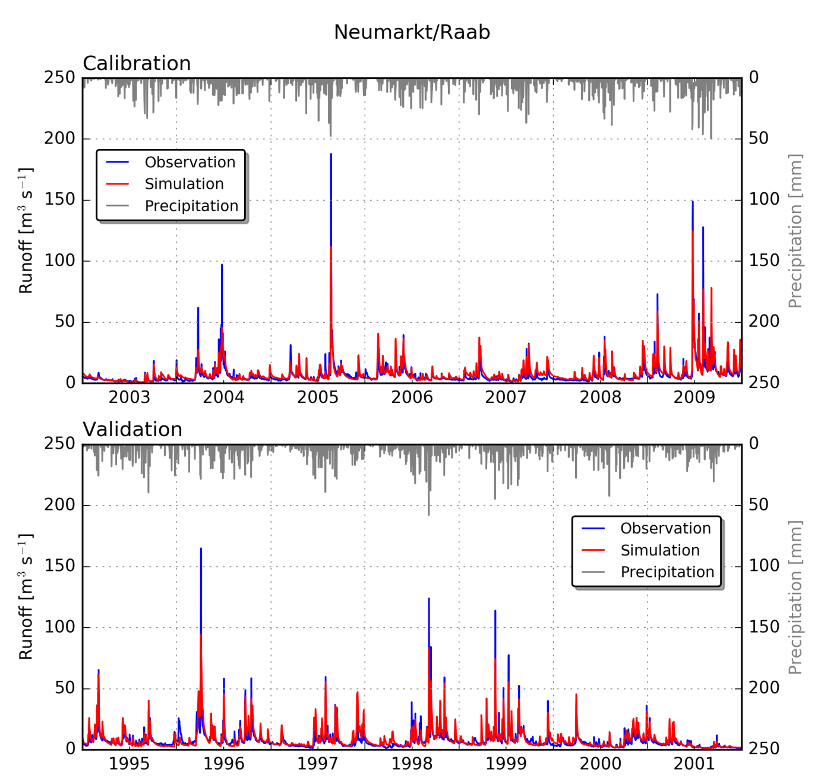
Fig. S3 Runoff time series over the calibration (top) and validation (bottom) period, of the observations (blue) and the calibrated model (red), for the entire Styrian Raab catchment at station Neumarkt. The precipitation time series (grey) are co-visualized in the panels from top downward (right-hand-side y axis).

S3 Water Budgets of Sensitivity Study Cases
Table S5 shows the water budget terms obtained for the entire catchment in response to the various types of changes. The residual ΔS (Precipitation – Runoff – actual Evapotranspiration) corresponds to the change in storage within the catchment. While this is negligible for the entire year (Table S5, right part), it can be seen that a reduction in precipitation and/or an increase in evapotranspiration during the summer (Table S5, left part), in general, is partly compensated by an increased drainage from the storage, which mitigates the effect on the summer river runoff.
Table S5 Water balance with mean values from 1982 to 2011 for the extended summer months May to September (Summer), used in this paper, and all months of the year (Total year) for comparison. P denotes precipitation, Q runoff, ETa actual evapotranspiration, and ΔS the balance P-Q-ETa.
Types of change |  | Summer |  |  |  | Total year
 |  | P  [mm] | Q  [mm] | ETa  [mm] | ΔS  [mm] | P  [mm] | Q  [mm] | ETa  [mm] | ΔS  [mm]
 | Base | 512 | 106 | 435 | -29 | 824 | 264 | 562 | -2
moderate | TC | 512 | 80 | 484 | -52 | 824 | 214 | 611 | -1
moderate | PC | 461 | 77 | 433 | -49 | 773 | 214 | 560 | -1
moderate | LUC | 512 | 112 | 429 | -29 | 824 | 272 | 554 | -2
moderate | WMC | 512 | 105 | 436 | -29 | 824 | 263 | 563 | -2
moderate | TP | 461 | 57 | 479 | -75 | 773 | 169 | 606 | -2
moderate | TPL | 461 | 63 | 472 | -74 | 773 | 178 | 597 | -2
moderate | TPLW | 461 | 60 | 474 | -73 | 773 | 176 | 599 | -2
strong | TC | 512 | 59 | 532 | -79 | 824 | 167 | 659 | -2
strong | PC | 358 | 36 | 421 | -99 | 671 | 125 | 548 | -2
strong | LUC | 512 | 118 | 420 | -26 | 824 | 282 | 544 | -2
strong | WMC | 512 | 104 | 436 | -28 | 824 | 263 | 563 | -2
strong | TP | 358 | 21 | 473 | -136 | 671 | 79 | 597 | -5
strong | TPL | 358 | 28 | 462 | -132 | 671 | 93 | 583 | -5
strong | TPLW | 358 | 22 | 466 | -130 | 671 | 89 | 588 | -6

Supplementary References
Carsel RF, Parrish RS (1988) Developing Joint Probability Distributions of Soil Water Retention Characteristics. Water Resour Res 24:755–769. doi: 10.1029/WR024i005p00755
Cullmann J, Mishra V, Peters R (2006) Flow analysis with WaSiM-ETH - model parameter sensitivity at different scales. Adv Geosci 9:73–77. doi: 10.5194/adgeo-9-73-2006
Duan Q, Sorooshian S, Gupta V (1992) Effective and efficient global optimization for conceptual rainfall-runoff models. Water Resour Res 28:1015–1031. doi: 10.1029/91WR02985
Duan Q, Sorooshian S, Gupta VK (1994) Optimal use of the SCE-UA global optimization method for calibrating watershed models. J Hydrol 158:265–284. doi: 10.1016/0022-1694(94)90057-4
Kunstmann H, Stadler C (2005) High resolution distributed atmospheric-hydrological modelling for Alpine catchments. J Hydrol 314:105–124. doi: 10.1016/j.jhydrol.2005.03.033
Moriasi DN, Arnold JG, Van Liew MW, et al (2007) Model evaluation guidelines for systematic quantification of accuracy in watershed simulations. Trans ASABE 50:885–900. doi: 10.13031/2013.23153
Nash JE, Sutcliffe JV (1970) River flow forecasting through conceptual models part I — A discussion of principles. J Hydrol 10:282–290. doi: 10.1016/0022-1694(70)90255-6
Schulla J (2015) Model Description WaSiM. Technical Report, www.wasim.ch (09.03.2016)

