Indices of Canada’s future climate for general and agricultural adaptation applications
Guilong Li¹, Xuebin Zhang¹, Alex J. Cannon¹, Trevor Murdock², Steven Sobie², Francis Zwiers², Kevin Anderson¹, Budong Qian³
¹Climate Research Division, Environment and Climate Change Canada, Toronto, Ontario, Canada
²Pacific Climate Impacts Consortium, University of Victoria, Victoria, BC, Canada
³Ottawa Research and Development Centre, Agriculture and Agri-Food Canada, Ottawa, Ontario, Canada

Supplementary Materials

Table S1. Definition of indices
Index | Description | Unit
Temperature indices
Hot days (TX: TX25, TX30, TX33, TX35, TX37)) | Number of days with maximum temperature above 25°C,30°C, 33°C, 35°C, 37°C | Days
Hot nights (TN: TN18, TN20, TN22, TN25) | Number of days with minimum temperature above 18°C, 20°C, 22°C, 25°C | Days
Hot spell days (TXc: TXc25, TXc30, TXc33, TXc35, TXc37) | The total number of hot days during hot spells. A hot spell is defined as 3 or more consecutive hot days | Days
Hot spell nights (TNc: TNc18, TNc20, TNc22, TNc25) | The total number of hot nights during hot spells. A hot spell is defined as 3 or more consecutive hot nights | Days
The longest hot spell days (TXLc: TXLc25, TXLc30, TXLc33, TXLc35, TXLc37) | The longest length of hot spell days for hot days defined above | Days
The longest hot spell nights (TNLc: TNLc18, TNLc20, TNLc22, TNLc25) | The longest length of hot spell nights for hot nights defined above | Days
Hot day and night (Hot) | Number of days when the daily maximum temperature above 30°C and the daily minimum temperature above 20°C in the same day | Days
Cold days (TNm: TNm15, TNm20, TNm25, TNm30) | Number of days with minimum temperature below -15°C, -20°C, -25°C, -30°C | Days
Frost free days (FF) | The period between the last observed occurrence of frost (minimum temperature below 0°C) in the spring and the first observed occurrence of frost in the autumn | Days
Killing frost free days (KFF) | The period between the last observed occurrence of killing frost (minimum temperature below -2°C) in the spring and the first observed occurrence of killing frost in the autumn | Days
Heating degree days (HDD) | The number of degrees Celsius that a day’s average temperature is below 18°C, accumulated over the heating season | °C-day
Cooling degree days (CDD) | The number of degrees Celsius that a day’s average temperature is above 18°C, accumulated over the cooling season | °C-day
Precipitation indices
Number of days with precipitation (Prep1) | Number of days with precipitation > 1mm /day | Days
Number of days with precipitation ≥ 10mm/day (Prep10) | Number of days with precipitation ≥ 10mm/day | Days
Annual One-day Maximum Precipitation (P1D) | Annual One-day Maximum Precipitation within relevant growing season | mm/day
Annual Ten-day Maximum Precipitation (P10D) | Annual Ten-day Maximum Precipitation within relevant growing season | mm/10d
Agroclimatic indices
Length of Growing Season (GSL) | Length of growing season is the number of days between the start date and the end date of a growing season. We define growing season for three different crop types as outlined below.  - Cool Season Crops (e.g. spring wheat, barley, canola):  Start: When the weighted 5d mean temperature ≥ 5°C has reached for five consecutive days in first half of the year  End: When the weighted 5d mean daily maximum temperature ≥ 30°C for five consecutive days in July or August or Aug. 31, whichever occurs earlier  - Overwintering Crops (e.g.biennial or perennial herbaceous crops and fruit trees):  Start: Same as for cool season crops.  End: When the weighted 5d mean temperature has dropped and stayed below 5°C in second half of the year.  - Warm Season Crops (e.g. corn, soybean):  Start: When the weighted 5d mean temperature ≥ 10°C has reached for five consecutive days in first half of the year  End: When the weighted 5d mean temperature has dropped and stayed below 10°C in second half of the year. | Days
Crop Heat Units (CHU) | Y_{max} =3.33(T_{max} -10)-0.084(T_{max} -10) ² where T_{max}≥10°C  Y_{min} =$\frac{9}{5}$ (T_{min} - 4.4) where T_{min}≥4.4°C  Daily CHU =( Y_{max} +Y_{min})/2  CHU is the accumulated daily CHU values within the relevant growing season. | Heat unit
Effective Growing Degree Days (EGDD) | Daily growing degree days (GDD): $GDD=\frac{T_{max}+T_{min}}{2}-CT_{min} if \frac{T_{max}+T_{min}}{2}≥CT_{min}$  CT_{min}: 5°C for cool season and overwintering crops and 10°C for warm season crops  EGDD is the accumulated daily GDD values within the relevant growing season multiplied by a day length factor (DLF) that equals 1.0 when the latitude (LAT) is below 49°N and 1.18 higher than 61°N. DLF = -19.3257 + 1.158643(LAT) - 0.022107689(LAT)² +0.0001413685(LAT)³ | °C-day

Table S2: Coordinates of the 10 observing stations used in Fig. S1
Station Name | Station ID | Latitude | Longitude | Station  Elevation (m) | ANUSPLIN  Elevation (m)
Agassiz | 1100120 | 49°15´N | 122°22´W | 15 | 159
Beaverlodge | 3070560 | 55°12´N | 119°24´W | 732 | 748
Dauphin | 5040680 | 51°06´N | 100°03´W | 304 | 295
Edmonton | 3012205 | 53°18´N | 113°35´W | 715 | 720
Fredericton | 8101600 | 45°55´N | 66°37´W | 40 | 42
Kapuskasing | 6073975 | 49°24´N | 82°26´W | 218 | 218
Lethbridge | 3033890 | 49°42´N | 112°47´W | 899 | 907
London | 6144475 | 43°02´N | 81°09´W | 278 | 276
Winnipeg | 5023222 | 49°54´N | 97°14´W | 239 | 239
Estevan | 4012400 | 49°04´N | 103°00´W | 572 | 560

Table S3. The 24 GCMs used in the study
Model Name | Spatial Resolution  (longitude by latitude) | Institution
BNU-ESM | 2.81°×2.81° | College of Global Change and Earth System Science, Beijing Normal University
CCSM4 | 1.25°×0.94° | National Center for Atmospheric Research
CESM1-CAM5 | 1.25°×0.94° | National Science Foundation, Department of Energy, National Center for Atmospheric Research
CNRM-CM5 | 1.40°×1.40° | Centre National de Recherches Meteorologiques / Centre Europeen de Recherche et Formation Avancees en Calcul Scientifique
CSIRO-Mk3.6.0 | 1.87°×1.87° | Commonwealth Scientific and Industrial Research Organisation in collaboration with the Queensland Climate Change Centre of Excellence
CanESM2 | 2.81°×2.81° | Canadian Centre for Climate Modelling and Analysis
FGOALS-g2 | 2.81°×3.00° | LASG, Institute of Atmospheric Physics, Chinese Academy of Sciences; and CESS, Tsinghua University
GFDL-CM3 | 2.50°×2.00° | Geophysical Fluid Dynamics Laboratory
GFDL-ESM2G | 2.50°×2.00° | Geophysical Fluid Dynamics Laboratory
GFDL-ESM2M | 2.50°×2.00° | Geophysical Fluid Dynamics Laboratory
HadGEM2-AO | 1.87°×1.24° | Met Office Hadley Centre (additional HadGEM2-ES realizations contributed by Instituto Nacional de Pesquisas Espaciais)
HadGEM2-ES | 1.87°×1.24°
IPSL-CM5A-LR | 3.75°×1.87° | Institut Pierre-Simon Laplace
IPSL-CM5A-MR | 2.50°×1.25° | Institut Pierre-Simon Laplace
MIROC-ESM | 2.81°×2.81° | Japan Agency for Marine-Earth Science and Technology, Atmosphere and Ocean Research Institute (The University of Tokyo), and National Institute for Environmental Studies
MIROC-ESM-CHEM | 2.81°×2.81°
MIROC5 | 1.40°×1.40° | Atmosphere and Ocean Research Institute (The University of Tokyo), National Institute for Environmental Studies, and Japan Agency for Marine-Earth Science and Technology
MPI-ESM-LR | 1.87°×1.87° | Max Planck Institute for Meteorology (MPI-M)
MPI-ESM-MR | 1.87°×1.87° | Max Planck Institute for Meteorology (MPI-M)
MRI-CGCM3 | 1.12°×1.12° | Meteorological Research Institute
NorESM1-M | 2.50°×1.87° | Norwegian Climate Centre
NorESM1-ME | 2.50°×1.87° | Norwegian Climate Centre
BCC-CSM1-1 | 2.81°×2.81° | Beijing Climate Center, China Meteorological Administration
BCC-CSM1-1-m | 1.12°×1.12° | Beijing Climate Center, China Meteorological Administration

Table S4. Projected multi-model median changes in climate indices at the 2.1°C global warming level computed from statistically downscaled outputs from 24 GCMs. The 5th and the 95th percentiles of the projected changes are shown in brackets.
Region  Indices | BC | Prairie | ON | QC | ATL | NN
TX30 | 2.5  (0.8, 5.5) | 7.2  (2.3, 12.4) | 8.8  (2.3, 14.1) | 2.7  (0.6, 5) | 2.1  (0.7, 4.2) | 0.5  (0.1, 1.3)
TN20 | 0  (0, 0.1) | 0.8  (0.3, 2) | 2.7  (1, 5.3) | 0.7  (0.2, 1.5) | 0.6  (0.2, 1.5) | 0.1  (0, 0.3)
TXc30 | 1.9  (0.5, 4.4) | 5.7  (1.7, 10.5) | 6.3  (1.5, 11.1) | 1.6  (0.3, 3.3) | 1.1  (0.3, 2.5) | 0.3  (0, 0.9)
TNc20 | 0  (0,0 ) | 0.3  (0, 0.9) | 1.2  (0.2, 2.6) | 0.2  (0, 0.5) | 0.1  (0, 0.6) | 0.1  (0, 0.2)
TXL30 | 1.1  (0.3, 2.7) | 2.5  (0.7, 4.9) | 2.7  (0.8, 4.9) | 0.8  (0.2, 1.7) | 0.5  (0.1, 1.3) | 0.2  (0, 0.6)
TNL20 | 0  (0,0) | 0.2  (0, 0.7) | 0.7  (0.2, 1.7) | 0.2  (0, 0.4) | 0.1  (0, 0.5) | 0  (0, 0.1)
Hot | 0  (0, 0.1) | 0.7  (0.2, 1.8) | 2.2  (0.7, 4.5) | 0.5  (0.1, 1.2) | 0.3  (0.1, 0.9) | 0.1  (0, 0.2)
TNm15 | -14.2  (-23.2, -4.9) | -18.5  (-31.1, -6.9) | -16.4  (-29.2, -6.5) | -20.2  (-37, -7.8) | -16.9  (-30.6, -7) | -21.3  (-35.9, -11.2)
FF | 31.3  (17.1, 52.6) | 18  (8.7, 34.6) | 21.9  (11, 43.9) | 21.6  (10.1, 43.2) | 20.7  (8.9, 40.6) | 20.2  (7.3, 41.9)
KFF | 29.4  (15.6, 47.5) | 17.9  (7.7, 33.8) | 19.5  (8.8, 38.2) | 20.5  (10.1, 40) | 19.8  (8.7, 36.6) | 17.9  (7.2, 34.7)
HDD | -730.6  (-1088.5, -440.4) | -780.8  (-1210.3, -421.2) | -770.1  (-1234.1, -412.9) | -869  (-1398.9, -452.1) | -730.3  (-1169.1, -383.8) | -1056.8  (-1702.9, -714.2)
CDD | 25.8  (9.9, 50.9) | 85.4  (36.8, 140) | 108  (46.4, 163.6) | 41.8  (15.8, 70.7) | 42  (21, 80.2) | 10.3  (2.8, 22.1)
Prep1 | 1.2  (-5.6, 7.8) | 2.6  (-3.2, 8.3) | 2.6  (-4.2, 8.8) | 6.5  (0.4, 15.8) | 2.7  (-2.6, 8.8) | 7.2  (1.2, 14.8)
Prep10 | 2.1  (-0.5, 4.9) | 0.9  (-0.5, 2.7) | 1.7  (-0.3, 4.1) | 2.7  (0.6, 5) | 3.3  (0.6, 6.6) | 0.6  (-0.1, 1.5)
Intensity | 0.3  (0, 0.6) | 0.2  (-0.1, 0.5) | 0.2  (0, 0.5) | 0.3  (0.1, 0.5) | 0.4  (0.1, 0.7) | 0.2  (0, 0.3)
Drydays | -0.1  (-2.8, 2.8) | -0.8  (-4.3, 3) | -0.5  (-3, 2.2) | -1.2  (-3.3, 1.1) | -0.5  (-2, 1.2) | -4.2  (-10.8, 3.3)
GSL(Cool) | 11.1  (0.6, 23.6) | 1.7  (-6.8, 12.4) | 0.2  (-8.4, 13.1) | 7  (-2.5, 22.8) | 7.8  (-0.9, 21.9) | 12.4  (0.1, 29.2)
GSL(Warm) | 23.3  (11.3, 38.8) | 15.5  (6.8, 31.2) | 17  (6.1, 37.9) | 19.3  (7.9, 35.7) | 18.6  (8.8, 33) | 12.9  (3.5, 27.1)
GSL  (Overwintering) | 23  (11.3, 38.3) | 15.9  (5.8, 30.1) | 16.6  (7.4, 34.5) | 19.6  (6.2, 41.6) | 18.9  (7.4, 40.4) | 17.2  (3.9, 36.3)
CHU(Cool) | 344.3  (145, 613.1) | 217.9  (80.9, 464.2) | 184.4  (52.9, 411.5) | 284.6  (86.8, 511.3) | 278.7  (96.4, 482.5) | 195.9  (37, 402.9)
CHU(Warm) | 508.2  (248.6, 849.5) | 511.6  (281.7, 826.8) | 567.1  (338.6, 916.2) | 457  (211.3, 749.7) | 449.8  (228.1, 735.9) | 249.7  (70.7, 480.2)
CHU  (Overwintering) | 497.6  (251.7, 828.1) | 513.4  (286.8, 818.1) | 565  (341.4, 899.4) | 458.9  (206.1, 728) | 451.3  (229.8, 735.1) | 237.2  (58.9, 471.4)
EGDD(Cool) | 229  (106.1, 404) | 163.6  (75, 322.2) | 143.8  (58.1, 288.4) | 184.7  (63.9, 326.3) | 174.5  (65.9, 309) | 145.2  (31.5, 291.4)
EGDD(Warm) | 206.8  (92.5, 355.4) | 270.4  (141.2, 412.1) | 292.5  (157.9, 426) | 190.8  (83, 298.4) | 191  (96.9, 310.4) | 96.6  (25.9, 189.5)
EGDD  (Overwintering) | 333  (173.7, 554.6) | 363.2  (204, 565.9) | 390.4  (229.9, 609.1) | 298.9  (136.5, 476.6) | 283.8  (146.5, 473.8) | 175.9  (48.1, 345.2)
P1D(Cool) | 1.9  (-, 6.6) | 0.8  (-4, 6.7) | 1  (-3, 6.) | 1.7  (-1.8, 6.1) | 2.7  (-1.7, 8.4) | 1.1  (-2.9, 5.6)
P1D(Warm) | 3  (-1.6, 8.4) | 2.1  (-3, 8.2) | 2.4  (-1.9, 7.8) | 2.6  (-1.5, 7.7) | 3.9  (-1.8, 9.9) | 2.2  (-2, 6.7)
P1D  (Overwintering) | 3.1  (-1, 8.2) | 2  (-3, 8.) | 2.4  (-2.2, 7.5) | 2.6  (-1.1, 7.1) | 3.8  (-1.3, 9.9) | 1.6  (-2.2, 5.7)
P10D(Cool) | 5.9  (-4.4, 16.7) | 2.4  (-6.7, 14.1) | 2.5  (-5.6, 13.1) | 3.7  (-4.3, 12.5) | 5.7  (-4, 16.1) | 2.9  (-5.7, 12.2)
P10D(Warm) | 8.3  (-3.6, 22.2) | 5.1  (-4.8, 16.2) | 5.1  (-3.7, 15.4) | 5.8  (-3.5, 15.5) | 7.7  (-2.6, 18.9) | 5.3  (-3.8, 14.5)
P10D  (Overwintering) | 8.8  (-2.1, 21.9) | 4.8  (-5.3, 16) | 5.2  (-3.6, 14.4) | 5.7  (-1.9, 13.4) | 7.2  (-1.9, 17.1) | 4.2  (-4.1, 12.8)

Table S5. Same as Table S4 but for projected changes at the 4.5°C global warming level.
Region  Indices | BC | Prairie | ON | QC | ATL | NN
TX30 | 16  (5, 32.8) | 34.3  (10.4, 50.9) | 38  (15.2, 55.6) | 14.5  (6.8, 29.1) | 12.1  (5.6, 28.1) | 3.5  (0.9, 8.6)
TN20 | 0.6  (0.1, 4.2) | 10.1  (2.2, 25.1) | 17.3  (7.6, 37) | 5.3  (2.8, 14.8) | 6.5  (2.7, 19.5) | 1.1  (0.4, 3.9)
TXc30 | 13.5  (3.8, 29.5) | 30.8  (8.8, 47.5) | 32.8  (12.1, 50.8) | 11  (4.6, 24.4) | 8.7  (3.3, 22.6) | 2.7  (0.7, 7.4)
TNc20 | 0.2  (0, 2.6) | 6.4  (0.9, 20.4) | 11.8  (4.2, 30.5) | 2.7  (1.1, 10.5) | 3.7  (1.1, 14.8) | 0.7  (0.3, 3)
TXL30 | 6.1  (2.1, 12.6) | 12.8  (4.1, 20.9) | 11.4  (4.6, 19.7) | 4.1  (1.8, 10.1) | 3.9  (1.5, 11) | 1.4  (0.4, 4)
TNL20 | 0.1  (0, 1.6) | 3.4  (0.6, 10.2) | 5.4  (2.2, 13) | 1.4  (0.7, 4.8) | 1.9  (0.7, 8) | 0.4  (0.1, 1.9)
Hot | 0.5  (0.1, 3.9) | 9.6  (1.9, 23.1) | 15.4  (6.4, 33.8) | 4.1  (2.1, 12.9) | 4.1  (1.7, 14.9) | 0.9  (0.3, 3.2)
TNm15 | -31.7  (-43.3, -19.4) | -50.5  (-67.2, -27.7) | -51.6  (-69.7, -28.7) | -63.3  (-88.9, -33.5) | -45.8  (-60.2, -29.5) | -68  (-116.2, -40.3)
FF | 76.8  (52.5, 107.7) | 47.6  (32.5, 72.6) | 55  (39, 86.6) | 58.1  (39.1, 92.7) | 57.6  (38.5, 90.4) | 56.8  (31.7, 88.9)
KFF | 70.4  (48.1, 97.2) | 46.2  (30.2, 66.7) | 49.8  (34, 75.3) | 53.4  (35.3, 80.6) | 54.1  (34.2, 79.6) | 49.4  (26.9, 78.5)
HDD | -1873.5  (-2363.1, -1234) | -2036.4  (-2615, -1273.7) | -1990.3  (-2794.9, -1382.9) | -2256.7  (-3202.2, -1535.9) | -1894.9  (-2641.2, -1384.6) | -2880.3  (-4228.7, -1983)
CDD | 168.2  (55.5, 323.5) | 385.8  (151.6, 555.2) | 408.1  (206.7, 629.5) | 183  (108.3, 351.7) | 187.5  (107.6, 386.6) | 57.7  (19.7, 122.1)
Prep1 | 2.2  (-10.3, 10.2) | 5.6  (-5.3, 13.7) | 6.4  (-5.3, 16.5) | 15.9  (5.8, 30.9) | 5  (-2.8, 14.9) | 20.2  (10.6, 40.9)
Prep10 | 5.8  (2, 10.2) | 2  (-0., 4.5) | 3.9  (0.7, 7) | 5.8  (2.6, 9.4) | 6.8  (3.5, 12.2) | 1.8  (0.7, 3.4)
Intensity | 0.9  (0.4, 1.3) | 0.4  (0, 0.8) | 0.5  (0.2, 0.9) | 0.6  (0.3, 1) | 0.9  (0.5, 1.4) | 0.4  (0.2, 0.7)
Drydays | -0.1  (-2.9, 4.8) | -2  (-5.8, 2.7) | -1.6  (-4.3, 1.8) | -2.4  (-4.9, 0.4) | -1  (-2.6, 0.9) | -10.6  (-18.3, -2.8)
GSL(Cool) | 23.5  (9.9, 42) | 3.8  (-7.1, 18.2) | 0.1  (-10, 22.1) | 13.9  (3.5, 39.8) | 20.6  (8.8, 44.9) | 28.6  (10.2, 51.3)
GSL(Warm) | 61.1  (38.6, 84.5) | 43.6  (28.5, 68.9) | 44.4  (30, 81.7) | 50.1  (34.3, 88) | 51.1  (36.1, 87.4) | 37.8  (17.6, 71.1)
GSL  (Overwintering) | 63.7  (39, 90.9) | 46.3  (28.1, 67.7) | 46.7  (29, 77.7) | 50.8  (31.6, 90.6) | 56  (37.2, 93.4) | 49.4  (23.3, 82.7)
CHU(Cool) | 821.9  (534.8, 1165.7) | 476.1  (306.6, 916) | 381.9  (207.9, 936.7) | 682.6  (427.1, 1184.9) | 654.6  (436.3, 1081.5) | 576.9  (251.5, 1071.7)
CHU(Warm) | 1512.3  (912.4, 2084) | 1457.6  (907.5, 2124) | 1502.5  (1034.4, 2409) | 1281.8  (874.4, 2188) | 1295.2  (928.7, 2173.9) | 808.8  (361.4, 1440)
CHU  (Overwintering) | 1493  (881.4, 2033.9) | 1434.4  (891.1, 2082.1) | 1490.9  (1017.4, 2377.8) | 1293.1  (860.1, 2158.3) | 1303.9  (914.7, 2152.4) | 782.2  (337.8, 1394.9)
EGDD(Cool) | 587.8  (379.7, 815.3) | 415.5  (258.7, 701) | 343.4  (213.3, 736.6) | 468.8  (300.1, 811.9) | 439.1  (293.5, 729.3) | 430.9  (196.9, 764.5)
EGDD(Warm) | 724.6  (372, 1040.7) | 888.7  (465.8, 1197.3) | 860.4  (528.1, 1300.2) | 596.9  (390.2, 994.1) | 588.7  (396.6, 996.4) | 345.2  (142.1, 623.6)
EGDD  (Overwintering) | 1048.6  (605.2, 1451.2) | 1115.1  (631.8, 1547.9) | 1101.6  (701.3, 1724.4) | 867.2  (580.6, 1450.5) | 849.9  (593.3, 1430.5) | 589.3  (261.5, 1023.1)
P1D(Cool) | 4.7  (-0.1, 10) | 1  (-4.9, 8.) | 2.4  (-, 8) | 3.9  (-0.2, 9) | 6.5  (1.7, 13.4) | 3.2  (-1.1, 7.8)
P1D(Warm) | 8.7  (2.5, 15.7) | 4  (-2, 11.3) | 5.8  (0.1, 12.8) | 6.7  (1.6, 13.3) | 10  (3.7, 17.8) | 5.1  (0.8, 9.7)
P1D  (Overwintering) | 8.7  (3, 14.8) | 3.6  (-2.5, 10.8) | 5.5  (-0.2, 12.1) | 6.5  (1.8, 12.6) | 9.7  (4.1, 17.4) | 4.7  (0.4, 9.2)
P10D(Cool) | 13.9  (-0.2, 29) | 2.6  (-10.4, 19.1) | 4.6  (-6.5, 16.2) | 7.2  (-2.5, 17.9) | 13.1  (2.9, 26.4) | 7.5  (-1.7, 17.8)
P10D(Warm) | 24.2  (6.4, 44) | 7.9  (-4.9, 24.4) | 10.8  (-0.6, 23.5) | 13.2  (2.2, 26.1) | 19.2  (7.3, 34.4) | 11.4  (2, 21.6)
P10D  (Overwintering) | 23.9  (8.8, 42) | 7  (-5.8, 23.3) | 10.1  (-0.3, 22.6) | 12.6  (3.1, 24) | 18.5  (7.7, 32.1) | 10.9  (1.9, 21.1)
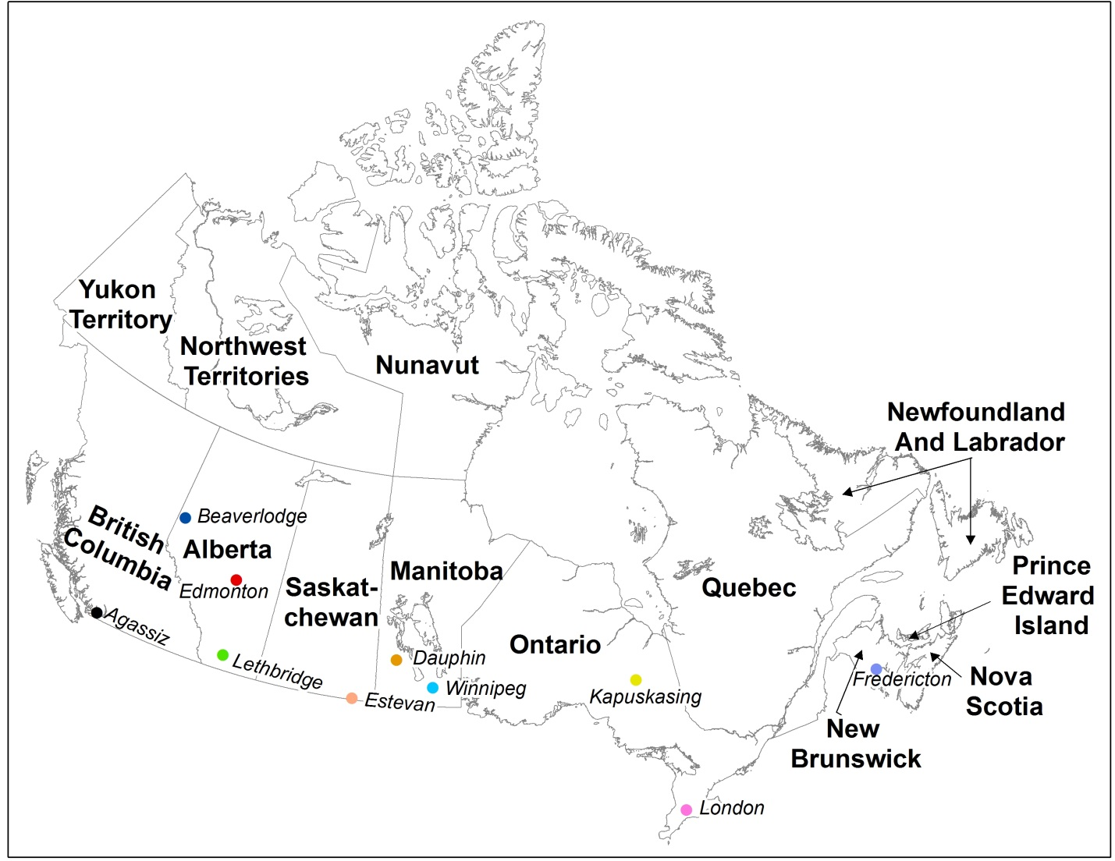
Figure S1. A map of Canada showing the boundaries of provinces. The locations of the 10 stations (listed in Table S2) are marked with color dots along with their names in smaller-sized font. The six regions used in Tables S4 and S5 are BC (British Columbia), Prairie (Alberta, Saskatchewan, Manitoba), ON (Ontario), QC (Quebec), ATL (New Brunswick, Nova Scotia, Prince Edward Island, Newfoundland and Labrador), NN (Yukon, Northwest Territories, Nunavut).

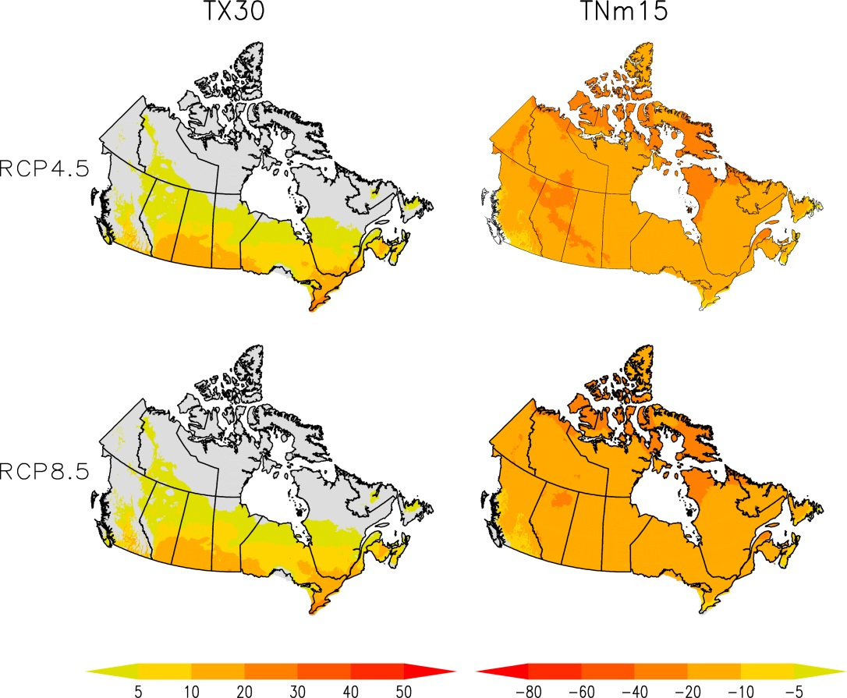
Figure S2. Projected multi-model median changes in the number of hot days (TX30, left panel), and cold nights (TNm15, right panel) for a global warming level of 2°C under RCP4.5 (top panel) and RCP8.5 (lower panel) under the RCP8.5 scenario. Changes are expressed in days per year relative to the 1986 to 2005 climatology. Grid boxes are marked as grey if hot days or cold nights are not projected to occur (less than one day per year) in a future period.

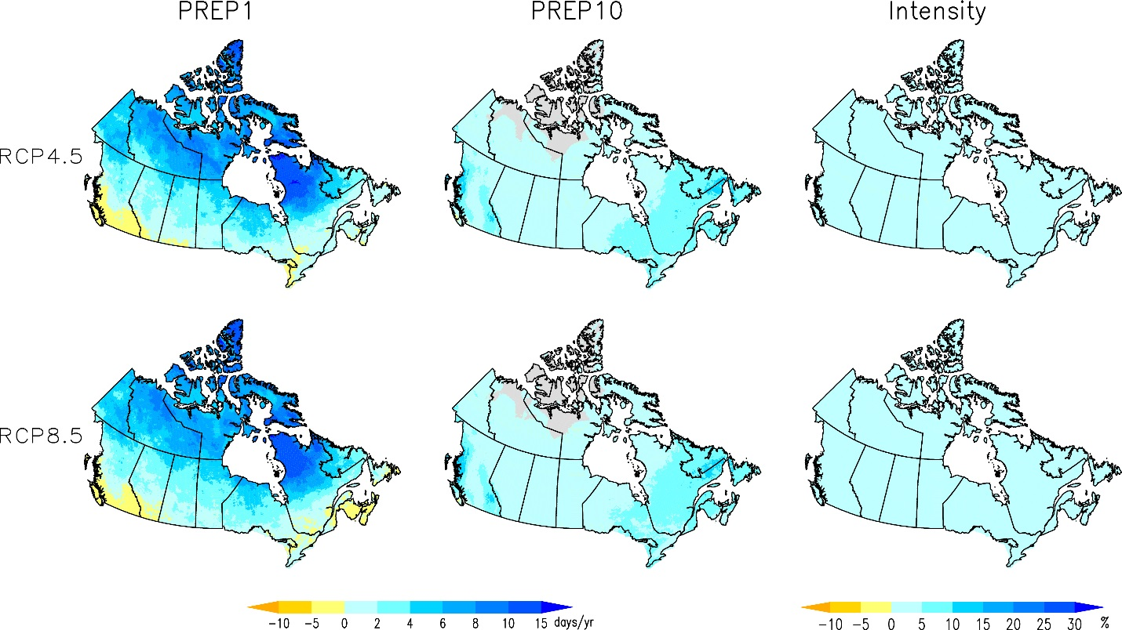
Figure S3. Projected multi-model median changes in the number of precipitation days (PREP1, in days/yr; left panel), in the number of heavy precipitation days (PREP10, in days/yr; center panel), and in daily precipitation intensity (Intensity, in %; right panel) for global warming level of 2°C under RCP4.5 (top panel) and RCP8.5 (lower panel). Changes are relative to the 1986 to 2005 climatology.

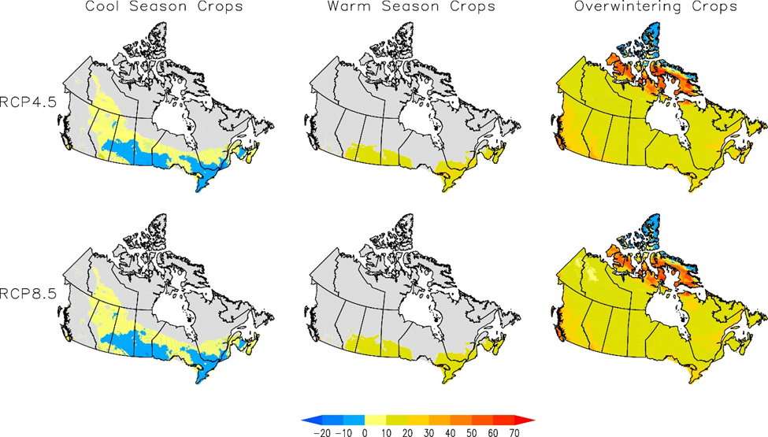
Figure S4. Projected multi-model ensemble median changes in the length of growing seasons (in days per year) for cool season crops (left panel), warm season crops (central panel), and overwintering crops (right panel) for a global warming level of 2°C under RCP4.5 (upper panel) and RCP8.5 (lower panel). Changes are relative to the 1986 to 2005 climatology. Grid boxes are masked grey for the cool season crops if the effective growing degree days are projected to be less than 1200 degree-days in a future period, and for warm season crops if crop heat units are projected to be less than 2800 in a future period.

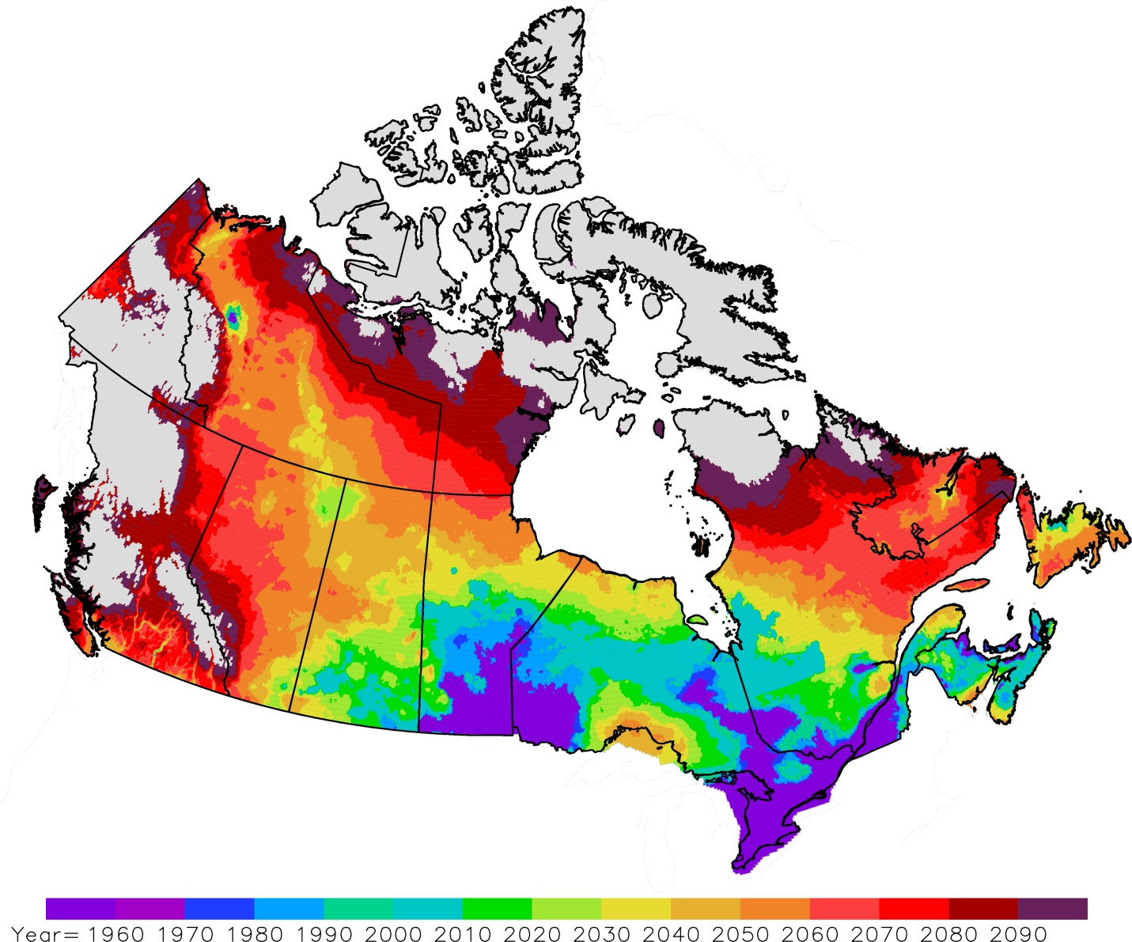
Figure S5. The first occurrence of the year at which there is at least one day with daily minimum temperature greater than 20°C in the statistically downscaled daily minimum temperatures projected by at least 12 of 24 GCMs. Areas are marked in grey if daily minimum temperatures greater than 20°C are not projected to occur by at less than 12 GCMs.

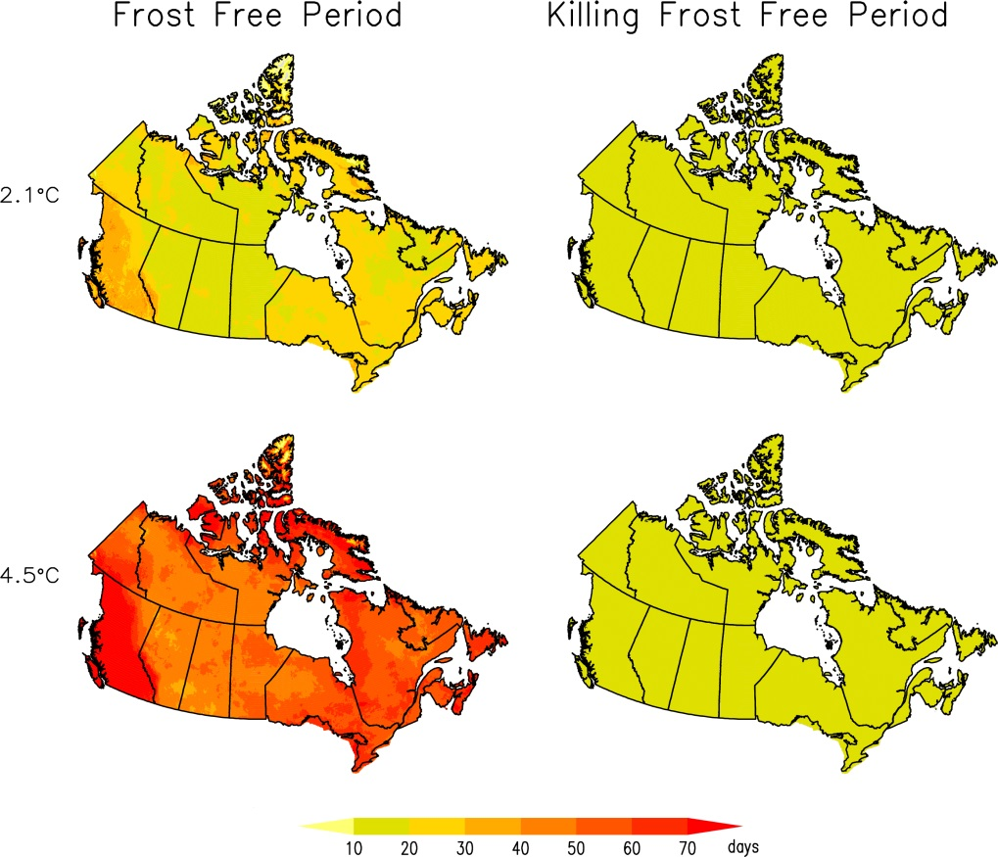
Figure S6. Projected multi-model median changes in the length (in days) of frost free period (left panel) and killing frost free period (right panel) at the 2.1°C and 4.5°C global warming levels.

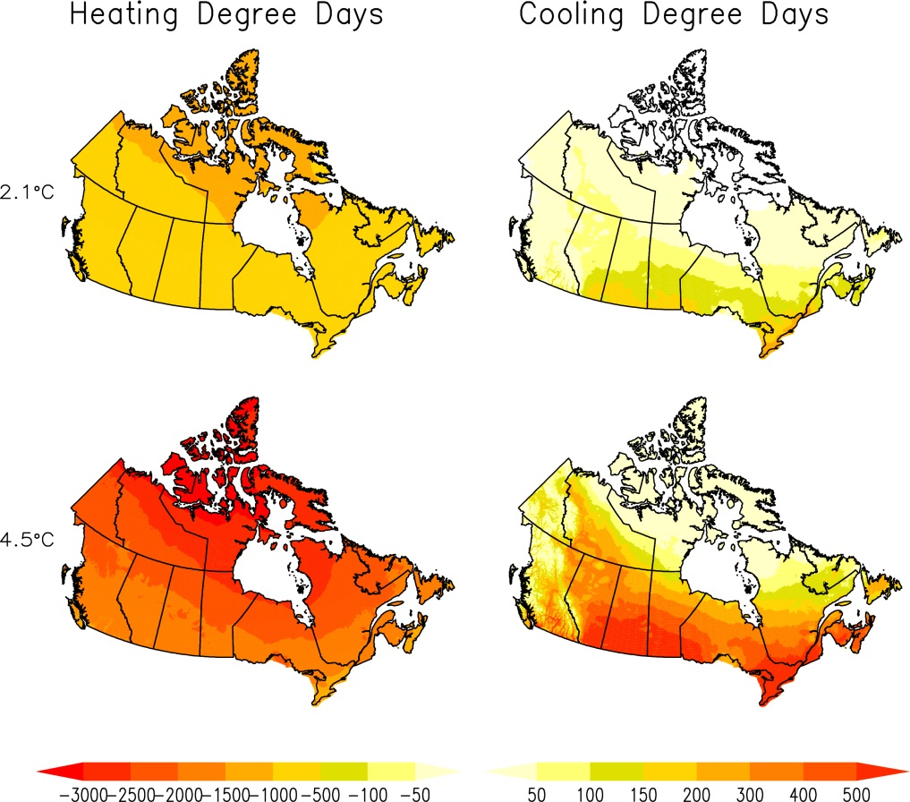
Figure S7. Projected multi-model median changes in heating degree days (in units of °C-days, left panel) and in cooling degree days (in units of °C-days, right panel) at the 2.1°C and 4.5°C global warming levels.

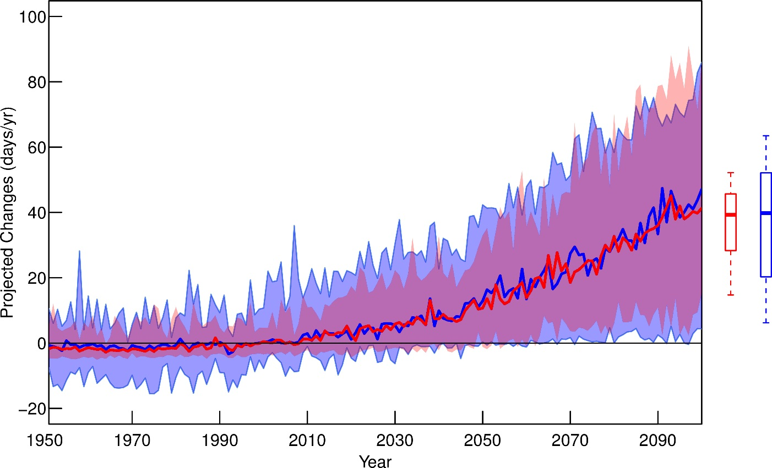
Figure S8. Projected multi-model median changes in the number of days with maximum temperature greater than 30°C in Ontario, relative to 1986-2005 climatology, by the raw GCM output (blue line) and by the statistically downscaled data (red line), based on historical forcing simulations (1950-2005) and their RCP8.5 extensions (2006-2100). The blue and purple (or red) shading shows the ranges of projected changes across the 24 models (blue, raw GCM output; red, downscaled GCM output; purple indicates where ranges overlap). The box plots to the right show the projected changes averaged over 2081-2100, with the middle bars indicating the median changes, the boxes indicating the 25-75% range and the whiskers indicating the 5-95% range of changes. The unit is days per year.

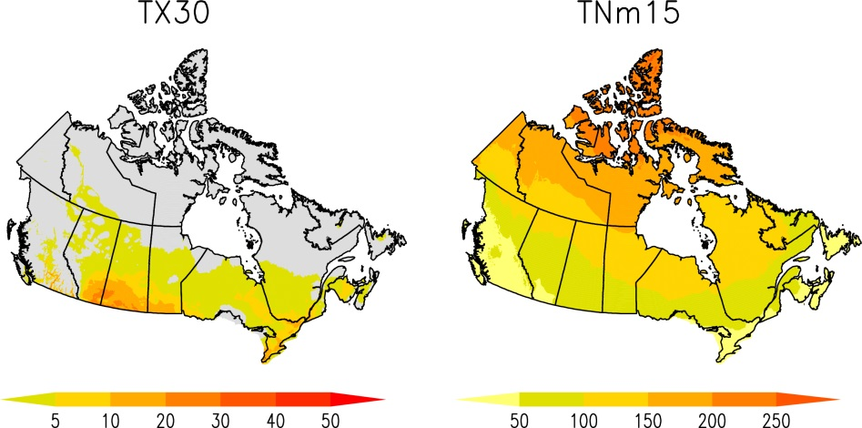

Figure S9. 1950-2010 average of the number of hot days (TX30, left panel), and the number of cold nights (TNm15, right panel) computed from the gridded observational temperature data.

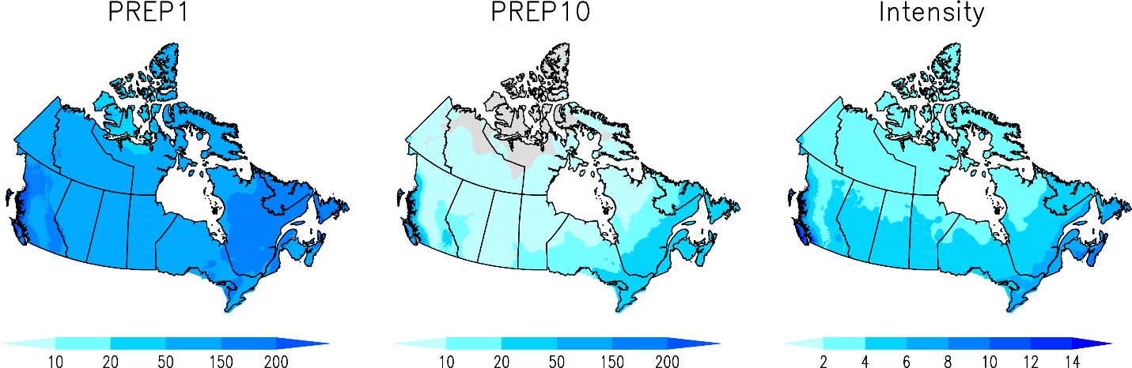
Figure S10. 1950-2010 average of in the number of precipitation days (PREP1, in days; left panel), in the number of heavy precipitation days (PREP10, in days; center panel), and in daily precipitation intensity (Intensity, in mm; right panel) computed from the gridded observational precipitation data.

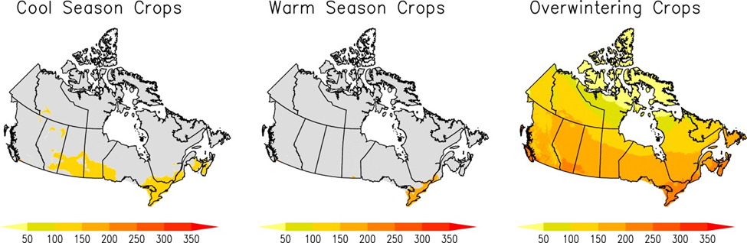
Figure S11. 1950-2010 average of the length of growing seasons (in days) for cool season crops (left panel), warm season crops (central panel), and overwintering crops (right panel) computed from the gridded observational temperature data.

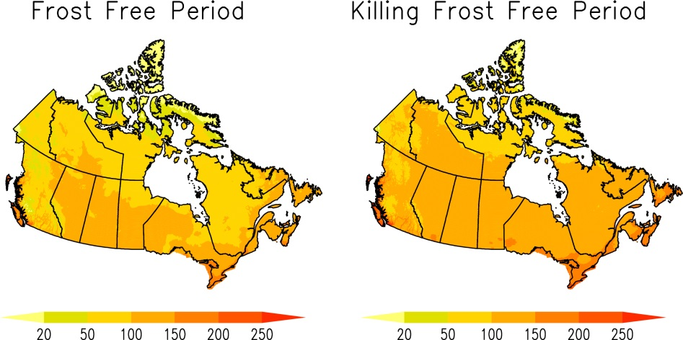

Figure S12. 1950-2010 average of the length of frost free period hot days (in days, left panel), and the length of killing frost free period (in days, right panel) computed from the gridded observational temperature data.

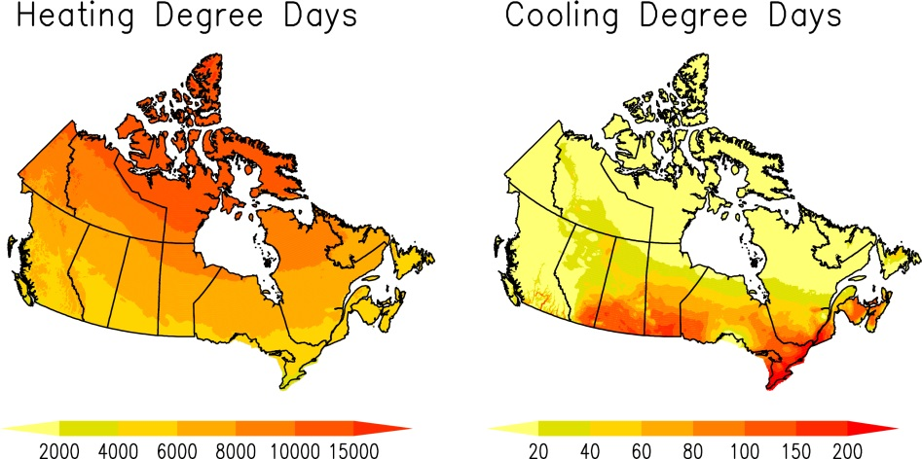

Figure S13. 1950-2010 average of heating degree days (in degree-days; left panel) and cooling degree days (in degree-days; right panel) computed from the gridded observational temperature data.

