Appendix
- Comparison of Ilorin synoptic station observations with large-scale gridded products
We used synoptic station observations to correct model’ simulations in order to better represent local climate. However, before using synoptic stations data for calibration it is always good to check how commonly used observations (i.e large-scale gridded products like reanalysis or satellite-gauge merge products) would perform when compared to our synoptic station data acquired from Nigerian Meteorological Agency (NiMet). We use the Global Precipitation Climate Center reanalysis (GPCC) (Schneider et al., 2011) as large-scale gridded gauge-based data. This product is known to have a good agreement with station data (Manzanas et al., 2014) over a region of Ghana that is also part of the guinea savannah. We also used the satellite-gauge merge data ARC2 (African Rainfall Climatology version 2). Figure 8 shows a general good agreement among datasets for based on annual cycle (correlation of 0.98 and 0.99) over 1985-2010. Some differences in magnitude are also observed for some months (e.g in June and September, both GPCC and ARC2 under-estimate NiMet observations). This graph shows that our synoptic data are realistic but also tell us that using large-scale products for bias-correction of model simulations might be not be appropriate (assuming that synoptic stations data represent better local climate).
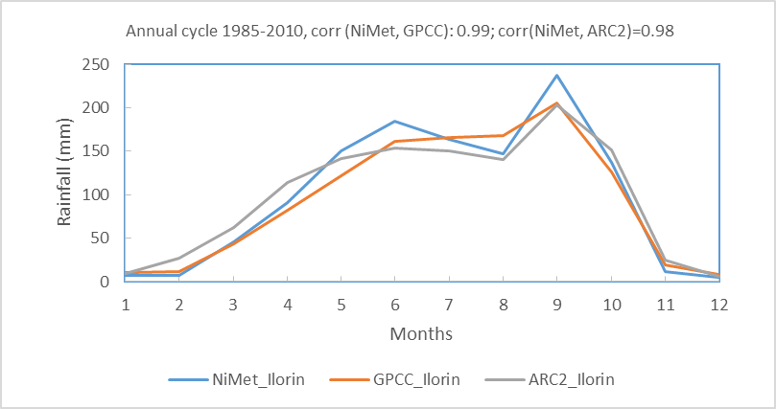
Fig. 8: Comparison of synoptic observations with GPCC V6 and ARC2 gridded data. Gridded data are extracted by applying a field mean of a box that covers Awin basin (Fig.1) and containing the synoptic station.
- Analysis of the regional climate model (RegCM4) simulations assessment
The raw model runs (P, $T_{min}$, $T_{max}$, and RH) were compared to the observations over the control period 1985-2004 based on descriptive statistics. Absolute and relative bias equations used by Leander and Buishand (2007) were applied. The formula gives the percentage of change between the raw RegCM4 simulations with the observations of rainfall, temperature and relative humidity for the reference period 1985-2004. Leander and Buishand (2007) used the relative bias formula for P and RH; and the absolute bias formula for T following equations 4 and 5 respectively.
Relative bias % = $\frac{{\overline{X}}_{Obs}-{\overline{X}}_{raw_RegCM4}}{{\overline{X}}_{Obs}} ×$ 100, (Equation 4)
Absolute bias % = ${\overline{X}}_{Obs}-{\overline{X}}_{raw_RegCM4}$ (Equation 5)
where: ${\overline{X}}_{Obs}$ and ${\overline{X}}_{raw_RegCM4}$ are the means monthly observations from NiMET and the raw RegCM4 simulations over the control period 1985-2004.

- Results on the regional climate model (RegCM4) assessment
The descriptive statistics in Table 3 shows differences in multi-year average values, for the control period, between the rainfall observations (1164.8 mm) and raw model simulations driven by MPI (1216.6 mm) and GFDL (1065.6 mm).The standard deviation (S) of rainfall observations is also different from that of raw simulations. Raw runs driven by MPI overestimate observed average rainfall while those driven by GFDL underestimate it. Fig. 9 gives relative biases and shows disparities in annual cycle of rainfall for the control period. Negative biases (overestimation of model runs) occur mainly in July, August and September while positive biases (underestimation of model runs) occur in other months. This can be explained by existing small-scale processes occurring at local scale that cannot be captured by the RegCM4 model despite its parametrizations. Table 3 also shows differences among average in $T_{min}$ and $T_{max}$ observed (21.58 °C and 32.38 °C respectively) and simulated by RegCM4 driven by MPI (20.95 °C and 30.95 °C respectively) and by GFDL (20.23 °C and 30.95 °C respectively). S of observed and simulated temperatures does not differ much proving that temperature is generally well reproduced by the RegCM4 but still slightly (1 to 2 °C) underestimate observed temperature. Fig. 10 and 11 give absolute biases and show disparities in the annual cycle of $T_{min}$ and $T_{max}$ respectively. Simulated $T_{min}$ overestimates observed $T_{min}$ during the rainy season (May, June, July, and August). Whereas, simulated $T_{max}$ underestimates observed $T_{max}$ for all months over the control period. Table 3 shows that multi-year average values of observed RH (64.2%) differ from simulated RH driven by MPI (50.44%) and GFDL (49.26%). RH runs driven by both MPI and GFDL are underestimated. The disparities can be seen in the annual cycle over the control period through analysis of the relative bias in Fig. 12. This figure shows that RH runs underestimate (positive bias) observation during January, February, March, April, November, and December. In summary, there are differences between observations and models runs proving that different GCMs driving the RegCM4 can lead to different results with regards to MPI and GDFL (Mourato et al. 2014). Correcting future simulations using errors found between observations (reference) and model simulations in the control period is therefore important.
Table 3 : Descriptive statistics for the control period 1984-2004
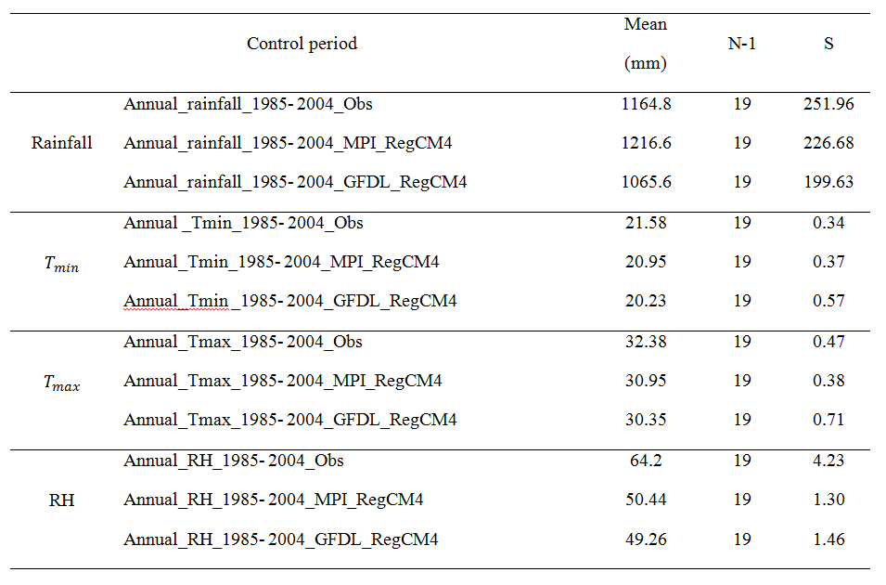

Fig. 9: Relative bias (%) of the annual cycle of rainfall from raw MPI and GFDL-driven runs compared with observations over the control period 1985-2004.

Fig. 10: Absolute bias (°C) of the annual cycle of minimum temperature from raw MPI and GFDL-driven runs compared with observations over the control period 1985-2004

Fig. 11: Absolute bias (°C) of the annual cycle of maximum temperature from raw MPI and GFDL-driven runs compared with observations over the control period 1985-2004

Fig. 12: Relative bias (%) of the annual cycle of relative humidity from raw MPI and GFDL-driven runs compared with observations over the control period 1985-2004

- Methodological Flow Chart for Bias Correction.
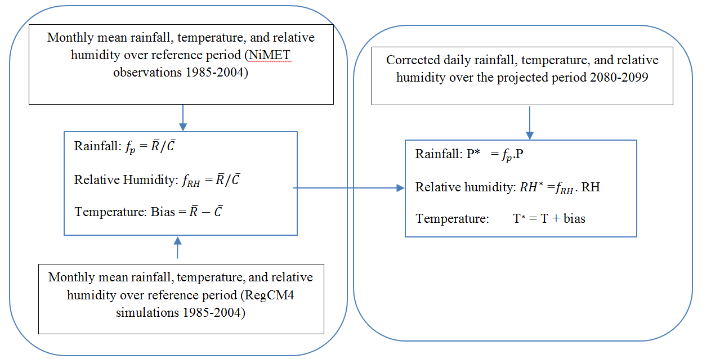
Fig. 13: Methodological Flow Chart for Bias Correction. Correction of rainfall : Daily simulated rainfall P in the future was transformed into P* such that P* = $f_{p}×P$, using a scaling factor, $f_{p}$ = $\overline{R}/\overline{C}$ , where: $\overline{R}$ and $\overline{C}$ are monthly mean value observed rainfall from NiMET and simulated rainfall from RegCM4 respectively over 1985-2004 and for each grid cell. The scaling factor $f_{p}$ was used to correct future RegCM4 rainfall over the period of 2080-2099. Correction of temperature: In contrast to precipitation amount, biases of temperature were calculated as the difference of monthly mean values of simulated data (C) and observed reference data (R) for each grid and over the control period 1985-2004: bias = $\overline{R}$ – $\overline{C}$ and T* = T+ bias. Correction of relative humidity: The bias correction of RH is similar to that of rainfall because of positive constraints. RH values greater than 1 i.e 100% are simply truncated as suggested by (Haerter et al. 2011).
- Significances tests
Table 4: P-value of the Welch test for changes in mean from present to future scenarios
Present climate | MPI_RegCM4_ RCP4.5 | MPI_RegCM4_ RCP8.5 | GFDL_RegCM4_ RCP4.5 | GFDL_RegCM4_RCP8.5 | Ensmean_RCP4.5 | Ensmean_RCP8.5
HS | 0.006171 | 9.88E-07 | 9.99E-05 | 1.98E-05 | 8.15E-05 | 1.01E-07
BMN | 0.0366 | 9.09E-05 | 0.001339 | 0.000703 | 0.002016 | 4.92E-05

SCHNEIDER, U., BECKER, A., FINGER, P., MEYER-CHRISTOFFER, A., RUDOLF, B. AND ZIESE, M., 2011. GPCC full data reanalysis version 6.0 at 0.5: monthly land-surface precipitation from rain-gauges built on GTS-based and historic data. doi: 10.5676/DWD_GPCC. FD_M_V6_050, 5.
MANZANAS, R., AMEKUDZI, L.K., PREKO, K., HERRERA, S. AND GUTIÉRREZ, J.M., 2014. Precipitation variability and trends in Ghana: An intercomparison of observational and reanalysis products. Climatic change, 124(4), pp.805-819.
Novella, N.S. and Thiaw, W.M., 2013. African rainfall climatology version 2 for famine early warning systems. Journal of Applied Meteorology and Climatology, 52(3), pp.588-606.
LEANDER R AND BUISHAND TA. 2007. Resampling of regional climate model output for the simulation of extreme river flows. Journal of Hydrology 332: 487-496.
MOURATO S, MOREIRA M AND CORTE-REAL J. 2014. Water availability in southern Portugal for different climate change scenarios subjected to bias correction. Journal of Urban and Environmental Engineering 8: 109.
HAERTER J, HAGEMANN S, MOSELEY C AND PIANI C. 2011. Climate model bias correction and the role of timescales. Hydrology and Earth System Sciences 15: 1065-1079.

