Supplementary material

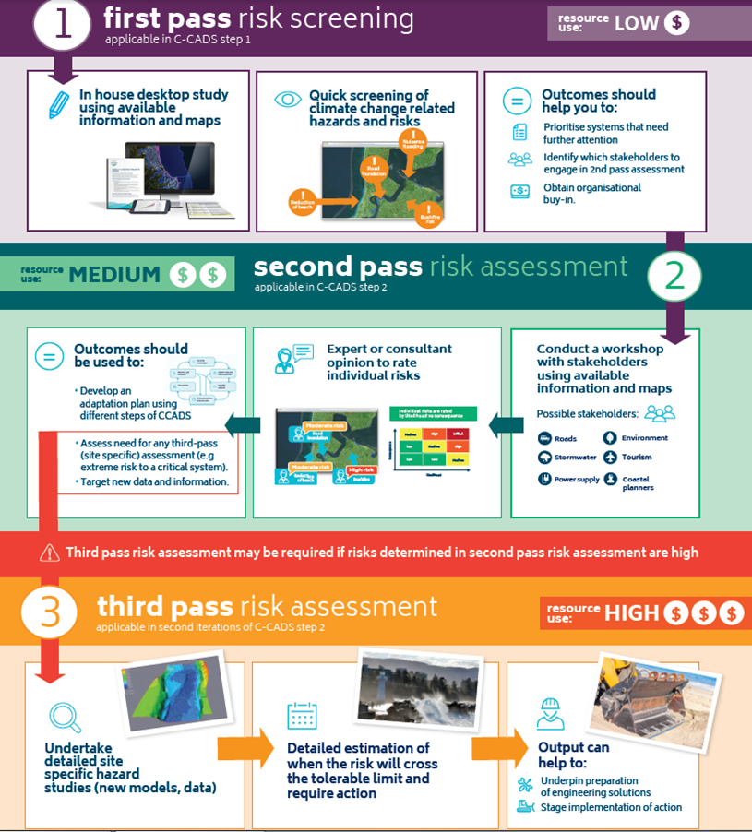
Figure A-1 CoastAdapt infographic on the three-tier risk assessment framework

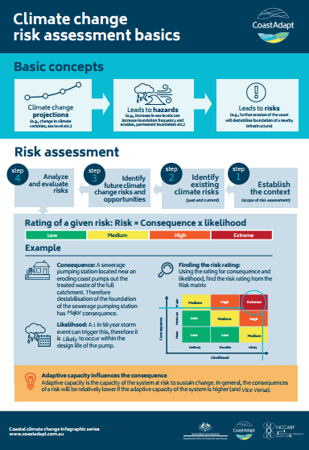
Figure A-2 CoastAdapt infographic on risk assessment basics.

Table A-1 Summary overview of issues to be addressed at the three levels of risk assessment in CoastAdapt

1st pass
Risk
Assessment
2nd pass
Risk Assessment
3rd pass (detailed) Risk Assessment
Step-1: Establish the context
Step-2: Identify existing risk (past and current)
Step-3: Identify future risk and opportunities
Step-4: Analyse and evaluate risk
- Objective/goal
- Time frame and climate change scenario (for variables that are relevant to the decision areas under investigation)
- System under analysis (e.g. public infrastructure, private properties, ecosystems)
- Scale of analysis (e.g. entire council, a single beach community, a single infrastructure etc.)
- Identify relevant stakeholders and establish mechanisms to involve them in the process.

- Identify whether any record of occurrence of climatic hazard in the past in the area? Use findings of 1st pass screening to narrow down the list of hazards (relevant to the decision area)
- What was the consequence of that event (i.e. identify systems that were affected)?
- Are there any risk management strategies in place to protect previously affected systems from future occurrence of that hazard?
- Understand and identify residual risk of a given system (i.e. risk that remains even after putting a risk management strategy in place)
- Explore climate change projections for the selected time frame/s and emission scenario/s
- Understand whether a change in climate variable or sea level in future will lead to hazards that can pose risks to any systems (i.e. assets).
- Investigate whether any existing risk (from step 2) can increase under future climate change projections?
- Identify new risks that can emerge under future climate change projections.
- Identify possible consequences of a given risk and the likelihood of each consequence occurring (also consider system interdependencies).

- Identify risk evaluation criteria (e.g. maintain public infrastructure, protect private properties, minimise impact on environment, ensure business continuity etc.)
- Adopt scales for rating consequence of a risk (i.e. impact of a risk on risk evaluation criteria) and likelihood of that happening
- Take one risk at a time and using adopted scales, rate the consequence of climate change impact for the area. Also rate the likelihood of that happening. Repeat this step for each risk evaluation criteria
- Adopt a risk rating scale (e.g. high, medium, low etc.)
- Using information generated above, identify the rating of the risks
- Using the risk rating identify the risks that may cause you most problems in future which should be investigated further
- Objective/goal
- Time frame
- Climate change scenario (for relevant variables and sea levels only but with further details)
- System under analysis (e.g. public infrastructure, private properties, ecosystems)
- Scale of analysis (e.g. entire council, a single beach community, a single infrastructure etc.)
- Using information derived from a first-pass or second-pass assessment on past hazard in the area list the system component/s (e.g. assets) that was/were affected in the past events.
- What was the consequence of those events? (qualitative or quantitative estimation)
- Are there any risk management strategies in place to tackle any future occurrence of that risk?
- Understand and identify residual risk of a given system (i.e. risk that remains even after putting a risk management strategy in place)
- Identifying relevant climate change and sea-level rise projections of the area (for selected scenarios in step 1) and assess further data needs.
- For the hazards that have been shortlisted in second-pass assessment, commission detailed studies to identify the exact nature, rate and extent of identified risks under future climate and sea-level change.
- Using the output of these detailed studies identify system components that are at-risk (exposure)
- Understand how sensitive system components (e.g. assets) are to the identified risk exposures. This might need to use information generated in the detail site specific analysis and modelling (also consider system interdependencies).
- Also explore and understand the capacity of the system components or organization managing them to respond to any future exposures.
- Using information generated above determine vulnerability of the system component
- Identify risk evaluation criteria (e.g. maintain public infrastructure, protect private properties, minimise impact on environment, ensure business continuity etc.)
- Adopt scales for rating consequence of a risk (catastrophic, moderate, low etc.) and likelihood of a given consequence happening (rare, unlikely, possible etc.)
- Take one system component at a time and using adopted scales, rate the consequence of their identified risk occurring in future. Also rate the likelihood of that happening.
- Repeat the above step for each risk evaluation criteria
- Adopt a risk rating scale (e.g. high, medium, low etc.)
- Using information generated above, identify the risk rating of the system components
- Using the risk ratings along with vulnerability ratings (step-3) identify the system components whose risk need to be addressed in priority (e.g. high vulnerability-high risk)

- Objective/goal
- Scale
- Time frame
- Climate change scenario (for most climate variables and sea level)
- Identify whether any record of occurrence of climatic hazard in the past in the area?
- Are there any risk management strategies in place to tackle any future occurrence of that hazard?
- Explore climate change projections for the selected time frame/s and emission scenario/s and identify potential hazards
- For each hazards, can any existing risk (from step-2) get worse under future projected changes?
- Can any new risk emerge under future projected changes?
- Identify a set of decision areas or systems (e.g. geographical areas, business operation, assets, ecosystems etc.) that has the potential to be at-risk in future

Table A-2 CoastAdapt national datasets and their relevance in the three-tiers of risk assessment
CoastAdapt Dataset | Relevant Time | Tier of risk assessment where it should be used
Sea-level rise projections for 237 coastal councils in Australia. | Future | Second and third
Projected inundation mapping for 237 coastal local councils in Australia for 2050 and 2100 and two greenhouse gas scenarios | Future | First and second
Allowances showing the height that a coastal structure needs to be raised to maintain its existing risk level in future (for 237 councils) | Future | Second and third
Downscaled projection of temperature extremes: mean annual number of days with maximum temperature greater than 30 °C, | Future | All
Downscaled projection of temperature extremes: mean annual number of days with minimum temperature greater than 25 °C, | Future | All
Downscaled projection of temperature extremes: average of longest run of days in each year with maximum temperature greater than 30 °C, | Future | All
Downscaled projection of rainfall extremes: mean annual number of days when rainfall exceeds the historic 99.9th percentile | Future | All
Projection of rainfall extremes: mean annual number of months when total rainfall is less than the historic 10th percentile | Future | All
Water observations from space: An indication of the present-day flooding risk, based on satellite observations | Past | First and second
Secondary coastal compartments map | Present | Second and third
Expert knowledge on coastal compartments: Qualitative expert description of each secondary compartment on landform, stability etc. | Present and future | Second and third
Smartline basic and Smartline advanced: Geomorphology map of the Australian coastline presented as a segmented line tagged with attributes (geology, stability etc.) | Present and future | Smartline basic: First  Smartline advanced: Second and third
Local government boundary | Present | All

Table A-3 Example likelihood scale (from AGO 2006)
Rating | Recurrent risk | Single event
Almost certain | Could occur several times per year | More likely than not: probability greater than 50%
Likely | May arise about once per year | As likely as not: 50/50 chance
Possible | May arise about once in 10 years | Less likely than not but still appreciable: probability less than 50% but still quite high
Unlikely | May arise about once in 25 years | Unlikely but not negligible: probability noticeably greater than zero
Rare | Unlikely during the next 25 years | Negligible: probability very small, less than zero

Table A-4 Example of consequence scale
Consequence | Criteria appropriate for assets that are owned by the organisation assessing its risk | Criteria appropriate for community assets (infrastructure and services) | Criteria appropriate for environmental assets | Criteria appropriate for business continuity (capacity of the organisation to manage a disruption)
Catastrophic | Asset(s) completely damaged and/or large-scale engineering works required for reinstating. | Community assets and private properties completely damaged with irreversible loss | Irreversible loss of environmental assets | Significant disruption in business operation (virtually dysfunctional)
Major | Extensive structural damage to the asset(s) requiring significant engineering stabilisation work. Major disruption in the asset's service | Extensive damage to community assets with wide spread impacts.  Long-term loss of private property | Extensive damage to environmental assets with long-term effects and that can have impact in local economy and life style.  High cost involved to recover using management efforts | Major disruption in business operation with significant loss of revenue and market reputation
Moderate | Moderate damage to some part of the structure of the asset(s) and require large engineering stabilisation work.  Moderate disruption in the asset's service | Considerable impact upon access to community assets. Major long-term impact upon private property. | Considerable impact on environment but with no long-term effects and can be recovered with moderate management efforts | Considerable impact in business operation with loss of revenue
Minor | Limited damage to some part of the asset(s) requiring some small-scale stabilisation work resulting in minor service disruption | Minor short-term impacts (mainly reversible) on community assets and services. Minor long-term impacts to private property. | Limited impact on the environment but can be recovered using minimum management efforts | Minor impact in business operation as disruption mostly can be managed through standby or alternate options. However, some loss of revenue or cost involved
Insignificant | Little disruption in service but no structural damage to the asset(s) | Little disruption of non-critical community assets | Little impact on environment and recovery occurs without management efforts | Little impact in business operation.
No risk | No assets are at risk | No community assets and/or private property are at risk | No environmental assets are at risk | No impact on business operation

Table A-5 Example risk ratings scale (from AGO 2006)
Likelihood | Consequences
Likelihood | Insigniﬁcant | Minor | Moderate | Major |  | Catastrophic
Almost certain | Medium | Medium | High | Extreme |  | Extreme
Likely | Low | Medium | High | High |  | Extreme
Possible | Low | Medium | Medium | High |  | High
Unlikely | Low | Low | Medium | Medium |  | Medium
Rare | Low | Low | Low |  | Low | Medium

Table A-6 Example of a simple vulnerability rating scale (coloured cells show degree of vulnerability)
Adaptive capacity | Sensitivity
Adaptive capacity | Low | Medium | High
High | Low | Low | Medium
Medium | Low | Medium | High
Low | Medium | High | Extreme

Table A-7 Example planning prioritisation matrix
 | Low Risk | High Risk
Low vulnerability | Least priority | Intermediate priority
High vulnerability | Intermediate priority | Top priority

Table A-8 Example of risk evaluation/success criteria (from AGO 2006)
Sector | Example of evaluation/success criteria
Local government authorities | - Maintain public safety  - Protect and enhance the local economy  - Protect existing community structures and the lifestyle enjoyed by the people of the region  - Sustain and enhance the physical and natural environment  - Ensure sound public administration and governance
Public utility | - Maintain service quality  - Ensure reliable service delivery  - Manage interaction with other providers to achieve cost-effective operation  - Ensure that community and regulatory standards of administration are met  - Maintain and strengthen community conﬁdence in the organisation
For-profit business | - Build shareholder value  - Achieve planned growth  - Protect the supply chain  - Maintain required human resources  - Ensure regulatory and legislative compliance

Table A-9: Four risk assessment templates available from CoastAdapt
Risk assessment templates | When to use?
Template 1: First-pass risk screening: | Suitable for a quick screen of climate change hazards and associated risks.
Template 2: First-pass risk screening: | Useful if you want to redo the first-pass risk screening with more information and effort.
Template 3: Second-pass risk assessment: | Can be used for recording information during a second-pass risk assessment workshop.
Template 4: Third-pass risk assessment: | Can be used for recording information during a third-pass risk assessment workshop.

Reference
Australian Greenhouse Office (2006) Climate change impacts and Risk Management: A guide for business and government. Australian Government, Canberra. https://www.environment.gov.au/system/files/resources/21c04298-db93-47a6-a6b0-eaaaae9ef8e4/files/risk-management.pdf). Accessed 23 July 2018

