Assessing the impacts of climate change on biodiversity: Is below 2°C enough?

  - Journal Climatic Change

Sarahi Nunez Ramos, Eric Arets, Rob Alkemade, Caspar Verwer and Rik Leemans

Corresponding author: Sarahi Nunez Ramos
Environmental Systems Analysis Group, Wageningen University and Research, PO Box 47, 6700 AA Wageningen, the Netherlands
E-mail: sarahi.nunezramos@wurl.nl

Online Resource 1: Methods and Materials

1.1 Systematic Literature Review
We conducted a systematic review following the guidelines for CEE Evidence Synthesis Protocols (CEE 2013). The review question addressed was: What is the impact of global mean temperature increase at different intervals on terrestrial biodiversity (Fraction of Remaining Species and Fraction of Remaining Area with Suitable Climate of taxonomic groups and biomes)?
First, we developed a search strategy to indicate how the process was conducted and to ensure reproducibility. The search strategy consists of:
- Defining search terms, search strings and/or combination of searches. We identified four major topics that would help to answer our review question. For each topic, we identified search terms and we combined them into search strings to be used in our search to find relevant studies.

- Climate change elements: (climat* SAME change*) OR (temperature SAME change*) OR (temperature SAME increase) OR (global SAME warming) OR (climat* SAME warming);
- Biodiversity elements: (biodiversity) OR (diversity SAME species) OR (species SAME richness*) OR (species SAME distribution*) OR (species SAME abundance*) OR (species SAME occurrence*) OR (species SAME turnover) OR (species SAME loss*) OR (species SAME gain*) OR (species SAME composition) OR (species SAME assemblage*);
- Bioclimatic modelling elements: (bioclimat* model*) OR (niche* model*) OR (climat* model*) OR (distribution model*) OR (habitat model*) OR (ecologic* model*) OR (occurrence model*) OR (species distribution model*) OR (model* distribution*) OR (model* range*) OR (climat* envelope*) OR (envelope* model*); and
- Modelling projections elements: (future SAME distribution*) OR (climat* SAME scenario*) OR (climat* SAME projection) OR (climat* SAME prediction) OR (climat* SAME pathway*).
The ISI Web-of-Science database (http://apps.webofknowledge.com/) was selected as our bibliographic database. We used EndNote X7.2.1 to store the results from the search process and retrieve them for further analysis.
- Eligibility criteria and screening process. We defined a screening process to decide whether the studies yielded in the search were eligible for inclusion in the review (Fig. OR1. 1).

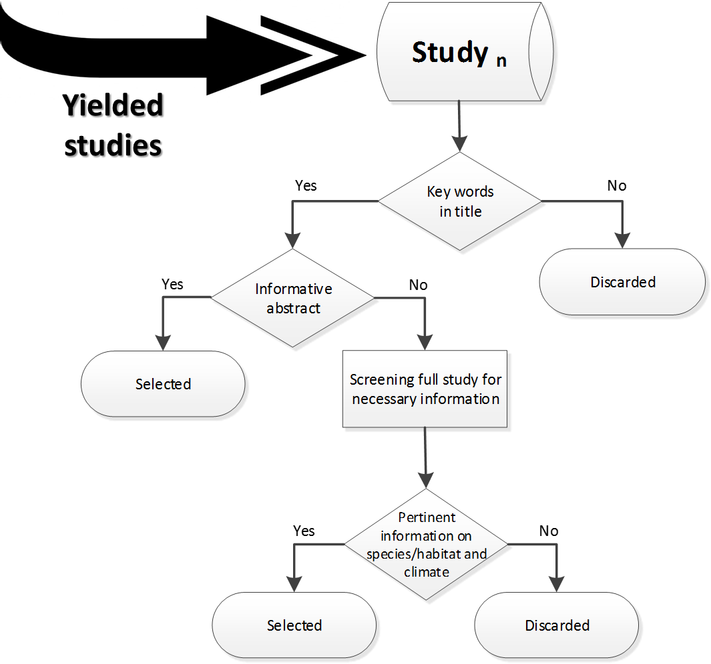
Fig. OR1. 1 Selection process used in the systematic literature review

- Study inclusion criteria. To critically appraise the inclusion of studies, we defined specific criteria. We selected those studies that met the following criteria:
C1: Study presents data on species composition (i.e. the number of species >1) and indicates the number of species (n) in the original and the projected climate situations (i.e., before and after climate change) (for FRS);
C2: Study presents data on species composition (i.e. the number of species >1) and indicates the number of species (n) and their area with suitable climate in the original and the projected climate situations (i.e. before and after climate change) (for FRA);
C3: Study indicates the spatial resolution of the original analysis;
C4: Study indicates the location and extension of the case study to calculate spatial extent and to determine terrestrial biomes;
C5: Study provides information on global temperature increase used in the original analysis; or indicates the type of climate-change scenario and general circulation model used;
C6: Study indicates the reference and projected years for climate change; and
C7: Study specifies the taxonomic groups assessed in the original analysis.
Studies that focussed on distributions of single species, aquatic species or exotic invading species or assessing historical effects of climate-change on species were considered to be outside the scope of our research. When the selected studies provided data for dispersal and no-dispersal cases, we extracted data for the no-dispersal case.
- Data extraction strategy. We estracted data from the selected studies. The data were store into an Excel file (i.e. database). Each study was assigned with a code (i.e., ‘rq1_1’) corresponding to the original search results. Each study was exhautively checked in its methods and results sections in order to extract the necessary information. When the study indicated that additional information was in the supplementary material, we also checked those files to ensure a complete review of the study.

1.2 Variance estimate
The sampling variances were calculated as follows:
i) following references 1, 2 and assuming that the species data in the original study show a Poisson distribution whereby Ơ²=µ, thus:
(Equation 1)
$$Ơ^{2}= \frac{{S_{di}}^{2}}{{S_{oi}}^{2}} \left[\frac{1}{S_{di}}+\frac{1}{S_{oi}} \right]$$
where Ơ² is the variance of the effect size FRS for species, S_{di} is number of expected species in disturbed situation with climate change and S_{oi} is number of species in original situation without climate change. A full description of how the variance was calculated is presented in elsewhere (Kuiper et al. 2014).
ii) assuming the variance of the internal error:
(Equation 2)
$$Ơ^{2}=\frac{\sum_{i}^{S}{(H_{di}-} µ)2}{S}$$
where Ơ² is the variance of effect size FRH, H_{di} is the climatically suitable habitat for species i in disturbed situation with climate change, µ is the mean of H_{d} among all species and S is the number of species. A full description of how the variance was calculated is presented elsewhere (Kuiper et al. 2014).
And iii) assuming binomial distribution:
(Equation 3)
$$Ơ^{2}=FRH(1-FRH)$$
where Ơ² is the variance of effect size FRH and FRH is Fraction Remaining Climatically Suitable Habitat for all species in the original study.

1.3 Meta-analysis
Random-effects structures
We ran random-effects structures with a full-fixed effects structure to account for the resolution and spatial extent of the studies. We specified study identity, grid cell resolution and spatial extent of the original studies as random-effects factors. Since the resolution of the grid cells is given in different units (e.g. degrees, arc-minutes, kilometres, hectares), we converted all units into degrees (°) to indicate a common resolution unit among the studies. We calculated the spatial extent of the study area for each original study (and multiple locations when the study requested it) in ArcGIS 10.5. We used the ArcGIS Spatial Analyst Toolbox to locate the case-study area on a common map and to extract the necessary information to account for the spatial extent (i.e. number of pixels). We controlled for different resolutions and spatial extent of studies within the models. We fitted the following random-effects structures:
- (1 | 1)
- (1 | Study)
- (1 | Resolution)
- (1 | Extent)
- (1 | Study + 1 | Resolution)
- (1 | Study + 1 | Extent)
- (1 | Study + 1 | Resolution + 1 | Extent)
- (1 | Resolution + 1 | Extent)
The structures were run with a full fixed effects structure and without intercept:
Equation 4
$$mods=\sim -1+gmti+I\left({gmti}^{2}\right)+biome.aggre+biome.aggre∙gmti+biome.aggre∙I\left({gmti}^{2}\right)$$
Random-effects meta-models
We ran the random-effects meta-models separately for three cases: i) the response of the effect sizes FRS and FRA; ii) the logit-transformed of the effect sizes FRS and FRA; and iii) the log₁₀-transformed of the effect sizes FRS and FRA. Meta-analyses for logit and log₁₀-transformed data are performed to account for non-normal distribution of the data and to help reducing heterogeneity to make results more robust. The first case uses the effect sizes FRS and FRA and sampling variances to derive the pooled effect. We used sampling variances to assign more weight to studies with low estimated variance of the effects size, this usually includes studies with a high number of species (Osenberg et al. 1999; Kuiper et al. 2014). The second case used the logit-transformed FRS and FRA and it was calculated as $Logit=LN(\frac{R}{1-R})$, where R is the effect size FRS or FRA. The model that is fitted to logit, used the number of original species to weight each study to correct for non-normality and to account for uncertainty in estimates of heterogeneity (Ioannidis et al. 2007; Urban 2015). The logit of 0 and 1 are not defined, therefore and for consistency, 0.5 was added as a new observation to effect sizes with values of 0 and 1, and corrected as $FRS= \frac{\left(S_{di}+0.5\right)}{(S_{oi}+1)}$ (e.g. Viechtbauer 2010). The third case used the log₁₀-transformed of the effect sizes FRS and FRA and aimed to linearize the power-law relationship as they are normally distributed around zero, allowing the use of simple linear regressions (Hedges et al. 1999; Gerstner et al. 2014). FRS and FRA were log₁₀-transformed to fit random-effects models using the number of original species to weight each study.
Table OR1.1 List of mixed-effects meta-models fitted to datasets FRS to explore sources of heterogeneity in meta-analysis
Code | Model | Description
M1.FRS | Effect size ~ variance + random =(1 | Study + 1 | Extent) | Basic model fitted to datasets without moderators
M2.FRS | Effect size ~ variance + random =(1 | Study + 1 | Extent) + GMTI intervals | Series of sub-models fitted to datasets at different temperature intervals: 1-2°C, 2-3°C, 3-4°C and >4°C
M3.FRS | Effect size ~ variance + random =(1 | Study + 1 | Extent) + GMTI intervals  +taxonomic group | Series of sub-models fitted to datasets and to individual taxonomic groups (vertebrates and plants) at different temperature intervals: 1-2°C, 2-3°C, 3-4°C and >4°C
M4.FRS | Effect size ~ variance + random =(1 | Study + 1 | Extent) + mods = ~ GMTI | Model including ‘gmti’ as moderator and fitted to datasets
M5.FRS | Effect size ~ variance + random =(1 | Study + 1 | Extent) + mods = ~ GMTI + biome + GMTI*biome | Model including ‘gmti’ and ‘biomes’ as moderators and their interaction, fitted to datasets
M6.FRS | Effect size ~ variance + random =(1 | Study + 1 | Extent) + mods = ~ biome + GMTI | Model including ‘biomes’ as moderator and fitted to datasets

Table OR1.2 List of mixed-effects meta-models fitted to dataset FRA to explore sources of heterogeneity in meta-analysis
Code | Model | Description
M1.FRA | Effect size ~ variance + random =(1 | Extent) | Basic model fitted to datasets without moderators
M2.FRA | Effect size ~ variance + random =(1 | Extent) + GMTI intervals | Series of sub-models fitted to datasets at different temperature intervals: 1-2°C, 2-3°C, 3-4°C and >4°C
M3.FRA | Effect size ~ variance + random =(1 | Extent) + GMTI intervals  +taxonomic group | Series of sub-models fitted to datasets and to individual taxonomic groups (vertebrates and plants) at different temperature intervals: 1-2°C, 2-3°C, 3-4°C and >4°C
M4.FRA | Effect size ~ variance + random =(1 | Extent) + mods = ~ GMTI | Model including ‘gmti’ as moderator and fitted to datasets
M5.FRA | Effect size ~ variance + random =(1 | Extent) + mods = ~ GMTI + biome + GMTI*biome | Model including ‘gmti’ and ‘biomes’ as moderators and their interaction, fitted to datasets
M6.FRA | Effect size ~ variance + random =(1 | Extent) + mods = ~ biome + GMTI | Model including ‘biomes’ as moderator and fitted to datasets

Moderator variable: Biomes
We introduced the variable ‘biomes’ as a moderator to determine sources of heterogeneity. In principle terrestrial biomes were classified following the information provided in the original study (e.g. biomes classification from the Integrated Model to Assess the Global Environment (Stehfest et al. 2014) or the Namibian biomes (Thuiller et al. 2006). For those studies that did not provide a biomes classification, we classified them according to the Terrestrial Ecoregions used by the Nature Conservancy (Olson et al. 2001). We then aggregated the biomes into common classes to overcome data deficiency for some of the categories (see Table OR1.3 in Online Resource 1).

Table OR1.3 Classification of biomes used in previous studies and new simplified categories defined for the meta-analysis
Code | Category | Source | Aggregated category
1 | Tropical and Subtropical Moist Broadleaf Forests | WWF_MHTNAMª | Tropical forest
2 | Tropical and Subtropical Dry Broadleaf Forests | WWF_MHTNAM | Tropical forest
3 | Tropical and Subtropical Coniferous Forests | WWF_MHTNAM | Tropical forest
4 | Temperate Broadleaf and Mixed Forests | WWF_MHTNAM | Temperate forest
5 | Temperate Conifer Forests | WWF_MHTNAM | Temperate forest
6 | Boreal Forests/Taiga | WWF_MHTNAM | Boreal forest
7 | Tropical and Subtropical Grasslands, Savannas and Shrublands | WWF_MHTNAM | Shrublands
8 | Temperate Grasslands, Savannas and Shrublands | WWF_MHTNAM | Grasslands
9 | Flooded Grasslands and Savannas | WWF_MHTNAM | Grasslands
10 | Montane Grasslands and Shrublands | WWF_MHTNAM | Grasslands
11 | Tundra | WWF_MHTNAM | Tundra and ice
12 | Mediterranean Forests, Woodlands and Scrub | WWF_MHTNAM | Shrublands
13 | Deserts and Xeric Shrublands | WWF_MHTNAM | Deserts
14 | Mangroves | WWF_MHTNAM | Shrublands
98 | Inland water | WWF_MHTNAM | Water
99 | Rock and ice | WWF_MHTNAM | Tundra and ice
7 | Ice | IMAGE^{b} | Tundra and ice
8 | Tundra | IMAGE | Tundra and ice
9 | Wooded tundra | IMAGE | Tundra and ice
10 | Boreal forest | IMAGE | Boreal forest
11 | Cool coniferous forest | IMAGE | Boreal forest
12 | Temperate mixed forest | IMAGE | Temperate forest
13 | Temperate deciduous forest | IMAGE | Temperate forest
14 | Warm mixed forest | IMAGE | Temperate forest
15 | Grassland and steppe | IMAGE | Grasslands
16 | Hot desert | IMAGE | Deserts
17 | Scrubland | IMAGE | Shrublands
18 | Savannah | IMAGE | Grasslands
19 | Tropical Woodland | IMAGE | Tropical forest
20 | Tropical forest | IMAGE | Tropical forest
21 | Mediterranean vegetation | IMAGE | Shrublands
1 | Desert an xeric shrublands | Thuiller et al 2006 | Deserts
2 | Flooded grasslands and savanna | Thuiller et al 2006 | Shrublands
3 | Mangroves | Thuiller et al 2006 | Shrublands
4 | Mediterranean forests | Thuiller et al 2006 | Shrublands
5 | Montane grasslands and savanna | Thuiller et al 2006 | Shrublands
6 | Tropical grasslands and savanna | Thuiller et al 2006 | Shrublands
7 | Tropical moist broadleaf forests | Thuiller et al 2006 | Tropical forest
ª Categories as defined in Olson et al. (2001)
^{b} Categories as defined in the Integrated Model to Assess the Global Environment (IMAGE); see Stehfest et al. (2014)

References
Benítez-López A, Alkemade R, Verweij PA (2010) The impacts of roads and other infrastructure on mammal and bird populations: A meta-analysis. Biological Conservation 143:1307-1316 doi:http://dx.doi.org/10.1016/j.biocon.2010.02.009
CEE (2013) Guidelines for Systematic Review and Evidence Synthesis in Environmental Management. Version 4.2. Centre for Evidence-Based Conservation, Bangor University, UK. www.environmentalevidence.org/Documents/Guidelines/Guidelines4.2.pdf
Gerstner K, Dormann CF, Vaclavik T, Kreft H, Seppelt R (2014) Accounting for geographical variation in species-area relationships improves the prediction of plant species richness at the global scale. Journal of Biogeography 41:261-273 doi:10.1111/jbi.12213
Hedges L, Gurevitch J, Curtis P (1999) The meta-analysis of response ratios in experimental ecology. Ecology 80:1150-1156 doi:10.1890/0012-9658(1999)080[1150:tmaorr]2.0.co;2
Ioannidis JPA, Patsopoulos NA, Evangelou E (2007) Uncertainty in heterogeneity estimates in meta-analyses. BMJ : British Medical Journal 335:914-916 doi:10.1136/bmj.39343.408449.80
Kuiper J, Janse J, Teurlincx S, Verhoeven J, Alkemade R (2014) The impact of river regulation on the biodiversity intactness of floodplain wetlands. Wetlands Ecology and Management 22:647-658 doi:10.1007/s11273-014-9360-8
Olson D et al. (2001) Terrestrial ecoregions of the worlds: A new map of life on Earth. Bioscience 51:933-938 doi:10.1641/0006-3568(2001)051[0933:teotwa]2.0.co;2
Osenberg C, Sarnelle O, Cooper S, Holt R (1999) Resolving ecological questions through meta-analysis: Goals, metrics, and models. Ecology 80:1105-1117 doi:10.2307/177058
Stehfest E et al. (2014) Integrated Assessment of Global Environmental Change with IMAGE 3.0. Model Description and Policy Applications. PBL Netherlands Environmental Assessment Agency, The Hague
Thuiller W, Midgley G, Hughes G, Bomhard B, Drew G, Rutherford M, Woodward F (2006) Endemic species and ecosystem sensitivity to climate change in Namibia. Global Change Biology 12:759-776 doi:10.1111/j.1365-2486.2006.01140.x
Urban M (2015) Accelerating extinction risk from climate change. Science 348:571-573 doi:10.1126/science.aaa4984
Viechtbauer W (2010) Conducting meta-analyses in R with the metafor package. Journal of Statistical Software 36(3):1-48 doi:10.18637/jss.v036.i03

