Appendix
1 Introduction
Figure A1: Recorded rainfall in 2015 compared to median rainfall, by month, 2010 to 2015
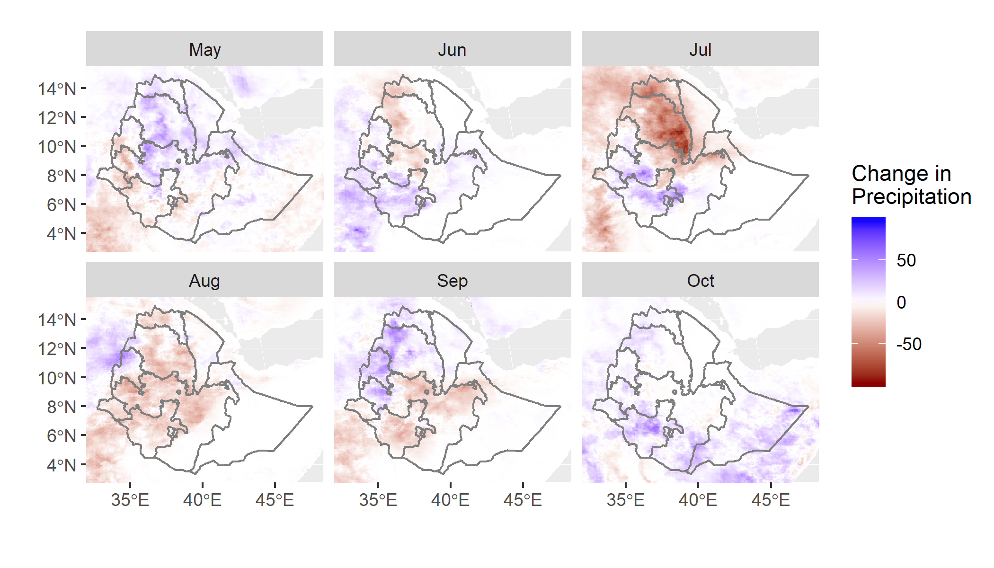
3 Methods
3.1 Data Sources
3.1.1 Survey Data - Agricultural Sample Survey Data (2010-2015)
The AgSS is an annual, government- administered survey that measures agricultural production in Ethiopia. The survey interviews approximately 45,000 farmers each year and collects information on household demographics, farm management, and planting, harvesting and sales at the plot level. Typically, about 20 farm households are randomly sampled from small, village-level areas of approximately 200 households, termed “sub-kebeles”. A kebele is the smallest, official administrative division in Ethiopia, with approximately 1,000 households. Each kebele is divided into five sub-kebeles, based roughly on population. There are over 75,000 sub-kebeles in the country.
We did not apply sampling weights because approximately 25 percent of the sub-kebeles sampled by CSA were omitted; moreover our primary interest is in estimating local effects, not total production.
We choose drought losses of 25 percent or more as a cutoff value given the decreasing number of observations at higher loss levels, as Table A1 illustrates for wheat.

Table A1: Wheat drought loss - Percentage of observations available at different levels of loss between 2010 and 2015 for wheat
 | 10% | 25% | 50% | 75%
% observations | 38.66 | 17.55 | 5.21 | 1.57

3.1.2 Remotely Sensed Data - Greenness, Precipitation and Evaporation
Normalized Difference Vegetation Index
For the sake of simplicity and replicability, we focus on NDVI from among a large list of possible spectral indices, because it is commonly used for agriculture applications (Lessio, Fissore, and Borgogno-Mondino 2017; Mann and Warner 2017; Mann and Warner 2015; Funk and Budde 2009). Due to the staggered nature of acquisition, these products are treated as partially overlapping windows representing eight-day periods (Doraiswamy, Stern, and Akhmedov 2007). After removal of clouds and other flagged low-quality cells, we remove all non-agricultural cells through the use of a purpose-built, machine-learning-based land classification for Ethiopia for the period of interest.
Water Availability Variables
The Actual Evapotranspiration Anomaly (ETA) variable used in this study is the current Actual Evapotranspiration (AET) compared to the mean for 2003 to 2013. Thus, ETA is a proxy for drought, as low current values of AET would correspond to reductions either in available energy to move water, or in water itself. Potential evapotranspiration (PET) is an estimate of the total amount of water that could be moved through the system if water was not a limiting factor. As such it is an ideal indicator of available (or excessive) energy in the form of heat, but commonly includes the impact of wind speed, pressure, and humidity among other factors. More simply, PET can be viewed as a proxy for temperature. Both ETA and PET are available for download through FEWS NET (2017).
3.3.1 Estimation Strategy
Random Forests Description Random forests (RF) are a flexible ensemble learning method that aggregates across multiple classification or regression trees, each based on a randomized subset of variables (Ho, 1995). Each tree is formed through hierarchical splitting, whereby each binary split (e.g. NDVI < 0.1) is identified as the most informative, as defined by the greatest reduction in a Gini impurity. A split is followed by additional binary splits until some stopping criterion is met for each individual tree. Many trees are then fit using random subsets of variables, each fitting different parts of the same training data. These trees are then averaged or aggregated by a voting mechanism. This ensemble method improves performance by finding the mode or median of ‘weak learners’. This process in turn allows RFs to avoid over-fitting and, therefore, to perform consistently out-of-sample and with noisy data sets (Friedman, Hastie, Tibshirani, 2001).
Training vs. Testing Data Before running any models, we divide the data into two sets. A random sample of 85 percent of all sub-kebeles are retained for the training and tuning of models, while the remaining 15 percent are set aside for out-of-sample testing of our models. Because some missing values were present in independent variables, a K-nearest-neighbor (KNN) algorithm was used to impute these values. For an arbitrary sample, the K=5 closest neighbors are found in the set, and the value for the missing value is imputed using the mean of these values (Kuhn, 2019). The KNN algorithm used here centers all data by default, therefore all variables have been centered around their mean values. Training and testing data were imputed separately to avoid information leakage.
Training Data: Cross Validation and Tuning To enhance the out-of-sample performance of our models, we employ parameter tuning and cross validation when training our models. We limit tuning to choosing the number of features (variables) randomly selected for use in each tree. For each crop, we do a grid search and find the parameter tuning that provides the best performance. To ensure that these parameter tunings work well, we utilize out-of-bag (OOB) error. OOB errors can provide unbiased estimates of error in out-of-sample data because random forests already use bootstrapping for fitting individual trees. As such, it can take the place of the validation or test error and is cheaper to compute than using cross validation. The model is tuned to optimize performance of the Kappa coefficient. The optimal parameter value is the one with the highest Kappa value and is specific to each crop model.
Testing Data: Out-of-Sample Performance As noted above, we withheld 15 percent of sub-kebeles from our training sample and used the data for these “test” sub-kebeles to assess the true out-of-sample performance of our tuned RF models. Specifically, we test our tuned RF models by predicting whether losses were 25 percent or higher, by crop, for each of the test sub-kebeles using remotely-sensed data alone. We then compare our predictions to actual losses reported in the AgSS survey. We employ three common performance metrics: a) overall accuracy, 2) Kappa coefficient, and 3) the recall rate.
Spatial Autocorrelation: Following the examples of Krawchuk (2012 & 2009) and Mann et al. (2016), we chose a very small training sample (15%) to minimize the effects of autocorrelation. Given the relatively small total number of observations (1,780 sub-kebeles) across an extremely large geographic area, any randomly chosen training and testing data set will have very little spatial overlap.

To ensure this was the case, we ran a series of simulations in which we generated 50 random testing (85%) and training (15%) splits of the AgSS data. For each of the 50 runs, we calculated the distance between any given testing data point and all of the training data points. The median distance between a testing point and its training points is 370 km, and the 1st quartile is 228 km. Both of which are substantial distances, and unlikely to be affected by spatial autocorrelation. To put these distances in context, refer to the scale bar in Figure 2.

To check how frequently a testing observation shares the same administrative unit as a training observation, we calculated the percentage of testing observation in the same spatial unit as the training observations. We found that any randomly drawn testing observation has the same woreda code (group of villages or districts) as 0.23% of training observations. At the zonal level (sub-regional boundaries displayed in grey for the Tigray region in Figure 2), this percentage only increases to 1.91%.

We believe this implies that, although autocorrelation may play a role in enhancing the performance metrics in this paper, its role has been substantively minimized by sparse sampling.

4 Results
4.1.1 Maize Losses
Figure A2: Maize loss prediction - plot of importance of ten most important variables
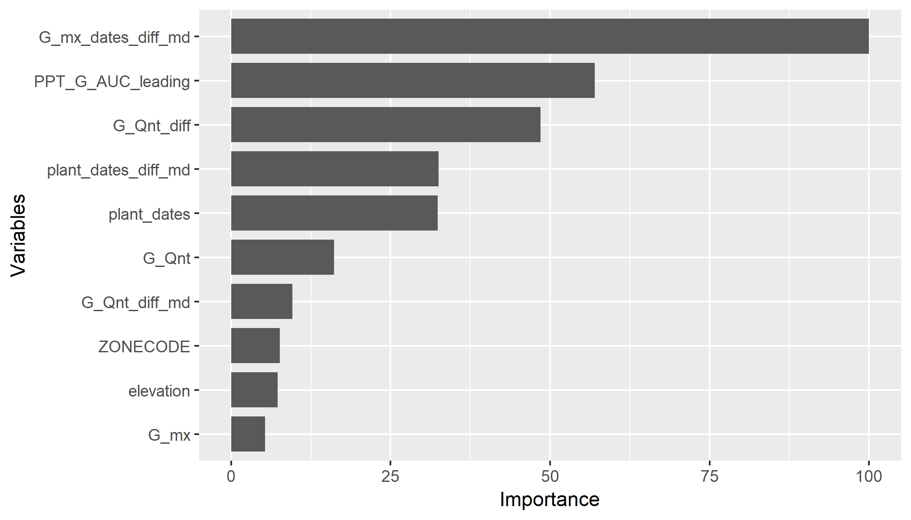

4.1.2 Wheat Losses
Figure A3: Wheat loss prediction - plot of importance of ten most important variables
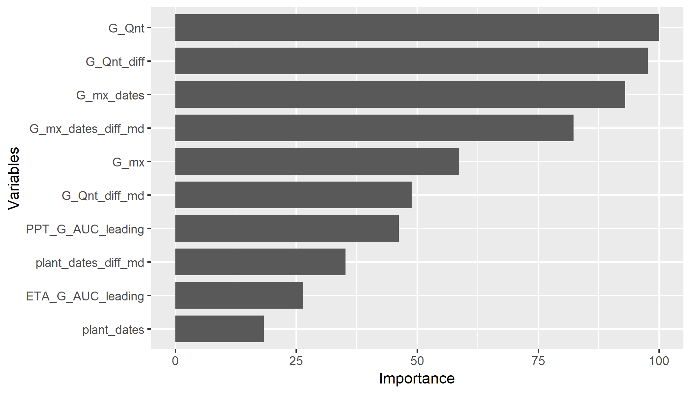

4.1.3 Teff, Barley and Sorghum Losses
Sorghum Losses
Turning to sorghum losses, the confusion matrix and performance metrics for our out-of-sample predictions of substantial losses for this crop are presented in Tables A2 and A3.
Table A2: Out-of-sample confusion matrix for reported losses >= 25% for sorghum
TRUE = Crop losses >= or equal to 25% for sorghum
 | Reference
Predicted |  | FALSE | TRUE
Predicted | FALSE | 878 | 20
Predicted | TRUE | 6 | 59
Table A3: Out-of-sample performance metrics for reported losses >= 25% for sorghum
 |  | Accuracy | Kappa | Recall
 | Value | 0.97 | 0.81 | 0.75
Overall, we find a high level of accuracy in our out-of-sample predictions, with overall accuracy of 97 percent. Prediction of substantial sorghum crop losses was good, with a recall rate of 0.75, indicating that 75 percent, or 59 out of 79, of substantial loss cases were predicted correctly. Six cases were falsely predicted as substantial crop losses.

Barley Losses
We now examine the ability of our models to predict substantial out-of-sample crop losses for barley. The confusion matrix is presented in Table A4 and our three performance metrics are presented in Table A5.
Table A4: Out-of-sample confusion matrix for reported losses >= 25% for barley
TRUE = Crop losses >= or equal to 25% for barley
 | Reference
Predicted |  | FALSE | TRUE
Predicted | FALSE | 829 | 35
Predicted | TRUE | 17 | 49
Table A5: Out-of-sample performance metrics for reported losses >= 25% for barley
 | Accuracy | Kappa | Recall
Value | 0.94 | 0.62 | 0.58
Here too we obtain a high overall accuracy of 94 percent. However, prediction of substantial losses is less accurate than for maize, wheat and sorghum: the recall rate for barley is 0.58, indicating that 58 percent, or 49 out of 84, of all substantial loss cases were predicted correctly. Seventeen cases were falsely predicted as substantial loss cases.
Teff Losses
Finally, we turn to the prediction of teff crop losses out-of-sample. The confusion matrix is presented in Table A6 and the three performance metrics in Table A7.
Table A6: Out-of-sample confusion matrix for reported losses >= 25% for teff
TRUE = Crop losses >= or equal to 25% for teff
 | Reference
Predicted |  | FALSE | TRUE
Predicted | FALSE | 1051 | 33
Predicted | TRUE | 20 | 44
Table A7: Out-of-sample performance metrics for reported losses >= 25% for teff
 | Accuracy | Kappa | Recall
Value | 0.95 | 0.6 | 0.57
As for all the other cereals examined, we obtain a high overall accuracy level of 95 percent. The recall rate is similar to that for barley, with a recall rate of only 0.57, indicating that 57 percent, or 44 out of 77, of all substantial loss cases were predicted correctly. Twenty cases were falsely predicted as substantial loss cases.

Ethiopia has four official administrative divisions. These are, in order of decreasing geographic size: regions, zones, woredas and kebeles. There are approximately 12 regions, 88 zones, 690 woredas and 15,000 kebeles.
Gini impurity measures how often a randomly chosen observation from a set would be incorrectly labeled if it was randomly labeled according to the distribution of labels in the subset. Gini impurity reaches zero when all cases fall into a single category.
Kappa is a performance indicator similar to the percentage of observations that are correctly classified but controls for the fact that observations correctly assigned to categories with large numbers of observations are easier to correctly assign by chance.
The recall rate is the percentage of sub-kebeles with “substantial drought losses” that are correctly classified by our models.

