Negative emissions and international climate goals - Learning from and about mitigation scenarios (Supplementary Electronic Material)
Protocol for selecting and screening paragraphs

Submitted to Climatic Change

Jérôme Hilaire^{1,2}, Jan Minx^{1,3}, Max Callaghan¹, Jae Edmonds⁴, Gunnar Luderer², Gregory Nemet⁵, Joeri Rogelj^{6,7,8}, Maria del Mar Zamora¹

¹ Mercator Research Institute on Global Commons and Climate Change, Torgauer Straße 12-15, EUREF Campus #19, 10829 Berlin, Germany
² Potsdam Institute for Climate Impact Research (PIK), Member of the Leibniz Association, Potsdam, Germany
³ School of Earth and Environment, University of Leeds, Leeds LS2 9JT, United Kingdom
⁴ Pacific Northwest National Laboratory – Joint Global Change Research Institute, 5825 University Research Court, College Park, MD, 20740, United States
⁵ La Follette School of Public Affairs, University of Wisconsin–Madison, 1225 Observatory Drive, Madison, WI 53706, United States of America
⁶ ENE Program, International Institute for Applied Systems Analysis (IIASA), Laxenburg, Austria
⁷ Grantham Institute, Imperial College London, London SW7 2AZ, UK
⁸ Institute for Atmospheric and Climate Science, ETH Zurich, Zurich, Switzerland

Corresponding author: hilaire@mcc-berlin.net (+49 30 33 85 537 251)

Inhalt
Introduction 1
Protocol for screening paragraphs, and saving and categorizing statements 3
Getting started 3
Starting the MCC webtool 3
Screening paragraphs, and saving and categorizing statements 3
Graphical User interface 6
Statement classification 7
Study boundaries and assumptions 7
Common statements and broad categories 8
Other statement captured during the initial phase 11
Finding relevant paragraphs 14

Introduction
The importance of NETs in climate scenarios has grown rapidly over the past decade, driven by dwindling carbon budgets and increasingly stringent climate goals. In order to help future assessment processes, it is imperative to provide a comprehensive and transparent list of all negative emission statements appearing commonly across the scenario literature. This step is also very important to enable an open and meaningful societal discussion on negative emissions.

Our initial approach was to dig statements from about 130 studies manually. To that end, we extracted all statements containing the following keywords: negative emission, NETs, carbon dioxide removal and CDR. Then we generalized and categorized these statements (see Table 1 in our first submission).

For the revisions of our study, we added 20 recent studies and further parsed the full text of all studies with a machine learning algorithm to split it into paragraphs. The paragraphs were subsequently uploaded to the MCC web tool for evidence synthesis. One advantage of this tool is that it allows us to find all paragraphs relevant to negative emissions more efficiently than before. This is now done by using regular expressions (e.g. [Ee]missions.\w.negative to look for instance for sentences containing “emissions become negative”). More interestingly we can use it to save and categorize any relevant statement on NETs on a single platform and can work collaboratively.

Combining our initial categorization with this newly developed tool, we aim at providing a table that comprehensively includes all relevant NETs statements whilst transparently giving important meta information such as number of models and scenarios, name of models, climate goals…

Protocol for screening paragraphs, and saving and categorizing statements

Getting started
- Print and read carefully the table of study boundaries and that of common statements resulting from our initial review (see next section)
- Please install Chrome, Firefox or Safari. The webtool may not work properly otherwise. Note also that the functionalities do not work on mobile devices.
- Read the protocol in full before starting to use the webtool

Starting the MCC webtool
- Open the url: https://apsis.mcc-berlin.net/
- Click on the top link (i.e. scoping) to log into the scoping app
- Enter your login details (see e-mail)
- Open the NETs-IAMs project by clicking on its ID (27)
- Click on your username in the blue navigation bar at the top of the screen
- Click on the number of paragraphs to review (! To review)

Screening paragraphs, and saving and categorizing statements
- For each study, paragraphs appear in the natural text order
- Read the paragraph that appears in bold letters (Scrolls down if necessary)
- Select relevance of the paragraph (i.e. yes, no, maybe, parsing error)
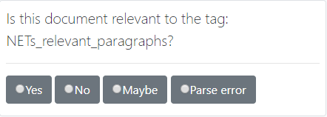
- Extract a statement by selecting its text in the paragraph (with bold letters) and by clicking on the “green plus” button that appears subsequently. If successful, the statement should appear in a yellow box with a red border and its text should appear in red.
- To categorize a statement, start by clicking on it to open a menu. This menu offers a range of options:
  - 6 buttons for studies boundaries and assumptions
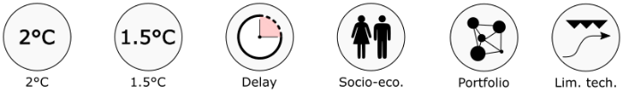
  - 5 buttons to broadly categorise statements that are not related to any of the 17 common statements

  - 17 buttons classified along the 5 broad categories and corresponding to common statements identified during our initial scoping)
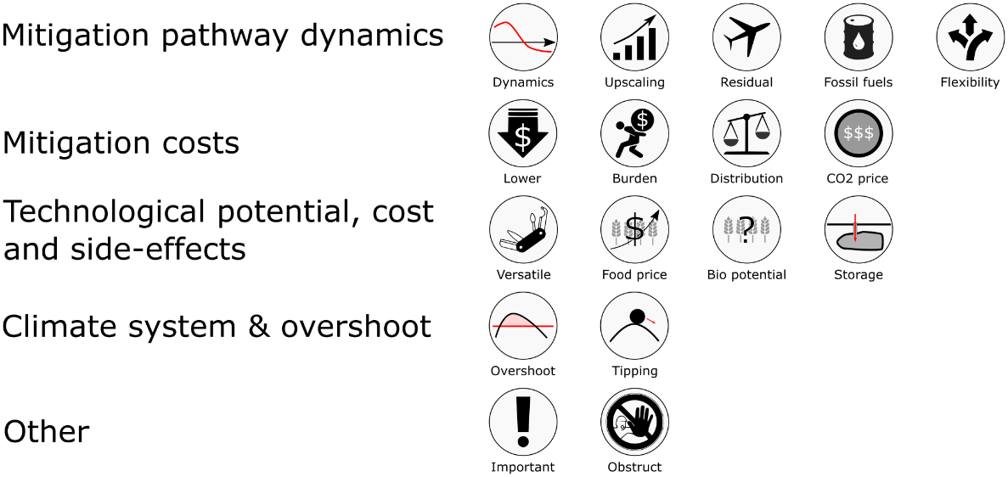
All buttons are of the type on/off. That is they are green when activated and grey otherwise. Several buttons can be activated if necessary, in particular boundaries can be combined with statements and broad categories. Two or more common statements can also be selected if a sentence combines several existing statements.
Note #1: A description of the all buttons is available in the table in the next section of this document
Note #2: Statements can be removed by clicking on the red button on the top right.
b
a
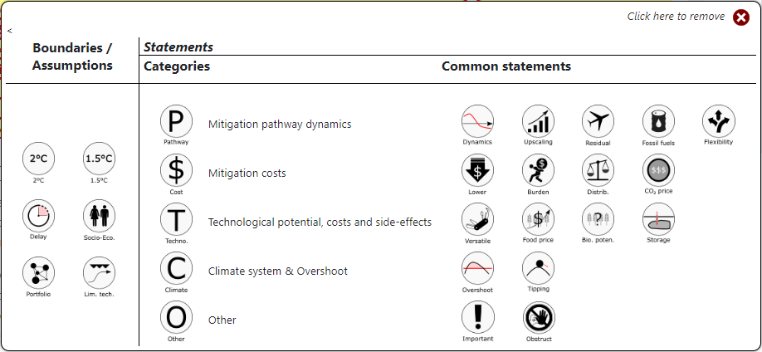
c

- (Optional) Comments and notes can be left by using the textbox on the right hand side.

- Click on Save/Next to go to the next paragraph. (If you have entered a note, make sure that the relevance of the paragraph is still rated)


The first few paragraphs may take you a few minutes to process. Once familiarized with the statements and the tool, it should take about 1 min to highlight and categorize all relevant statements in a normal sized paragraph.

Graphical User interface

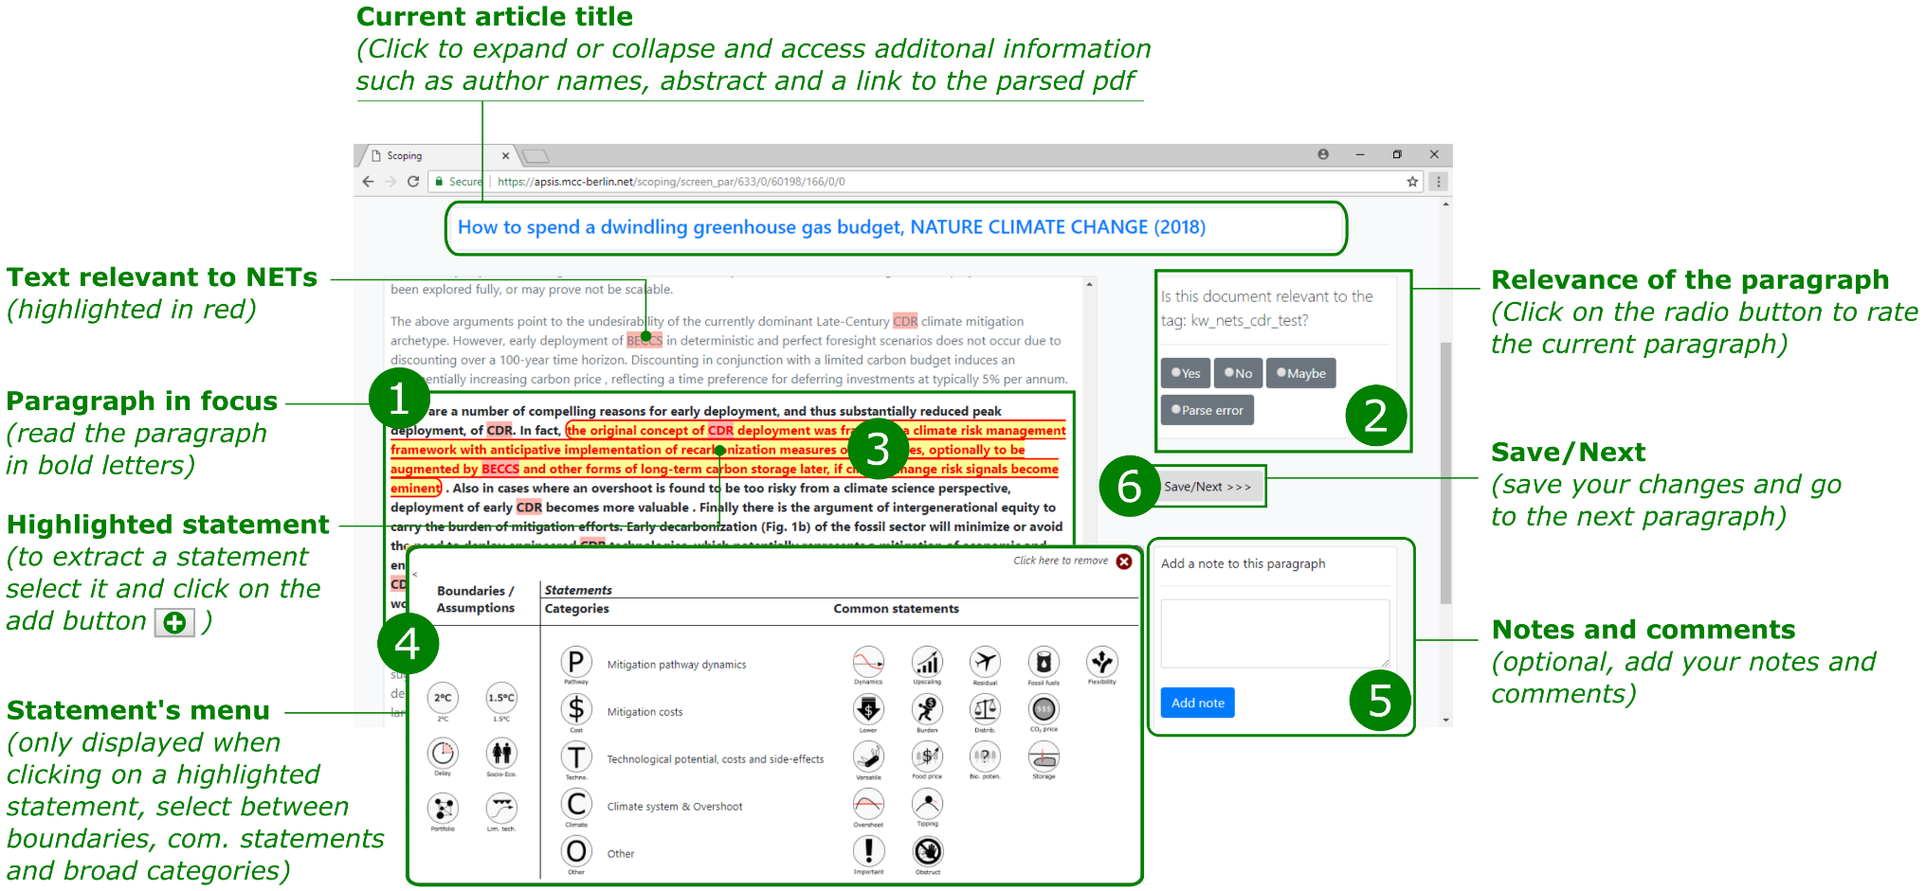

Statement classification

Study boundaries and assumptions

# | Icon | Statement | ID | Nb studies
1 |  | Statements related to the 2°C climate goal (also 450ppm, 2.6W/m2)  Ex: Unless climate change mitigation starts before 2030, globally and at a sufficient aggregated effort level, keeping warming below 2°C will not be achieved without NETs. | H2_2C | 2
2 | 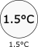 | Statements related to the 1.5°C climate goal (also 350ppm, 1.9W/m2)  Ex: Under a continuation of current socio-economic trends (e.g. social, economic and technological trends follow historical patterns), keeping warming below 1.5°C will require the use of NETs | H3_1.5C | 2
3 |  | Statements related to the impact of delays and regional fragmentation in climate policy  Ex: Delays and regional fragmentation in climate action increase the dependence on NETs. | H4_Delay | ?
4 |  | Statements related to the influence of socio-economic factors on NETs deployment.  Ex: The level of NETs deployment depends on assumptions on socio-economic dynamics (e.g. GDP, population, individual preferences) | H5_SSP | ?
5 |  | Statements related to NETs portfolios | H6_NETs_portfolio | ?
6 |  | Statements related to technological limitations (e.g. limited bioenergy, limited) | H7

Common statements and broad categories
# | Icon | Statement | ID | Nb studies
1. Mitigation pathway dynamics
1 |  | The availability and use of NETs increase near-term emissions (e.g. 2020-2050) and the speed of decarbonisation in the long-term (e.g. 2050-2100). Net emissions become negative in the second half of the century. | D1_Dynamics | 16
2 |  | NETs require rapid upscaling in the near-term (2030-2050) | D2_Upscaling | 2
3 |  | NETs can compensate for “residual emissions” (i.e. emissions that arise from sectors and activities that are difficult to decarbonize, e.g. aviation) | D3_Residual | 4
4 |  | By redirect investments from low-carbon technologies to fossil fuel technologies, the availability and use of NETs allow the prolonged used of fossil fuels. Conversely, reducing the availability and use of NETs increase the number of stranded assets in the fossil fuel sector. | D4_Fossil fuels | 6
5 |  | NETs allow for a greater flexibility in the timing of mitigation policies (which decreases costs) | D6_Flex | 3
2. Mitigation costs
6 |  | The availability and use of NETs lower carbon prices and so decrease aggregated discounted mitigation costs. Any techno-economic limitations of NETs would result in an increase of mitigation costs (e.g. biomass limitations for BECCS) | C1_Lower | 15
7 |  | NETs become an economic burden to governments once net emissions are negative | C3_Burden | 3
8 |  | The wide use of NETs entails major regional distributional effects. However it can balance the intergenerational distribution of mitigation costs of climate stabilization that otherwise would rise rapidly towards the end of the century. | C4_Distribution | 2
9 |  | Compared to other mitigation technologies, BECCS is relatively costly option. Hence it requires a high carbon price (> US$100) for upscaling. | C5_Expensive | 3
3. Technology specific
10 |  | BECCS is a versatile technology that can generate a variety of energy types (e.g. electricity, synthetic liquid fuels, hydrogen) from diverse biomass feedstocks. | T1_Versatile | 4
11 |  | The deployment of BECCS increases food prices due to land competition between energy and food biomass feedstocks. However food prices would still be high without BECCS because other bioenergy-based mitigation technologies would increase in importance. | T2_Food price | 6
12 |  | The anticipated availability and use of NETs can be used as a reason to postpone near-term climate action. (This is a modelling result that arises because of the discount rate which makes NETs) | T5_Obstruct | 2
4. Earth system/NETs interactions
13 |  | The availability and use of NETs is associated with an overshoot (e.g. CO₂ concentration, radiative forcing, temperature) and postponement of global emissions peak | O1_Overshoot | 11
14 |  | Temperature overshoot associated with NETs deployments increasing the risks of triggering climate tipping points. High temperature overshoot decreases the probability of meeting climate targets | O2_Tipping | 6

5. Other
15 |  | Statements highlighting the importance of NETs  Ex: NETs are important technological options for stringent climate goals such as the temperature goals of the Paris Agreement (i.e. 1.5°C, well-below 2°C) | R1_Important | 27

Generic categories

16 |  | Statements related to mitigation pathway dynamics | Z2_pathway
17 |  | Statements related to mitigation costs | Z3_cost
18 |  | Statements related to technological potentials, costs and side-effects | Z4_technology
19 |  | Statements related to climate system | Z5_climate
20 |  | Statements related to other categories | Z6_other

Other statement captured during the initial phase

 |  | Large uncertainties remain on bioenergy potentials. Limited biomass availability reduces dramatically the use of BECCS | T3_Bio potential | 4
 |  | Over the course of this century, global geological storage capacity is not a techno-economic issue. Storage of CO2 in geological reservoirs largely depends on public acceptance. | T4_Storage | 5
 |  | By allowing the compensation of any unit of CO2 emitted in the atmosphere, NETs can effectively increase carbon budgets |  | 1
 |  | BECCS value is not in its ability to produce energy but rather in that of sequestrating CO₂ |  | 2
 |  | Because BECCS can generate electricity, the power sector could play a central role for decarbonization |  | 2
 |  | All major world regions engage in BECCS deployment but regions with large storage capacity sequestrate most emissions. |  | 2
 |  | Africa has a large potential for BECCS |  | 1
 |  | Regions with NETs can compensate for regions without NETs under assumptions of global cooperation |  | 1
 |  | It is less costly to use a carbon tax and to recycle its revenues to subsidize NETs |  | 1

Default IAM assumptions and settings across the literature:
- Socio-economic dynamics: continuation of current trends (similar to SSP2)
- Climate action starts as early as possible (usually 2010)
- Climate action starts globally
- NETs are available and deployed with great potential when and where necessary
- Cost-effectiveness framework
- Climate goal must be met in 2100

Appendix: Using regular expressions to find relevant paragraphs

To select all relevant paragraphs, we search all paragraph that match the following regular expression:

[Ee]mission[s]?\\s(\\w+\\s){1,3}negative|NETs|CDR[^M]|[Nn]egative.emission[s]?|[Nn]egative.[cC][0Oo]2.emission[s]?|[Nn]egative.carbon.emission[s]?|[Nn]egative.carbon.dioxide.emission[s]?|[Cc]arbon.dioxide.removal|[Cc]arbon.removal|[Cc][0Oo]2.removal|[Cc]arbon.dioxide.sequestration|[Cc]arbon.sequestration|[Cc][0Oo]2.sequestration|[Bb]iomass.with.[Cc]arbon.[Cc]apture.and.[Ss]torage|[Bb]ioenergy.with.[Cc]arbon.[Cc]apture.and.[Ss]torage|BECS|BECCS|Bio-CCS|[Dd]irect.[Aa]ir.[Cc]apture|DAC|DACCS|[Aa]fforestation|^AR[^a-zA-Z0-9]|[^a-zA-Z0-9]AR[^a-zA-Z0-9]|[Ee]nhanced.weathering|^EW[^a-zA-Z0-9]|[^a-zA-Z0-9]EW[^a-zA-Z0-9]|Biochar|[Ss]oil.[Cc]arbon.[Ss]equestration|^SCS[^a-zA-Z0-9]|[^a-zA-Z0-9]SCS[^a-zA-Z0-9]|[Oocean].[Ff]ertili[sz]ation|^OF[^a-zA-Z0-9]|[^a-zA-Z0-9]OF[^a-zA-Z0-9]

The regular expression above captures the following items:
- NETs
- Negative emission
- Negative CO2 emission
- Negative carbon emission
- Negative carbon dioxide emission
- Emission [any word] negative
- CDR
- Carbon dioxide removal
- CO2 removal
- Carbon dioxide sequestration
- Carbon sequestration
- CO2 sequestration
- AR
- Afforestation
- Reforestation
- BECS
- BECCS
- Biomass with CCS
- Biomass with carbon (capture and storage)
- Bio-CCS
- DAC
- DACCS
- Direct air capture
- EW
- Enhanced weathering
- Biochar
- OF
- Ocean fertilization
- SCS
- Soil Carbon Sequestration

