Online Resource 1. Concordance among rankers on each of the sort-tasks, with Sidak-adjusted p values.

Sort-task |  | Concordance  (Kendall coefficient) | Chi-square test of significance
Perceived ease of comprehension
 | IPCC authors' rankings for undergraduates | W = .566 | χ2 (9) = 91.76, p < .001, n = 18
 | IPCC authors' rankings for policy-makers | W = .503 | χ2 (9) = 77.03, p < .001, n = 17†
 | Undergraduates' rankings | W = .473 | χ2 (9) = 161.63, p < .001, n = 38
Importance for future climate policy
 | IPCC authors' rankings | W = .517 | χ2 (9) = 83.78, p < .001, n = 18

†n = 17; one of the 18 participants did not provide a ranking for the policy-maker task.

Online Resource 2. Association between perceptions of ease of comprehension given by IPCC authors about undergraduates (red circles, n = 18) and by undergraduates (green triangles, n =38). Diamonds show median ranks for each group, with 95% confidence intervals. Figures ordered top-to-bottom by author median ranks, from easiest to comprehend to most difficult to comprehend. For each figure, Mann-Whitney tests for differences in distributions between groups are shown, with Sidak-adjusted p-values and standardised effect sizes.

Figure | U | Effect size (r) | Median ranks with 95% confidence intervals  (1 = easiest, 10 = most difficult)
 |  |  | 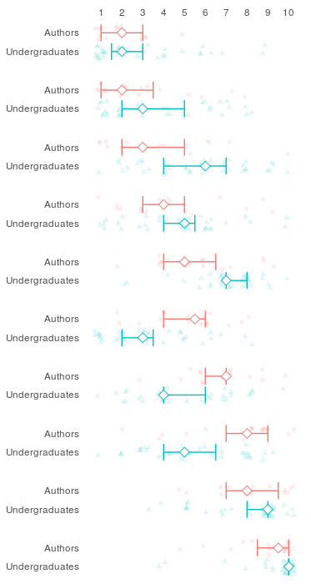
SPM4 | 278.5  p = .943 | .154
SPM9 | 273.5  p = .919 | .163
SPM1 | 198.0  p = .105 | .340
SPM3 | 284.0  p = .973 | .138
SPM7 | 183.0  p = .045 | .379
SPM2 | 165.0  p = .017 | .419
SPM8 | 179.0  p = .037 | .388
SPM10 | 164.5  p = .016 | .421
SPM6 | 331.0  p = 1.000 | .027
SPM5 | 251.0  p = .423 | .258

Online Resource 3. Selected figures from the IPCC Working Group I, Fifth Assessment Report, Summary for Policymakers.
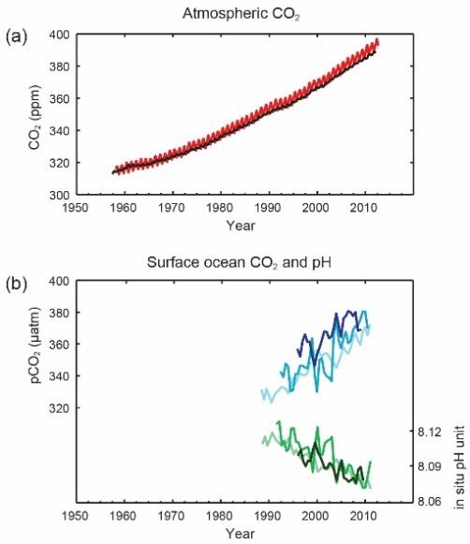
Figure SPM4 from the IPCC AR5 WG1 SPM, which was considered by IPCC authors and undergraduate students to be the easiest to comprehend among the set of ten SPM figures. Figure reproduced from IPCC 2013.
The figure is accompanied by the following caption: Multiple observed indicators of a changing global carbon cycle: (a) atmospheric concentrations of carbon dioxide (CO₂) from Mauna Loa (19°32’N, 155°34’W – red) and South Pole (89°59’S, 24°48’W – black) since 1958; (b) partial pressure of dissolved CO₂ at the ocean surface (blue curves) and in situ pH (green curves), a measure of the acidity of ocean water. Measurements are from three stations from the Atlantic (29°10’N, 15°30’W – dark blue/dark green; 31°40’N, 64°10’W – blue/green) and the Pacific Oceans (22°45’N, 158°00’W − light blue/light green).

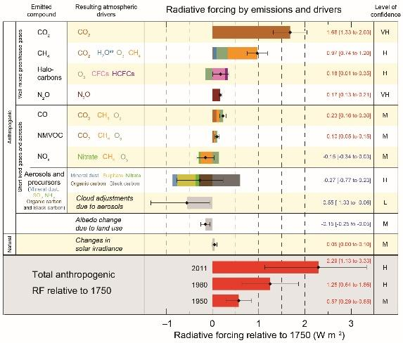
Figure SPM5 from the IPCC AR5 WG1 SPM, which was considered by IPCC authors and undergraduate students to be the most difficult to comprehend among the set of ten SPM figures. Figure reproduced from IPCC 2013.
The figure is accompanied by the following caption: Radiative forcing estimates in 2011 relative to 1750 and aggregated uncertainties for the main drivers of climate change. Values are global average radiative forcing (RF¹⁴), partitioned according to the emitted compounds or processes that result in a combination of drivers. The best estimates of the net radiative forcing are shown as black diamonds with corresponding uncertainty intervals; the numerical values are provided on the right of the figure, together with the confidence level in the net forcing (VH – very high, H – high, M – medium, L – low, VL – very low). Albedo forcing due to black carbon on snow and ice is included in the black carbon aerosol bar. Small forcings due to contrails (0.05 W m^{–2}, including contrail induced cirrus), and HFCs, PFCs and SF₆ (total 0.03 W m^{–2}) are not shown. Concentration-based RFs for gases can be obtained by summing the like-coloured bars. Volcanic forcing is not included as its episodic nature makes is difficult to compare to other forcing mechanisms. Total anthropogenic radiative forcing is provided for three different years relative to 1750.
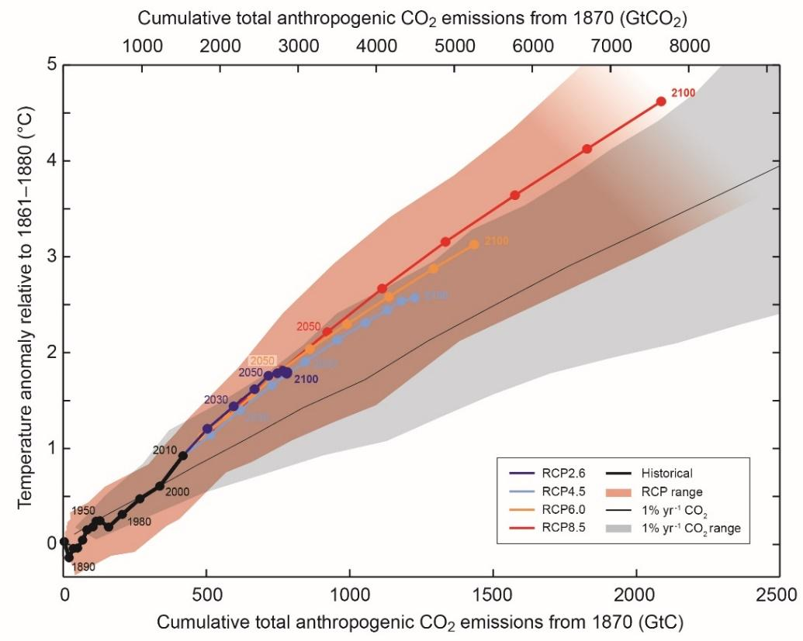
Figure SPM10, from the IPCC AR5 WG1 SPM, which was considered by IPCC authors to be the most important figure from the report to help inform future climate policy. Figure reproduced from IPCC 2013.
The figure is accompanied by the following caption: Global mean surface temperature increase as a function of cumulative total global CO₂ emissions from various lines of evidence. Multi-model results from a hierarchy of climate-carbon cycle models for each RCP until 2100 are shown with coloured lines and decadal means (dots). Some decadal means are labeled for clarity (e.g., 2050 indicating the decade 2040−2049). Model results over the historical period (1860 to 2010) are indicated in black. The coloured plume illustrates the multi-model spread over the four RCP scenarios and fades with the decreasing number of available models in RCP8.5. The multi-model mean and range simulated by CMIP5 models, forced by a CO₂ increase of 1% per year (1% yr^{–1} CO₂ simulations), is given by the thin black line and grey area. For a specific amount of cumulative CO₂ emissions, the 1% per year CO₂ simulations exhibit lower warming than those driven by RCPs, which include additional non-CO₂ forcings. Temperature values are given relative to the 1861−1880 base period, emissions relative to 1870. Decadal averages are connected by straight lines.

Online Resource 4. Schematic examples of dimensions of visual complexity (Rosenholtz et al. 2007; Olivia et al. 2004) which may be particularly relevant to human perceptual processing of data visuals.
Dimensions of visual complexity | Lower complexity  (less entropy) example | Higher complexity  (more entropy) example | Notes
Quantity | 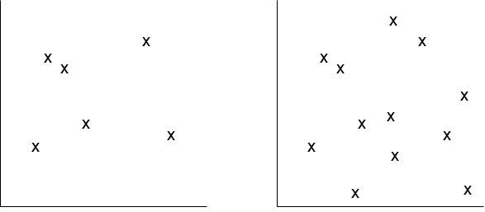 |  | Visual complexity increases with greater quantity of (unorganised) information.
Organisation | 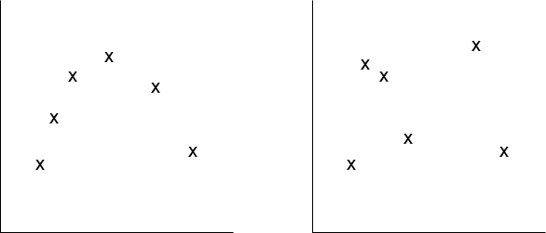 |  | Visual complexity decreases with greater structural organisation of information.  Note that additional information (greater quantity) can result in less complexity if the additional information adds structural organisation.
Variety  e.g. shape | 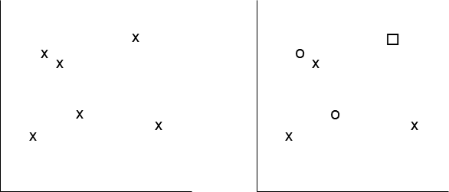 |  | Visual complexity increases with greater variety of visual elements.
Variety  e.g. colour | 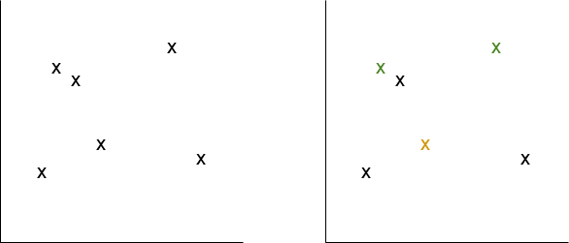 |  | Idem.
Openness | 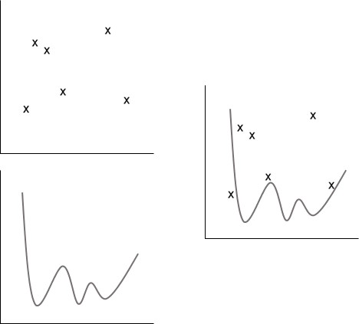 |  | Visual complexity increases with less openness (i.e. greater density of information that creates clutter).  Note though that where visual elements represent information that is intended to be compared/combined by the reader, greater spatial proximity may faciliate processing of the visual (Wickens and Carswell 1995).

Online resource references
IPCC (2013) Summary for policymakers. In: Stocker TF, Qin D, Plattner G-K, Tignor M, Allen SK, Boschung J, Nauels A, Xia Y, Bex V, Midgley PM (eds) Climate Change 2013: The Physical Science Basis. Contribution of Working Group I to the Fifth Assessment Report of the Intergovernmental Panel on Climate Change. Cambridge University Press, Cambridge, pp 3–29.
Olivia A, Mack ML, Shrestha M, Peeper A (2004). Identifying the perceptual dimensions of visual complexity of scenes. In Forbus K, Gentner D and Regier T (eds) Proceedings of the Annual Meeting of the Cognitive Science Society, 26. https://escholarship.org/uc/item/17s4h6w8
Rosenholtz R, Li Y, Nakano L (2007) Measuring visual clutter. J Vision. https://doi.org/10.1167/7.2.17
Wickens CD, Carswell CM (1995) The proximity compatibility principle: Its psychological foundation and relevance to display design. Hum Factors 37, 473-494.

