Supplementary Material

Streamflow response to climate change in the Greater Horn of Africa

Feyera A. Hirpa¹, Lorenzo Alfieri², Thomas Lees¹, Jian Peng¹, Ellen Dyer¹, and Simon J. Dadson^{1,3}

¹School of Geography and Environment, University of Oxford, Oxford, UK
² Disaster Risk Management Unit, European Commission Joint Research Centre, Ispra, Italy
³Centre for Ecology and Hydrology, Wallingford, UK

Journal: Climatic Change

Corresponce to:
Dr. Feyera A. Hirpa
School of Geography and the Environment
University of Oxford
South Parks Road, Oxford, OX1 3QY
United Kingdom
Email: feyera.hirpa@ouce.ox.ac.uk
Phone: +44 7954 009180

Table S1 The SST and SIC from CMIP5 models were used for driving the climate model. We have excluded one simulation (HadCM3LC) from the original runs for our analysis. This is because: 1) the HadCM3LC was not a member of the CMIP5 experiment, 2) its improved version (HadGEM2-ES) is already included in our analysis, and 3) it produces rainfall patterns which are significantly different from the other simulations (see Figure S1), which may lead to unrealistic streamflow projections in the GHA region.

SST and SIC forcing | Full Name
IPSL‐CM5A‐LR | IPSL Earth System Model - Low Resolution
GFDL‐ESM2M | Geophysical Fluid Dynamics Laboratory Earth System model
HadGEM2‐ES | Hadley Centre Global Environmental Model version 2 Earth System Configuration
EC‐EARTH | European Community Earth-System Model
GISS‐E2‐H | NASA Goddard Institute for Space Studies E2-H Model
IPSL-CM5A-MR | IPSL Earth System Model - Medium Resolution

Table S2 The list of streamflow stations used for evaluation. The sub-regions are defined based on a combination flow seasonality and river basins.
ID | Station name | Q group | River name | Basin name | Country of station | Observed long term mean Q (m³/s) | Lat (ºN) | Lon (ºE)
G1603 | Gambella | A | Baro | Nile | Ethiopia | 384.9 | 8.25 | 34.57
G1684 | Eddiem | A | Blue Nile | Nile | Sudan | 1431.4 | 11.23 | 34.98
G1685 | Ros-Old | A | Blue Nile | Nile | Sudan | 1468.6 | 11.85 | 34.38
G1686 | Sennar U-S | A | Blue Nile | Nile | Sudan | 1195.9 | 13.55 | 33.63
G1687 | Khartoum | A | Blue Nile | Nile | Sudan | 1313.7 | 15.60 | 32.51
M0011 | ROSEIRES DAM | A | Blue Nile | Nile | Sudan | 1388.3 | 11.85 | 34.38
G1688 | Dongola | B | Nile | Nile | Sudan | 2221.3 | 19.16 | 30.53
M0017 | Makalal | B | White Nile | Nile | South Sudan | 1012.5 | 9.58 | 31.62
G6108 | Wolkite | C | Wabi | Upper Ghibe | Ethiopia | 23.5 | 8.25 | 37.76
G6109 | Asendabo | C | Gilgel Ghibe | Upper Ghibe | Ethiopia | 38.1 | 7.75 | 37.18
G6110 | Wolkite | C | Walga | Upper Ghibe | Ethiopia | 12.5 | 8.33 | 37.60
G6111 | Shebe | C | Gojeb | Upper Ghibe | Ethiopia | 58.0 | 7.417 | 36.38
G6112 | Seka | C | Seka | Upper Ghibe | Ethiopia | 3.5 | 7.60 | 36.75
AW031 | Hombole | D | Awash | Awash | Ethiopia | 41.7 | 8.383 | 38.78
G1045 | Tendaho | D | Awash | Awash | Ethiopia | 67.3 | 11.68 | 40.95
G1053 | Adaitu | D | Awash | Awash | Ethiopia | 63.3 | 11.13 | 40.78
G1067 | Melka Sedi | D | Awash | Awash | Ethiopia | 50.6 | 9.39 | 40.13
G1074 | Metahara | D | Awash | Awash | Ethiopia | 32.9 | 8.85 | 39.85
G1606 | Beletweyne | E | Shabelle | Juba-Shabelle | Somalia | 80.8 | 4.75 | 45.25
G1607 | Bulo Burti | E | Shabelle | Juba-Shabelle | Somalia | 72.0 | 3.85 | 45.55
G5244 | Jamaame | E | Juba | Juba-Shabelle | Somalia | 179.4 | 0.02 | 42.68
G6086 | Marerey | E | Juba | Juba-Shabelle | Somalia | 188.0 | 0.42 | 42.72
G6088 | Afgooye | E | Shabelle | Juba-Shabelle | Somalia | 52.4 | 2.14 | 45.12
M0002 | Ihimbu (55232321) | F | Little Ruaha | Rufiji | Tanzania | 17.0 | -7.88 | 35.80
M0004 | Mtandika (55232437) | F | Lukosi (Trib. Rufiji) | Rufiji | Tanzania | 20.6 | -7.56 | 36.43
M0005 | Bahi | F | Bubu | Bubu | Tanzania | 5.2 | -5.97 | 35.30
M0006 | Mahinga (55250007) | F | Ruvuma | Rovuma | Tanzania | 50.7 | -11.22 | 35.29
M0020 | Kanzenze | F | Nyabarongo | Nile | Rwanda | 107.8 | -2.06 | 30.11
M0021 | Rusumo | F | Kagera | Nile | Rwanda | 223.5 | -2.38 | 30.79

Table S3 Classification of the streamflow stations according to the flow seasonality and river basin

Q groups | Basin, country of the station | Climate | High-flow season
A | Blue Nile, Baro | Unimodal | JJAS
B | White Nile (South Sudan), Nile (Sudan) | Unimodal | JJAS
C | Upper Ghibe (Ethiopia) | Unimodal | JJAS
D | Awash (Ethiopia) | Unimodal | JJAS
E | Juba-Shabelle (Somalia) | Bimodal | MAM, OND
F | Southern region  (Rwanda and Tanzania) | Unimodal (Tanzania) | NDJFMAM

Table S4 Summary of streamflow evaluation after removing the bias in the long-term mean flow using the multiplying factor (MF) for each station (Eq 1). The Kling-Gupta Efficiency (KGE), correlation (R), Nash–Sutcliffe Efficiency (NSE) and Bias (B) shows the evaluation of simulated monthly flows (ensemble mean of the 6 simulations) with respect to the observed monthly flows. The MF was estimated as the ratio of the long-term mean flows between the observed and modelled lows.

ID | Q group | KGE | R | NSE | B | MF
G1603 | A | 0.74 | 0.88 | 0.76 | 0.18 | 0.67
G1684 | A | 0.83 | 0.93 | 0.86 | 0.1 | 0.31
G1685 | A | 0.87 | 0.91 | 0.82 | 0.11 | 0.32
G1686 | A | 0.74 | 0.89 | 0.78 | 0.17 | 0.25
G1687 | A | 0.73 | 0.87 | 0.74 | 0.04 | 0.25
M0011 | A | 0.88 | 0.93 | 0.86 | 0.33 | 0.3
G1688 | B | 0.75 | 0.84 | 0.7 | 0.01 | 0.13
M0017 | B | -0.43 | 0.72 | -2.33 | -0.01 | 0.11
G6108 | C | 0.75 | 0.86 | 0.73 | -0.02 | 0.06
G6109 | C | 0.75 | 0.81 | 0.66 | 0.02 | 0.38
G6110 | C | 0.61 | 0.8 | 0.62 | -0.63 | 0.03
G6111 | C | 0.6 | 0.7 | 0.49 | -0.4 | 1.49
G6112 | C | 0.7 | 0.77 | 0.59 | -0.01 | 0.08
G1045 | D | 0.44 | 0.59 | 0.35 | 0.77 | 0.08
G1053 | D | 0.48 | 0.56 | 0.28 | 0.63 | 0.09
G1067 | D | 0.65 | 0.7 | 0.24 | 0.84 | 0.15
G1074 | D | 0.61 | 0.64 | 0.15 | -0.46 | 0.22
AW031 | D | 0.6 | 0.83 | 0.65 | 0.2 | 0.28
G1606 | E | 0.37 | 0.48 | 0.2 | 2.23 | 0.09
G1607 | E | 0.4 | 0.52 | 0.25 | -0.68 | 0.08
G5244 | E | 0.48 | 0.6 | 0.35 | -0.12 | 0.1
G6086 | E | 0.44 | 0.6 | 0.36 | -0.3 | 0.2
G6088 | E | 0.59 | 0.59 | 0.21 | 0.06 | 0.06
M0002 | F | 0.06 | 0.41 | -1.59 | 0.33 | 0.79
M0004 | F | -0.56 | 0.26 | -4.34 | -0.8 | 0.52
M0005 | F | 0.41 | 0.42 | -0.01 | -4.61 | 0.11
M0006 | F | 0.36 | 0.52 | -0.51 | -1.44 | 0.45
M0020 | F | -0.16 | 0.47 | -2.16 | -0.68 | 0.45
M0021 | F | -0.36 | 0.3 | -3.31 | -0.89 | 0.31

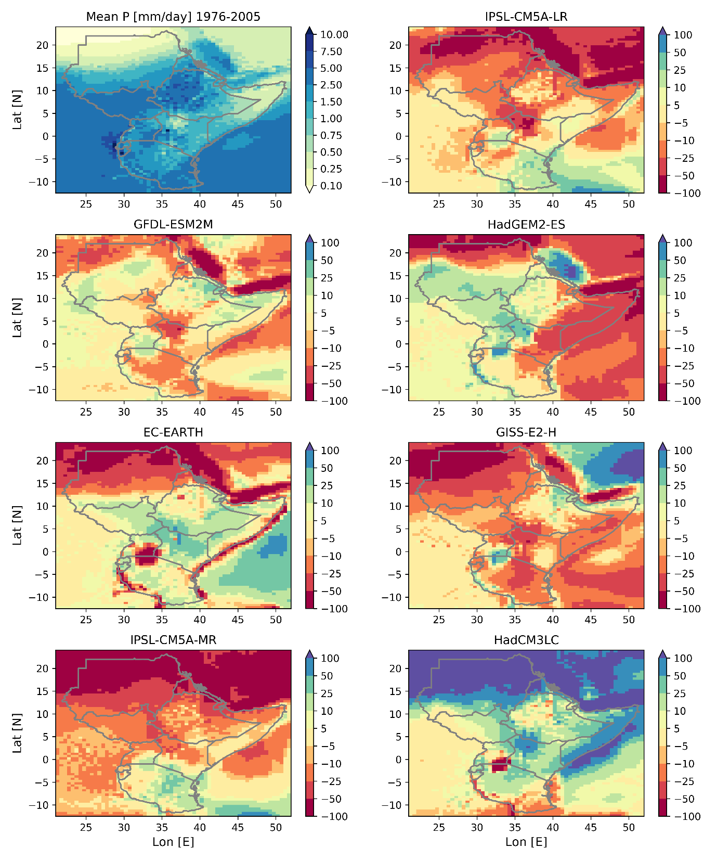
Fig. S1 The percentage difference in mean annual rainfall between the 7 simulations and their ensemble mean. Note that the streamflow produced with the HadCM3LC SST forcing is not included in our analysis.

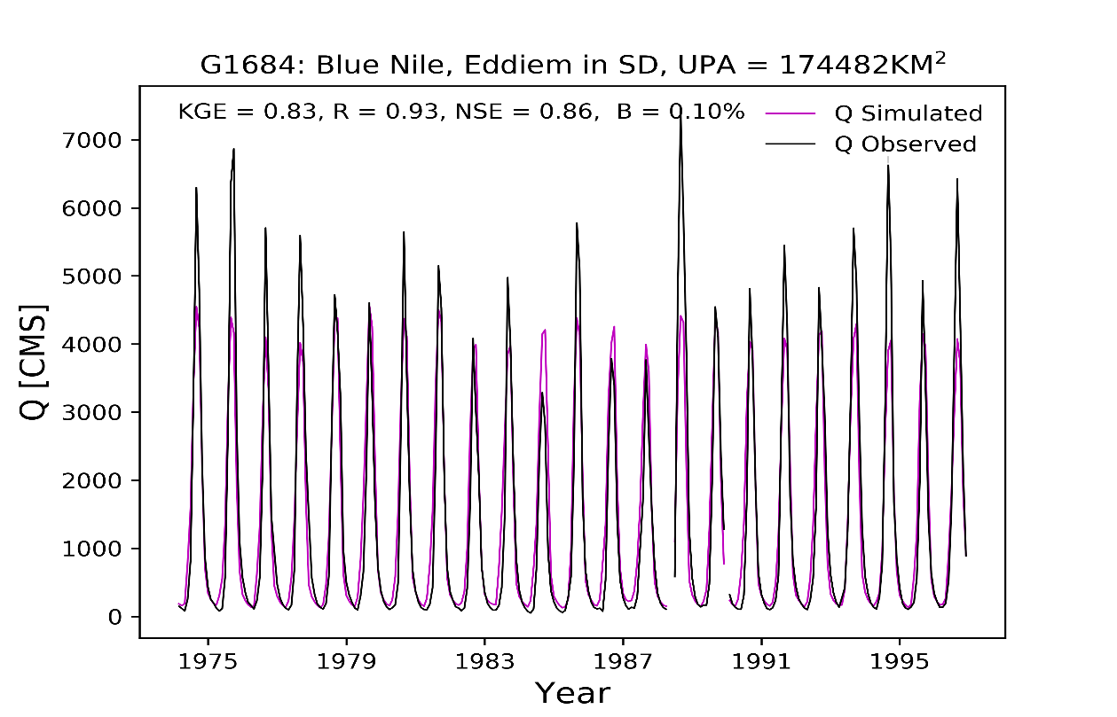
Figure S2 Comparison of monthly observed and simulated (ensemble mean) flows (Q). The KGE, R, NSE and B were computed after the bias reduction was applied (Eq 1).

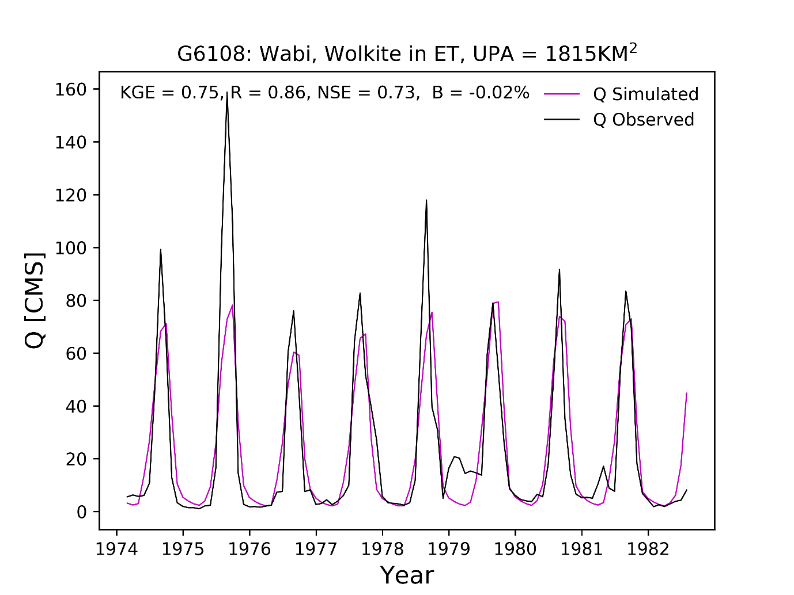
Figure S2 continued.

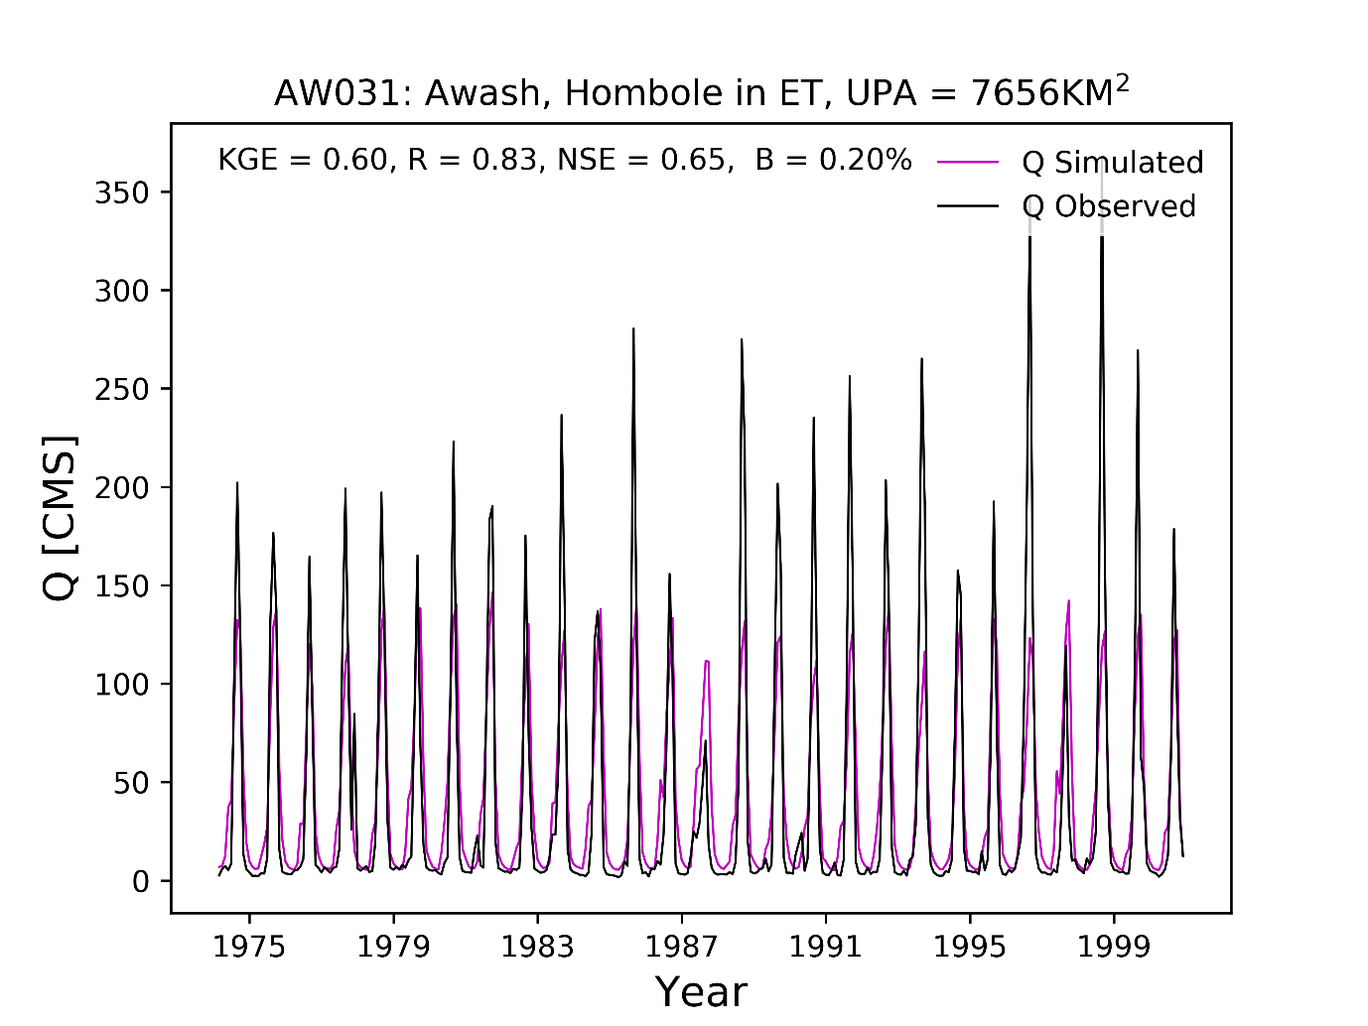
Figure S2 continued.

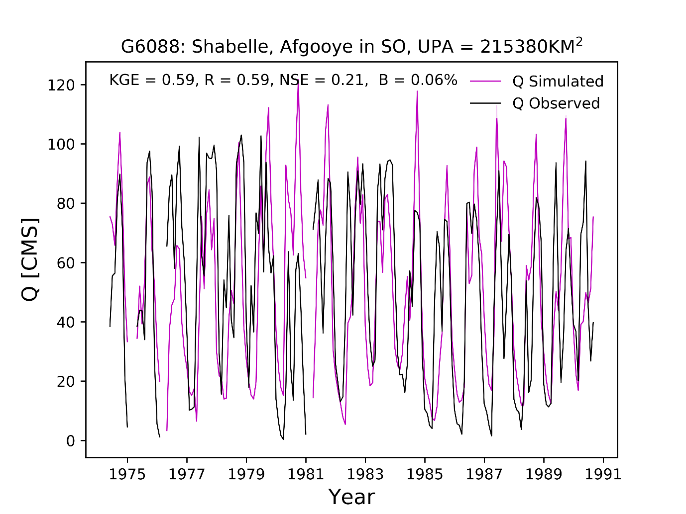
Figure S2 continued.

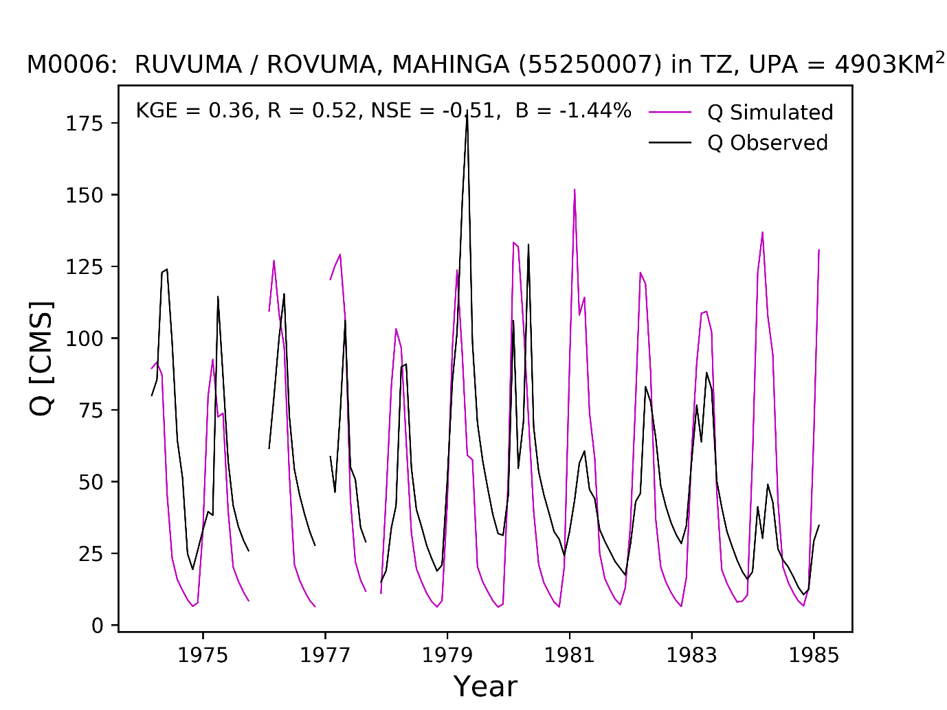
Figure S2 continued.

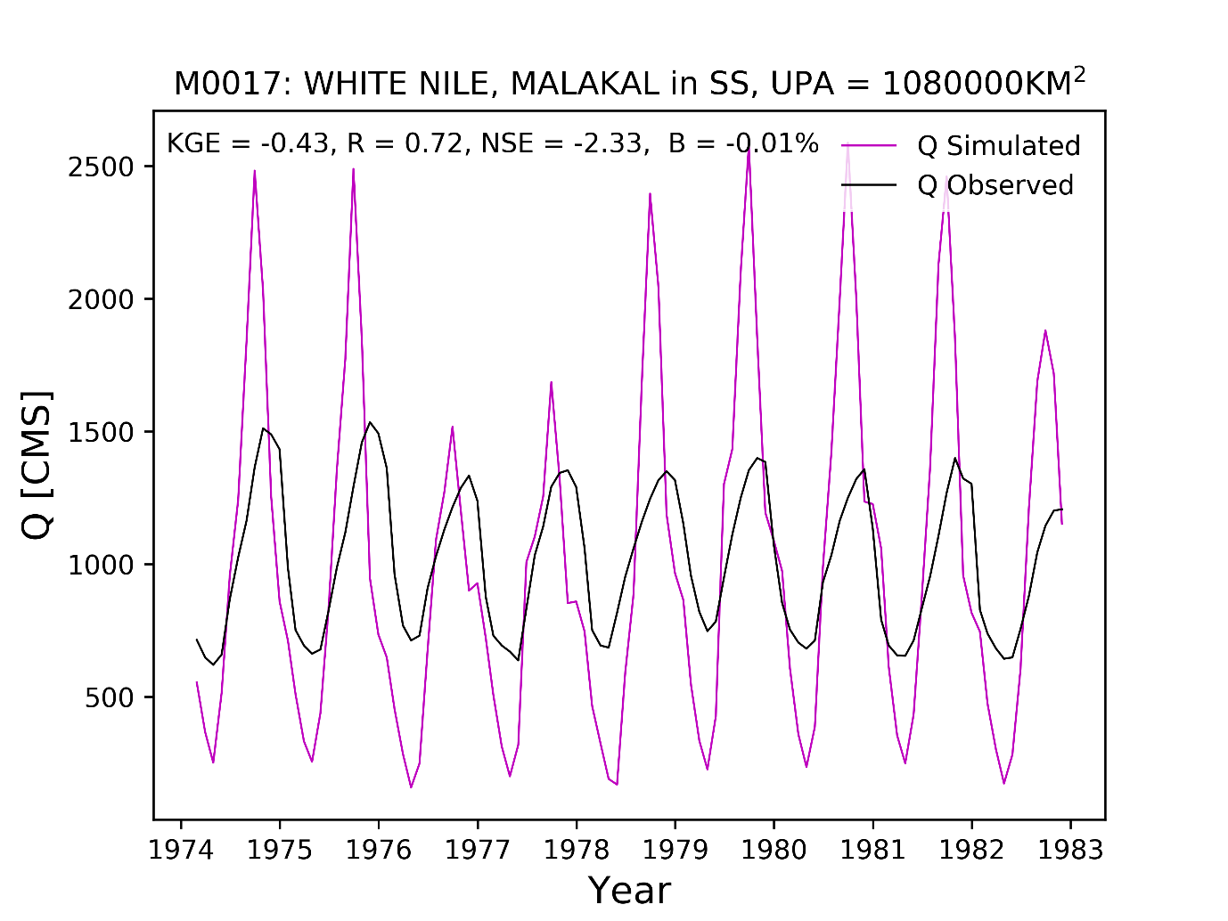
Figure S2 continued.

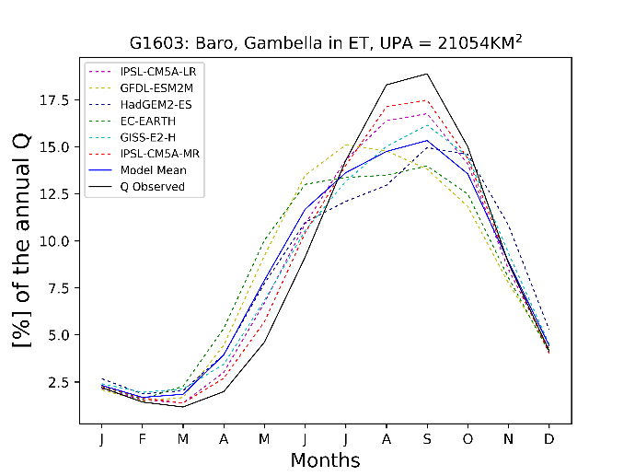 | 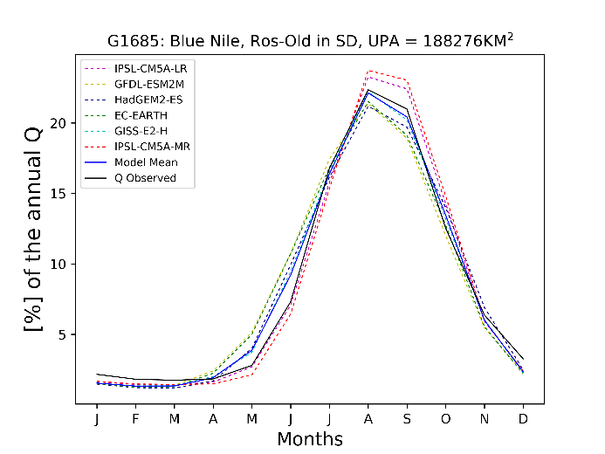
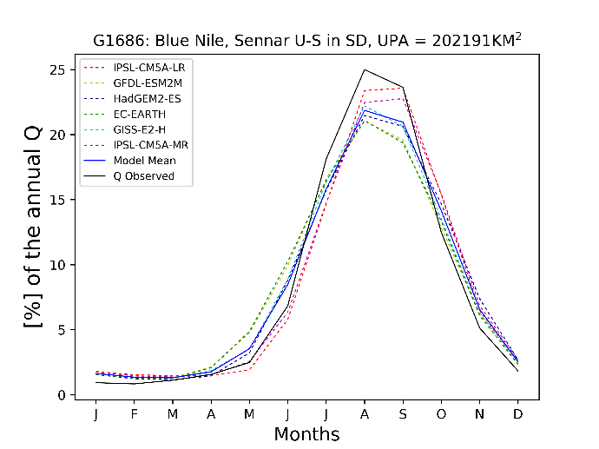 | 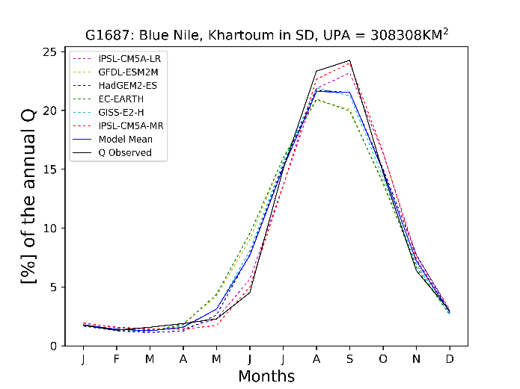
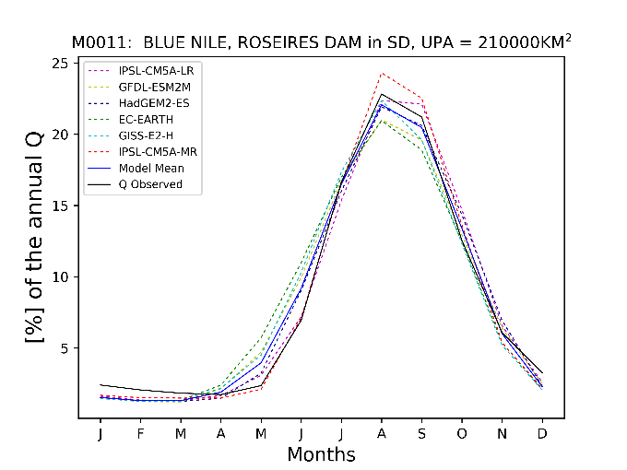 | 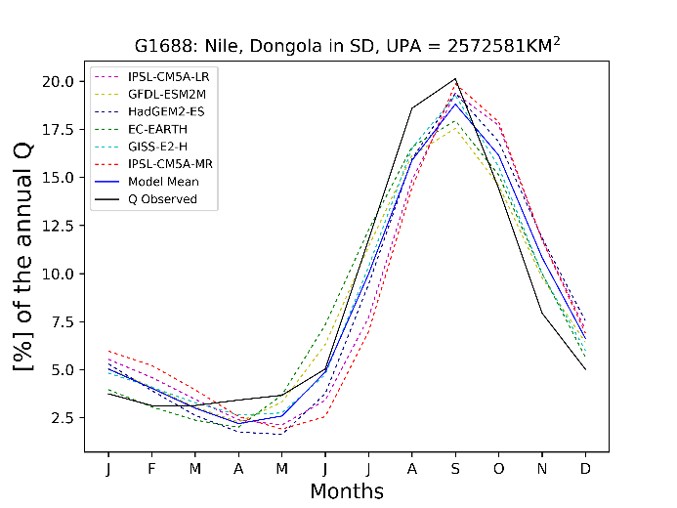

Fig. S3 Streamflow seasonality for all stations. The seasonality and monthly climatology were are calculated over 1976-2005 period.

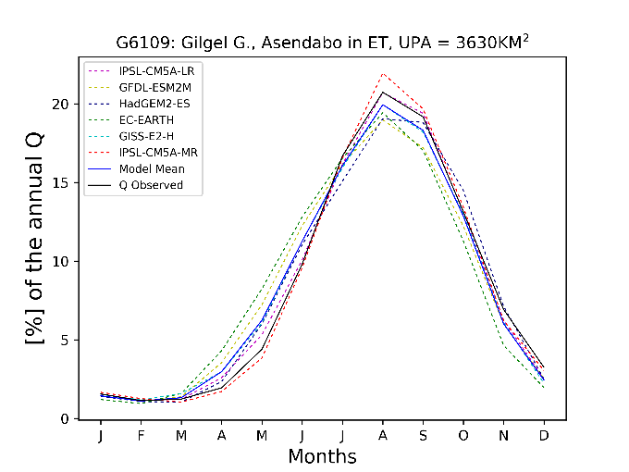 | 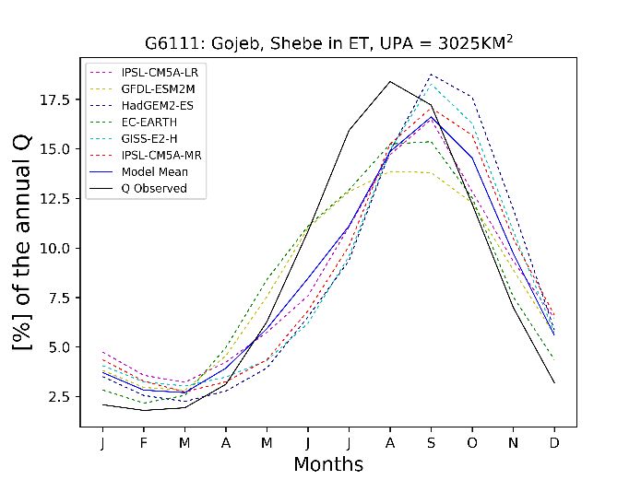
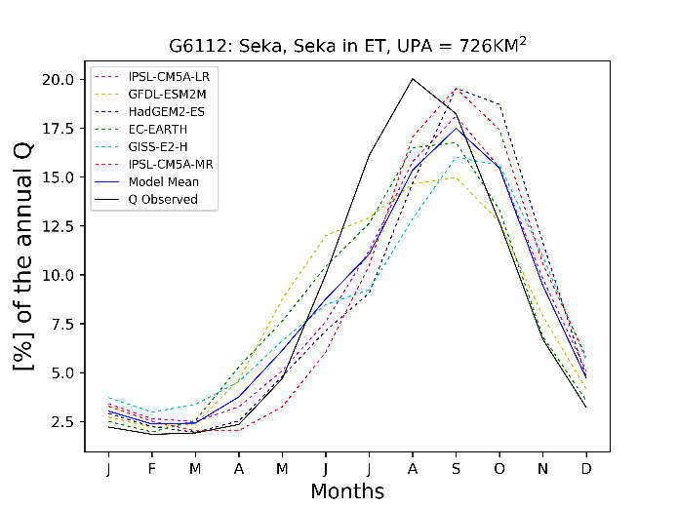 | 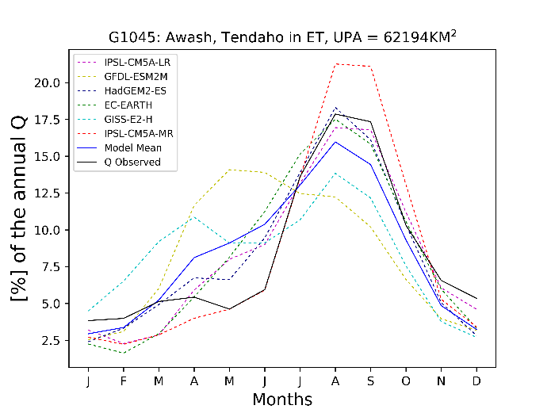
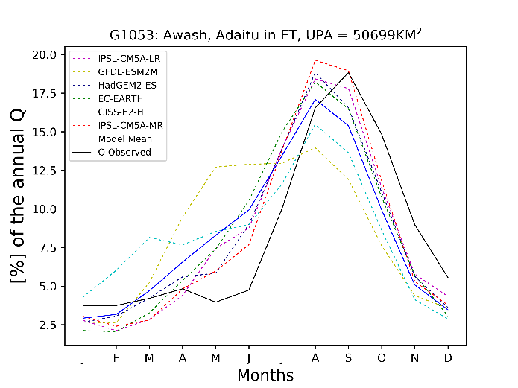 | 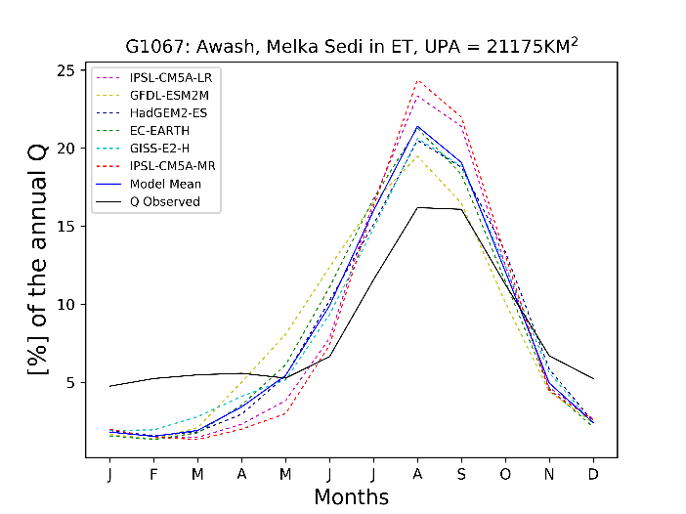

Fig. S3 continued.

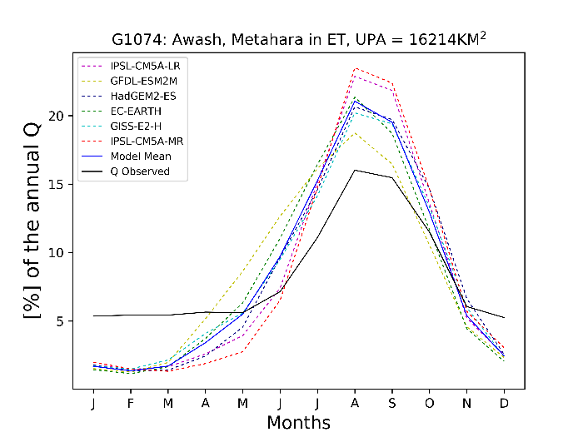 | 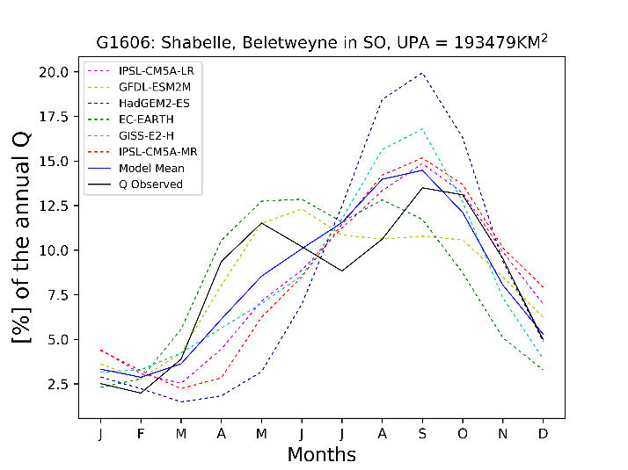
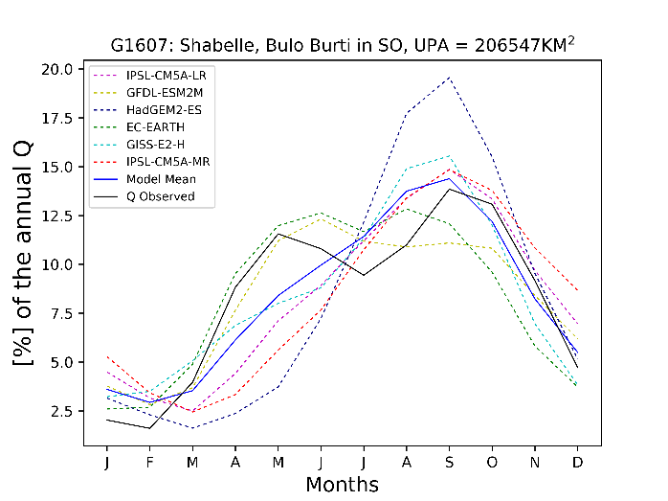 | 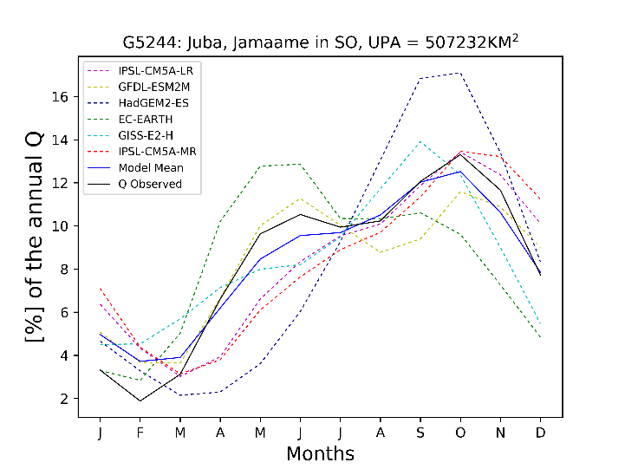
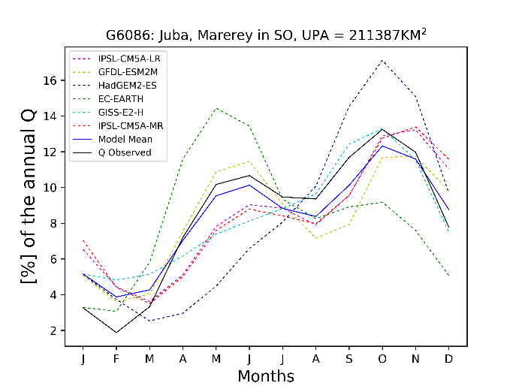 | 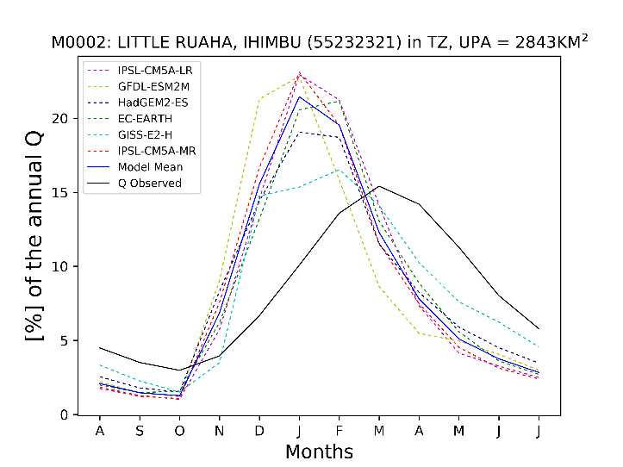
Fig. S3 continued.

 | 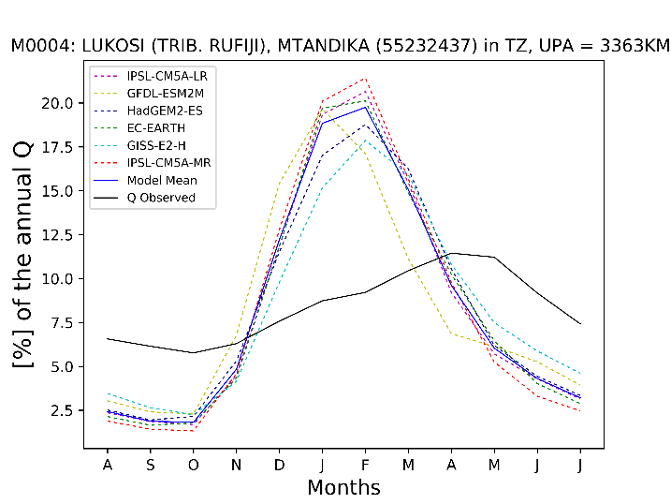
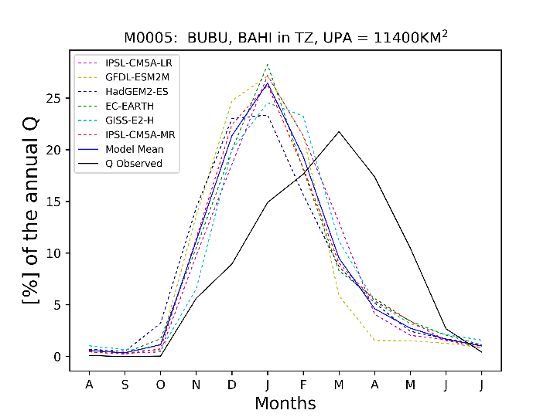 | 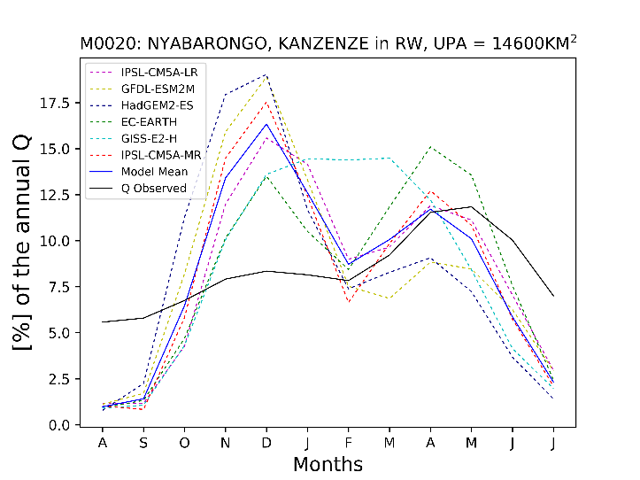
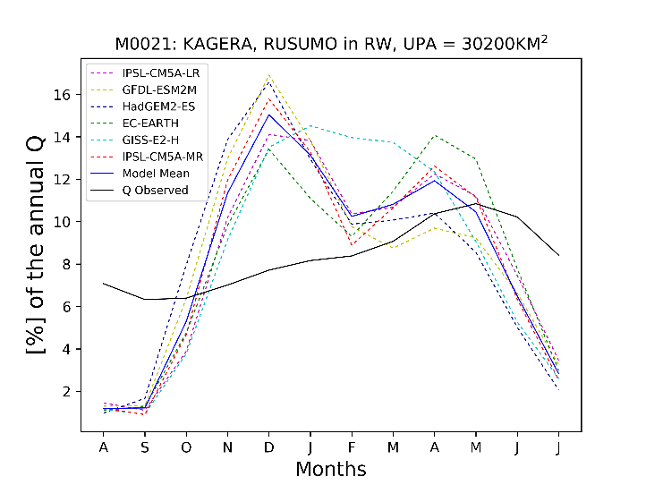
Fig. S3 continued.

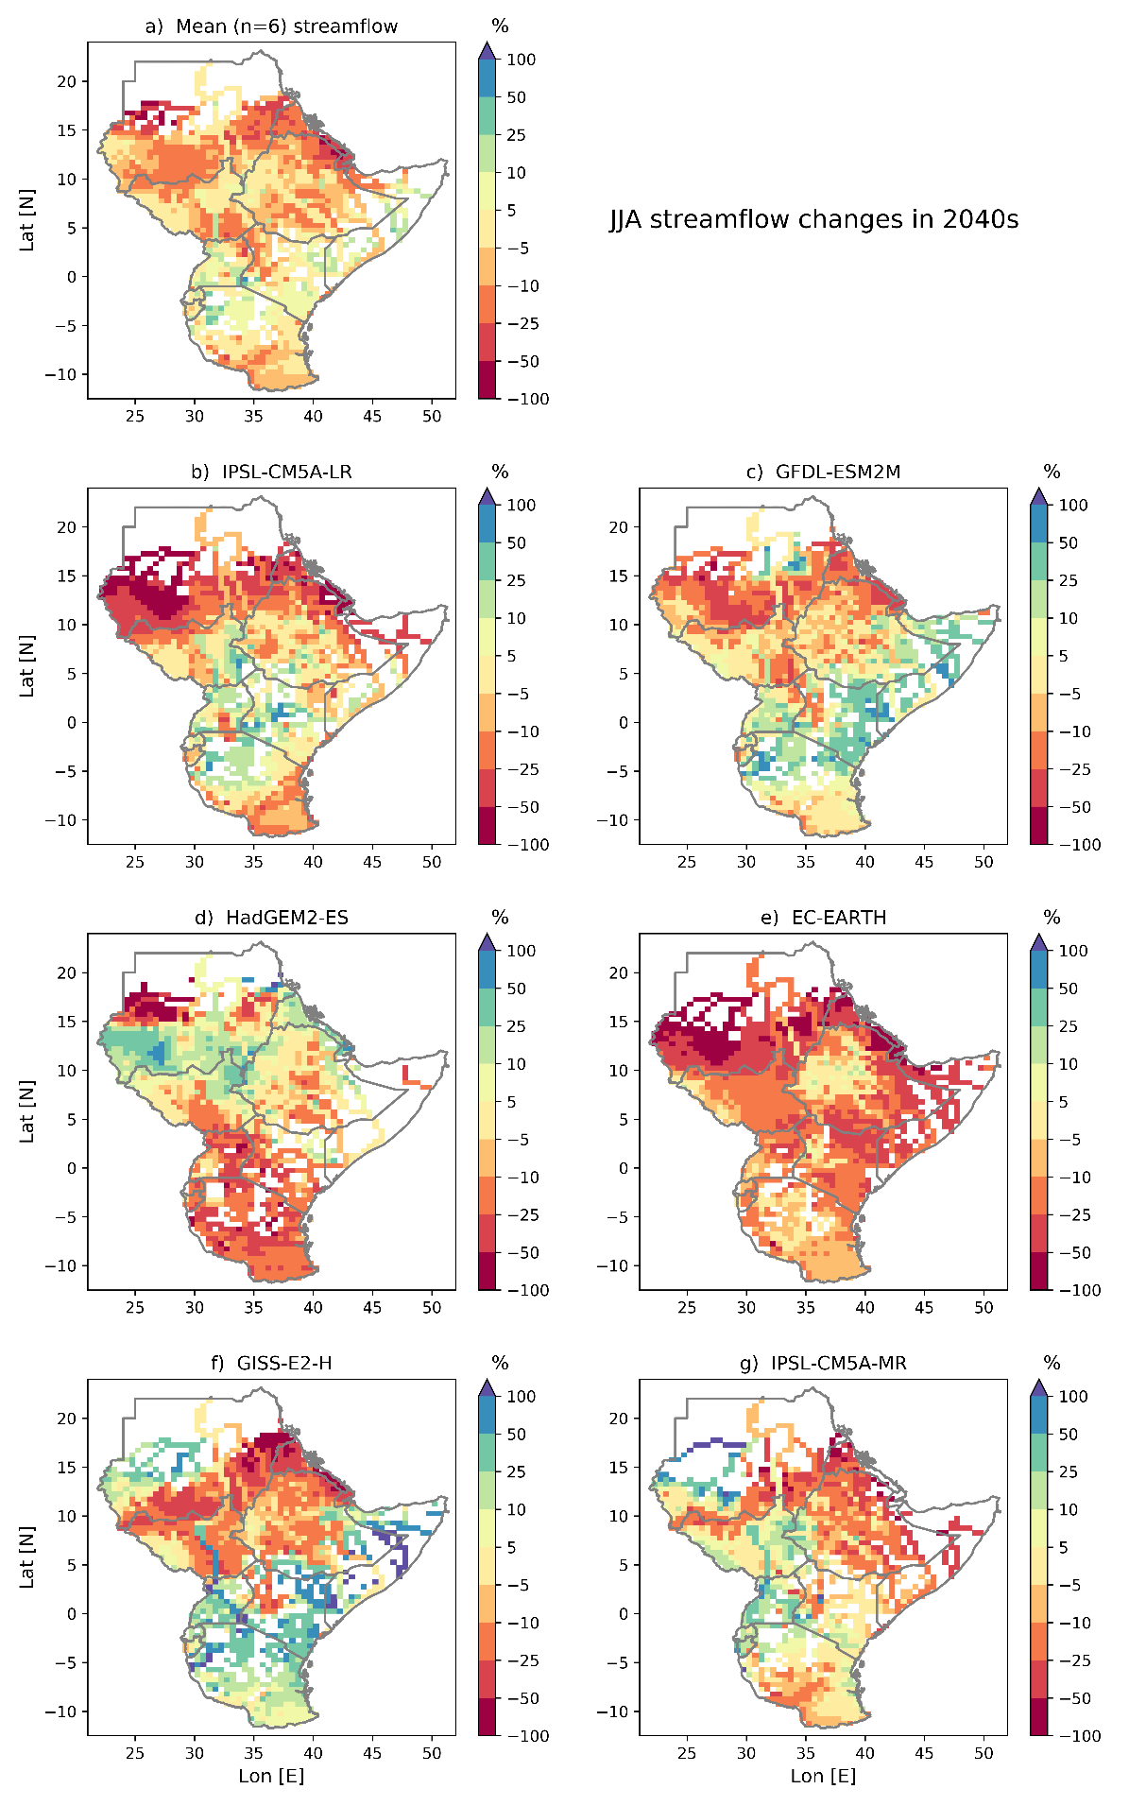

Fig. S4 Projected streamflow changes in 2040s for the JJAS season. Land areas with Q values less than 5 m3/s (white) are filtered out.

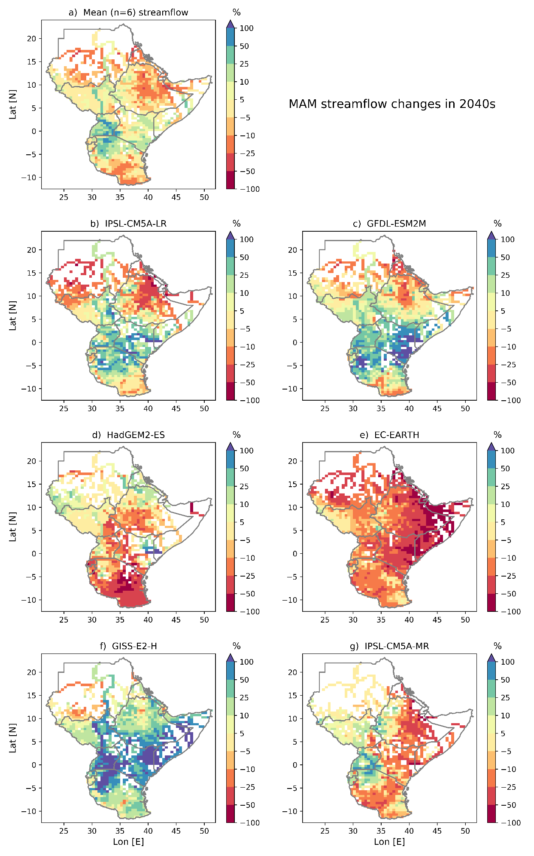
Fig. S5 Projected streamflow changes in 2040s for the MMA season. Land areas with Q values less than 5 m3/s (white) are filtered out.

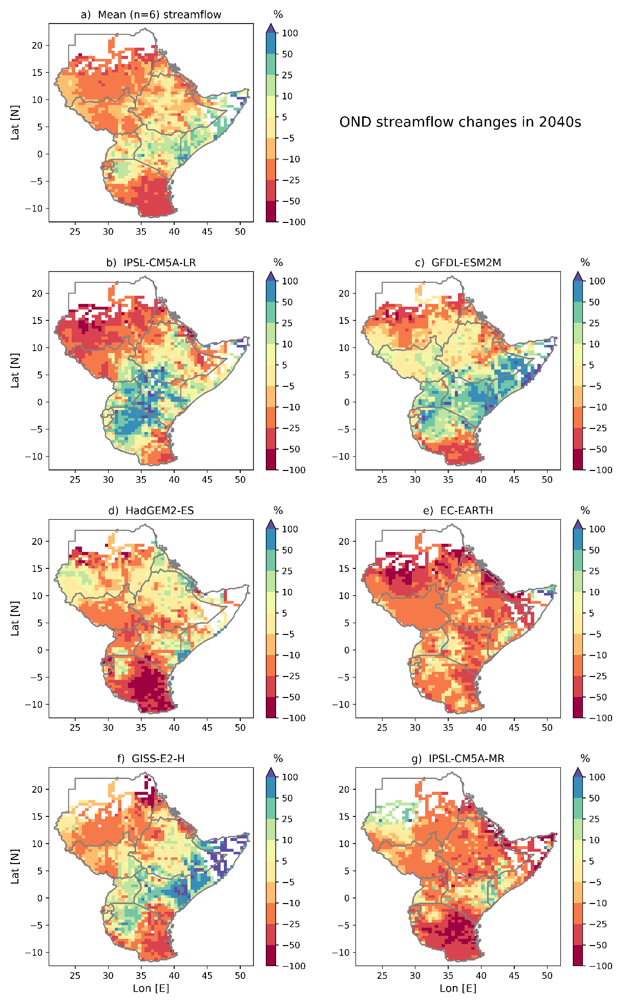

Fig. S6 Projected streamflow changes in 2040s for the OND season. Areas with Q values less than 5 m3/s (white) are filtered out.

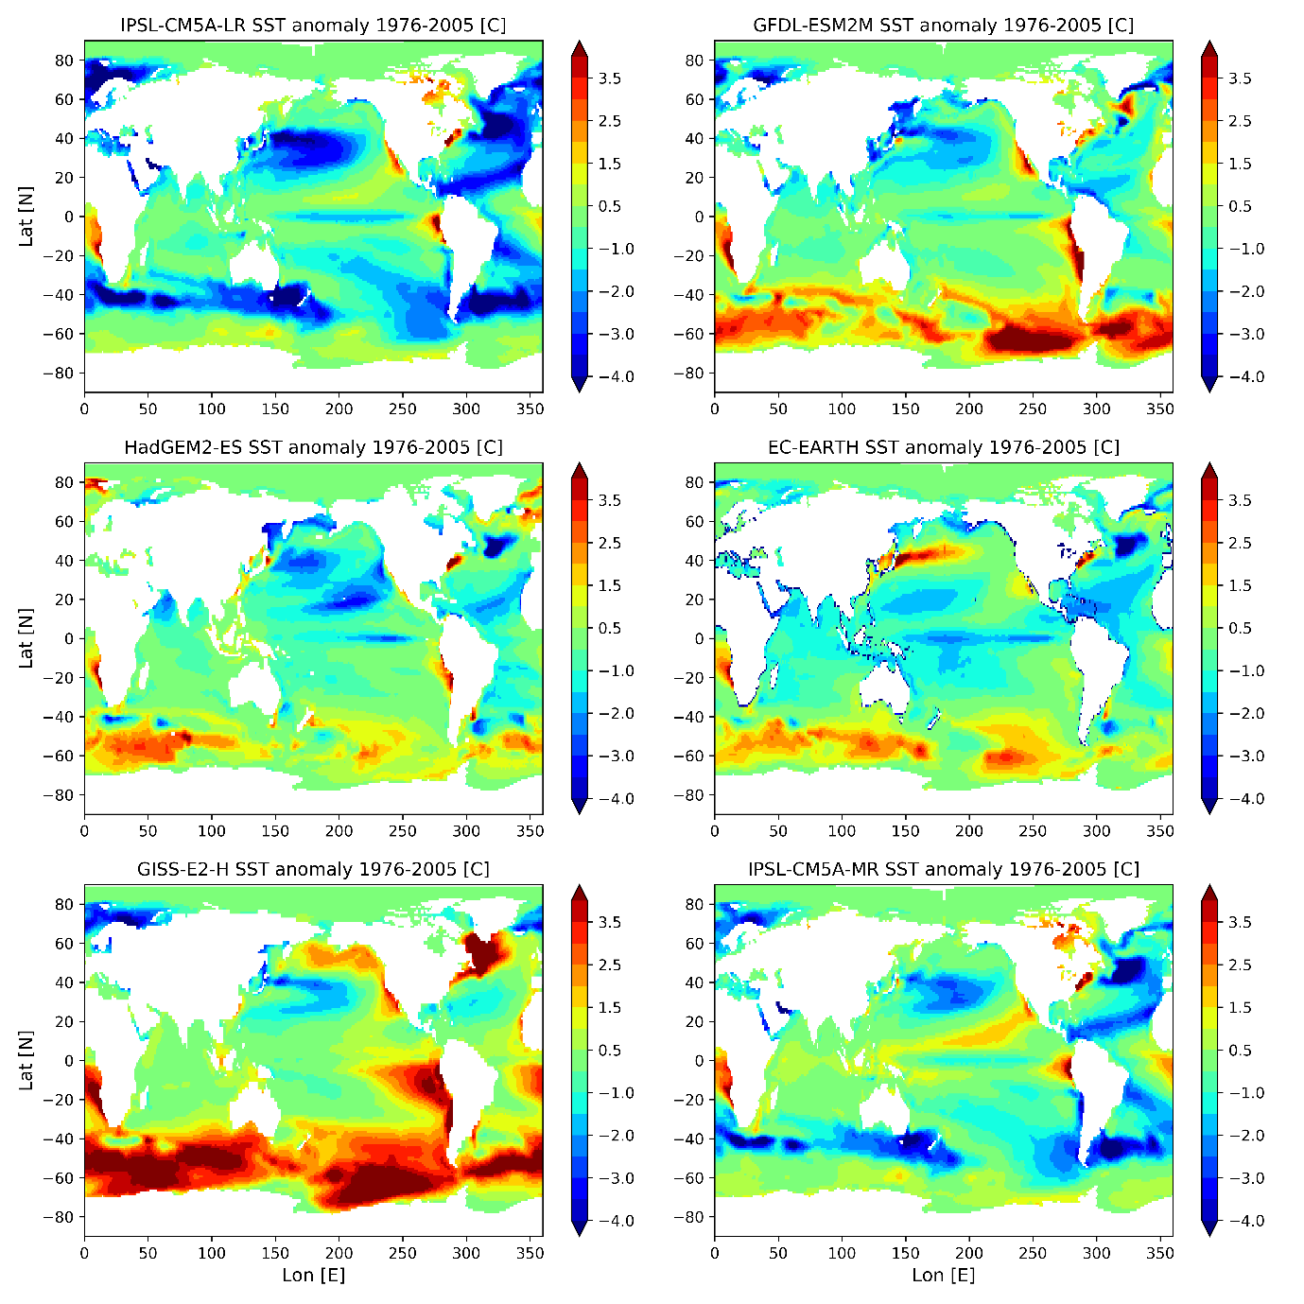
Fig. S7 Long-term mean (1976-2005) SST anomaly computed as the difference from HadISST values.

