Supplementary material #2
Explanation of method for determination of Take-Off Distance Required, and Maximum Take Off Mass (when runway length limited) for Airbus A320 TODR and MTOM within paper “The impacts of climate change on Greek Airports” by Gratton, Padhra, Rapsomanikis and Williams.
Airbus A320 take-off distance required (TODR) and maximum take-off mass (MTOM) were determined using a take-off performance model developed at the University of West London (see the Appendix). The model is based on the method presented in (Blake 2009) in which Newton’s second law of motion is used to determine the aircraft’s acceleration profile. This is used to determine the aircraft velocity at incremental points which is integrated to determine total take-off distance. Full details of the model are provided in the Supplementary Information section.
The method used to determine TODR at airports with sufficient runway length is calculated using the following order of actions:
- The airfield elevation above mean sea level was used to determine the atmospheric pressure and temperature as per the International Standard Atmosphere (ISA).
- Using the year’s minimum temperature and the ISA atmospheric pressure, the air density was determined using the ideal gas law.
- The year’s mean headwind velocity and the air density value were used to calculate the aircraft lift and drag forces.
- The maximum engine thrust was determined by correcting for temperature by taking the difference between the ISA temperature at the airfield elevation and the year’s minimum temperature.
- The calculated lift, drag and thrust forces were used to determine the acceleration profile of the aircraft at the maximum take-off mass of 78,000kg.
- The aircraft’s ground acceleration was determined at incremental true airspeed values of 1m/s and then integrated to determine the runway distance to lift-off. The airborne acceleration was extrapolated to 35ft above the take-off surface.
- In accordance with aviation regulations CX- 25.113 (See appendix), for a dry runway, the regulated take-off distance is 115% of the calculated take-off distance from brake release to the point 35ft above the take-off surface.
The method used to determine MTOM at runway length limited airports followed the same order of actions as for the TODR calculations. However, the take-off mass of the aircraft was incrementally reduced to the nearest 1kg until the regulated take-off distance was less than the take-off distance available (TODA).
Main Text Reference
Blake, W. (2009), ‘Jet Transport Performance Methods’, Flight Operations Engineering, Boeing Commercial Airplanes, pp742.
Appendix to Supplementary Material #1, explanation of the A320 Performance Model.
This appendix outlines the details of a model developed to determine the take-off distance of a commercial jet transport aircraft.

List of symbols

a - Aircraft Acceleration (m/s²)
C_{D0} - Parasite Drag Coefficient
C_{D} - Drag Coefficient
C_{L} - Lift Coefficient
C_{T1} - 1st Take-off Thrust Coefficient (N)
C_{T2} - 2nd Take-off Thrust Coefficient (ft)
C_{T3} - 3rd Take-off Thrust Coefficient (1/ft²)
D - Drag Force (N)
k - Lift-induced Coefficient
F - Friction Force (N)
g - Gravitational Acceleration (m/s²)
H_{p} - Geopotential Pressure Altitude (ft)
L - Lift Force (N)
m - Aircraft Mass (kg)
R - Normal Reaction Force (N)
S - Wing Reference Area (m²)
T - Engine Thrust (N)
V_{TAS} - True Airspeed (m/s)
W - Aircraft Weight (N)
X_{A} - Airborne Acceleration Distance (m)
x - Distance (m)
θ - Runway Slope Angle (Deg)
µ - Rolling Friction Coefficient
ρ - Air Density (kg/m³)
Φ - Take-off Angle (deg)

- Modelling of aircraft forces and take-off calculations

The model is based on Newton’s second law of motion in which the resultant force acting on the aircraft is a product of its mass and acceleration.
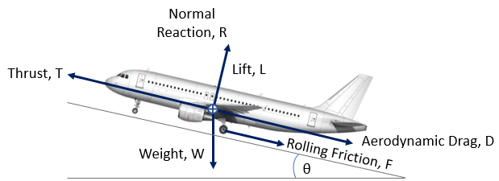

Figure 1 – Schematic of the forces acting on an aircraft during the take-off run.

Figure 1 shows the forces acting on an aircraft during the take-off run with the runway surface sloping upwards at an angle, θ to the horizontal plane. By resolving the forces parallel to the direction of the aircraft’s motion and using Newton’s Second Law of Motion:

$T-D-F-Wsinθ=ma$ [Eq. 1]

where T is the engine thrust, D is the aerodynamic drag, F is the friction force, W is the aircraft weight, m is the aircraft mass and a is the acceleration.
The aircraft weight, W is

$W=mg$ [Eq.2]

where g is the gravitational acceleration and taken to be 9.81m/s².

The net normal reaction force, R acting on the aircraft is:

$R=Wcosθ-L$ [Eq.3]

and therefore, the friction force between the aircraft tyres and the runway surface is

$F=μR=μ(Wcosθ-L)$ [Eq.4]

where µ is the rolling friction coefficient.

When combining [Eq. 2-Eq.4] with [Eq. 1], aircraft acceleration is given as:

$$a=\frac{T-D-μ\left(mgcosθ-L\right)-mgsinθ}{m}$$
[Eq.5]
[Eq. 5] can be also be written as:

$$a=\frac{T-D+μL-mg(μcosθ-sinθ)}{m}$$
[Eq.6]

  - Engine Thrust

Take-off thrust at standard atmosphere condition is calculated using the method proposed in (Nuic 2013) using the formula:

$T_{max}=C_{T1}×\left(1-\frac{H_{p}}{C_{T2}}+C_{T3}×H_{p}^{2}\right)$ [Eq.7]

where C_{T1}, C_{T2}, C_{T3} are thrust coefficients and H_{p} is the geopotential pressure altitude, in feet. The thrust coefficients are specific to the aircraft and engine type and available through the Eurocontrol Base of Aircraft Data (BADA 2013) tables.

  - Aircraft Lift Force

Lift is:

$L=1/2ρV_{TAS}^{2}SC_{L}$ [Eq.8]

Lift coefficient is a function of angle of attack and higher at take-off since the aircraft is in rotation, and lower prior to rotation. Mean C_{L} is determined by calibrating the model derived aircraft take-off distance with that published by the aircraft manufacturer, for the same conditions.

  - Aerodynamic Drag

Drag is:
$D=1/2ρV_{TAS}^{2}SC_{D}$ [Eq.9]
and
$C_{D}=C_{D0}+kC_{L}^{2}$ [Eq.10]

C_{D0} and k are specific to the aircraft type and configuration. Here the values are taken from the Eurocontrol Base of Aircraft Data (BADA 2013) tables, with the aircraft in the take-off configuration.

  - Rolling friction coefficient

Rolling friction coefficient between the aircraft tyres and the runway surface is dependent on the properties of the tyres and characteristics of the runway surface. A number of sources have quoted values in the range 0.015-0.025 (Austin Mair and Birdsall, 1996; Currey 1988; Gerthoeffert et al. 2014). Here, the model uses the value of 0.02 as used by (Koudis et al. 2017).

  - Take-off Distance Calculation

To determine take-off distance, using Eq. 6, acceleration is calculated at incremental true airspeed values of 1m/s until L=W. By assuming that the incremental acceleration is constant, the incremental distance, Δx travelled by the aircraft is given by:

$∆x=\frac{\overline{V}∆V}{\overline{a}}$ [Eq.11]

The total distance from brake release to the point where the aircraft’s main landing gear lifts off the runway is the sum of incremental distances.
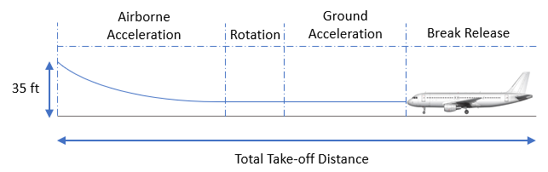

Figure 2 – Phases of take-off from brake release to an altitude of 35ft

Take-off distance is the distance covered by the aircraft from brake release to the point where the lowest part of the aircraft is 35 ft (15m) above the take-off surface, as illustrated in Figure 2, so including the airborne acceleration phase.

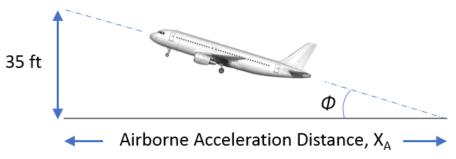

Figure 3 – Aircraft airborne acceleration phase from lift-off to 35ft above take-off surface

If the take-off angle is known and assuming a linear take-off path, the airborne acceleration distance, X_{A}, in metres can be calculated using:

$X_{A}=0.3048×\left(\frac{35}{ cos∅}\right)$ [Eq.12]

The climb angle, Φ is taken as an average from actual flight data supplied by a major European airline operating a range of jet aircraft types. The average climb angle, Φ is found to be constant at 7.7 degrees from lift-off to 35ft above the take-off surface.

The total take-off distance is then the sum of the ground and airborne acceleration phases. According to CS 25.113 (EASA 2017), for a dry runway, the regulated take-off distance is 115% of the calculated take-off distance from brake release to the point 35ft (15m) above the take-off surface.

- Model Performance

The model was validated using manufacturer’s values for equivalent conditions. For the Airbus A320-231 aircraft operated using IAE V2500 model engines aircraft and engine coefficients are listed for in the Eurocontrol Base of Aircraft Data (BADA 2013) tables. The manufacturer published take-off distances are in (Airbus 2005 and presented for ISA Conditions for take-off masses ranging from approximately 61,000kg to a maximum take-off mass of 78,000kg. Table 1 compares values.

Aircraft  Take-off Mass (kg) | Regulated Take-off Distance (m) |  | Percentage Difference
Aircraft  Take-off Mass (kg) | Manufacturer Value | Model-Derived Value | Percentage Difference
61,235 | 1233 | 1243 | -0.81
63,503 | 1344 | 1347 | -0.22
65,771 | 1455 | 1456 | -0.07
68,039 | 1579 | 1571 | +0.51
70,307 | 1689 | 1694 | -0.30
72,575 | 1798 | 1823 | -1.39
74,843 | 1946 | 1959 | -0.67
77,111 | 2134 | 2103 | +1.45
79,379 | 2362 | 2256 | +4.49
Table 1 – Comparison of take-off distance values for an Airbus A320 aircraft, stated by the manufacturer and that determined from the model.

Across a wide range of aircraft take-off masses, Table 1 shows that the model-derived take-off distance is less than 4.5% from the value quoted by the manufacturer and in many cases less than 1.5%.

Appendix References

Airbus (2005), ‘Aircraft Characteristics: Airport and Maintenance Planning’, Airbus SAS, Rev 34 – Feb 01/18, pp393.

Austyn Mair, W. and Birdsall, D.L. (1996), ‘Aircraft Performance’ Cambridge University Press, Cambridge, U.K. pp.324.

Blake, W. (2009), ‘Jet Transport Performance Methods’, Flight Operations Engineering, Boeing Commercial Airplanes, pp742.

Currey, N.S. (1988), ‘Aircraft Landing Gear Design: Principles and Practices’ (4th edition, American Institute of Aeronautics and Astronautics Inc, Washington D.C.

EASA [European <Union> Aviation Safety Agency] (2017) Certification Specification and Acceptable Means of Compliance for Large Aeroplanes, CS-25 Amendment 19
Gerthoffert, J., Grosjean, C., Cerzo, V. and Do, M., (2014), ‘Modelling of aircraft breaking coefficient from IMAG friction measurements’, Airports in Urban Networks.

Koudis, G.S., Hu, S.J., Majumdar, A. Jones, R. and Stettler, M.E.J.,(2017), ‘Airport emissions reductions from reduced thrust takeoff operations’, Transportation Research Part D: Transport and Environment, 52(A), 15-28.

Nuic, A. (2013), ‘User Manual for the Base of Aircraft Data (BADA)’, EEC Technical/Scientific Report No. 13/04/16-01, Revision 3.11, Eurocontrol, pp89.

