Supplementary Table 1 Information of calculation domains
# of Domain | The range of domain | The grid size | # of grids
1 | 117°E ~ 132°,  20°N ~ 42°N | Δx = 9,060 m, Δy = 11,561 m | 151 ｘ 211
2 | 123°E ~ 131°,  31°N ~ 39°N | Δx = 4,563 m, Δy = 5,547 m | 160 ｘ 160
3 | 124°E ~ 130.5°,  32.5°N ~ 36°N | Δx = 2,282 m, Δy = 2,773 m | 260 ｘ 140
4 | 127°E ~ 130°,  33.5°N ~ 35.75°N | Δx = 761 m, Δy = 925 m | 360 ｘ 270
Supplementary Table 2 Genesis and lysis locations of the typhoons for observation (IBTrACS) and simulations using MRI-AGCM3.2H (future change, ΔX = X_{HFA} – X_{HPA})
Climate  condition | Abbreviation  for experiments | Typhoon genesis |  | Typhoon lysis
Climate  condition | Abbreviation  for experiments | Mean location  (lon, lat) [°] | Its future change*  (Δlon, Δlat) [°] | Mean location  (lon, lat) [°] | Its future change  (Δlon, Δlat) [°]
Present | Observation | (138.16, 15.66) | - | (144.49, 42.40) | -
 | HPA | (136.37, 16.64) | - | (138.10, 40.20) | -
Future | HFA-c0-rcp26 | (136.41, 17.05) | (0.04, 0.41) | (140.58, 41.19) | (2.48, 1.00)
 | HFA-c0-rcp45 | (136.35, 17.10) | (-0.02, 0.46) | (140.23, 41.15) | (2.13, 0.95)
 | HFA-c0-rcp85 | (136.06, 17.01) | (-0.31, 0.38) | (140.54, 41.13) | (2.44, 0.93)
 | HFA-c1-rcp85 | (135.92, 17.38) | (-0.45, 0.74) | (140.00, 41.14) | (1.90, 0.94)
 | HFA-c2-rcp85 | (136.66, 17.22) | (0.29, 0.58) | (140.23, 41.60) | (2.13, 1.40)
 | HFA-c3-rcp85 | (135.57, 17.43) | (-0.80, 0.79) | (140.38, 41.22) | (2.28, 1.02)
*A positive value means the movements to the eastward and northward for longitude and latitude, respectively.

Supplementary Table 3 Maximum storm surge heights (Maximum SSH)-induced by sea level pressure and wind and its range on each calculation grid of D2 for each ensemble experiment. The number in parentheses next to the values of difference by wind is the ratio of maximum SSH by wind to maximum SSH.
Experiment name | Range of maximum SSH induced |  | Difference = b-a
Experiment name | by pressure  [a b] | by wind  [a b] | by pressure | by wind
IBTrACS | [0.767 0.780] | [0 2.223] | 0.013 | 2.223 (74.03%)
HPA | [0.582 0.593] | [0 1.948] | 0.011 | 1.948 (71.48%)
HFA-rcp26-c0 | [0.706 0.717] | [0 2.839] | 0.011 | 2.839 (78.52%)
HFA-rcp45-c0 | [0.706 0.725] | [0 3.869] | 0.019 | 3.869 (83.33%)
HFA-rcp85-c0 | [0.696 0.706] | [0 6.164] | 0.010 | 6.164 (88.85%)
HFA-rcp85-c1 | [0.550 0.554] | [0 1.857] | 0.004 | 1.857 (70.44%)
HFA-rcp85-c2 | [0.838 0.854] | [0 3.556] | 0.016 | 3.556 (80.69%)
HFA-rcp85-c3 | [0.838 0.859] | [0 2.412] | 0.021 | 2.412 (73.97%)

Supplementary Fig.1 Probability of the annual passing number of the typhoons around Korean Peninsula for (a) observations (IBTrACS) between 1984 and 2003, (b) simulation using MRI-AGCM3.2H from 1984 to 2003 and (c) projection using MRI-AGCM3.2H from 2080 to 2099

Supplementary Fig.2 Probability density functions of the typhoon intensity (minimum central pressure (MCP)) comparing observation (IBTrACS) and for simulation using MRI-AGCM3.2H under the present climate condition (HPA). (a) original (b) with the bias corrected of MCP of HPA and IBTrACS

Supplementary Fig.3 Probability density functions of the typhoon intensity, which was expressed as a minimum central pressure, from ensemble experiments: for present and (a) all future ensemble experiments, (b) future ensemble experiments with different global scenarios and (c) future ensemble experiments with different SST condition

Supplementary Fig.4 Projected maximum storm surge heights [unit : m] targeting the Korean Peninsula for ensemble experiments using MRI-AGCM3.2H (a) under the present climate condition (abbreviated as “HPA”), (b) under the RCP8.5 scenario with Cluster 1 of CMIP5 SST (abbreviated as “HFA-c1-rcp85”), (c) HFA-c2-rcp85, (d) HFA-c3-rcp85, (e) under the rcp2.6 scenario with ensemble mean of CMIP5 SST experiments (abbreviated as “HFA-c0-rcp26”), (f) HFA-c0-rcp45 and (g) HFA-c0-rcp85. The letters in each panel indicate the city name with more than 2.0 m of maximum storm surge height. Refer to Fig. 1 for the meaning of each letter

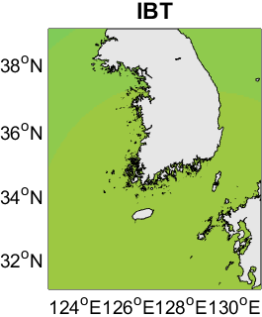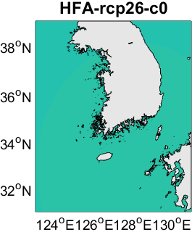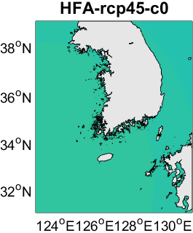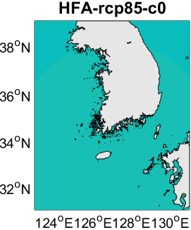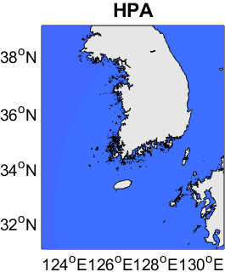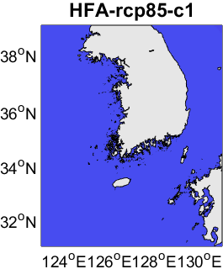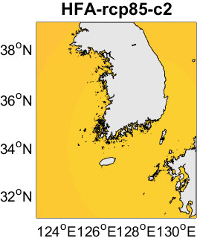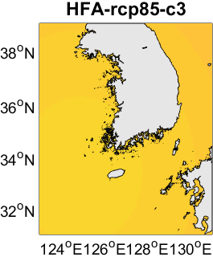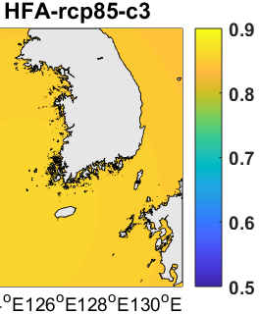

Supplementary Fig.5 Maximum storm surge heights-induced by sea level pressure [unit : m] targeting the Korean Peninsula depending on climate experiment conditions. The letters above each panel indicate the experiment conditions

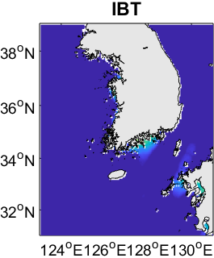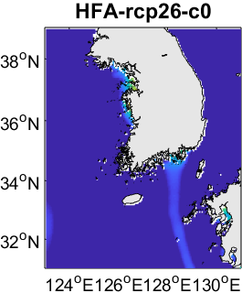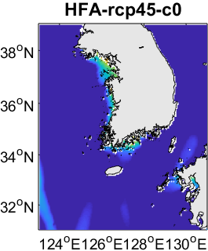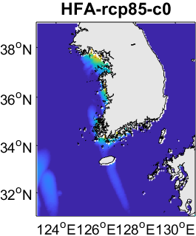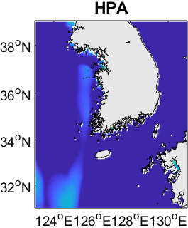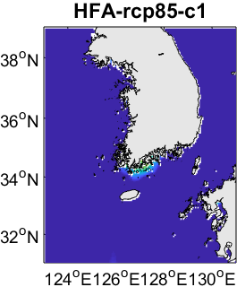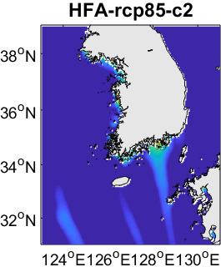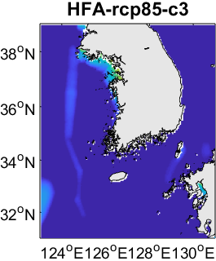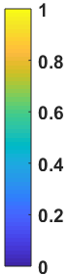

Supplementary Fig.6 The ratio of maximum storm surge heights-induced by wind to total maximum storm surge heights [unit : m] targeting the Korean Peninsula depending on climate experiment conditions

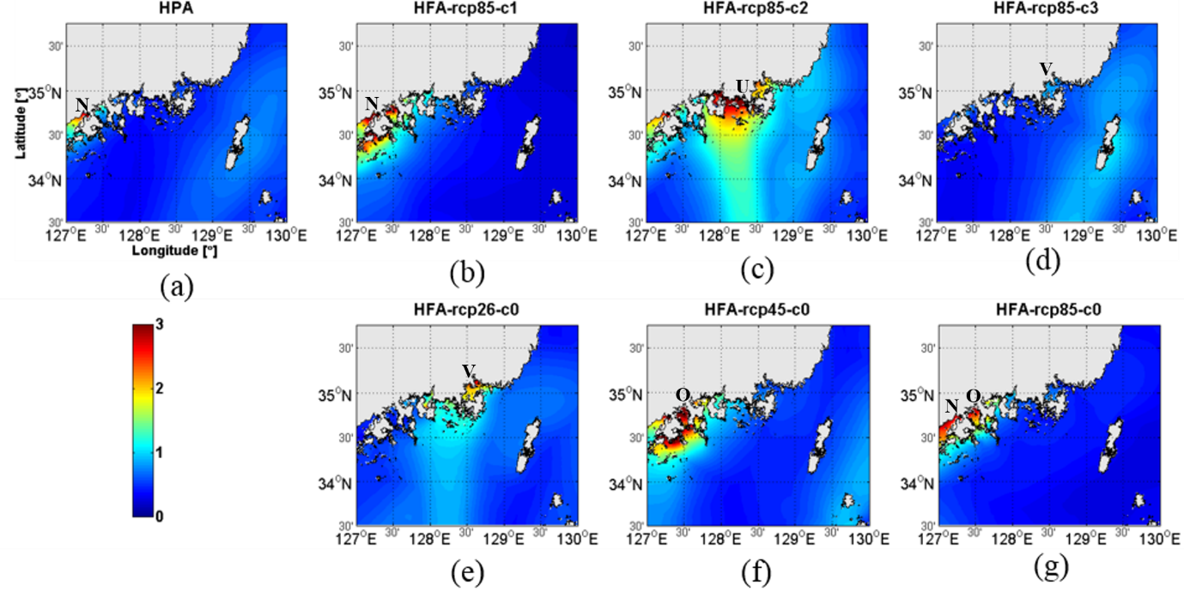

Supplementary Fig.7 Projected maximum storm surge heights [unit : m] around the southeastern region for ensemble experiments using MRI-AGCM3.2H (a) under the present climate condition (abbreviated as “HPA”), (b) under the RCP8.5 scenario with Cluster 1 of CMIP5 SST (abbreviated as “HFA-c1-rcp85”), (c) HFA-c2-rcp85, (d) HFA-c3-rcp85, (e) under the rcp2.6 scenario with ensemble mean of CMIP5 SST experiments (abbreviated as “HFA-c0-rcp26”), (f) HFA-c0-rcp45 and (g) HFA-rcp85-c. The letters in each panel indicate the city name. Refer to Fig. 1 for the meaning of each letter.

Supplementary Note1 Maximum storm surge heights and vulnerable areas to storm surge around the Korean Peninsula under present and future climate conditions

In the present climate condition, the maximum SSHs larger than 2 m occurred at Asanman bay (denotes D in Supplementary Fig.4 (a)) and Boryeong (E, 2.73 m which is the value of maximum SSH in D2) on the west coast and at Boseong (M) on the south coast in the KP. On the other hand, in the future climate condition, locations and the extent of areas exposed to SSHs higher than 2 m substantially varied among the ensemble experiments.

Supplementary Figs.4 (b), (c), (d) and (g) show the projected maximum SSTs based on ensemble experiments using four SST patterns with RCP8.5. The letters in the Fig.S4 indicate the city names where maximum SSH more than 2 m simulated. It is shown that the southern coasts are vulnerable to storm surge in HFA-c1-rcp85. The highest value of maximum SSH was 2.64 m at Boseong (M). Most of coasts except east coast were exposed to the high SSHs more than 1 m in HFA-c2-rcp85. The highest value of maximum SSH with 4.4 m occurred near Boryeong (E) on the west coast. The west coast was found to be more vulnerable to SSH in HFA-c3-rcp85 and HFA-c0-rcp85. The highest values of maximum SSH for the two experiments were 3.26 m at Asanman (D) and 4.87 m at Boryeong (E), respectively. The highest values of maximum SSH for HFA-c0-rcp85 was 6.2 m at the Haeju (★) in North Korea, so this study suggests the maximum value at Boryeong in South Korea as the highest value in D2. Vulnerable area to storm surges in the future climate condition varied with given SST conditions and those were highly dependent on some specific high intensity typhoons.

Supplementary Figs.4 (e), (f) and (g) indicate the maximum SSHs based on the ensemble experiments with the given three greenhouse gas concentration scenarios; denoted as HFA-c0-rcp26, HFA-c0-rcp45 and HFA-c0-rcp85. The west and southeast coasts were vulnerable in HFA-c0-rcp26, whereas the west, southwest and south coasts were prone in other experiments. The highest maximum SSHs in each experiment were 3.62 m at Boryeong (E), 4.64 m at Ganghwa (A) and 4.87 m at Boryeong (E), respectively. The vulnerable areas to future storm surge and the extent of maximum SSHs were different according to the selected greenhouse gas concentration scenarios.

Supplementary Note2 The meaning of the expression ‘the number of typhoons is small (limited)’

The expression of “the number of typhoons is small (limited)” might be interpreted to mean that the total number of typhoons is small, since MRI-AGCM simulated fewer typhoon events than observed ones. But authors intended to express the number of typhoons with similar characteristics is small, which would result from the lack of the total number of typhoons. In other words, this means that it is difficult to analyze the contribution of each typhoon characteristic to the value of SSH, because the number of typhoons having similar paths and different strengths or having the same strength and different paths is small. For example, let’s look at the figure below presenting each typhoon that occurred under HFA-rcp26-c0 condition (Attached Fig. 1). Typhoon 13 is considered to cause large SSHs under this condition. However, there is no typhoon event with the same intensity as Typhoon 13 and having a different route. In addition, there are very few cases of typhoons that have a similar path to Typhoon 13 and have different strength though Typhoon 14 shows a similar path. The situation is similar in other future climate conditions.

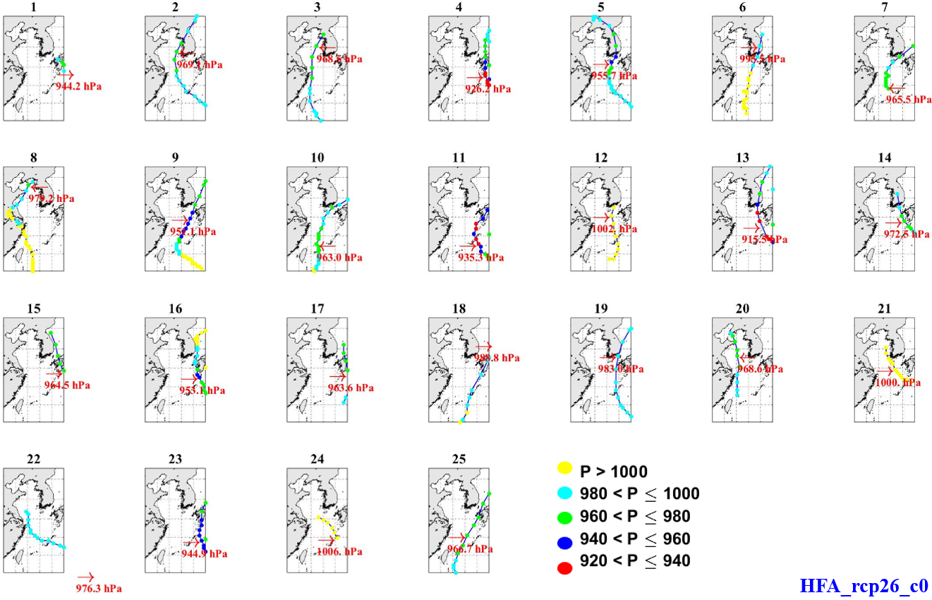
Attached Fig. 1 Each typhoon track of HFA_rcp26_c0

Supplementary Note3 Maximum storm surge heights and storm surge prone area in the southeastern region of the Korean Peninsula under present and future climate conditions

The maximum SSHs higher than 2 m only occurred at Goheung (denotes N in Supplementary Fig.7 (a)) in the west part of the southeastern region and the highest maximum SSH was 2.83 m in the present climate condition, whereas the potential highest maximum SSHs increased up to 5.49 m at Tongyoung (U) in the center part of southeastern region in the future climate condition, HFA-rcp45-c0. The location and the extent of the vulnerable areas varied considerably according to the experiment condition.

