Supplementary Information

S1. Models (IMAGE / GAINS)

IMAGE 3.0 modelling framework

The description of the IMAGE 3.0 model below has been used in other EMF30 studies in the Climatic Change Special Issue (Harmsen et al., 2019). It relies heavily on and uses text from the online IMAGE 3.0 model documentation, which in turn is fully based on the IMAGE 3.0 book (Stehfest et al., 2014). The online documentation can be found here:
http://themasites.pbl.nl/models/image/index.php/Welcome_to_IMAGE_3.0_Documentation
A stepwise introduction to the modeling framework can be found at the following link:
http://themasites.pbl.nl/models/image/index.php/IMAGE_framework
IMAGE 3.0 is an integrated assessment modeling framework that simulates global and regional environmental consequences of changes in human activities (Stehfest et al., 2014). The model is a simulation model, i.e. changes in model parameters are calculated on the basis of the information from the previous time-step. The model includes a detailed description of the energy and land-use system and simulates most of the socio-economic parameters for 26 regions and most of the environmental parameters on the basis of a geographical grid of 30 by 30 minutes or 5 by 5 minutes (depending on the variable). The IMAGE framework is comprises two main systems: 1) the human or socio-economic system that describes the long-term development of human activities relevant for sustainable development; and 2) the earth system that describes changes in natural systems, such as the carbon and hydrological cycle and climate.
Exogenous assumptions on population, economic development, lifestyle, policies and technology change form a key input into the energy system model TIMER (De Vries et al., 2001; Van Vuuren et al., 2007) and the food and agriculture system model MAGNET (Woltjer et al., 2014).
TIMER simulates long-term trends in energy use, issues related to depletion, energy-related greenhouse gas and other air polluting emissions, together with land-use demand for energy crops. The focus is on dynamic relationships in the energy system, such as inertia and learning-by-doing in capital stocks, depletion of the resource base and trade between regions. As a simulation model, TIMER differs from most macroeconomic models, which let the system evolve on the basis of minimizing cost or maximizing utility under boundary conditions. As such, TIMER can be compared to energy simulation models, such as POLES and GCAM.
MAGNET describes, in interaction with the main IMAGE framework, changes in food production and trade for a broad set of crops and animal products. The model is is a multi-regional, static, applied CGE model based on neoclassical microeconomic theory.
A key component of the earth system is the LPJmL model that is included in IMAGE 3.0, and that covers the terrestrial carbon cycle and vegetation dynamics. This model is used to determine productivity at grid cell level for natural and cultivated ecosystems. Climatic change is calculated as global mean temperature change using a slightly adapted version of the MAGICC 6.3 climate model.

IMAGE version for EMF-30
The IMAGE version used in EMF30 is based on the version used in the development of the shared socio-economic pathways (SSPs) (Riahi et al., 2017; Van Vuuren et al., 2017). The multi-model EMF30 scenarios follow assumptions as defined for the middle-of-the-road trajectory of SSP2. The future development of pollutant emissions is projected based on a combination of activity changes in IMAGE and exogenous emission factor input from the GAINS model (Amann et al., 2011). As a default, emission factor assumptions are based on the SSP storylines, as described and analyzed by Rao et al. (2017). The scenarios in the EMF30 studies include assumptions on pollutant control measures beyond the SSP assumptions, based on assessments from the ECLIPSE project (Klimont et al., 2017; Stohl et al., 2015).
In this study on black carbon, several scenarios have the same setup as in the multi-model exercise (SSP2 = NoPolicy, SSP2_26 = ClimPolicy, SSP2_Climate = BCOCEndUse). The respective SSP3 scenarios (SSP3, SSP3_34, SSP3_Climate) are based on the same assumptions, but applied to the SSP3 storyline and with a less stringent climate target in the mitigation case (3.4 W/m²). The health scenarios are additional to the multi-model setup and cover more sectors.

References
De Vries HJM, et al. (2001) The targets image energy model regional (TIMER) -Technical documentation. PBL Netherlands Environmental Assessment Agency (formerly MNP), Bilthoven/The Hague www.pbl.nl/en.
Riahi K, et al. (2017) The Shared Socioeconomic Pathways and their energy, land use, and greenhouse gas emissions implications: An overview. Global Environmental Change.
Stehfest E, et al. (2014) Integrated Assessment of Global Environmental Change with IMAGE 3.0. Model description and policy applications. The Hague: PBL Netherlands Environmental Assessment Agency.
Van Vuuren DP, et al. (2007) Stabilizing greenhouse gas concentrations at low levels: an assessment of reduction strategies and costs. Climatic Change 81.
Van Vuuren DP, et al. (2017) Energy, land-use and greenhouse gas emissions trajectories under a green growth paradigm. Global Environmental Change 42:237-250.
Woltjer GB, et al. (2014) The Magnet Model - Module description. LEI - part of Wageningen University and Research Centre, The Hague.

GAINS

The text below is an extended version of section 2.2 in the main text, with a more detailed description of the underlying methodology of the GAINS model version applied in this study.
The potential for further application of the air pollution control technologies in the scenarios has been based on emission factor data from the GAINS model (Amann et al., 2011). GAINS has been a widely used source for such projections (Braspenning Radu et al., 2016; Rao et al., 2016; Rao et al., 2017; Shindell et al., 2012; Stohl et al., 2015). Pollution control measures are expressed as region-/sector-/technology-/fuel-specific emission factors and include several hundreds of measures. These represent the reduction of BC emissions and co-emitted pollutants (included here are OC, SO₂ and NOx, as these are most relevant in terms of climate and health impact). For BC sources in transport, the technologies include several EURO stages, including installation of diesel particulate filter (DPF). In the residential sector, various types of heating and cooking stoves and heating boilers are included; ranging from inefficient and highly polluting installations (or simple three stone stoves) to advanced modern solid fuel stoves and boilers including pellets. Detailed information about the included types of fuels, installations and control technologies can be found in Klimont et al. (2017). The development of air pollutant emission factors in the baseline emission scenario relies on the current legislation (CLE) dataset in GAINS that reflects the status of air quality legislation as of 2014 (for more detailed discussion see Stohl et al. (2015) and Rao et al. (2016). From 2020, the CLE data also includes lower pollutant emissions from international shipping (IMO, 2018).

The main sectoral mitigation measures included in the Health and Climate scenarios are based on the ECLIPSE project database (V5a) (Klimont et al., 2017; Stohl et al., 2015). The reduction potential is regionally specific, depending on the source structure and already committed controls, since they might limit rapid introduction of best available technology, and has no cost constraints, i.e., the most efficient measures (independent of their costs) are introduced as quickly as possible (see also Amann et al. (2013)). In GAINS, emissions of all air pollutants were computed for 174 regions/countries, based on international energy and industrial statistics, emission inventories and national emission reporting. For this study, these have been aggregated to the 26 world regions in IMAGE. The activity, emission, and emission factor trajectories using the EMF30 sectors and IMAGE regions as calculated in the GAINS model are also available from the dedicated online application of the model . Final emissions are calculated by applying future GAINS emission factors (for 2030 and 2100) to IMAGE activities. Base year (2015) emission factors in IMAGE are calibrated with historical estimates for anthropogenic emissions from the Community Emissions Data System for historical emissions (CEDS) (Hoesly et al., 2018) and open burning emissions (van Marle et al., 2017). These are linearly interpolated to 2030 (see supplement S3 for a literature comparison for global sectoral BC emissions in 2015).

The main sectoral mitigation measures (MFR) include: Residential and commercial 1) A phase-out of the end-use of coal and biomass consumption for cooking and heating by 2030 (note that this is the only measure not realized via emission factors, in accordance with the EMF30 scenario setup) 2) Replacement of kerosene wick lamps with LED lamps, Transport 1) Eliminating high-emitting vehicles 2) Widespread Euro VI equivalent emission standards (incl. particle filters on diesel engines), Transformation 1) Modernized (mechanized) coke ovens, Industry 1) Replacement of artisanal brick kilns with more efficient and cleaner kilns (e.g., zig-zag, vertical shaft kiln, Marquez kiln), Power Sector 1) Coal plants with high efficiency particle filters, desulfurization and deNOx technology. Note that the power sector is a relatively small BC and OC source (1-2% of total emissions), but a large SO₂ (±50%) and NOx source (±25%). These measures are mainly impactful from a health point of view.
Air pollution policy costs, calculated in GAINS, represent the total annualized costs of mitigation measures, and thus include the mitigation of all included pollutants: BC, OC, SO₂, NOx. For calculating emission control costs, GAINS relies on international investment costs and operating experience of pollution control equipment and extrapolates it to country-specific conditions using respective energy and labour costs. The basis of the methodology is described in Amann et al. (2011) and details available from model documentation reports (Cofala and Syri, 1998a, b; Klimont et al., 2002; Klimont et al., 2000; Klimont and Winiwarter, 2015).The costs have been determined for both the current legislation baseline case (CLE)(corresponds with SSP2 and SSP3) and the MFR case. The costs have been broken out separately for the health (mitigation in all sectors) and climate (mitigation in residential and transport) cases. Costs in all scenarios are scaled with sectoral total final energy activities in IMAGE compared to GAINS

References

- Amann M, et al. (2011) Cost-effective control of air quality and greenhouse gases in Europe: Modeling and policy applications. Environmental Modelling & Software 26:1489-1501.
- Amann M, et al. (2013) Regional and Global Emissions of Air Pollutants: Recent Trends and Future Scenarios. Annual Review of Environment and Resources 38:31-55.
- Braspenning Radu O, et al. (2016) Exploring synergies between climate and air quality policies using long-term global and regional emission scenarios. Atmospheric Environment 140:577-591.
- Hoesly RM, et al. (2018) Historical (1750–2014) anthropogenic emissions of reactive gases and aerosols from the Community Emissions Data System (CEDS). Geoscientific Model Development 11:369-408.
- IMO (2018) International Maritime Organization: Amendments to the annex of the protocla of 1997 to amend the international convention for the prevention of pollution from ships (2016)(start date: 1 March 2018).
- Klimont Z, et al. (2002) Modelling Particulate Emissions in Europe A Framework to Estimate Reduction Potential and Control Costs. IIASA Interim Report IR-02-076.
- Klimont Z, et al. (2000) Estimating Costs for Controlling Emissions of volatile organic compounds ( VOC) from Stationary Sources in Europe. IIASA Interim Report, IR-00-51.
- Klimont Z, et al. (2017) Global anthropogenic emissions of particulate matter including black carbon. Atmospheric Chemistry and Physics 17:8681-8723.
- Klimont Z, Winiwarter W (2015) Estimating Costs and Potential for Reduction of Ammonia Emissions from Agriculture in the GAINS Model, in: Reis, S., Howard, C., Sutton, M.A. (Eds.), Costs of Ammonia Abatement and the Climate Co-Benefits. Springer Netherlands, p. 284.
- Rao S, et al. (2016) A multi-model assessment of the co-benefits of climate mitigation for global air quality. Environmental Research Letters 11
- Rao S, et al. (2017) Future air pollution in the Shared Socio-economic Pathways. Global Environmental Change.
- Shindell D, et al. (2012) Simultaneously mitigating near-term climate change and improving human health and food security. Science 335:183-189.
- Stohl A, et al. (2015) Evaluating the climate and air quality impacts of short-lived pollutants. Atmos. Chem. Phys. 15:10529–10566.

S2. Value of statistical life and comparison costs and health benefits

Table S2.1: Value of Statistical Life (VSL) including morbidity (in Million 2015$). Method used from (Markandya et al., 2018), data from IMAGE SSPs (Van Vuuren et al., 2017).
 | SSP2 |  |  | SSP3
 | 2015 | 2030 | 2100 | 2015 | 2030 | 2100
Brazil | 1.1 (0.6-1.6) | 1.5 (0.9-2.2) | 4.5 (2.6-6.5) | 1.0 (0.6-1.6) | 1.4 (0.8-2.0) | 1.5 (0.8-2.1)
Canada | 4.6 (2.6-6.5) | 5.2 (3.0-7.4) | 10.2 (5.8-14.6) | 4.6 (2.6-6.5) | 5.2 (3.0-7.5) | 10.9 (6.2-15.6)
Central Europe | 1.6 (0.9-2.2) | 2.2 (1.3-3.2) | 6.5 (3.7-9.3) | 1.6 (0.9-2.2) | 2.1 (1.2-3.0) | 3.7 (2.1-5.3)
China+ | 1.0 (0.6-1.5) | 2.3 (1.3-3.3) | 6.7 (3.8-9.6) | 1.1 (0.6-1.5) | 2.1 (1.2-3.0) | 3.2 (1.8-4.5)
East Africa | 0.2 (0.1-0.2) | 0.3 (0.1-0.4) | 3.8 (2.2-5.4) | 0.1 (0.1-0.2) | 0.2 (0.1-0.3) | 0.9 (0.5-1.3)
India | 0.2 (0.2-0.5) | 0.6 (0.4-0.9) | 3.8 (2.2-5.5) | 0.3 (0.2-0.5) | 0.6 (0.3-0.8) | 1.1 (0.6-1.5)
Indonesia | 0.5 (0.3-0.7) | 1.0 (0.5-1.4) | 5.5 (3.2-7.9) | 0.5 (0.3-0.7) | 0.9 (0.5-1.2) | 1.9 (1.1-2.7)
Japan | 4.5 (2.6-6.5) | 5.2 (3.0-7.5) | 11.1 (6.3-15.8) | 4.5 (2.6-6.5) | 5.2 (3.0-7.4) | 7.9 (4.5-11.3)
Korea | 2.4 (1.4-3.5) | 3.6 (2.0-5.1) | 9.0 (5.2-12.9) | 2.4 (1.4-3.5) | 3.5 (2.0-5.0) | 6.9 (4.0-9.9)
Middle East | 1.2 (0.7-1.6) | 1.5 (0.9-2.2) | 4.4 (2.5-6.3) | 1.1 (0.7-1.6) | 1.4 (0.8-2.1) | 1.9 (1.1-2.8)
Mexico | 1.5 (0.8-2.1) | 2.0 (1.1-2.8) | 7.4 (4.2-10.6) | 1.5 (0.8-2.1) | 1.8 (1.0-2.6) | 2.8 (1.6-3.9)
North Africa | 0.6 (0.3-0.8) | 0.9 (0.5-1.2) | 4.3 (2.5-6.1) | 0.5 (0.3-0.8) | 0.8 (0.4-1.1) | 1.8 (1.0-2.6)
Oceania | 4.1 (2.4-5.9) | 4.9 (2.8-6.9) | 10.1 (5.8-14.5) | 4.1 (2.3-5.9) | 4.8 (2.7-6.8) | 6.8 (3.9-9.7)
Central America | 0.9 (0.5-1.3) | 1.3 (0.8-1.9) | 8.0 (4.6-11.5) | 0.9 (0.5-1.3) | 1.2 (0.7-1.7) | 2.8 (1.6-4.0)
Rest of South Africa | 0.2 (0.2-0.4) | 0.4 (0.2-0.6) | 4.6 (2.6-6.6) | 0.3 (0.2-0.4) | 0.4 (0.2-0.5) | 1.2 (0.7-1.8)
Rest of South-America | 1.0 (0.6-1.5) | 1.5 (0.8-2.1) | 5.5 (3.2-7.9) | 1.0 (0.6-1.4) | 1.4 (0.8-1.9) | 2.5 (1.5-3.6)
Rest of South Asia | 0.2 (0.1-0.3) | 0.3 (0.2-0.5) | 3.2 (1.8-4.5) | 0.2 (0.1-0.3) | 0.3 (0.2-0.4) | 0.9 (0.5-1.3)
Russia | 1.2 (0.7-1.8) | 1.9 (1.1-2.7) | 4.8 (2.8-6.9) | 1.2 (0.7-1.7) | 1.8 (1.0-2.6) | 2.9 (1.7-4.2)
South Africa | 1.1 (0.6-1.6) | 1.7 (1.0-2.4) | 5.7 (3.2-8.1) | 1.1 (0.6-1.6) | 1.6 (0.9-2.2) | 2.8 (1.6-4.0)
South East Asia | 0.6 (0.3-0.8) | 0.9 (0.5-1.3) | 4.5 (2.6-6.4) | 0.6 (0.3-0.8) | 0.8 (0.5-1.2) | 1.9 (1.1-2.7)
Kazakhstan | 0.6 (0.3-0.8) | 1.1 (0.6-1.6) | 3.7 (2.1-5.2) | 0.6 (0.3-0.8) | 1.0 (0.6-1.5) | 2.0 (1.2-2.9)
Turkey | 1.5 (0.8-2.1) | 2.1 (1.2-3.0) | 6.7 (3.8-9.5) | 1.4 (0.8-2.1) | 1.9 (1.1-2.7) | 2.7 (1.6-3.9)
Ukraine | 0.6 (0.3-0.8) | 0.9 (0.5-1.3) | 3.8 (2.2-5.5) | 0.6 (0.3-0.8) | 0.8 (0.5-1.2) | 2.1 (1.2-3.0)
USA | 5.1 (2.9-7.4) | 6.1 (3.5-8.7) | 8.7 (5.0-12.4) | 5.1 (2.9-7.3) | 6.1 (3.5-8.7) | 7.9 (4.5-11.3)
West Africa | 0.2 (0.1-0.3) | 0.4 (0.2-0.6) | 5.1 (2.9-7.3) | 0.2 (0.1-0.3) | 0.3 (0.2-0.5) | 1.4 (0.8-2.0)
West Europe | 4.3 (2.5-6.2) | 4.9 (2.8-7.0) | 11.2 (6.4-16.0) | 4.3 (2.5-6.2) | 4.8 (2.8-6.9) | 8.0 (4.6-11.5)
World | 1.4 (0.8-1.9) | 1.8 (1.0-2.6) | 5.5 (3.1-7.8) | 1.3 (0.8-1.9) | 1.7 (1.0-2.4) | 2.1 (1.2-3.0)

Figure S2.1 Economic costs of climate policy and air quality policy combined vs VSL health benefits. Shown by world region for the periods 2015-2030 (left) and 2015-2100 (right). Costs and benefits are shown in comparison to the baselines (SSP2 and SSP3). Positive values represent cumulative discounted costs of air quality (i.e. air pollution controls) and climate policy combined (discount rate: 5%). Negative values represent cumulative discounted benefits when applying the VSL from table S2.1 with the regional mortality in the scenarios. Whiskers indicate the global benefits at the low and high VSL estimates. LAM = Latin Amerika, MAF = Middle-East and Africa, REF = Former Soviet Union and reforming economies of Eastern Europe. Note different scales on the y-axes.
In this section, the costs of climate policy and air pollutant control are compared to the monitized health benefits, using the VSL in combination with the number of avoided deaths. Note that this can only serve as an indication of the size of both values and not as a direct comparison, since both variables describe a fundamentally different type of cost (direct first order investments vs. percieved societal costs).
In Figure S2.1, the region-specific results of the policy costs (climate and air quality combined) / VSL-based health benefits analysis are presented. Since the avoided climate impacts are excluded from the analysis, it is limited to understanding the air quality health benefits in relation to policy costs. Note further that this analysis can only be considered indicative and conservative since the indoor air pollution health benefit is also not included. If it would have been, it would likely lead to higher benefits (especially in Africa where indoor air pollution related mortality is relatively high).

When applying a medium value of the VSL, the global health benefits from reduced outdoor air pollution are of the same order of magnitude as the climate policy costs and air quality policy costs (additional to the baseline). This is consistent with findings from Kitous et al. (2017) and Markandya et al. (2018). Figure S2.2 shows the net result of this analysis, when costs and benefits cancel each other out.
When applying a medium value of the VSL (upper panels), ambitious air pollution measures are cost-effective from a global perspective in all scenarios (especially for all Health scenarios but also in the Climate scenarios). Compared to the baseline cases, the benefits in terms of avoided deaths outweigh all policy costs (climate and air quality). This is similar for the short and long term.
The net global benefits are mostly realized in China and India. There are net positive costs in the OECD and REF (former Soviet states and reformed Eastern European countries), because of better pollution controls in the baseline (i.e. a lower health benefit) and relatively high policy costs (air quality and climate). In most scenarios, there are also net costs in MAF (Middle-East and Africa) because of relatively lower VSL values.
Over the whole century, climate mitigation scenarios without additional air quality policy (SSP2_26 and SSP3_34) are generally not found to be cost-effective when only considering health benefits (note that this picture changes when climate benefits would also be considered). Benefits are 73%-75% of total costs.
When applying the lower (conservative) value of the VSL (center panels), ambitious air pollution measures in the baseline cases (SSP2_Health, SSP3_Health, SSP2_Climate, SSP3_Climate) are still cost-effective from a global standpoint, with the net benefits almost exclusively realized in China, India and the rest of Asia. There is mixed picture when climate policy comes into play. In the SSP2_26 cases, the climate policy costs are higher than the health benefits. The SSP3_34 cases with additional air pollution measures can be cost-effective, but only when considering the costs and benefits until 2030 (until 2100 the costs are higher). To understand the impact of the choice of the discount rate, Figure S2.3 shows the results with a medium VSL value, but now with a discount rate of 2% (roughly similar to global economic growth). With this discount rate, the general image remains unchanged, only costs and benefits are much higher, especially in the long term.
Figure S2.2 Net costs and benefits of climate policy and air quality policy. Costs and benefits are shown in comparison to the baselines (SSP2 and SSP3). Values represent costs minus benefits (both cumulative discounted with a 5% discount rate) from Figure S2.1 by world region for the periods 2015-2030 (left) and 2015-2100 (right). Upper panels: medium value for VSL, Center panels: low value for VSL, Lower panels: high value for VSL, LAM = Latin Amerika, MAF = Middle-East and Africa, REF = Former Soviet Union and reforming economies of Eastern Europe. Note different scales on the y-axes.
Figure S2.3 Net costs and benefits of climate policy and air quality policy, sensitivity analysis with a 2% discount rate. Costs and benefits are shown in comparison to the baselines (SSP2 and SSP3). Values represent costs minus benefits (both cumulative discounted with a medium VSL value (as S2.2 upper panel), but with a 2% discount rate) by world region in the periods 2015-2030 (left) and 2015-2100 (right). LAM = Latin Amerika, MAF = Middle-East and Africa, REF = Former Soviet Union and reforming economies of Eastern Europe. Note different scales on the y-axes.

S3. BC emissions calibration and literature comparision

The pollutant emissions in IMAGE have been calibrated with historical estimates for anthropogenic (CEDS; Hoesly et al., 2018) and open burning (van Marle et al., 2017) emissions, with data up to 2015, on a sectoral and (IMAGE 26 world) regional level. The CEDS/Van Marle et al. (2017) data includes the most recent updates in emission factors, is based on a more consistent and reproducible methodology, and leads to estimates that are comparable to, but generally slightly higher than existing global inventories. Figure S3.1 shows the global, sectoral BC base year (2015) emissions in comparison to CEDS/Van Marle et al. (2017) and other widely used literature/databases. Extrapolations to 2015 (for GAINS/ECLIPSE, RCP, EDGAR) are based on sectoral emission changes in CEDS/Van Marle et al. (2017) between 2010 and 2015. The BC emissions in IMAGE are slightly (0.65 Mt) higher than in CEDS/Van Marle et al. (2017), mainly due to higher land-use emissions, which have not been calibrated.. Because of the calibration, base year emissions in IMAGE are 2.4 Mt higher than the model average in the EMF30 project. Note that the base year emissions do not strongly influence the outcomes of this study, since GAINS emission factor data is used for the assessed future years; 2030 and 2100.

Figure S3.1: Global total BC emissions in the base year (2015) in IMAGE, shown for all major sectors and compared to BC emission databases (CEDS (including open burning emisisons) (Hoesly et al., 2018; van Marle et al., 2017), GAINS/ECLIPSE (Klimont et al., 2017; Stohl et al., 2015), EMF30 (EMF, 2019), RCP (Lamarque et al., 2011) and EDGAR 4.2.3 (EC-JRC/PBL, 2016). IMAGE is calibrated using CEDS data. Extrapolations to 2015 (for GAINS/ECLIPSE, RCP, EDGAR) are based on sectoral emission changes in CEDS between 2010 and 2015.

S4. Emissions and emission reductions of OC, SO₂ and NOx

Figure S4.1: Global sectoral OC emissions in the four SSP reference scenarios (excluding additional ambitious BC / pollutant mitigation) (AWB = Agricultural waste burning).
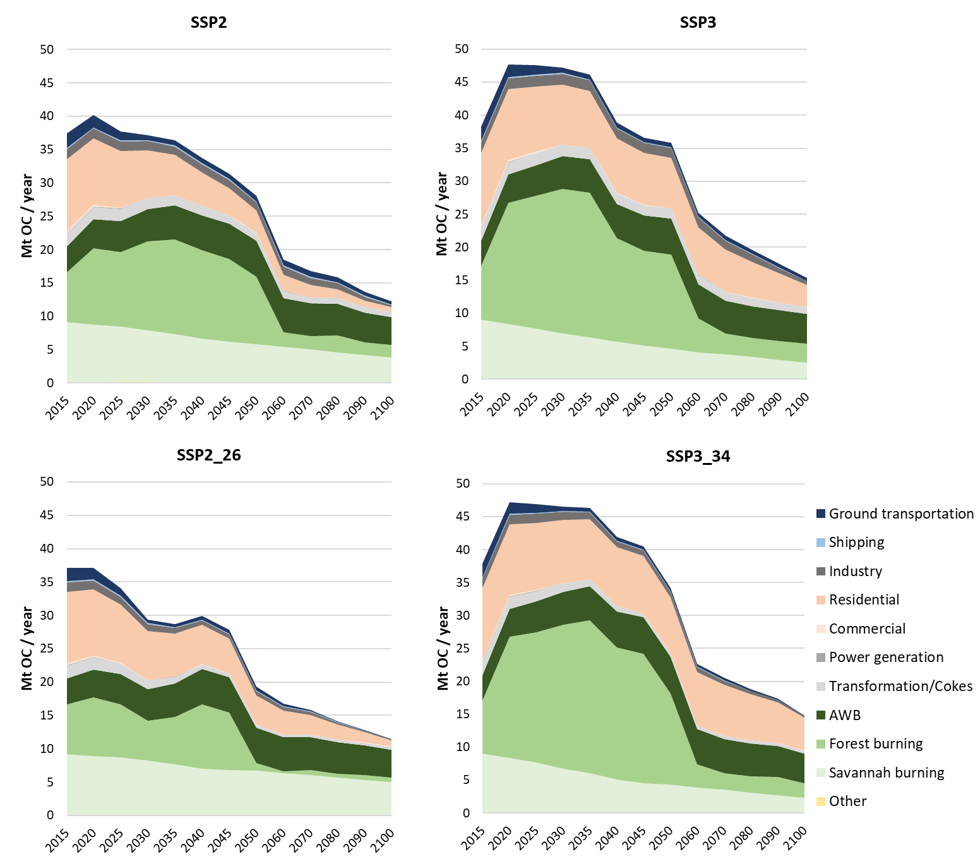

Figure S4.2: Global sectoral OC emissions and avoided emissions in 2030 and 2100. Avoided emissions are the differences with the baseline scenarios (SSP2, SSP3) and are presented as negative values.
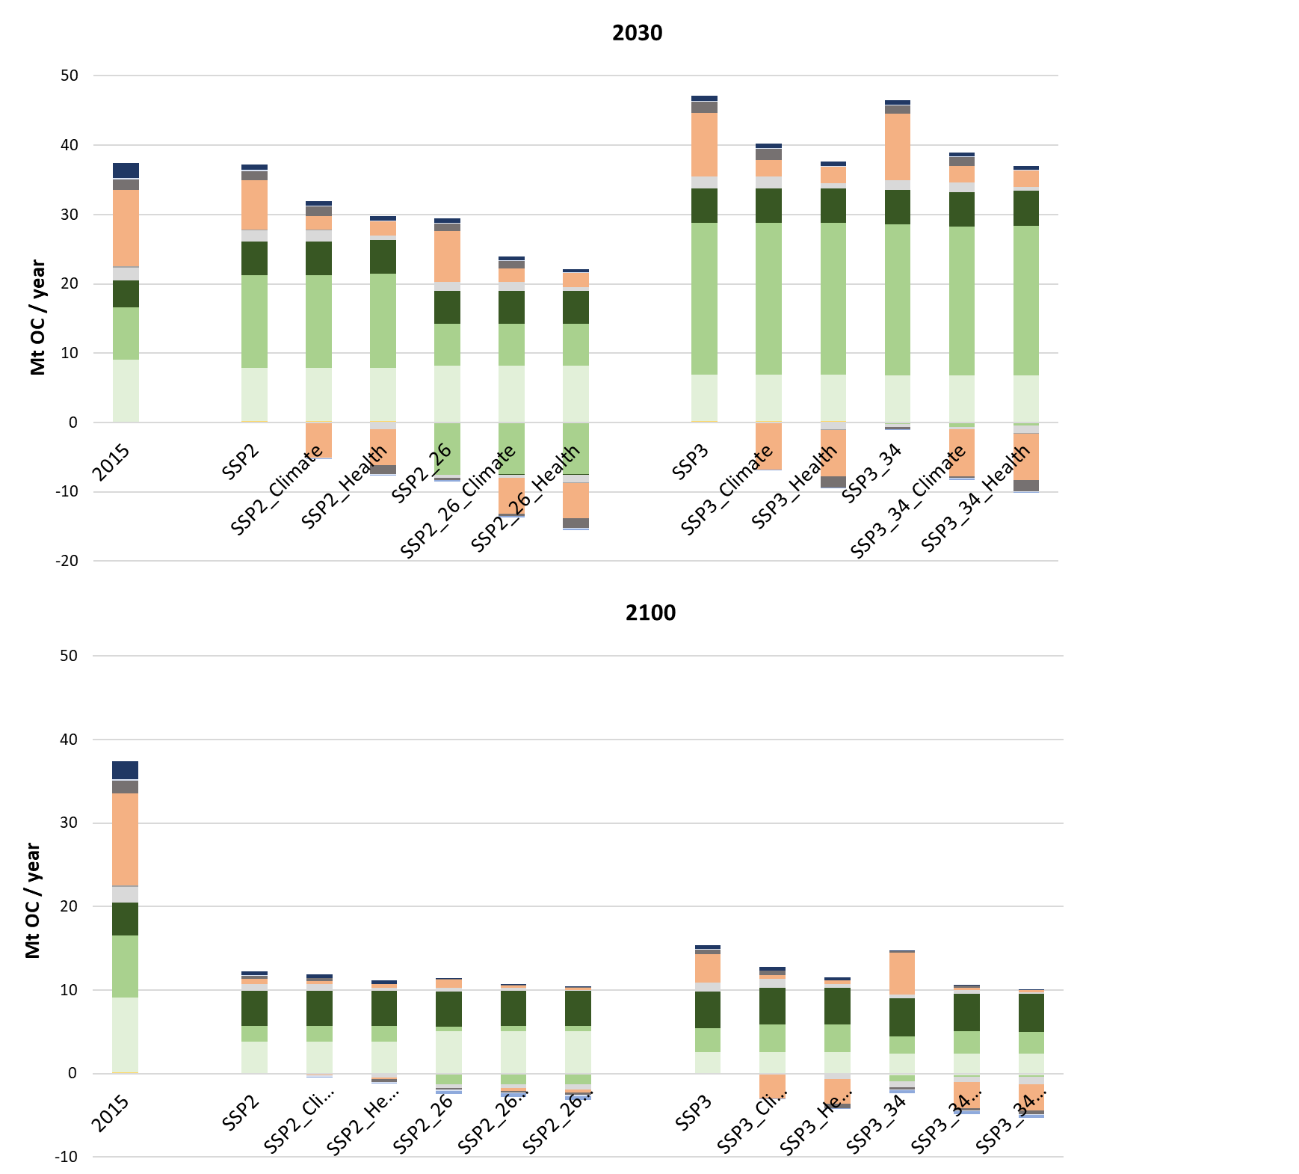
Figure S4.3: Global sectoral SO₂ emissions in the four SSP reference scenarios (excluding additional ambitious BC / pollutant mitigation).

Figure S4.4: Global sectoral SO₂ emissions and avoided emissions in 2030 and 2100. Avoided emissions are the differences with the baseline scenarios (SSP2, SSP3) and are presented as negative values.

Figure S4.5: Global sectoral NO₂ emissions in the four SSP reference scenarios (excluding additional ambitious BC / pollutant mitigation).

Figure S4.6: Global sectoral NO₂ emissions and avoided emissions in 2030 and 2100. Avoided emissions are the differences with the baseline scenarios (SSP2, SSP3) and are presented as negative values.
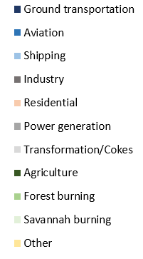

S5. Policy costs

Note: Table S5.1 shows the cumulative discounted totals for the 2015-2030 and 2015-2100 periods. Table S5.2 shows the costs in 2030 and 2100.

Table S5.1: Cumulative global air quality and climate policy costs by scenario. Costs represent cumulative discounted totals in the 2015-2030 and 2015-2100 periods (with a 5% discount factor). Air quality policy costs represent air pollutant control via all BC measures and includes the co-mitigation of OC, SO₂ and NOx. Air pollution policy cost is the cost of pollution abatement measures only (i.e. not costs/benefits due to air pollution reduction or any indirect economic costs/benefits). Reduction of forest and savannah burning are included in climate policy costs, since CO₂ mitigation and ecosystem protection are considered the main mitigation drivers. The last column represents the total policy costs are share of global GDP. See table S5.2 for the yearly cost estimates in 2030 and 2100.
Scenario | Policy costs
 | (in billion $ (2015)/year)
 | Air quality policy costs |  |  |  |  |  | Climate policy costs | Total policy costs | Policy costs as share of global GDP (%)
 | Industry | Residential  /commercial | Transport | Power generation | Trans-formation | Total air quality | Total Climate | Total
2015 - 2030
SSP2 | 269 | 297 | 2368 | 876 | 15 | 3825 | 0 | 3825 | 0.3%
SSP2_Climate | 269 | 905 | 2457 | 876 | 15 | 4522 | 0 | 4522 | 0.3%
SSP2_Health | 770 | 905 | 2457 | 1584 | 30 | 5746 | 0 | 5746 | 0.4%
SSP2_26 | 240 | 281 | 2208 | 752 | 15 | 3497 | 6292 | 9789 | 0.7%
SSP2_26_Climate | 241 | 856 | 2296 | 757 | 15 | 4165 | 5483 | 9648 | 0.7%
SSP2_26_Health | 688 | 855 | 2291 | 1359 | 30 | 5224 | 6073 | 11297 | 0.8%
SSP3 | 276 | 313 | 2378 | 882 | 15 | 3864 | 0 | 3864 | 0.3%
SSP3_Climate | 276 | 955 | 2468 | 882 | 15 | 4596 | 0 | 4596 | 0.3%
SSP3_Health | 789 | 955 | 2468 | 1595 | 30 | 5837 | 0 | 5837 | 0.4%
SSP3_34 | 248 | 298 | 2247 | 764 | 15 | 3571 | 3598 | 7169 | 0.5%
SSP3_34_Climate | 253 | 916 | 2358 | 779 | 15 | 4320 | 2409 | 6729 | 0.5%
SSP3_34_Health | 724 | 916 | 2360 | 1409 | 30 | 5439 | 2566 | 8005 | 0.6%
2015 - 2100
SSP2 | 567 | 620 | 4817 | 1590 | 27 | 7622 | 0 | 7622 | 0.2%
SSP2_Climate | 567 | 1877 | 5024 | 1591 | 27 | 9086 | 0 | 9086 | 0.2%
SSP2_Health | 1699 | 1877 | 5024 | 2962 | 56 | 11618 | 0 | 11618 | 0.2%
SSP2_26 | 473 | 561 | 4117 | 1119 | 27 | 6296 | 39576 | 45872 | 1.0%
SSP2_26_Climate | 473 | 1678 | 4315 | 1129 | 27 | 7623 | 37000 | 44623 | 0.9%
SSP2_26_Health | 1409 | 1677 | 4290 | 2062 | 56 | 9495 | 38987 | 48481 | 1.0%
SSP3 | 587 | 689 | 4773 | 1617 | 27 | 7693 | 0 | 7693 | 0.2%
SSP3_Climate | 587 | 2037 | 4977 | 1620 | 27 | 9248 | 0 | 9248 | 0.2%
SSP3_Health | 1758 | 2037 | 4977 | 3017 | 56 | 11845 | 0 | 11845 | 0.3%
SSP3_34 | 492 | 616 | 4271 | 1169 | 27 | 6575 | 26162 | 32738 | 0.8%
SSP3_34_Climate | 505 | 1836 | 4538 | 1207 | 27 | 8113 | 20326 | 28439 | 0.7%
SSP3_34_Health | 1509 | 1833 | 4529 | 2234 | 56 | 10161 | 23271 | 33432 | 0.8%

Table S5.2: Global air quality and climate policy costs by scenario in 2030 and 2100. Air quality policy costs represent air pollutant control via all BC measures and includes the co-mitigation of OC, SO₂ and NOx. Air pollution policy cost is the cost of pollution abatement measures only (i.e. not costs/benefits due to air pollution reduction or any indirect economic costs/benefits). Reduction of forest and savannah burning are included in climate policy costs, since CO₂ mitigation and ecosystem protection are considered the main mitigation drivers. The last column represents the total policy costs are share of global GDP.
Scenario | Policy costs
 | (in billion $ (2015)/year)
 | Air quality policy costs |  |  |  |  |  | Climate policy costs | Total policy costs | Policy costs as share of global GDP (%)
 | Industry | Residential  /commercial | Transport | Power generation | Trans-formation | Total air quality | Total Climate | Total
2030
SSP2 | 32 | 35 | 582 | 76 | 1 | 726 | 0 | 726 | 0.4%
SSP2_Climate | 32 | 111 | 582 | 140 | 1 | 867 | 0 | 867 | 0.5%
SSP2_Health | 100 | 111 | 613 | 140 | 3 | 967 | 0 | 967 | 0.6%
SSP2_26 | 26 | 32 | 497 | 50 | 1 | 606 | 3118 | 3725 | 2.1%
SSP2_26_Climate | 26 | 100 | 500 | 93 | 1 | 721 | 2563 | 3284 | 1.9%
SSP2_26_Health | 82 | 100 | 524 | 92 | 3 | 800 | 3140 | 3940 | 2.2%
SSP3 | 34 | 39 | 588 | 77 | 1 | 739 | 0 | 739 | 0.4%
SSP3_Climate | 34 | 124 | 588 | 142 | 1 | 888 | 0 | 888 | 0.5%
SSP3_Health | 104 | 124 | 619 | 142 | 3 | 992 | 0 | 992 | 0.6%
SSP3_34 | 28 | 35 | 518 | 52 | 1 | 634 | 1449 | 2083 | 1.3%
SSP3_34_Climate | 29 | 114 | 531 | 102 | 1 | 778 | 913 | 1691 | 1.0%
SSP3_34_Health | 90 | 114 | 561 | 102 | 3 | 870 | 1073 | 1944 | 1.2%
2100
SSP2 | 26 | 33 | 861 | 82 | 1 | 1004 | 0 | 1004 | 0.2%
SSP2_Climate | 26 | 92 | 861 | 152 | 1 | 1132 | 0 | 1132 | 0.2%
SSP2_Health | 95 | 90 | 708 | 155 | 3 | 1051 | 0 | 1051 | 0.2%
SSP2_26 | 18 | 26 | 520 | 12 | 1 | 577 | 9119 | 9696 | 1.5%
SSP2_26_Climate | 18 | 62 | 532 | 23 | 1 | 636 | 9122 | 9758 | 1.5%
SSP2_26_Health | 55 | 62 | 547 | 22 | 3 | 689 | 9119 | 9808 | 1.5%
SSP3 | 28 | 43 | 778 | 87 | 1 | 938 | 0 | 938 | 0.3%
SSP3_Climate | 28 | 103 | 777 | 162 | 1 | 1071 | 0 | 1071 | 0.3%
SSP3_Health | 86 | 103 | 818 | 162 | 3 | 1172 | 0 | 1172 | 0.3%
SSP3_34 | 18 | 30 | 586 | 22 | 1 | 657 | 8677 | 9334 | 2.8%
SSP3_34_Climate | 19 | 62 | 603 | 41 | 1 | 726 | 6693 | 7419 | 2.2%
SSP3_34_Health | 57 | 60 | 619 | 41 | 3 | 780 | 8444 | 9224 | 2.7%

S6. Uncertainty analysis climate parameters

This section provides an uncertainty analysis of the climate focused BC measures in SSP2 and SSP3 to determine the GMT reduction under different climate assumptions. In a Monte Carlo analysis, SSP2, SSP3, SSP2_Climate and SSP3_Climate have been run with a probabilistic version of MAGICC6 (Meinshausen et al., 2011) with 171 cases per scenario that represent alternate configurations of 82 climate model parameters (climate sensitivity, ocean heat diffusion rate and radiative forcing strength of aerosol and GHG species) resulting in a range of possible GMT changes. Figure S6.1 (for the SSP2 scenarios) and Figure S6.2 (for the SSP3 scenarios) show that, although the uncertainty in GMT change is very large (with a range in 2030 that is larger than 0.3 ºC for all scenarios), the range in GMT difference (i.e. uncertainty in the effect of climate focused BC measures) is much smaller. In the SSP2 case, this amounts to -0.009 ºC to -0.014 ºC in 2030. In SSP3, this is projected to be -0.013 ºC to -0.022 ºC in 2030 (and leading to a maximum difference in 2060 (not shown): -0.021 ºC to -0.038 ºC). The GMT estimates as projected with the default version of MAGICC6 used in this study fit well within these ranges. This suggest that, despite uncertainties, there is likely a small temperature-reducing potential from the climate-focused BC measures here. Furthermore, the projected GMT reducing effect from BC measures is likely not much larger than presented in this study.

Figure S6.1: Result probabilistic MAGICC6 runs for the SSP2 and SSP2_Climate scenarios. Upper panel: GMT change range (line represents median scenario). Lower panel: range in GMT difference between the two scenarios (line represents difference in median case).
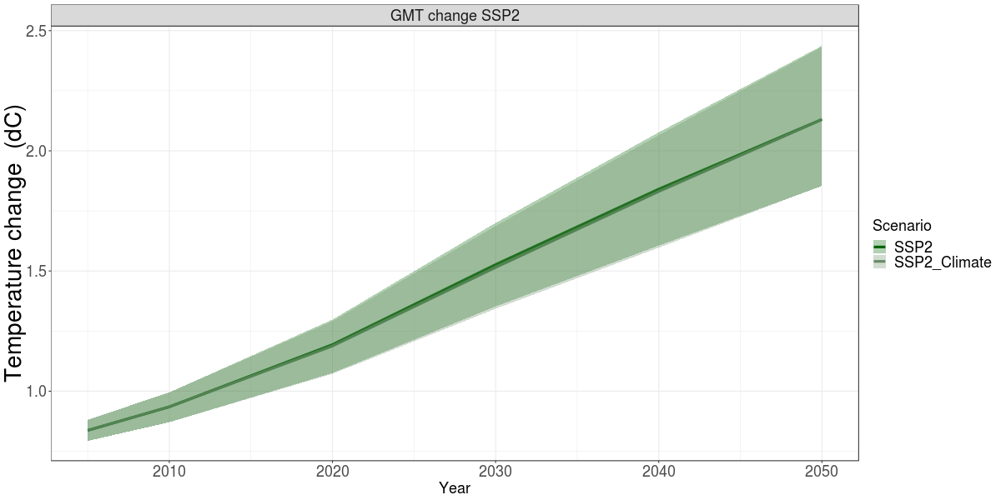
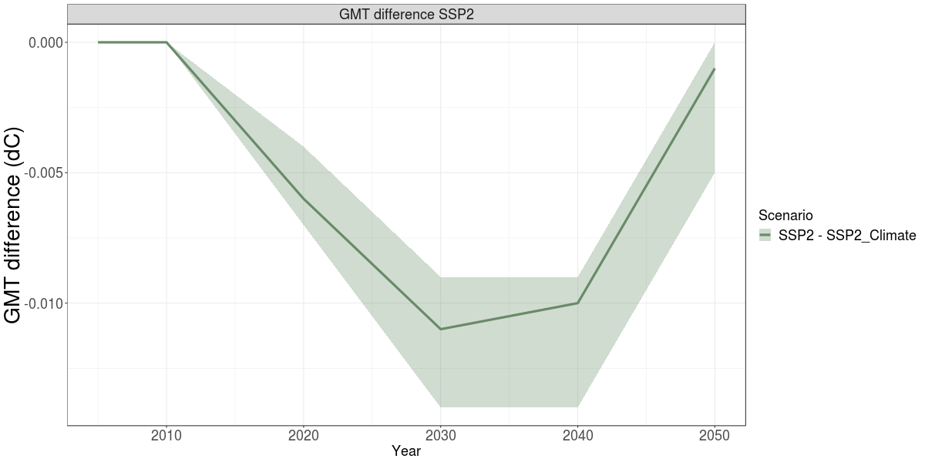

Figure S6.2: Result probabilistic MAGICC6 runs for the SSP3 and SSP3_Climate scenarios. Upper panel: GMT change range (line represents median scenario). Lower panel: range in GMT difference between the two scenarios (line represents difference in median case).
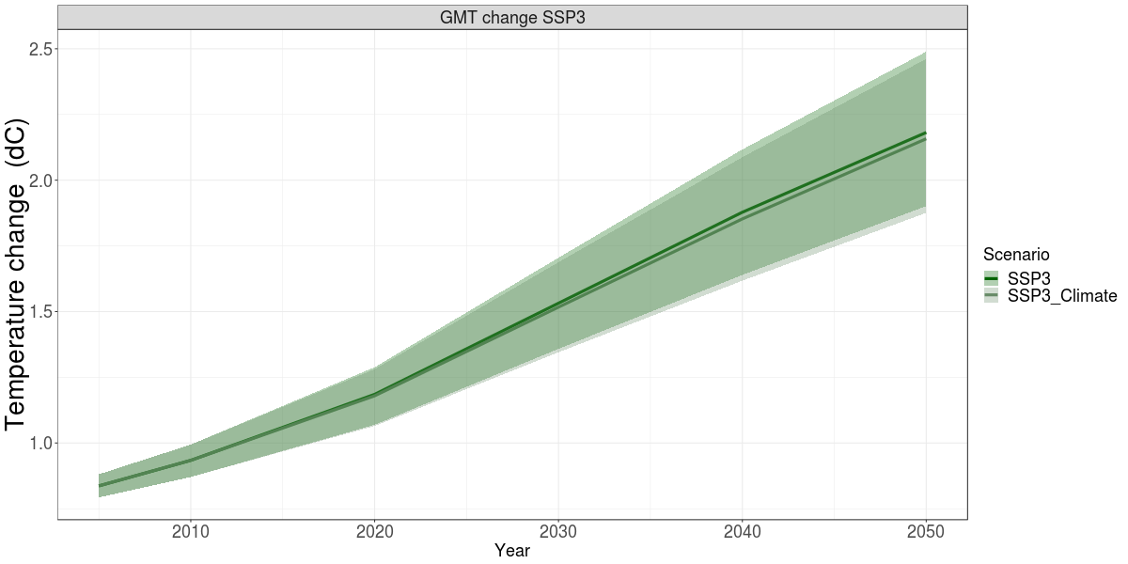
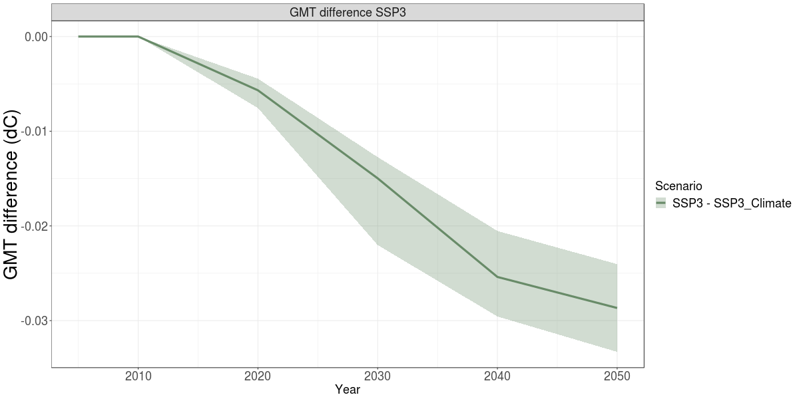

S7. Literature co-benefits climate and air pollution policy

Table S7.1 Literature overview co-benefits between climate and air quality. The studies depicted here have been selected based on the following requirements: they are peer-reviewed journal papers, analyze global synergies and/or trade-offs between climate and air pollution policy and offer quantitative results (CC = climate change, AQ = air quality)
 | Description | Primary policy goal | Benefits | Climate effects by forcer: | Air quality / health effects by pollutant: | Cost metrics | Health metrics | Type of scenarios | Models | Description
Anenberg et al., 2012 | Analysis of health co-benefits resulting from methane and black carbon mitigation | CC&AQ | AQ (health) | Climate effects not analyzed (stringent BC and CH4 measures) | PM2.5, trop03 | None | Premature deaths | Baseline, stringent measures scenario | Other studies/GAINS (emission pathways), GISS-PUCCINI/ECHAM-HAMMOZ (pollutant concentrations), own study (health) | doi:10.1289/ehp.1104301
Bertram et al., 2018 | Analysis of synergies between multiple SDG policy goals in a 1.5dC scenario. | CC | AQ (emissions) | Combined effect of all forcers | SO2 (from energy supply) | None | Air pollutant emissions | Baseline, 2dC, 1.5dC, for different combinations of climate policies | REMIND-MAGPIE (emission pathways), | doi:10.1088/1748-9326/aac3ec
Bollen et al., 2009 | Cost-benefit analysis of air quality and climate policy | CC&AQ | AQ (health), CC (avoided damages) | CO2 (PM10 for AQ) | Combined effect of all pollutants | Costs and benefits CC&AQ | Premature deaths and VSL | Baseline, >3dC climate targets, AQ only, AQ+Climate | MERGE (emission pathways, Health) | doi:10.1016/j.reseneeco.2009.03.001
Braspenning Radu et al., 2016 | Analysis of synergies between climate policy and air pollution policy | CC&AQ | AQ (emissions) | Combined effect of all forcers | SO2, NOx, BC, OC, VOC, CO | None | Air pollutant emissions | Baseline, 2dC, combined with different levels of air pollution policy ambitions | IMAGE / GAINS (emission pathways) | doi:10.1016/j.atmosenv.2016.05.021
Chuwah et al, 2013 | Analysis alternative pollution control assumptions in the RCP scenarios | CC&AQ | CC&AQ | Combined effect of all forcers | CH4, CO, NOx, VOC, SO2, BC, tropO3 | None | Air pollutant emissions and concentrations | RCP2.6 and RCP6.0 combined with high and low pollution control assumptions | IMAGE (emission pathways), TM5 (atmospheric chemistry and climate) | doi:10.1016/j.atmosenv.2013.07.008
Harmsen et al. 2019 | Assessment of climate change mitigation potential of short-lived forcers, addtional to the NDCs | CC&AQ | CC (GMT) | CH4, BC/OC SO2, Trop O3, HFCs | n.a. | n.a. | n.a. | Baseline, NDC, 2dC, either with or without additional SLCF mitigation | Multiple IAMs (emission pathways), MAGICC (climate) | doi:10.1007/s10584-019-02436-3)
Kitous et al., 2017 | Analysis of climate policy air quality co-benefits | CC | AQ (health & agricultural production) | Combined effect of all forcers | SO2, NOx, PM2.5, VOC, CO, NH3 | Climate policy cost, Air quality benefits | Premature deaths and VSL | Baseline, NDC, 2dC, combined with different levels of air pollution policy ambitions | POLES (emission pathways), MAGICC (climate), FASST / GEM-E3 (health, agriculture) | doi:10.2760/474356
Markandya et al., 2018 | Comparison of climate policy costs with AQ related health co-benefits | CC | AQ (health) | Combined effect of all forcers | Combined effect of all pollutants | Climate policy cost, Air quality health benefits | Premature deaths and VSL | Baseline, NDC, 2dC, 1.5dC | GCAM (emission pathways), MAGICC (climate), FASST (health) | doi:10.1016/S2542-5196(18)30029-9
McCollum et al., 2013 | Analysis of synergies between climate policy, energy security and air pollution control | CC | AQ | Combined effect of all forcers | Combined effect of all pollutants | Climate policy cost, pollution control policy costs | Air pollutant emissions | Several hundreds, representing different combinations of climate, air pollution and energy security policy ambition. | MESSAGE/GAINS (emission pathways), TM5 followed by applying WHO CRA method (health) | doi:10.1007/s10584-013-0710-y
Nemet et al., 2010 | Meta-analysis of earlier co-benefit studies. | CC | AQ (health), CC (avoided damages) | Combined effect of all forcers | Combined effect of all pollutants | Benefits AQ&CC | (Avoided) costs | n.a. | The meta-analysis includes several reduced-complexity IAMs for cost-benefit analysis | doi:10.1088/1748-9326/5/1/014007
Rafaj et al., 2018 | Analysis of synergies between air quality and the SDG goals | CC&AQ | AQ (health) | Combined effect of all forcers | SO2, NOx, PM2.5, NH3 | Climate policy cost, pollution control policy costs | Premature deaths | Baseline, stringent pollutant control, strong SDG scenario | GAINS, own study (emission pathways), own study (health) | doi:10.1016/j.gloenvcha.2018.08.008
Rao et al. 2016 | Analysis of co-benefits between climate policy and air pollution policy | CC&AQ | AQ (health) | Combined effect of all forcers | SO2, NOx, BC, OC, VOC, CO, NH3 | None | Air pollutant concentrations | Baseline, 2dC, combined with different levels of air pollution policy | Multiple IAMs (emission pathways), MAGICC (climate), FASST (health) | doi:10.1088/1748-9326/11/12/124013
Rao et al., 2017 | Analysis of air pollution pathways in the SSPs (limited co-benefit analysis) | CC&AQ | AQ (emissions) | Combined effect of all forcers | SO2, NOx, BC, OC, VOC, CO, NH3 | None | Air pollutant emissions | Baseline, 2dC, 3dC, combined with different levels of air pollution policy ambitions and socio-economic conditions | Multiple IAMs (emission pathways), MAGICC (climate) | doi:10.1016/j.gloenvcha.2016.05.012
Reis et al., 2018 | Analysis of all 5 SSPs (with different climate targets) and the heath benefits using FASST. Health benefits expressed in different indicators. | CC | AQ | Combined effect of all forcers | Combined effect of all pollutants | None | Multiple metrics | Baseline, 1.5-3dC, under different socio-economic assumptions | Multiple IAMs (emission pathways), MAGICC (climate), FASST (health) | doi:10.3390/su10103645
Rogelj et al., 2014 | Analysis of indirect non-CO2 reduction resulting from CO2 mitigation. | CC&AQ | CC (GMT) | CO2, CH4, BC, HFC, SO2 | n.a | None | n.a. | Baseline, 2dC, combined with combinations of CH4, BC, HFC and SO2 measures | AR4/5 scenario ensemble (emission pathways), MAGICC probabilistic (climate) | doi:10.1073/pnas.1415631111
Rogelj et al., 2014b | Analysis of the air pollution emission ranges in the RCP sceanarios | CC&AQ | AQ | Combined effect of all forcers | SO2, NO2, BC, OC, VOC, CO | None | Air pollutant emissions | RCP scenarios (2.6, 4.5, 8.5) | MESSAGE/GAINS (emission pathways), MAGICC (climate) | doi:10.1038/nclimate2178
Shindell et al., 2012 | Analysis of climate and health benefits of CH4 and BC mitigation | CC&AQ | AQ (health & agricultural production), CC (GMT/impacts) | CO2, CH4, BC | CH4, BC | Costs and benefits CC&AQ | Premature deaths and VSL | Baseline, baseline combined with CO2, BC and/or CH4 measures | Own study (emission pathways), ECHAM / GISS / own study (climate), own study (health) | doi:10.1126/science.1210026
Smith & Mizrahi, 2013 | Assessment of climate change mitigation potential of short-lived forcers | CC&AQ | CC (GMT) | CO2, CH4, BC, OC SO2, Trop O3, StratH2O, Other Kyoto | n.a. | n.a. | n.a. | Baseline, RCP45 | GCAM (emission pathways), MAGICC (climate) | doi:10.1073/pnas.1308470110
West et al., 2013 | Assessement of health co-benefits resulting from climate policy | CC | AQ (health) | Combined effect of all forcers | Combined effect of all pollutants | Benefits AQ | Premature deaths and VSL | Baseline, RCP45 | MOZART (global chemical transport), MAGICC (climate), own study (health) | doi:10.1038/nclimate2009

http://gains.iiasa.ac.at/gains/IAM/index.login

