How evaluation of global hydrological models can help to obtain more credible projections of river discharge under climate change
Valentina Krysanova¹, Jamal Zaherpour², Iulii Didovets¹, Simon Gosling³, Dieter Gerten¹, Naota Hanasaki⁴, Hannes Müller Schmied⁵, Yadu Pokhrel⁶, Yusuke Satoh⁷, Qiuhong Tang⁸ and Yoshihide Wada⁹
¹Potsdam Institute for Climate Impact Research, Germany
²Independent researcher
³School of Geography, University of Nottingham, United Kingdom
⁴Center for Climate Change Adaptation, National Institute for Environmental Studies, Japan
⁵Institute of Physical Geography, Goethe-University Frankfurt, Frankfurt am Main, Germany
⁵Senckenberg Leibniz Biodiversity and Climate Research Centre, (SBiK-F) Frankfurt, Frankfurt am Main, Germany
⁶Department of Civil and Environmental Engineering, Michigan State University, USA
⁷National Institute for Environmental Studies, Tsukuba, Japan
⁷International Institute for Applied Systems Analysis, Laxenburg, Austria
⁸Key Laboratory of Water Cycle and Related Land Surface Processes, Institute of Geographic Sciences and Natural Resources Research, Chinese Academy of Sciences, China
⁹International Institute for Applied Systems Analysis (IIASA), Laxenburg, Austria

Supplementary material

Section S1. Definition of metrics for the evaluation of models
NSE: Nash-Sutcliffe efficiency calculated on flows
NSE = $1-\frac{\sum_{t=1}^{N}{{\left(Q_{s,t}-Q_{o,t}\right)}^{2}}}{\sum_{t=1}^{N}{{\left(Q_{o,t}-{\overline{Q}}_{o}\right)}^{2}}}$
The Nash and Sutcliffe efficiency (NSE) is a normalized statistic that determines the relative magnitude of the residual variance compared to the measured data variance (Nash and Sutcliffe, 1970). It is usually used in hydrological modelling to assess predictive ability of models.
The NSE can range from −∞ to 1. An efficiency of NSE = 1 corresponds to a perfect match of modeled discharge to the measured data. If NSE = 0, this indicates that the model simulations are as accurate as the mean of the observed data, whereas the negative NSE values indicate that the observed mean is a better predictor than the model. Generally, the closer the NSE is to 1, the more accurate the model predictions are.
Nash JE, Sutcliffe JV (1970) River flow forecasting through conceptual models part I -a discussion of principles.J Hydrol 10:282–290
PBIAS: percent bias in overall flows
PBIAS = $\frac{\sum_{t=1}^{N}{(Q_{s,t-}Q_{o,t})}}{\sum_{t=1}^{N}{Q_{o,t}}}*100$
Percent bias (PBIAS) measures the average tendency of the simulated values to be larger or smaller than the observed ones. The optimal value of PBIAS is 0.0, with low-magnitude values (e.g. between -10% and 10%) indicating accurate model simulation. Positive values indicate overestimation bias, whereas negative values indicate model underestimation bias.
Moriasi DN, Arnold JG, Van Liew MW, Bingner RL, Harmel RD, Veith TL (2007) Model evaluation guidelinesfor systematic quantification of accuracy in watershed simulations. T Asabe 50:885–900
Δσ: percent bias in standard deviation
Δσ = $\frac{σ_{s}{-σ}_{o}}{σ_{o}}*100$
The amplitude of the observed and modeled mean annual cycle are compared using the relative difference in standard deviation, in percent.
Gudmundsson L, Wagener T, Tallaksen LM, Engeland K (2012) Evaluation of nine large-scale hydrological models with respect to the seasonal runoff climatology in Europe. Water Resour Res 48

Section S2. Spatial analysis
To enable spatial analysis, AIs were averaged over eight hydrobelts for all gHMs, and also specifically for every model. The results are shown in Table S4 below.
All models together, as well as MATSIRO, PCR-GLOBWB and WaterGAP2 perform better in northern subtropical (NST) and equatorial (EQT) zones than in other hydrobelts. Also LPJmL and DBH show their best performance in NST. The H08 model differs from others in this respect with its best performance in the southern dry hydrobelt (SDR).
The northern dry (NDR) and southern dry (SDR) show the lowest performance when all models are considered, and also for the most of individual models. However, WaterGAP2 is performing weaker in the boreal (BOR) and southern mid-latitude (SML) zones than in others, though its performance there is still better than that of other models. However, these findings cannot be generalized, because some hydrobelts include only 3-4 catchments.

Table S1. The 57 GRDC selected catchments; catchments are ordered based on their hydrobelt north to south and within hydrobelts based on GRDC code smallest to largest (BOR = boreal, NML = northern mid-latitude, NDR = northern dry, NST = northern subtropical, EQT = equatorial, SML = southern, mid-latitude, SDR = southern dry and SST = southern subtropical)
No | GRDC  Code | River | Gauging  Station | Related  Hydrobelt | Catchment and GRDC station specifications
 |  |  |  |  | Area (km²) | Longitude | Latitude | Data length (yr) and range
1 | 2903430 | LENA | STOLB | BOR | 2460000 | 126.8 | 72.37 | 32 (71-02)
2 | 2906900 | AMUR | KOMSOMOLSK | BOR | 1730000 | 137.12 | 50.63 | 26 (71-06)
3 | 2909150 | YENISEI | IGARKA | BOR | 2440000 | 86.5 | 67.48 | 32 (75-10)
4 | 2912600 | OB | SALEKHARD | BOR | 2949998 | 66.53 | 66.57 | 39 (71-10)
5 | 2998510 | KOLYMA | KOLYMSKAYA | BOR | 526000 | 158.72 | 68.73 | 28 (78-08)
6 | 2999910 | OLENEK | 7.5KM D/S OF RIVER PUR | BOR | 198000 | 123.22 | 72.12 | 39 (71-10)
7 | 4208150 | MACKENZIE | NORMAN WELLS | BOR | 1570000 | -126.85 | 65.28 | 30 (71-10)
8 | 4213550 | SASKATCHEWAN | THE PAS | BOR | 347000 | -101.18 | 53.83 | 40 (71-10)
9 | 4213650 | ASSINIBOINE | HEADINGLEY | BOR | 153000 | -97.4 | 49.87 | 40 (71-10)
10 | 4213680 | RED | EMERSON | BOR | 104000 | -97.22 | 49 | 40 (71-10)
11 | 4213800 | WINNIPEG | SLAVE FALLS | BOR | 126000 | -95.57 | 50.22 | 38 (71-10)
12 | 4214260 | CHURCHILL | ABOVE GRANVILLE FALLS | BOR | 228000 | -100.45 | 56.15 | 36 (71-10)
13 | 4214520 | ALBANY | NEAR HAT ISLAND | BOR | 118000 | -83.87 | 51.33 | 31 (73-10)
14 | 6970250 | NORTHERN DVINA | UST-PINEGA | BOR | 348000 | 42.17 | 64.1 | 31 (71-10)
15 | 2180800 | YELLOW | HUAYUANKOU | NML | 730036 | 113.65 | 34.92 | 40 (71-10)
16 | 4115200 | COLUMBIA | THE DALLES, OREG. | NML | 613830 | -121.17 | 45.61 | 40 (71-10)
17 | 4127800 | MISSISSIPPI | VICKSBURG, MISS. | NML | 2964252 | -90.9 | 32.32 | 37 (71-10)
18 | 4143550 | ST. LAWRENCE | CORNWALL | NML | 773892 | -74.78 | 45.01 | 40 (71-10)
19 | 4207900 | FRASER | HOPE | NML | 217000 | -121.45 | 49.38 | 40 (71-10)
20 | 6340110 | LABE | NEU-DARCHAU | NML | 131950 | 10.88 | 53.23 | 40 (71-10)
21 | 6435060 | RHINE | LOBITH | NML | 160800 | 6.11 | 51.84 | 40 (71-10)
22 | 6442600 | DANUBE | MOHACS | NML | 209064 | 18.67 | 46 | 29 (71-99)
23 | 6972430 | NEVA | NOVOSARATOVKA | NML | 281000 | 30.72 | 59.8 | 40 (71-10)
24 | 6977100 | VOLGA | VOLGOGRAD PP | NML | 1360000 | 44.72 | 48.77 | 39 (71-10)
25 | 6978250 | DON | RAZDORSKAYA | NML | 378000 | 40.67 | 47.5 | 38 (71-10)
26 | 7222222* | YANGTZE | CUNTAN | NML | 804859 | 106.6 | 29.62 | 31 (71-01)
27 | 4152450 | COLORADO | LEES FERRY, ARIZ. | NDR | 289562 | -111.58 | 36.87 | 40 (71-10)
28 | 4356100 | SANTIAGO | EL CAPOMAL | NDR | 128943 | -105.12 | 21.83 | 31 (71-03)
29 | 4358300 | PANUCO | LAS ADJUNTAS | NDR | 58115 | -98.57 | 21.98 | 30 (71-02)
30 | 1531450 | WHITE VOLTA | NAWUNI | NST | 92950 | -1.08 | 9.7 | 24 (71-07)
31 | 1834101 | NIGER | LOKOJA | NST | 2074171 | 6.77 | 7.8 | 25 (71-05)
32 | 2469260 | MEKONG | PAKSE | NST | 545000 | 105.8 | 15.12 | 23 (71-93)
33 | 4362600 | USUMACINTA | BOCA DEL CERRO | NST | 50743 | -91.5 | 17.42 | 25 (71-02)
34 | 1147010 | CONGO (ZAIRE) | KINSHASA | EQT | 3475000 | 15.3 | -4.3 | 40 (71-10)
35 | 3512400 | MARONI | LANGA TABIKI | EQT | 60930 | -54.43 | 4.98 | 25 (71-96)
36 | 3629000 | AMAZONAS | OBIDOS | EQT | 4640300 | -55.5 | -1.9 | 27 (71-97)
37 | 3629180 | RIO TAPAJOS | BARRA DO SAO MANUEL | EQT | 332163 | -58.08 | -7.32 | 26 (75-06)
38 | 3630050 | XINGU | ALTAMIRA | EQT | 446570 | -52.22 | -3.2 | 35 (71-08)
39 | 3631100 | RIO JARI | SAO FRANCISCO | EQT | 51343 | -52.55 | -0.68 | 38 (71-10)
40 | 3649900 | TOCANTINS | ITUPIRANGA | EQT | 727900 | -49.35 | -5.13 | 24 (71-10)
41 | 1196400 | LIMPOPO | OXENHAM RANCH | SST | 98160 | 27.96 | -22.95 | 30 (71-02)
42 | 3650359 | RIO ITAPECURU | CANTANHEDE | SST | 50800 | -44.38 | -3.63 | 34 (71-07)
43 | 3650481 | RIO PARNAIBA | LUZILANDIA | SST | 322823 | -42.37 | -3.45 | 26 (82-06)
44 | 3651678 | RIO GRANDE | BOQUEIRAO | SST | 65900 | -43.8 | -11.33 | 39 (71-10)
45 | 3651805 | SAO FRANCISCO | MANGA | SST | 200789 | -43.93 | -14.76 | 37 (71-08)
46 | 3652450 | JEQUITINHONHA | JACINTO | SST | 62365 | -40.3 | -16.13 | 34 (71-10)
47 | 3664160 | IGUACU | SALTO CATARATAS | SST | 67317 | -54.43 | -25.68 | 35 (71-05)
48 | 3667060 | PARAGUAI | PORTO MURTINHO | SST | 474500 | -57.89 | -21.7 | 37 (71-07)
49 | 5101200 | BURDEKIN | CLARE | SST | 129660 | 147.24 | -19.76 | 40 (71-10)
50 | 1159100 | ORANJE | VIOOLSDRIF | SDR | 850530 | 17.73 | -28.76 | 38 (71-10)
51 | 5410100 | COOPER CREEK | CALLAMURRA | SDR | 230000 | 140.87 | -27.7 | 33 (74-06)
52 | 5607100 | MURCHISON RIVER | EMU SPRINGS | SDR | 82300 | 114.54 | -27.85 | 35 (71-06)
53 | 5607200 | GASCOYNE RIVER | NUNE MILE BRIDGE | SDR | 73400 | 113.77 | -24.82 | 29 (71-00)
54 | 5607400 | ASHBURTON RIVER | NANUTARRA | SDR | 70200 | 115.49 | -22.54 | 33 (72-06)
55 | 3652890 | PARAIBA DO SUL | CAMPOS-P. M. | SML | 55083 | -41.33 | -21.75 | 37 (71-07)
56 | 5101301 | FITZROY | THE GAP | SML | 135860 | 150.1 | -23.1 | 40 (71-10)
57 | 5204250 | DARLING RIVER | LOUTH | SML | 489300 | 145.11 | -30.54 | 26 (71-07)
*not included in GRDC database, obtained from local authority
Table S2. Characteristics of hydrobelts and catchments within each hydrobelt (BOR = boreal, NML = northern mid-latitude, NDR = northern dry, NST = northern subtropical, EQT = equatorial, SML = southern mid-latitude, SDR = southern dry and SST = southern subtropical), and change in number of catchments compared to Zaherpour et al. (2018). The source of hydrobelt area and runoff is Meybeck et al. (2013)
Hydrobelt | Area of hydrobelt  (10³ km²) | Hydrobelt runoff  (mm/yr) | No. of catchments in each hydrobelt | Catchments area in each hydrobelt  (10³ km2) | Catchments area to  hydrobelt area (%)
BOR | 25995 | 223 | 14 | 13298 | 51.2
NML | 24199 | 343 | 12 | 7940 | 32.8
NDR | 30234 | 36 | 2=>3 | 477 | 1.6
NST | 10579 | 383 | 1=>4 | 2763 | 26.1
EQT | 16826 | 960 | 3=>7 | 9734 | 57.9
SST | 10599 | 233 | 4=>9 | 1472 | 13.9
SDR | 8677 | 31 | 2=>5 | 1306 | 15.1
SML | 4008 | 292 | 2 | 680 | 17.0
Sum/Ave. | 131119* | 277* | 57 | 37670 | 26.9
*Total of non-glaciated land

Table S3. GRDC and DDM30 areas and coordinates of stations for 57 catchments ordered as in Table S1
Table S4. Spatially averaged aggregated indices for hydrobelts (simple averaging over all basins in every hydrobelt) considering all models and specifically for every separate model. One or two highest average AI values per model and for all models are marked bold, and two or three lowest average AIs per model and for all models are shaded grey.

Table S5. Differences in impacts in the far future period related to reference period under RCP 6.0 in terms of deviations of monthly and annual means and spreads (as shown in Figs. 2-4) between two approaches: the weighted mean and the ensemble mean, as well as occurrence of seasonal shifts when the second approach is applied.
Basin | Differences in mean monthly | Diff. in mean annual | Seas. shifts? | Diff. in spreads
 |  |  |  | box: 25-75% | min / max
Mekong | negligible, < 1% | 0% | no | 0 | 0
Amazonas | small decrease, < 2% | small | no | -15% | -6%
 |  | -1%
Sao Francisco | small decrease (I-IV) or increase (VI-XII) | small | no | -6% | -7%
 | IX-X: 5-7% | 1%
Mississippi | small increase all mon. | small | no | -53% | -43%
 | VII-IX: 5-7% | 3%
Congo (Zaire) | small/medium increase all mon. | moderate, 5.3% | no | -82% | -79%
 | I: 6%, V-IX: 5-9%, XII: 7% | change of sign
Fitzroy | small to moderate increase 11 mon. | moderate | no | -21% | -32%
 | I-IV: 8-11%, VIII-X: 6-10%, XII: -5% | 5.5%
Mackenzie | medium/large: 5 months, both direct. | small, < 1% | yes | 0 | -1%
 | I-V: (-16%, +18%) | (compensation)
Lena | medium/large: 4 months, both direct. | small, 2.4% | yes | -31% | -19%
 | IV: 26%, VII-VIII: (-5%, -7%), XII: 7% | (compensation)
Volga | large increase: 5 mon. | moderate | no | 10% | -28%
 | I-IV: 15-40%, XII: 8% | 10%
Santiago | large increase 10 mon. | large | yes | -19% | -50%
 | I-VI: 17-91%, IX-XII: 9-13% | 30%
Oranje | large increase 11 mon. | large | yes | -28% | -82%
 | I-X: 14-95%, XII: 16% | 36%
Limpopo | large increase 11 mon., decrease 1 mon. | large | yes | -72% | -80%
 | I: 205%, II-XI: 13-79%, XII: -21% | 51%

Fig. S1 Performance of six gHMs in terms of NSE for 57 catchments. Y scale was cut by -200. Statistics for NSE: min/max, median and average values are summarized in Table below the graph. Abbreviations: mon: monthly dynamics, season - seasonal dynamics, gswp3 and wfdei: two forcings
(a)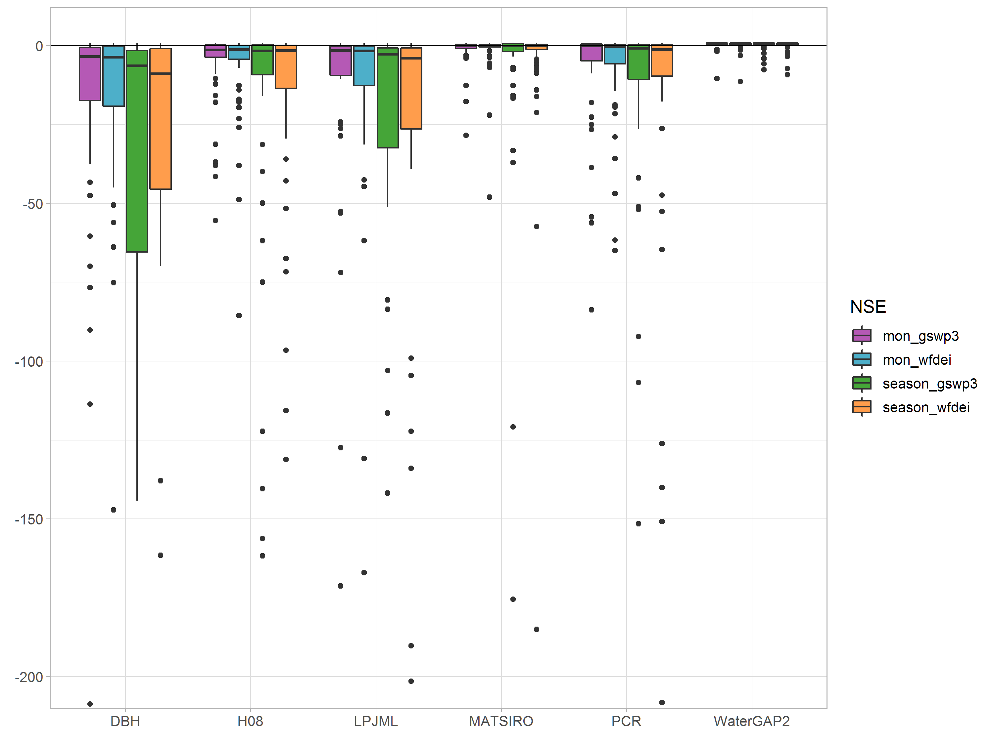Statistics for NSE

Fig. S2 Performance of six gHMs in terms of PBIAS for 57 catchments. Red dashed lines indicate -100% and +100% levels. Y scale was cut by +2000%. Statistics for PBIAS: min/max, median and average values are summarized in Table below the graph. Abbreviations: mon: monthly dynamics, gswp3 and wfdei: two forcings
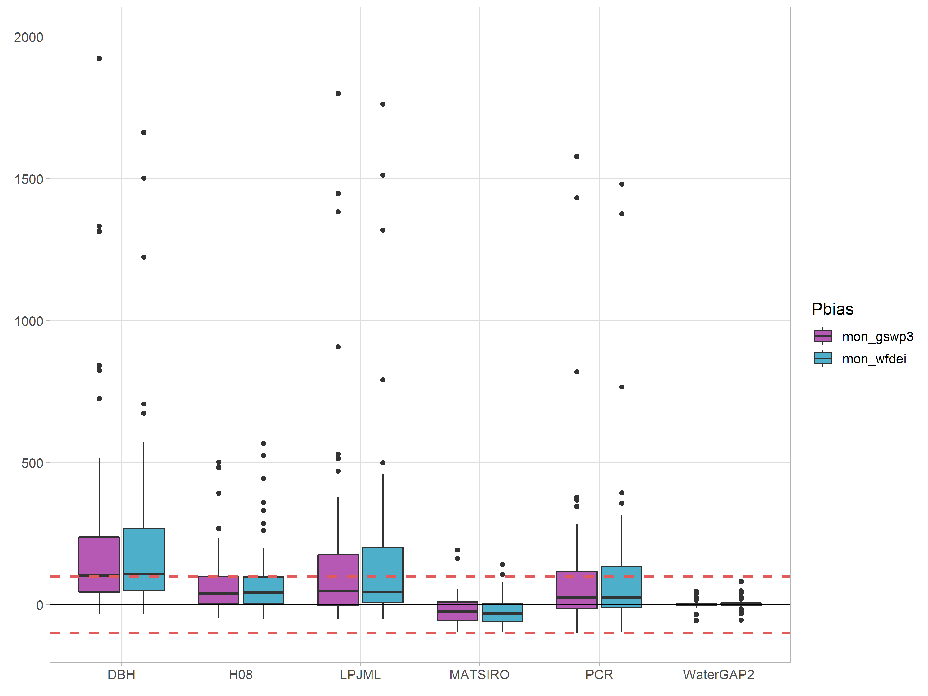
Statistics for PBIAS

Fig. S3 Performance of six gHMs in terms of bias in standard deviation for 57 catchments. Red dashed lines -100% and +100% levels. Y scale was cut by 2000%. Statistics for three criteria: min/max, medians and average values are summarized in Table below the graph. Abbreviations: season - seasonal dynamics, gswp3 and wfdei: two forcings
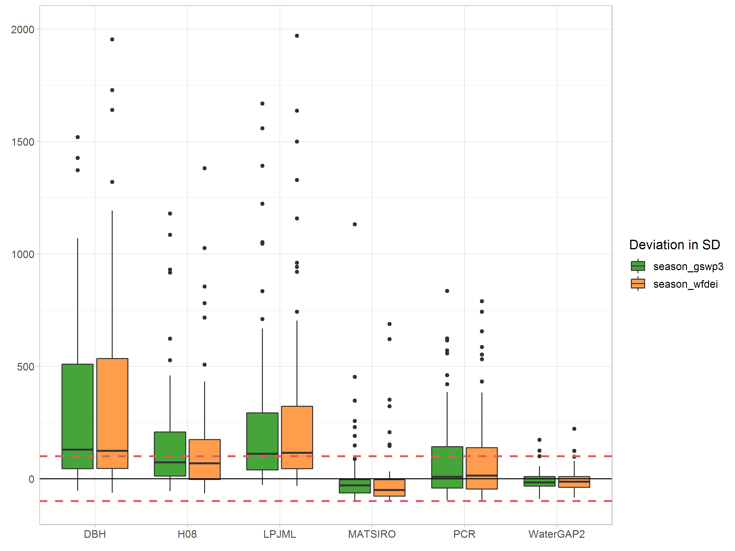
Statistics for bias in standard deviation

Fig. S4. Comparison of the projected mean monthly impacts and uncertainty ranges for four basins using the EM (left side) and WCO (right side) approaches (note different Y scales for Limpopo)
