Supplementary material
A: Errors in the WATCH forcing data relative to historical observations from 1971 to 2000. The observed data is from German weather service and Federal Office of Meteorology and Climatology MeteoSwiss for the sub-catchments of the Rhine in Germany and Switzerland, from “Daily high-resolution gridded climate data set for Europe” (www.ensembles-eu.org) for the sub-catchment of the Rhine in France, from the China Meteorological Administration (CMA) for the Yellow and from the Climate-Parameter-elevation Regressions on Independent Slopes Model (PRISM, http://www.wcc.nrcs.usda.gov/climate/prism.html) for the Mississippi. The red colour highlights the absolute bias for temperature larger than 0.5 °C and the absolute percent bias (Pbias) for precipitation larger than 10. The yellow colour highlights the r2 smaller than 0.7. The “-“ indicates that there is no observed data available for this study.
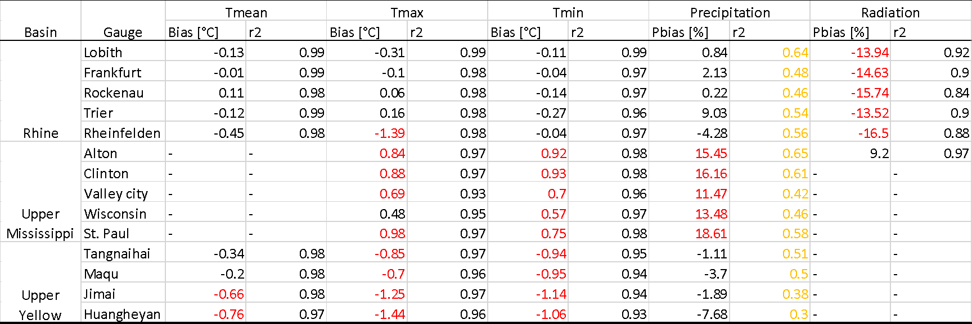

B: Comparison between the observed annual precipitation and the observed annual mean runoff in the period 1981 – 2001 for the sub-catchment Huangheyan.
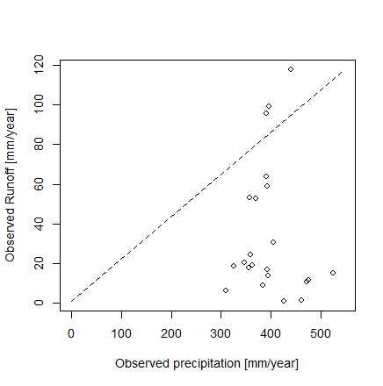

C: The 1-, 5- and 10-year moving average time series of mean temperature (upper panel) and precipitation (lower panel) of the WATCH data for the three catchments (a-c). The grey dash lines show the long-term mean temperature or precipitation.
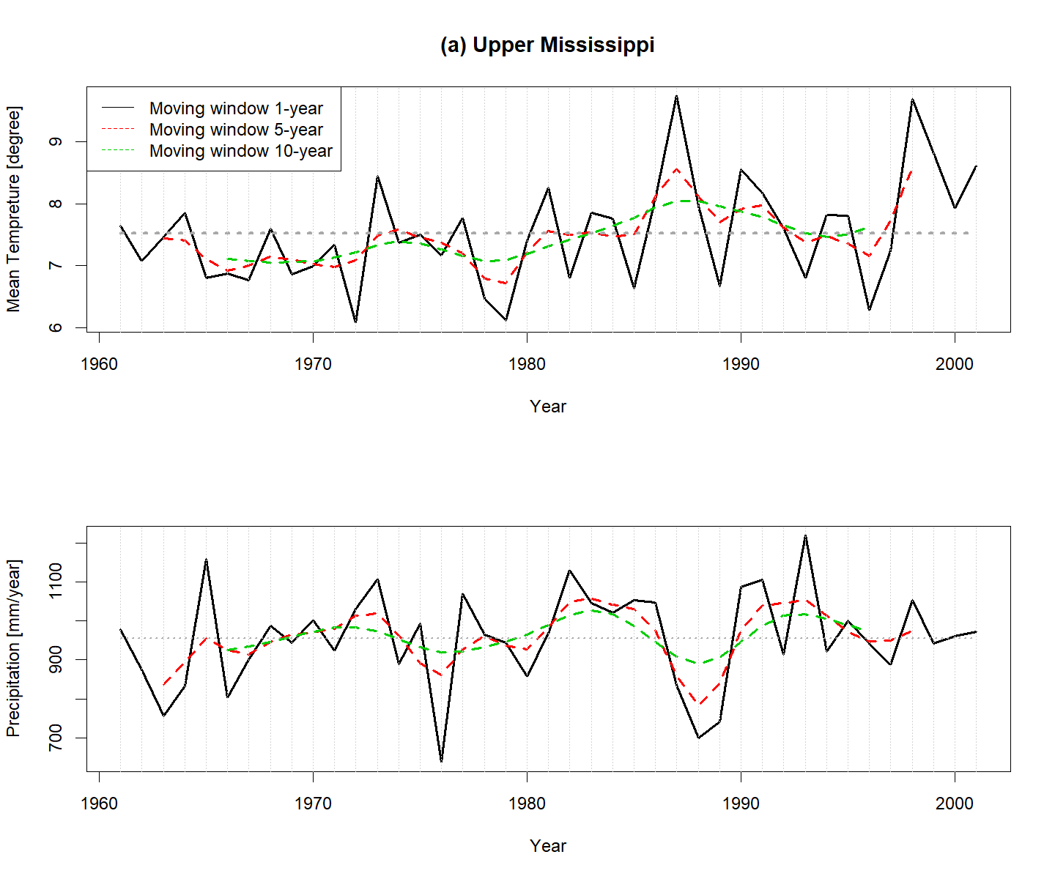
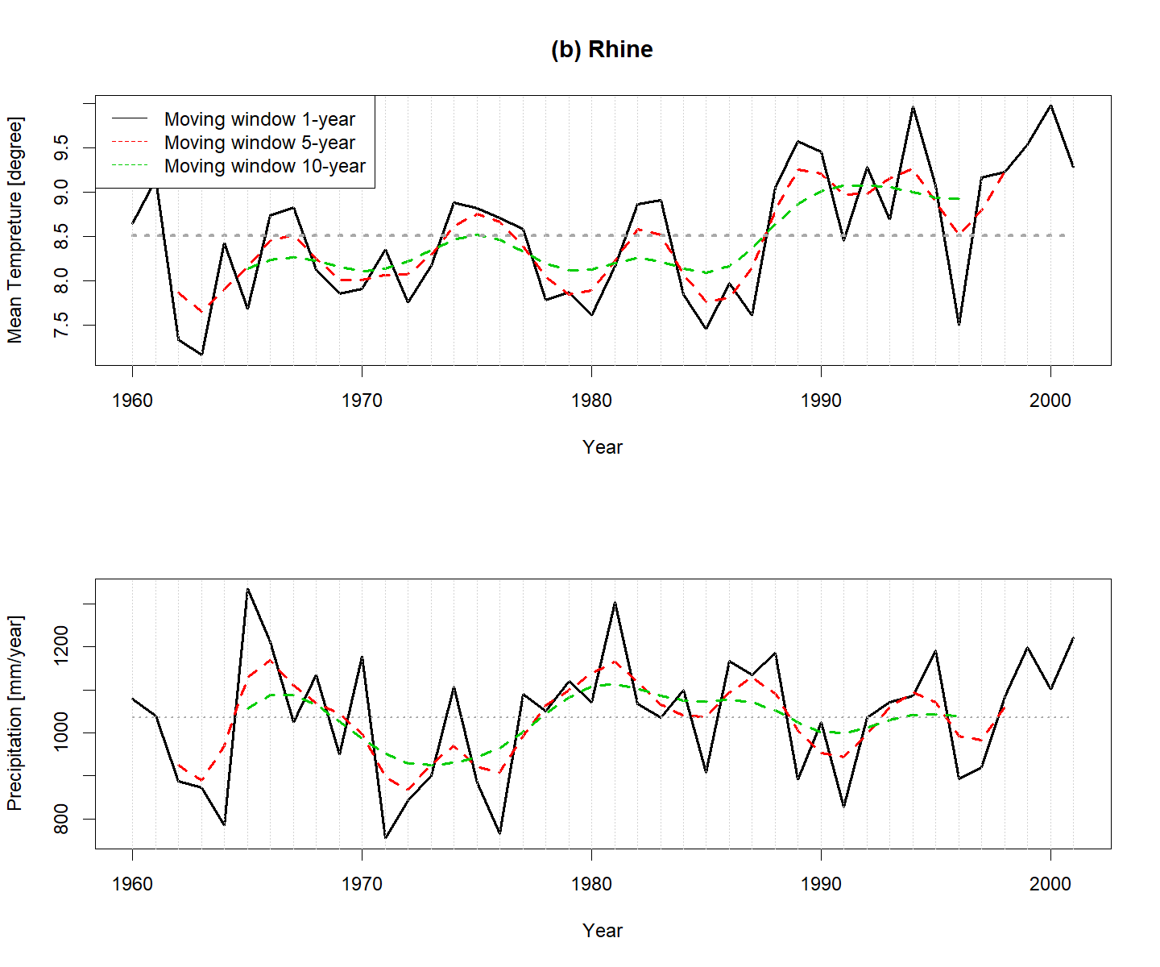
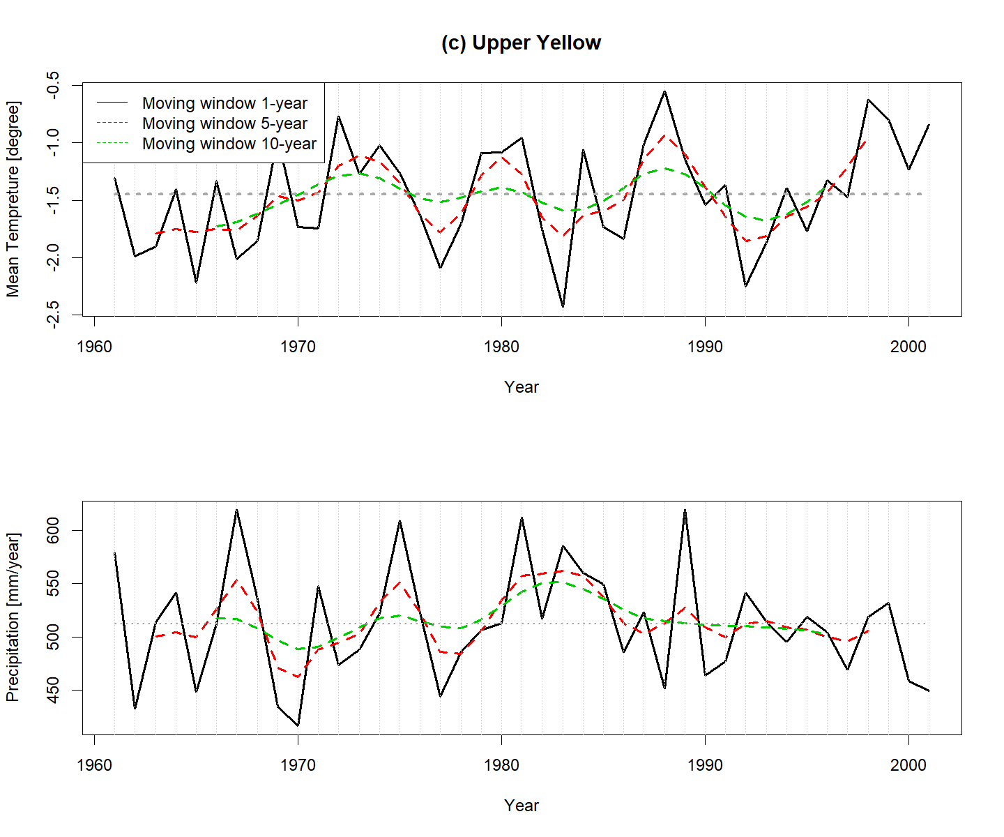

D: The comparison results between the monthly simulated and GLEAM actual evapotranspiration (AET) for 1980 – 2000 (a) and the correlation (r2) of the simulated and GLEAM monthly AET time series at the sub-basin or grid scale for all catchments and models (b).
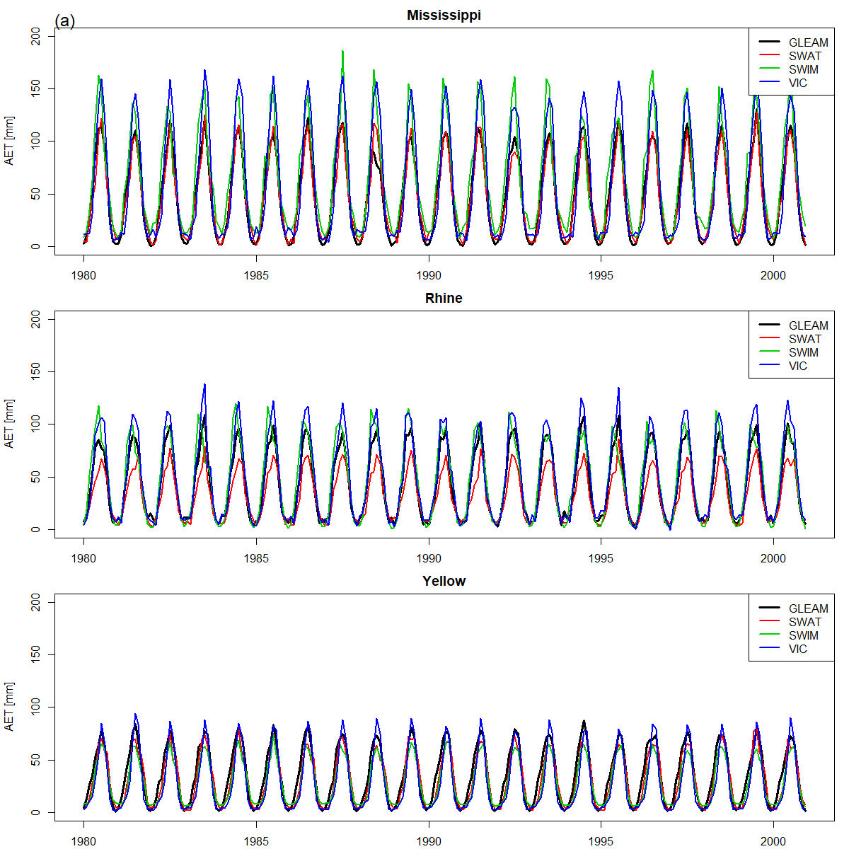
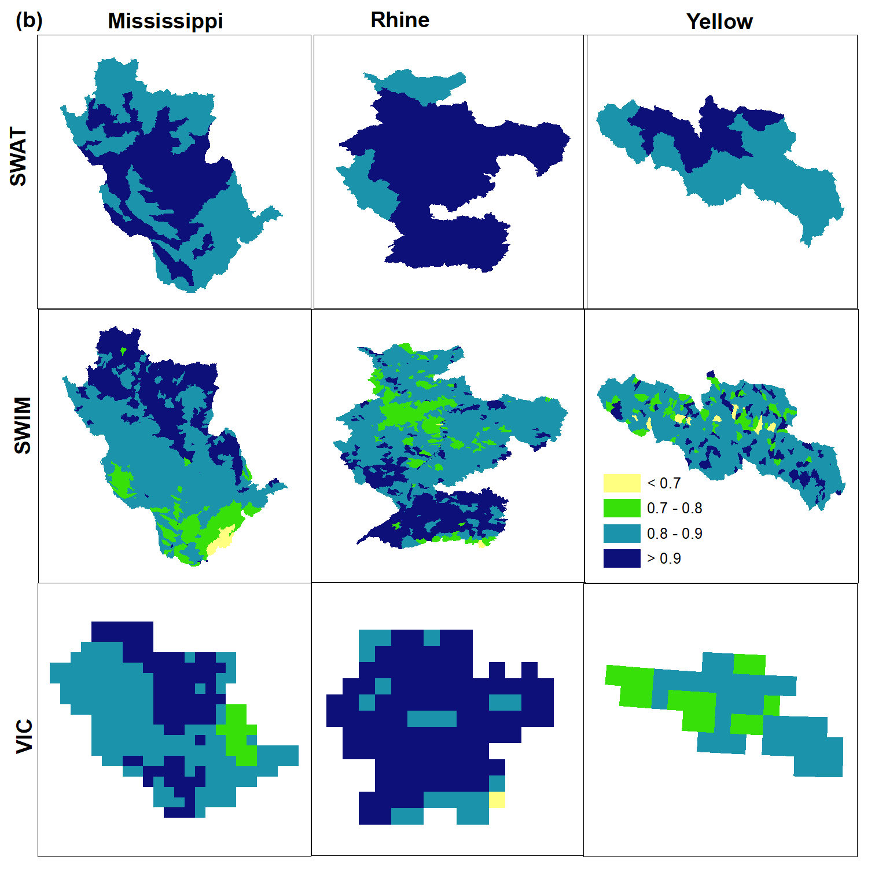

E: The statistically significant trends identified in the observed and simulated time series of hydrological indicators for the period 1971 – 2000.

F: The relative changes of high flow (HF), median flow (MF) and low flow (LF) for each combination of GCMs and HMs under RCP 2.6 (a), 4.5 (b), 6.0 (c) and 8.5 (d) scenarios using both simple (Sim.) and enhanced (Enh.) calibration methods. The red, green and blue dots indicate the results from the SWAT, SWIM and VIC models while the large and small dots show the significant and insignificant changes, respectively.
(a)
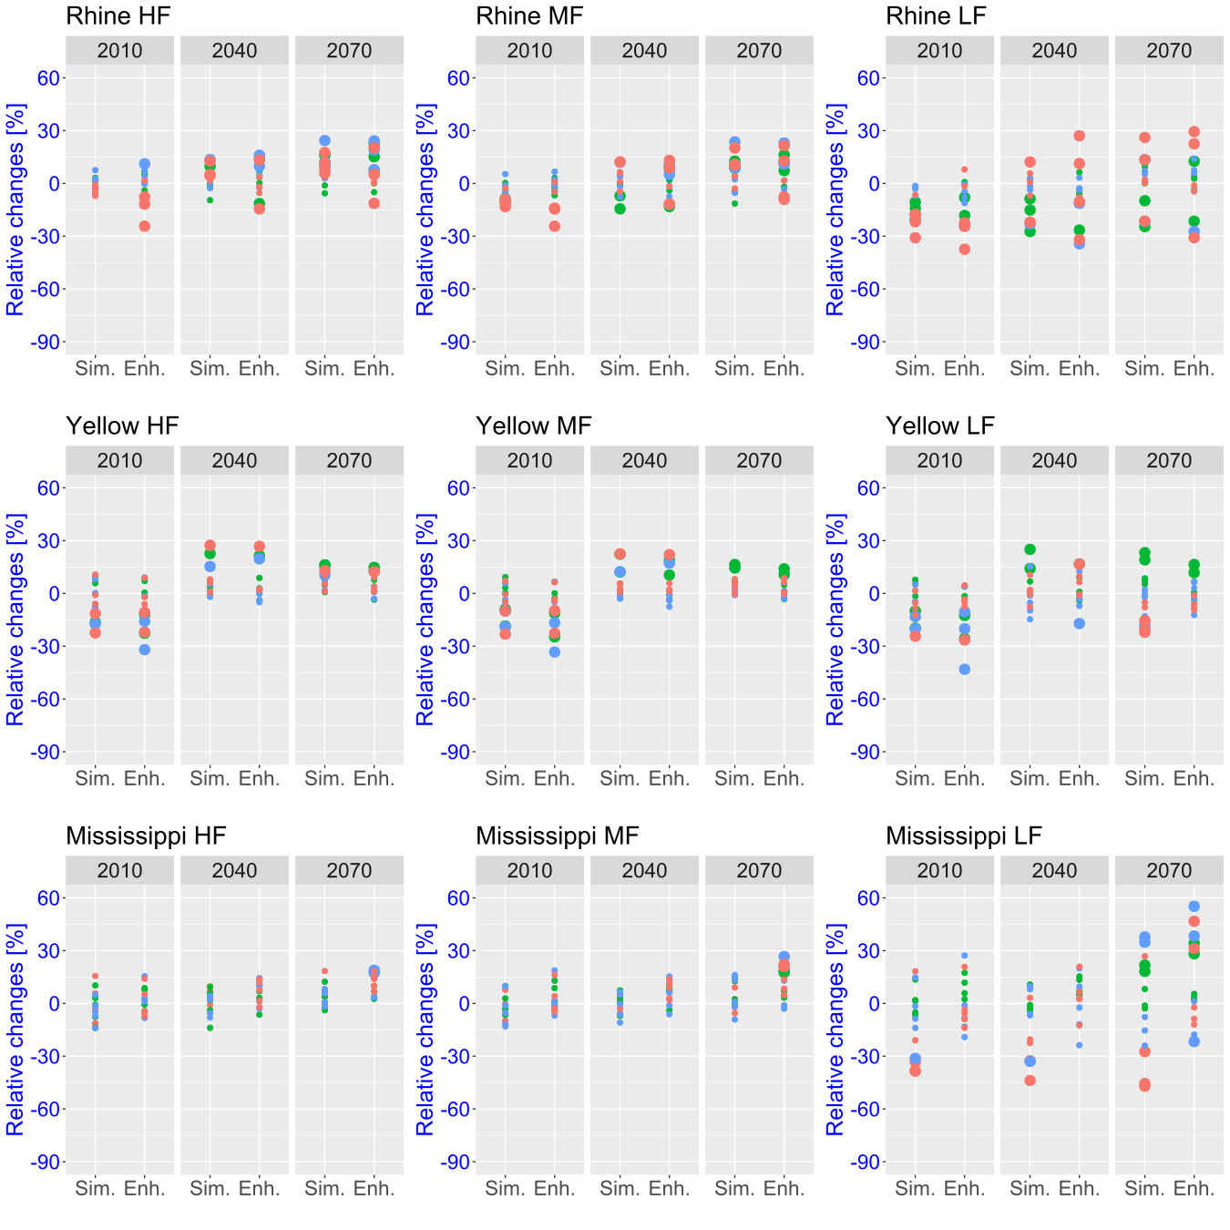

(b)
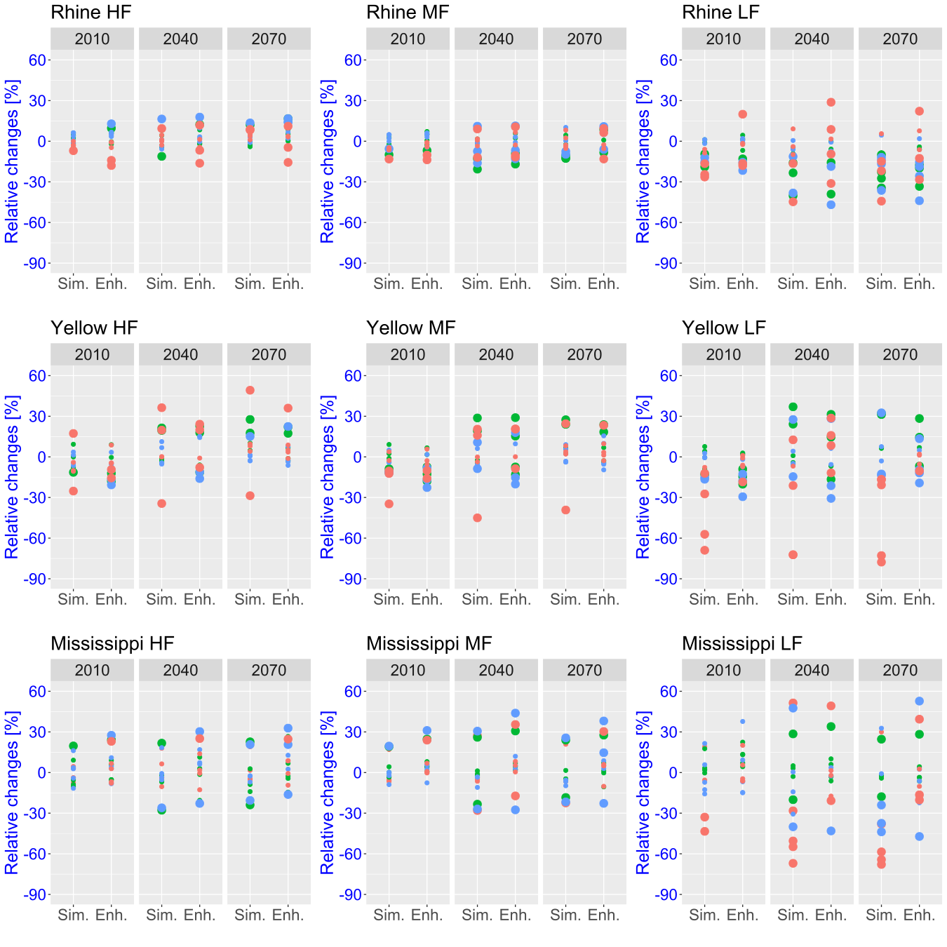

(c)
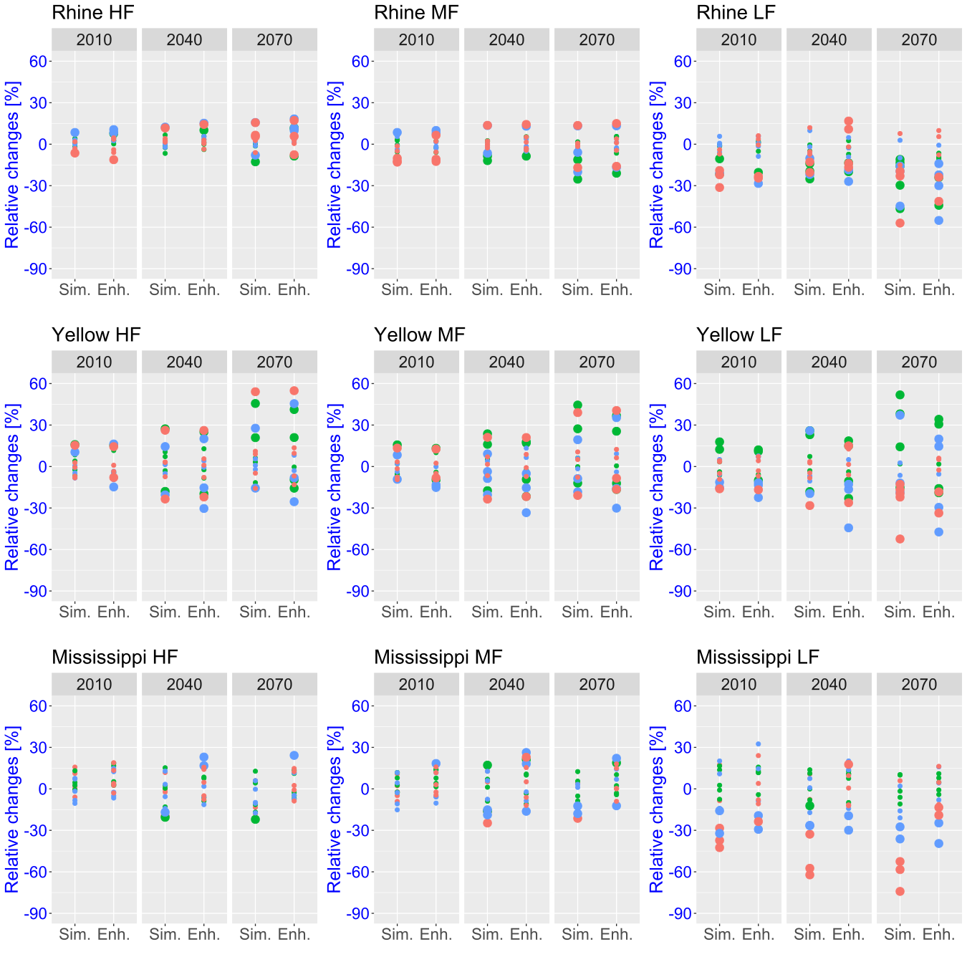

(d)
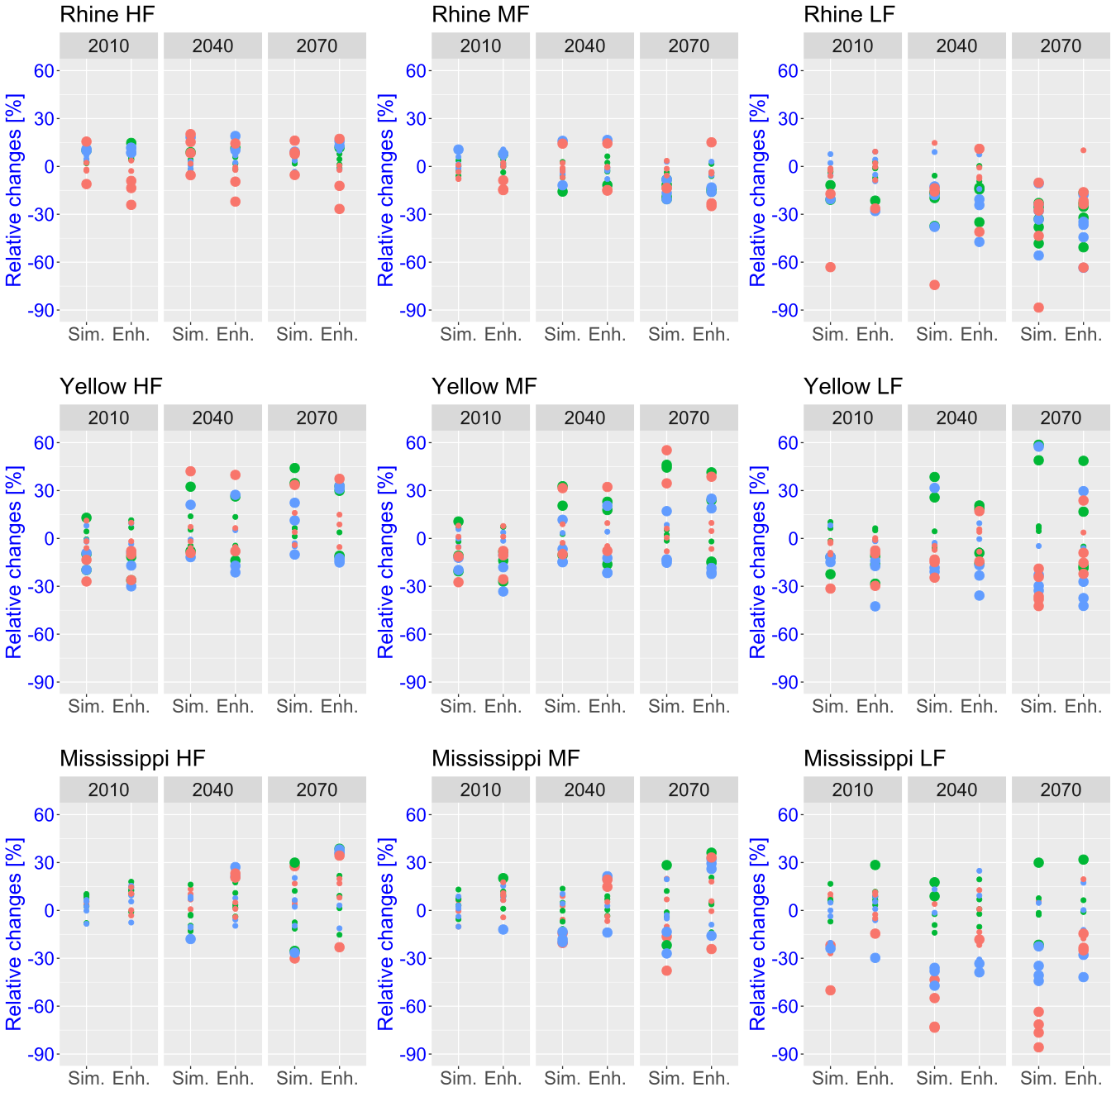

G: Comparison of numbers of projections with positive significant changes (dark blue bars), positive insignificant changes (light blue bars), negative significant changes (red bars) and negative insignificant changes (orange bars) for high flow (HF), median flow (MF) and low flow (LF) using five global climate models and three hydrological models, which were calibrated using the simple (sim.) and enhanced (enh.) methods, under the RCP 2.6 (a), 4.5 (b) and 6.0 (c) scenario for three scenario periods. The black, green and brown dots show the ensemble median, mean and weighted mean of relative changes, respectively.
(a)
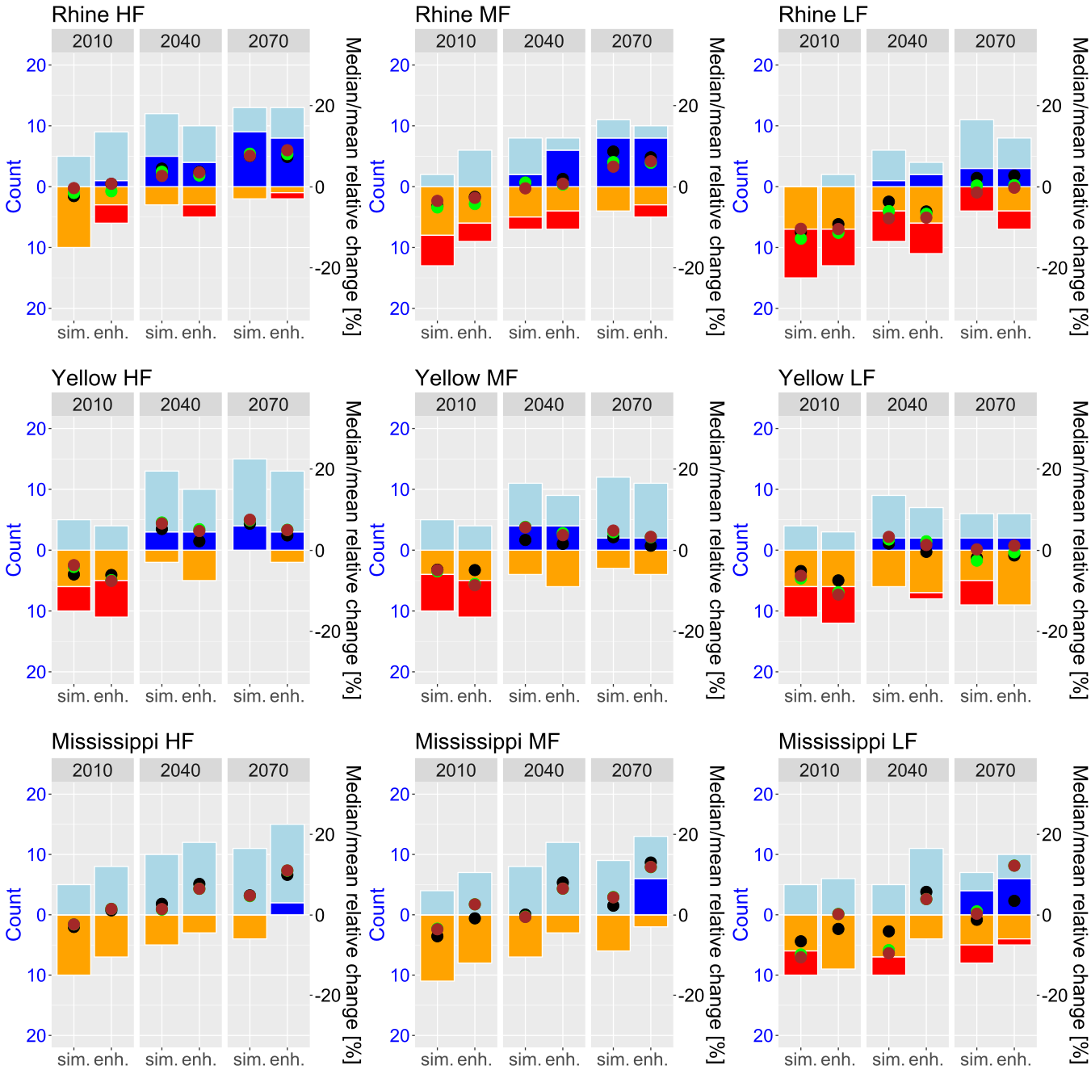

(b)
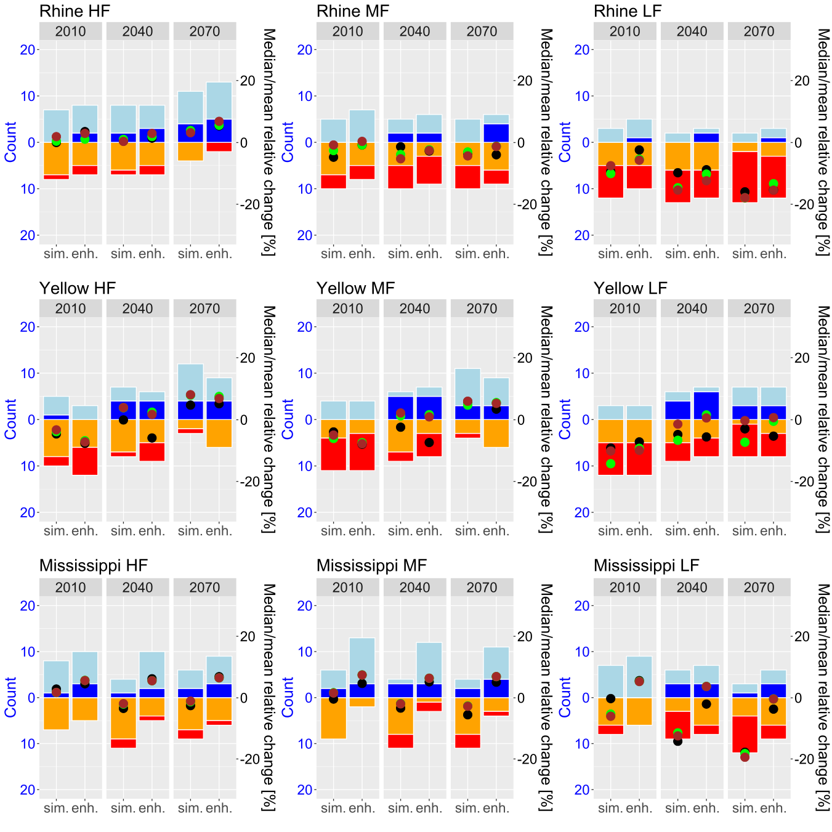

(c)
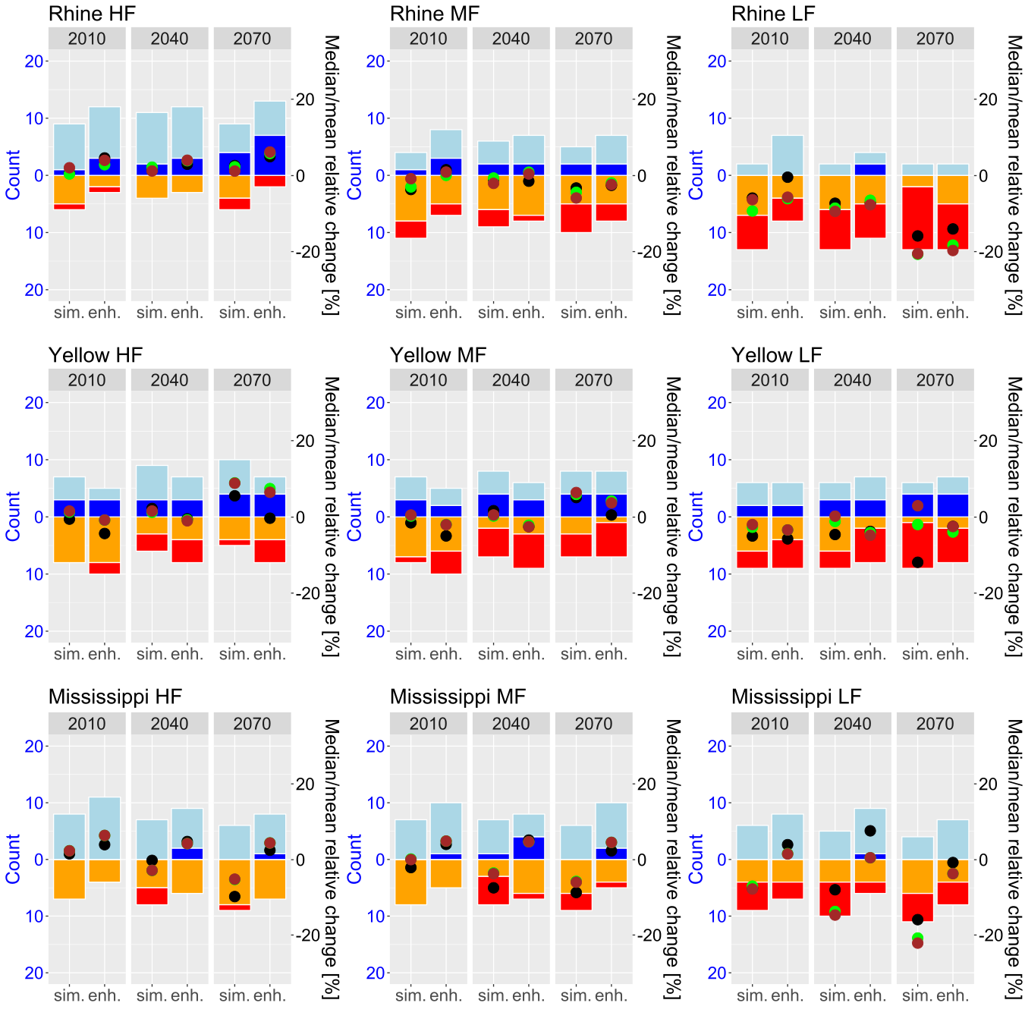

H: The moderate to strong difference of ensemble medians (a), means (b), weighted means (c) and strict weighted means (d) between the simple and enhanced calibration methods for high flow (HF), median flow (MF) and low flow (LF) in all three scenario periods. The moderate absolute difference (5% - 10%) is indicated by yellow colour and strong absolute difference (> 10%) by red. The minor differences (< 5%) are not shown.
(a)

(b)

(c)

(d)

I: Ensemble means of monthly discharge changes relative to the reference period in % for RCP 8.5 in the far future based on the simple (red line) and enhanced (green line) methods for the Rhine (a), Yellow (b) and Mississippi (c).
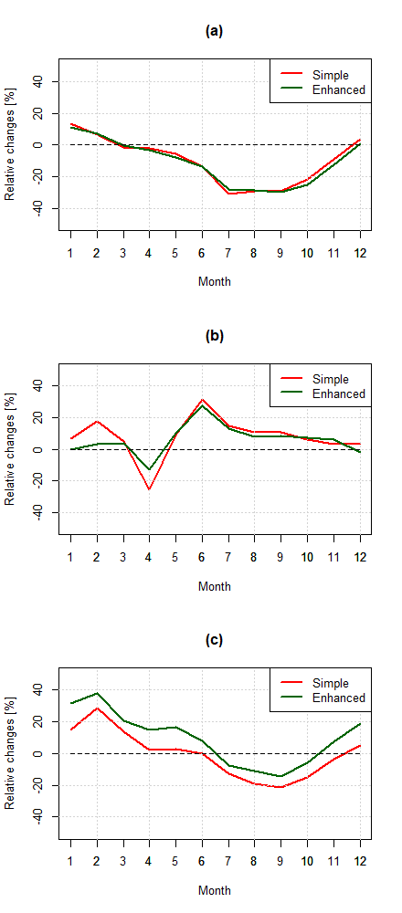
J: Comparison of sums of squares of variation (blue colour) of an ensemble of relative changes (4 RCPs * 5 GCMs * 3 HMs) in high flow (HF), median flow (MF) and low flow (LF) and the shares of uncertainty related to hydrological models (red colour) between the simulations based on the simple (solid line) and enhanced (dashed line) calibrations for all 30-year periods from 2007 to 2099.

