Supplementary material for

Effect of model calibration strategy on climate projections of hydrological indicators at a continental scale

Yeshewatesfa Hundecha¹, Berit Arheimer¹, Peter Berg¹, René Capell¹, Jude Musuuza¹, Ilias Pechlivanidis¹, Christiana Photiadou¹
¹ Swedish Meteorological and Hydrological Institute, Folkborgsvägen 1, 601 76 Norrköping, Sweden

Text S1: Bias adjustment of climate model data
The forcing data from the climate model ensemble were bias-adjusted towards the EFAS-Meteo reference data set by employing the method based on Haerter et al. (2011). The calibration period was set to 1990-2018, to include as much as possible of the rather short records of EFAS-Meteo. The method makes use of two separate timescales for the adjustment. The method was implemented with the following main steps for each grid point separately:
· Each time series (model and reference) are separated into two new time series
1. a daily time series subjected to a 30-day running mean
2. a daily time series of the anomalies of the original data to the 30-day running mean. The anomalies are additive for temperature, and multiplicative for precipitation.
· For each day-of-year (i.e. not on calendar months as in most bias adjustment procedures, to avoid introducing “steps” at calendar month changes), empirical distributions are calculated for each of the four time series, based on the 30 days surrounding the selected day-of-year and for the full time period. The sample size is therefore 30*(2018-1990+1)=870 days for each transfer function relating the model and observational distributions.
· Each of the two model time series are then bias adjusted based on the transfer function which transfers the model to the reference distribution.
· Finally, the final adjusted model time series is constructed by (additively or multiplicatively) merging the 30-day mean and anomaly time series.
This more complex method, compared to directly applying the empirical quantile mapping to daily data, was chosen to avoid potentially affecting climate change signals by statistical artifacts of inflated variance. As shown by, e.g., Haerter et al. (2011) and Berg et al., (2012), a model with a variance bias is likely to have an amplified climate change signal compared to the original model.

Table S1: Calibrated HYPE model parameters and their categories
Process | Parameter | Units | Min | Max
HRU parameters (soil type dependent)
Water holding | Fraction of soil water available for ETP (wcfc) | - | 0.01 | 0.5
 | Wilting point as fraction of soil depth (wcwp) | - | 0.01 | 0.5
 | Effective porosity as fraction of soil depth (wcep) | - | 0.01 | 0.5
Percolation | Maximum percolation capacity (mperc) | mm/d | 5 | 120
Recession | Soil recession coefficient (rrcs) | - | 0.001 | 0.6
Surface runoff | Threshold for macro pore flow (mactrinf) | mm/day | 0 | 100
 | Threshold soil water as fraction of soil depth for macro pore flow and surface runoff (mactrsm) | - | 0 | 1
 | Fraction of macro pore flow (macrate) | - | 0.05 | 0.5
 | Fraction of surface runoff (srrate) | - | 0.05 | 0.5
HRU parameters (landuse type dependent)
Evapotranspiration | Crop coefficient used to scale reference ETP (k_{c}) | - | 0.8 | 1.2
Snow | Threshold temperature for snowmelt (ttmp) | °C | 0 | 0
 | Degree-day factor (cmlt) | mm/d °C | 1 | 4
Surface runoff | Recession coefficient for surface runoff (srrcs) | - | 0.01 | 0.2
General parameters (catchment scale)
Evapotranspiration | Threshold soil water for activation of PET (lp) | % | 0.8 | 1
 | Temperature correction for elevation in relation to mean subcatchment elevation (tcelevadd) | °C/100m | 0 | 0.7
 | Adjustment factor for PET (cevpcorr) | - | -0.2 | 0.2
 | Adjustment factor for temperature (tempcorr) | - | -0.2 | 0.2
Precipitation | Threshold elevation for precipitation adjustment (pcelevth) | m | - | -
 | Adjustment factor for precipitation with elevation (pcelevadd) | mm/100m | 0 | 5
Flood speed | Clelerity of flood wave (rivvel) | m/s | 0.5 | 1.5
 | Fraction of delay in water course (damp) | - | 0.4 | 0.9
Recession | Correction factor for soil recession coefficient (rrcscorr)  Slope dependent recession coefficient in the upper soil layer (rrcs3) | -  - | -0.2  0.0 | 0.2  0.1
Lake Rating curves | Lake recession factor (gratk) | - | 1 | 2
 | Exponent parameter to lake depth (gratp) | - | 1 | 100

Table S2: River flow stations used for model calibration
Station name | River | Drainage area(km2) | Latitude | Longitude | Model calibrated
Polmak | Tana (NO, FI) | 14165 | 70.09 | 27.90 | BM
Porog | Onega | 55770 | 63.57 | 38.77 | BM
Kukkolankoski Oevre | Torneaelven, Tornionjoki | 33929.6 | 65.98 | 24.06 | BM
Vargoens Krv | Goeta Aelv | 46885.5 | 58.36 | 12.39 | BM
Anjala | Kymijoki | 36275 | 60.70 | 26.82 | BM
Raasakka (Near the mouth) | Iljoki | 14191 | 65.32 | 25.45 | BM
Kista | Altaelva | 6187 | 69.83 | 23.52 | BM
Langens | Glama | 40540 | 59.64 | 11.15 | BM
Movanagher | Lower Bann | 5209.8 | 54.98 | -6.54 | BM
Ceatal Izmail | Danube | 807000 | 45.22 | 28.75 | BM
Dovikfoss | Dramselv | 16120 | 59.89 | 9.91 | BM
Isohaara (Near the mouth) | Kemijoki | 50686 | 65.78 | 24.50 | BM
Sikfors Krv | Piteaelven | 10816.1 | 65.57 | 21.13 | BM
Harjavalta | Kokemaenjoki | 26117 | 61.39 | 21.96 | BM
Umeae | Umeaelven | 26567.8 | 63.83 | 20.25 | BM
Skatila (Lansorsund) | Kyronjoki | 4833 | 63.17 | 21.85 | BM
Aelvkarleby Krv | Dalaelven | 28920.5 | 60.56 | 17.44 | BM
Novosaratovka | Neva | 281000 | 59.86 | 30.51 | BM
Holmen | Motala Stroem | 15384 | 58.59 | 16.12 | BM
Versen | Ems | 8369 | 52.74 | 7.24 | BM
Colwick | Trent (N. England) | 7486 | 52.95 | -1.06 | BM
Kingston | Thames | 9948 | 51.41 | -0.30 | BM
Smalininkai | Nemunas - Neman | 81200 | 55.04 | 22.19 | BM
Intschede | Weser | 37720 | 52.97 | 9.11 | BM
Hohensaaten-Finow AP | Oder | 109564 | 52.88 | 14.17 | BM
Neu Darchau | Elbe | 131950 | 53.24 | 10.89 | BM
Lobith | Rhine | 160800 | 51.85 | 6.10 | BM
Bertnem | Namsen | 5163 | 64.47 | 12.06 | BM
Tczew | Vistula (Wisla) | 194376 | 54.12 | 18.88 | BM
Asco Coca | Ebro | 82245 | 41.19 | 0.57 | BM
Ljusne Stroemmar Krv | Ljusnan | 19816.9 | 61.21 | 17.08 | BM
Mazyr (Mozyr) | Prypyat | 101000 | 52.04 | 29.29 | BM
Poses | Seine | 65000 | 49.30 | 1.25 | BM
La Chapelle Sur Loire | Loire | 56500 | 47.23 | 0.20 | BM
Puente Pino | Duero | 63160 | 41.56 | -6.20 | BM
Orense | Minho | 12925 | 42.35 | -7.89 | BM
Cantillana | Guadalquivir | 44871 | 37.59 | -5.81 | BM
Epinal | Moselle | 1220 | 48.16 | 6.45 | M00, MXX
Salles | Leyre | 1650 | 44.55 | -0.87 | M00, MXX
Tinholt | Vechte | 1405 | 52.61 | 6.95 | M00, MXX
Hellwege Schl. V | Wumme | 955 | 53.08 | 9.19 | M00, MXX
Ahlergaarde | Skjern A | 1040 | 55.95 | 8.72 | M00, MXX
Hanusovce | Topla | 1050 | 49.04 | 21.52 | M00, MXX
Dasiunai | Nevezis | 5510 | 55.17 | 23.83 | M00, MXX
Zruc'nad Sazavou | Sazava | 1420.8 | 49.74 | 15.11 | M00, MXX
Saint-Lambert-du-Lattay | Layon | 920 | 47.32 | -0.63 | M00, MXX
Banska Bystrica | Hron | 1766 | 48.73 | 19.13 | M00, MXX
Sauze St Martin | Ardeche | 2240 | 44.39 | 4.37 | M00, MXX
La Roque Sur Ceze | Ceze | 1060 | 44.19 | 4.53 | M00, MXX
Trespaderne | Nela | 1093 | 42.81 | -3.40 | M00, MXX
Horgheim | Rauma | 1142 | 62.47 | 7.78 | M00, MXX
Metz | Seille | 1280 | 49.10 | 6.19 | M00, MXX
Zalaapati | Zala | 1528 | 46.71 | 17.12 | M00, MXX
Jasztelek | Zagyva | 4207 | 47.48 | 19.99 | M00, MXX
Nomeny | Seille | 925 | 48.89 | 6.23 | M00, MXX
Bouzonville | Nied | 1160 | 49.3 | 6.54 | M00, MXX
Tauberbischofsheim | Tauber | 1583 | 49.5 | 9.77 | M00, MXX
Todireni | Jijia | 1040 | 47.61 | 27.13 | M00, MXX
Fresselines | Creuse | 1235 | 46.38 | 1.68 | M00, MXX
Cather Park | Suir | 1582.7 | 52.46 | -7.92 | M00, MXX
New Bridge | Suir | 1090.3 | 52.46 | -7.98 | M00, MXX
Enniscorthy | Slane | 1319.9 | 52.55 | -6.57 | M00, MXX
Brownsbarn | Nore | 2418.3 | 52.50 | -7.09 | M00, MXX
Johns Bridge | Nore | 1644.1 | 52.65 | -7.25 | M00, MXX
Ballyduff | Blackwater (Munster) | 2333.7 | 52.14 | -8.05 | M00, MXX
Killavullen | Blackwater (Munster) | 1256.7 | 52.14 | -8.49 | M00, MXX
Samlesbury | Ribble | 1145 | 53.76 | -2.64 | M00, MXX
Sheepmount | Eden (N. England) | 2286.5 | 54.91 | -2.95 | M00, MXX
St. Marys Bridge | Derwent (Trib. Trent) | 1054 | 52.93 | -1.47 | M00, MXX
Manley Hall | Dee (Wales) | 1019.3 | 52.97 | -2.97 | M00, MXX
Nantgaredig | Tywi | 1090.4 | 51.86 | -4.20 | M00, MXX
Tenbuury | Teme | 1134.4 | 52.31 | -2.59 | M00, MXX
Teillet-Argenty | Cher | 1600 | 46.24 | 2.67 | M00, MXX
Rigny-Sur-Arroux | Arroux | 2277 | 46.53 | 4.03 | M00, MXX
Clonmel | Suir | 2143.7 | 52.35 | -7.70 | M00, MXX
Lohjanjarvi-Pel Tokoski | Karjaanjoki | 1935 | 60.17 | 23.86 | M00, MXX
Tovdalselv | Flaksvatn | 1794 | 58.29 | 8.18 | M00, MXX
Vaarakoski | Janisjoki | 1851 | 62.17 | 30.66 | M00, MXX
Gimdalsby | Giman | 2163.9 | 62.82 | 15.71 | M00, MXX
Semla | Kolbacksan | 2205.5 | 60.02 | 15.76 | M00, MXX
Ersbo | Vaesterdalaelven | 1103.8 | 61.31 | 13.01 | M00, MXX
Getebro | Alsteran | 1332.7 | 57.01 | 16.16 | M00, MXX
Borgardet 2 | Sundbornsan | 1850 | 60.75 | 15.93 | M00, MXX
Over Tanger | Hagan | 961.9 | 60.90 | 15.74 | M00, MXX
Torpshammar Krv | Giman | 4295.5 | 62.51 | 16.38 | M00, MXX
Flasjon nedre | Flasjoan | 1049.8 | 64.13 | 15.88 | M00, MXX
Vaestersel | Moaelven | 1465.2 | 63.43 | 18.30 | M00, MXX
Fallforsen ovre | Logdealven | 1198.8 | 63.80 | 18.96 | M00, MXX
Dalkarlshyttan | Borsan | 1182.6 | 59.59 | 15.26 | M00, MXX
Luujoki Haaran Ala Puolelle | Kuivajoki | 1279 | 65.62 | 25.27 | M00, MXX
Horgheim | Rauma | 1142 | 62.47 | 7.78 | M00, MXX
Oloron-Sainte-Marie | Gave D'oloron | 1085 | 43.12 | -0.59 | M00, MXX
Radovljica I | Sava | 908 | 46.34 | 14.16 | M00, MXX
Solkan I | Soca / Insonzo | 1573 | 45.98 | 13.66 | M00, MXX
Bellinzona | Ticino | 1515 | 46.19 | 9.01 | M00, MXX

Table S3: Overview of seasonal ensemble mean relative changes between the end of century (2071-2100) and the historical period (1971-2000) ((future – historical)/historical*100), for different indicators for the three main model setups. The multi-model ensemble is shown as the median of the seven members. The median (P50) of the spatial patterns are presented. All results are for RCP8.5.
 |  |  | DJF |  |  | MAM |  |  | JJA |  |  | SON
 | [%]* | BM | M00 | <MXX> | BM | M00 | <MXX> | BM | M00 | <MXX> | BM | M00 | <MXX>
Runoff | p50 | 32,1 | 35,7 | 42,4 | -8,3 | 0,1 | -3,1 | -11,5 | -11,2 | -14,1 | 16,6 | 3,6 | 8,4
Discharge | p50 | 29.7 | 39.1 | 43.0 | -6.3 | -0.7 | -4.0 | -21.4 | -16.6 | -20.3 | 0.8 | -0.4 | 1.8
Aridity-actual | p50 | 261.7 | 243.1 | 244.9 | 87.5 | 64.2 | 69.2 | 23.1 | 12.6 | 15.9 | 88.8 | 69.1 | 74.3
Aridity-potential | p50 | 277.5 | 269.4 | 269.6 | 96.0 | 85.1 | 85.2 | 46.1 | 41.6 | 41.6 | 124.9 | 113.7 | 113.7
Soil moisture | p50 | -1.1 | 3.3 | 1.5 | -5.8 | -10.3 | -8.9 | -23.0 | -28.9 | -26.9 | -19.6 | -16.9 | -18.0

* Only the median of the spatial patterns of the changes are shown. For some of the variables, the absolute values in some catchments can be very low for some seasons and if a high value is projected due to climate change, the percentage change can be unrealistically high and the extremes of the spatial pattern of the changes (5th and 95th percentile values) are not shown.

Fig. S1 Differences between the EFAS-Meteo and E-OBS data sets for the period 1990-2018 for (a) mean annual temperature, (b) mean annual precipitation, (c) number of events more intense than 10mm/day, and (d) the difference in number of consecutive dry days (<1mm/day) periods of at least 5 days

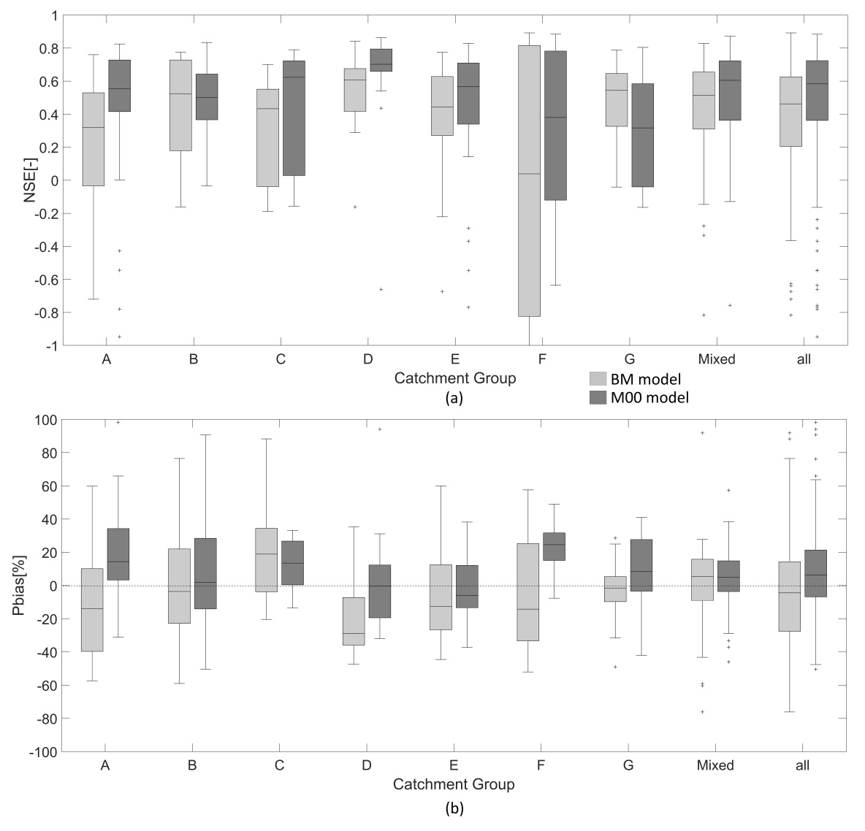
Fig. S2 Comparison of the model performance between the BM and M00 models at the validation stations when they are categorized into different catchment groups used for the regionalization of the M00 model. (A catchment predominantly belongs to a group if at least 50% of its drainage area belongs to the group; otherwise it is categorized as mixed)

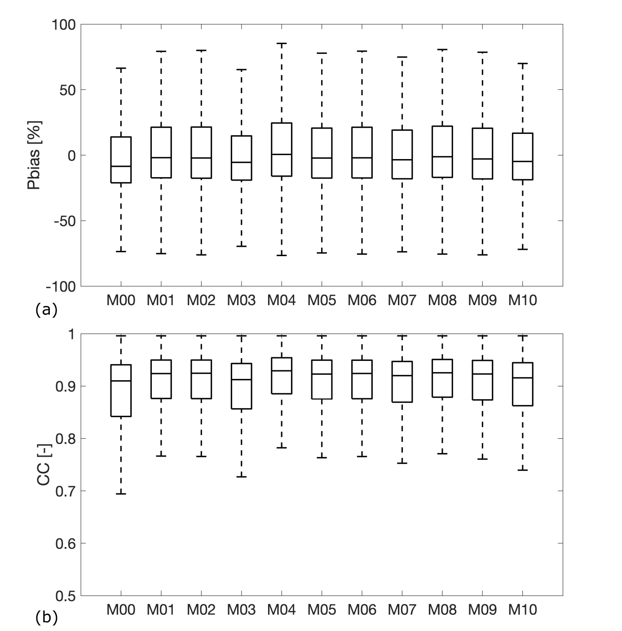
Fig. S3 Performance of the different models in terms of Pbias and correlation coefficient (CC) when evaluated against MODIS actual evaporation across all subcatchments of the model domain

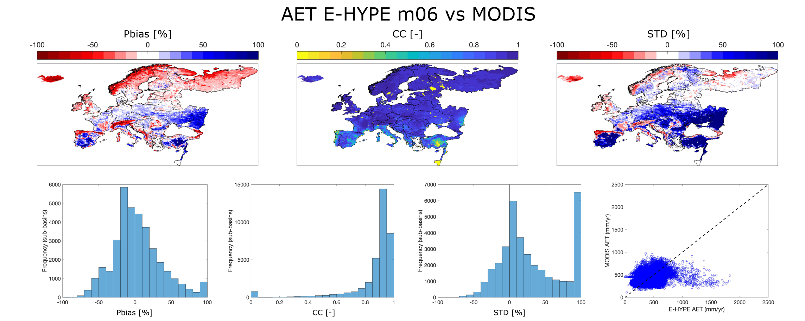
Fig. S4 Spatial maps of the performance of the E-HYPE M 06 in terms of volume (Pbias; percentage volumetric bias), timing (CC; correlation coefficient) and variability (STD; percentage bias in standard deviation) including also their histograms. Finally the bottom left figure shows the dotty pot of E-HYPE and MODIS actual evaporation for all 35408 sub-basins

Fig. S5 Mean annual runoff for the BM (top row), M00 (middle row), and median of the multi-model ensemble (bottom row). Historical period 1971-2000 (left column), relative change by the end of the century 2071-2100 (middle column), differences between the projections of M00 and MXX to BM in percentage units (right column)

Fig. S6 Mean annual maximum daily discharge for the BM (top row), M00 (middle row), and median of the multi-model ensemble (bottom row). Historical period 1971-2000 (left column), relative change by the end of the century 2071-2100 (middle column), differences between the projections of M00 and MXX to BM in percentage units (right column)

Fig. S7 Mean annual soil moisture for the BM (top row), M00 (middle row), and median of the multi-model ensemble (bottom row). Historical period 1971-2000 (left column), relative change by the end of the century 2071-2100 (middle column), differences between the projections of M00 and MXX to BM in percentage units (right column)

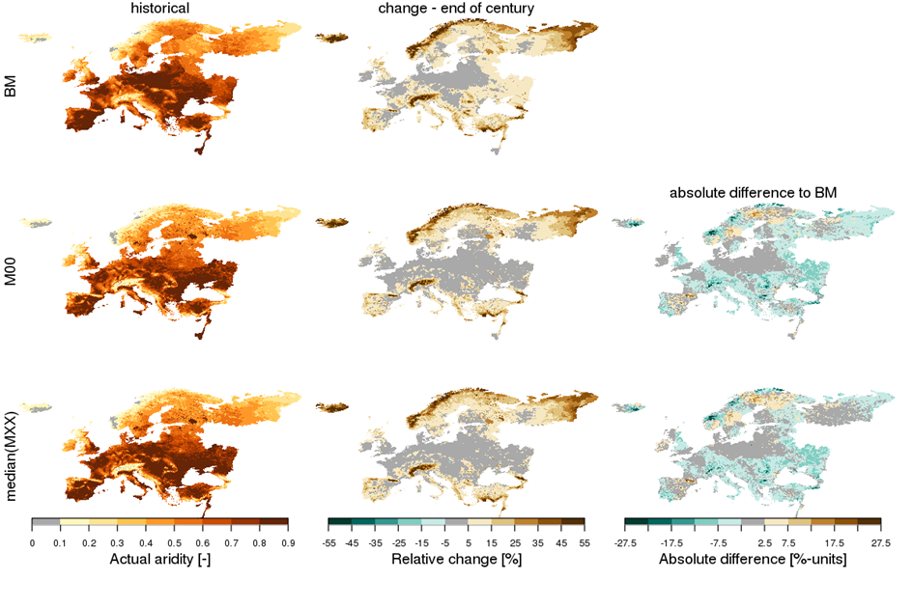
Fig. S8 Mean annual actual aridity for the BM (top row), M00 (middle row), and median of the multi-model ensemble (bottom row). Historical period 1971-2000 (left column), relative change by the end of the century 2071-2100 (middle column), differences between the projections of M00 and MXX to BM in percentage units (right column)

Fig. S9 DJF runoff for the BM (top row), M00 (middle row), and median of the multi-model ensemble (bottom row). Historical period 1971-2000 (left column), relative change by the end of the century 2071-2100 (middle column), differences between the projections of M00 and MXX to BM in percentage units (right column).

Fig. S10 MAM runoff for the BM (top row), M00 (middle row), and median of the multi-model ensemble (bottom row). Historical period 1971-2000 (left column), relative change by the end of the century 2071-2100 (middle column), differences between the projections of M00 and MXX to BM in percentage units (right column).
Fig. S11 JJA runoff for the BM (top row), M00 (middle row), and median of the multi-model ensemble (bottom row). Historical period 1971-2000 (left column), relative change by the end of the century 2071-2100 (middle column), differences between the projections of M00 and MXX to BM in percentage units (right column).

Fig. S12 SON runoff for the BM (top row), M00 (middle row), and median of the multi-model ensemble (bottom row). Historical period 1971-2000 (left column), relative change by the end of the century 2071-2100 (middle column), differences between the projections of M00 and MXX to BM in percentage units (right column).
Fig. S13 DJF soil moisture for the BM (top row), M00 (middle row), and median of the multi-model ensemble (bottom row). Historical period 1971-2000 (left column), relative change by the end of the century 2071-2100 (middle column), differences between the projections of M00 and MXX to BM in percentage units (right column)
Fig. S14 MAM soil moisture for the BM (top row), M00 (middle row), and median of the multi-model ensemble (bottom row). Historical period 1971-2000 (left column), relative change by the end of the century 2071-2100 (middle column), differences between the projections of M00 and MXX to BM in percentage units (right column)
Fig. S15 JJA soil moisture for the BM (top row), M00 (middle row), and median of the multi-model ensemble (bottom row). Historical period 1971-2000 (left column), relative change by the end of the century 2071-2100 (middle column), differences between the projections of M00 and MXX to BM in percentage units (right column)
Fig. S16 SON soil moisture for the BM (top row), M00 (middle row), and median of the multi-model ensemble (bottom row). Historical period 1971-2000 (left column), relative change by the end of the century 2071-2100 (middle column), differences between the projections of M00 and MXX to BM in percentage units (right column)
Fig. S17 DJF actual aridity for the BM (top row), M00 (middle row), and median of the multi-model ensemble (bottom row). Historical period 1971-2000 (left column), relative change by the end of the century 2071-2100 (middle column), differences between the projections of M00 and MXX to BM in percentage units (right column)
Fig. S18 MAM actual aridity for the BM (top row), M00 (middle row), and median of the multi-model ensemble (bottom row). Historical period 1971-2000 (left column), relative change by the end of the century 2071-2100 (middle column), differences between the projections of M00 and MXX to BM in percentage units (right column)
Fig. S19 JJA actual aridity for the BM (top row), M00 (middle row), and median of the multi-model ensemble (bottom row). Historical period 1971-2000 (left column), relative change by the end of the century 2071-2100 (middle column), differences between the projections of M00 and MXX to BM in percentage units (right column)
Fig. S20 SON actual aridity for the BM (top row), M00 (middle row), and median of the multi-model ensemble (bottom row). Historical period 1971-2000 (left column), relative change by the end of the century 2071-2100 (middle column), differences between the projections of M00 and MXX to BM in percentage units (right column)
Fig. S21 DJF discharge for the BM (top row), M00 (middle row), and median of the multi-model ensemble (bottom row) for (left column)the historical period 1971-2000, (middle column) relative change by the end of the century 2071-2100 under RCP8.5, and (right column) differences between the relative changes of M00 and MXX to BM, e.g. the bottom right panel is the absolute difference between the bottom centre panel and the top centre panel, in percentage units.
Fig. S22 MAM discharge for the BM (top row), M00 (middle row), and median of the multi-model ensemble (bottom row) for (left column)the historical period 1971-2000, (middle column) relative change by the end of the century 2071-2100 under RCP8.5, and (right column) differences between the relative changes of M00 and MXX to BM, e.g. the bottom right panel is the absolute difference between the bottom centre panel and the top centre panel, in percentage units.
Fig. S23 JJA discharge for the BM (top row), M00 (middle row), and median of the multi-model ensemble (bottom row) for (left column)the historical period 1971-2000, (middle column) relative change by the end of the century 2071-2100 under RCP8.5, and (right column) differences between the relative changes of M00 and MXX to BM, e.g. the bottom right panel is the absolute difference between the bottom centre panel and the top centre panel, in percentage units.
Fig. S24 SON discharge for the BM (top row), M00 (middle row), and median of the multi-model ensemble (bottom row) for (left column)the historical period 1971-2000, (middle column) relative change by the end of the century 2071-2100 under RCP8.5, and (right column) differences between the relative changes of M00 and MXX to BM, e.g. the bottom right panel is the absolute difference between the bottom centre panel and the top centre panel, in percentage units.

