Navigating through the jungle of information. Informational self-efficacy predicts climate change-related media exposure, knowledge, and behaviour

Laura S. Loy, Karen R.S. Hamann & Gerhard Reese

Supplemental Material

Supplement: Theoretical model
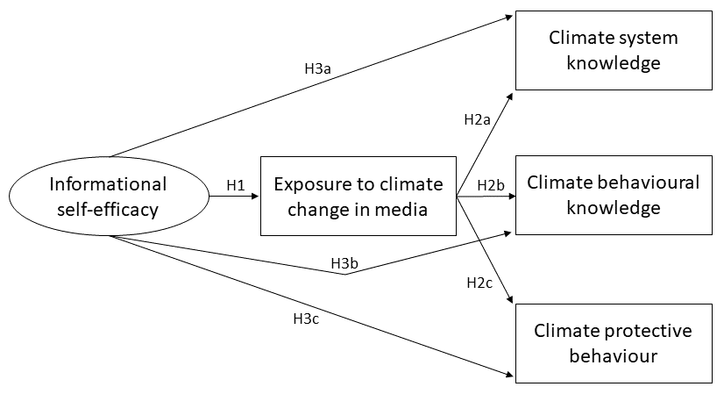
Fig. 2. Theoretical model including the research hypotheses. In addition, we expected that informational self-efficacy with regard to the issue of climate change positively predicts climate system knowledge (H4a), climate behavioural knowledge (H4b), and climate protective behaviour (H4c) indirectly through more media exposure.

Supplement: Power analysis
The a priori power analysis was not conducted for the analysis of the current manuscript but for the primary models that are reported elsewhere (see Loy, 2018). To our knowledge, there are no satisfactory state-of-the art methods to determine sample size for SEM (Kline, 2016). We used the N (ratio of sample size): q (number of parameters estimated in a SEM) rule as a rough guideline. A recommended ratio is at least 20:1 (Kline, 2016, p. 16; see also Jackson, 2003). In the model reported in the current paper, we estimated 20 parameters which would require 400 participants according to the N:q rule. Hence, our sample of N = 498 is well suited.

Supplement: Data Analysis
We analysed the data using the statistical environment R (version 3.6.1). We used the package lavaan (Rosseel & Jorgensen, 2019) for confirmatory factor analyses (CFA) and structural equation modelling (SEM). In addition to considering p-values, we tested relations for significance by applying bootstrapped confidence intervals with 5,000 samples (Hayes & Scharkow, 2013), using the package boot (Canty & Ripley, 2019). The package psych (Revelle, 2019) served for exploratory factor analysis. We applied an Expectation Maximisation (EM) algorithm for ordinal data to replace missing values in the media exposure variables using the package cat (Harding & Tuse, 2015). The Rasch analyses were performed using the package eRm (Mair et al., 2019).
In evaluating model fit, we refer to Hair et al. (2014). Depending on sample size, they recommend to report and interpret χ², CFI or TLI, and RMSEA or SRMR. We decided to report all of them. Depending on the number of observed variables in a model, the following values can serve as a guideline for samples of N > 250, even though the authors caution against over-interpreting strict rules of thumb. Insignificant χ² values should be expected for less than 12 variables, significant values for more variables. CFI or TLI should be > .95 for less than 12 variables, > .92 for 12-29 variables, and > .90 for 30 and more variables. SRMR should not be regarded for less than 12 variables and be ≤ .08 (with CFI ≥ .92) for 12 and more variables. RMSEA should be < .07 (with CFI ≥ .97) for less than 12 variables, < .07 (with CFI ≥ .92) for 12-29 variables, and < .07 (with CFI ≥ .90) for 30 and more variables (Hair et al., 2014, p. 584).

Supplement: Measures

Informational self-efficacy regarding the issue of climate change
German items on internal and external self-efficacy:

Im Folgenden geht es nun darum, wie Sie Ihren Umgang mit Informationen zum Thema Klimawandel erleben. Inwieweit lehnen Sie die folgenden Aussagen ab oder stimmen den Aussagen zu?
1 = lehne vollkommen ab, 2 = lehne überwiegend ab, 3 = lehne eher ab, 4 = teils/teils, 5 stimme eher zu, 6 = stimme überwiegend zu, 7 = stimme voll und ganz zu
Ich bin in der Lage, mich über das Thema Klimawandel so zu informieren, dass…
- …ich das Thema gut verstehen kann.
- …ich die wichtigsten Informationen auswählen kann.
- …ich mir eine Meinung bilden kann.
- …ich diesbezügliche politische Entscheidungen beurteilen kann.
- …ich mit Anderen darüber diskutieren kann.
- …ich Anderen das Thema erklären kann.
- …ich mich klimaschützend verhalten kann.

German items on epistemic self-efficacy:

Inwieweit lehnen Sie die folgenden Aussagen ab oder stimmen den Aussagen zu?
1 = lehne vollkommen ab, 2 = lehne überwiegend ab, 3 = lehne eher ab, 4 = teils/teils, 5 stimme eher zu, 6 = stimme überwiegend zu, 7 = stimme voll und ganz zu
- Ich bin zuversichtlich, dass ich bezogen auf das Thema Klimawandel die Wahrheit herausfinden kann.
- Auch wenn Informationen über den Klimawandel zunächst widersprüchlich erscheinen, kann ich die zu Grunde liegenden Tatsachen ermitteln.
- Ich bin in der Lage, objektive Fakten zum Thema Klimawandel ausfindig zu machen.

We calculated an exploratory factor analysis (EFA) to explore the underlying structure of the scale (Field et al., 2012). Kaiser-Meyer-Olkin coefficients were between .86 and .96 and the items hence well suited. Parallel analysis (Horn, 1965) suggested three factors. We first conducted an unrotated maximum likelihood factor analysis to examine the Eigenvalues of nine extracted factors. The Eigenvalues of the first three factors were 6.15, 1.26, and 0.50. A scree plot ambiguously suggested two to four factors (see Figure 3). Then, we conducted an unrotated maximum likelihood factor analysis to examine the Eigenvalues of three extracted factors, which were 6.02, 1.10, and 0.36. Finally, we calculated a maximum likelihood factor analysis with oblique promax rotation extracting three factors (TLI = .99, RMSEA = .049, 90% CI [.027, .069]). It clearly differentiates the three factors without substantial cross-loadings.
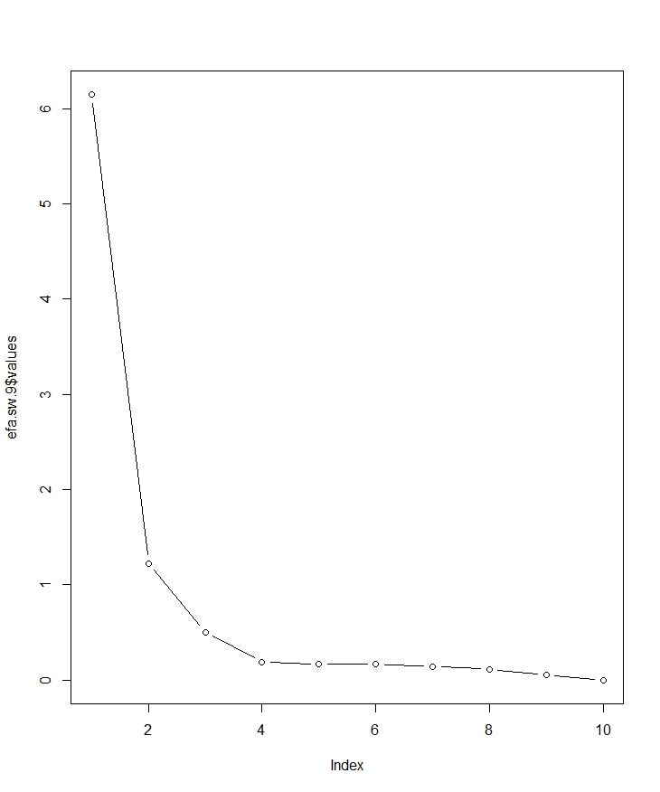
Factors number
Eigenvalue
Fig. 3. Scree plot with Eigenvalues resulting from an unrotated maximum likelihood factor analysis of the informational self-efficacy items

To our knowledge, parallel analysis is the most established method to determine the number of factors in an exploratory factor analysis. However, another method is the Kaiser criterion, which assumes factors with Eigenvalues > 1 as relevant. Even though parallel analysis suggested a three-factor solution, the Eigenvalue of the third factor was below the Kaiser criterion. Therefore, we also conducted a maximum likelihood factor analysis for a two-factor solution. Table 4 contains the results which indicate that the two factors differentiate the two original measures, we based our items on. The internal and external factor can be interpreted as one factor of “informational self-efficacy” (Loy et al., 2019), and the second factor as “epistemic self-efficacy” (Pingree, 2011). However, fit indices were not satisfactory for the two-factor solution (TLI = .91, RMSEA = .132, 90% CI [.116, .146]). We therefore decided to use the three-factor model in our further analysis, as we also deemed the differentiation of the internal and external dimension theoretically and practically interesting.

Table 4. Exploratory maximum likelihood factor analysis for a two-factor solution
Item | Factor 1 | Factor 2 | h²
I am able to inform myself sufficiently about the issue of climate change to …  1. … understand the topic well. | .95 | -.10 | .78
2. … select the most important information. | .92 | -.08 | .75
3. … form an opinion. | .89 | -.04 | .76
4. … evaluate respective political decisions. | .63 | .18 | .58
5. … discuss with others about it. | .85 | -.03 | .69
6. … explain the topic to others. | .69 | .19 | .67
7. … behave in a climate protective manner. | .62 | .11 | .48
8. I feel confident that I can find the truth about the issue of climate change. | -.02 | .85 | .70
9. Even though information on climate change seems contradictory at first, I can figure out the basic facts. | -.05 | .95 | .85
10. I am capable of finding objective facts about the issue of climate change. | .06 | .84 | .78
% of variance | 45.6 | 24.8

Next, we also examined some items in detail. In a further maximum likelihood factor analysis, we excluded Item 7 (i.e., “I am able to inform myself sufficiently about the issue of climate change to behave in a climate protective manner”). This item was conceptually close to climate protective behaviour and we aimed to see whether this item drives the correlation with behaviour. Kaiser-Meyer-Olkin coefficients were between .85 and .95 and the items hence well suited. Parallel analysis (Horn, 1965) suggested three factors with Eigenvalues of 5.54, 1.09, and 0.32. Table 5 contains the results for the respective factor analysis. A similar pattern emerged, differentiating three factors without substantial cross-loadings. The correlation between the internal and external factor was r = .79, between the internal and epistemic factor r = .55, and between the external and epistemic factor r = .64. A CFA for a three-dimensional model with superordinate factor yielded excellent model fit, χ²(24) = 55.56, p < .001; CFI = .98; TLI = .97; RMSEA = .051, 90% CI [.038, .065]; SRMR = .033. The bivariate correlation between external self-efficacy excluding Item 7 and climate protective behaviour was r = .37 and hence similar to when Item 7 was included (i.e., r = .41, see Table 7). We concluded that our results were not solely driven by Item 7.

Table 5. Exploratory maximum likelihood factor analysis for informational self-efficacy excluding Item 7
Item | Factor “internal” | Factor “external” | Factor “epistemic” | h²
I am able to inform myself sufficiently about the issue of climate change to …  1. … understand the topic well. | .94 | -.02 | -.01 | .85
2. … select the most important information. | .91 | -.03 | .02 | .82
3. … form an opinion. | .70 | .18 | .03 | .75
4. … evaluate respective political decisions. | .15 | .56 | .13 | .61
5. … discuss with others about it. | .24 | .74 | -.11 | .76
6. … explain the topic to others. | -.03 | .90 | .05 | .83
8. I feel confident that I can find the truth about the issue of climate change. | .02 | -.03 | .84 | .70
9. Even though information on climate change seems contradictory at first, I can figure out the basic facts. | -.02 | -.02 | .95 | .86
10. I am capable of finding objective facts about the issue of climate change. | .01 | .08 | .82 | .77
% of variance | 28.5 | 22.3 | 26.4

Furthermore, looking at the item formulation, it could be argued that Item 4 rather fits in the internal than the external dimension (even though the factor loadings suggest otherwise, see Table 1 in the main manuscript). Nevertheless, we conducted a CFA excluding Item 4 and compared it to the model including Item 4. The fit indices for the model including Item 4 were: χ²(32) = 67.30, p < .001; CFI = .98; TLI = .97; RMSEA = .047, 90% CI [.035, .059]; SRMR = .032. Excluding Item 4, they were: χ²(24) = 50.98, p < .001; CFI = .98; TLI = .97; RMSEA = .048, 90% CI [.034, .061]; SRMR = .031. Comparing both models showed that in terms of χ², the reduced model was slightly better: χ²_{diff} (8) = 16.32, p = .038. However, as the other fit indices appear both very well, we decided to keep all items in order to cover the whole range of the scale.
To evaluate the validity of this three-dimensional model, we regarded the average variances extracted (AVE) by the factors. Values of ≥ .67 indicated convergent construct validity (see Table 2 in the main manuscript). Moreover, AVE estimates for two factors were greater than the square of the correlation between the two factors (i.e., .61 for internal/external factor, .28 for internal/epistemic factor, .36 for external/epistemic factor) indicating discriminant construct validity (Hair et al., 2014, p. 605).

Media exposure to the issue of climate change
Table 6 displays the frequencies of exposure to the climate change issue in the assessed media outlets.
Table 6. Exposure to the climate change issue in several media outlets
 |  | 1  Never | 2  Once in half a year or less | 3  Several times in half a year | 4  Once a month | 5  Several times a month | 6  Several times a week
 | Md ª | n | N | N | n | n | n | MV
1. Private TV channels | 3 | 79 (16%) | 112 (22%) | 139 (28%) | 71 (14%) | 77 (15%) | 16 (3%) | 4 (1%)
2. Public TV channels | 3 | 49 (10%) | 78 (16%) | 141 (28%) | 84 (17%) | 118 (24%) | 25 (5%) | 3 (1%)
3. Radio | 3 | 96 (19%) | 97 (19%) | 129 (26%) | 70 (14%) | 79 (16%) | 21 (4%) | 6 (1%)
4. Regional newspapers | 3 | 98 (20%) | 79 (16%) | 131 (26%) | 72 (14%) | 90 (18%) | 21 (4%) | 7 (1%)
5. Supra-regional newspapers | 3 | 142 (29%) | 80 (16%) | 123 (25%) | 60 (12%) | 71 (14%) | 15 (3%) | 7 (1%)
6. Weekly newspapers | 2 | 153 (31%) | 95 (19%) | 111 (22%) | 67 (13%) | 56 (11%) | 10 (2%) | 6 (1%)
7. Brochures | 2 | 165 (33%) | 88 (18%) | 98 (20%) | 76 (15%) | 49 (10%) | 17 (3%) | 5 (1%)
8. Academic journals | 2 | 170 (34%) | 83 (17%) | 86 (17%) | 81 (16%) | 56 (11%) | 15 (3%) | 7 (1%)
9. Internet | 3 | 58 (12%) | 79 (16%) | 125 (25%) | 84 (17%) | 98 (20%) | 44 (9%) | 10 (2%)
9a. Online newspapers | 2 | 198 (40%) | 78 (16%) | 106 (21%) | 53 (11%) | 48 (10%) | 12 (2%) | 3 (1%)
9b. Social media | 2 | 234 (47%) | 83 (17%) | 67 (13%) | 40 (8%) | 53 (11%) | 18 (4%) | 3 (1%)
9c. Video-sharing websites | 1 | 263 (53%) | 80 (16%) | 68 (14%) | 42 (8%) | 31 (6%) | 12 (2%) | 2 (0%)
9d. Discussion platforms | 1 | 268 (54%) | 68 (14%) | 69 (14%) | 42 (8%) | 38 (8%) | 8 (2%) | 5 (1%)
Note. MV = missing values. ª We report the median rather than the arithmetic mean because the scale’s answer format was ordinal.

Climate change knowledge
Only after study completion did we notice a programming mistake on the last page of the knowledge questionnaire that contained the questions on action effectiveness. The answer categories were accidentally displayed in reverse order as “false”, “true”, and “don’t know”. Some participants noticed the switch and addressed it in their comments, expressing uncertainty about it. However, we have to assume that not all participants were aware of the switch and, hence, the items cannot reliably be used.

Rasch modelling
We applied Rasch modelling for our knowledge and behaviour measures, which is a common approach in educational and achievement assessment (for details, see Bond & Fox, 2007). Rasch modelling is a special case of the psychometric item response theory (i.e., an alternative to classical test theory). Persons and items form a transitive order, which is based on item difficulty. Hence, easy knowledge questions are answered correctly by many people, difficult questions by few people; easy behaviours are performed by many people, difficult behaviours by few people. The latent person parameters (i.e., in our case knowledge, behaviour) can be estimated independently from the items used. The latent item parameters (i.e., item difficulty) can be estimated independently from the sample used. This is called specific objectivity. The probability that a person solves a knowledge question or agrees to a behavioural item is determined by the difference between the person parameter and the item parameter. The estimated individual person scores in our study reflect “how far people reach” regarding climate-related knowledge and climate protective behaviours. We use these scores in our path model as more precise estimates compared to mere sum scores and as an alternative to the confirmatory factor analyses which are embedded in classical structural equation modelling. The reason for this is that our measures are in our view more appropriately analysed with Rasch modelling than with classical test theory (for details, see Frick et al., 2004; Kaiser & Frick, 2002; Kaiser & Wilson, 2000, 2004).
As an indicator of reliability for Rasch scales, we report their person separation reliability R_{p} (Bond & Fox, 2007). Ranging between 0 and 1, it represents how well people can be differentiated on the measured construct by estimating the “replicability of person placement across other items measuring the same construct” (p. 284). There are no clear rules of thumb regarding acceptable values and many authors caution against putting too much emphasis on person separation reliability (e.g., Mair et al., 2018, p. 73). However, we regarded separation reliability and compared it with values from prior studies. In addition, we report the item mean square infit. It indicates by how much the actual empirical response pattern deviates from Rasch model expectations (Bond & Fox, 2007, p. 238). The expected value is 1 and actual values can range from 0 to positive infinity. A value of 1+x signifies 100x% more variation in the empirical data than predicted by the Rasch model (e.g., a value of 1.10 indicates 10% more variation). The Rasch model is a probabilistic model. Therefore, a certain amount of variation conforms to the model. Bond and Fox (2007) caution against strict rules to evaluate misfit. However, they propose a rough guideline for identifying unacceptable departures from the value of 1 relative to sample size: values > 1.3 can be classified as misfits for samples of N < 500; values > 1.2 for samples between 500 and 1000 participants (p. 286).

Supplement: Results

Correlations between the study variables
Table 7. Bivariate correlations between the study variables
Variable | 1 | 1a | 1b | 1c | 2 | 3 | 4
1. Informational self-efficacy
1a. Internal | .87*
1b. External | .92* | .78*
1c. Epistemic | .81* | .53* | .60*
2. Media exposure (sum index) ª | .31* | .22* | .32* | .27*
3. Climate system knowledge | .37* | .38* | .34* | .28* | .23*
4. Climate behavioural knowledge | .23* | .24* | .22* | .15* | .09* | .68*
5. Climate protective behaviour | .38* | .32* | .41* | .27* | .26* | .23* | .21*
Note. Pearson correlations. ª Polyserial correlations are displayed for the ordinal sum index. Factor scores and Rasch scores were used for the calculation. * p < .05

Analysis differentiating the media channels
Table 8 displays regression analyses for climate system knowledge, climate behavioural knowledge, and climate protective behaviour predicted by exposure to the assessed media outlets. We additionally included the two interpersonal communication exposure options which were assessed in the study, namely “talks or events”, and “conversations with others” (for a discussion, see Loy, 2018).
Table 8. Multiple regression analyses for contact with the climate change issue in communication and the outcome variables
 | Climate  system  knowledge | Climate behavioural knowledge | Climate  protective behaviour
1. Private TV | -.02 | -.13 | -.10
2. Public TV | .16* | .13 | .06
3. Radio | .04 | -.04 | -.09
4. Regional newspapers | -.10 | .03 | .06
5. Supra-regional newspapers | .06 | .01 | .01
6. Weekly newspapers | -.10 | -.16 | .01
7. Brochures | .19* | .16* | -.04
8. Academic journals | .01 | .09 | .09
9. Internet | .21* | .19* | .09
9a. Online newspapers | .11 | .11* | .05
9b. Social media | -.13* | -.11 | -.08
9c. Video-sharing websites | -.03 | -.02 | .04
9d. Discussion platforms | -.02 | -.04 | .02
10. Talks or events | -.22* | -.26* | -.21*
11. Conversations with others | .07 | .07 | .35*
R² | .15 | .12 | .16
Note. Standardised coefficients are displayed. * p < .05

Analyses differentiating the dimensions of informational self-efficacy
We conducted three SEMs for the separate dimensions of informational self-efficacy as predictors (see Figure 4). All three models fit the data well except for χ² (internal: χ²(8) = 24.53, p = .002; CFI = .99; TLI = .96; RMSEA = .065, 90% CI [.036, .097]; SRMR = .021; external: χ²(14) = 44.48, p < .001; CFI = .98; TLI = .96; RMSEA = .067, 90% CI [.046, .089]; SRMR = .029; epistemic: χ²(8) = 13.15, p = .107; CFI = 1.00; TLI = .99; RMSEA = .036, 90% CI [.000, .069]; SRMR = .015).
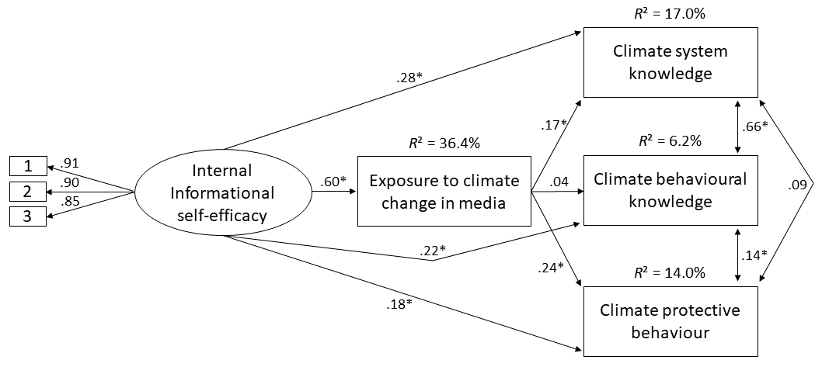
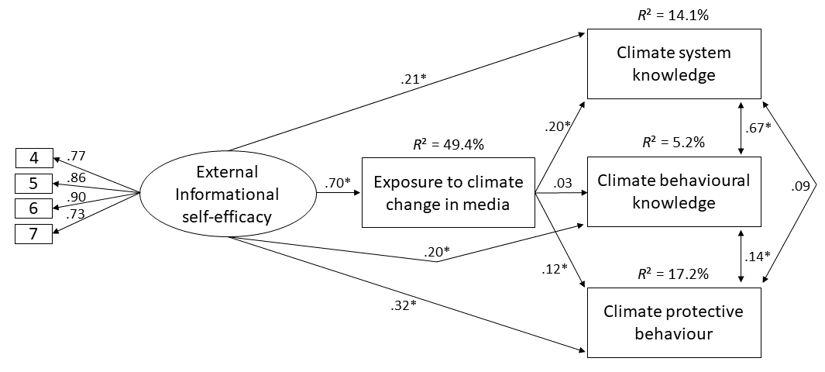
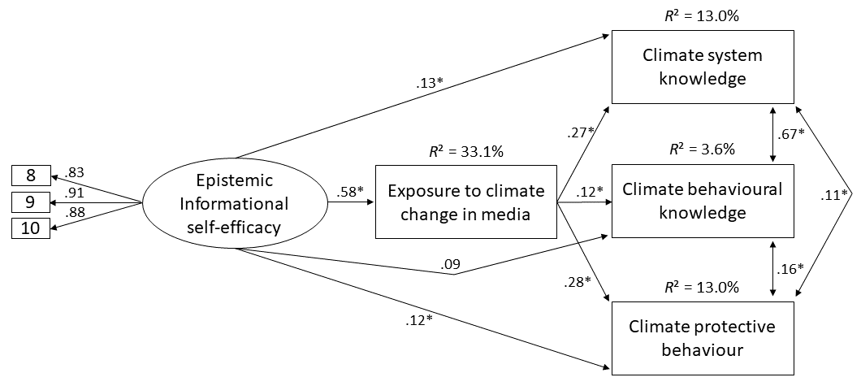
Fig. 4. Structural equation models for the separate dimensions of informational self-efficacy. Standardised coefficients are displayed. The relations between climate system knowledge, climate behavioural knowledge, and climate protective behaviour represent residual covariances. * p < .05.

References
Bond, T. G., & Fox, C. M. (2007). Applying the Rasch model: Fundamental measurement in the human sciences (2nd ed.). Routledge.
Canty, A., & Ripley, B. (July 2019). boot: Bootstrap functions. R package version 1.3-23. https://cran.r-project.org/web/packages/boot/boot.pdf
Field, A., Miles, J., & Field, Z. (2012). Discovering statistics using R. Sage Publications.
Frick, J., Kaiser, F. G., & Wilson, M. (2004). Environmental knowledge and conservation behavior: Exploring prevalence and structure in a representative sample. Personality and Individual Differences, 37, 1597–1613. https://doi.org/10.1016/j.paid.2004.02.015
Hair, J. F., Black, W. C., Babin, B. J., & Anderson, R. E. (2014). Multivariate Data Analysis (7th ed.). Pearson Education Limited.
Harding, T., & Tuse, F. (February 2015). cat: analysis of categorical-variable datasets with missing values. R package version 0.0-6.5. https://cran.r-project.org/web/packages/cat/cat.pdf
Hayes, A. F., & Scharkow, M. (2013). The relative trustworthiness of inferential tests of the indirect effect in statistical mediation analysis: Does method really matter? Psychological Science, 24(10), 1918–1927. https://doi.org/10.1177/0956797613480187
Horn, J. L. (1965). A rationale and test for the number of factors in factor analysis. Psychometrika, 30(2), 179–185. https://doi.org/10.1007/BF02289447
Jackson, D. L. (2003). Revisiting sample size and number of parameter estimates: Some support for the N:q hypothesis. Structural Equation Modeling: A Multidisciplinary Journal, 10(1), 128–141. https://doi.org/10.1207/S15328007SEM1001_6
Kaiser, F. G., & Frick, J. (2002). Entwicklung eines Messinstrumentes zur Erfassung von Umweltwissen auf der Basis des MRCML-Modells [Development of a measure to assess environmental knowledge on the basis of the MRCML model]. Diagnostica, 48(4), 181–189. https://doi.org/10.1026//0012-1924.48.4.181
Kaiser, F. G., & Wilson, M. (2000). Assessing people's general ecological behavior: A cross-cultural measure. Journal of Applied Social Psychology, 30(5), 952–978. https://doi.org/10.1111/j.1559-1816.2000.tb02505.x
Kaiser, F. G., & Wilson, M. (2004). Goal-directed conservation behavior: The specific composition of a general performance. Personality and Individual Differences, 36(7), 1531–1544. https://doi.org/10.1016/j.paid.2003.06.003
Kline, R. B. (2016). Principles and practice of structural equation modeling (4th ed.). Guilford Press.
Loy, L. S. (2018). Communicating climate change. How proximising climate change and global identity predict engagement [Dissertation]. Universität Hohenheim, Stuttgart.
Loy, L. S., Masur, P. K., Schmitt, J. B., & Mothes, C. (2019). Psychological predictors of political Internet use and political knowledge in light of the perceived complexity of political issues. Information, Communication & Society, 22(12), 1733–1750. https://doi.org/10.1080/1369118X.2018.1450886
Mair, P., Hatzinger, R., & Maier, M. J. (March 2018). Extended Rasch modeling: The R package eRm. https://cran.r-project.org/web/packages/eRm/vignettes/eRm.pdf
Mair, P., Hatzinger, R., & Maier, M. J. (June 2019). eRm: extended Rasch modeling. R package version 1.0-0. https://cran.r-project.org/web/packages/eRm/eRm.pdf
Pingree, R. J. (2011). Effects of unresolved factual disputes in the news on epistemic political efficacy. Journal of Communication, 61(1), 22–47. https://doi.org/10.1111/j.1460-2466.2010.01525.x
Revelle, W. (January 2019). psych. R package version 1.8.12. https://cran.r-project.org/web/packages/psych/psych.pdf
Rosseel, Y., & Jorgensen, T. D. (August 2019). lavaan: latent variable analysis. R package version 0.6-5. https://cran.r-project.org/web/packages/lavaan/lavaan.pdf

