The Compensation Effect of Winter Snow on Larch Growth over Northeast China
Yuanqiao Li ^{a,b}, Xiuchen Wu ^{a,b*}, Yongmei Huang ^{a,b}, Xiaoyan Li ^{a,b}, Fangzhong Shi ^{a,b}, Shoudong Zhao ^{a,b}, Yuting Yang ^{c}, Yuhong Tian ^{a,b}, Pei Wang ^{a,b}, Shulei Zhang ^{a,b}, Cicheng Zhang ^{a,b}, Yang Wang ^{a,b}, Chongyang Xu ^{d}, Pengwu Zhao ^{e}

ª Faculty of Geographical Science, Beijing Normal University, Beijing, 100875, China
^{b} State Key Laboratory of Earth Surface Processes and Resource Ecology, Beijing Normal University, Beijing, 100875, China
^{c} State Key Laboratory of Hydroscience and Engineering, Department of Hydraulic Engineering, Tsinghua University, Beijing 100084, China.
^{d} College of Urban and Environmental Science, MOE Laboratory for Earth Surface Processes, Peking University, Beijing, China
^{e} College of forestry, Inner Mongolia Agricultural University, Hohhot, China

Corresponding author: Xiuchen Wu, Faculty of Geographical Science, Beijing Normal University, Beijing, 100875, China. E-mail: xiuchen.wu@bnu.edu.cn; Telephone: +86-10-5880 0148.

Supplementary materials

Table S1
Table S1. Basic information for the meteorological stations near tree-ring sites
Sites | Meteorological stations | MAP (mm) | Elevation (m) | Distance (km) | Longitude (E) | Latitude (N) | Time span
WLB | Balinzuoqi | 373 | 486.2 | 64 | 119.24 | 44.09 | 1961-2015
BRG | Xiwuzhumuqinqi | 330 | 1000.6 | 56 | 118.36 | 44.35 | 1961-2015
WCG | Aershan | 448 | 997.2 | 60 | 119.86 | 47.1 | 1961-2015
WEG | Eerguna | 432 | 581.4 | 61 | 120.11 | 50.15 | 1961-2015
GH | Tulihe | 452 | 732.6 | 50 | 121.41 | 50.29 | 1961-2015
Note: MAP means mean annual precipitation.

Figure S1
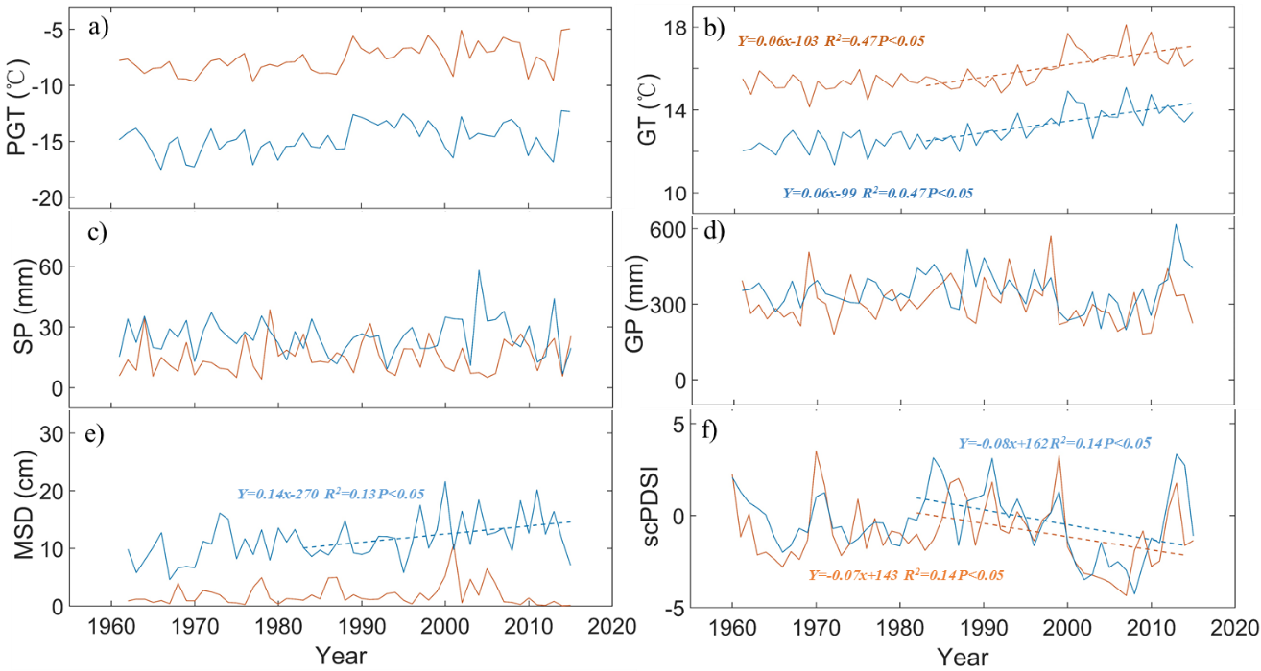
Fig. S1. Temporal changes in different climate factors during 1960-2015. (a) pre-growing season temperature (PGT), (b) mean growing season temperature (GT), (c) spring precipitation (SP), (d) growing-season precipitation (GP), (e) mean winter snow depth (MeanSD), (f) mean annual self-calibrating Palmer Drought Severity Indices (scPDSI) in biological year. Solid blue lines indicate temporal changes in climate factors at climate stations surrounding WEG, GH and WCG in semi-humid region, solid red lines indicate temporal changes in climate factors at climate stations surrounding WLB and BRG in semi-arid region. Dashed lines indicate linear trend during 1980-2015, respectively.

Table S2
Table S2. The average of the correlation coefficient between each tree chronology and the master chronology in each plot
 | Time span
 | 1950-1974 | 1960-1984 | 1970-1994 | 1980-2004 | 1990-2014 | 2000-2024
WLB | / | / | / | 0.66 | 0.72 | 0.72
BRG | / | / | / | 0.68 | 0.72 | 0.73
WCG1 | / | / | / | 0.71 | 0.72 | 0.72
WCG2 | / | 0.62 | 0.66 | 0.72 | 0.70 | 0.70
WEG | / | / | / | 0.78 | 0.81 | 0.80
GH | 0.69 | 0.70 | 0.68 | 0.70 | 0.74 | 0.74
Note: Correlations of 25-year dated segments, lagged 10 years. / indicates there is no data available.

Figure S2
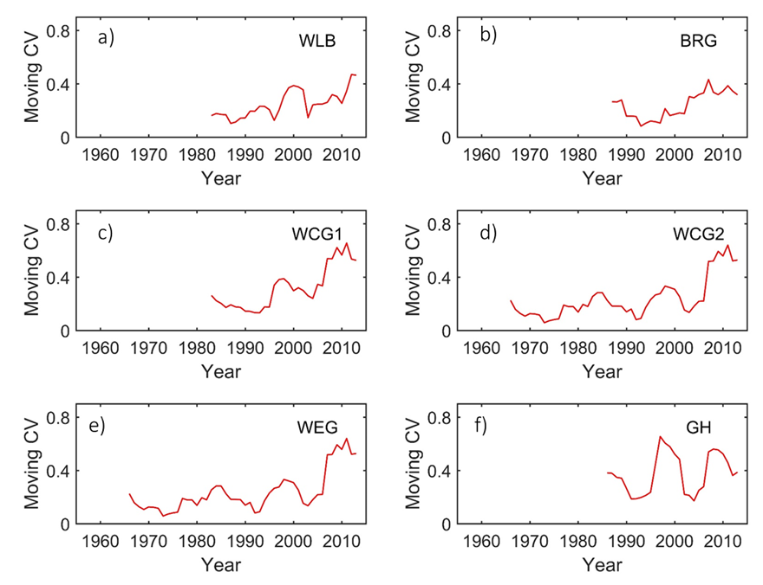
Fig. S2. Moving coefficient of variation (CV) of tree-ring chronologies of Larix principis-rupprechtii in WLB and BRG (a, b), and Larix gmelinii in WCG1 and WCG2 (c, d), WEG and GH (e, f).

Figure S3

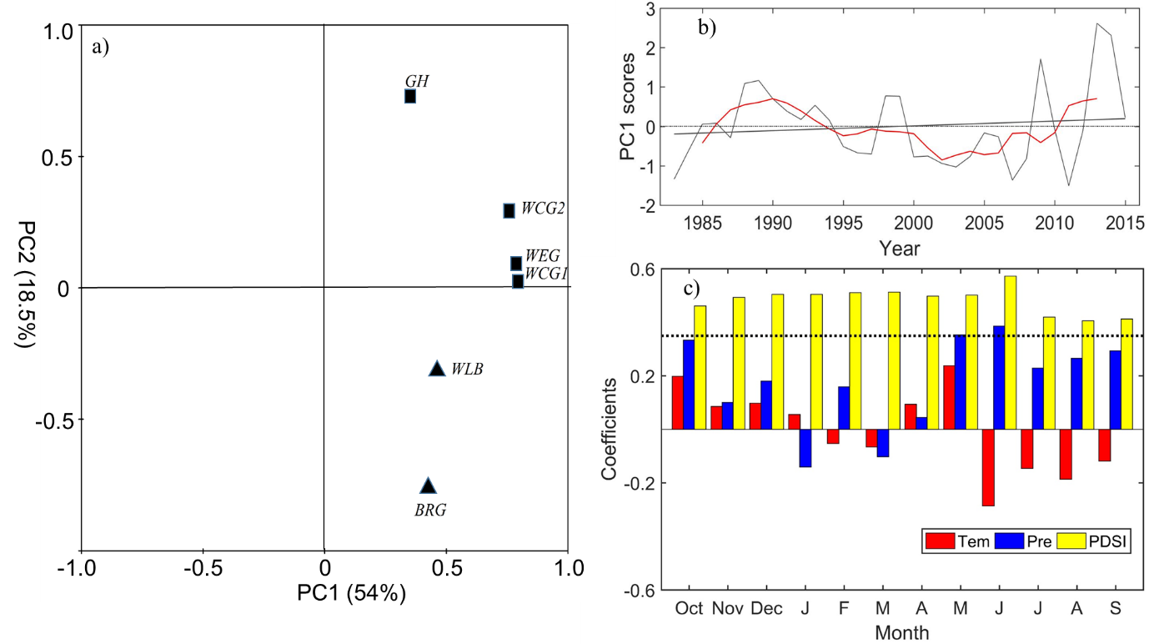
Fig. S3. Plots of principal component analysis (PCA) loadings of the 6 chronologies in period of 1984-2015 (a). Black straight line indicates the linear trend in the PC1, and red line indicates a five-year moving averages (b). Relationships between PC1 scores and regional mean temperature (Tem), precipitation (Pre) and Palmer Drought Severity Indices (PDSI) through October of prior year to September of current year during 1983–2015 (c).

Figure S4

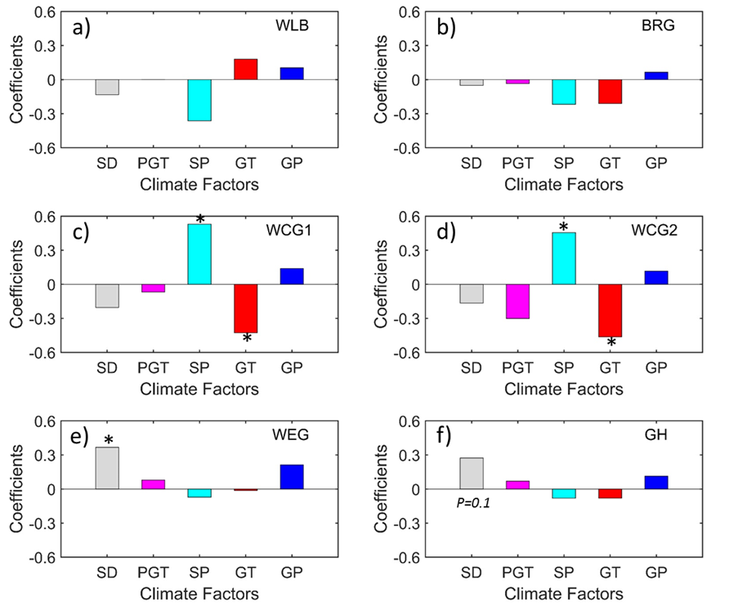

Fig. S4. Normalized regression coefficients of partial least square regression (PLSR) between six tree ring chronologies and different climate factors (a-f). Bars show the PLSR coefficients of winter snow depth (SD), pre-growing season temperature (PGT), spring precipitation (SP), growing-season precipitation (GP), and mean growing season temperature (GT). Stars indicate statistically significant (p < 0.05).

Figure S5

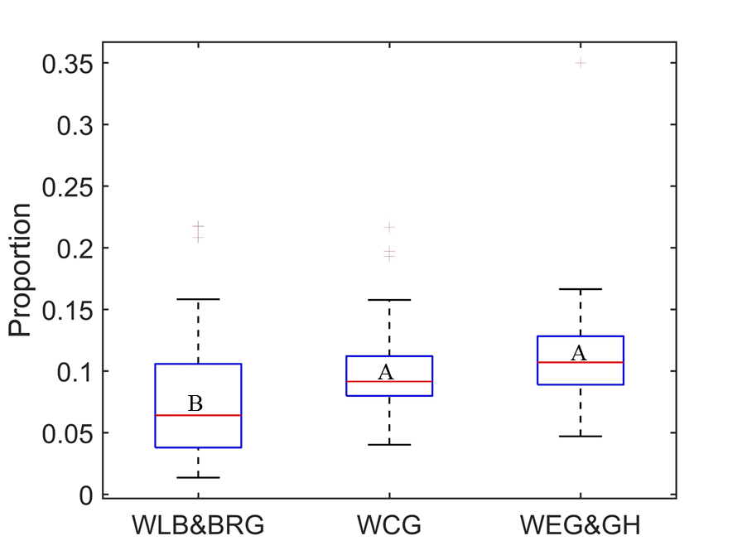
Fig. S5. The proportion of winter snow water equivalent to pre-growing season precipitation at 6 tree sampling sites. WCG shown here includes two sites (WCG1 and WCG2). Different letters among study sites indicate statistically significant.

Table S3
Table S3. Wet years and dry years identified by 1 standard deviations of scPDSI values
Sites | Wet Years | Dry Years
WLB | 1986, 1987, 1988, 1990, 1991, 1994, 1998, 1999, 2012, 2013. | 2002, 2003, 2004, 2005, 2006, 2007, 2010, 2011.
BRG | 1986, 1987, 1988, 1990, 1991, 1994, 1998, 1999, 2012, 2013. | 2002, 2003, 2004, 2005, 2006, 2007, 2010, 2011.
WCG1 | 1984, 1986, 1988, 1990, 1991, 1995, 1999, 2012, 2013, 2014. | 2000, 2001, 2002, 2003, 2004, 2005, 2006, 2007, 2008, 2009, 2010.
WCG2 | 1984, 1986, 1988, 1990, 1991, 1995, 1999, 2012, 2013, 2014. | 2000, 2001, 2002, 2003, 2004, 2005, 2006, 2007, 2008, 2009, 2010.
WEG | 1983, 1984, 1985, 1989, 1990, 1991, 1992, 1994, 1998, 1999. | 1987, 2001, 2002, 2003, 2005, 2006, 2007, 2008, 2009, 2015.
GH | 1983, 1984, 1985, 1989, 1990, 1991, 1992, 1994, 1999, 2014. | 1987, 2001, 2002, 2003, 2005, 2006, 2007, 2008, 2009, 2015.

