Electronic Supplementary Material ESM 2 - 6
Title:
Past and future snowmelt trends in the Swiss Alps: the role of temperature and snowpack

Authors:
Maria Vorkauf¹ evamaria.vorkauf@unibas.ch
Christoph Marty² marty@slf.ch
Ansgar Kahmen¹ ansgar.kahmen@unibas.ch
Erika Hiltbrunner¹ erika.hiltbrunner@unibas.ch

¹University of Basel, Department of Environmental Sciences, Botany, Schönbeinstrasse 6, 4056 Basel, Switzerland
² WSL Institute for Snow and Avalanche Research SLF, Flüelastrasse 11, 7260 Davos Dorf, Switzerland

Corresponding author
Maria Vorkauf¹, University of Basel, Department of Environmental Sciences, Botany,
Schönbeinstrasse 6, 4056 Basel
evamaria.vorkauf@unibas.ch, +41 61 207 35 04

Keywords
Climate change, scenario modelling, time series analysis, growing season, high-elevation, IMIS stations

Original research article submitted to Journal: Climatic Change

ESM2 Stations with data gaps in snowmelt dates (years) and how these gaps were filled
Station | Years | Gap filling of snowmelt
1GB | 1960 | Derived from snow depth measurements
1MR | 1960 | Derived from snow depth measurements
2EN | 1970 | Derived from snow depth measurements
6RI | 1958, 1970 | Based on similar course of HS during these two years
GOS | 2015 | Derived from snow depth measurements
GRH | 1975, 1979, 1991,  1993, 1995, 1997 | Correlation with GUE
GTT | 1954, 2012 | Correlation with 1WE
GUE | 1961, 1965, 1973 | Derived from snow depth measurements
GUE | 2004 - 2014 | Correlation with GRH

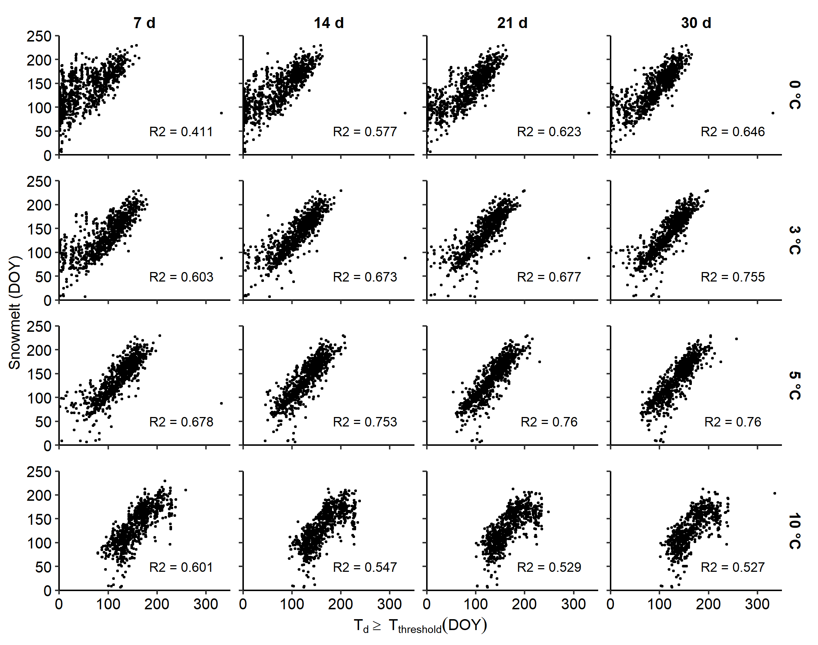
ESM 3 Snowmelt date (DOY) in relation to the first day (DOY) when the mean air temperature of a running window (d: 7, 14, 21, 30 days; columns) reaches a temperature threshold (T: 0, 3, 5, 10 °C; rows) with the corresponding coefficient of determination R²

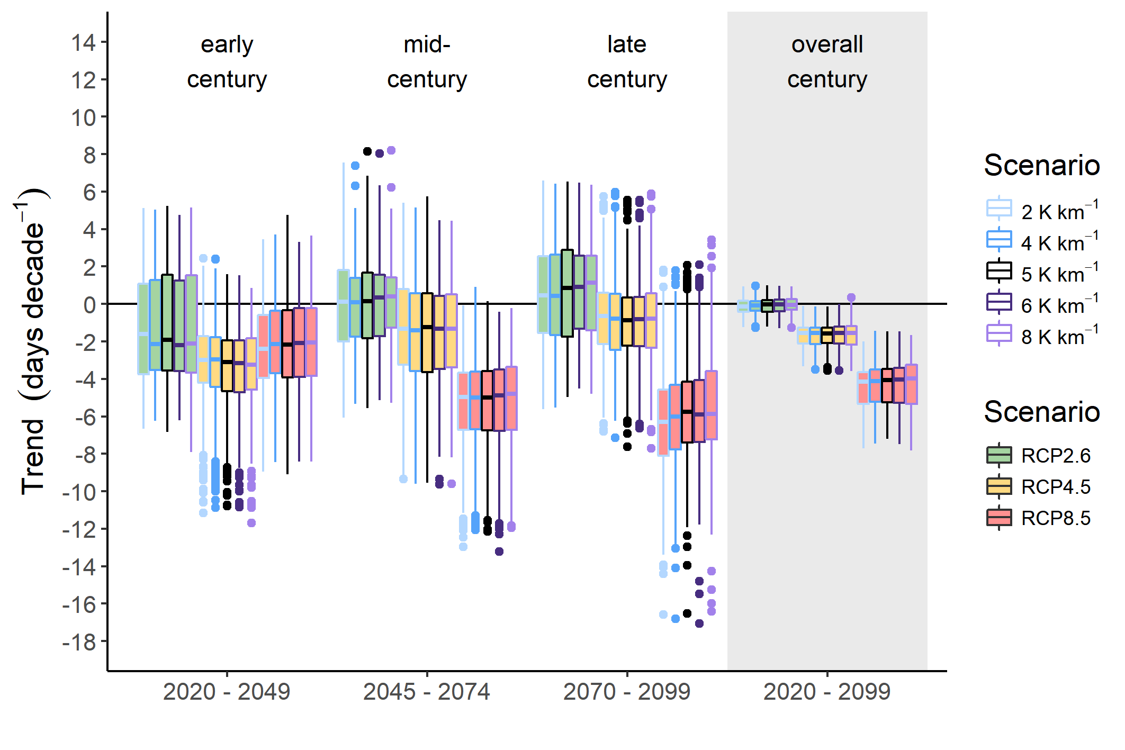
ESM4 Projected trends in snowmelt dates of 14 IMIS stations throughout the 21st century for the three emission scenarios RCP2.6, RCP4.5 and RCP8.5. In total 68 simulations basing on downscaled regional climate models: 12 for RCP2.6, 25 for RCP4.5, and 31 for RCP8.5. The colour of the whiskers indicates the lapse rate for air temperature used for correcting for elevational differences between the grid cells of climate change scenarios and the IMIS station. The coloured box contains 50% of all simulations per RCP scenario and time period

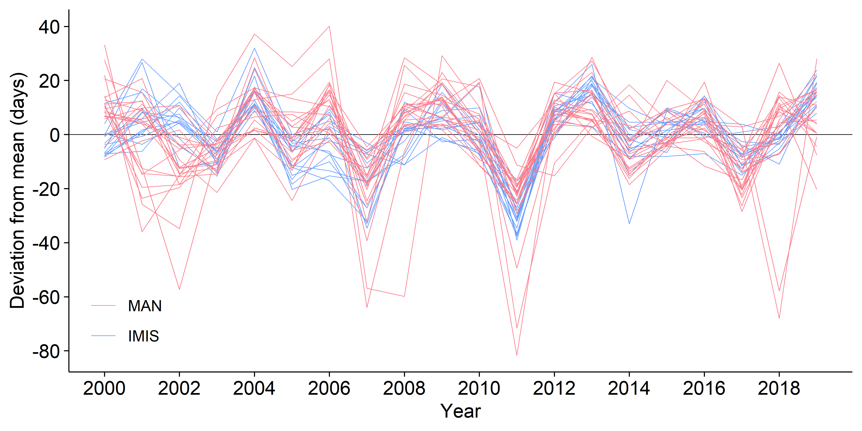
ESM5 Yearly deviation of snowmelt dates from the 10-year average (2000-2009) for manual 22 MAN (red) and 15 automatic IMIS (blue) stations

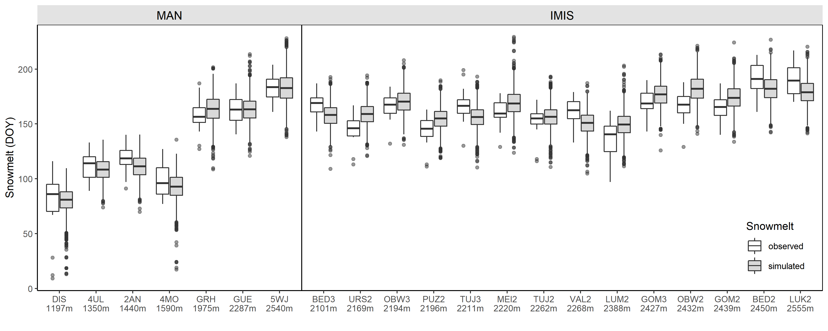
ESM6 Observed snowmelt (white boxplots) and simulated snowmelt based on the retrospective climate change scenarios (grey boxplots) for the reference period for the stations. The reference period for MAN stations is 1990 – 2019, for IMIS stations 2000 – 2019. Each boxplot contains all 68 simulations of three RCP scenarios for each year of the reference period (MAN: 30 x 68, IMIS: 20 x 68)

