Climate effects on US infrastructure: the economics of adaptation for rail, roads, and coastal development
James E. Neumann¹, Paul Chinowsky³, Jacob Helman³, Margaret Black¹, Charles Fant¹, Kenneth Strzepek^{1,2}, and Jeremy Martinich⁴
¹Industrial Economics, Inc., Cambridge, Massachusetts, USA, ²Massachusetts Institute of Technology, Cambridge, Massachusetts, USA, ³Resilient Analytics, Inc. and University of Colorado, Boulder Colorado, USA, ⁴U.S. Environmental Protection Agency, Washington, District of Columbia, USA
Supplemental Information on National Coastal Property Model (NCPM)
Overview

In previous work, the Environmental Protection Agency (EPA) and other funders, in cooperation with Industrial Economics Inc. (IEc), developed the National Coastal Property Model to identify areas at risk from permanent inundation due to sea-level rise (SLR) and from temporary flooding due to storm surge and to evaluate an economically efficient adaptation response. The NCPM has been used in some form, with comprehensive coastal cover, for over a decade, and for other local and national scale analyses since 1995.

The major versions of the NCPM as currently configured are as follows.

- Version 1: NCPM v1 was a sea level rise only model and is described in Neumann et al. (2010a and 2010b)

- Version 2: NCPM v2 included a storm surge damage and adaptive response component, described in Neumann et al. (2015)

- Version 3: NCPM v3 includes numerous updates that are detailed in this supplement and in various working papers and technical reports.

This supplement describes changes to the NCPM made since Version 2 published in 2015 and used in the second modeling phase of the Climate change Impacts and Risk Analysis (CIRA) project (U.S. EPA 2017). Since this last published description, modifications have been made to the NCPM, which include:

- Energy infrastructure damage assessment
- Updating sea level rise projections
- Updating storm surge heights
- Improving the decision rules used for selecting protection the best protection options
- Updating model initialization (or spin-up)
- Updating property values

Energy Infrastructure Damage

In 2015, energy infrastructure was added as an additional type of infrastructure damage assessed. The objective of this module is to analyze the value of at-risk coastal energy infrastructure and the costs of adapting that infrastructure to SLR and storm surge. Prior to 2015, we analyzed the extent to which coastal energy infrastructure within the contiguous U.S. could be vulnerable to SLR and storm surge (Version 2). One of the updates since 2015 was to build upon Version 2 by considering the adaptive response and evaluating direct costs to energy infrastructure. The adaptive response component is described below.

To evaluate exposure to these threats, spatial data were downloaded from the Energy Information Administration’s (EIA’s) U.S. Energy Mapping System (USEIA 2016). In particular, we gathered data on natural gas, natural gas liquid, crude oil, and petroleum pipelines as well as power plants, petroleum refineries, liquefied natural gas import/export terminals, crude oil rail terminals, petroleum product terminals, and natural gas market hubs. To estimate energy infrastructure sensitivity to the risks of SLR and storm surge, the EIA data were joined to the county-level data used in the NCPM. The data were summarized by grid cell, producing statistics such as facility counts, kilometers of pipeline by type, and total capacity levels for power plants and petroleum refineries, and incorporated into the NCPM.

The first step in evaluating the adaptive response is to value the facilities and pipelines at risk. Facilities were valued using the property values incorporated into the NCPM. The property value data in the NCPM were primarily derived from assessor data and where these data were not available from Census property value data. Some corrections were made to the property value data where grid cells containing energy facilities had particularly low or high values. Low valued grid cells (those with values less than $250,000) were scaled upwards using the average value per facility calculated by facility type and applying this value to the facilities falling within the grid cell. High valued grid cells (those with values more than $50 million) were scaled downwards according to the percentage of value derived from industrial and commercial land uses.

Pipelines were valued based on replacement cost, or the cost of constructing new pipeline. Average construction cost for natural gas, natural gas liquid, and crude oil pipeline were calculated using data from the INGAA Foundation, which represents natural gas pipelines and companies that provide goods and services to pipelines (INGAA Foundation 2014). These costs were applied to our spatial pipeline data assuming that the cost to construct petroleum pipelines would be most similar to the cost to construct crude oil pipelines to estimate the pipeline value per grid cell.

The next step in evaluating the adaptive response is to determine the value that could be lost due to SLR inundation or flooding caused by storm surge. For SLR inundation, this value is simply the total property value. On the other hand, because storm surge only causes temporary inundation, the full property value would not be lost following these episodic events. Instead, we apply depth-damage functions from the Army Corps to calculate the percentage of a property’s structural value that could be lost. For pipelines, we assume that the full value of pipeline would be lost (i.e., the pipeline would be completely destroyed) due to any amount of storm surge. Although it is likely that pipeline along the coast would be built to withstand some amount of storm surge, we were unable to identify evidence of this. Therefore, our assumption of complete loss provides a high-end estimate of potential damages to this type of energy distribution infrastructure.

Once we have determined the value that could be lost due to SLR inundation and flooding, the model weighs these values against the costs to protect the property. Figures S-1 S-2 outline the protection decisions contained within the model. In summary, when at risk from SLR, a property will be abandoned if the cost to protect the property is greater than its value. If the cost is less than the value of the property the property will either armor or nourish depending upon whether it is located on a sandy beach. The value of a property includes both the assessed property value plus the value of any energy pipelines located within the property.

In the case of storm surge there is one additional decision option available to property owners, to neither abandon nor protect, but temporarily incur storm surge damages and the costs associated with repair. For storm surge, a property will be abandoned if storm surge damages over a 10-year time frame are greater than the value of the property, if not the property will temporarily incur storm surge damages if the costs to protect are greater than the 10-year storm surge damages and will either armor or elevate, whichever is lower cost, if the costs to protect are less than the 10-year storm surge damages.

Figure S-1 SLR Decision Tree with Energy Analysis
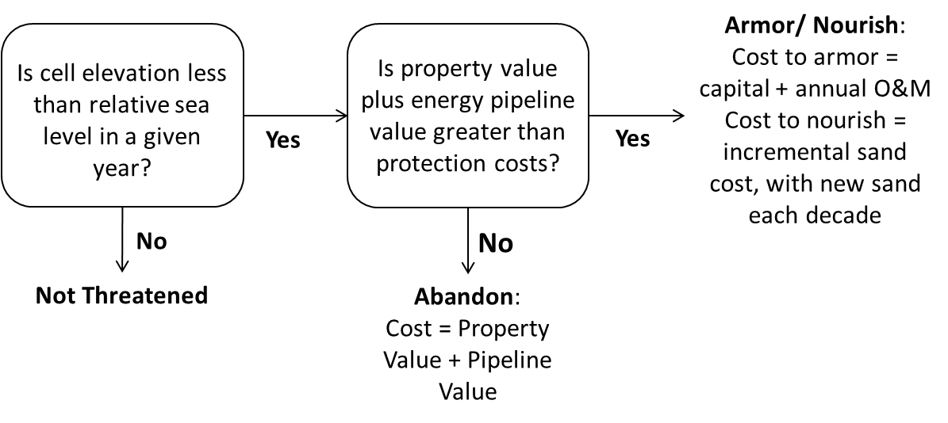
Figure S-2 Storm Surge Decision Tree with Energy analysis
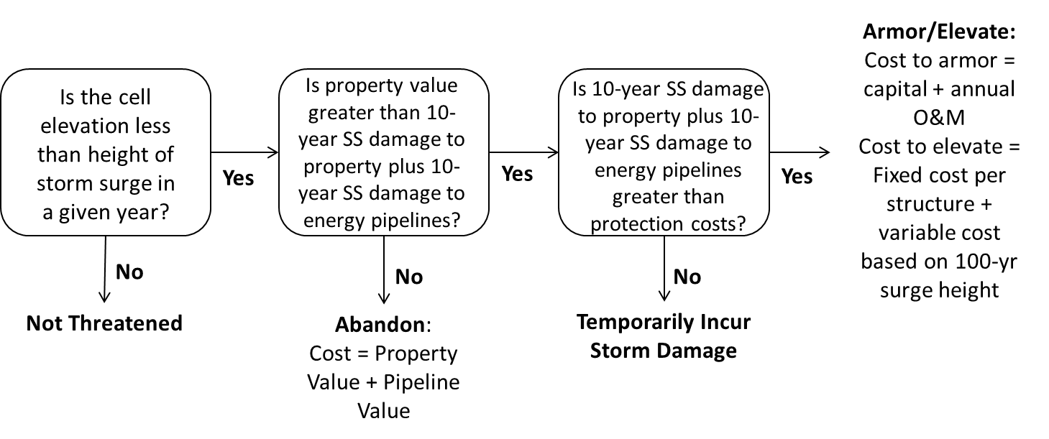
The storm surge analysis can be run for 17 multi-county study areas (covering 70 of the 302 coastal counties in the NCPM) for which we have modeled storm surge from Emanuel (2013). These results are then extrapolated to the remaining 232 unmodeled counties using a discrete approach that first assigns the unmodeled counties to the closest multi-county study area within the same coastal region (East, Gulf, or West Coast) and then assigns the unmodeled counties to a modeled county within that study area based on the closest match for property value at risk. This extrapolation allows us to preliminarily assess the impacts to energy infrastructure at a national level. The storm surge component of the energy analysis can also be run using the comprehensive historic storm surge data available for all coastal counties – when this alternative storm surge data is used, no extrapolation is necessary.

Sea Level Rise Projections

For the Fourth National Climate Assessment, Sweet et al. (2017) developed a set of six global sea level rise scenarios that used the Kopp et al. (2014) projections to tie global scenarios to regional sea level changes. The highest of their six scenarios (the ‘extreme’ scenario) led to 2.5 m (8.2 ft) of global mean sea level (GMSL) rise between 2000 and 2100. The decision to add this 2.5 m scenario (which ended at 2.0 m for the Third National Climate Assessment) was based on newer evidence about the contributions of Antarctic ice-sheets to sea level rise (Kopp et al. (2017) and arguments from Miller et al. (2013) that 2.3–2.7 m (7.5–8.9 ft) of global mean sea level (GMSL) rise by 2100 was within the realm of physically plausibility. In addition, leveraging the Kopp et al. (2014) projection engine, the results from Sweet et al. (2017) include local sea level rise grids for each of their six GMSL rise scenarios. For this analysis, we use these 1-degree gridded projections from Sweet et al. (2017) by aggregating to the county-level. Of the three uncertainty scenarios—low, medium, high—we use the medium.

Storm Surge Probabilities

Previous studies using the NCPM relied on projected storm surge probabilities derived from Emmanuel (2013). The modeling in Emanuel (2013) is complex and computationally expensive. As a result, storm surge probabilities were produced for 70 counties (of the 302) where major damages were expected. In previous NCPM work, an extrapolation technique was used to estimate damages for the remaining 232 counties. For this analysis we use historical tide gauge measurements (NOAA 2018), which allows direct estimation of storm surge for all counties. Using these tide gauges, we extracted the maximum daily water level from each record, and de-trended the resulting set of maximum gauge heights from each time series. From the detrended data, we then calculated a distribution of storm surge heights by fitting a generalized extreme value distribution to the annual maximum time series from each gauge. This provided an estimate of the surge heights associated with return intervals ranging from 2 years to 500 years. Tide gauges with less than 10 years of data were excluded. Stations were matched to counties using proximity and topography. Storm surge probabilities may change in the future. However, for this analysis we opt to use historical tide gauge information because these provide greater coverage across coastal counties.

Property Protection Decision Rules

The original formulation of the NCPM triggered adaptation decisions for storm surge with simplified cost-benefit tests. The decision rules for permanent inundation associated with SLR were not changed. However, the decision rules for adaptation to episodic flooding caused by storm surge, which rises as sea levels rise, were reformulated to enable a traditional cost-benefit test. New rules were developed that compare the cost of different adaptation options within each cell to the expected reduction in damages that would result from those adaption options. As with the previous version of the NCPM, we assume that armoring and elevation will be implemented for the 100-year flood. The new cost-benefit test compares an estimate of discounted avoided damages over the next 30 years with the cost of each adaptation option. This decision rule is based on an estimate of expected annual damages (EAD) and expected annual benefits of adaptation. EAB is the avoided damages given the assumption that adaptation will prevent damages for events up to and including the current 100-year flood. The decision relies on the following variables:

P = Property value in a cell; varies across cells and is inflated over the model run
C = Cost of adaptation; varies across cells and adaptation type. For abandonment, C = P. For armoring and elevation, cost includes capital and present value of maintenance.
EAD = Expected annual damages = Area A + Area B from Figure S-3 below.
EADP = Expected annual damages with adaptation in place = Area B (i.e., damages for events larger than the 100-year event)
EAB = expected annual benefits of adaptation = EAD – EADP
The new cost-benefit test compares an estimate of discounted avoided damages over the next 30 years with the cost of each adaptation option (see Figure S-4). The decision rule is based on an estimate of expected annual damages (EAD) and expected annual benefits of adaptation.

Figure S-3 Illustration of how the NCPM estimates expected annual damage. The area under the curve represents EAD; area A is the EAD for floods that have at least 1% annual chance exceedance and area B is the EAD for floods that have less than 1% annual chance exceedance. The NCPM estimatesdamages for flood events shown by the larger points along the curve.

Figure S-4 New adaptation decision rule for storm surge in the NCPM

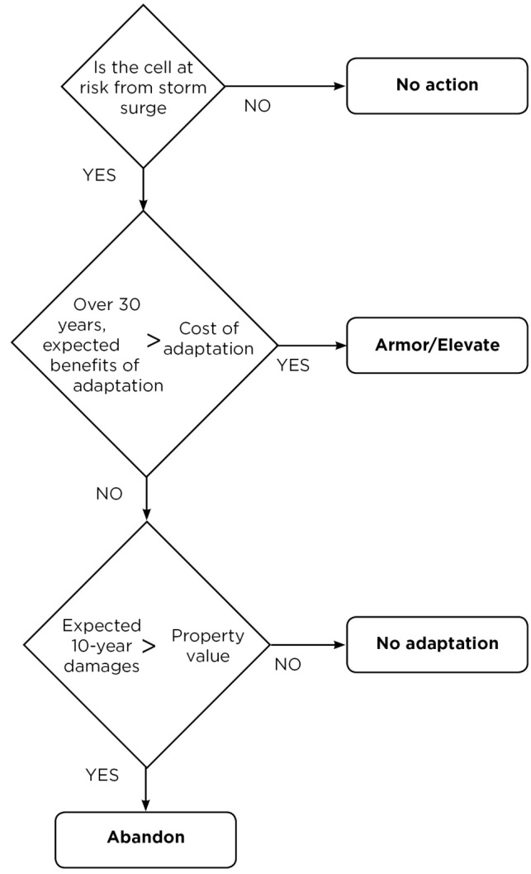

For each adaptation decision, the NCPM looks ahead 30 years, using current EAD as the approximation. The NCPM discounts future EAD, which has for Federal Government sponsored analyses been the 3 percent (real) rate required by OMB Circular A-4, to obtain a present value of expected damages over 30 years. Expected damages are estimated with and without adaptation for the 100-year event in order to estimate a present value of expected benefits of adaptation. In its simplest form, the decision rule implements the lowest cost adaptation option if EAB for that option exceeds C. This represents a traditional cost-benefit test for optimal risk reduction investment.

Model Initiation (Spinup)

Comprehensive data on existing storm surge protection (sea walls, elevated structures) across CONUS, to our knowledge, is not available. We account for existing protection by first running the NCPM over an initiation period. This technique is also called model “spin-up” and is often used in dynamic models to provide a consistent starting point for each simulation. Model initiation allows for the most cost-effective protection during model initiation, with all options available independent of the adaptation scenario. These costs are excluded in the total costs. There is evidence (Bakkensen and Mendelsohn 2016) that suggests there is little meaningful adaptation to coastal flood risk in the U.S. Further, there is ample evidence that people’s flood risk choices, including mitigation investments, do not follow traditional rational economic assumptions (Wachinger et al. 2013; Bubeck et al. 2012; Poussin et al. 2014). With this in mind, it’s likely that our model initiation overbuilds—i.e., decisions made are more cost effective than reality. If we were to use a less than optimal initiation, three main issues arise. First, the model would need to estimate a suboptimal decision framework that mimics reality—a difficult task for model developers and nearly-impossible without historical information to tune or calibrate the results. Second, the model needs to start from a “stable” state. For example, if the model starts in a sub-optimal state for a proactive adaptation, a slug of protection will occur in the earlier years.

Costs were estimated nationally both with and without model initiation for the 150 cm, without adaptation scenario in order to better understand the impacts of model initiation on the final costs. The 150 cm scenario represents a high-end estimate but not as extreme as 200 or 250 cm and we expect model initiation (or spinup) to have the largest impact on the No Adaptation scenario than either the Reactive or Proactive scenarios. Figure S-5 shows a comparison of these costs over time (left) and with a scatter plot (right) on a decadal basis. As shown, without spinup scenario starts in the first year with costs already reaching over $150 billion and rising to $350 billion. This gap of $150 billion persists between the with and without spinup results, although over time this gap lessens over time, as shown by the curve in the scatter plot.
Figure S-5: Comparison of costs with and without spinup in timeseries (left) and in a scatter plot (right), without adaptation, undiscounted, billion $2017 / year, for the 150 cm scenario

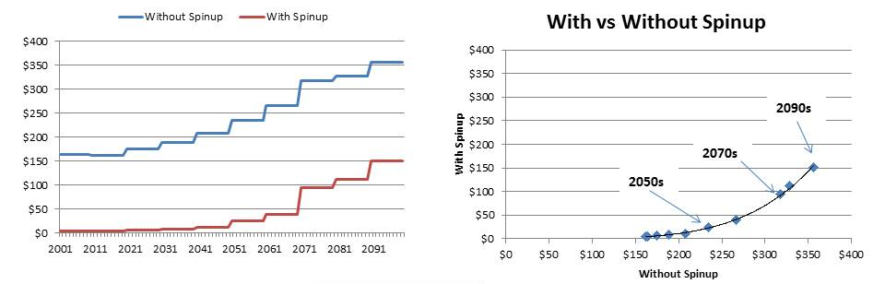

Comparison of costs for two sites

Two sites were chosen for comparison because these sites have history with extensive storm surge damage. The two- county Tampa site (Pinellas and Hillsborough Counties) was chosen because it represents the highest estimated SLR and storm surge damage among Gulf Coast sites – Tampa also has an interesting combination of open ocean and back bay frontage; includes urban, rural, and beachfront settings; and includes a complex canal- style development that can be particularly difficult to assess in an aggregate model of this type. The four- county Virginia Beach site was chosen because it ranks high on most SLR and storm surge vulnerability assessments and also includes a mix of urban, suburban, and beachfront development. Further, the Virginia Beach area has experienced a relatively high historic SLR rate for Atlantic Ocean fronting sites owing to high rates of subsidence (mainly due to isostatic rebound effects). The Virginia Beach site includes Hampton, Portsmouth, Norfolk, and Virginia Beach counties.

Table 1 shows differences in the resulting total costs (2001-2100) between Version 2 of the NCPM and the updated version that includes the updated SLR, updated storm surge probabilities, new decision rules, and model initiation. The main driver for these differences in total costs (particular discounted totals) is model initiation, which includes high abandonment costs for these two study sites, as well as costs for armoring and elevating. The new decision rules also significantly reduced abandonment, especially for the Tampa site (see Figure S-6).

Table S-1 Comparison of costs for two study sites, Tampa and Virginia Beach, undiscounted and discounted $2015, for 2001-2100 and the 150 cm SLR scenario.
 | Cost Type | Undiscounted Costs |  |  | Discounted Costs
 | Cost Type | Version 2 | Updated Version* | Differ-ence | Version 2 | Updated Version* | Differ-  ence
Tampa | Armor | $9,659 | $6,333 | -34% | $4,092 | $1,706 | -58%
Tampa | Elevate | $202 | $66 | -67% | $177 | $30 | -83%
Tampa | Nourish | $11,338 | $11,338 | 0% | $2,164 | $2,164 | 0%
Tampa | Abandon | $17,978 | $77 | -100% | $20,882 | $17 | -100%
Tampa | Storm Surge | $22,150 | $15,940 | -28% | $10,246 | $5,648 | -45%
Tampa | Total | $61,327 | $33,754 | -45% | $37,562 | $9,566 | -75%
Virginia Beach | Armor | $6,080 | $4,898 | -19% | $2,044 | $1,299 | -36%
Virginia Beach | Elevate | $30 | $22 | -29% | $16 | $6 | -61%
Virginia Beach | Nourish | $5,910 | $5,910 | 0% | $1,166 | $1,166 | 0%
Virginia Beach | Abandon | $1,151 | $793 | -31% | $1,152 | $165 | -86%
Virginia Beach | Storm Surge | $5,469 | $3,179 | -42% | $2,941 | $1,297 | -56%
Virginia Beach | Total | $18,641 | $14,803 | -21% | $7,318 | $3,934 | -46%

* Includes updated SLR, updated storm surge, probabilities, decision rules, and model initiation

Figure S-6 Comparison of cell-by-cell decisions for the Tampa study site over the evaluation period, 2000-2100, for 150 cm SLR scenario. Note that model initiation is included in both maps.

Version 2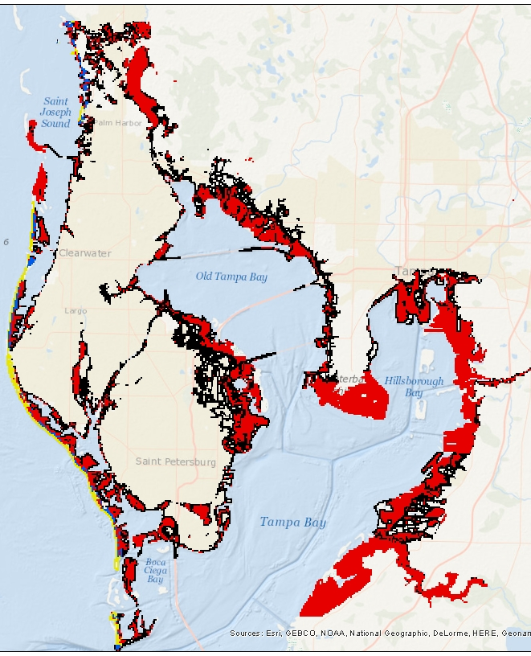 | Updated Version*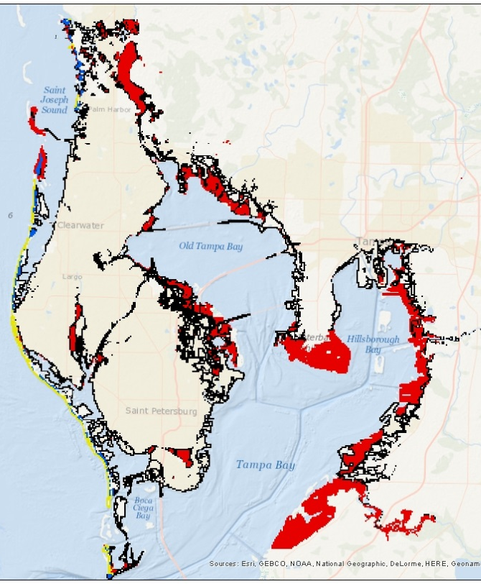
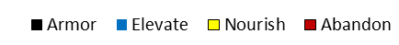
* Includes updated SLR, updated storm surge, probabilities, new decision rules

Property Value Database Update

Spatially explicit property value data, when compared to the cost of protection, ultimately determines whether at-risk cells will be protected or abandoned. In 2009, we obtained the broadest possible coverage of assessed values for individual parcels, including all residential, commercial, industrial, institutional, and government properties, by contracting with a commercial service (DataQuick Information Systems) that compiles assessed property data from assessors’ records across the country. This acquired data was provided to us aggregated to the Census block group level. Property values reflect mostly 2009 and 2008 property assessments, with some 2007 assessments. We converted all property values to 2006 dollars as a pre-processing step. Note that, except to the extent they are incorporated or capitalized in property values, the value of public infrastructure is excluded from property values.
In 2018, coastal property values in the NCPM were updated to 2017 values using the Zillow Home Value Index (ZHVI), which is freely available for two resolutions: by (1) zip code nationally and (2) for select municipalities by “neighborhood” (smaller than zip code but larger than census block).
ZHVI was used to scale the previous values (2006) to 2017 by
$$V_{2017}=V_{2006}*\left({{ZHVI}_{2017}}/{{ZHVI}_{2006}}\right)$$
This method maintains the finer spatial resolution of the census block data, but updates the values closer to those in 2017.
Calculating these ratios is simple; however, since the ZHVI is provided at varying resolutions and is, in rare cases, missing for certain zip codes, maintaining the finest resolution available and filling in the missing data is more complex.
We do this by applying the following steps:
- Neighborhood level data: If the Zillow neighborhood data is available, assign the calculated ratio for the neighborhood.
  - In some cases, we have neighborhood designation without the necessary data to calculate the ratios. In these cases, the average ratio was calculated based on the neighborhood’s city designation.
  - If data was not available at the city level, the neighborhood was not assigned a ratio and the Zip-resolution data was used.
- Zip level data: For all grids that are not assigned a ratio at the neighborhood level, we apply the following rules
  - If zip code is included in the Zillow data, use zip code property value ratio
  - For zip codes missing from Zillow database, ratios were imputed by
    - Use the average ratio in the county
    - If no data for the county, use average ratio across the State

Below is a summary of available or unavailable ZHVI data for calculating the ratios:
- 7,441 neighborhoods have data in Zillow excel workbook
- 10,924 neighborhoods in Zillow neighborhood shapefile
- 5,830 neighborhoods in the Zillow shapefile are missing from the Excel workbook
- 234 neighborhoods in Excel workbook are missing property value data and cannot calculate a ratio for
- 409 neighborhoods are found in cities that have no data collected
- 95 cities have no data collected
Table S-2 below shows the property values by region for the original DataQuick property values obtained in 2010 and compares these with the property values adjusted by the ZHVI (in 2018) as just described. These values represent all property with elevation less than 50 cm as these are the most vulnerable to sea level rise. Also, all values are brought to year 2017 dollars so they are comparable. The largest changes are in the South Atlantic with a 23% reduction in value. The Gulf and North Atlantic show reduction while the Pacific shows an increase of about 9%. Overall property values decrease by 5%. Figure S-7 shows these same comparisons for all coastal States. We see that Florida property values decrease significantly compared to other States.

Table S-2 Property Values by Region (bill $2017), all property with elevation less than 50 cm)
Region | Dataquick  (2010) | ZHVI updated  (2018) | Difference | % Change
Gulf | $1,308 | $1,197 | -$111 | -8%
Pacific | $1,955 | $2,130 | $175 | 9%
North Atlantic | $4,235 | $4,125 | -$110 | -3%
South Atlantic | $1,957 | $1,498 | -$459 | -23%
Total | $9,455 | $8,950 | -$505 | -5%

Figure S-7 Changes in property value (billion $2017, all property with elevation less than 50 cm). Change is presented by value in the bar chart and by percent in the row labels.

Tables S-3 and S-4 compare the costs to coastal property (NCPM model results) for RCP8.5 for the No Adaptation scenario and the Proactive Adaptation scenario, respectively. Nationally, the No Adaptation costs are reduced by about 4%, while projected costs are reduced by about 8% for the Proactive Adaptation scenario. Note that these results include all of the updates to the model described above as part of Version 1.3.

Table S-3 Total costs to coastal property for the No Adaptation scenario for RCP8.5 (billions of $2017)
Region | Dataquick (2010) | ZHVI updated (2018) | Difference
North Atlantic | $154 | $140 | -9%
South Atlantic | $923 | $888 | -4%
Gulf | $481 | $472 | -2%
Pacific | $77 | $75 | -3%
Total | $1,635 | $1,575 | -4%

Table S-4 Total costs to coastal property for the proactive adaptation scenario for RCP8.5 (billions of $2017)
Region | Dataquick (2010) | ZHI updated (2018) | Difference
North Atlantic | $143 | $113 | -21%
South Atlantic | $166 | $156 | -6%
Gulf | $196 | $190 | -3%
Pacific | $39 | $42 | 6%
Total | $545 | $500 | -8%

References

Bakkensen, L. A., & Mendelsohn, R. O. 2016. Risk and adaptation: evidence from global hurricane damages and fatalities. Journal of the Association of Environmental and Resource Economists, 3(3), 555-587.
Bubeck, Philip, Wouter JW Botzen, and Jeroen CJH Aerts. 2012. "A review of risk perceptions and other factors that influence flood mitigation behavior." Risk Analysis 32(9): 91481-1495.
Emanuel, K. A. 2013. Downscaling CMIP5 climate models shows increased tropical cyclone activity over the 21st century. Proceedings of the National Academy of Sciences, 110, 12219-12224.
INGAA Foundation, Inc. March 18, 2014. “North American Midstream Infrastructure through 2035: Capitalizing on Our Energy Abundance.” An INGAA Foundation Report, Prepared by ICF International.
Kopp, R.E., R.M. Horton, C.M. Little, J.X. Mitrovica, M. Oppenheimer, D.J. Rasmussen, B.H. Strauss, and C. Tebaldi. 2014. Probabilistic 21st and 22nd century sea-level projections at a global network of tide-gauge sites. Earth's Future, 2, no. 8, 383-406, doi:10.1002/2014EF000239.
Kopp, R.E., R.M. DeConto, D.A. Bader, C.C. Hay, R.M. Horton, S. Kulp, M. Oppenheimer, D. Pollard, and B.H. Strauss. 2017. Evolving understanding of Antarctic ice-sheet physics and ambiguity in probabilistic sea-level projections. Earth's Future, 5, no. 12, 1217-1233, doi:10.1002/2017EF000663.
Neumann JE, Hudgens DE, Herter J, Martinich J. 2010a. The Economics of Adaptation along Developed Coastlines. Wiley Interdiscip Rev Clim Chang 2(1):89–98

Neumann, JE, Hudgens DE, Herter J, Martinich J. 2010b. Assessing Sea-Level Rise Impacts: A GIS-Based Framework and Application to Coastal New Jersey. Coastal Management, 38, 433-455.

Neumann, J., K. Emanuel, S. Ravela, L. Ludwig, P. Kirshen, K. Bosma, and J. Martinich. 2015. Joint Effects of Storm Surge and Sea-level Rise on U.S. Coasts. Climatic Change, 129, 337-349, doi: 10.1007/s10584-014-1304-z.

NOAA (National Oceanic and Atmospheric Administration). 2018. NOAA Tides and Currents - Water Levels. Available at https://tidesandcurrents.noaa.gov/stations.html?type=Water+Levels. Accessed June 2018.
Poussin, J. K., Botzen, W. W., & Aerts, J. C. 2014. Factors of influence on flood damage mitigation behaviour by households. Environmental Science & Policy, 40:69-77.
Sweet, W.V., R. Horton, R.E. Kopp, A.N. LeGrande, and A. Romanou. 2017. Sea level rise. In: Climate Science Special Report: Fourth National Climate Assessment, Volume I [Wuebbles, D.J., D.W. Fahey, K.A. Hibbard, D.J. Dokken, B.C. Stewart, and T.K. Maycock (eds.)]. U.S. Global Change Research Program, Washington, DC, USA, pp. 333-363, doi: 10.7930/J0VM49F2.
U.S. Energy Information Administration. 2016. U.S. States, State Profiles and Energy Estimates, Notes & Sources. http://www.eia.gov/state/notes-sources.cfm#maps
U.S. EPA. 2017. Multi-Model Framework for Quantitative Sectoral Impacts Analysis: A Technical Report for the Fourth National Climate Assessment. U.S. Environmental Protection Agency, EPA 430-R-17-001.

Wachinger, G., Renn, O., Begg, C., & Kuhlicke, C. 2013. The risk perception paradox—implications for governance and communication of natural hazards. Risk analysis, 33(6): 1049-1065.

.

https://www.zillow.com/research/data/ Accessed in August 2018

