Online Supplementary Material

Section 2.2: Reviews of risk and vulnerability assessments
Expanding on section 2.2 of the article, the following section summarizes the main findings of previous large-scale reviews of existing risk and vulnerability assessments, many of which indicator-based. Preston et al. (2011) review 69 climate vulnerability assessments published in the peer-reviewed and grey literature, including 45 assessments that took a spatially explicit approach to mapping vulnerability. Their review focuses on comparing the goals and objectives, the conceptual framing and the methodological approach of these assessments, and evaluates to which degree they were co-designed with relevant stakeholders. Key findings include, that (i) assessments vary depending on the focus of the assessment (vulnerability of what) and the hazard context (vulnerability to what), (ii) the conceptual framing influences the choice of vulnerability drivers considered in the assessments, (iii) vulnerability mapping is an emergent practice, and (iv) that only a limited number of studies have engaged with stakeholders. Beccari (2016) reviews 106 index-based sub-national risk, vulnerability and resilience assessments in regards to their methodological approach (i.e. key steps in index construction). His study finds substantial variation in index construction methodologies, however a number of common trends also became evident from the review: indicators were commonly chosen by experts, either not normalized or normalized using min-max approaches, and were combined using equal weights. Maps represented the most common format of visualizing the results. The analysis also revealed a large variation in the variables that were used in assessments, ranging from as few as two to as many as 235 (with 75% using less than 40 variables). Population density and unemployment rate were by far the most commonly used indicators, followed by population above 65 and GDP per capita. Ford et al. (2018) reviewed 587 climate change vulnerability assessments published in the peer-reviewed literature since 1990. Based on their comprehensive review they identify seven key concerns to inform future research: prioritization of physical and/or environmental over social vulnerability drivers, promotion of a rather static understanding of human-environmental interactions, neglect of cross-scale interactions, ambiguity in some of the underlying drivers of vulnerability, limited influence on decision making and, confirming a point stressed by Preston et al. (2011) before, limited collaboration with stakeholders. Hagenlocher et al. (2019b) reviewed and evaluated 105 drought vulnerability and risk assessments across spatial (local to global) and temporal scales. Their analysis shows that more than 40% of the assessments did not provide a clear definition of risk, index-based approaches are used most frequently (>60% of all assessments; confirming findings from Beccari (2016), the majority did not specify their weighting method, only few conducted any form of validation of their results, and less than 40% provided recommendations for action and policy. De Sherbinin et al. (2019) reviewed 84 climate change vulnerability mapping studies with the aim to identify best practices and limitations and provide recommendations for future spatial assessments. Their study confirms findings of previous similar efforts described above (e.g. frequent use of index-based approaches, challenges in map validation, and insufficient engagement with stakeholders), but also finds increasing conceptual convergence in the way that an increasing number of assessments is based on the latest risk definitions put forward by the Intergovernmental Panel on Climate Change (IPCC). Lastly, and most recently, Ward et al. (2020) reviewed the scientific literature on global scale risk assessments for different hazards (e.g. cyclones, droughts, floods, earthquakes, wildfires, tsunamis, volcanoes) focusing notably on the question in how far these studies have considered future projections of hazard, exposure and vulnerability. One key finding of their study is that studies focusing on climatological, meteorological and hydrological hazards tend to consider future projections more often as compared to studies focusing on geological hazards.

Section 4.1: Comparison of the four different global risk indices
Expanding on 4.1 of the paper, this section and Table SM1 provide a detailed overview of the four different global risk indices including their aims and sub-components. The WRI aims to analyze the risk of 171 countries to suffer harm or damage from natural hazards. Conceptually, risk is framed as being the product of exposure and vulnerability. The WRI defines vulnerability as the sum of susceptibility, lack of coping capacity and lack of adaptive capacity. People affected by natural hazards such as floods, cyclones, and sea level are the exposed element. Conceptually, INFORM is closely related to the WRI, as it defines risk as the product of exposure multiplied by vulnerability and the lack of coping capacity in 191 countries. Similar to the WRI, INFORM views exposure as the amount of people exposed to natural hazards. However, it is quite different from the WRI in that it considers exposure not only to natural hazards but, in a second exposure component, also to human hazards, understood as current and projected conflicts. This difference originates in the fact that INFORM puts the focus on the risk to humanitarian crisis and disaster, acknowledging the strong feedback and cascading impacts particularly between violent conflicts and disasters related to natural hazards. However, given that the focus of our paper here is on climate and disaster risk and that we want to consistently compare between indices with this focus, we use only the exposure to natural hazards when comparing the different exposure dimensions.

GAIN aims to assess how well countries (n=175) are prepared to deal with climate change. Conceptually, it considers a country’s readiness (consisting of economic, governance and social readiness) and juxtaposes it to vulnerability, considering six main sectors (food, water, health, ecosystem services, human habitat and infrastructure). In contrast to the WRI and INFORM approach, GAIN includes exposure in the vulnerability component. It calculates vulnerability as exposure multiplied by susceptibility and the lack of adaptive capacity. The focus on climate change and projected changes of global natural features (e.g. Projected change of cereal yields or warm periods) instead of probabilistic models (e.g. annual expected exposed people to floods) as exposure is an additional unique feature.

The CRI does not follow the standard risk framework but incorporates the relative and absolute fatalities and economic losses of weather-related loss-events for 181 countries over the past 20 years (1999-2018). Hence, it is very different from the other three indices as it concentrates exclusively on past damages. It does not apply a forward-looking and hypothetical perspective of risk and it does not offer detailed information on the sub-components of risk.

Table SM1: Comparison of the four different global risk indices, their aims and sub-components.
 | World Risk Index | INFORM | ND-GAIN | Climate Risk Index
Aim | Analyze the risk of a country to suffer harm or damage from natural hazards | Analyze a country’s risk of humanitarian crisis and disaster | Analyze which countries are best prepared to deal with global changes | Analyze to what extent countries have been affected by weather-related loss-events
Concept | Risk = Exposure * Vulnerability; with Vulnerability = Susceptibility + (1-Coping Capacity) + (1-Adaptive Capacity ) | Risk = Exposure x Vulnerability x (1-Coping Capacity) | ND-GAIN = (Readiness – Vulnerability + 1) * 50  Vulnerability = Exposure * Sensitivity * (1-Adaptive Capacity) | Risk = fatalities + economic losses
Hazards | Natural hazards:  floods, tropical cyclones, droughts, earthquakes |  | Climate change | n/a (not explicitly considered)
Hazards | Natural hazards:  sea level rise | Natural hazards: tsunami  Human hazards: Current & projected conflict intensity | Climate change | n/a (not explicitly considered)
Exposure | People in hazard prone areas |  | Projected change in: (1) yield, (2) people, (3) annual runoff, (4) groundwater recharge, (5) deaths from climate-induced diseases, (6) length of transmission season for vector-borne diseases, (7) biome distribution, (8) marine biodiversity, (9) warm periods, (10), flood hazards, (11) hydropower generation capacity, (12) sea level rise impacts, (13) | n/a (not explicitly considered)
Focus | Risk & vulnerability (natural hazards) | Risk & vulnerability (natural hazards, conflict) | Climate risk & impacts (loss of life, economic losses) | Climate risk & adaptation
Countries | 171 | 191 | 175 | 181
Indicator | 27 | 54 | 45 | 2
Missing data treatment | Yes (based on similar sources for a period of up to 10 years) | Yes (based on similar sources for a period of up to 5 years) | Yes (linear interpolation) | n/a
Outlier treatment | No information made available by index developers | Yes, in an iterative process based on skewness and kurtosis | Cuts off 10-percentile or 90-percentile of heavily skewed indicators | n/a
Multicollinearity treatment | No information made available by index developers | Correlation analysis used to identify collinearities | n/a | n/a
Normalization approach | Not applied to all indicators; if applied then linear max normalization (i.e. dividing scores by max score) | Linear min-max [0-1] applied to all indicators | Linear min-max [0-1] applied to all indicators (while using thresholds) | n/a
Weighting of indicators | Equal weighting of indicators at the sub-component level | Equal weighting of indicators | Equal weights of indicators | n/a
Aggregation method | Averaging of vulnerability indicators; multiplicative aggregation of exposure and vulnerability | Mix of arithmetic and geometric average of indicator scores | Arithmetic mean | n/a
Source | (Behlert et al., 2020) | (UN OCHA, 2020) | (Chen et al., 2015) | (Eckstein et al., 2019)
Year of publication | 2020 | 2020 | 2015 | 2019

Section 4.1: List of indicators used in the different indices
Expanding on section 4.1 of the paper, Table SM2 provides a full list of indicators used in the different indices. Figure SM1 then provides the Euler diagrams with the indicator overlaps. The number of individual and overlapping indicators was counted for the overall risk as well as the sub-components. Results were visualized using the Eulerr (Larson, 2020) package in R (R Core Team, 2020). We used Euler diagrams which only show the actual overlaps between the indicators, in contrast to the Venn diagrams, which display all possible overlaps possible, even if they do not contain any objects.

Table SM2: Indicators used in the different indices

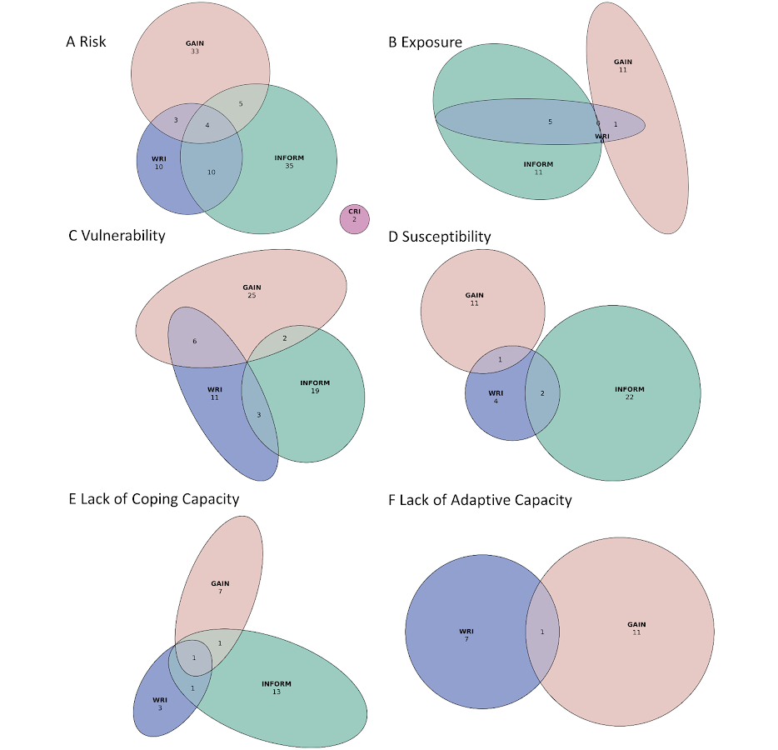

Figure SM2: Euler diagram on the similarities of the risk indices and their sub-components in regards to underlying indicators. Overall risk (a), exposure (b), vulnerability (c), susceptibility (d), lack of coping capacity (e) and lack of adaptive capacity (f).

Section 4.2: Correlations between WRI, INFORM, GAIN and CRI by index and sub-index
Expanding on section 4.2 of the paper, Table SM2 provides an overview over the correlations between the different indices and their sub-components, organized by the respective index.

Table SM3: Correlation coefficients between the different risk indices and their different components on exposure (Exp), vulnerability (Vul), susceptibility (Susc), lack of coping capacity (LCC) or readiness and lack of adaptive capacity (LAC), grouped by indices. The significance levels are indicated by the asterisks: ** correlation is significant at the 0.01 level (2-tailed) and * correlation is significant at the 0.05 level (2-tailed). The green color shading indicates the strength of correlation with a grouping into moderate (> 0.5), medium-strong (>0.7), strong (>0.8) and very strong (>0.9) correlations.

Section 4.3: Ranges and means of country scores across different indices
Expanding on section 4.3 of the paper, Figure SM3 plots the inter-index means against the ranges of all countries considered, in overall risk as well as different risk components. Panel 3a) shows that for countries’ overall risk scores no significant difference in the inter-index range of results can be observed across the spectrum of high-to-low risk countries. Ranges in countries’ risk normalized risk scores between the four indices considered span from zero to almost one. Countries with the highest risk mean (0.8 to 1.0 in a scale from zero to one) show amongst the lowest ranges (< 0.6 in a scale from zero to one). Panel b shows that a similar pattern can be observed when considering only the exposure sub-components of the three indices considered (the CRI is only included into the overall risk analysis).
For vulnerability and susceptibility (panels c and d), the picture looks different with, first, a lower overall range and, second, a mild negative correlation in that countries with higher vulnerability or susceptibility tend to have a slightly lower range in their inter-index scores. Countries with the highest vulnerability and susceptibility scores (0.8 to 1.0 in a scale from zero to one) all have ranges < 0.4 (in a scale from zero to one).
The smallest inter-index ranges can be observed in the capacity related sub-components, i.e. lack of coping capacity (LCC) and lack of adaptive capacity (LAC). Almost all countries stay within a range bandwidth of between 0 and 0.4. The mean range is only 0.1 for LCC and even below 0.09 for LAC, even though one has to consider that in the latter case only two indices provide information (WRI and GAIN), instead of three in the case of LCC. In other words, there is much higher inter-index agreement (i.e. less of a range) between the capacity-related sub-components, when compared to the vulnerability/susceptibility and particularly the exposure and risk information. These findings are in line with the higher correlations observed in the two capacity sub-components (Table 1). In both LCC and LAC, the low range persists across the entire spectrum of mean capacity. A potential explanation is the comparatively strong overlap in terms of the underlying indicators (section 4.1).

Figure SM3: Relationships between the mean scores and ranges between normalized scores of countries in different indices for overall risk (A), exposure (B), vulnerability (c), susceptibility (D), lack of coping capacity (E) and lack of adaptive capacity (F). The number of data points refers to the availability of index information for the respective country from either two, three or four indices. Cases with just one available data point were excluded from the analysis.

Section 4.3: Ranks of countries across different indices
Expanding on section 4.3 of the paper, Figure SM4 presents an analysis on how country-level ranks differ when moving from one index to the next. A number of patterns can be observed. Illustrative cases of these patterns are highlighted through coloring.

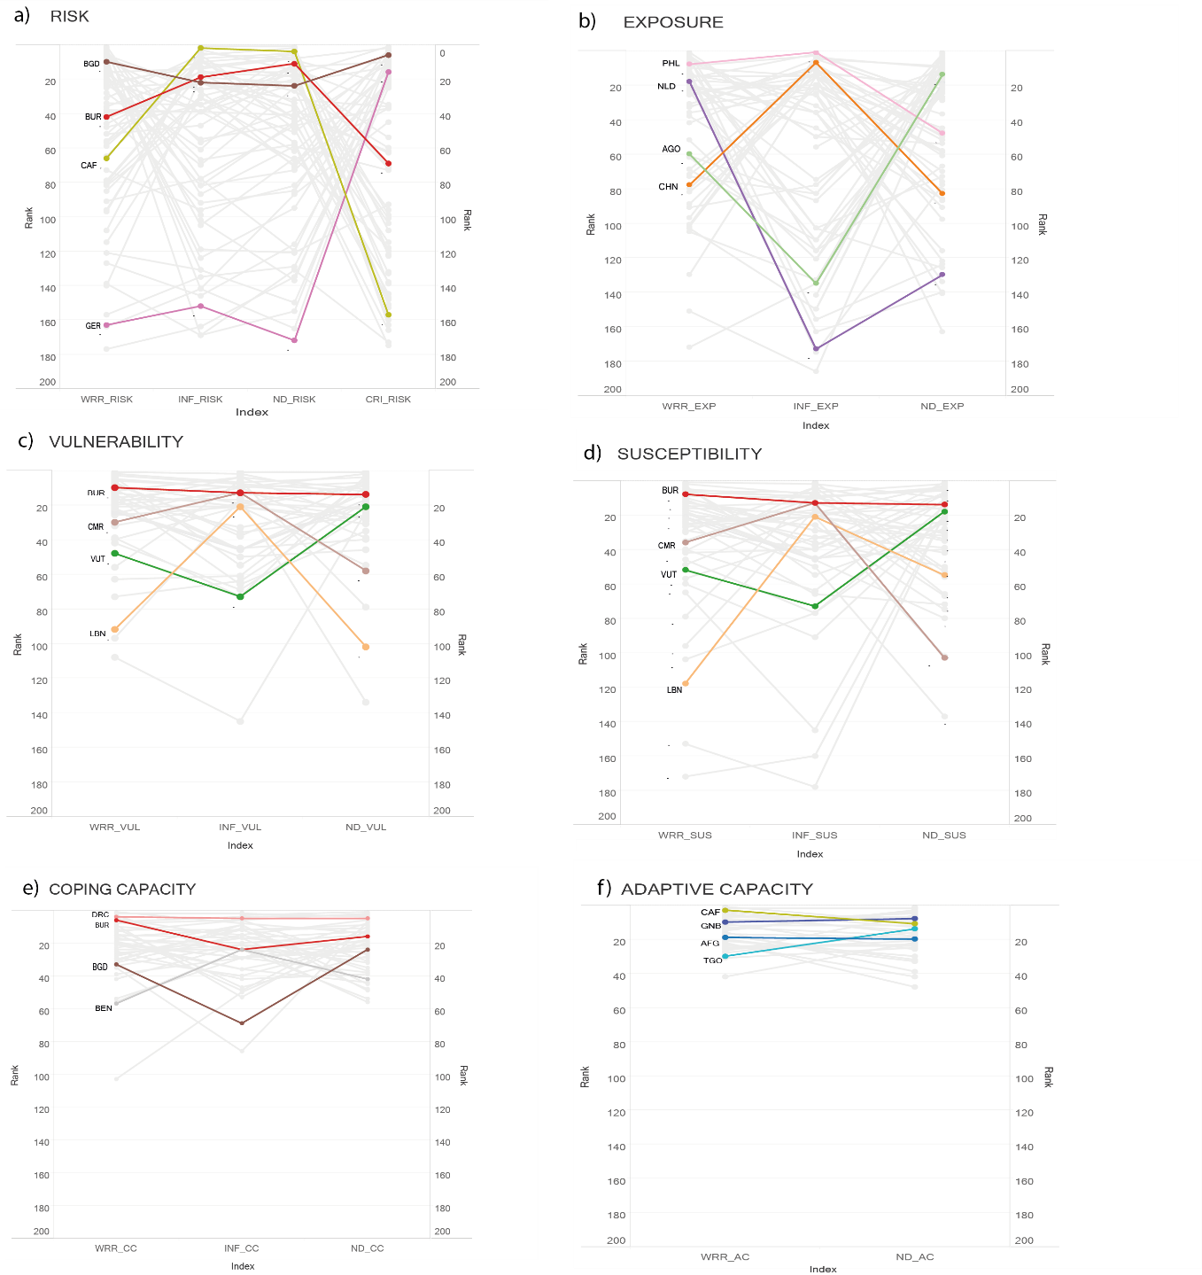
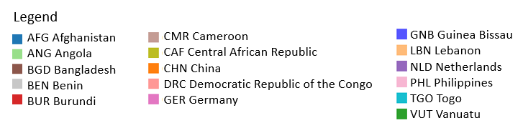
Figure SM4. Comparison of country rankings across global risk indices for the overall risk score (a), and the individual sub-components (b-f) of selected countries. The coloured lines highlight typical countries of the different patterns that can be observed in the grey lines, i.e. amongst the countries overall. Low numbers on the Y-Axis indicate high ranks, meaning high risk, exposure etc.

Section 4.3: Inter-index ranges across different country groups
Expanding on the analysis provided in section 4.3 of the paper, Figure SM5 plots the range of normalized scores for overall risk and its components for the global as well as filtered for different country groups relevant for climate and disaster risk policy debates. The Y-axis shows the different country groups considered: Global, Continent (Africa, Asia, America, Europe, Oceania), UN DESA’s Development Status groups (More developed regions, Less Developed Regions, LDCs, Landlocked Developing Countries) and finally policy-relevant groups such as Small Island Developing States (SIDS) and the Vulnerable 20 group (V20). The X-Axis shows the normalized range scores from 0 to 1. Each boxplot represents the range of scores for risk or one of its sub-components for that particular country group. Furthermore, the plots also reveal the median value of each country group for risk and its sub-components across the different indices.

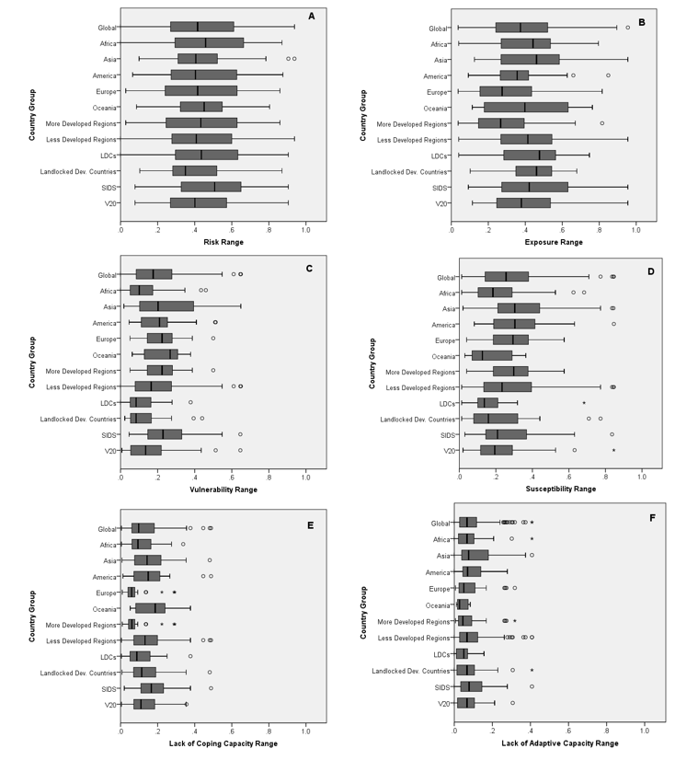
Figure SM5: Box plots showing the distribution of ranges of normalized scores of countries across indices for different country groups for overall risk (a) and each of its sub-components (b) exposure, (c) vulnerability, (d) susceptibility, (e) lack of coping capacity and (f) lack of adaptive capacity.

Panel A shows the range of normalized overall risk scores across all four indices (WRI, GAIN, INFORM and CRI). The figure shows no clear trend i.e. all country groups indicate a similar range of scores between 0 to 1. The pattern changes slightly for panel B showing the range of exposure scores (using INFORM’s natural exposure). The smallest ranges or in other words, highest agreement in exposure scores among the different indices can be observed for the country groups America and Landlocked Developing Countries. For vulnerability and susceptibility, in panels C and D, the picture changes significantly. The overall extent of the range in vulnerability and susceptibility scores is almost entirely less than 0.4 and 0.6 respectively (on a scale from 0 to 1), for all country groups. The LDCs group shows the highest agreement in these two panels with a small range less than 0.4, on a scale from 0 to 1. Similarly, panels E and F on lack of coping capacity and lack of adaptive capacity, show a small range less than 0.4, on a scale from 0 to 1. This small range in both capacity dimensions are in line with the findings in Section 4.3. This observation of a higher agreement could be potentially explained by the stronger overlap of indicators and weighting methodologies used across the indices for LCC and LAC. Another observation for box plots on LAC and LCC is the increase in the number of outliers in comparison to the rest of the panels. This can be potentially attributed to more missing data in these two sub-components in comparison to the other sub-components.
Some interesting patterns can be observed in particular country groups. For example, in climate policy negotiations and for questions of climate funding, LDCs, SIDS, African and V20 countries are often highlighted as the priority countries. Their distributions show a high median, particularly for overall risk and exposure. Potential implications include a high disagreement on their scores among the indices, which in turn question the robustness of the use of one or the other index over another in guiding decisions and negotiations. On the other hand, lower medians and smaller ranges in the other components indicate a higher agreement among their scores. However, this must be interpreted with caution due to the possibility of the influence of missing data on this observed distribution. In general, a slightly higher agreement can be seen in the more developed regions in comparison to the less developed regions.

Section 4.3: Agreement on hotspot countries
In a final step of the analysis, we evaluate the level of agreement or disagreement across the four global risk indices for those countries with the highest risk, exposure, vulnerability, susceptibility, lack of coping capacity (LCC) and lack of adaptive capacity (LAC). Expanding on section 4.3 in the paper, we also selected the top 25 countries in risk and each sub-component and for each index in order to then count whether and to which degree countries are ranked in the top 25 consistently across the different indices.

Figure SM6 shows the outcomes of the hotspot analysis that was conducted by comparing the top 25 countries with the highest risk (panel a), exposure (panel b), vulnerability (c), susceptibility (d), lack of coping capacity (e) and lack of adaptive capacity (f) in the four global risk indices considered here.
For risk, in total 66 countries are listed in the top 25 of one of the four indices. 20 countries are ranked in the top 25 countries in two of the four indices. Four countries (i.e. Afghanistan, Myanmar, Mozambique, and Niger) are listed in three of the four indices. Two countries (i.e. Bangladesh and Haiti) are listed amongst the top 25 countries in all four risk indices. While there are strong overlaps in sub-Saharan Africa and parts of Asia, panel a also reveals clearly that there are significant differences in regards to risk hotspots. Only six countries in the Americas are listed in the top 25 of either of the indices, including two in the Caribbean (i.e. Bahamas, Haiti), four in Central America (i.e. Costa Rica, Guatemala, El Salvador, and Nicaragua), and none in South America.
For the exposure sub-components of WRI, INFORM and GAIN, a different pattern emerges (panel b). While 43 countries appear in the list of top 25 in at least one of the three indices, and 16 countries in two of the three indices, there is no country that is mentioned in all three indices as a top 25 country. There is a comparatively high cross-index agreement on exposure for countries with large low-elevation coastal zones (LECZ), such as Bangladesh, Dominican Republic, India, Japan, Kiribati, Papua New Guinea, the Philippines, or small islands (e.g., Kiribati, Solomon Islands, Timor Leste, Tonga), featuring exposure to multiple hazards.
For vulnerability (WRI, INFORM, GAIN), the analysis reveals a much stronger consistency across indices as compared to the risk and exposure components. While 18 countries appear in the list of top 25 in at least one of the indices, 12 countries are mentioned in two, and 11 countries in all three global risk indices with a vulnerability sub-component. With this robustness in mind, a strong hotspot emerges in sub-saharan Africa (panel c). Out of the 11, ten are located in sub-Saharan Africa (i.e. Burundi, Chad, the Central African Republic, DRC, Ethiopia, Liberia, Mali, Niger, Sudan and Uganda), with Afghanistan being the only exception. For susceptibility (panel d) a quite similar picture emerges with eight countries being on the list of top 25 countries in all four indices, all of which also being located in sub-Saharan Africa.
The highest agreement across indices can be observed in the capacity-related sub-components, i.e. lack of coping capacity (LCC) (panel e) and lack of adaptive capacity (LAC) (panel f): (i) for LCC 11 countries appear in the top 25 of the three indices that have a LCC sub-component (i.e. WRI, INFORM, GAIN), and (ii) for LAC 18 countries appear amongst the top 25 countries in the WRI and GAIN (as the two indices who have such a component. Similar to vulnerability and susceptibility a strong cluster of consistent index scores emerges in sub-Saharan Africa, again with the exception of Afghanistan, Papua New Guinea (only in the LAC component), Iraq and Yemen (both only in the LCC component).

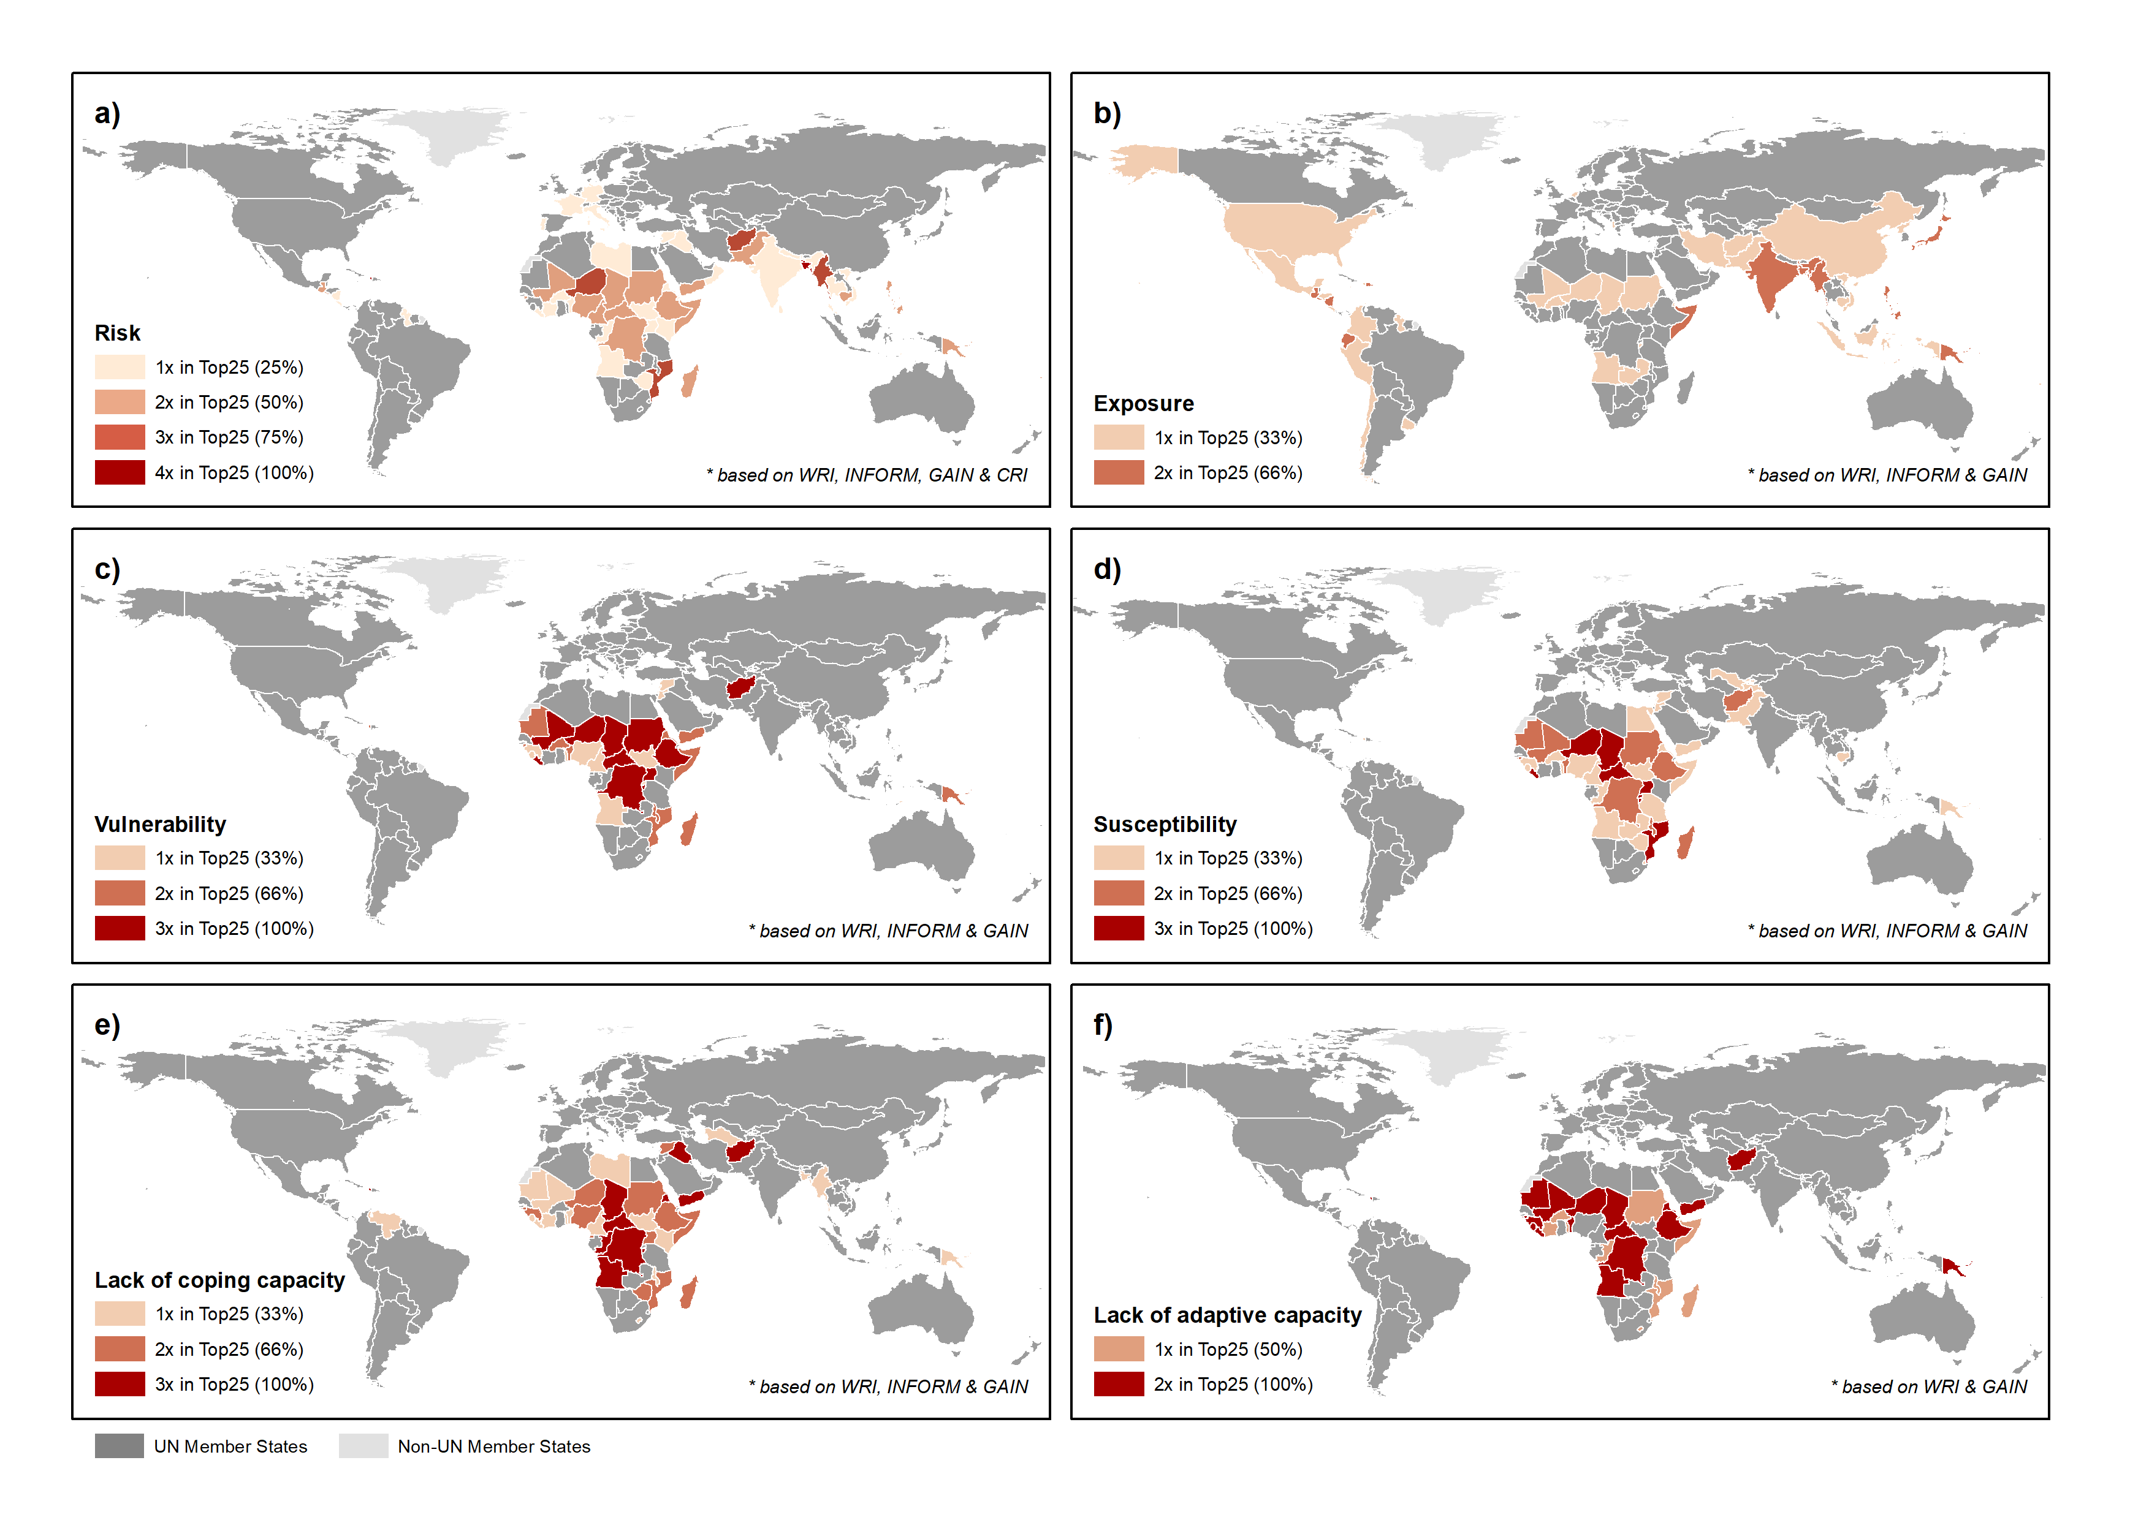 Figure SM6: Consistency across global risk indices for the overall risk score, (a) and the individual sub-components of risk (b-f) when focusing on the top 25 countries with the highest score in risk and its sub-components. Dark red indicates a higher number of mentions in the top 25 of each of the four risk indices considered here.

