Supplementary Material

 | N | Mean | SD | Min | Max
Migration intentions | 37,673 | 0.354 | 0.478 | 0 | 1
WSDI annual trend, 1979–2016 | 37,673 | 0.345 | 0.354 | -0.31 | 2.83
WSDI annual trend, 2009–2016 | 37,086 | 2.197 | 3.499 | -8.52 | 17.19
WSDI change | 37,673 | 9.388 | 10.384 | -7.38 | 81.55
WSDI 10-year average | 37,673 | 14.062 | 9.657 | 0 | 76
WSDI 3-year average | 37,673 | 0.218 | 0.175 | 0 | 1.32
HWM 10-year average | 37,673 | 1.182 | 1.367 | 0.14 | 13.41
SPEI 3-year average | 37,673 | -0.406 | 0.645 | -3.16 | 1.79
Climate literacy | 37,673 | 0.443 | 0.497 | 0 | 1
Female | 37,666 | 0.500 | - | 0 | 1
Age | 37,644 | 36.75 | 14.75 | 18 | 106
Table S1a: Summary Statistics I

 | N | %
Education (N=37,485)
No education | 8,140 | 21.7
Primary education | 10,237 | 27.3
Secondary education | 13,660 | 36.44
Post-secondary education | 5,448 | 14.5
Profession (N=35,508)
Not working | 7,188 | 20.2
Farmers | 9,841 | 27.7
Unskilled workers | 11,335 | 31.9
Specialists | 3,474 | 9.8
Students | 3,670 | 10.3
News consumption (N=37,656)
Never | 7,101 | 18.9
Less than once a month | 15,116 | 40.1
A few times a month | 8,054 | 21.4
A few times a week | 5,189 | 13.8
Every day | 2,196 | 5.8
Table S1b: Summary Statistics II

Items | Question wordings
Migration intentions | How much, if at all, have you considered moving to another country to live?  Not at all, A little bit, Somewhat, A lot
Climate literacy | Have you heard about climate change or haven’t you had the chance to hear about this yet?  No, Yes  (If Yes) What does the phrase “climate change” mean to you?  Negative changes in the weather like more droughts, floods or extreme heat, Positive changes in the weather like better rainfall patterns or longer growing seasons, Other changes in weather patterns  (If Yes) Do you think climate change is making life in [in your country] better or worse, or haven’t you heard enough to say?  Much better, Somewhat better, Neither/no change/about the same, Somewhat worse, Much worse
News consumption | How often do you get news from the following sources? Radio, Television, Newspapers, Internet, Social Media such as Facebook or Twitter  Every day, A few times a week, A few times a month, Less than once a month, Never
Education | No education, Primary education, Secondary education, Post-secondary education.
Profession | What is your main occupation?  Never had a job, Student, Housewife/Homemaker, Agriculture/Farming/Fishing/Forestry, Trader/Hawker/Vendor, Retail/Shop, Unskilled manual worker (e.g., cleaner, laborer, domestic help, unskilled manufacturing worker), Artisan or skilled manual worker (e.g., trades like electrician, mechanic, machinist or skilled manufacturing worker), Clerical or secretarial, Supervisor/Foreman/Senior Manager, Security services (police, army, private security), Mid-level professional (e.g., teacher, nurse, mid-level government officer), Upper-level professional (e.g., banker/finance, doctor, lawyer, engineer, accountant, professor, senior-level government officer), Other
Location | Rural, urban
Table S1c: Question wordings

Short name | Long name | Brief description | Units | Reference paper
WSDI | Warm Spell Duration Index | Annual number of days contributing  to events in which 6 or more consecutive  days experience Tmax > 90th percentile | Days | Zhang et al., 2011
SPEI | Standardized  Precipitation  Evapotranspiration  Index | A multi-scale drought measure  specified using precipitation and  evaporation, here computed at 12 monthly scales | Unitless | Vicente-Serrano,  2010
HWM | Heat Wave Magnitude | Average temperature across all individual heatwaves, wherein an individual heatwave is defined as 3 or  more consecutive days with Tmax > 90th percentile | °C | Perkins and Alexander, 2013
Table S2: Climate Extreme Indices

 | (1) | (2) | (3) | (4) | (5) | (6) | (7)
 | WSDI annual trend  1979-2016 | WSDI annual trend  2009-2016 | WSDI change  [2009-2016]-[1979-2008] | WSDI 10-year average | WSDI  3-year average | HWM  10-year average | SPEI  3-year  average
Climate literacy | 0.0716*** | 0.0806*** | 0.0748*** | 0.0708*** | 0.0710*** | 0.0786*** | 0.0862***
 | (0.0078) | (0.0072) | (0.0076) | (0.0099) | (0.0095) | (0.0075) | (0.0070)
Climate change index | 0.0345* | 0.0027 | 0.0011* | 0.0005 | 0.0193 | -0.0021 | 0.0065
 | (0.0180) | (0.0019) | (0.0006) | (0.0006) | (0.0394) | (0.0067) | (0.0087)
Climate literacy*Index | 0.0455*** | 0.0023 | 0.0013** | 0.0012** | 0.0746** | 0.0073** | -0.0027
 | (0.0161) | (0.0019) | (0.0006) | (0.0006) | (0.0356) | (0.0037) | (0.0087)
Female | -0.0841*** | -0.0849*** | -0.0842*** | -0.0842*** | -0.0843*** | -0.0841*** | -0.0839***
 | (0.0051) | (0.0051) | (0.0051) | (0.0051) | (0.0051) | (0.0051) | (0.0051)
Age | -0.0066*** | -0.0066*** | -0.0066*** | -0.0066*** | -0.0066*** | -0.0066*** | -0.0066***
 | (0.0002) | (0.0002) | (0.0002) | (0.0002) | (0.0002) | (0.0002) | (0.0002)
Country FE | Yes | Yes | Yes | Yes | Yes | Yes | Yes
Climate zone FE | Yes | Yes | Yes | Yes | Yes | Yes | Yes
Month–year FE | Yes | Yes | Yes | Yes | Yes | Yes | Yes
N | 37,637 | 37,052 | 37,637 | 37,637 | 37,637 | 37,637 | 37,637
R2 | 0.113 | 0.114 | 0.113 | 0.113 | 0.113 | 0.113 | 0.113
Notes: Estimates from OLS models. Standard errors clustered at the survey interview location in parentheses. *** p<0.01, ** p<0.05, * p<0.1
Table S3: Effect of Climate Change Variables on Migration Intentions for Climate Literates and Illiterates

 | (1) | (2) | (3) | (4) | (5) | (6) | (7)
 | WSDI annual trend  1979-2016 | WSDI annual trend  2009-2016 | WSDI change  [2009-2016]-[1979-2008] | WSDI 10-year average | WSDI  3-year average | HWM  10-year average | SPEI  3-year  average
Climate literacy | 0.221*** | 0.292*** | 0.241*** | 0.207*** | 0.227*** | 0.268*** | 0.303***
 | (0.0376) | (0.0371) | (0.0363) | (0.0479) | (0.0463) | (0.0367) | (0.0344)
Climate change index | 0.145 | 0.0173* | 0.0053 | 0.00206 | 0.111 | -0.0128 | 0.0132
 | (0.0939) | (0.0099) | (0.0033) | (0.0034) | (0.202) | (0.0321) | (0.0432)
Climate literacy*Index | 0.263*** | 0.0053 | 0.0073*** | 0.0075** | 0.384** | 0.0354** | -0.0165
 | (0.0798) | (0.0095) | (0.0028) | (0.0029) | (0.173) | (0.0174) | (0.0419)
Female | -0.352*** | -0.355*** | -0.352*** | -0.352*** | -0.352*** | -0.351*** | -0.350***
 | (0.0266) | (0.0268) | (0.0266) | (0.0266) | (0.0266) | (0.0266) | (0.0266)
Age | -0.0306*** | -0.0306*** | -0.0306*** | -0.0306*** | -0.0306*** | -0.0305*** | -0.0306***
 | (0.0012) | (0.0012) | (0.0012) | (0.0012) | (0.0012) | (0.0012) | (0.0012)
Primary education | 0.259*** | 0.260*** | 0.261*** | 0.262*** | 0.262*** | 0.262*** | 0.260***
 | (0.0414) | (0.0419) | (0.0414) | (0.0413) | (0.0414) | (0.0414) | (0.0414)
Secondary education | 0.557*** | 0.564*** | 0.559*** | 0.559*** | 0.560*** | 0.560*** | 0.558***
 | (0.0414) | (0.0417) | (0.0414) | (0.0414) | (0.0415) | (0.0416) | (0.0415)
Post-secondary education | 0.898*** | 0.888*** | 0.900*** | 0.900*** | 0.900*** | 0.897*** | 0.897***
 | (0.0544) | (0.0546) | (0.0543) | (0.0546) | (0.0545) | (0.0544) | (0.0546)
Country FE | Yes | Yes | Yes | Yes | Yes | Yes | Yes
Climate zone FE | Yes | Yes | Yes | Yes | Yes | Yes | Yes
Month–year FE | Yes | Yes | Yes | Yes | Yes | Yes | Yes
N | 37,449 | 36,873 | 37,449 | 37,449 | 37,449 | 37,449 | 37,449
Notes: Estimates from Ordinal Logistic models. DV migration intentions categorized into “no at all”, “a little bit”, “somewhat”, and “a lot”. Standard errors clustered at the survey interview location in parentheses. *** p<0.01, ** p<0.05, * p<0.1
Table S4: Effect of Climate Change Variables on Migration Intentions for Climate Literates and Illiterates, Ordinal Logistic Regression

 | (1) | (2) | (3) | (4) | (5) | (6) | (7)
 | WSDI annual trend  1979-2016 | WSDI annual trend  2009-2016 | WSDI change  [2009-2016]-[1979-2008] | WSDI 10-year average | WSDI  3-year average | HWM  10-year average | SPEI  3-year  average
Climate literacy | 0.0455*** | 0.0561*** | 0.0490*** | 0.0446*** | 0.0456*** | 0.0540*** | 0.0603***
 | (0.0076) | (0.0071) | (0.0074) | (0.0098) | (0.0094) | (0.0075) | (0.0069)
Climate change index | 0.0312* | 0.0027 | 0.0011* | 0.0005 | 0.0214 | -0.0019 | 0.0041
 | (0.0169) | (0.0019) | (0.0006) | (0.0006) | (0.0375) | (0.0061) | (0.0083)
Climate literacy*Index | 0.0477*** | 0.0021 | 0.0014** | 0.0012** | 0.0753** | 0.0067* | -0.0039
 | (0.0156) | (0.0019) | (0.0006) | (0.0006) | (0.0350) | (0.0036) | (0.0086)
Female | -0.0710*** | -0.0716*** | -0.0710*** | -0.0710*** | -0.0710*** | -0.0709*** | -0.0708***
 | (0.0052) | (0.0052) | (0.0052) | (0.0052) | (0.0052) | (0.0052) | (0.0052)
Age | -0.0057*** | -0.0057*** | -0.0057*** | -0.0057*** | -0.0057*** | -0.0057*** | -0.0057***
 | (0.0002) | (0.0002) | (0.0002) | (0.0002) | (0.0002) | (0.0002) | (0.0002)
Primary education | 0.0444*** | 0.0447*** | 0.0448*** | 0.0449*** | 0.0450*** | 0.0449*** | 0.0447***
 | (0.0075) | (0.0076) | (0.0075) | (0.0075) | (0.0075) | (0.0075) | (0.0075)
Secondary education | 0.109*** | 0.110*** | 0.109*** | 0.109*** | 0.109*** | 0.109*** | 0.109***
 | (0.0081) | (0.0081) | (0.0081) | (0.0081) | (0.0081) | (0.0081) | (0.0081)
Post-secondary education | 0.186*** | 0.184*** | 0.187*** | 0.187*** | 0.187*** | 0.186*** | 0.186***
 | (0.0109) | (0.0109) | (0.0109) | (0.0110) | (0.0110) | (0.0109) | (0.0110)
Constant | 0.618*** | 0.610*** | 0.626*** | 0.627*** | 0.621*** | 0.629*** | 0.626***
 | (0.0493) | (0.0481) | (0.0500) | (0.0498) | (0.0492) | (0.0504) | (0.0499)
Country FE | Yes | Yes | Yes | Yes | Yes | Yes | Yes
Climate zone FE | Yes | Yes | Yes | Yes | Yes | Yes | Yes
Month–year FE | Yes | Yes | Yes | Yes | Yes | Yes | Yes
N | 37,449 | 37,449 | 37,449 | 37,449 | 37,449 | 37,449 | 37,449
R2 | 0.125 | 0.126 | 0.125 | 0.125 | 0.125 | 0.125 | 0.125
Notes: Estimates from OLS models. Standard errors clustered at the survey interview location in parentheses. *** p<0.01, ** p<0.05, * p<0.1
Table S5: Effect of Climate Change Variables on Migration Intentions for Climate Literates and Illiterates, Controlling for Education

 | (1) | (2) | (3) | (4)
Ref: no education
Primary education | 0.066***
 | (0.009)
Secondary education | 0.210***
 | (0.011)
Post-secondary education | 0.382***
 | (0.012)
Ref: Out of work
Farmers |  | 0.051***
 |  | (0.009)
Unskilled workers |  | 0.091***
 |  | (0.008)
Specialists |  | 0.292***
 |  | (0.011)
Students |  | 0.195***
 |  | (0.010)
Ref: Never
Less than once a month |  |  | 0.122***
 |  |  | (0.007)
A few times a month |  |  | 0.221***
 |  |  | (0.009)
A few times a week |  |  | 0.319***
 |  |  | (0.011)
Every day |  |  | 0.335***
 |  |  | (0.014)
Ref: Rural
Urban |  |  |  | 0.084***
 |  |  |  | (0.008)
Country FE | Yes | Yes | Yes | Yes
Climate zone FE | Yes | Yes | Yes | Yes
Month–year FE | Yes | Yes | Yes | Yes
Observations | 37,819 | 35,830 | 38,035 | 38,071
R2 | 0.115 | 0.090 | 0.101 | 0.067
Notes: Estimates from OLS models. Standard errors clustered at the survey interview location in parentheses. *** p<0.01, ** p<0.05, * p<0.1
Table S6: Correlates of Climate Change Literacy

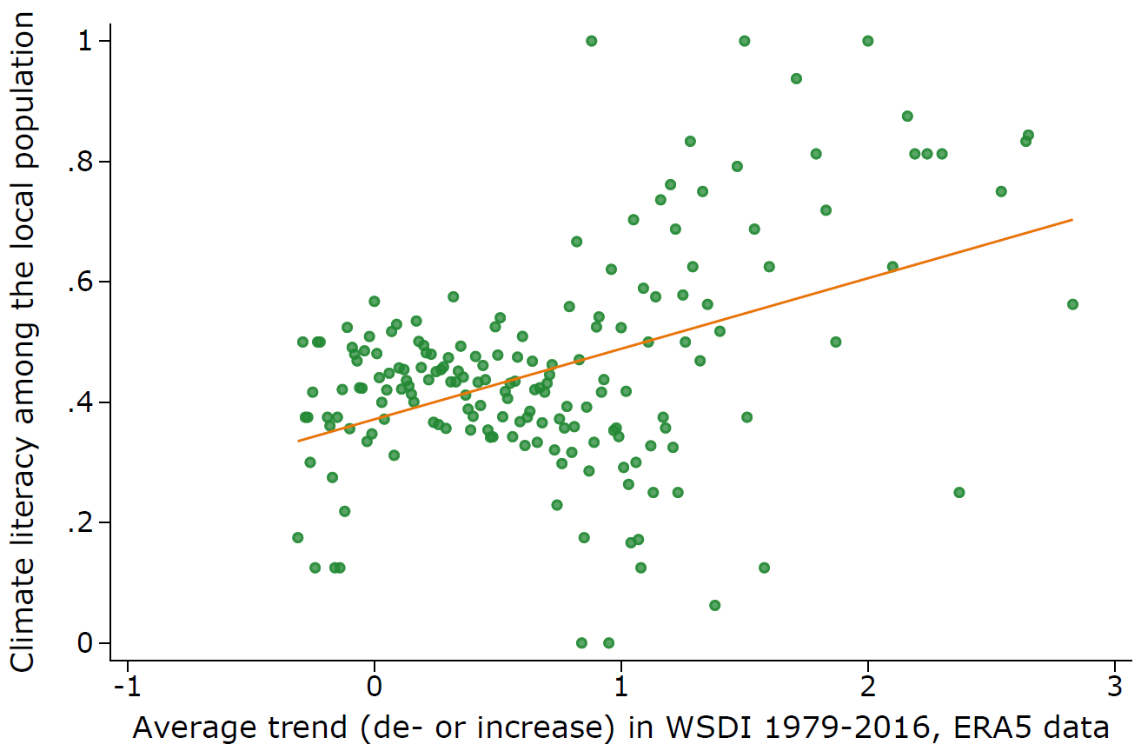
Notes: The figure shows the average number of respondents who have heard of climate change aggregated by the local WSDI trend.
Figure S1: Correlation of Climate Change Literacy and local WSDI trend

