Supporting Information
Evidences of soil warming from long-term trends (1951–2018) in North Rhine-Westphalia, Germany

Kristof Dorau¹, Chris Bamminger², Daniel Koch¹ & Tim Mansfeldt¹

¹ University of Cologne, Faculty of Mathematics and Natural Sciences, Department of Geosciences, Institute of Geography, Albertus-Magnus-Platz, D-50923 Köln, Germany
² North Rhine Westphalian State Agency for Nature, Environment and Consumer Protection, Department of Soil Protection/Contaminated Sites/Ecotoxicology, Leibnizstraße 10, D-45659 Recklinghausen, Germany

*Corresponding author (k.dorau@uni-koeln.de)

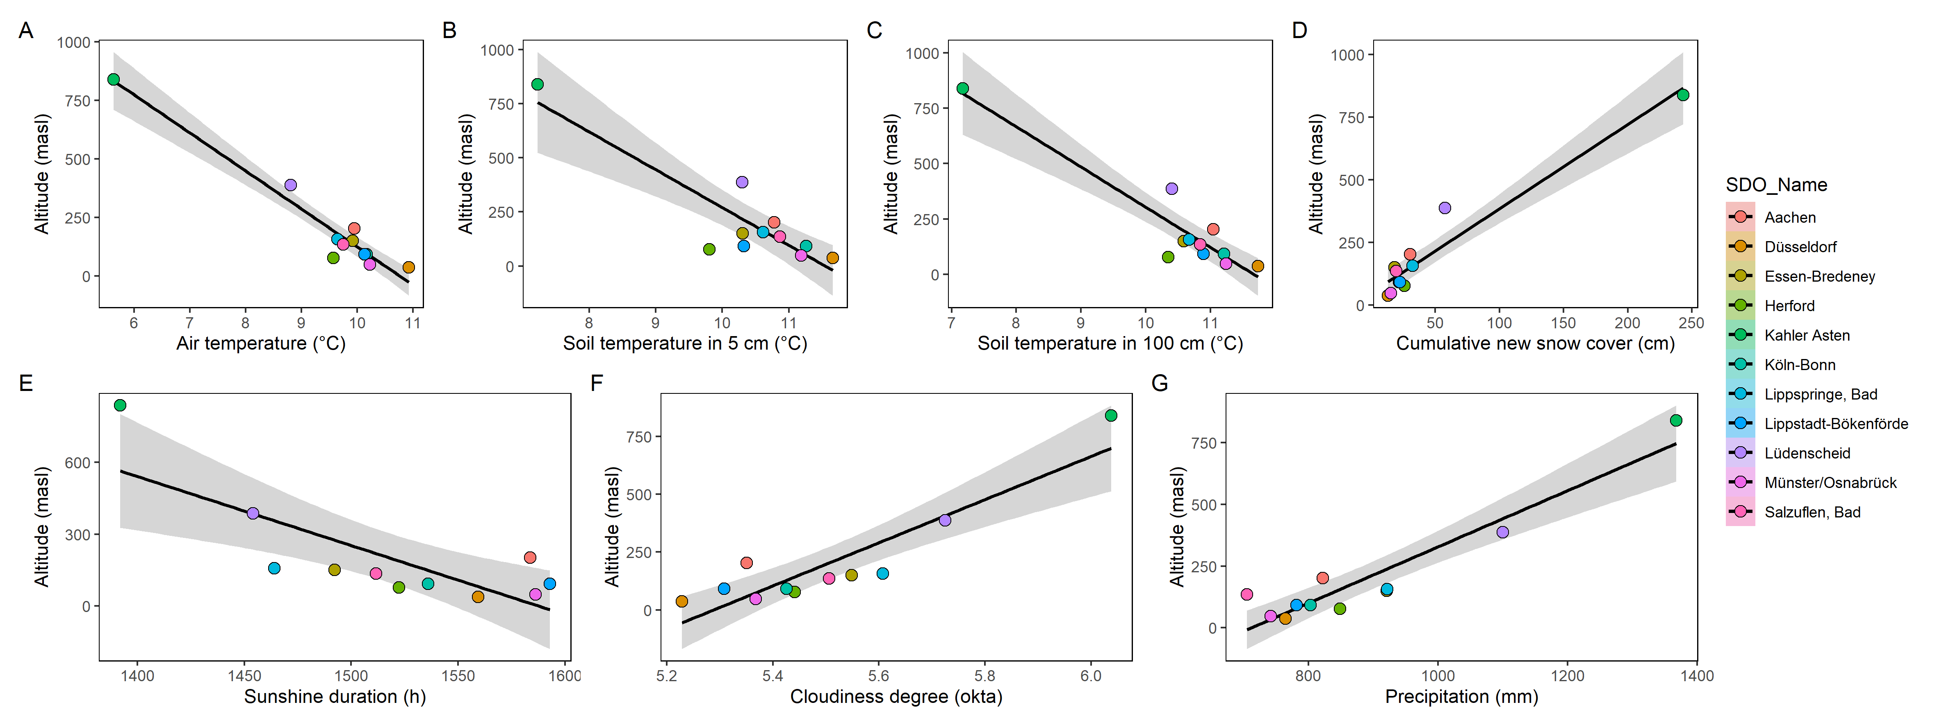
Figure S1 Altitude-dependent correlation with meteorological (A; D to G) and pedological variables (B and C) of the study sites in North Rhine-Westphalia. The grey band highlights the 95% confidence level interval for predictions from a linear model.
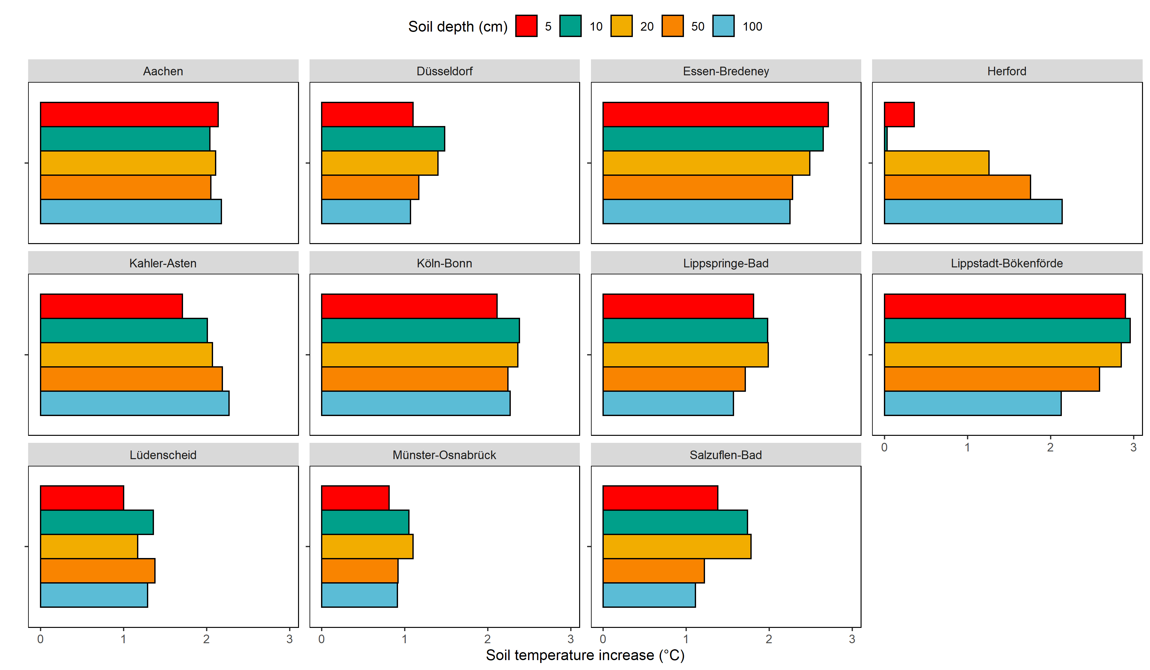
Figure S2 Increase in soil temperature for each study site per depth. The data is based on the extracted trend of the raw data derived by the seasonal trend decomposition.

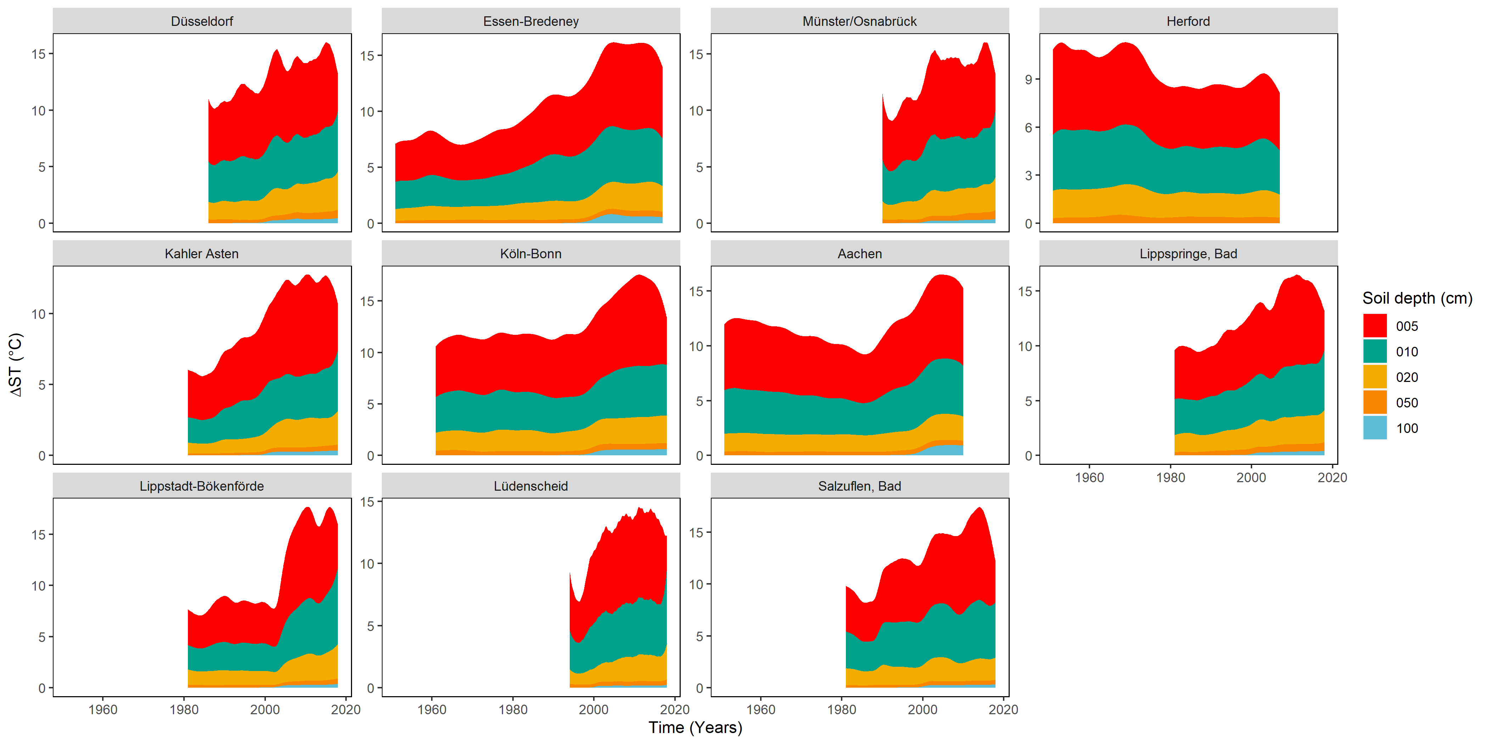
Figure S3 Development of diurnal soil temperature fluctuations (ΔST) calculated as difference between the daily maximum and the daily minimum value for the study sites and the depths under investigation visualized as stacked area chart.
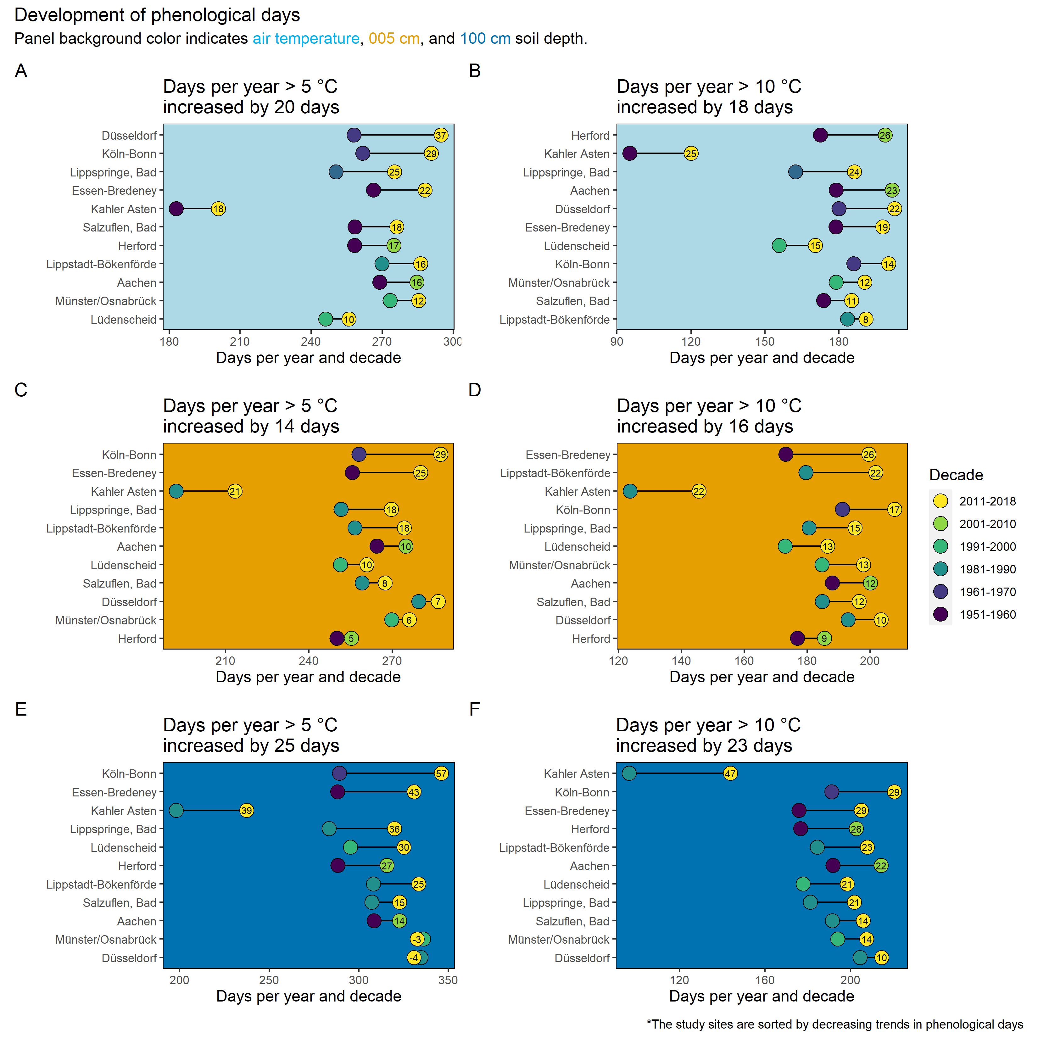
Figure S4 The development of phenological days with temperatures > 5 °C (A, C, E) and > 10 °C per year (B, D, F) is the mean per decade and the colored circles indicate the first and the last decade where monitoring for the individual study site was conducted. The length of the line reflects the increase in phenological days.
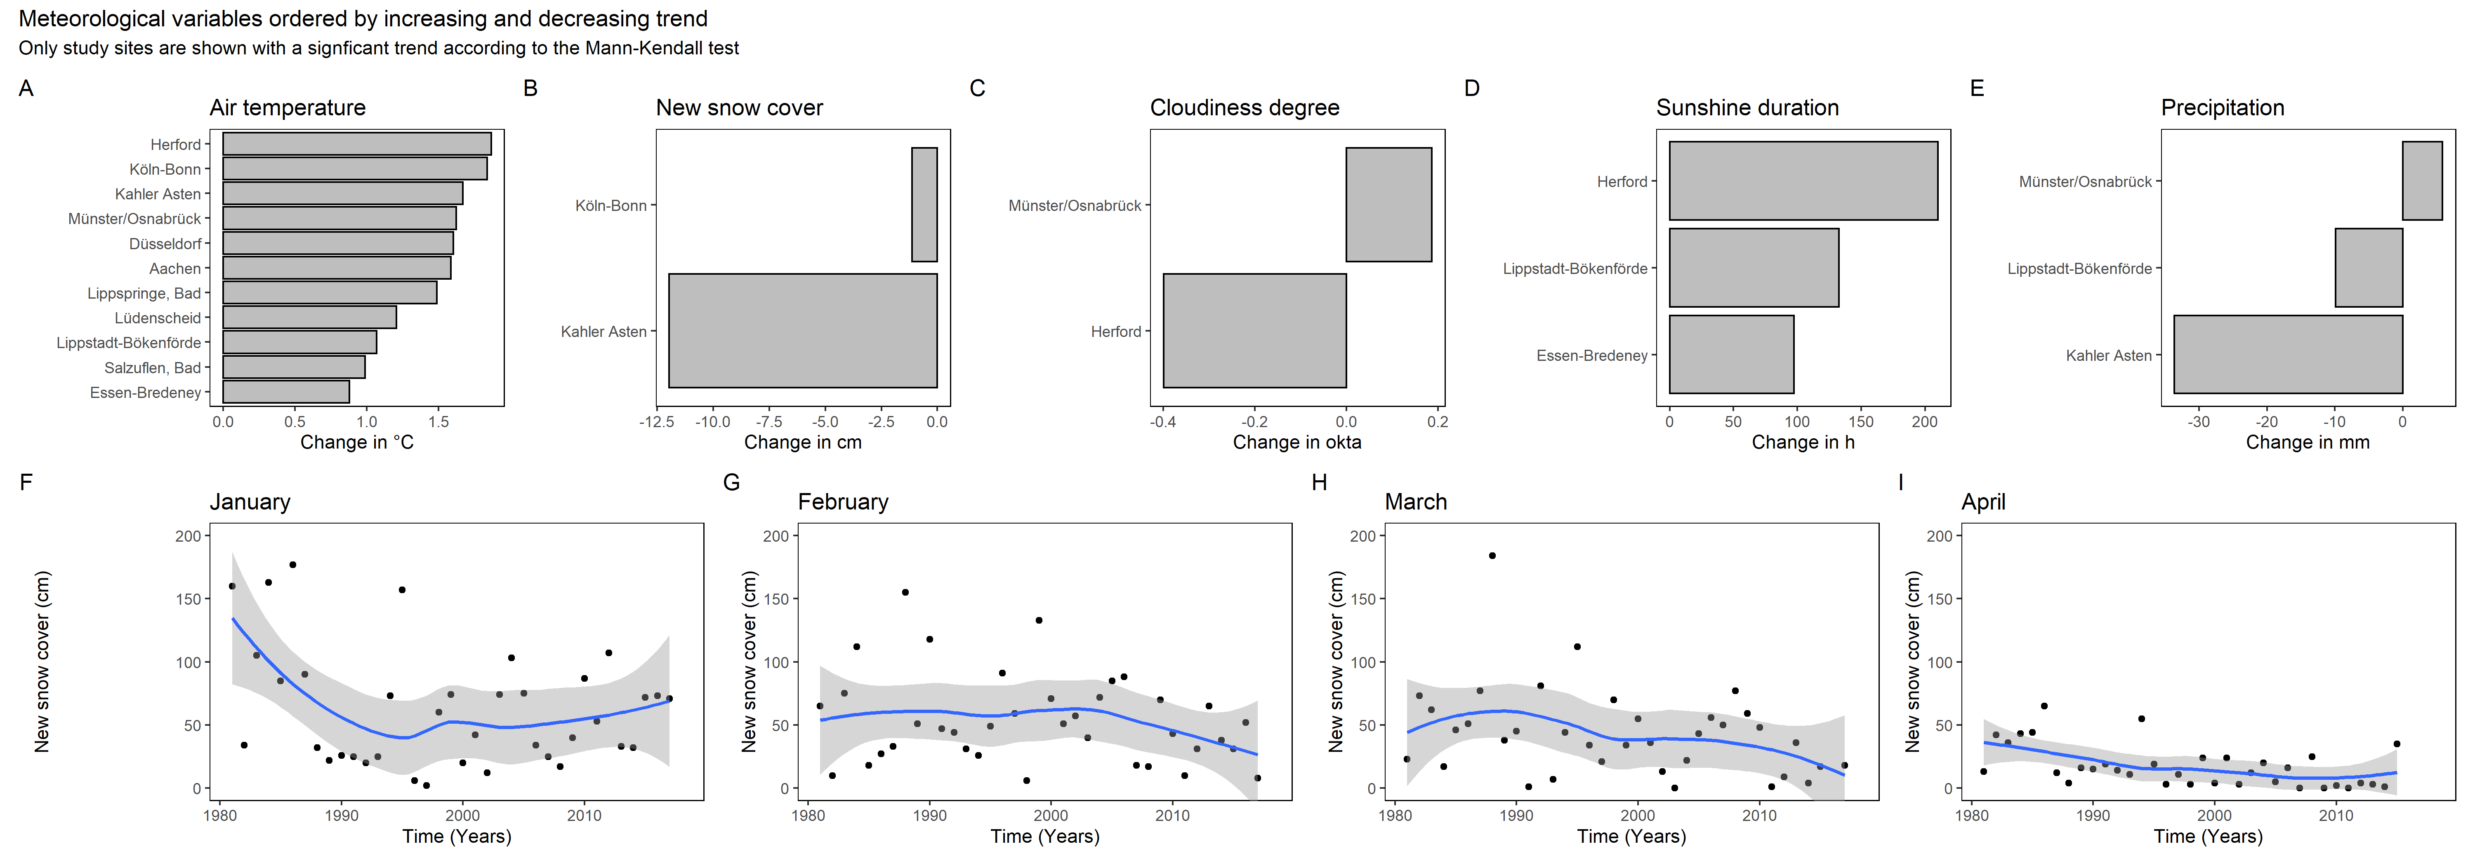
Figure S5 Meteorological variables that showed a statistical significant trend according to the seasonal adjusted Mann-Kendall test for air temperature (A), new snow cover (B), cloudiness degree (C), sunshine duration (D), and precipitation (E). The development of new snow cover for the months January to April (F to I) is highlighted for the site Kahler Asten with the decomposed trend line (blue line) and the 95% confidence level (grey band).

